

Assignment 5.1 Exercise
SHAP Loan Approval Explainability Analysis
In this exercise, you will analyze the loan approval dataset and utilize SHAP to understand feature contributions to model predictions. The goal is to interpret how specific features affect decisions and reflect on the ethical implications of such models.
Instructions:
- Complete “Step 3: SHAP Explanations” in the assignment_5.1_notebook copy and paste your output and respond to the questions into this exercise document.
- Provide short responses to the reflection questions in “Step 4: Ethical Reflection”

Note: Claude (Anthropic, claude-sonnet-4-6) was used to assist with completing the SHAP code cells in the assignment notebook.

Step 3: SHAP Explanations
Use SHAP to explain the predictions of your logistic regression model.
1a. Generate the SHAP force plot for the first data point in your test set using the SHAP values. The force plot should explain how individual features contribute to pushing the model’s prediction towards or away from class 1.
Paste the force plot here:
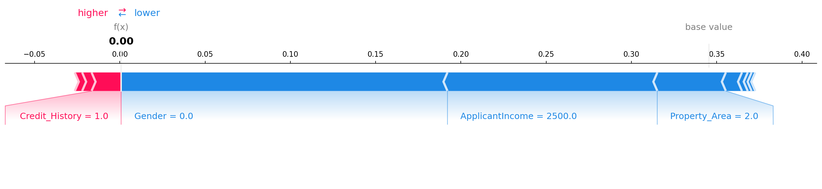

1b. Which features are pushing the prediction towards class 1? Which features are pushing the prediction away from class 1?
Response:
Features pushing the prediction TOWARD Class 1 (loan approval):
- Credit_History (+0.0148): The applicant has a credit history, which modestly supports approval.
- CoapplicantIncome (+0.0054): A small positive contribution from co-applicant income.
- Dependents (+0.0040): Having dependents contributes a marginal positive signal.

Features pushing the prediction AWAY from Class 1 (loan approval):
- Gender (-0.1902): The strongest single factor pulling the prediction away from approval. This applicant is female (Gender=0). A feature of this magnitude on a protected attribute is a direct indicator of model bias.
- ApplicantIncome (-0.1213): The applicant's income of $2,500 is below average, significantly reducing the predicted approval probability.
- Property_Area (-0.0397): The property location (urban area) contributes a small negative push.
- Married (-0.0095): Being unmarried adds a minor negative contribution.
Self_Employed (-0.0034), LoanAmount (-0.0023), Loan_Amount_Term (-0.0022): Minor negative contributions from these features.

2a. Create a bar plot that displays the SHAP values (feature contributions) for the second data point and SHAP values for class 1. The bar plot will show how much each feature contributes to the model's prediction for class 1, with the features ranked by their contribution.)
Paste the bar plot here:
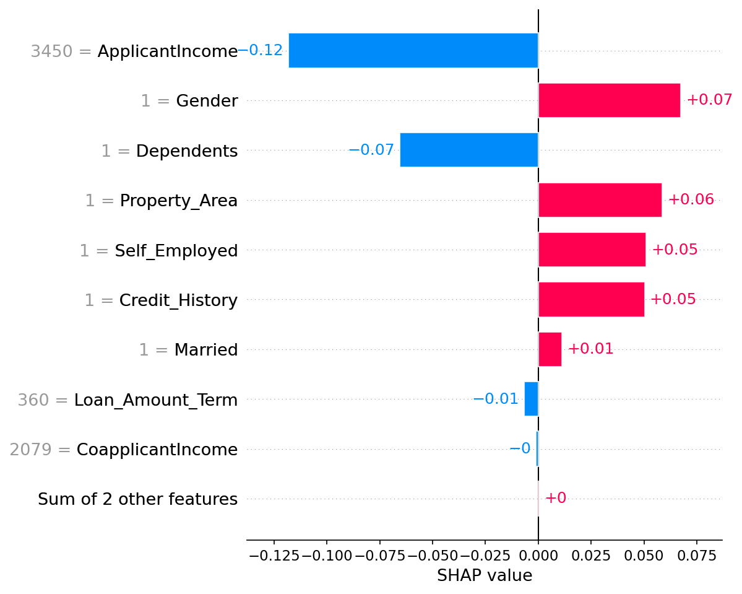

2b. Which feature had the greatest influence on the prediction for this data point? Were most features pushing the prediction toward or away from class 1? Are there any surprising variables that are influencing the prediction?
Response:
Greatest influence: ApplicantIncome (-0.1180) had the largest absolute SHAP value for this applicant, pushing away from approval despite the applicant having an income of $3,450. Relative to the full dataset distribution, this income is still below the threshold the model has learned to associate with approval.

3a. Create a beeswarm plot to visualize the global importance of features.
Paste the beeswarm plot here:
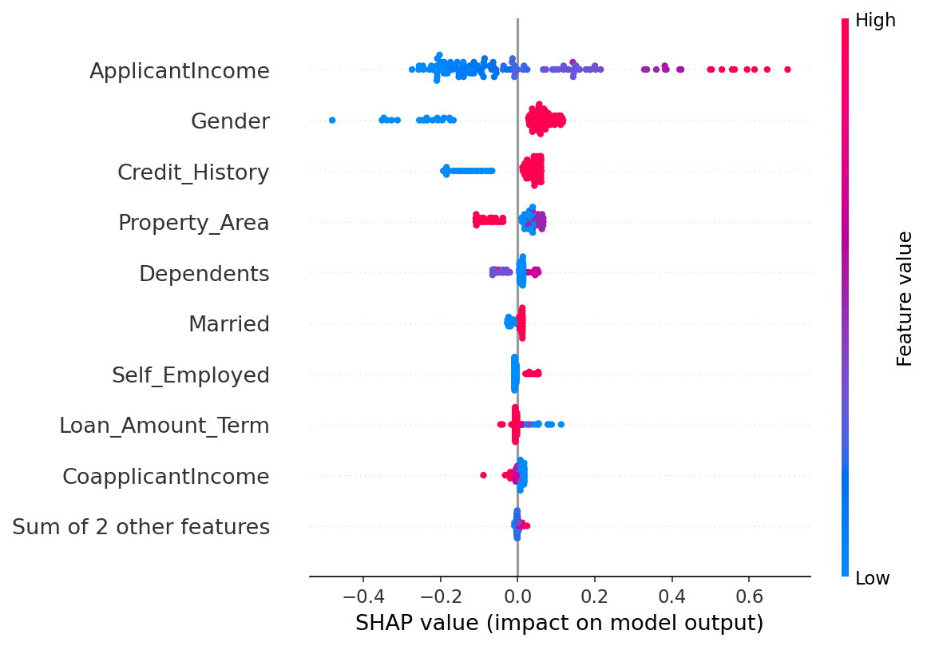

3b. Which feature appears to be the most important across all data points? Are there any features that have a mixed effect (i.e. pushing predictions towards class 1 and other times pushing them away?) What could cause this variability? How do the color of the dots help you interpret the relationship between the feature value and the prediction? Are there any notable findings?
Response:
Most important feature: ApplicantIncome (mean |SHAP| = 0.1810) is the single most influential feature globally. High income values (red) cluster on the positive SHAP side, pushing toward approval; low income values (blue) cluster on the negative side. This is an economically intuitive and defensible relationship.
Second most important: Gender (mean |SHAP| = 0.0952) — a protected attribute — is the second most globally influential feature, with SHAP values ranging from -0.48 (female) to +0.12 (male). This range and direction reveal systemic bias: the model is applying gender as a near-decisive factor for a substantial portion of applicants.

Step 4: Ethical Reflection
As you explored the SHAP plots, you were able to see how individual features contribute to a model's predictions, increasing transparency. However, even with these interpretability tools, there are broader ethical concerns regarding bias and transparency in machine learning systems.
Machine learning models, particularly those used in high-stakes areas like healthcare, finance, and criminal justice, can inadvertently reinforce societal biases present in the training data (e.g., based on race, gender, income). While tools like SHAP provide insights into how models make decisions, they do not prevent biased outcomes.
1. How can explainability tools such as SHAP help identify and address bias in machine learning models?
Your response:
SHAP provides quantified, per-feature contributions that make bias operationally visible rather than merely theoretically possible. In this loan approval analysis, SHAP surfaced two critical bias signals that would be invisible in a standard accuracy report:
- Global feature importance: Gender ranked as the second most influential predictor globally (mean |SHAP| = 0.0952), despite being a protected attribute with no legitimate relationship to creditworthiness. A standard accuracy metric of 91% would suggest a highly reliable model; SHAP reveals that reliability is partly built on discriminatory patterns.
- Directional asymmetry: The SHAP range for Gender (-0.48 to +0.12) demonstrates that the penalty for being female is nearly four times larger in magnitude than the benefit of being male. This asymmetry would go undetected without per-prediction explainability.
- Intersectional audit capability: By examining SHAP values for specific subgroups — e.g., female applicants with positive credit history — practitioners can test whether bias compounds across multiple demographic attributes.

2. How does explainability contribute to transparency in machine learning systems?
Your response:
Machine learning models deployed in high-stakes domains — lending, hiring, healthcare — are often challenged as 'black boxes' that produce outcomes without justification. SHAP addresses this at three levels:
- Individual transparency: Each applicant's decision can be decomposed into a ranked list of contributing factors. A denied applicant can be told not just 'your loan was denied' but 'your income level was the primary factor, followed by your property area.' This supports the right to explanation increasingly enshrined in regulations such as the EU AI Act and GDPR Article 22.
- Institutional transparency: Aggregated SHAP plots (beeswarm, global bar) allow compliance officers and external auditors to verify that the model is not systematically using protected attributes, providing an auditable evidence trail.
- Developer accountability: During model development, SHAP forces engineers to confront what the model has actually learned, rather than relying solely on aggregate performance metrics that can mask discriminatory behavior.

