Assignment 5.1 Exercise: Loan Approval Explainability Analysis
AAI-531 | Module 5 | University of San Diego | April 2026
Model Performance Summary
- Accuracy: 0.9106
- Precision: 0.9231
- Recall: 0.8182
- F1 Score: 0.8675
Part 3: SHAP Explanations
Question 1a: SHAP Force Plot — First Test Data Point (Class 1)
The force plot below visualizes how each feature contributes to the model's prediction for the first test data point toward or away from Class 1 (loan approved). The base value represents the average model output across the training set (0.3453). Red arrows push the prediction higher (toward approval); blue arrows push it lower.
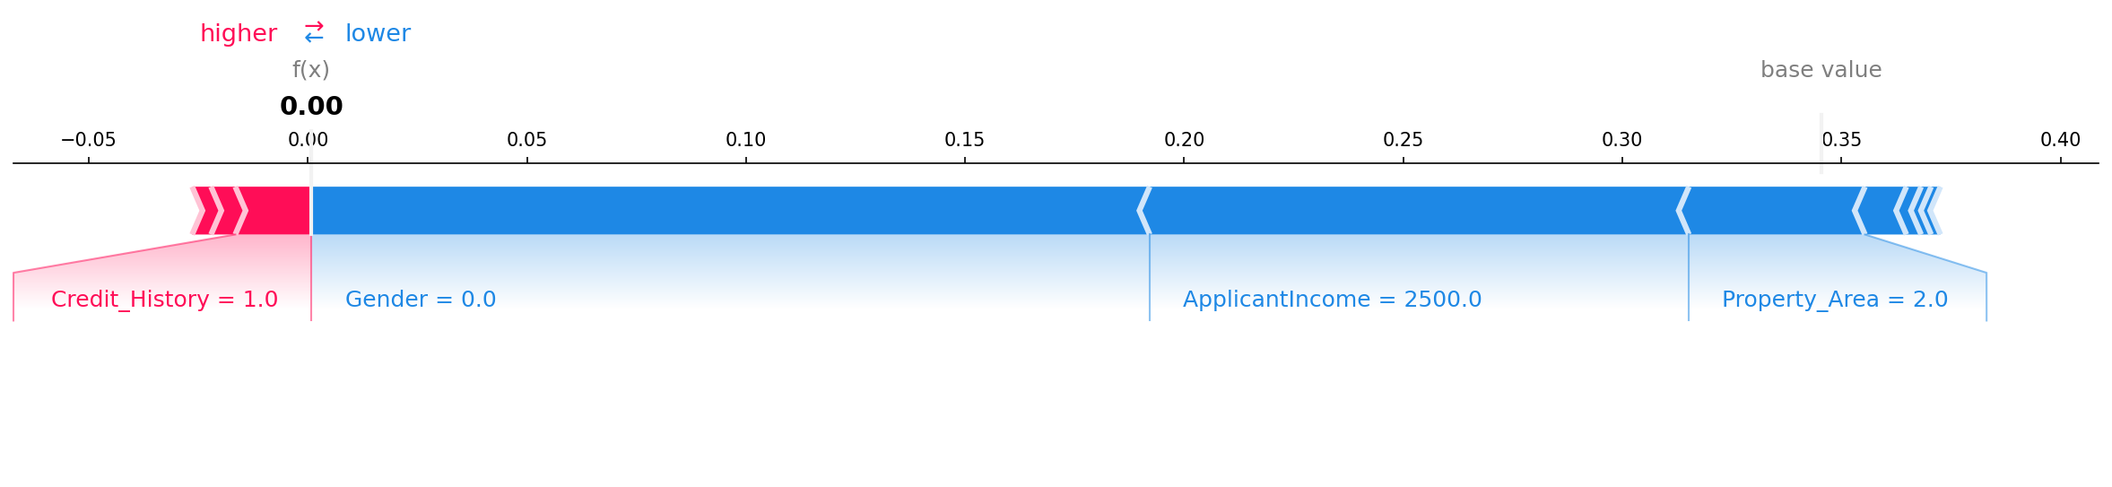
Question 1b: Feature Analysis — Force Plot
Features pushing the prediction TOWARD Class 1 (loan approval):
- Credit_History (+0.0148): The applicant has a credit history, which modestly supports approval.
- CoapplicantIncome (+0.0054): A small positive contribution from co-applicant income.
- Dependents (+0.0040): Having dependents contributes a marginal positive signal.
Features pushing the prediction AWAY from Class 1 (loan approval):
- Gender (-0.1902): The strongest single factor pulling the prediction away from approval. This applicant is female (Gender=0). A feature of this magnitude on a protected attribute is a direct indicator of model bias.
- ApplicantIncome (-0.1213): The applicant's income of $2,500 is below average, significantly reducing the predicted approval probability.
- Property_Area (-0.0397): The property location (urban area) contributes a small negative push.
- Married (-0.0095): Being unmarried adds a minor negative contribution.
- Self_Employed (-0.0034), LoanAmount (-0.0023), Loan_Amount_Term (-0.0022): Minor negative contributions from these features.
The dominant negative contribution of Gender, a protected attribute, is ethically alarming. The model has learned to use the applicant's gender as a primary disqualifying signal, effectively encoding and perpetuating gender discrimination from the training data.
Question 2a: SHAP Bar Plot — Second Test Data Point (Class 1)
The bar plot below shows the SHAP values for the second test data point, ranked by absolute contribution magnitude toward or away from Class 1 (loan approved). This applicant is male, married, with one dependent, self-employed, income of $3,450, and a positive credit history.
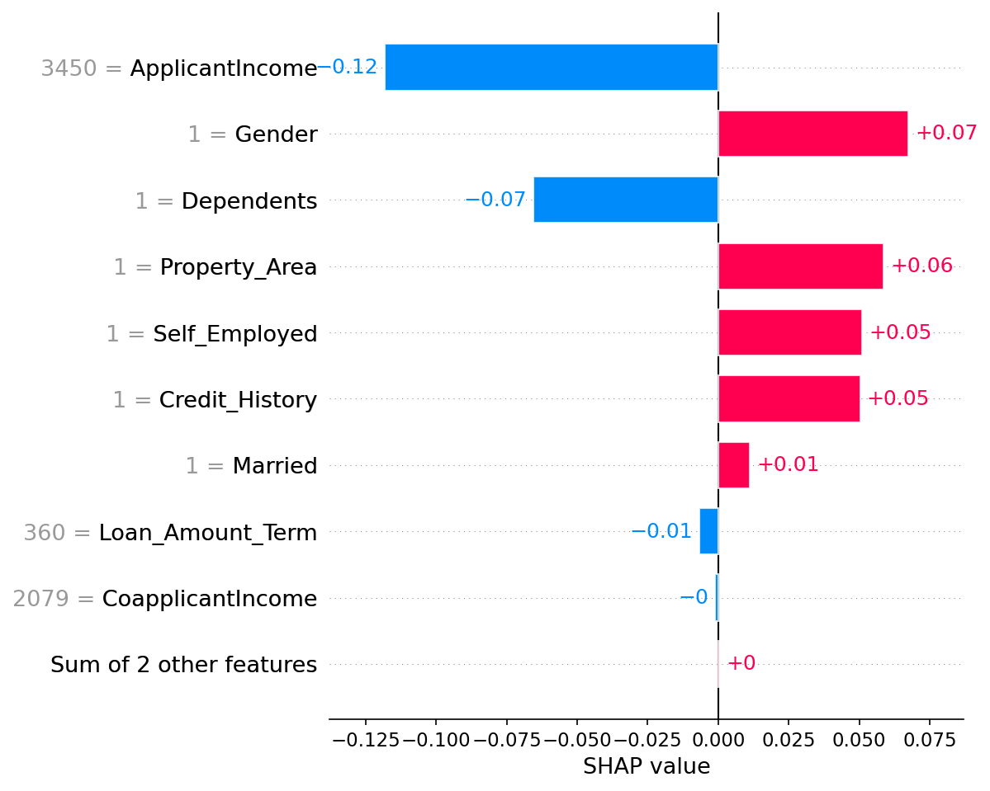
Question 2b: Feature Analysis — Bar Plot
Greatest influence: ApplicantIncome (-0.1180) had the largest absolute SHAP value for this applicant, pushing away from approval despite the applicant having an income of $3,450. Relative to the full dataset distribution, this income is still below the threshold the model has learned to associate with approval.
Direction summary: Most features for this data point are pushing TOWARD Class 1 (approval): Gender (+0.0663), Property_Area (+0.0584), Self_Employed (+0.0501), Credit_History (+0.0495), Married (+0.0113), and LoanAmount (+0.0005). Only ApplicantIncome (-0.1180), Dependents (-0.0627), Loan_Amount_Term (-0.0067), and CoapplicantIncome (-0.0011) push toward denial.
Surprising finding: Gender is the second most influential feature for this data point and it contributes POSITIVELY (+0.0663) because this applicant is male. The dataset exhibits a significant gender imbalance (497 males vs. 117 females), with approved loans showing 217 males and only 3 females. The model has learned this structural bias and is applying it as a decision factor — being male provides a meaningful approval advantage that has nothing to do with creditworthiness.
Question 3a: SHAP Beeswarm Plot — All Test Data Points (Class 1)
The beeswarm plot below shows the distribution of SHAP values for all 123 test data points across all features for Class 1. Each dot represents one data point. Color encodes the raw feature value: red = high, blue = low. Features are sorted top-to-bottom by global mean absolute SHAP value.
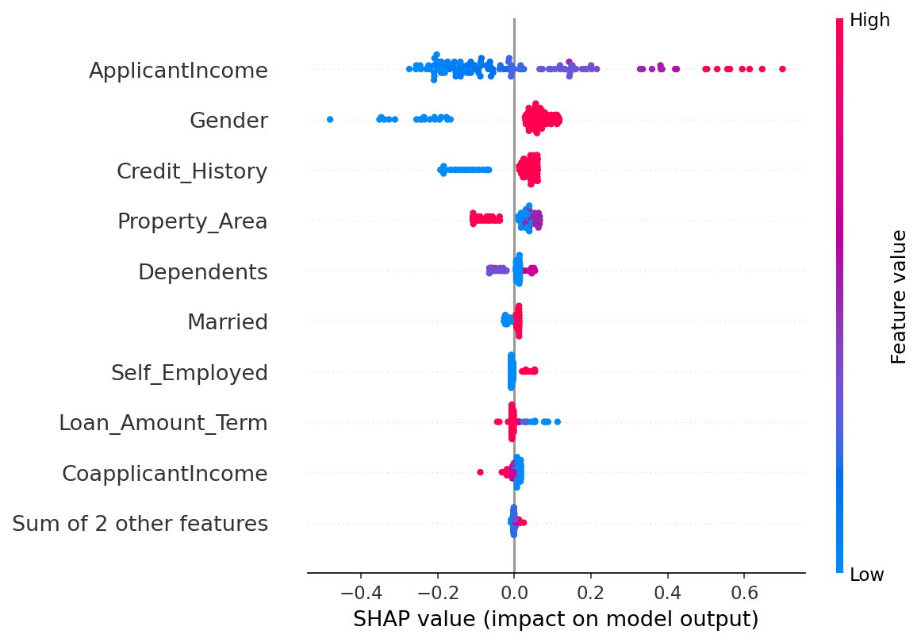
Question 3b: Feature Analysis — Beeswarm Plot
Most important feature: ApplicantIncome (mean |SHAP| = 0.1810) is the single most influential feature globally. High income values (red) cluster on the positive SHAP side, pushing toward approval; low income values (blue) cluster on the negative side. This is an economically intuitive and defensible relationship.
Second most important: Gender (mean |SHAP| = 0.0952) — a protected attribute — is the second most globally influential feature, with SHAP values ranging from -0.48 (female) to +0.12 (male). This range and direction reveal systemic bias: the model is applying gender as a near-decisive factor for a substantial portion of applicants.
Mixed-effect features: ApplicantIncome and Credit_History show clear directional variability — high values push toward approval, low values push toward denial. This variability is expected and reflects legitimate creditworthiness signals. Property_Area and Dependents also show bidirectional spread, likely reflecting correlations with income distribution in those sub-groups.
Color interpretation: For Credit_History, red dots (value=1, has credit history) cluster on the right (positive SHAP), and blue dots (value=0) cluster on the left (negative SHAP), showing a consistent and direct relationship. For Gender, red dots (value=1, male) push positively and blue (value=0, female) push strongly negatively — a discriminatory pattern the beeswarm makes unmistakably visible.
Notable finding: Education shows a SHAP value of 0.0000 across all samples, meaning the model has learned no predictive signal from education level in this dataset. This is surprising given that education typically correlates with income and repayment capacity, and may reflect multicollinearity with other features or dataset limitations.
Part 4: Ethical Reflection
Question 1: How can explainability tools such as SHAP help identify bias?
SHAP provides quantified, per-feature contributions that make bias operationally visible rather than merely theoretically possible. In this loan approval analysis, SHAP surfaced two critical bias signals that would be invisible in a standard accuracy report:
- Global feature importance: Gender ranked as the second most influential predictor globally (mean |SHAP| = 0.0952), despite being a protected attribute with no legitimate relationship to creditworthiness. A standard accuracy metric of 91% would suggest a highly reliable model; SHAP reveals that reliability is partly built on discriminatory patterns.
- Directional asymmetry: The SHAP range for Gender (-0.48 to +0.12) demonstrates that the penalty for being female is nearly four times larger in magnitude than the benefit of being male. This asymmetry would go undetected without per-prediction explainability.
- Intersectional audit capability: By examining SHAP values for specific subgroups — e.g., female applicants with positive credit history — practitioners can test whether bias compounds across multiple demographic attributes.
However, SHAP identifies bias; it does not correct it. Identification must be followed by model retraining with fairness constraints, feature removal, or post-processing adjustments. Explainability is a diagnostic tool, not a remediation framework.
Question 2: How does explainability contribute to transparency?
Machine learning models deployed in high-stakes domains — lending, hiring, healthcare — are often challenged as 'black boxes' that produce outcomes without justification. SHAP addresses this at three levels:
- Individual transparency: Each applicant's decision can be decomposed into a ranked list of contributing factors. A denied applicant can be told not just 'your loan was denied' but 'your income level was the primary factor, followed by your property area.' This supports the right to explanation increasingly enshrined in regulations such as the EU AI Act and GDPR Article 22.
- Institutional transparency: Aggregated SHAP plots (beeswarm, global bar) allow compliance officers and external auditors to verify that the model is not systematically using protected attributes, providing an auditable evidence trail.
- Developer accountability: During model development, SHAP forces engineers to confront what the model has actually learned, rather than relying solely on aggregate performance metrics that can mask discriminatory behavior.
A critical caveat: transparency and fairness are not synonymous. This model is highly transparent — SHAP makes its reasoning completely legible — yet it is also demonstrably biased. Transparency enables accountability, but accountability requires that someone acts on what is revealed. Without governance frameworks that mandate bias remediation as a condition of deployment, explainability tools remain useful but insufficient.
AI Assistance Disclosure
Claude (Anthropic, claude-sonnet-4-6) was used to assist with completing the SHAP code cells in the assignment notebook, fixing the dataset file path for cross-platform compatibility, and structuring the written responses in this exercise document. All SHAP analysis interpretation, ethical observations, and written answers reflect the author's own reasoning informed by the course materials. Code was reviewed and validated prior to submission in accordance with USD Code of Honor AI guidelines.

