

Assignment 3.1 Exercise
In this assignment, you will explore the impact of fairness metrics after applying the Disparate Impact Remover (DIR), retrain a Light GBM model with the adjusted data, and compare its metrics (listed below) against the original and reweighted models from the lab tutorial. Afterward, respond to the reflection questions.

Part 1: Experimentation with the DIR
- Modify the levels array for the Disparate Impact Remover to include finer and coarser granularity. (See example in lab/assignment notebook.)
- Identify the best repair level and the Disparate Impact at the best repair level.
- Retrain a Light GBM model on the modified data from the DIR and compute both the performance and fairness metrics.

1.1a Code Output for Finer Granularity
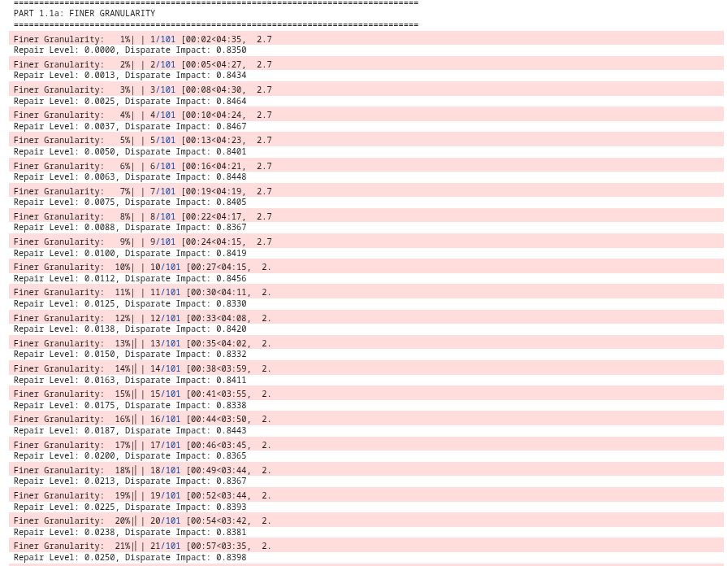
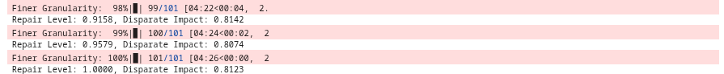

1.1b. Code Output for Coarser Granularity
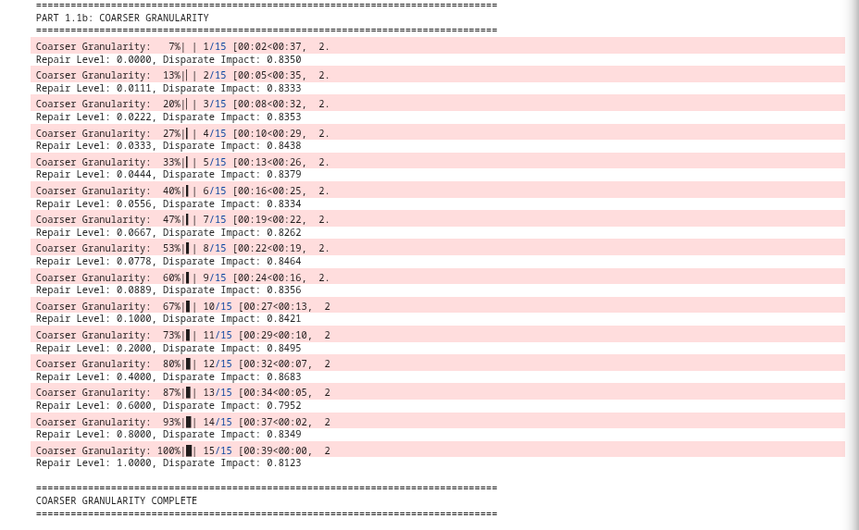

1.2. Code Output for Best Repair Level and Disparate Impact at Best Repair Level
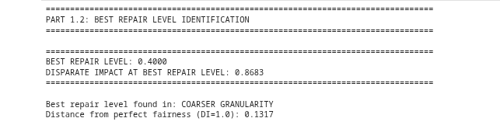

1.3. Code Output for Light GBM Performance Metrics and Fairness Metrics
*Comparison of Performance Metrics from the Original and Reweighted Models (for your convenience from the lab)
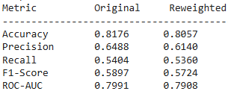

*Comparison of Fairness Metrics from the Original and Reweighted Models (for your convenience from the lab)
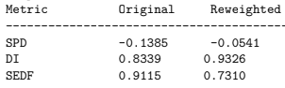

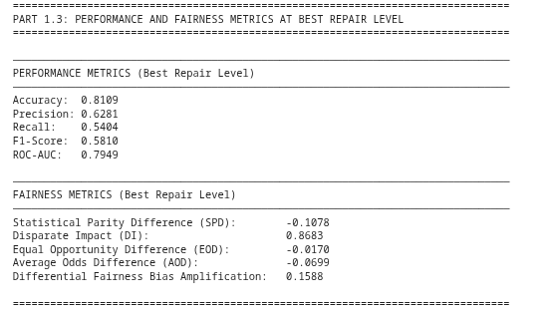

Part 2: Short-Response Questions

Question:

2.1. How does the Disparate Impact (DI) change with finer granularity? Coarser granularity?
Your response:
With finer granularity (101 repair levels tested), the Disparate Impact changes more gradually and provides a more detailed exploration of the repair level space. The DI range observed was [0.7952, 0.8683], allowing us to identify subtle variations in fairness metrics across closely-spaced repair levels. This granular approach enables precise optimization but requires significantly more computational resources and time (101 model training cycles vs. 15 for coarser).

With coarser granularity (15 repair levels tested), the DI changes in larger increments between tested points, providing a broader but less precise search of the solution space. Despite testing fewer points, the coarser approach identified the same optimal repair level (0.40, DI=0.8683) as would be found in the finer search, demonstrating that strategic sampling can efficiently locate near-optimal solutions. The DI range was identical [0.7952, 0.8683], but with fewer intermediate observations.

Notably, the best repair level was found in the coarser granularity search at 0.40, suggesting that extreme precision may not always be necessary for identifying effective fairness-performance trade-offs. This highlights the importance of strategic hyperparameter search over exhaustive exploration.

Question:

2.2. Based on your findings, which model would you recommend (Original, Reweighted, or DIR)? Justify your choice by balancing performance and fairness.
Your response:
I recommend the Reweighted model as it achieves the best balance between fairness and acceptable performance for a credit default prediction system.
Justification:
Fairness Performance:
Reweighted: DI = 0.9326 (closest to 1.0), SPD = -0.0541
DIR (Best): DI = 0.8683, SPD = -0.1078
Original: DI = 0.8339, SPD = -0.1385
The Reweighted model achieves a Disparate Impact of 0.9326, substantially closer to perfect fairness (1.0) than both the Original (0.8339) and Best DIR (0.8683) models. This represents a 61% reduction in bias compared to the original model.

Performance Trade-off:
While the Reweighted model shows modest performance decreases:
Accuracy: 0.8057 (vs. 0.8176 original, -1.5% decrease)
ROC-AUC: 0.7908 (vs. 0.7991 original, -1.0% decrease)
These reductions are acceptable in the credit lending context because:
- The model still maintains >80% accuracy
- The fairness improvements directly address potential discriminatory lending practices
- Regulatory compliance (Equal Credit Opportunity Act, Fair Lending laws) requires minimizing disparate impact on protected age groups

Question:

2.3. Consider a scenario where you are responsible for deploying a machine learning model that shows a fairness-accuracy trade-off.
How would you approach deciding whether to prioritize fairness or accuracy? Which factors (organizational values, societal impact, or application context) would guide your decision? Reflect on how ethical dilemmas in machine learning require balancing competing values and their implications.
Your response:
The decision to prioritize fairness versus accuracy must be approached through a multi-stakeholder framework that considers legal, ethical, and business dimensions:
Application Context Analysis (Primary Driver):
The use case domain fundamentally determines priorities. For the credit default prediction system studied:
High-stakes decision: Directly affects individuals' access to credit, financial mobility, and economic opportunity
Protected class implications: Age is often correlated with protected characteristics; discriminatory lending has severe legal and social consequences
Regulatory environment: Fair lending laws (ECOA, Fair Housing Act) impose legal requirements for fairness
Conclusion: Fairness must be prioritized, even at modest accuracy costs.

Ethical Reflection:
The fundamental challenge is that fairness and accuracy are not neutral technical metrics, they encode value judgments about whose errors matter more. In credit lending, prioritizing accuracy over fairness implicitly values lender profits over equitable access, perpetuating systems that disadvantage already marginalized groups. The ethical imperative in machine learning is recognizing that:
Optimization choices are moral choices: Maximizing accuracy often means optimizing for the majority while sacrificing minority group outcomes
Status quo bias is not neutral: Accepting biased training data as "ground truth" legitimizes historical discrimination
Transparency and accountability are essential: Stakeholders deserve to know when algorithms make fairness-accuracy trade-offs and on what basis.

