Goodjobnet.org
Overview

Welcome to the new Employment Center Website focused on making it easier to connect those seeking employment with nearby job opportunities.
Easy Access to jobs – just type goodjobnet.org in the browser address bar or location bar. You can do this with your phone, tablet or computer.
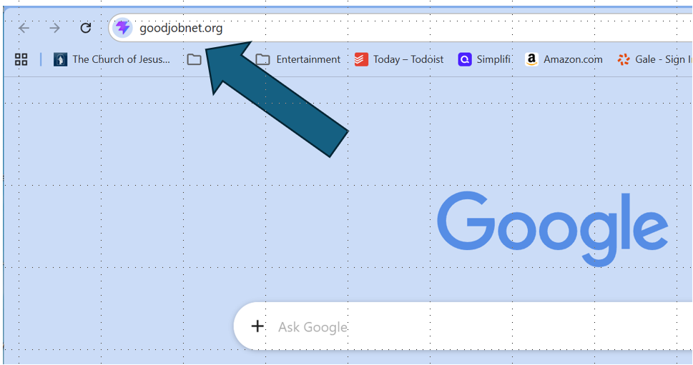

Entering goodjobnet.org into the browser address bar

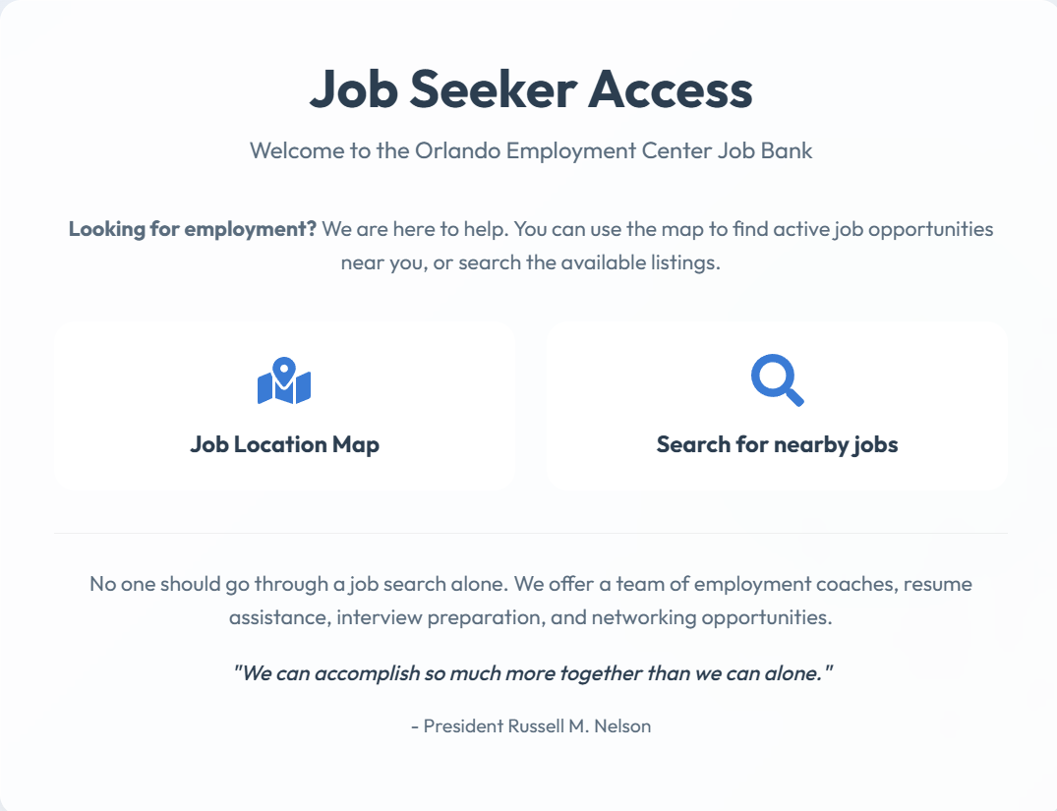
Two options provided on the dashboard: Job location map and Search for nearby jobs
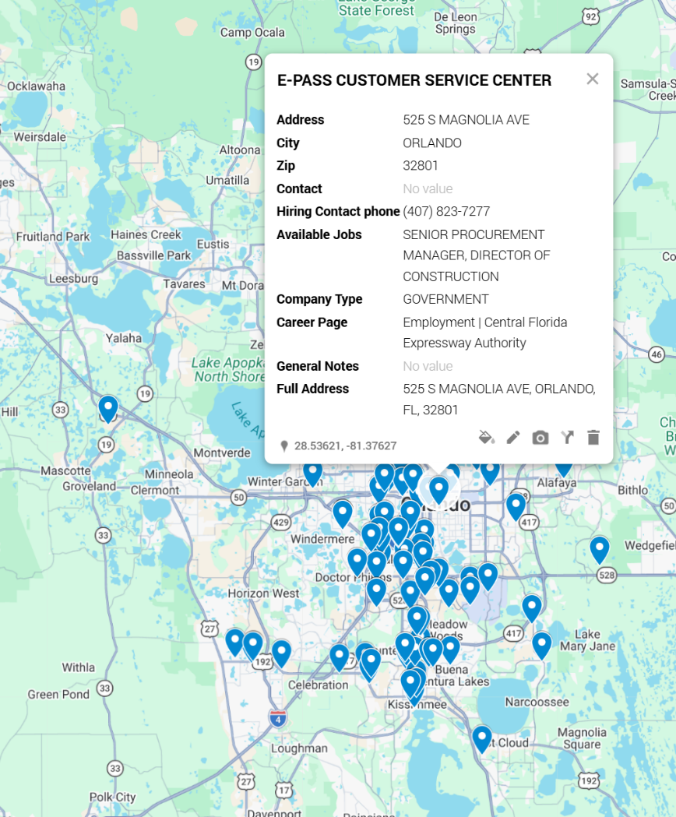
Job Location Map shows locations for pre-vetted jobs. Click on pins for additional information
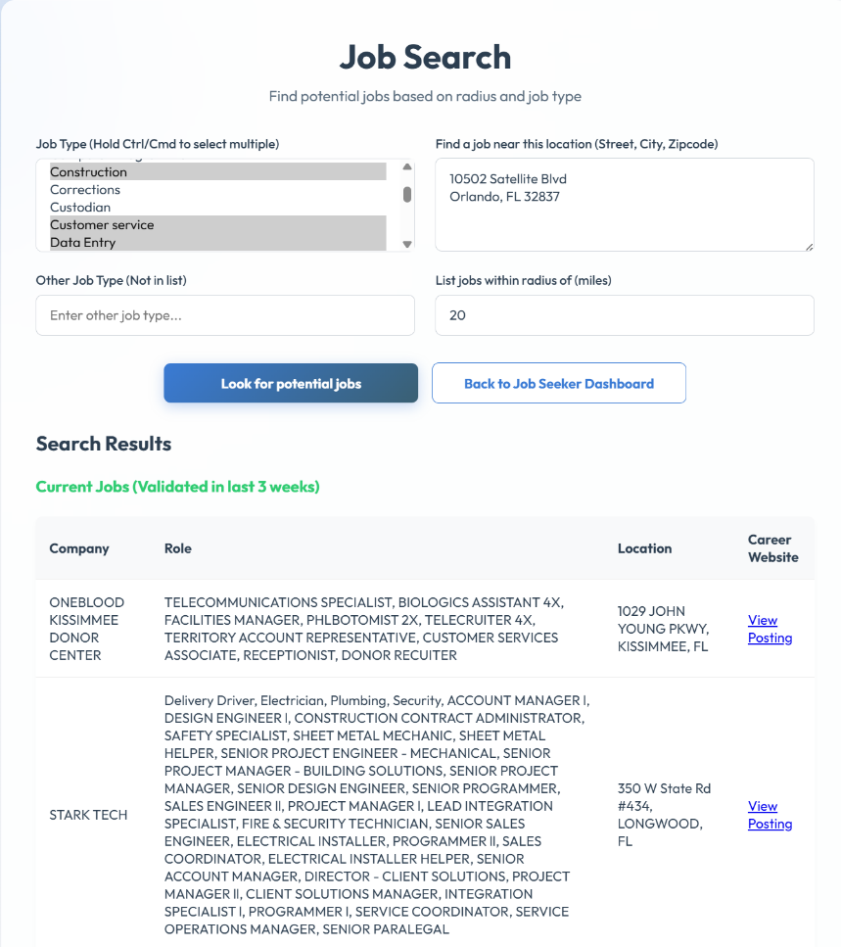
Job Search: Enter types of jobs you are looking for, enter an address (just a zip code will work), and a radius. Jobs that meet the criteria are displayed along with links to information for each job

