Dispatch Router Performance Testing

07 November 2020

Mick Goulish
mgoulish@redhat.com

Viewing note: This document contains some animated gif images which may not work if viewed in a browser. Pleas view from your desktop with Libre Office.

How the Latency Tests Work

Linear router networks were used in the following topologies (routers marked with letters) :

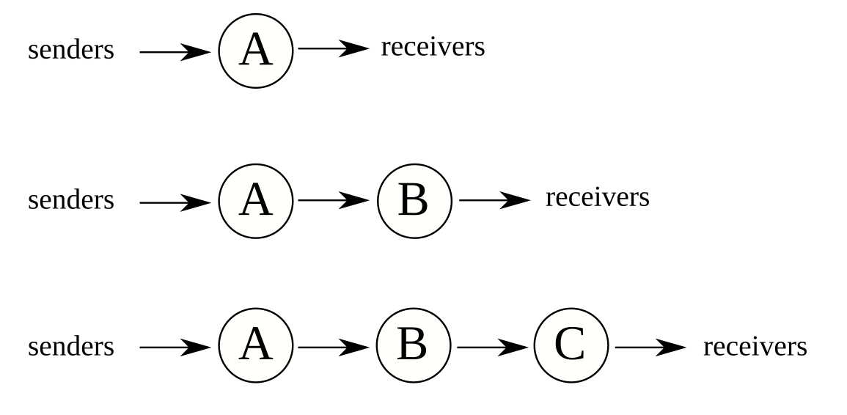

- Senders and receivers come in pairs: each sender sends to one receiver using a unique address.
- Each sender is throttled to 10 messages per second.
- Each message has 100 byte payload.
- No sender begins sending until all clients have finished starting up and attaching to their routers.
- Senders insert a timestamp into message just before sending. Receiver extracts timestamp upon reception and calculates flight time (latency).
- No client does I/O or memory allocation during messaging time.
- Receivers save flight time information in an array and do not write it out until all receivers have finished receiving expected number of messages.
- All routers and clients are colocated on one machine.
- Machine is 32-core AMD 3970X 3.7 GHz 256 MB.
- Cores are locked at 3.7 GHz
- Dispatch Router code version: 1.15.0-SNAPSHOT
- Proton code version: 0.33.0-SNAPSHOT
- First second and last second of data are trimmed off before analyzing and graphing data, because they contain test-generated effects.

Latency Results for 1, 2, and 3 Routers

Please Note: The following three graphs all have the same scale on the Y-axis.

1 Router
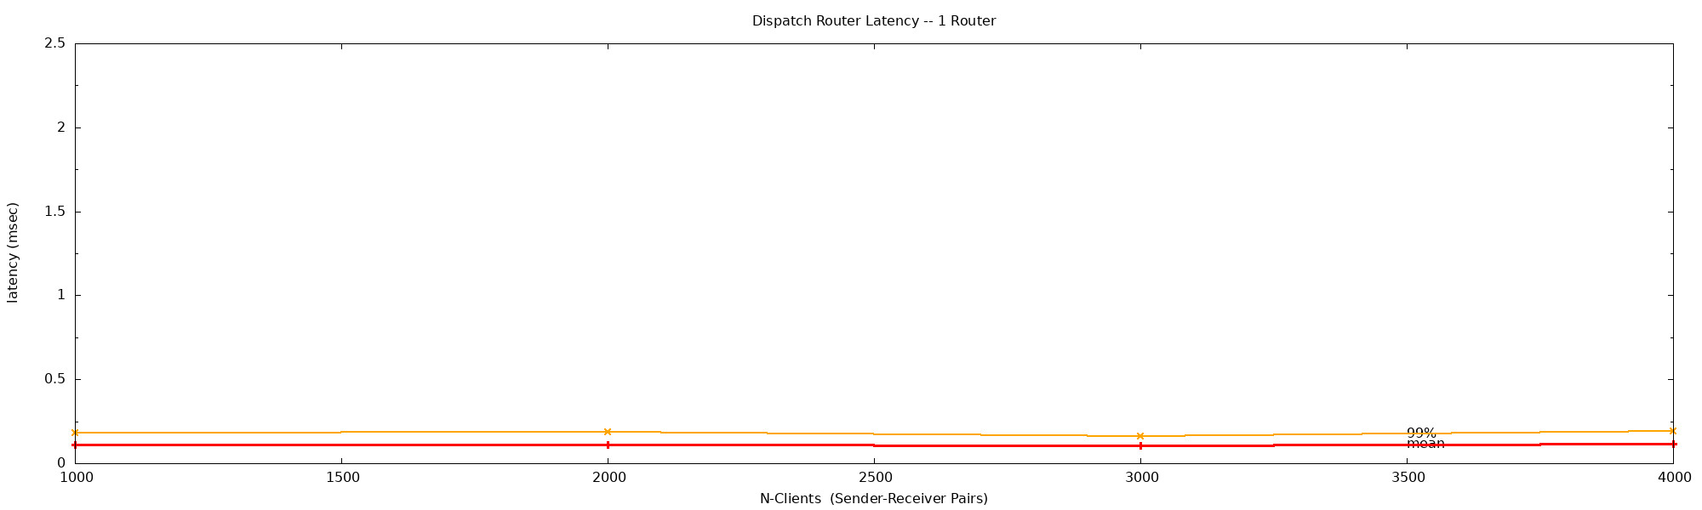

2 Routers
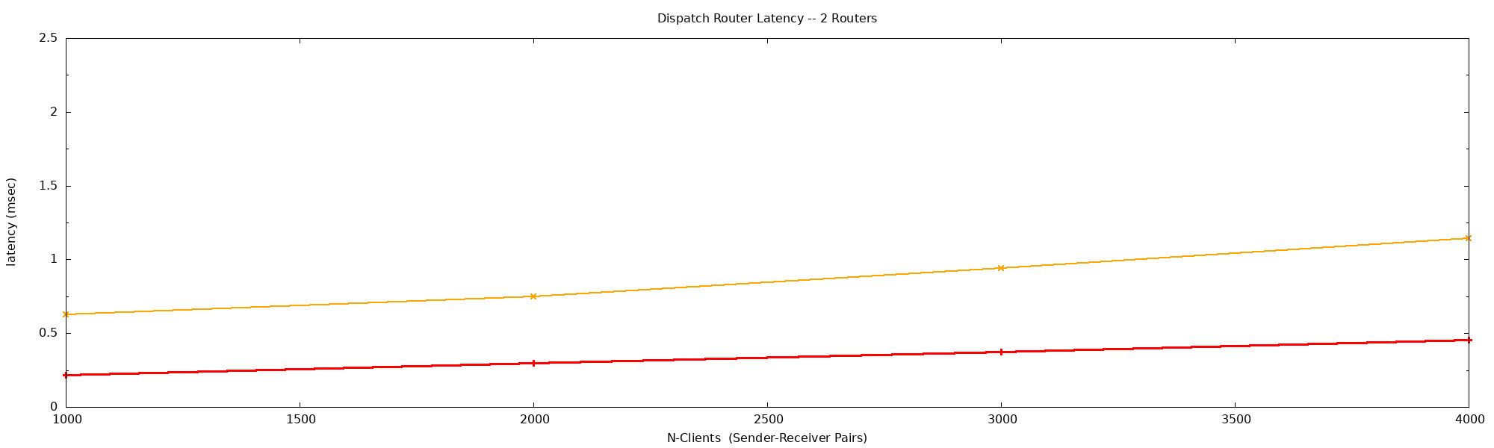

3 Routers
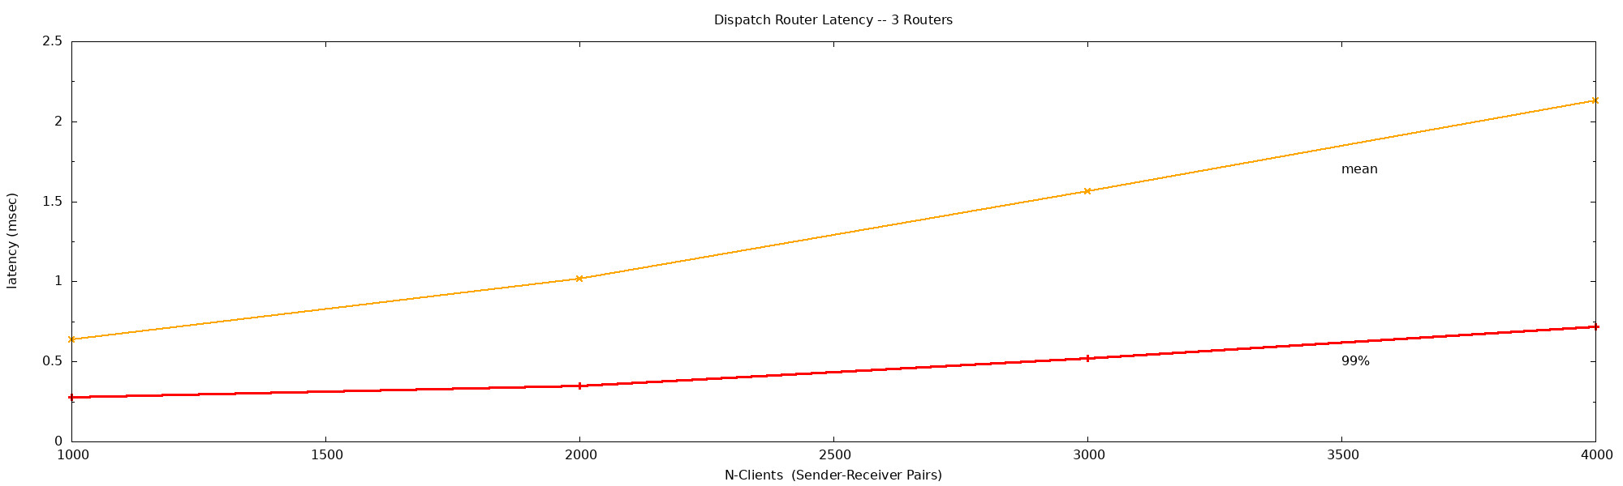

1-Router Latency Test Timeline Charts

These charts are timelines of all the data that was counted for the latency tests. (The first and last 1-second intervals have been trimmed off to eliminate test-generated effects.)
Each blue cross represents a single message. You can see that there are occasional momentary latency spikes, which increase in frequency and severity as number of clients increases.
Ted asked a good question: would those spikes still be there if we ran this on a Real-Time kernel?
Red lines show 99% line: 99% of all messages are at or below that latency.

Please Note: the following charts have different scales on the Y-axis.

1000 Client-Pairs
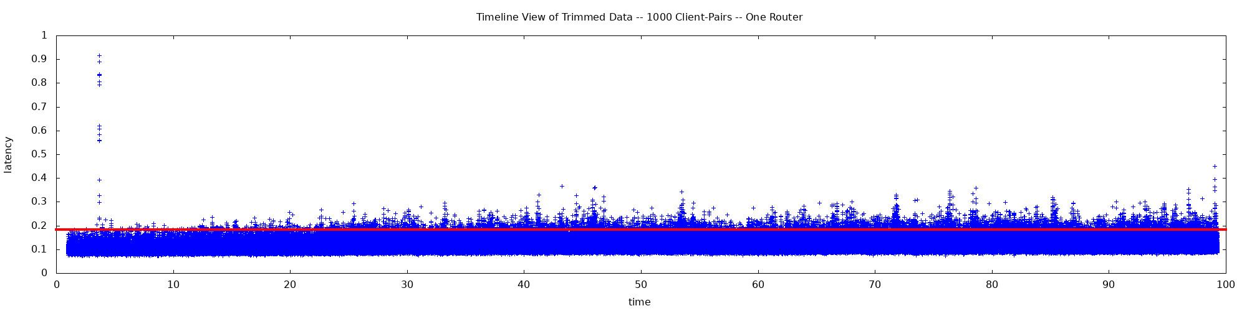

2000 Client-Pairs
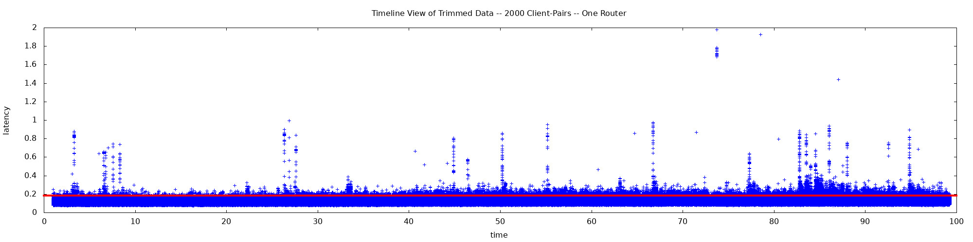

3000 Client-Pairs
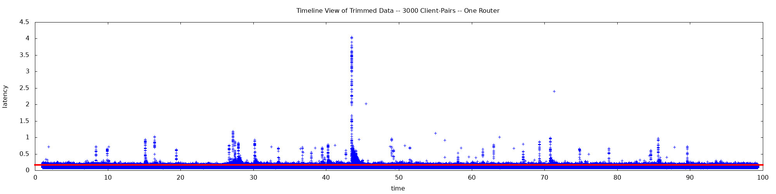

4000 Client-Pairs
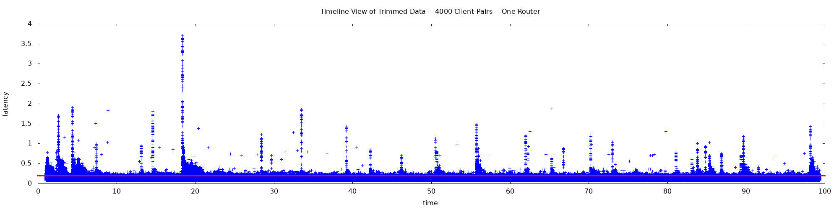

Throughput

In throughput tests a much smaller number of sender-receiver pairs is used and the senders are allowed to run unthrottled. 100-byte payload images.

Single-router throughput reaches a peak of 400,000 messages per second and degrades only slightly as n-clients increase from 5 to 100.

Please note that 400,000 messages per second equals 800,000 transfers per second by the router.

Two- and three-router throughput hovers near 100,000 messages per second.

One Router
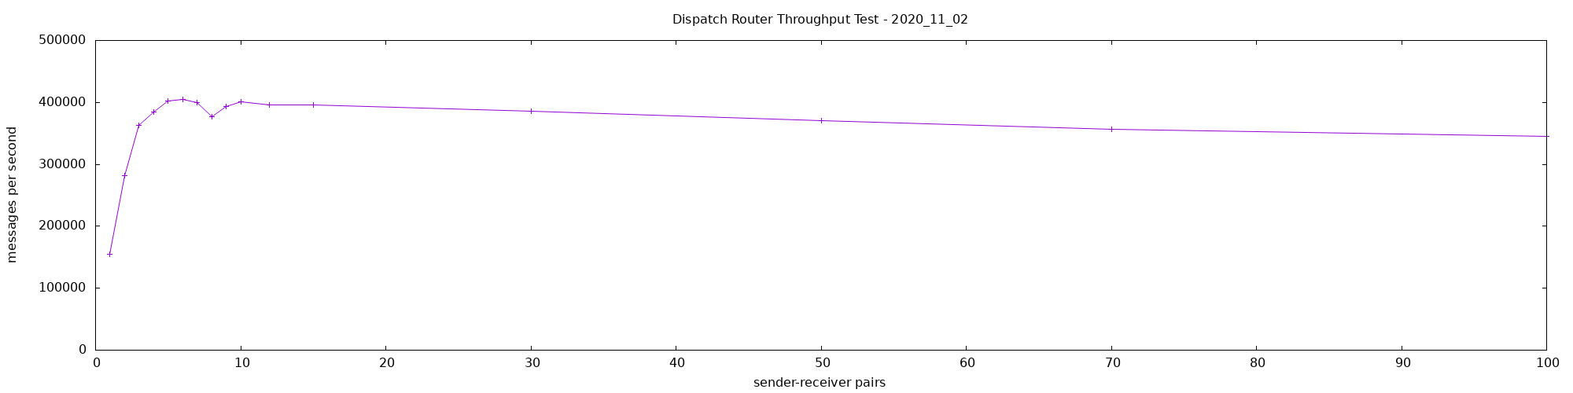

Two Routers
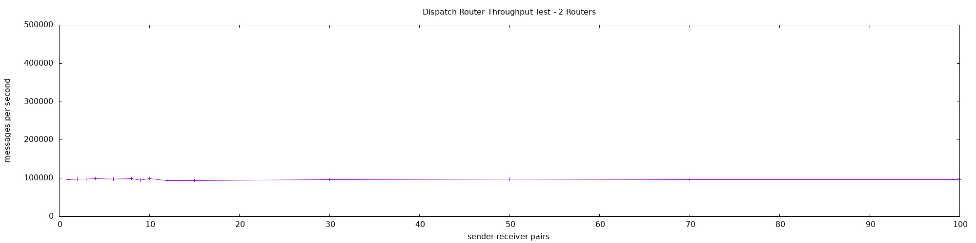

Three Routers
