Dispatch Router Performance Testing

07 November 2020

Mick Goulish
mgoulish@redhat.com

Viewing note: This document contains some animated gif images which may not work if viewed in a browser. Pleas view from your desktop with Libre Office.

How the Latency Tests Work

Linear router networks were used in the following topologies (routers marked with letters) :

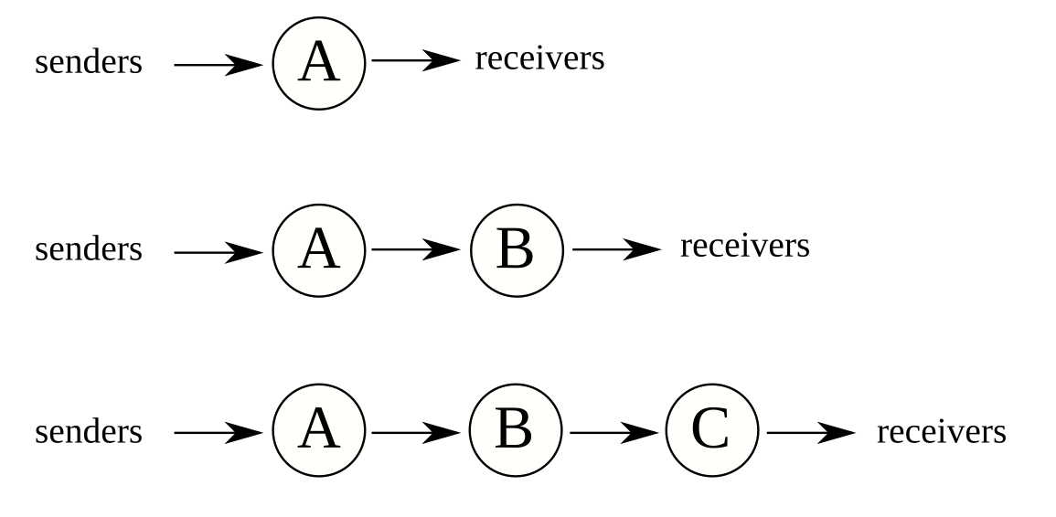

- Senders and receivers come in pairs: each sender sends to one receiver using a unique address.
- Each sender is throttled to 10 messages per second.
- Each message has 100 byte payload.
- No sender begins sending until all clients have finished starting up and attaching to their routers.
- Senders insert a timestamp into message just before sending. Receiver extracts timestamp upon reception and calculates flight time (latency).
- No client does I/O or memory allocation during messaging time.
- Receivers save flight time information in an array and do not write it out until all receivers have finished receiving expected number of messages.
- All routers and clients are colocated on one machine.
- Machine is 32-core AMD 3970X 3.7 GHz 256 MB.
- Cores are locked at 3.7 GHz
- Dispatch Router code version: 1.15.0-SNAPSHOT
- Proton code version: 0.33.0-SNAPSHOT

Latency Results Summary

Average Latency as Number of Clients Varies, for One, Two, and Three Routers
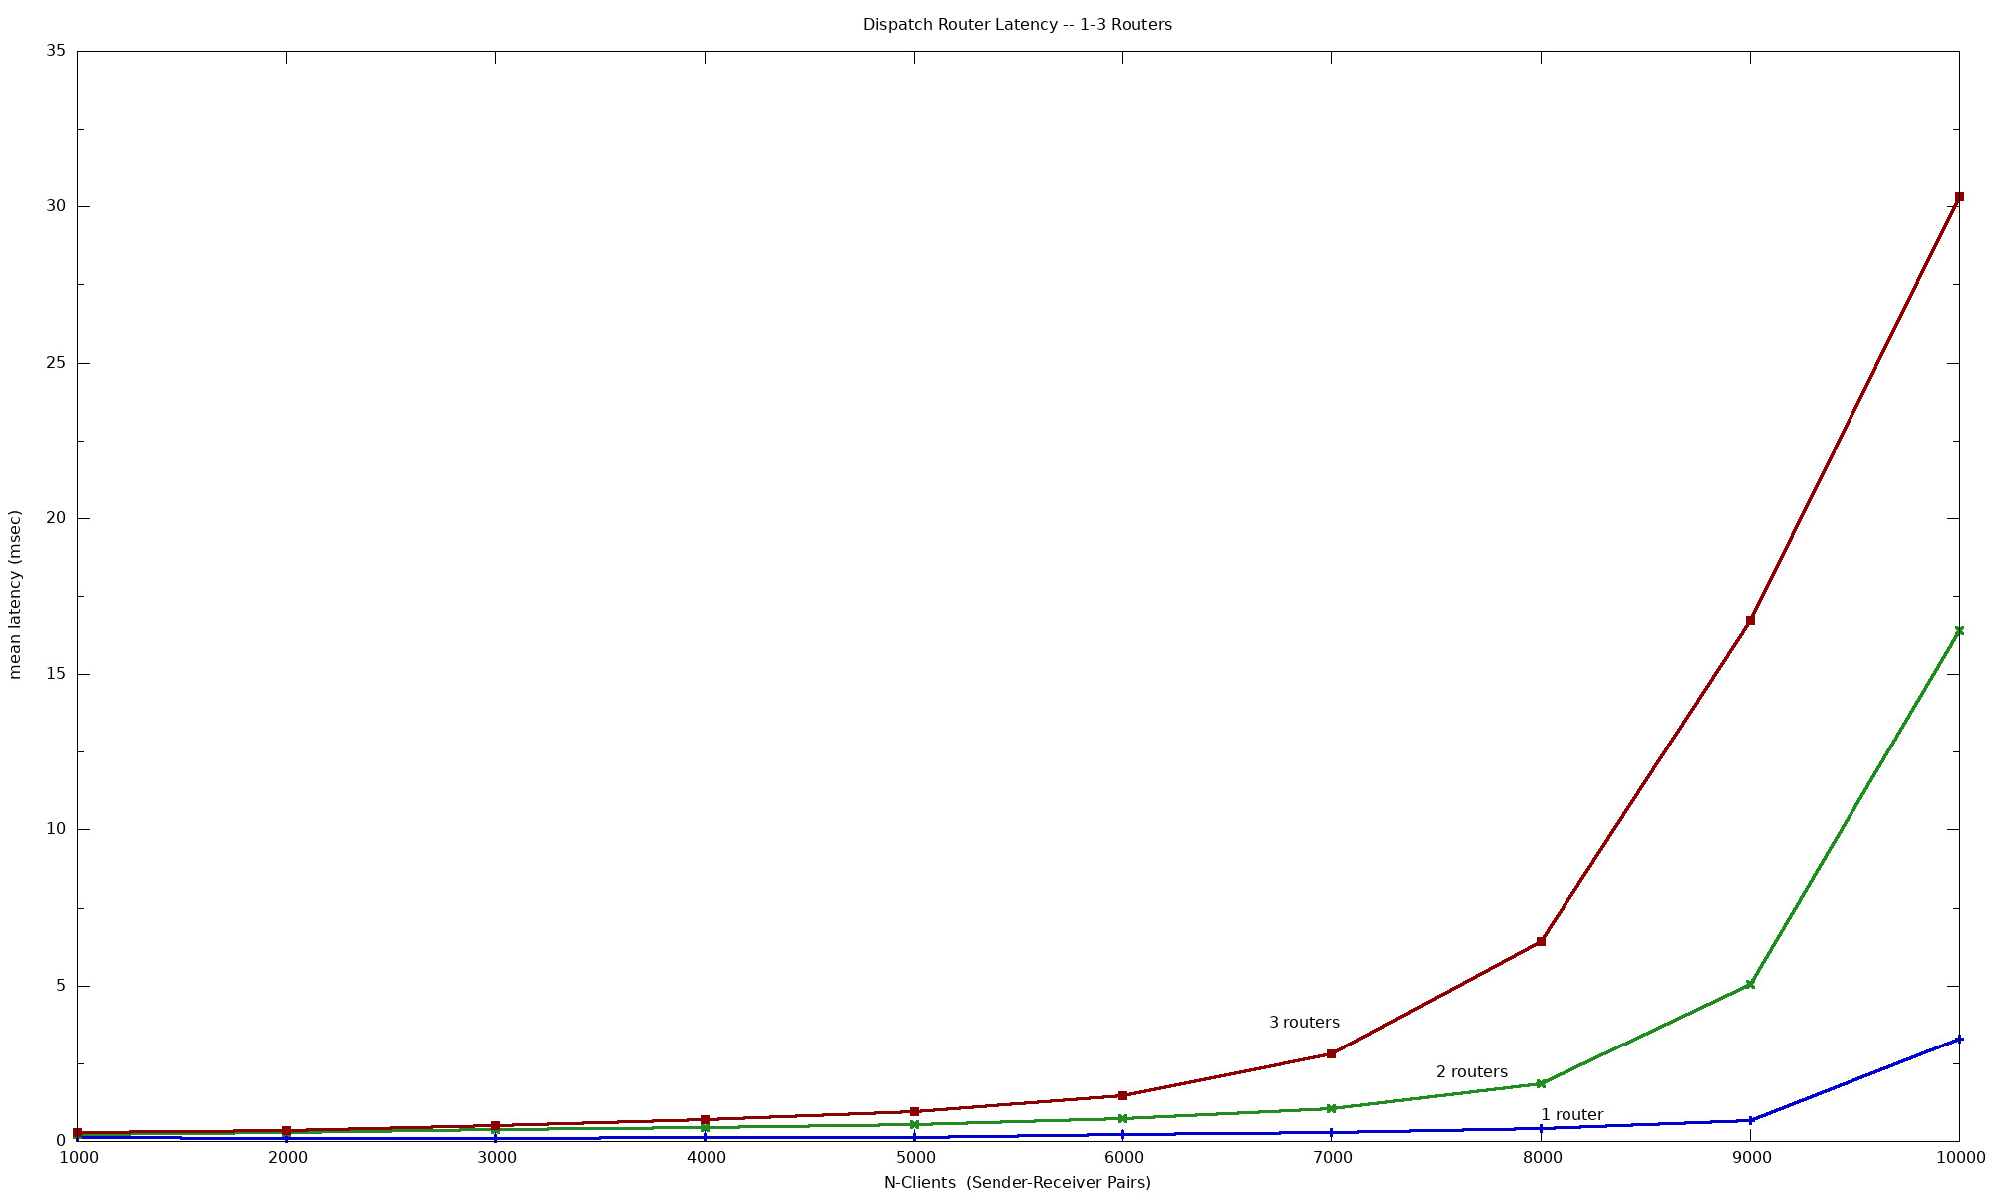

1-, 2- and 3-Router Results

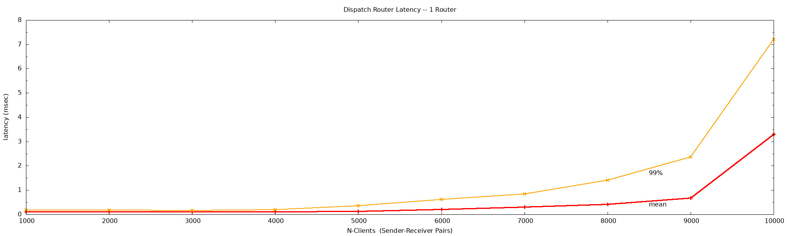
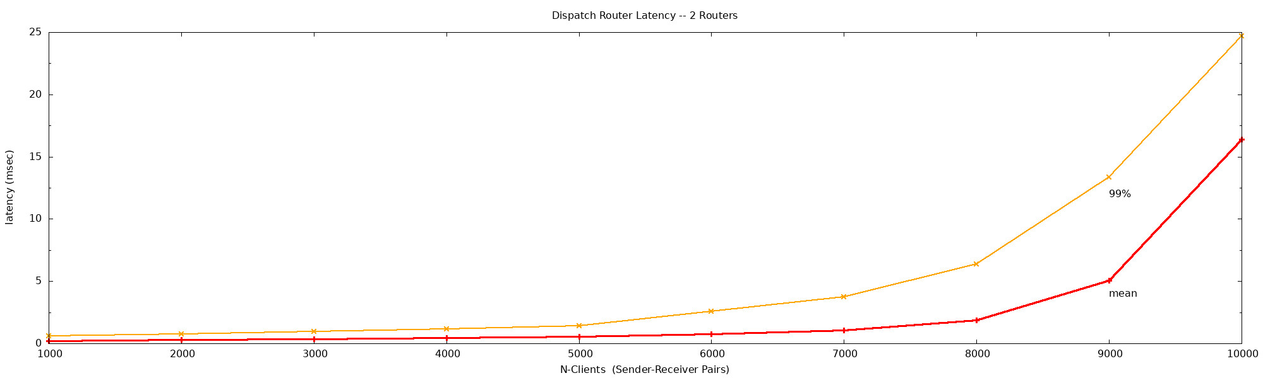
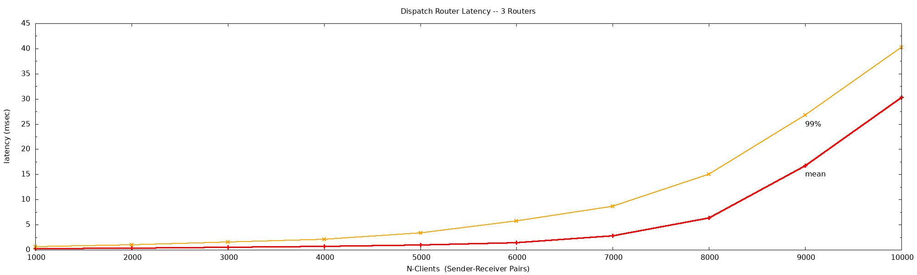

1-Router Test Timeline Charts

Red lines show 99% line: 99% of all messages are at or below that latency.

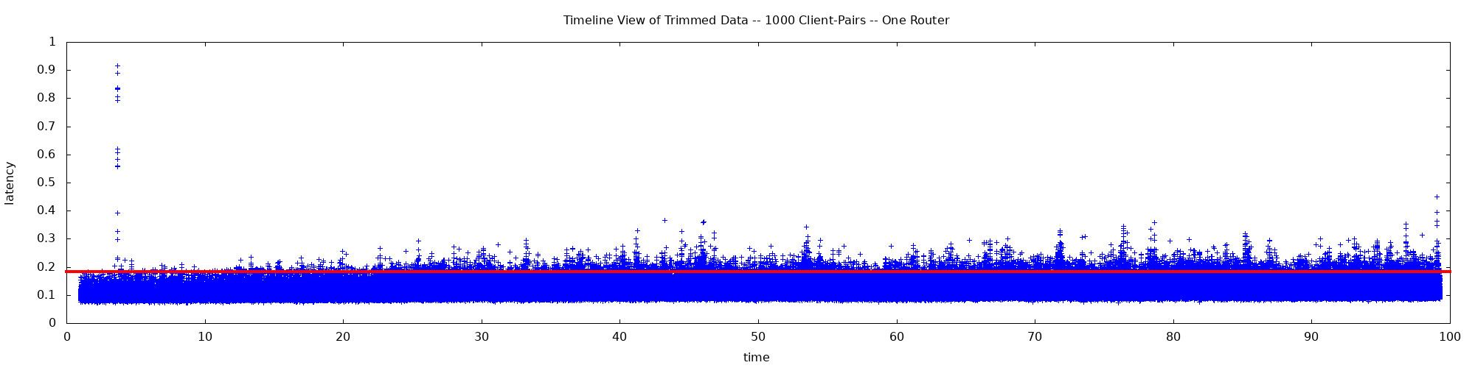

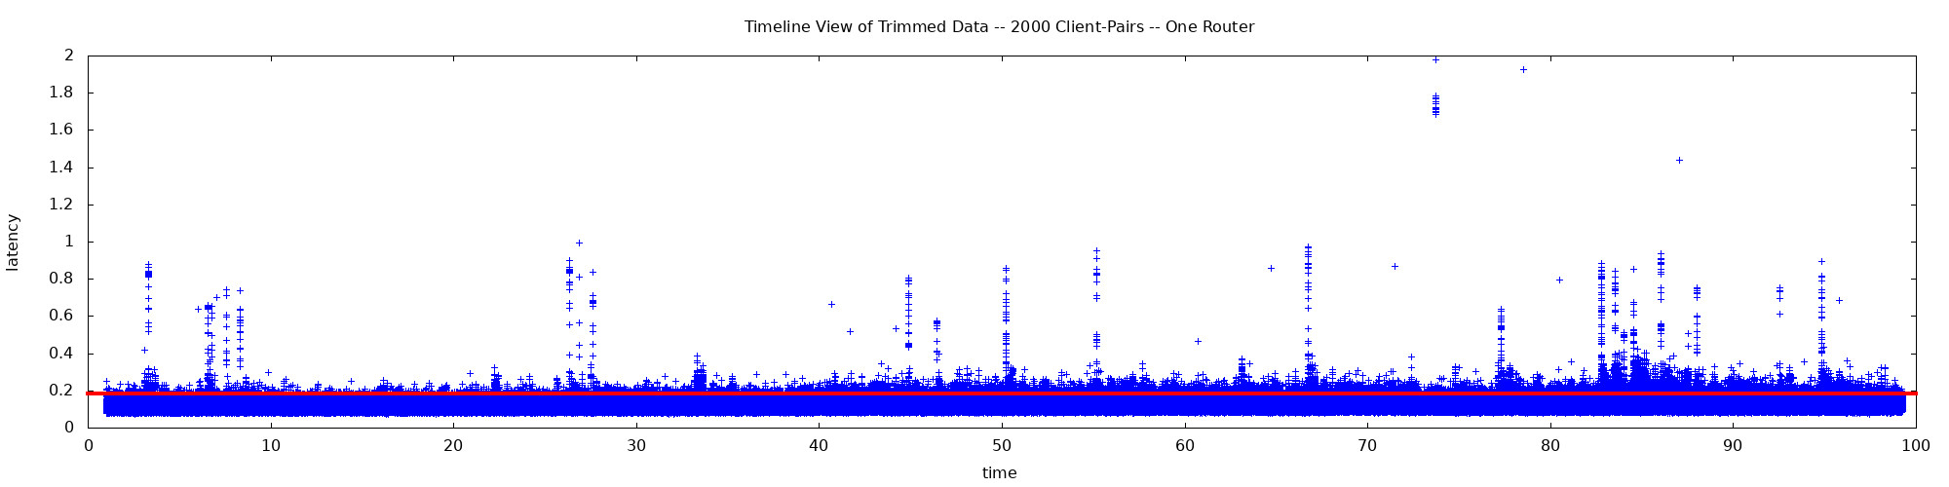

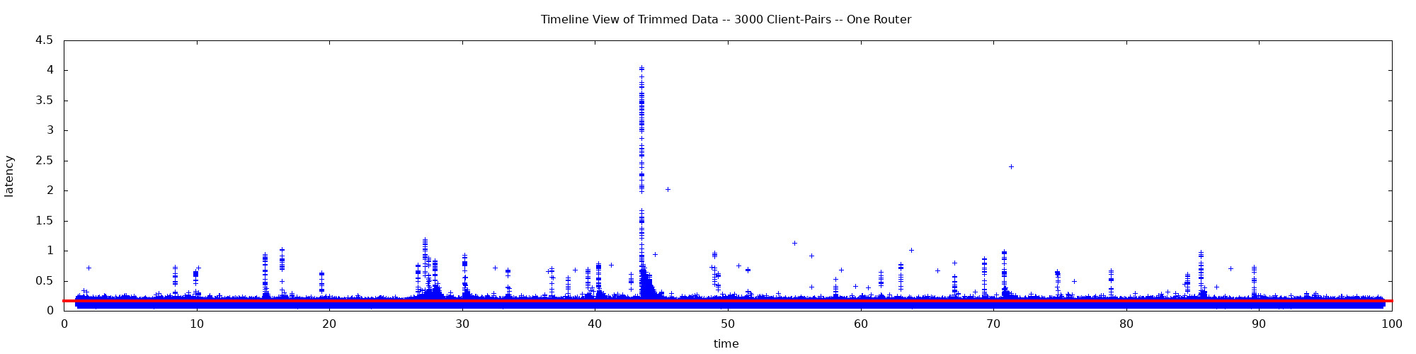

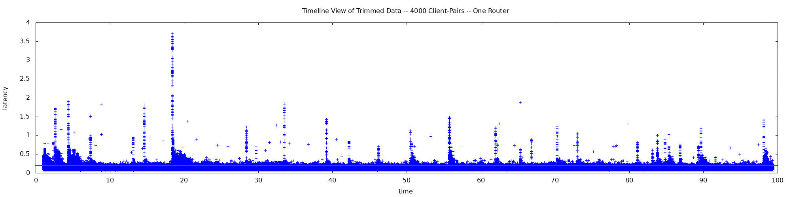

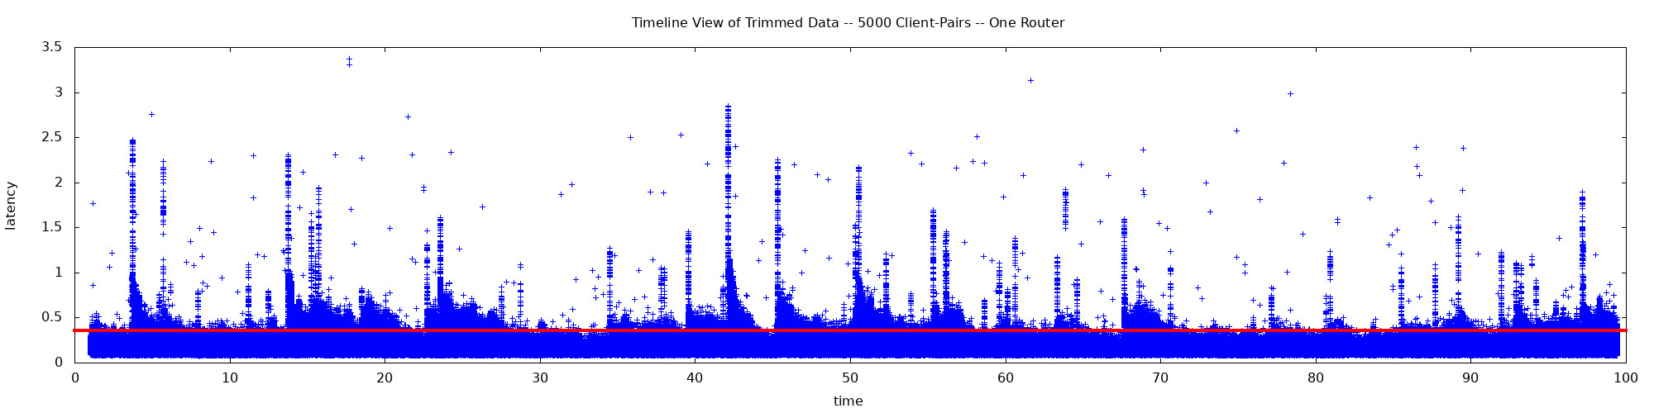
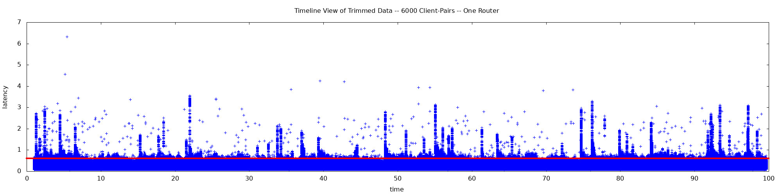

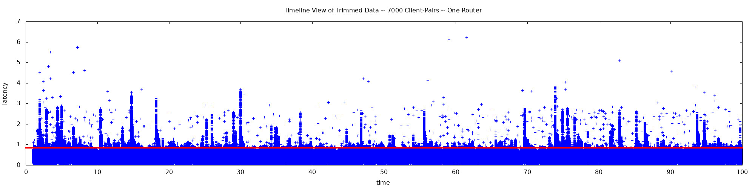

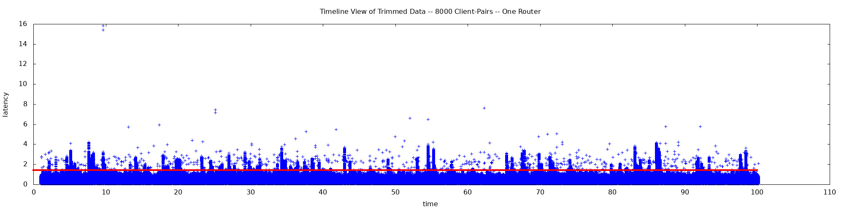

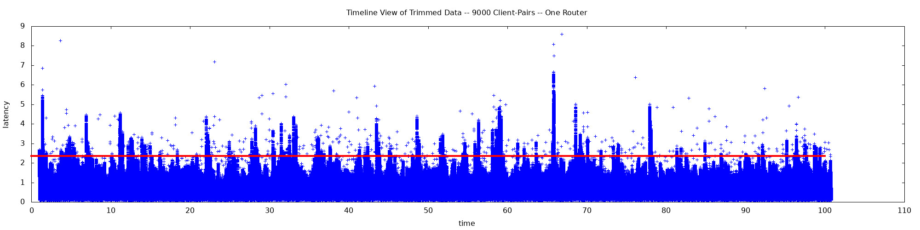

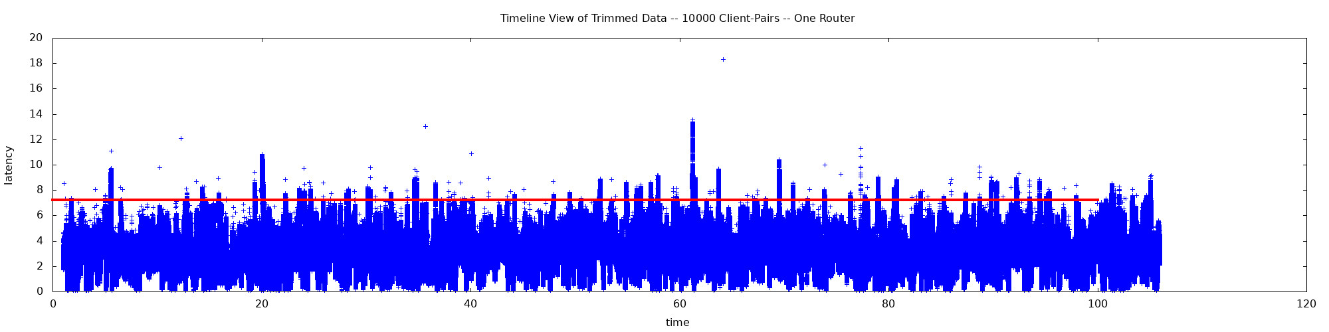

1-Router Test Timeline Animation

Same Y-axis scale on all charts.

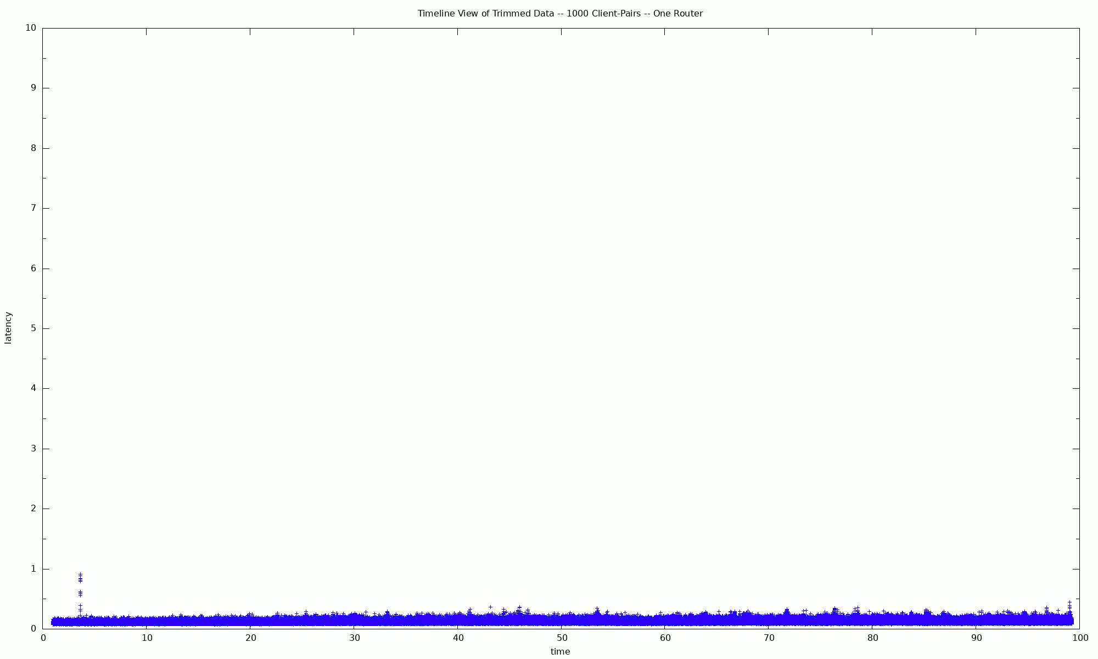

Throughput

In throughput tests a much smaller number of sender-receiver pairs is used and the senders are allowed to run unthrottled.

One Router
