Practical 9

Theme

- Identifying the scope and lifetimes of Java variables
- Identifying the scope of Python and Haskell variables
- Using Ada subtypes and cloned types, overriding name equivalence restrictions

Key concepts: variable declaration, variable scope, subtype, cloned type, structural and name equivalence of types, type casting

9.1 Start up and essential configuration
    - This week we are moving back to gitpod for the practical
    - You will find the files for this week’s lab in the lab09-vars folder on gitpod

If you plan to save changes to your work, then sign-in to your GitHub account and open your forked) version of the PLC2025 Git repo in GitPod by appending ‘gitpod.io/#’ to start of your repo’s URL and pressing enter.

If your repo is some commits behind the instructor repo then click on ‘Sync Repo -> Updated Branch’ to retrieve any new changes made to the instructor repo.
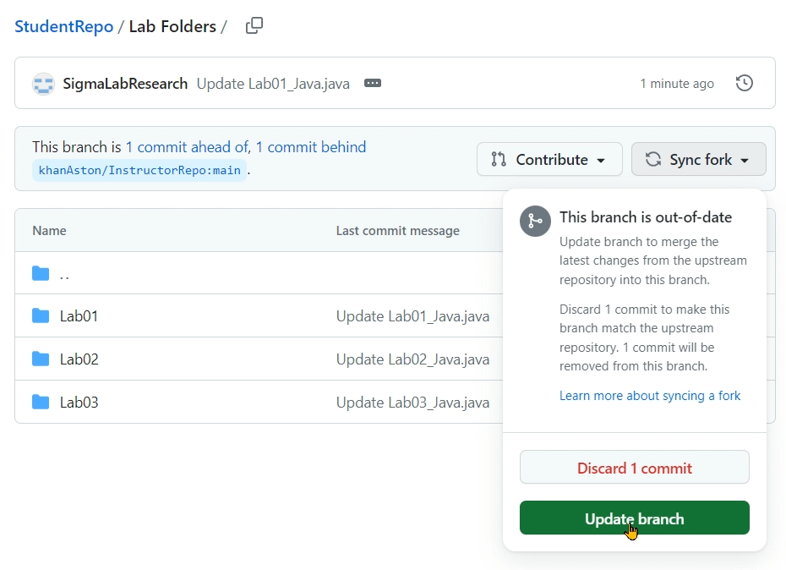

If you do not plan to save changes to your work on GitHub, then go directly to the instructor’s Git repo (khanAston/PLC2025) and open it in GitPod by appending ‘gitpod.io/#’ to start of your repo’s URL and pressing enter.

9.2 Identifying the scope of Java variables

Open the file java/PlaylistVars.java.

    - Describe the scope of variable length1 declared on line 73.
Hint. You can edit and compile the file to verify that your intuition is correct. For example, you can try inserting in various places the variable whose scope you are investigating. You will need to undo these changes or keep a copy of the original file nearby so that you can answer quiz questions using the line numbers of the original file.
Quiz. Answer review quiz Q1 related to this task.

9.3 Identifying the scope of Python variables
    - Study the file python/vars.py, paying attention to the scope of three different variables sharing the same name a.
Hint. Python variables are lexically scoped and their scope is non-linear, ie
spanning the whole enclosing block, before as well as after the (implicit) declaration.
Also, global variables do not automatically extend their scope into function bodies.

    - Fix a bug in file python/playlistVars.py related to the scope and declaration of a variable called playlist1.

The original (buggy) program prints playlist1 = []. After your correction, it should instead print the three values specified on line 58.
- Important. You must not edit anything in this file except the body of function
definePlaylist1, originally on lines 55–58.
Quiz. Answer review quiz Q2 related to this task.

9.4 Identifying the scope of Haskell variables

All tasks in this section relate to the file haskell/playlistVars.hs.
    - Identify the scope of variable minutes declared and assigned on line 48.
Quiz. Answer review quiz Q3 related to this task.

Ada subtypes and cloned types
    - Examine the program ada/playlistvars.adb and attempt to compile it.

When you attempt to compile and run the program, you will see two compiler errors (described over 6 lines), one on line 96 and one on line 98.
- Important. This program uses Ada pointers. You are not required to understand this aspect of the program. The tasks in this practical can be completed without understanding Ada pointers. Please ignore any occurrences of the keywords access, new and all, until you have completed the assessed tasks. You are welcome to study Ada pointers as an optional non-assessed topic.

    - Correct the program so that the file compiles and produces the correct output.

The expected output is:
Moonlight performed by C. Arrau (1046.0s) Pathetique performed by D. Barenboim (1009.0s) Advert for chocolate by Yummm (15.0s)
length1 = 2070.0
The corrections should affect only two lines in the file.
Quiz. Answer review quiz Q4 related to this task.

Understand the difference between value and reference semantics
    - Examine the programs ada/cparray.adb and java/ CpArray.java
Compile and run both programmes and observe their outputs. Syntax wise, both programmes seem like translated versions of each other; however, the value in b[1] (or B(1)) at the end of each programme is different. Think about the reason for this.

Quiz. Answer review quiz Q5 related to this task.

