IR-image
_Fd2020317979 | _Fd238991348

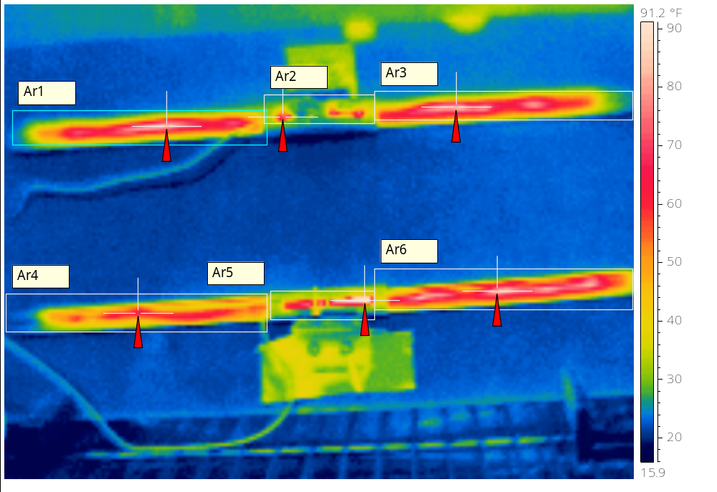
 | Chamber Temperature: 10°F  Test Voltage: 13.6VDC  Blade Pliable – Yes  Squeegee Pliable – Yes  Harness Pliable – Yes  Top Sample 19” 1.36A @ 14.6VDC  Bottom Sample 1.23A @ 14.6VCD
  Emissivity | 0.96
  Reflected Apparent Temperature | 73.9 °F
  Atmospheric Temperature | 78.6 °F
  Object Distance | 1.1 m
  Ar1 Max. Temperature | 86.1 °F
  Ar2 Max. Temperature | 74.4 °F
  Ar3 Max. Temperature | 82.2 °F
  Ar4 Max. Temperature | 67.2 °F
  Ar5 Max. Temperature | 92.1 °F
  Ar6 Max. Temperature | 86.8 °F

IR-image
_Fd807417800 | _Fd1026778420

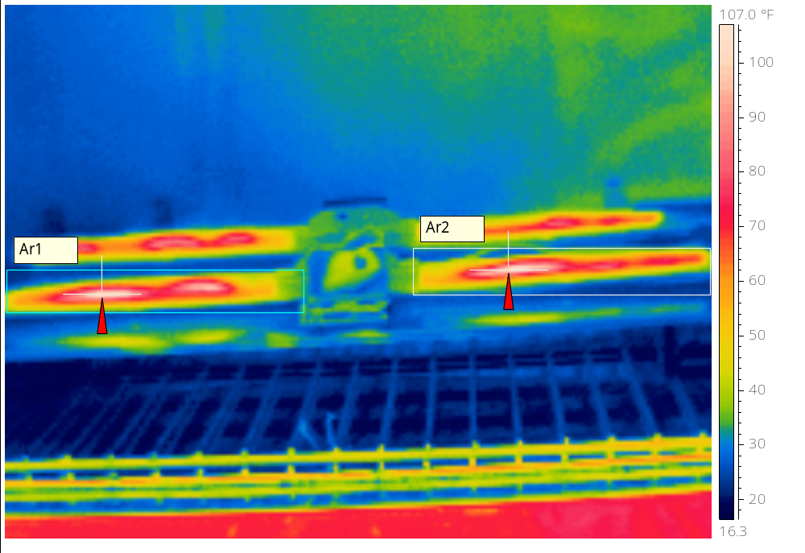
 | Front Sample 19” 1.36A @ 14.6VDC
  Emissivity | 0.96
  Reflected Apparent Temperature | 73.9 °F
  Atmospheric Temperature | 78.6 °F
  Object Distance | 1.1 m
  Ar1 Max. Temperature | 108.1 °F
  Ar2 Max. Temperature | 107.6 °F

IR-image
_Fd1396326834 | _Fd1428124542

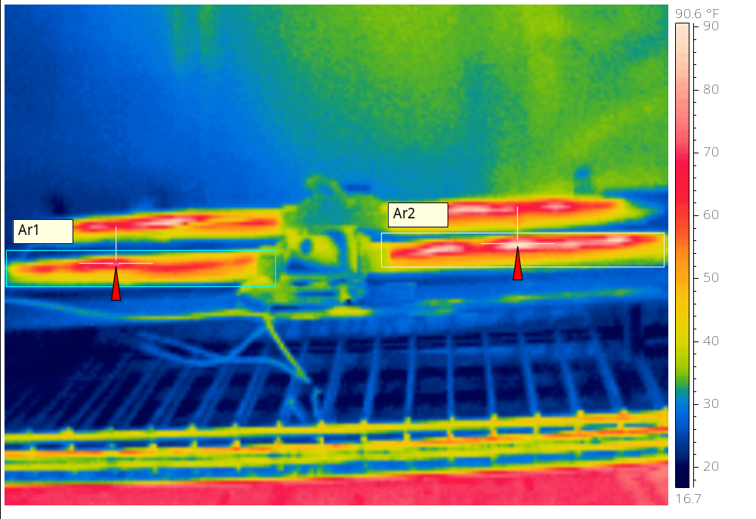
 | Front Sample 1.23A @ 14.6VCD
  Emissivity | 0.96
  Reflected Apparent Temperature | 73.9 °F
  Atmospheric Temperature | 78.6 °F
  Object Distance | 1.1 m
  Ar1 Max. Temperature | 73.1 °F
  Ar2 Max. Temperature | 89.9 °F

