IR-image
Image file name: IR_0519.jpg | Image date: 8/6/2010

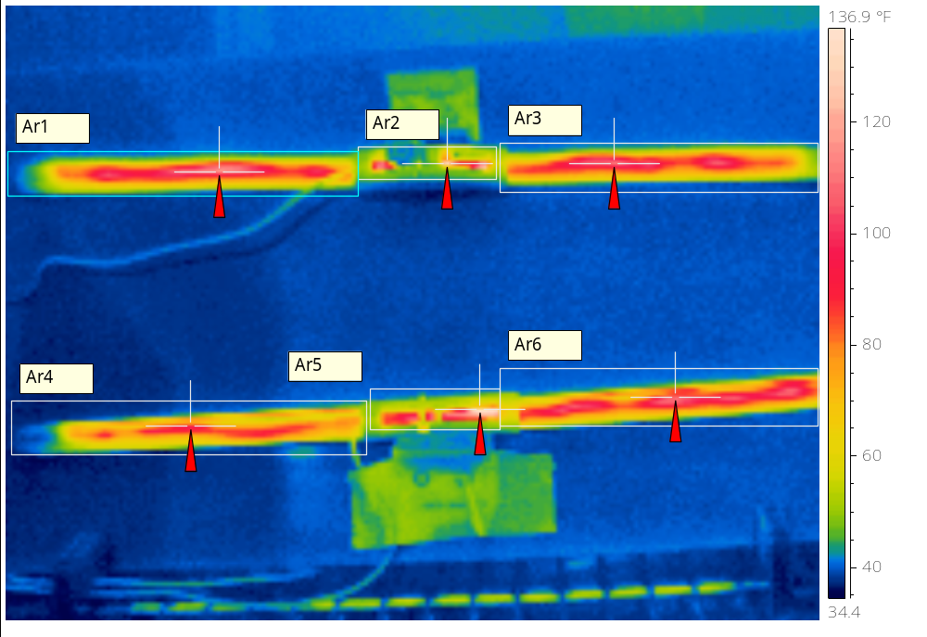
 | Chamber Temperature: 30°F  Test Voltage: 14.6VDC  Blade Pliable – Yes  Squeegee Pliable – Yes  Harness Pliable – Yes  Top Sample 19” 1.36A @ 14.6VDC  Bottom Sample 1.23A @ 14.6VCD
  Emissivity | 0.96
  Reflected Apparent Temperature | 73.9 °F
  Atmospheric Temperature | 78.6 °F
  Object Distance | 1.1 m
  Ar1 Max. Temperature | 116.6 °F
  Ar2 Max. Temperature | 132.1 °F
  Ar3 Max. Temperature | 110.7 °F
  Ar4 Max. Temperature | 96.6 °F
  Ar5 Max. Temperature | 138.5 °F
  Ar6 Max. Temperature | 109.2 °F

IR-image
Image file name: IR_0520.jpg | Image date: 8/6/2010

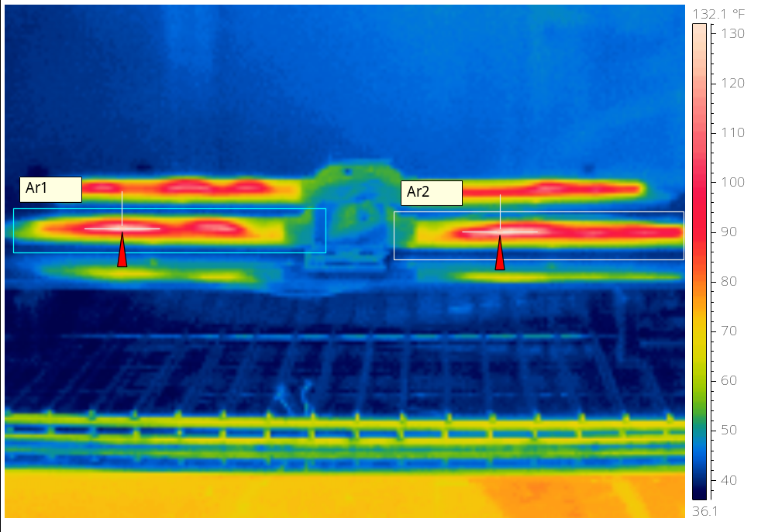
 | Front Sample 19” 1.36A @ 14.6VDC
  Emissivity | 0.96
  Reflected Apparent Temperature | 73.9 °F
  Atmospheric Temperature | 78.6 °F
  Object Distance | 1.1 m
  Ar1 Max. Temperature | 133.8 °F
  Ar2 Max. Temperature | 131.9 °F

IR-image
Image file name: IR_0521.jpg | Image date: 8/6/2010

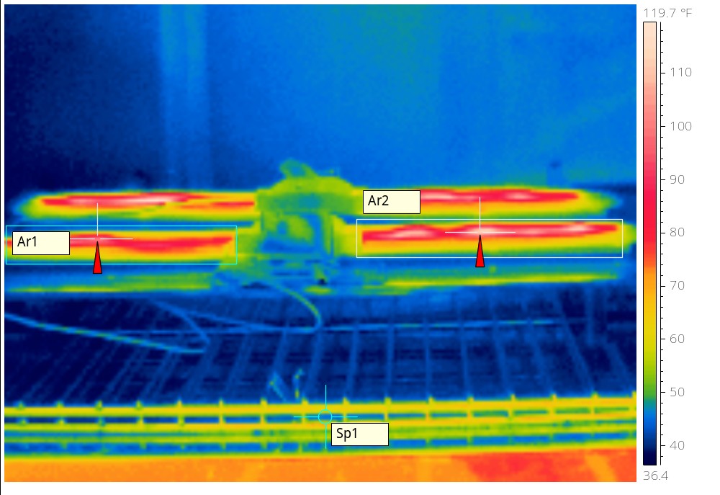
 | Front Sample 1.23A @ 14.6VCD
  Emissivity | 0.96
  Reflected Apparent Temperature | 73.9 °F
  Atmospheric Temperature | 78.6 °F
  Object Distance | 1.1 m
  Ar1 Max. Temperature | 101.2 °F
  Ar2 Max. Temperature | 114.4 °F
  Sp1 Temperature | 45.6 °F

