IR-image
Image file name: IR_0516.jpg | Image date: 8/6/2010

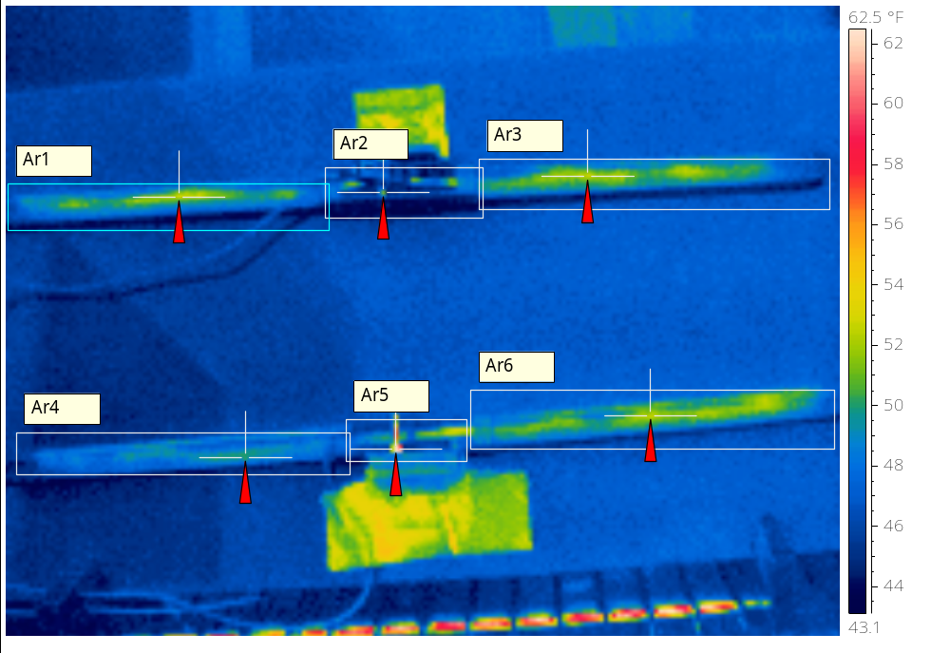
 | Chamber Temperature: 40°F  Test Voltage: 13.6VDC  Blade Pliable – Yes  Squeegee Pliable – Yes  Harness Pliable – Yes  Top Sample 19” 1.36A @ 14.6VDC  Bottom Sample 1.23A @ 14.6VCD
  Emissivity | 0.96
  Reflected Apparent Temperature | 73.9 °F
  Atmospheric Temperature | 78.6 °F
  Object Distance | 1.1 m
  Ar1 Max. Temperature | 52.9 °F
  Ar2 Max. Temperature | 51.6 °F
  Ar3 Max. Temperature | 52.9 °F
  Ar4 Max. Temperature | 50.2 °F
  Ar5 Max. Temperature | 66.6 °F
  Ar6 Max. Temperature | 52.7 °F

IR-image
Image file name: IR_0517.jpg | Image date: 8/6/2010

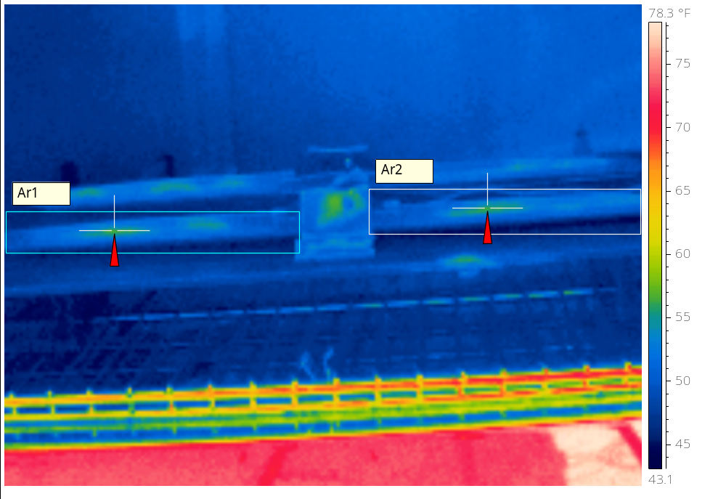
 | Front Sample 19” 1.36A @ 14.6VDC
  Emissivity | 0.96
  Reflected Apparent Temperature | 73.9 °F
  Atmospheric Temperature | 78.6 °F
  Object Distance | 1.1 m
  Ar1 Max. Temperature | 56.9 °F
  Ar2 Max. Temperature | 56.5 °F

IR-image
Image file name: IR_0518.jpg | Image date: 8/6/2010

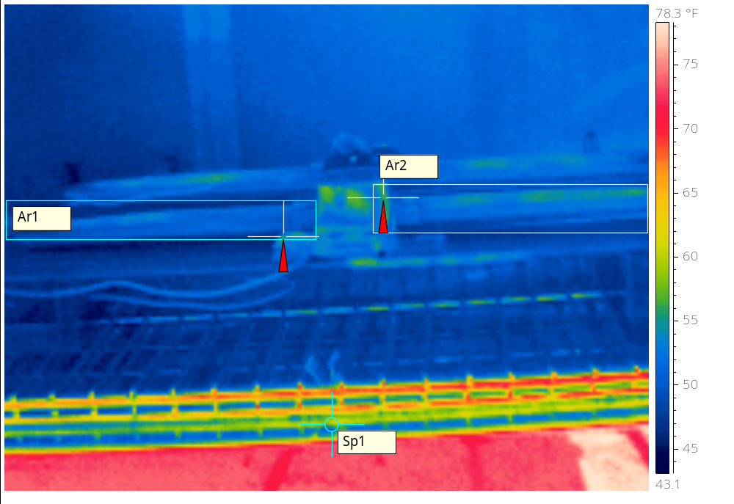
 | Front Sample 1.23A @ 14.6VCD
  Emissivity | 0.96
  Reflected Apparent Temperature | 73.9 °F
  Atmospheric Temperature | 78.6 °F
  Object Distance | 1.1 m
  Ar1 Max. Temperature | 56.1 °F
  Ar2 Max. Temperature | 56.6 °F
  Sp1 Temperature | 56.1 °F

