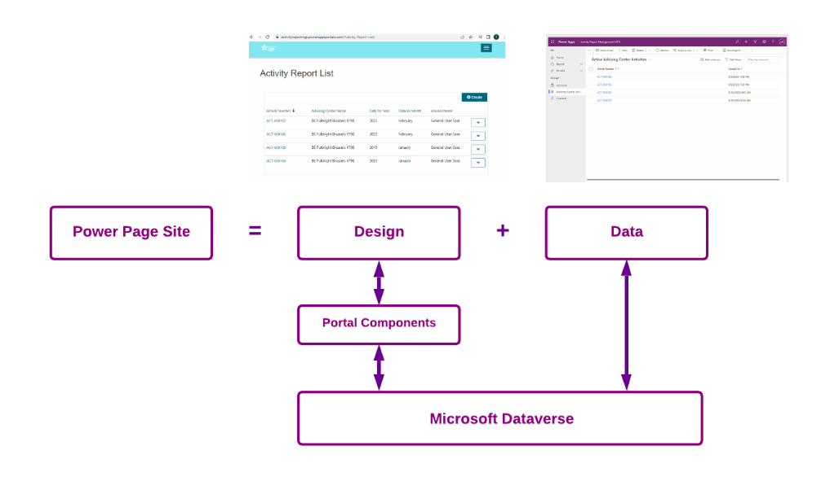

If we talk about the portal architecture, this is the underlying structure. it is basically made up of two things i.e. Designing Pages using Designer Studio & Data i.e. Dataverse.

Let us talk about Power page designer studio first,

1. When you create a portal, there is a website record gets created in the database. This record holds the name of portal, domain, url of the portal, portal security settings.
2. When you hit that particular portal URL then website binding which is connected this particular URL will call the website.
3. Create a page first, and then decide whether I have to use the form, list, multisetep form etc.

In order to design the power pages, we need power pages components like forms, list control, multi form control, power bi control. Data will be stored in Microsoft Dataverse.

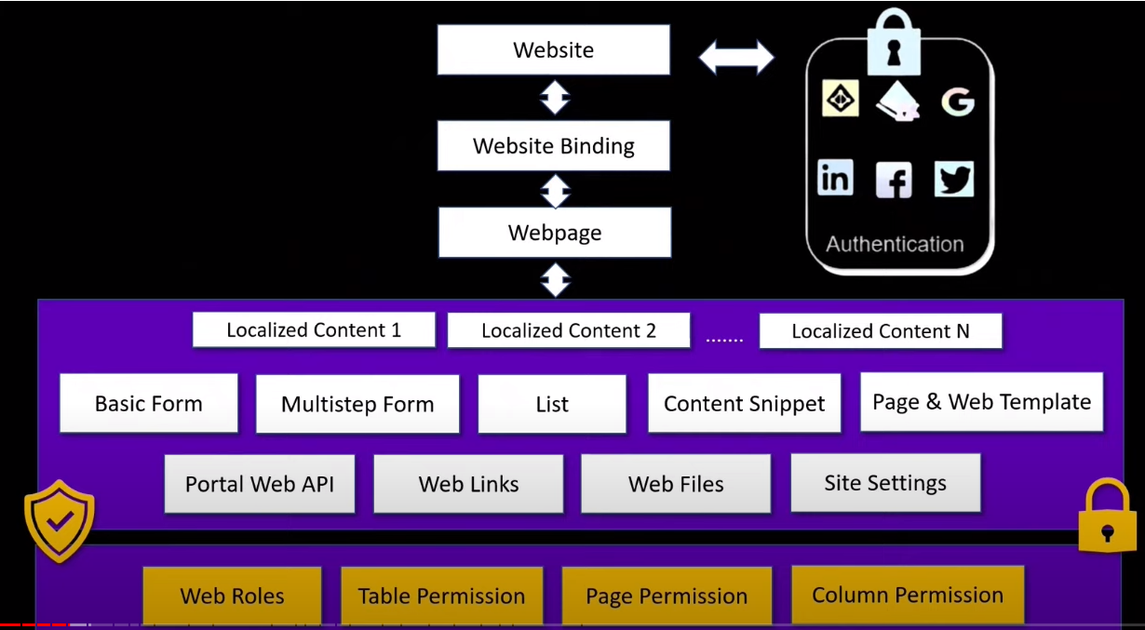

Dataverse is the database that is basically to store all sort of data related to the power pages, it could be either components or data along with out of the box data entities like Contacts, Accounts.

--=====================================================================================

Security

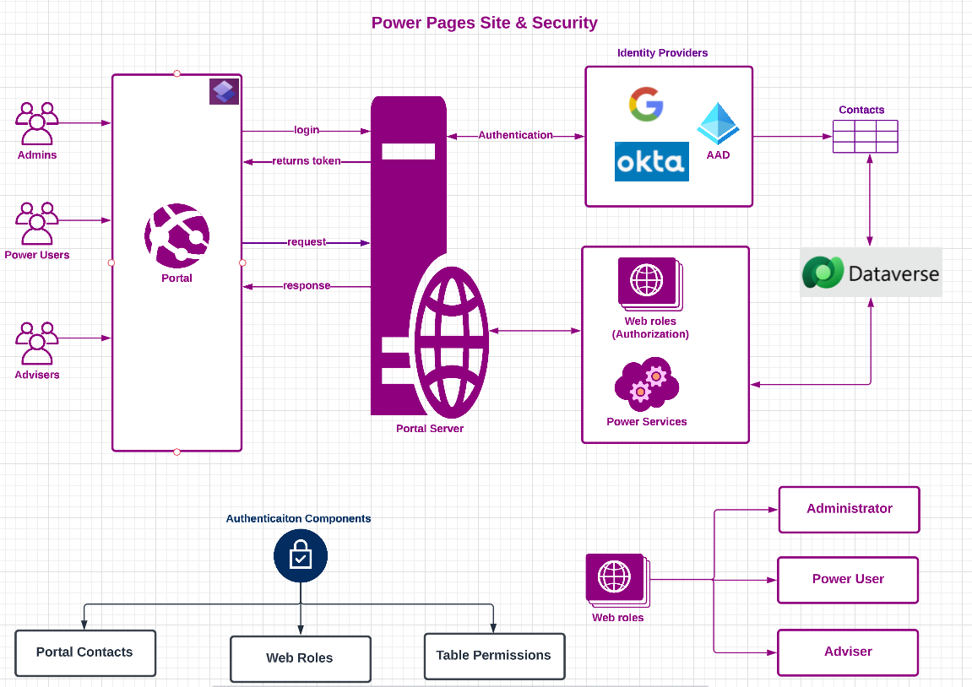

Identity Providers like Google, OKTA, Azure Active Directory that gives us the identity to allow access the portal.

Authenticated users area always visible in Dataverse as Contact.

After the contact has been configured to use the portal, contact must be given one or more web roles to perform any actions or to protect content.

Table permissions can be created using web roles to secure data

1. Login: As general user (sara)
2. Create new form
3. Redirect to list page.

NOTE: before switching to power user, make sure to click on home page.

1. Login as Power user
2. Now power user can see forms from different advising centers.
3. Let power user update the record.

Customization:

1. Move month on top of year
2. Add new fields like Notes in Study level

Registration:

1. Register as MG2 (general user)
2. Go to contacts
3. Assign web role & Advising Center CY
4. And then login again