Finding Similar Neighborhood to Denver in Chicago
Michael Gray
12/20/2020

1. Introduction
1.1 Background
Billy is living in the neighborhood Lincoln Park in Denver Colorado and while working on a project in Chicago Illinois he met some contacts and got a great job offer in Chicago. After thinking about the offer Billy decided to accept. He is excited about moving to a large city like Chicago with all the activities, however in the news Billy has learned that Chicago is having problems with gun violence and he doesn’t know where to look for an apartment. In addition, Billy is very happy with his current neighborhood in Denver, and wants to find a similar neighborhood in Chicago.
1.2 Problem
The available venues in Denver is a big reason Billy is happy with his neighborhood, and it is relatively safe. As a result, the venues from Billy’s neighborhood in Denver, will be compared to the venues around the 55+ ‘postal codes’ in Chicago to find an area that is most similar to his neighborhood in Denver. Then, the crime will be analyzed in Chicago to find an area where Billy will feel safe.
1.3 Interest
This analysis will be very important to Billy because starting a new job is a big decision. In addition, it can be difficult moving to a new city not knowing anybody or any of the nearby venues. As a result, if Billy can find an apartment in an area he is comfortable it will ease the transition starting a new job in a new city.

2. Data Acquisition and Cleaning
2.1 Data sources
In the project the Foursquare and Geocoders APIs’ are used. The Foursquare API is used to find the venues around a given location ( in latitude & longitude), more information can be found here https://developer.foursquare.com/developer/. The Geocoders API will be used to find the ‘latitude & longitude coordinates for the desired locations, more information can be found here https://geocoder.readthedocs.io/. Then, the ‘postal codes’, ‘population’, and ‘crime’ data in Chicago was downloaded from https://data.cityofchicago.org/.
2.2 Collecting & Cleaning data
First thing to do is get the coordinates in (latitude & longitude) for the neighborhood in Denver and for all the postal codes in Chicago. To get the coordinates for the neighborhood in Denver the Geocoder API is used (39.7331384, -105.0052409729397). Then, to get the coordinates for each postal code in Chicago all the postal codes need to be collected. for the postal codes in Chicago the dataset “Chicago Population Counts” found at https://data.cityofchicago.org/. In the dataset there are 60 entries and 20 features, there are two features of importance; the ‘Population – Total’, and ‘Record ID’. The postal codes will be used to get the coordinates for the areas in Chicago, and the population will be used later in the analysis.
Population and Postal Codes in Chicago
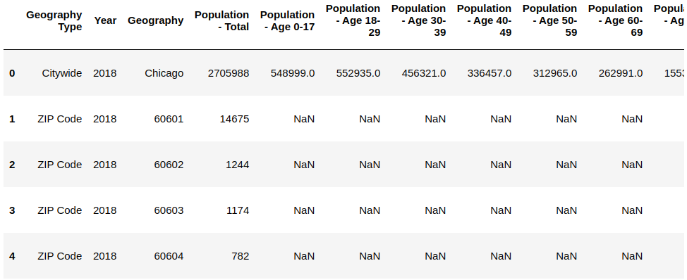
Then using the Geocoders the coordinates for each postal code was found, and a new data frame was built:
Chicago Postal Codes, Population and Coordinates
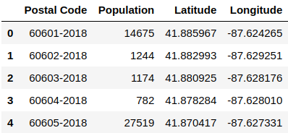
Next, to find the venues around each location the Foursquare API is used. By running the Foursquare query all the most popular venues are returned, however the free version of the API is used so that a maximum of 100 venues can be returned for each query. The API returns a .json file which is parsed to create a dataframe that combined with the dataframe above with the features to describe the center of the location with the coordinates, the venue with the coordinate, and the distance from the venue and the center location.
Venue Dataframe
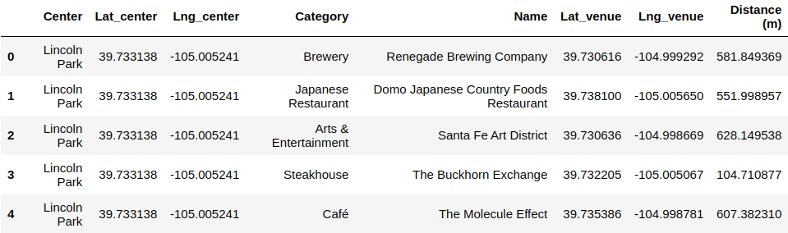
Lastly, the crime data in Chicago is used to find the crimes around each location. The crime data “Crimes _ 2019” was downloaded from https://data.cityofchicago.org/, and the dataset contains 260,000 entries with 22 rows.
Raw Chicago Crime Data
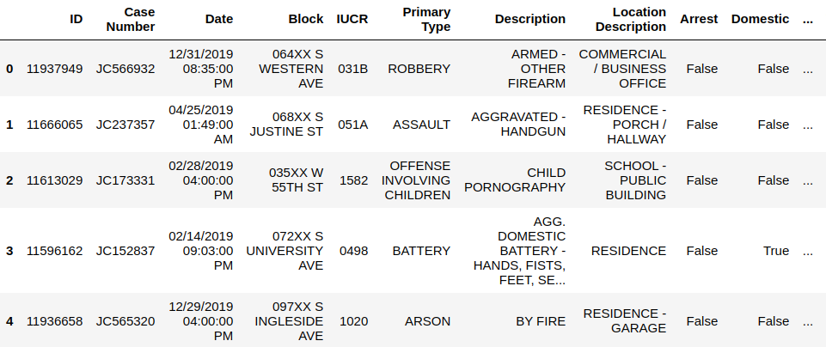
The crime data was then used to count the crimes around each location.

3. Methodology
The method for analyzing the data in this project is to use logistic regression. First, the dataframe of the venues.
Example of Venue Dataframe
In the datafame the only the features ‘Center’, ‘Category’, and ‘Distance (m)’ will be used. The feature ‘Category’ is of type object, so it will need to be expanded to integer features.
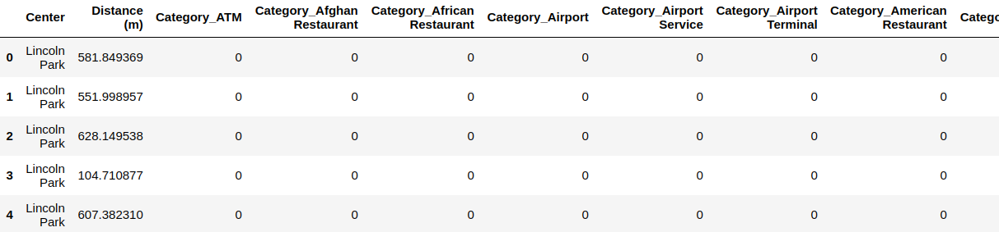
The feature ‘Distance (m)’ is currently in a floating point number from 0-1500m which is cannot be used for the analysis, as a result the feature will be converted to an integer with step sizes of 150m. The machine learning method used to analyze the data is linear regression. This method is appropriate because the objective is to find venues that are a close distance from the center location.
For the analysis linear regression analysis was performed on the venues around Lincoln Park, Denver, Colorado which had an accuracy of 0.73. Then, the model was used to predict the venues found around the postal codes in Chicago
Comparison to locations in Chicago
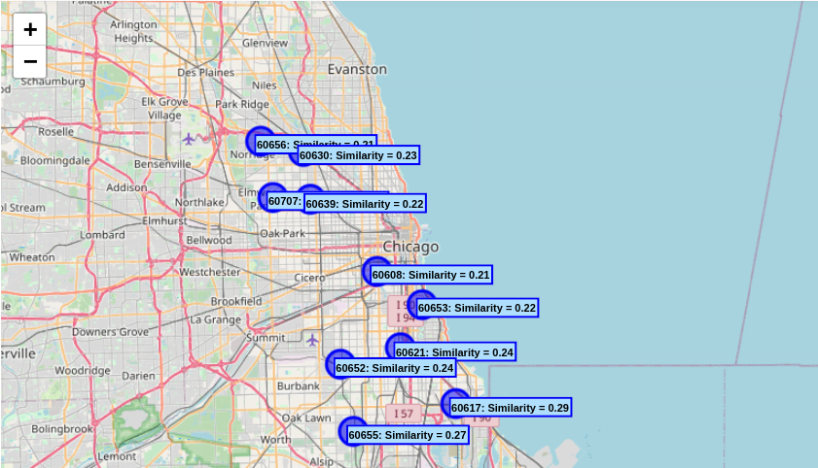
In addition, the crimes in Chicago were analyzed to find a location that is similar to the neighborhood in Denver and a relatively low crime rate. Since Chicago is such a large city there is a large amount of crimes in the city. As a result, only crimes considered to be the most sever were counted.
['ARSON', 'ASSAULT', 'BATTERY', 'BURGLARY', 'CRIM SEXUAL ASSAULT', 'CRIMINAL SEXUAL ASSAULT', 'HOMICIDE', 'KIDNAPPING', 'OFFENSE INVOLVING CHILDREN', 'ROBBERY', 'SEX OFFENSE']
The crimes above were counted for a radius of around each location in Chicago. Then, from the dataframe created with the population the was computed to find the local crime rate for each location.
City Similarity (10 most similar) and Crime/Person in Chicago
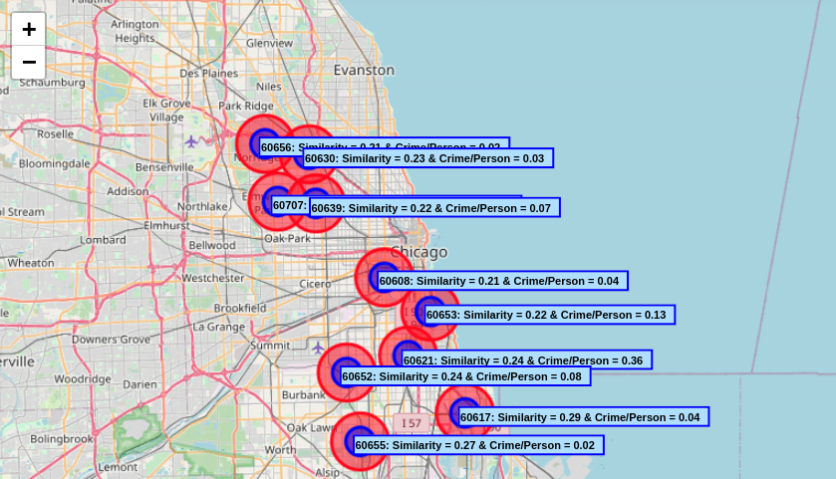
4. Results
In the analysis the similarity among the neighborhood is not very strong. For example, the most similar location in Chicago was 60607 with a accuracy score of 0.3 and a = 0.03.

Venues in Most Common Locations
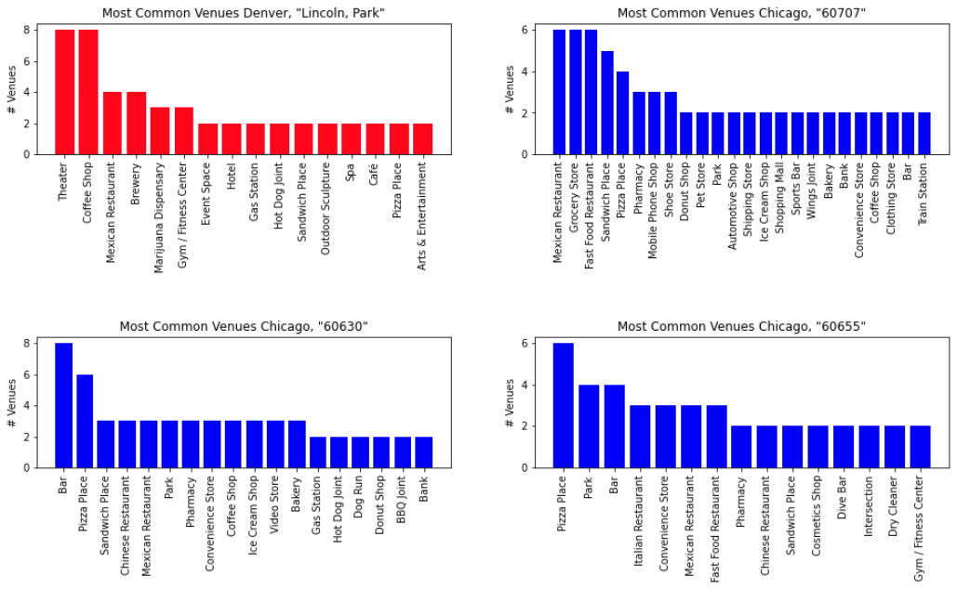
For the 3 most common Chicago location to the neighborhood in Denver, the analysis seems to show that they all have 3 or more Mexican restaurants and sandwich places.

5. Discussion
In the analysis it appears that the locations in Chicago are not very similar to the neighborhood in Denver. In addition, the best place for Billy to look for an apartment is in the northwest neighborhoods of Chicago. The northwest part of Chicago has relatively low crime and the area will be the most similar to his old neighborhood.

6. Conclusion
In the analysis it is shown that the northwest area of Chicago is the most similar to Lincoln Park, Denver, Colorado. In future analysis could be improved by analyzing the Chicago neighborhood in more detail. For example, the analysis could include traffic, property prices, education, ect. However, for this project I got to see how machine learning can be used to solve a real-world problem.

