Load Data into a DynamoDB Table
Melvin green
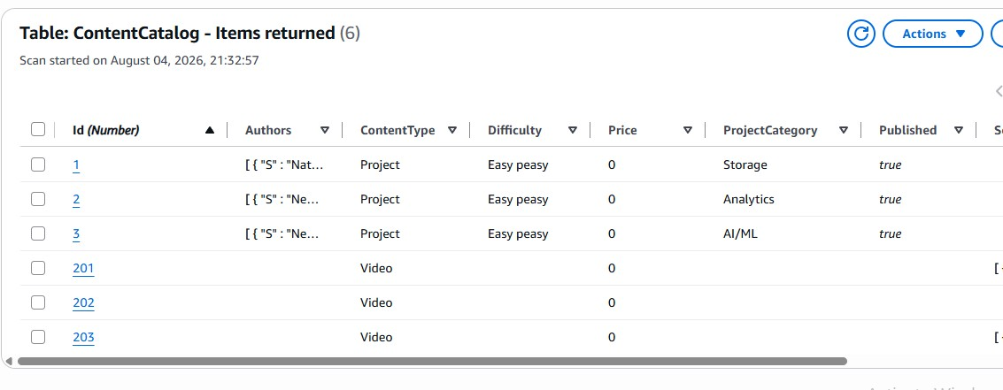
Introducing Today's Project!
What is Amazon DynamoDB?
Amazon DynamoDB is a non-relational database service. It is useful because non-relational databases use structures other than rows and columns to organize data. It also lets me enter data directly from the console.
How I used Amazon DynamoDB in this project
Here's a corrected and slightly expanded version: "In today's project, I used Amazon DynamoDB to create tables using CloudShell, load data into them via the AWS CLI, and edit that data directly within my DynamoDB tables. I also explored how DynamoDB's flexible, non-relational structure and partition keys make it a fast and scalable choice for storing content with varying attributes.
One thing I didn't expect in this project was...
One thing I didn't expect in this project is how efficient CloudShell could be when it came to creating, inserting, and deleting tables.
This project took me...
This project took me 1 hour to complete a document.

Create a DynamoDB table
DynamoDB tables organises data using...
An attribute is a piece of data about an item. In this case, our item is Nikko, and the attribute is the number of projects Nikko has completed.
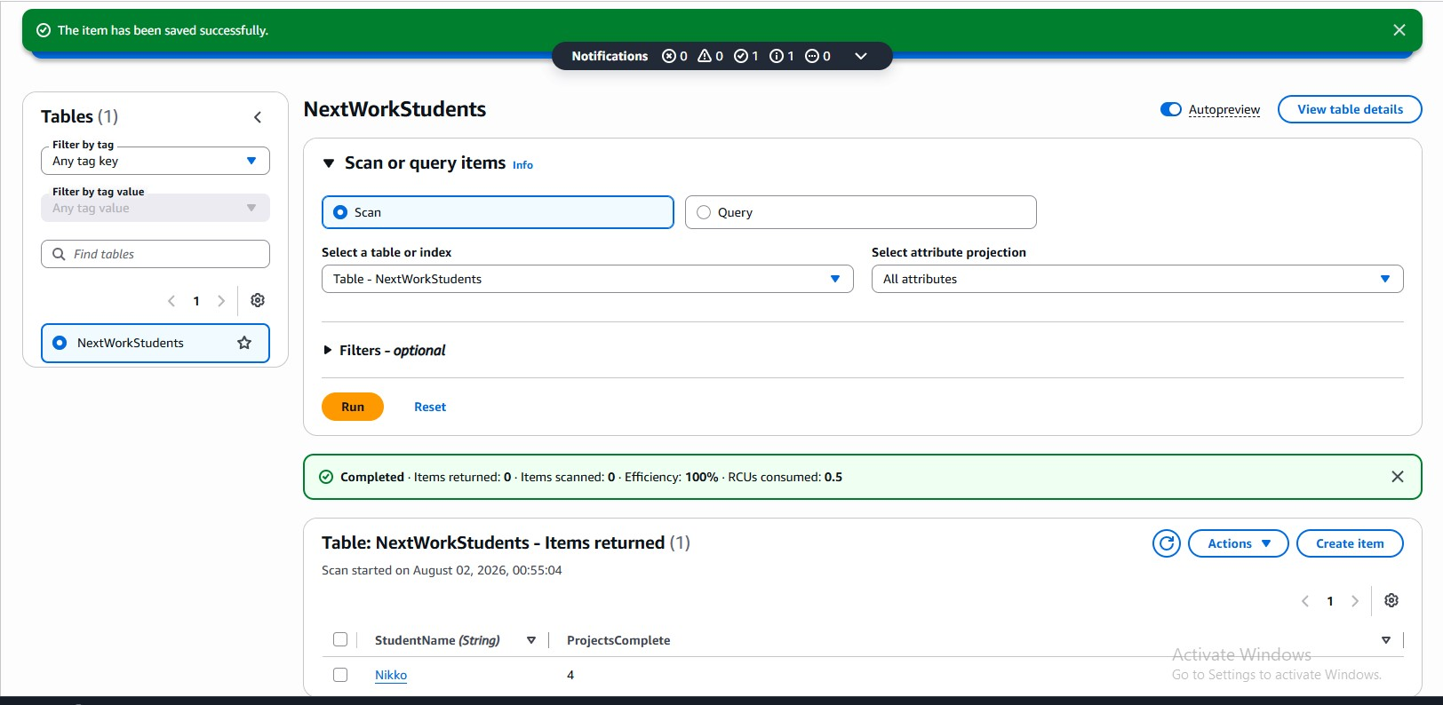

Read and Write Capacity
Read capacity units (RCUs) and write capacity units (WCUs) are ways to measure how much throughput DynamoDB allocates to read and write operations. One read capacity unit (RCU) allows one strongly consistent read per second, or two eventually consistent reads per second, for an item up to 4 KB in size. Write capacity units (WCUs) work similarly. One WCU allows one write per second for an item up to 1 KB in size, letting you add, update, or delete data.
Amazon DynamoDB's Free Tier covers a limited amount of provisioned capacity. I turned off auto scaling because auto scaling can automatically adjust your database's performance, which could cause you to exceed the Free Tier limits.
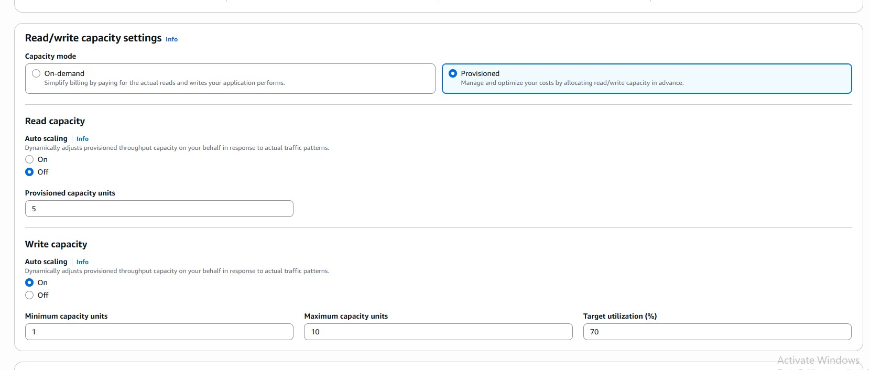

Using CLI and CloudShell
AWS CloudShell is a shell in my AWS Management Console, which gives me the ability to run code.
AWS CLI gives me the ability to run code and is the software that lets me create, delete, and update AWS resources with commands instead of clicking through my console
I ran a CLI command in AWS CloudShell that created 4 new tables in AWS DynamoDB, each with specific attributes and settings.
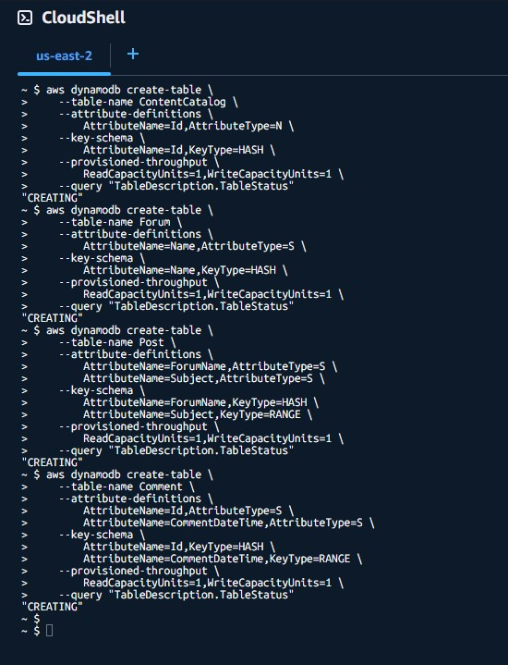

Loading Data with CLI
I ran a CLI command in AWS CloudShell using aws dynamodb batch-write-item, which is used to load or insert data. The --request-items flag tells DynamoDB that the items are stored inside a file that it needs to retrieve. Finally, file:// tells DynamoDB that the file is stored locally in the CloudShell environment, with the name FILENAME.json.
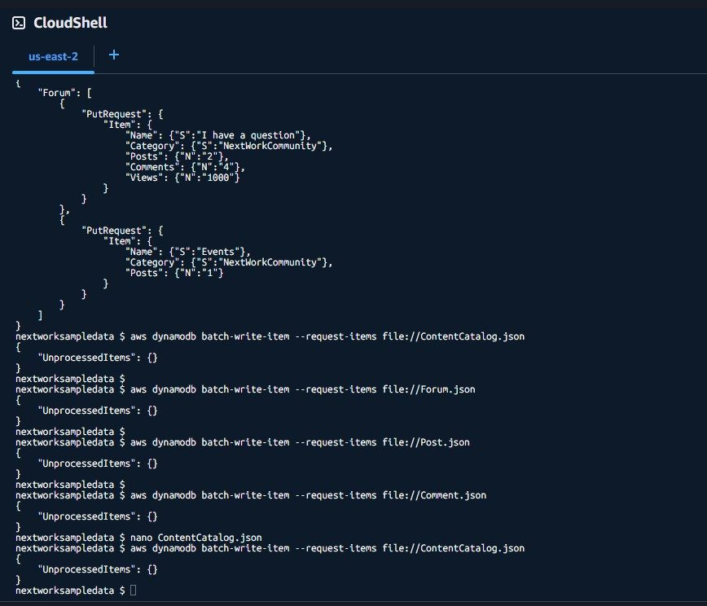

Observing Item Attributes
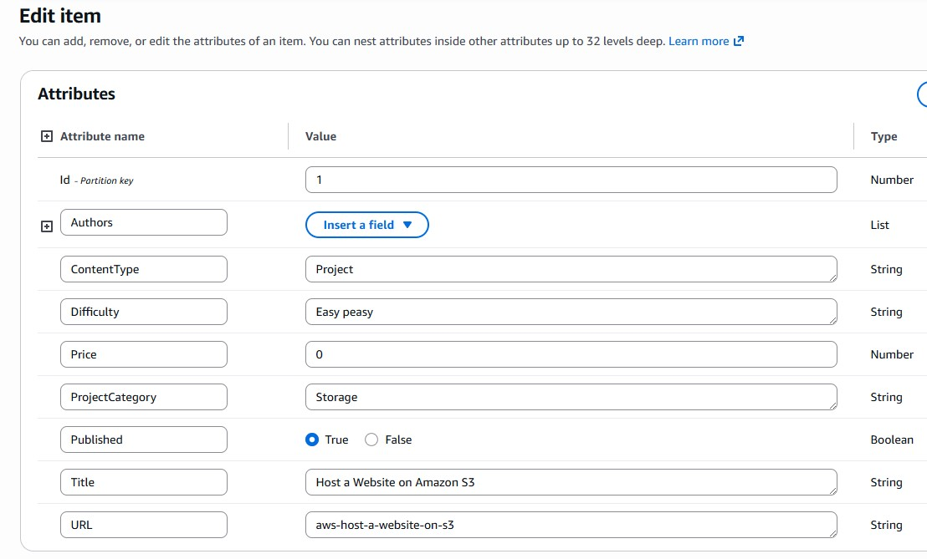
I checked a ContentCatalog item, which had the following attributes: Author,
ContentType, Difficulty, Price, ProjectCategory, Published, Title, and URL
I checked another ContentCatalog item, which had a different set of attributes:
ContentType, Price, Service, Title, URL, and VideoType.

Benefits of DynamoDB
Here's the corrected version: "A benefit of DynamoDB over relational databases is flexibility, because every item can have its own unique attributes, which is a huge advantage. For instance, you could have three of the same product, except the colors are different. As well as speed,
Another benefit over relational databases is speed, because DynamoDB tables can use partition keys to split up a table and quickly find the items they're looking for.


