**Assignment 5**

1. 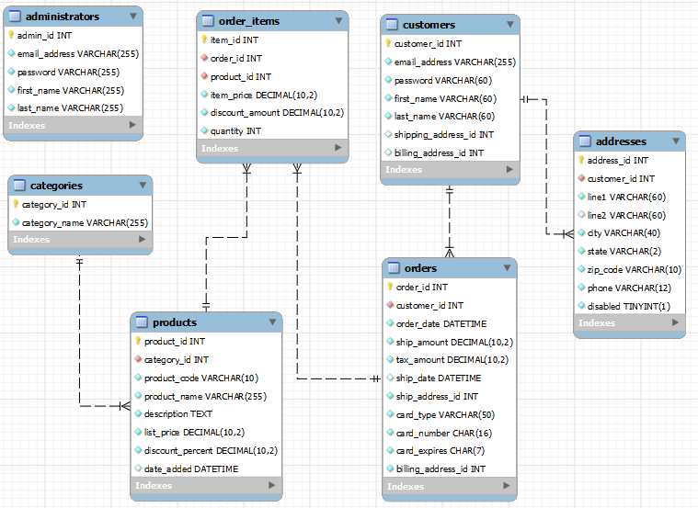

**Relationship between customers and addresses**

We have the customers as the left table and addresses as the right table.These tables have a one-to-one relationship.

customers table has `customer_id` an integer field as it’s primary key.

addresses table has `address_id` an integer field as it’s primary key.

addresses table has `customer_id` an integer field as a foreign key. This foreign key tells us about the customer that this address belongs to.

1. b. Following tables will be used to store the data:

students(student_id (PK), student_name, address, email)

majors (major_id, major_name)  
 classes (class_id (PK), class_name, major_id (FK))

student_class(id (PK), student_id (FK), class_id (FK))

The database EER diagram after normalization is given below

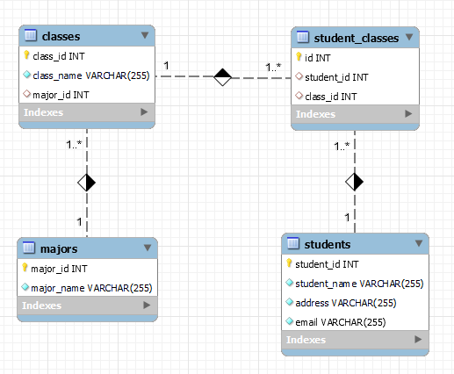

c. To achieve normalization these steps were taken

First Normal Form - As the classes column had multiple values and it should be atomic, A separate table to store classes information was created. Now we can store class_id in the students table to know what class a student is taking.

Second Normal Form - There is no partial dependency so after achieving 1NF we already have 2NF in this case.

Third Normal Form - There is a transitive dependency in the table with majors column. A course belongs to a major therefore we can store majors information in a separate table and have a foreign key for it in the classes table. Once this is done, we have class_id in students table and major_id in classes table as foreign keys.

BCNF - To achieve BCNF, we’ll create a table student_classes. This table will store information about student and classes they’ve opted for, this way multi-value dependency is removed from students table.