CareConnect Team A

Technical Design Document
Version 1.0

2026 Summer Cohort
University of Maryland Global Campus
Software Engineering 670 9040 Software Engineering Capstone
Professor Mir Assadullah
July 25th, 2026

Revision History

Editor Name | Date | Reason for Change | Version
2026 Summer Cohort | 7/25/2026 | Initial Document | 1.0
1.x | July 2026 | Integrated Team E Milestone 2 design for Ask AI retrieval, summary confirmation, USPS mail agent, STML, and safety/consent (new §§4.9, 5.11, 6.12–6.15, 11.19.7, 12.9). | Team E

Table of Contents
Revision History 2
Table of Contents 3
List of Tables 6
List of Figures 8
1. Introduction 11
1.1 Purpose 11
1.2 Scope 12
1.3 Definitions and Abbreviations 14
1.4 Project Documentation 18
1.5 References 18
1.6 Intended Audience 22
2. System Architecture Overview 23
2.1 Overview 23
2.2 Architecture Diagram 25
2.3 Component Responsibilities 27
2.4 External Dependencies 38
2.5 Workflows 42
2.6 System Users 48
3. Technology Stack 49
3.1 Technology Decisions and Assumptions 53
3.2 Technology Risks 54
4. Database and Data Model Design 54
4.1 Overview 55
4.2 Entity-Relationship Diagram 59
4.3 Table Definitions 64
4.4 New Tables and Migrations 73
4.5 Data Retention and PII Handling 79
4.6 Electronic Visit Verification (EVV) Entities 87
4.7 In-Home Residential Support Entities 88
4.8 Administration and Audit Entities 89
5. API Design 91
5.1 Overview 91
5.2 API Conventions 92
5.3 Authentication and Authorization 95
5.4 Video Call Endpoints 97
5.5 Transcription and Summary Endpoints (Planned) 99
5.6 Telemetry and Analytics Endpoints 100
5.7 RBAC and Access Management Endpoints 102
5.8 Error Handling and Graceful Degradation 103
5.9 Administrative, Audit, and Reporting APIs 106
5.10 API Versioning and Backward Compatibility 106
6. Feature Specification 106
6.1 Role-Based Access Control Design 107
6.2 Video Call and Transcription Pipeline Design 112
6.3 AI and Bedrock Integration Design 122
6.4 Telemetry and Analytics Design 146
6.5 Cross-Team Functional Dependencies 147
6.6 Electronic Visit Verification (EVV) Enhancements 153
6.7 AI-Assisted Invoicing (AWS Bedrock + Claude) 154
6.8 QR/Invite Care Circle Onboarding 155
6.9 Wearable Device Integration 156
6.10 Home Care Document Digitization 157
6.11 Screening and Comprehensive Assessment Workflows 158
7. Infrastructure and Deployment Design 159
7.1 AWS Infrastructure Overview 161
7.2 ECS Fargate Backend Deployment 170
7.3 Frontend Deployment via Amplify 171
7.4 Mobile Deployment Readiness 171
7.5 GitHub Actions CI/CD Pipeline 171
7.6 Secrets and Configuration Management 183
7.8 Deployment Environments 191
7.9 Rollback Procedure 192
8. Security Design 192
8.1 Overview 193
8.2 Authentication Flow 195
8.3 Transport Security 203
8.4 Data Encryption 205
8.5 Input and Output Sanitization 207
8.6 Telemetry Content Standard Policy (WBS Telemetry) 209
8.7 Summary of Security Controls by Work Package 211
8.8 Logging and Monitoring 212
9. Performance and Scalability 212
9.1 Performance and Scalability Objectives 212
9.2 Scalability Strategy 213
9.3 Performance Monitoring 214
9.4 Bottleneck Mitigation 214
10. Error Handling 215
11. Testing Strategy 217
11.1 Testing Objectives 218
11.2 Scope of Testing 218
11.3 Unit Testing 220
11.4 Integration Testing 222
11.5 Performance Testing 224
11.6 Security and Compliance Testing 226
TDD-B-11.6 Security Considerations for Testing 227
11.7 Accessibility Testing 228
TDD-B-11.7.2 Accessibility and VPAT Compliance 230
TDD-B-11.7.2.1 Automated Accessibility Tools 230
11.8 Test Environment 232
11.9 Inherited Test Inventory and Coverage Notes 235
11.10 Defect Tracking 240
11.11 Testing Technology Decisions and Assumptions 240
11.13 Code Coverage Strategy 243
11.14 Milestone 2 Prototype and Viability Results 244
11.15 Error Handling in Testing Infrastructure 248
12. Known Issues 256
12.1 Inherited product and security posture 256
12.2 Video call, recording, and transcription (WBS Video Calls) 258
12.3 Telemetry and analytics (WBS Telemetry) 259
12.4 Bedrock, Summaries, and AI Condition Detection (WBS AWS Bedrock / AI) 260
12.5 Deployment, Environment, and Data Schema (WBS Deployment) 261
12.6 RBAC and external dependencies (WBS RBAC and Project Plan Section 12) 261
12.7 Testing and quality process limitations 262
TDD-B-12.7 Known Issues, Limitations, and Open Items (Team B) 263
12.8 Known Issues and Limitations 266
13. UX/UI Design Specification 268
13.1 UI Design Approach and Principles 268
13.2 Screens and User Workflows Affected 268
13.3 Wireframes, Mockups, or Screen Notes 269
14. AI Usage Statement 275
15. Appendix 276
14.1 Appendix A: Reference Locations from Inherited Codebase 276
14.2 Appendix B: Enlarged Figures for Readability 277

List of Tables
- Table 1.1 — Definitions, Acronyms, and Abbreviations — Section 1.3
- Table 1.2 — Documents and Versions — Section 1.4
- Table 2.1 — AWS Services — Section 2.4.1
- Table 2.2 — AI Providers — Section 2.4.3
- Table 2.3 — Billing and Healthcare Integrations — Section 2.4.4
- Table 2.4 — Communication Services — Section 2.4.5
- Table 2.5 — Technology stack — Section 3
- Table 4.1 — users — Section 4.3.1
- Table 4.2 — patient — Section 4.3.1
- Table 4.3 — caregiver — Section 4.3.1
- Table 4.4 — caregiver_patient_link — Section 4.3.2
- Table 4.5 — family_member_link — Section 4.3.2
- Table 4.6 — call_recordings — Section 4.3.3
- Table 4.7 — call_transcript_segments — Section 4.3.3
- Table 4.8 — call_summaries — Section 4.3.3
- Table 4.9 — telemetry_events — Section 4.3.4
- Table 4.10 — patient_risks — Section 4.3.4
- Table 4.11 — call_attendees proposed entity — Section 4.3.5
- Table 4.12 — condition_flags proposed entity — Section 4.3.5
- Table 4.13 — call_attendees table — Section 4.4.2
- Table 4.14 — condition_flags — Section 4.4.3
- Table 5.1 — HTTP Methods — Section 5.2.2
- Table 5.2 — Transcription and Summary Endpoints — Section 5.5
- Table 5.3 — Telemetry and Analytics Endpoints — Section 5.6
- Table 5.4 — RBAC and Access Management Endpoints — Section 5.7
- Table 5.5 — HTTP Status Code Conventions — Section 5.8.2
- Table 6.1 — Primary services that participate in AI processing activities — Section 6.3.1.3
- Table 6.2 — Models currently configured within the platform — Section 6.3.2.1
- Table 6.3 — Primary components involved in Bedrock operations — Section 6.3.2.2
- Table 6.4 — Primary components involved in privacy-aware AI processing — Section 6.3.7.1
- Table 6.5 — Cross-team functional dependencies — Section 6.5.1
- Table 6.6 — Team A contacts by external team — Section 6.5.2
- Table 7.1 — Existing primary workflows — Section 7.5.2
- Table 7.2 — Primary configuration sources — Section 7.6.2
- Table 8.1 — Describes the planned outcomes, associated WBS points, and associated Milestones. — Section 8.1.1
- Table 8.2 — Token and local integration settings — Section 8.2.1
- Table 8.3 — Planned actions — Section 8.2.2
- Table 8.4 — New roles — Section 8.2.3.1
- Table 8.5 — RBAC Deliverables — Section 8.2.3.5
- Table 8.6 — Planned transport security — Section 8.3.2
- Table 8.7 — Planned data protection — Section 8.4.2
- Table 8.8 — Planned Sanitization — Section 8.5.2
- Table 8.9 — Telemetry Content Standard — Section 8.6
- Table 8.10 — Summary of Security Controls — Section 8.7
- Table 11.1 — Areas of testing focus — Section 11.2
- Table 11.2 — Unit test emphasis per WBS item — Section 11.3
- Table 11.3 — Assertions per scenario — Section 11.5
- Table 11.4 — Test anchors for each control point — Section 11.6
- Table 11.5 — Accessibility surface states to verify — Section 11.7
- Table 11.6 — Test environment — Section 11.8
- Table 11.7 — Existing test file coverage — Section 11.9.1
- Table 11.8 — Telemetry focused tests — Section 11.9.2
- Table 11.9 — Bedrock test coverage — Section 11.9.3
- Table 11.10 — Deployment test coverage — Section 11.9.4
- Table 11.11 — RBAC test coverage — Section 11.9.5
- Table 11.12 — Coverage summary — Section 11.9.6
- Table 12.1 — Summary of known state of current requirements — Section 12.1
- Table 12.2 — Issues and impact on testing — Section 12.2
- Table 12.3 — Dependencies and their effects — Section 12.6
- Table A.1 — Locations from inherited codebase — Section 14.1

List of Figures
- Figure 2.1 — CareConnect High-Level System Architecture — Section 2.2
- Figure 2.2 — Frontend Client Component Diagram — Section 2.3.1
- Figure 2.3 — API Layer Component Diagram (enlarged version in Appendix) — Section 2.3.2
- Figure 2.4 — Business Services Layer Component Diagram — Section 2.3.3
- Figure 2.5 — Persistence Layer Component Diagram — Section 2.3.4
- Figure 2.6 — Security Layer Component Diagram — Section 2.3.5
- Figure 2.7 — AI and Communication Layer Component Diagram — Section 2.3.6
- Figure 2.8 — Infrastructure Services Component Diagram — Section 2.3.7
- Figure 2.9 — High level workflow diagram — Section 2.5
- Figure 2.10 — Login and Authentication workflow diagram — Section 2.5.1
- Figure 2.11 — Video Calls and Post-Call Pipeline Workflow Diagram — Section 2.5.2
- Figure 2.12 — 2.5.3 Grant / Revoke and Enforcement Workflow diagram — Section 2.5.3
- Figure 2.13 — Deployment to AWS Workflow Diagram — Section 2.3.4
- Figure 4.1 — CareConnect Core Domain Entity Relationship Diagram — Section 4.2
- Figure 6.1 — CareConnect AI Processing and Bedrock Sentiment-Summary Pipeline — Section 6.3.1
- Figure 7.1 — CareConnect AWS Infrastructure and CloudFormation Stack Topology — Section 7
- Figure 7.2 — CareConnect AWS VPC Networking Diagram — Section 7.1.3
- Figure 7.3 — CareConnect Continuous Integration and Continuous Deployment Pipeline — Section 7.5
- Figure 8.1 — Illustration of the current implementation of the auth flow. — Section 8.2.1
- Figure 12.1 — Known issue disposition — Section 12.7
- Figure 14.1 — Section 2.3.2, Figure 2.3, Part 1 — Section 14.2.1
- Figure 14.2 — Section 2.3.2, Figure 2.3, Part 2 — Section 14.2.1

1. Introduction
The CareConnect Technical Design Document serves as the foundational technical blueprint for the CareConnect capstone project, bridging the gap between high-level functional requirements and concrete implementation. By translating the specifications outlined in the Software Requirements Specification (SRS) and the broader project plan, this document establishes the authoritative technical standards for the backend infrastructure, AI processing pipelines, and video call subsystems. It is designed to guide Team A developers through the implementation, extension, and hardening of the inherited codebase across milestones 2 through 4 of the SWEN 670 capstone.

Beyond its immediate utility for the development team, this document functions as a critical reference for cross-functional stakeholders, including the frontend team and course instructors. It explicitly captures the technical rationale, planned architectural approaches, and acceptance criteria for both current and deferred features. By documenting these details and identifying known dependencies, the paper ensures that the project's design intent remains cohesive and traceable as the team navigates the complexities of evolving the system across subsequent development stages.

1.1 Purpose
This Technical Design Document translates the functional and non-functional requirements established in the CareConnect Software Requirements Specification (SRS) and Project Plan into concrete technical decisions for the backend, infrastructure, AI pipeline, and video call subsystem. It serves as the authoritative reference for how the team will implement, extend, and harden the inherited CareConnect codebase across Milestones 2 through 4 of the SWEN 670 capstone.

The document is intended for use by Team A developers during implementation, by the SWEN 661 frontend team as an API consumer reference, and by course instructors evaluating design decisions against project requirements. Where implementation is deferred to a later milestone, this document records the planned approach, acceptance criteria, and known dependencies so the design intent is not lost between milestones.

1.2 Scope
This document covers the systems and components that fall within the team’s Work Breakdown Structure (WBS) ownership for the CareConnect capstone project. It serves to define the specific technical boundaries and integration points for the features assigned to Team A. By explicitly outlining these responsibilities, the document ensures alignment between the proposed architectural solutions and the project's overall functional requirements. As such, the following are in scope:

- Spring Boot backend (backend/core/) - all REST API endpoints, service layer, Spring security configuration, and data access components owned or modified by the team.
- PostgreSQL database schema - entity definitions, Flyway migrations, and data model extension introduced in the WBS.
- AWS infrastructure - ECS Fargate deployment, RDS, S3, Amazon Chime SDK, Kinesis Video Streams (KVS), Amazon Transcribe, and AWS Bedrock (Claude model).
- Flutter shared components - widgets and service clients directly consumed by the team’s features, including the video call pipeline, transcription viewer, SOAP summary screen, and telemetry event layer.
- CI/CD pipeline - GithHub Actions workflows, OIDC-based AWS role assumption, and deployment sequencing for application and infrastructure changes.
- UI - validation and integration of SWEN 661 implementations

As there are items that may be expected to be completed by the team, there are reserved items that we do not foresee bringing into our domain. As such, the following are explicitly out of scope for this document:
- The primary Flutter user interface built and owned by the SWEN 661 frontend team. The team specifies API contracts and shared component interfaces
- End-to-end user acceptance testing and any test infrastructure owned by the dedicated testing team.
- Business logic or features not assigned to the team in the approved WBS, including billing and invoicing workflows beyond RBAC access controls.

1.3 Definitions and Abbreviations
To better facilitate the reading of this documentation, special abbreviations and terms have been placed in one location for the entire document here. These definitions, acronyms, and abbreviations used across this document:

Table 1
Definitions, Acronyms, and Abbreviations
Term / Abbreviation | Definition
AWS Bedrock | Managed AWS service providing access to foundation AI models, used in CareConnect to power call summarization, SOAP note generation, and risk stratification via the planned Claude model.
BCrypt | Password hashing algorithm used by the inherited Spring Security configuration to store user credentials.
Chime SDK | Amazon Chime SDK for meetings - provides WebRTC-based video and audio conferencing infrastructure for CareConnect video calls.
CI/CD | Continuous Integration / Continuous Deployment - automated pipeline for building, testing, and deploying code changes via GitHub Actions.
CloudFormation | AWS infrastructure-as-code service used to provision and manage CareConnect's networked, platform, data, and service stack layers.
CORS | Cross-Origin Resource Sharing — HTTP header mechanism that controls which origins may call the CareConnect REST API.
Diarization | Automated process of identifying and labeling different speakers within an audio recording. Used as a fallback transcription strategy when per-attendee KVS streams are unavailable.
ECS Fargate | AWS serverless container execution environment used to host the Spring Boot backend without managing underlying EC2 instances.
Flyway | Database migration library used to version-control and apply PostgreSQL schema changes in a repeatable, ordered sequence.
HIPAA | Health Insurance Portability and Accountability Act - U.S. federal regulation governing the handling of protected health information (PHI). CareConnect applies HIPAA-aligned safeguards within academic scope; no formal certification is claimed.
HSTS | HTTP Strict Transport Security - response header instructing browsers to only communicate with the server over HTTPS.
JWT | JSON Web Token - stateless authentication credential issued by the CareConnect backend on successful login and validated on each subsequent request via the Spring Security filter chain.
KVS | Amazon Kinesis Video Streams - AWS service used to capture per-attendee audio streams from Chime SDK meetings for individual transcription jobs.
OIDC | OpenID Connect - identity protocol used by GitHub Actions to assume AWS IAM roles for deployment without storing long-lived credentials
PII | Personally Identifiable Information - data that could identify an individual, including name, email address, phone number, and date of birth. CareConnect telemetry is designed to exclude PII
PHI | Protected Health Information - any individually identifiable health information covered by HIPAA, including call transcripts, AI-generated summaries, and condition flags.
RBAC | Role-Based Access Control - authorization model that grants permissions to users based on their assigned role within the CareConnect care circle (e.g., Patient, Caregiver, Physician).
RDS | Amazon Relational Database Service - managed PostgreSQL hosting used by CareConnect in deployed environments.
SOAP Note | Subjective, Objective, Assessment, Plan - structured clinical documentation format used by CareConnect to organize AI-generated call summaries into clinically meaningful sections.
Spring Boot | Java application framework used to build the CareConnect backend REST API and service layer.
Spring Security | Spring framework module providing authentication, authorization, and HTTP security configuration for the CareConnect backend
SSM | AWS Systems Manager Parameter Store - used to store non-secret configuration values (e.g., region, ARNs) retrieved by the backend at runtime.
TDD | Test-Driven Development (in testing context) or Technical Design Document (in document context). Context determines meaning; this document uses TDD to refer to the Technical Design Document.
WebRTC | Web Real-Time Communication - open standard enabling peer-to-peer audio and video in browsers and mobile apps, underlying the Chime SDK integration.
WBS | Work Breakdown Structure - the hierarchical decomposition of Team A's project scope into deliverable sections, numbered in the Project Plan Section 14.
Concatenation Pipeline | The Chime SDK CreateMediaConcatenationPipeline process that stitches raw audio/video recording fragments into a single MP4 file.
Condition Flag | An AI-generated indicator of a potential health condition detected through voice or transcript analysis, stored with confidence scores and requiring clinical verification.
Media Capture Pipeline | An AWS Chime SDK Media Pipeline that records meeting audio and video to an S3 bucket during an active call.
Presigned URL | A time-limited S3 URL that grants temporary access to a private object without requiring AWS credentials from the requesting client.
Sentiment Score | A numeric value (0.0–1.0) representing the emotional tone detected in text, voice, or video channels during a call, classified as CALM, ANXIOUS, or DISTRESSED.
Speaker Label | A tag (e.g., spk_0, spk_1 or a care-circle role such as "Physician") assigned to transcript segments to identify the speaker.
Transcript Segment | An individual utterance within a call transcript, containing text content, start/end timestamps, and speaker attribution.

1.4 Project Documentation
As of June 13, 2026, the project documentation for the CareConnect Team A Technical Design Document has been updated to reflect the latest version numbers and completion statuses. This summary outlines the current progression of all key project deliverables as recorded in the document's revision history.
Table 2
Documents and Versions
Document | Version | Date
Project Plan | 2.0 | 05/30/2026
Software Requirements Specification | 2.0 | 05/30/2026
Technical Design Document | 1.0 | 06/13/2026
Software Test Plan | 1.0 | 06/13/2026
Programmers Guide | - | TBD
Deployment and Operations Guide | - | TBD
Users Guide | - | TBD
Test Report | - | TBD

1.5 References
Amazon Web Services. (n.d.). Amazon Bedrock documentation. https://docs.aws.amazon.com/bedrock/
Amazon Web Services. (n.d.). Amazon Chime SDK documentation. https://docs.aws.amazon.com/chime-sdk/
Amazon Web Services. (n.d.). Amazon Elastic Container Service documentation. https://docs.aws.amazon.com/ecs/
Amazon Web Services. (n.d.). Amazon Transcribe documentation. https://docs.aws.amazon.com/transcribe/
Amazon Web Services. (n.d.). AWS CloudFormation documentation. https://docs.aws.amazon.com/cloudformation/
Amazon Web Services. (n.d.). AWS Secrets Manager documentation. https://docs.aws.amazon.com/secretsmanager/
Amazon Web Services. (n.d.). AWS Systems Manager Parameter Store documentation. https://docs.aws.amazon.com/systems-manager/latest/userguide/systems-manager-parameter-store.html
Google. (n.d.). Flutter documentation. https://docs.flutter.dev
Pivotal Software. (n.d.). Spring Boot documentation. https://docs.spring.io/spring-boot/docs/current/reference/html/
Pivotal Software. (n.d.). Spring Security documentation. https://docs.spring.io/spring-security/reference/
PostgreSQL Global Development Group. (n.d.). PostgreSQL documentation. https://www.postgresql.org/docs/
SWEN 670 Team A. (30 May 2026). CareConnect Project Management Plan. Unpublished manuscript.
SWEN 670 Team A. (30 May 2026). CareConnect Software Requirements Specification. Unpublished manuscript.
SWEN 670 Team A. (13 June 2026). CareConnect Software Test Plan. Unpublished manuscript.
SWEN 670 Team B. (30 May 2026). CareConnect Project Management Plan. Unpublished manuscript.
SWEN 670 Team B. (30 May 2026). CareConnect Software Requirements Specification. Unpublished manuscript.
SWEN 670 Team B. (13 June 2026). CareConnect Software Test Plan. Unpublished manuscript.
SWEN 670 Team C. (30 May 2026). CareConnect Project Management Plan. Unpublished manuscript.
SWEN 670 Team C. (30 May 2026). CareConnect Software Requirements Specification. Unpublished manuscript.
SWEN 670 Team C. (13 June 2026). CareConnect Software Test Plan. Unpublished manuscript.
SWEN 670 Team D. (30 May 2026). CareConnect Project Management Plan. Unpublished manuscript.
SWEN 670 Team D. (30 May 2026). CareConnect Software Requirements Specification. Unpublished manuscript.
SWEN 670 Team D. (13 June 2026). CareConnect Software Test Plan. Unpublished manuscript.
SWEN 670 Team E. (30 May 2026). CareConnect Project Management Plan. Unpublished manuscript.
SWEN 670 Team E. (30 May 2026). CareConnect Software Requirements Specification. Unpublished manuscript.
SWEN 670 Team E. (13 June 2026). CareConnect Software Test Plan. Unpublished manuscript.
The GitHub Team. (n.d.). GitHub Actions documentation. https://docs.github.com/en/actions
UMGC Fall CareConnect Cohort (2025). Technical Design Document. Retrieved May 28th, 2026. https://umgc-cappms.azurewebsites.net/download/1c45811b-6d19-415a-8b17-02205cf5c942----SWEN670_CareConnect_TechnicalDesignDocument_v3.0.pdf
UMGC Fall EduLense Cohort (2025). Technical Design Document. Retrieved May 28th, 2026. https://umgc-cappms.azurewebsites.net/download/2f5e9be8-5785-43ae-a700-c691fd4da2f1----EduLense-TechnicalDesignDocument-M4.pdf
UMGC Spring CareConnect Cohort (2026). Technical Design Document. Retrieved May 28th, 2026. https://umgc-cappms.azurewebsites.net/download/003f7f93-a754-43f5-b520-2e31478cac71----Spring2026TDD.pdf
UMGC SWEN 670 Summer Cohort Project Manager Rivas, J. (28 May 2026). SWEN670_CareConnect_TechnicalDesignDocument_v3.0.

1.6 Intended Audience
This document is intended for multiple stakeholder groups involved in the development, testing, review, and maintenance of the CareConnect platform.
The primary audience includes:
- Software developers responsible for implementing functionality.
- Quality assurance personnel responsible for creating and executing test cases.
- Team leads and project managers responsible for milestone planning and coordination.
- Professor Assadulla and academic reviewers evaluating project progress and technical quality.
- The CareConnect client and stakeholders reviewing proposed solutions and deliverables.
- Future developers who may maintain or extend the platform after the completion of the capstone project.

2. System Architecture Overview
CareConnect’s architecture is a multi-tier, cloud-native healthcare coordination platform designed to provide a secure and scalable environment for patients, caregivers, family members, and healthcare professionals. The system employs a modular, layered architecture that strictly separates concerns, by decoupling the client-facing interfaces from the business logic, data persistence, and underlying infrastructure services. By leveraging a modern technology stack, including a Flutter-based frontend and a Java-based Spring Boot backend, the platform ensures consistent performance and maintainability across web, mobile, and desktop environments.

2.1 Overview
Section 2.1 describes the architectural approach, design goals, and high-level request flow from Flutter clients through the Spring Boot backend to PostgreSQL and AWS services. Subsections 2.1.1 through 2.1.3 expand these topics before the detailed diagram and component breakdown in Sections 2.2 and 2.3.

2.1.1 Architectural Approach
CareConnect is designed as a multi-tier healthcare coordination platform that supports patients, caregivers, family members, and healthcare professionals through a combination of mobile, web, and cloud-based services. The system follows a layered architecture pattern consisting of a Flutter client application, a Spring Boot backend API layer, a PostgreSQL data layer, and AWS-managed infrastructure services. This architecture promotes separation of concerns, scalability, maintainability, and secure handling of healthcare-related information.
The frontend is implemented using Flutter and supports Android, iOS, web, and desktop platforms. The backend is implemented using Java 17 and Spring Boot, exposing REST APIs and WebSocket endpoints for real-time communication features. Persistent application data is stored in PostgreSQL, with Amazon RDS used in cloud environments and Docker-hosted PostgreSQL used for local development.
The platform leverages AWS services including ECS Fargate, RDS PostgreSQL, Bedrock, Chime SDK, Transcribe, S3, Secrets Manager, Systems Manager Parameter Store, and CloudWatch to provide infrastructure, AI-assisted workflows, communication services, storage, and operational monitoring.

2.1.2 Architectural Goals
The following objectives serve as the foundational framework for all subsequent design decisions, ensuring the platform remains resilient, maintainable, and adaptable as new capabilities are introduced. These objectives align technical implementation with project requirements, healthcare privacy considerations, and long-term operational needs. Together, they guide the selection of technologies, architectural patterns, security controls, and deployment strategies used throughout the CareConnect platform.
The architecture was designed to achieve the following goals:
- Support secure healthcare communication and collaboration.
- Enable cross-platform access through a unified Flutter codebase.
- Provide scalable cloud-native deployment through AWS services.
- Support AI-assisted workflows such as call summarization, sentiment analysis, and condition detection.
- Maintain clear separation between presentation, business logic, and persistence layers.
- Facilitate future enhancements through modular service-oriented design.
- Support HIPAA-conscious handling of sensitive patient information.

2.1.3 High-Level Architecture
At a high level, user requests originate from Flutter clients and are routed through REST APIs or WebSocket connections to the Spring Boot backend. Business services perform application logic, access persistent data through repository layers, and interact with AWS services when AI, transcription, communication, storage, or analytics functionality is required. Results are then returned to the client for presentation to the user.

2.2 Architecture Diagram
The architecture diagram illustrates the relationship between client applications, backend services, data storage components, AWS infrastructure services, and external integrations. The diagram highlights the primary data flow from user interactions through the API layer, business services, persistence layer, and supporting cloud services.
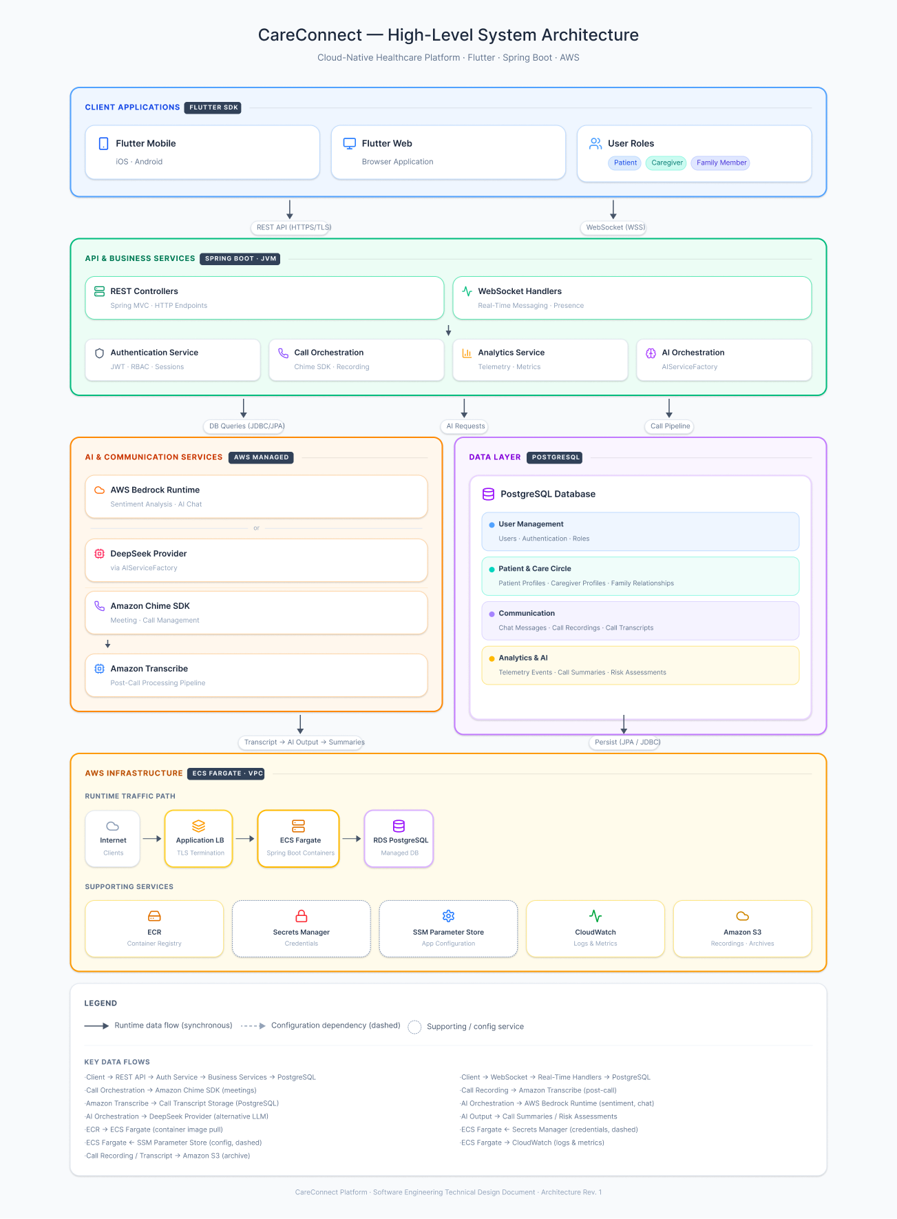
Figure 2.1: CareConnect High-Level System Architecture
At a high level, the Team D implementation follows a layered application model. The Flutter client invokes protected backend APIs over HTTPS. Requests first traverse shared authentication and role enforcement boundaries, then flow into Spring Boot controllers and service classes that apply validation, workflow rules, and persistence logic. External integrations such as AWS Bedrock, OCR/extraction services, EVV aggregator clients, and wearable provider adapters remain behind dedicated service boundaries so the user interface and domain rules are not tightly coupled to any single provider implementation.
Core backend components referenced across the attached materials include EvvController.java, EvvService.java, HhaExchangeBatchSubmissionService.java, InvoiceController.java, TextractService.java, LlmExtractionService.java, LinkManagementController.java, and FitbitService.java. These components fit the existing controller-service-client pattern already visible in the repository and readiness artifacts.
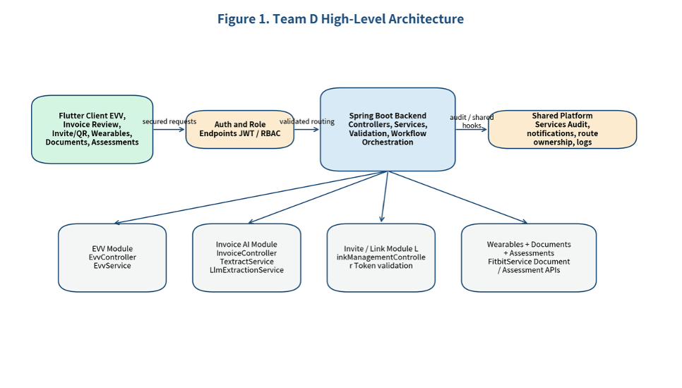
Figure 1. Team D high-level backend architecture.

2.3 Component Responsibilities
The CareConnect platform is organized into logical architectural components, each responsible for a specific area of functionality. This separation improves maintainability, testing, and future extensibility.

Component | Responsibility | Owner | Dependencies
Flutter Client Workflows | Captures user actions for EVV, invoices, invites, wearables, documents, and assessments; displays backend responses and review states | Frontend / shared client layer | Auth and role endpoints; Team D backend APIs
Auth and Role Endpoints | Apply JWT and RBAC controls before protected workflow access is granted | Shared platform ownership with Team A alignment | Role matrix, route ownership, token handling
InvoiceController.java | Receives invoice upload and extraction requests; coordinates extraction-review workflow entry points | Team D backend | TextractService, LlmExtractionService, storage, invoice status API
TextractService.java | Performs OCR-oriented extraction or document preprocessing before LLM mapping | Team D backend | Uploaded file handling, provider boundary, extraction contract
LlmExtractionService.java | Maps extracted text to structured invoice fields using LLM-assisted reasoning and confidence handling | Team D backend | AWS Bedrock / Claude, review workflow, audit metadata
EvvController.java / EvvService.java | Manage EVV lifecycle operations, validation, correction, and readiness visibility | Team D backend | Visit records, aggregator status API, submission preparation
HhaExchangeBatchSubmissionService.java | Prepares outbound EVV payloads and isolates submission logic behind a controllable boundary | Team D backend | VirginiaHhaExchangeClient, DcSandataAltEvvClient, mock or sandbox mode
LinkManagementController.java | Supports invite token issuance, acceptance, QR/link validation, and related onboarding flows | Team D backend | Auth and role endpoints, caregiver/patient link APIs
FitbitService.java and wearable adapters | Normalize provider payloads, support sync boundaries, and isolate external wearable integrations | Team D backend | OAuth adapters, metric ingestion service, mock payloads
Persistence Layer | Stores visit records, invoice drafts, invite tokens, document states, assessment states, and wearable sync metadata | Shared database / Team D feature usage | PostgreSQL, Spring Data JPA, approved schema paths
Shared Platform Services | Provide logging, monitoring, audit hooks, storage, and deployment infrastructure | Shared platform ownership | CloudWatch, S3, IAM, KMS, CI/CD pipeline
AI Gateway | Authentication, RBAC scope filtering, rate limiting, and Ask AI request routing. | Team E (Arturo Santana / Ravichandra Vasireddy) | Cognito/JWT, feature services
Retrieval Service (Ask AI) | Scoped hybrid search and grounded, cited answer assembly. | Team E (Ravichandra Vasireddy) | Data layer, Bedrock, safety framework
Summaries Service | Generate structured, cited summaries from diarized transcript text. | Team E (Fon Ade Asaa) | Transcript source, Bedrock, data layer
STML Service | Daily Memory Brief and recall experiences built on summaries and retrieval. | Team E (John Bui) | Summaries, Retrieval
USPS Mail Agent | Ingest, OCR, normalize, index, and classify Informed Delivery mail. | Team E (Arturo Santana) | Gmail OAuth, Textract, data layer
Safety/Consent Layer | Disclaimers, citations, secondary validation, and HITL escalation. | Team E (David Oguh) | All feature services, audit ledger

2.3.1 Frontend Client
The Flutter frontend serves as the primary interaction layer between users and the CareConnect platform. It provides a consistent cross-platform experience across mobile, web, and desktop environments while facilitating access to communication, care coordination, analytics, and account management features. The frontend is responsible for presenting information to users and interacting with backend services through REST APIs and WebSocket connections.
Responsibilities include:
- User authentication workflows.
- Dashboard and analytics visualization.
- Messaging and communication interfaces.
- Video call participation.
- Care coordination and task management.
- Interaction with backend APIs and WebSocket services.
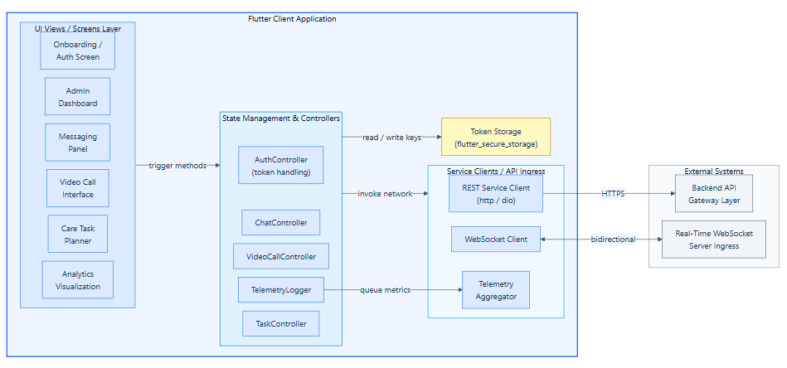
Figure 2.2: Frontend Client Component Diagram

2.3.2 API Layer
The API layer acts as the primary gateway between client applications and backend business services. It receives incoming requests, validates input, enforces security controls, and routes requests to the appropriate application services. This layer helps maintain separation between presentation concerns and business logic while providing a consistent interface for frontend clients.
Responsibilities include:
- Request validation.
- Authentication and authorization enforcement.
- Routing requests to business services.
- Formatting API responses.
- Error handling and response generation.
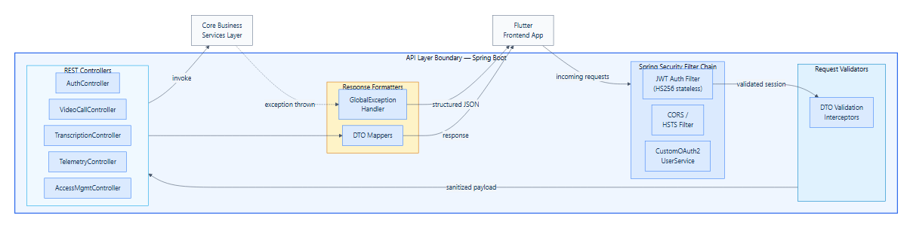
Figure 2.3: API Layer Component Diagram (enlarged version in Appendix)

2.3.3 Business Services Layer
The security layer protects platform resources and sensitive healthcare information through authentication, authorization, and access control mechanisms. It ensures that only authorized users can access protected resources while enforcing role-based permissions and security policies throughout the application. This layer serves as a foundational component supporting HIPAA-conscious system design and secure communication workflows.
Responsibilities include:
- User management.
- Caregiver and patient workflows.
- Analytics processing.
- AI-assisted summarization and sentiment analysis.
- Call processing and transcription orchestration.
- Notification management.
- Billing and subscription workflows.

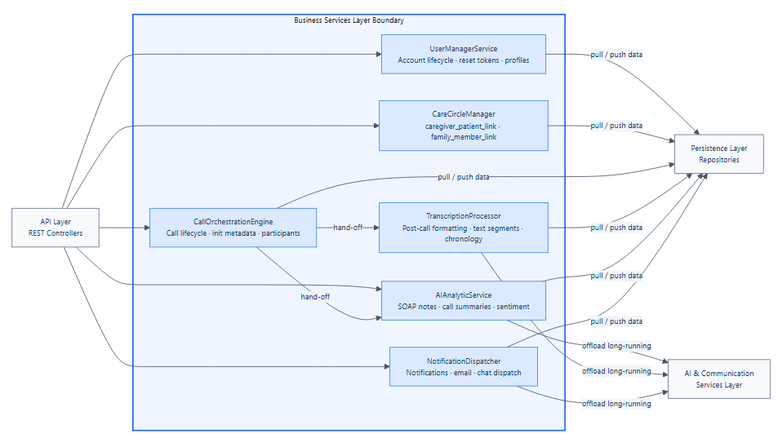
Figure 2.4: Business Services Layer Component Diagram

2.3.4 Persistence Layer
The persistence layer is responsible for managing the storage, retrieval, and lifecycle of application data. It provides an abstraction between business services and the underlying PostgreSQL database, ensuring that data operations remain consistent, maintainable, and scalable. By centralizing database access through repositories and entity models, the platform promotes separation of concerns and simplifies future schema evolution and optimization efforts.
Responsibilities include:
- CRUD operations.
- Database query execution.
- Entity management.
- Transaction coordination.
- Data persistence and retrieval.

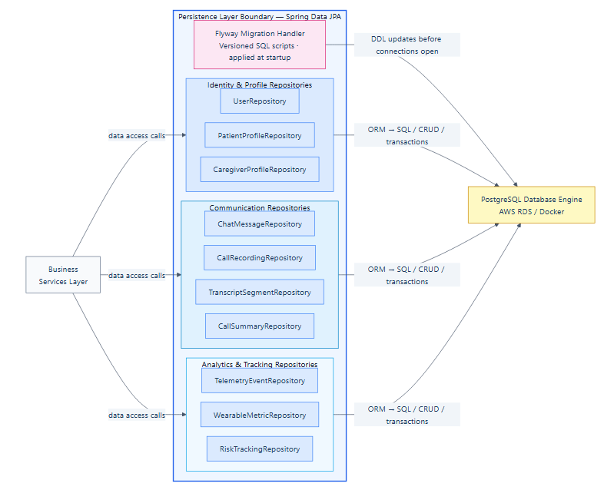
Figure 2.5: Persistence Layer Component Diagram

2.3.5 Security Layer
The security layer protects application resources and sensitive healthcare information through authentication, authorization, and access control mechanisms. It ensures that users can only access data and functionality permitted by their assigned roles and permissions while enforcing platform-wide security policies. This layer serves as a foundational component for maintaining trust, privacy, and HIPAA-conscious handling of healthcare-related information.
Responsibilities include:
- JWT creation and validation.
- Role and permission enforcement.
- User identity management.
- Access control validation.
- Security policy enforcement.

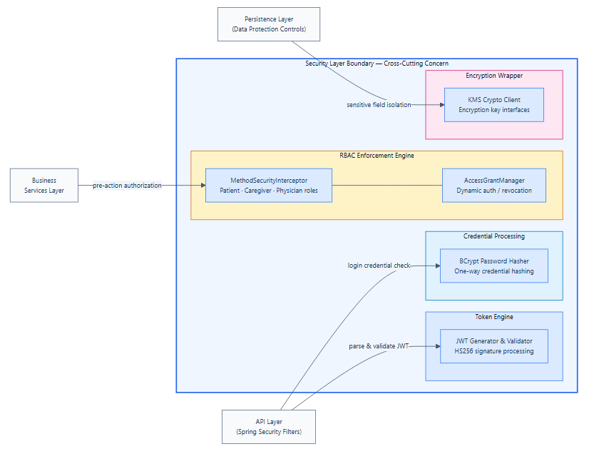
Figure 2.6: Security Layer Component Diagram

2.3.6 AI and Communication Services
The AI and communication services layer provides advanced capabilities that extend beyond traditional business operations. These services enable intelligent analysis of communication data, support real-time collaboration between users, and integrate with AWS-managed services for transcription, sentiment analysis, and AI-assisted insights. Together, these components enhance care coordination and provide the foundation for future healthcare-focused analytics and decision-support features.
Responsibilities include:
- Bedrock-powered AI summarization.
- Sentiment analysis.
- Risk assessment support.
- AWS Transcribe integration.
- Chime video communication.
- Real-time WebSocket communication.

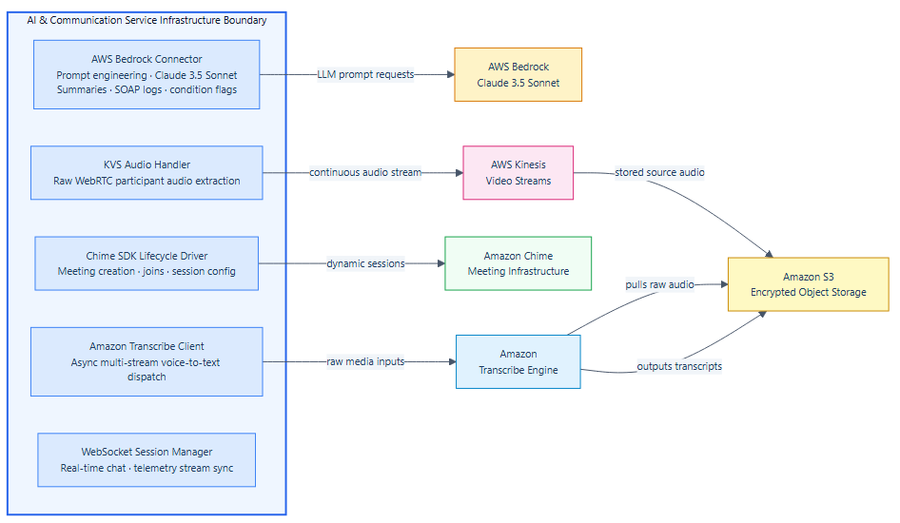
Figure 2.7: AI and Communication Layer Component Diagram

2.3.7 Infrastructure Services
Infrastructure services provide the cloud-based resources required to deploy, operate, and monitor the CareConnect platform. These services abstract operational concerns from application logic while supplying scalable compute, storage, networking, configuration management, and monitoring capabilities. By leveraging managed AWS services, the platform can support reliable operation, simplified maintenance, and future growth with minimal infrastructure overhead.
Responsibilities include:
- Container orchestration.
- Database hosting.
- Secret management.
- Configuration management.
- Storage services.
- Monitoring and logging.

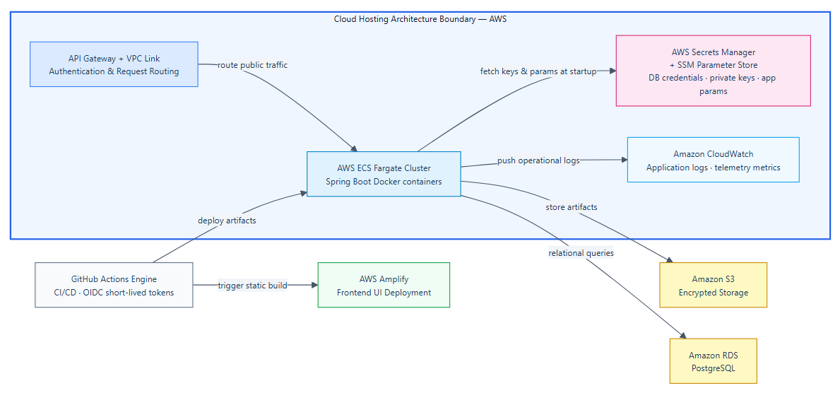
Figure 2.8: Infrastructure Services Component Diagram

2.4 External Dependencies
CareConnect relies on several external services and cloud platforms to provide authentication, AI capabilities, healthcare workflows, communication services, billing functionality, and operational infrastructure. These dependencies are integrated through service abstractions and configuration-driven provider selection mechanisms.

2.4.1 AWS Services
The CareConnect platform relies on several AWS-managed services to support application hosting, data storage, communication workflows, artificial intelligence capabilities, security, and operational monitoring. These services provide the cloud-native foundation required to support scalable deployment, secure processing of healthcare-related information, and reliable day-to-day platform operations. Table 3 summarizes the primary AWS services used within the system architecture.
Table 3
AWS Services
Service | Purpose
Amazon ECS Fargate | Backend container hosting
Amazon RDS PostgreSQL | Relational database hosting
Amazon S3 | Storage of recordings and related assets
Amazon Bedrock | AI summarization and sentiment analysis
Amazon Chime SDK | Video communication services
Amazon Transcribe | Speech-to-text processing
AWS Secrets Manager | Secure secret storage
AWS Systems Manager Parameter Store | Runtime configuration management
Amazon CloudWatch | Logging and monitoring
Amazon ECR | Container image storage

2.4.2 Authentication and Identity Providers
Authentication services are used to establish user identity and provide secure access to platform resources. These providers support user sign-in workflows while reducing the need to manage authentication credentials directly within the application. One of the authentication and identity providers is Google OAuth which is used for federated user authentication.

2.4.3 AI Providers
The platform utilizes a provider-based architecture that supports multiple AI services through a common integration layer. This approach enables flexibility in model selection, reduces vendor lock-in, and supports future expansion as AI capabilities evolve. Table 2.3 summarizes the AI providers referenced within the current architecture.
Table 2.2
AI Providers
Provider | Purpose
Amazon Bedrock | AI summarization and sentiment workflows
DeepSeek | Alternate AI provider integration
OpenRouter | Provider routing and model access

2.4.4 Billing and Healthcare Integrations
Several external services are integrated to support subscription management, payment processing, and healthcare-related data collection. These integrations allow the platform to leverage established third-party services while focusing development efforts on core CareConnect functionality. Table 2.3 summarizes the planned billing and healthcare integrations.
Table 2.3
Billing and Healthcare Integrations
Provider | Purpose
Stripe | Subscription and payment processing
Apple Billing Services | iOS subscription management
Google Play Billing | Android subscription management
Fitbit API | Wearable health data integration

2.4.5 Communication Services
Communication services support user engagement, notifications, and real-time collaboration throughout the platform. These services enable messaging, event notifications, and live communication capabilities that are critical to care coordination workflows. Table 2.4 identifies the primary communication services utilized by the system.

Table 2.4
Communication Services
Provider | Purpose
SendGrid | Email notification delivery
WebSocket Services | Real-time application communication

2.5 Workflows
The primary Team D workflows follow a common backend pattern: a user action triggers a protected API call, the controller validates input and user access, the service layer applies business rules, data is persisted or updated, and any external provider interaction is routed through a controlled adapter boundary. The same structural pattern is reused for EVV lifecycle changes, invoice extraction and review, invite acceptance, wearable synchronization, and document or assessment status changes.
Step | Action | System Response
1 | User initiates a protected workflow such as EVV update, invoice upload, invite acceptance, or assessment save | Flutter UI invokes the appropriate Team D API over HTTPS
2 | Authentication and role validation occur | Only authorized users proceed to controller handling; invalid or unauthorized requests are rejected early
3 | Controller layer validates request structure and forwards work to the appropriate service | Malformed input is rejected and safe error feedback is returned
4 | Service layer applies workflow rules and persistence operations | Domain state is updated in PostgreSQL and any file metadata or audit details are recorded
5 | Optional external-service processing occurs behind a provider boundary | Bedrock, OCR, EVV, or wearable interactions use mock, sandbox, or approved non-production paths
6 | Status, review state, or preview output is returned to the client | User sees success state, review queue, corrected data, or controlled failure message
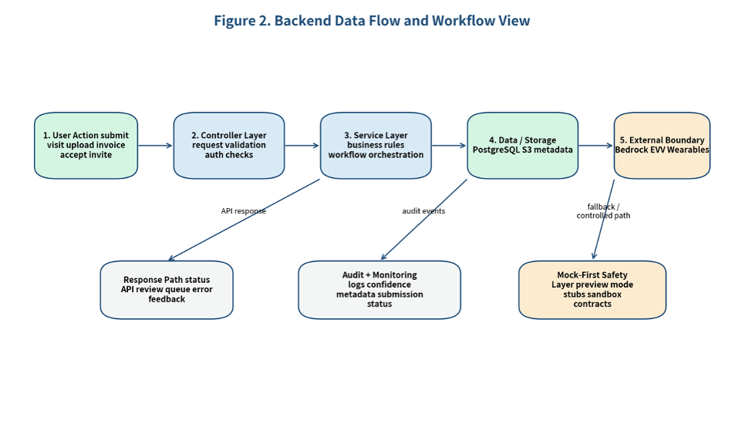
Figure 2.5 Team D backend data flow and workflow view.

In order to better visualize the way a user would use the app and the app would respond, the following workflow diagrams have been created. The first diagram below is the high level workflow diagram (Figure 2.9). The activities would include video calls, messages, and dashboard; optional paths include Bedrock summaries, Transcribe/sentiment, and platform telemetry.

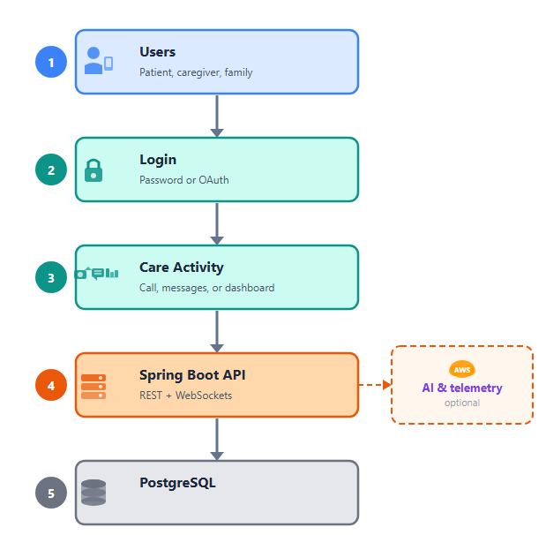
Figure 2.9: High level workflow diagram

2.5.1 Login and Authentication
The Login and Authentication process serves as the foundational security gateway for the CareConnect platform, ensuring that only verified users can access sensitive care activities, dashboards, and communication features. Figure 2.10 illustrates this.
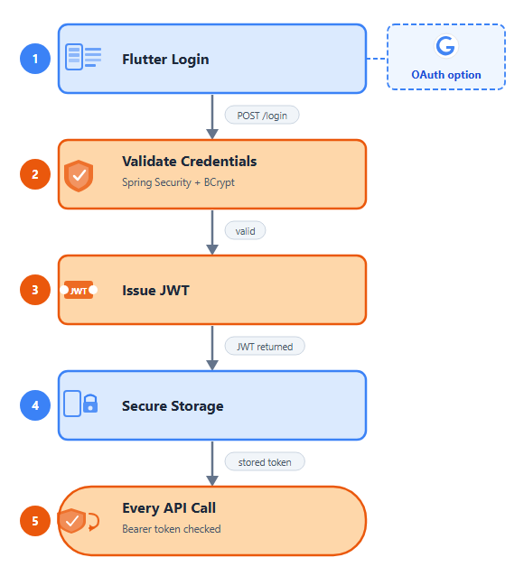
Figure 2.10: Login and Authentication workflow diagram

2.5.2 Video Calls and Post-Call Pipeline
The Video Calls and Post-Call Pipeline workflow shown in Figure 2.11 orchestrates the end-to-end journey of a clinical interaction, spanning from the initial join event through real-time audio/video processing to the automated generation of post-encounter insights.

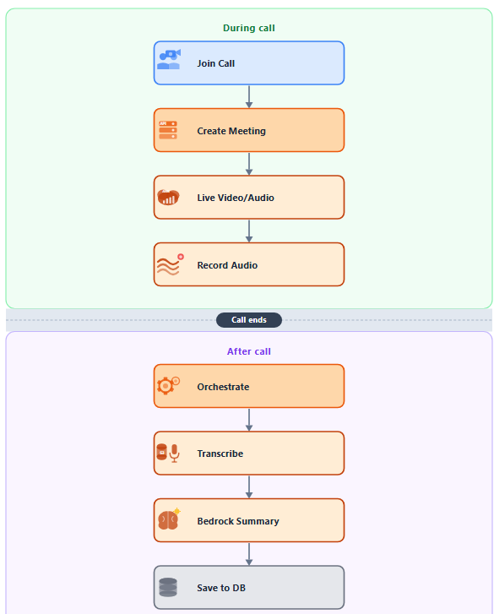
Figure 2.11: Video Calls and Post-Call Pipeline Workflow Diagram

2.5.3 Grant / Revoke and Enforcement
The Grant / Revoke and Enforcement workflow is shown in Figure 2.12 and defines the mechanism for managing dynamic access permissions within the CareConnect platform, ensuring that every data request is validated against established roles before access is granted or denied.

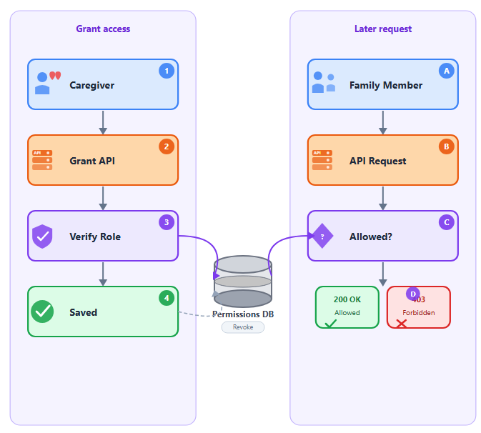
Figure 2.12: 2.5.3 Grant / Revoke and Enforcement Workflow diagram

2.3.4 Deployment to AWS
The Deployment to AWS architecture establishes a robust, automated CI/CD pipeline designed to ensure consistent, secure, and repeatable delivery of the CareConnect platform services into the cloud infrastructure.

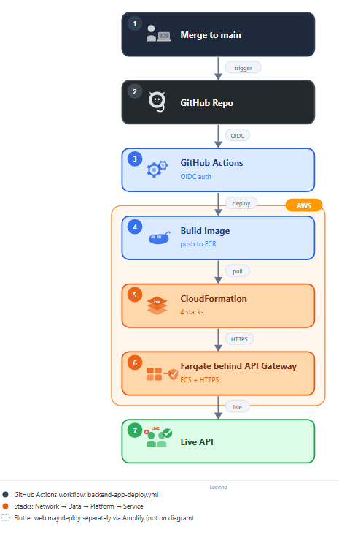
Figure 2.13: Deployment to AWS Workflow Diagram

2.6 System Users
Care recipients use Ask AI, review call and visit summaries, and monitor incoming mail with short-term-memory-first interaction patterns and accessibility constraints. Caregivers may use Ask AI and review summaries only for assigned patients under consent-scoped, default view-only access. Family members receive limited read-only visibility into selected information; RBAC continues to block restricted clinical detail.

User Type | Relevant Needs | Design Impact
Caregiver | Performs health visit; submits EVV check-in/check-out | EVV gap closure; wearable sync consent; invite receipt; assessment and screening submission
Patient/Client | Receives home care services; may share wearable biometric data | Wearable metrics target; screening and assessment subject
Supervisor | Manages caregiver assignments; reviews EVV records and assessments | EVV aggregator dashboard; invoice review; assessment read access
Billing Specialist | Processes invoices; reviews Bedrock-extracted field data | Invoice extraction workbench; field correction; approval workflow
Administrator | Full platform access; manages users, invites, and system configuration | Invite generation and revocation; aggregator configuration; document digitization approval
New Hire Coordinator | Onboards new caregivers; collects I-9, W-4, and Direct Deposit forms | Home care document digitization design; screening intake workflow
Human Reviewer / Clinician | Reviews high-risk (Tier 2) AI output held for HITL. | Requires a review/release queue and clear escalation ownership.
System Administrator | Configures roles, data-source indexing, retention, and AI access settings. | Requires externalized configuration and auditable admin actions.
Developer / Tester | Builds and validates Ask AI, summaries, USPS, STML, and safety work. | Needs clear APIs, data models, and testable behavior contracts.

3. Technology Stack
CareConnect is built on a cross-platform architecture combining a Spring Boot backend, a Flutter frontend, a PostgreSQL relational database, and a suite of AWS managed services. The stack was established by the prior cohort and inherited by the team. The team’s scope is to extend and harden this stack per the approved WBS rather than to replace or re-platform it.

Table 2.5
Technology stack
Layer | Technology / Service | Working version
Backend Framework | Spring Boot (Java) — REST API, business logic, Spring Security filter chain, WebSocket handlers | Spring Boot 3.4.5; Java 17 (pom.xml); OpenJDK Temurin 17.0.19 verified locally; embedded Tomcat 10.1.40; Hibernate ORM 6.6.13 (Boot-managed)
Frontend Framework | Flutter / Dart — cross-platform mobile and web client | Flutter 3.35.3 stable (.metadata revision a402d9a…, Dart 3.9.2 bundled); README minimum ≥3.8.1; also runs on Flutter 3.38.7 / Dart 3.10.7 (verified locally, not repo-pinned)
Database | PostgreSQL — RDS in deployed environments; Docker for local dev | Deployed: PostgreSQL 17.6 RDS (02-data.yaml); local: pgvector/pgvector:pg15 (Postgres 15 + pgvector) on port 5433 per programmer guide; JDBC driver 42.7.5
Schema Migrations | Flyway — versioned SQL migrations at application startup | 10.20.1 (flyway-core, Maven plugin); disabled in dev (spring.flyway.enabled=false)
Authentication | Spring Security + stateless JWT (HS256), BCrypt, OAuth2 | Spring Security 6.4.5; JJWT 0.11.5; spring-boot-starter-oauth2-client 3.4.5
AI / LLM | AWS Bedrock — summarization, SOAP notes, risk stratification, voice detection | AWS SDK bedrockruntime 2.31.75; dev model amazon.nova-lite-v1:0; sentiment default amazon.nova-pro-v1:0; LangChain4j 1.1.0; TDD still lists Claude 3.5 Sonnet as planned
Video Conferencing | Amazon Chime SDK for Meetings — WebRTC video/audio lifecycle | AWS SDK chimesdkmeetings 2.31.75, chimesdkmediapipelines 2.31.75; web client amazon-chime-sdk-js 3.26.0
Audio Capture | Amazon Kinesis Video Streams (KVS) — per-attendee audio from Chime | Not wired in repo yet (no KVS SDK dependency or backend usage found); TDD target service
Transcription | Amazon Transcribe — async per-attendee jobs, merged speaker labels | AWS SDK transcribe 2.31.75
File / Object Storage | Amazon S3 + KMS — recordings, audio, transcription JSON, documents; local files in dev | AWS SDK s3 2.31.75, s3-transfer-manager 2.31.75; dev uses local storage (app.file.storage.use-s3=false)
Container Hosting | AWS ECS Fargate — Spring Boot backend containers | CloudFormation 03-platform.yaml / 04-service.yaml; default task 1024 CPU / 3072 MiB; container port 8081; Fargate platform version not pinned
Frontend Hosting | AWS Amplify — Flutter web build + hosting from GitHub | Not configured in this repo (no amplify.yml); referenced in project docs only
Infrastructure as Code | AWS CloudFormation — layered stacks | Templates 01-network.yaml … 04-service.yaml under cloudformation-fargate/
CI/CD | GitHub Actions — build, test, deploy via OIDC | actions/checkout@v4, setup-java@v4, upload-artifact@v4, cache@v4; deploy workflows Java 17; build-and-analyze.yml Java 21 + unpinned snap install flutter
Secrets Management | AWS Secrets Manager + SSM Parameter Store | AWS SDK ssm 2.31.75; runtime retrieval by ECS task role
Local Development DB | Docker / Docker Compose — Postgres for local dev | Compose format 3.5 (pg_docker/docker-compose.yml); image pgvector/pgvector:pg15 on 5432; programmer guide container cc_pg_5433 on 5433; pgAdmin dpage/pgadmin4 (unpinned latest)
Backend Testing | JUnit 5, Mockito, AssertJ, @SpringBootTest, H2; JaCoCo; Checkstyle / SpotBugs / PMD / OWASP | JUnit 5.11.4; Mockito 5.21.0; AssertJ 3.26.3; H2 2.3.232; JaCoCo 0.8.12; Checkstyle 10.14.2 (plugin 3.3.1); SpotBugs 4.8.3.1; PMD 3.21.2; OWASP dependency-check 9.0.10
Frontend Testing | flutter_test, mockito, MockClient; integration_test + flutter drive E2E | mockito 5.6.4; http 1.6.0 (for MockClient); dio 5.9.2; integration_test from Flutter SDK
Token Storage (Client) | flutter_secure_storage — secure JWT storage on device | 9.2.4 (pubspec.lock)
API Documentation | springdoc OpenAPI UI | 2.7.0
AWS SDK (shared) | BOM for all AWS service clients above | 2.31.75 (aws.sdk.version in pom.xml)

3.1 Technology Decisions and Assumptions
Ask AI and summary enrichment assume AWS Bedrock for chat, structured summary support, and Titan embeddings; Aurora PostgreSQL with the pgvector extension and full-text search for hybrid retrieval; a Spring Boot IndexWorker consuming the indexing_outbox for SUMMARY_CREATED and TRANSCRIPT_INDEXED events; and Flutter clients for patient and caregiver Ask AI surfaces.
Decision or Assumption | Rationale | Impact
Reuse the shared Spring Boot architecture | The existing repository already contains controller, service, and integration patterns relevant to Team D scope | Reduces duplication and keeps backend implementation consistent with the rest of CareConnect
Keep provider logic behind adapters or clients | External providers such as Bedrock, EVV aggregators, and wearable APIs may change independently of domain logic | Allows contract updates without redesigning the core service layer
Use human-reviewed AI output only | Invoice extraction is informational support and must be validated by a user before final acceptance | Improves safety, auditability, and trust in extracted data
Adopt mock-first integration for unresolved dependencies | Several live integrations depend on credentials, route ownership, governance decisions, or sandbox availability | Allows development and testing progress without enabling unsupported production calls
Use relational persistence for workflow state and metadata | Visits, draft records, tokens, and approval states require consistent transactions and queryable relationships | Supports traceability and repeatable state management
Store large files outside relational core tables | Uploaded invoices and similar artifacts are more efficiently managed in object storage | Reduces database bloat and simplifies file lifecycle handling
Rely on Team A for base CI/CD and shared RBAC ownership | The project plan and pre-code summary assign core deployment pipeline and RBAC framework ownership outside Team D | Team D focuses on feature-complete artifacts that integrate cleanly into shared infrastructure
Avoid new assessment or home-care migrations until approved | Readiness artifacts identify Flyway and migration-numbering constraints | Prevents schema conflicts and keeps milestone work inside approved database scope
Access the LLM through an abstraction layer. | Provider choice and BAA access remain environment-dependent. | Provider can change without reworking Ask AI or summary clients.
Records-grounded RAG with schema-validated output. | Prevents unsupported medical content and enables provenance. | Every answer is cited or flagged; output stays records-bounded.
Hybrid retrieval (SQL + full-text + pgvector). | Supports both precise and conversational questions. | Higher recall; semantic matches remain likelihood-ranked, not exact.
Metadata-first USPS extraction, OCR as fallback. | USPS has no public Informed Delivery API for full image capture. | Mail records populate from metadata even when images are absent.

3.2 Technology Risks
Material risks for the AI retrieval path include Bedrock throttle and embedding latency, temporary NULL embedding vectors until backfill completes, hybrid-search cost under wide patient corpora, outbox lease parking while visit-summary indexing remains deferred, and Amplify CORS drift after app-only backend redeploys.
Risk | Impact | Mitigation
EVV aggregator target or credential delay | Live EVV submission may remain unavailable, limiting validation to payload preview or mock submission | Maintain a preview-only or mock-first EVV boundary and validate internal lifecycle correctness first
Bedrock / IAM provisioning delay | Provider-backed invoice extraction could be blocked even if internal review workflow is complete | Use controlled mock extraction responses that preserve the final contract shape
Wearable provider sandbox or rate-limit issues | Live wearable sync validation may be incomplete or unstable | Use adapter isolation, sample payload replay, and graceful degradation behavior
Migration and Flyway conflicts | Unapproved schema work could break shared environments or create merge conflicts | Constrain implementation to approved schema paths and document deferred migration work
RBAC or route ownership changes | Authorization behavior could drift across teams and invalidate endpoint assumptions | Coordinate with shared route ownership and role matrices before final integration
Improper AI or sensitive-data handling | Uploading protected data or trusting AI outputs without review could create security and compliance risk | Use sanitized test data, human review, and protected-route enforcement
Bedrock / LLM access delayed. | Blocks summary generation and Ask AI answers. | Build against a swappable LLM interface; confirm account access early.
LLM produces inaccurate or hallucinated content. | Unsafe or misleading medical-adjacent output. | Require citations; flag low confidence; apply secondary validation / HITL.
OCR accuracy insufficient for envelope images. | Missed or wrong mail extraction. | Confidence scoring; route low-confidence pieces to manual review.
Index refresh lag after transcript or summary save. | Stale Ask AI answers. | Async IndexWorker with lease covering embedding latency.

4. Database and Data Model Design
Chapter 4 documents the PostgreSQL data model: domain organization, design principles, entity relationships, schema details, and data retention/privacy strategy. It is the persistence reference for services and APIs described in Chapters 5 through 8.

4.1 Overview
Section 4.1 introduces database architecture, functional data domains, design principles, and the scope of existing versus planned Team A schema changes. Subsections 4.1.1 through 4.1.4 provide the conceptual foundation before the ERD and table-level specifications that follow.

4.1.1 Database Architecture
CareConnect utilizes PostgreSQL as its primary relational database management system for storing operational, communication, analytics, and healthcare-related data. The database serves as the system of record for user identities, patient and caregiver relationships, communication history, AI-generated insights, telemetry events, and application configuration. The architecture follows a normalized relational model that emphasizes data integrity, referential consistency, scalability, and support for future feature expansion.
The application accesses database resources through Spring Data JPA repositories, which provide abstraction between business services and the persistence layer. This design enables backend services to perform CRUD operations, transactional workflows, and complex query operations while maintaining separation of concerns between application logic and data storage.

4.1.2 Data Domain Organization
The CareConnect platform manages a diverse set of information ranging from user identities and care relationships to communication records, analytics data, and AI-generated insights. As the system continues to evolve, organizing data into clearly defined functional domains helps improve maintainability, simplifies feature development, and reduces coupling between unrelated areas of the application. This domain-driven approach also supports future enhancements by allowing related entities and services to be grouped around common business responsibilities.
To improve maintainability and support future enhancements, the CareConnect data model is organized into several functional domains:

Identity and Access Management
- User accounts
- Authentication artifacts
- Role and permission assignments
- Session and security-related records
Patient and Care Circle Management
- Patient profiles
- Caregiver profiles
- Family member relationships
- Care coordination records
Communication and Collaboration
- Chat conversations and messages
- Video call records
- Call participant information
- Call transcripts and recordings
Analytics and AI Processing
- Telemetry events
- Call sentiment results
- AI-generated summaries
- Risk assessments
- Condition detection results
Billing and Administrative Functions
- Invoices
- Subscription records
- Payment tracking
- Administrative reporting data
This domain-driven organization allows related entities to remain logically grouped while supporting independent development and maintenance of application features.

4.1.3 Design Principles
The CareConnect database serves as the foundation for storing operational, communication, healthcare, analytics, and AI-related data throughout the platform. To ensure the data model remains scalable, secure, and maintainable, several design principles were established during the database design process. These principles guided decisions related to schema organization, data integrity, performance considerations, and future extensibility.
The database design was developed according to the following principles:
- Maintain strong referential integrity through primary and foreign key relationships.
- Minimize data duplication through normalized table structures.
- Support efficient retrieval of patient, caregiver, and communication records.
- Enable scalable storage of telemetry and AI-generated data.
- Support future enhancements such as speaker identification, condition detection, and advanced analytics.
- Protect sensitive healthcare information through secure storage practices and privacy-aware data handling.
- Facilitate integration with AWS services including Bedrock, Chime, Transcribe, and analytics workflows.

4.1.4 Database Scope
The database supports both existing platform capabilities and planned Team A enhancements. Existing functionality includes user management, care coordination, messaging, video calls, transcript processing, analytics collection, and AI-assisted summarization. Planned enhancements introduce additional data structures to support attendee-level transcription, risk stratification, condition detection, expanded telemetry reporting, and enhanced role-based access control workflows.
Figure 4.1 illustrates the primary entity relationships and data domains that comprise the CareConnect persistence layer.

4.2 Entity-Relationship Diagram
The CareConnect data model is organized around several core business domains that support user management, care coordination, communication, analytics, and AI-assisted healthcare workflows. The entity relationship model was designed to maintain referential integrity while supporting the platform's existing capabilities and planned Team A enhancements. Figure 4.1 presents the primary entities and relationships within the system.
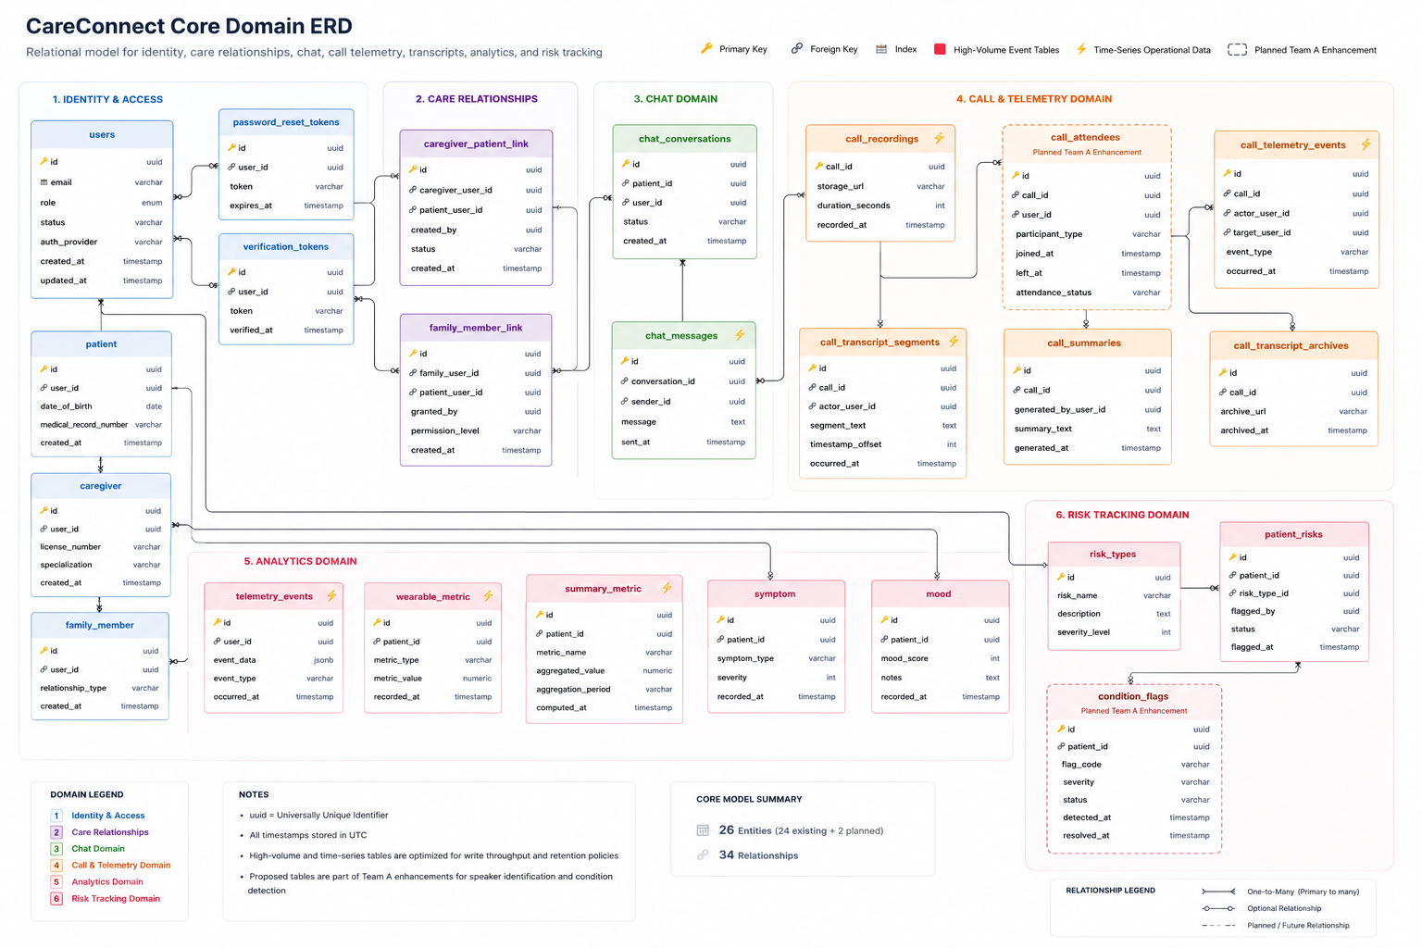
Figure 4.1: CareConnect Core Domain Entity Relationship Diagram

The diagram illustrates the logical relationships between users, patients, caregivers, family members, communication artifacts, analytics data, and risk assessment records. To improve readability, the diagram focuses on the core operational entities and excludes lower-level supporting tables that do not significantly contribute to understanding the overall system design.

4.2.1 Identity and Access Domain
The Identity and Access domain provides the foundation for authentication, authorization, and account management throughout the platform. The users table serves as the central identity entity and is referenced by patient, caregiver, and family member profiles. Supporting entities such as password_reset_tokens and verification_tokens facilitate account recovery and identity verification workflows.
This domain enables secure user authentication while maintaining separation between user credentials and role-specific profile information. The design supports multiple user types and future expansion of role-based access control capabilities.

4.2.2 Care Relationship Domain
The Care Relationship domain models the relationships between patients, caregivers, and family members. The caregiver_patient_link and family_member_link tables establish many-to-many associations that allow a patient to be connected to multiple caregivers and family members while preserving relationship-specific permissions and access controls.
This structure supports the CareConnect care-circle concept and provides the foundation for authorization decisions, communication workflows, and patient data sharing.

4.2.3 Communication Domain
The Communication domain supports messaging, video calling, transcription, and post-call processing. These entities collectively manage the storage and lifecycle of communication artifacts generated during user interactions. The domain serves as the foundation for collaboration features, transcript generation, sentiment analysis, and AI-assisted workflows.
Core entities include the following:
- chat_conversations
- chat_messages
- call_recordings
- call_transcript_segments
- call_summaries
- call_transcript_archives
- call_telemetry_events
These entities collectively support real-time communication, transcript generation, sentiment analysis, AI-assisted summarization, and long-term storage of communication artifacts. Relationships within this domain ensure that recordings, transcripts, summaries, and telemetry events remain associated with their originating calls.

4.2.4 Analytics Domain
The Analytics domain stores operational metrics, patient monitoring information, and aggregated reporting data. These entities support the collection, processing, and reporting of data used to evaluate platform performance, patient engagement, and healthcare-related trends. The domain is designed to accommodate both real-time event collection and historical analytics workloads.
Key entities include:
- telemetry_events
- wearable_metric
- summary_metric
- symptom
- mood
These entities support patient monitoring, trend analysis, dashboard reporting, and future administrative analytics functionality. The design accommodates both event-driven telemetry data and time-series healthcare metrics collected from users and connected devices.

4.2.5 Risk Tracking Domain
The Risk Tracking domain supports identification, classification, and monitoring of patient risks. The patient_risks entity maintains patient-specific risk records while risk_types provides standardized risk classifications and severity definitions.
This domain supports both manually identified risks and AI-assisted risk assessment workflows, enabling future expansion of automated clinical insight generation and proactive care interventions.

4.2.6 Planned Team A Enhancements
The ERD includes two proposed entities that support Team A functionality planned for future milestones:

call_attendees
The call_attendees table will provide attendee-level participation tracking for video calls. This enhancement supports speaker identification, per-attendee transcription, participation analytics, and improved call telemetry. Each attendee record will be associated with a specific call and user account while tracking join and leave events.

condition_flags
The condition_flags table will support AI-assisted condition detection workflows. Records will store identified conditions, severity levels, detection timestamps, and resolution status. This structure enables integration with Bedrock-powered analysis services and future risk stratification capabilities.

4.2.7 Design Considerations
The entity relationship model was designed to balance maintainability, scalability, performance, and security requirements while supporting both current platform functionality and future enhancements. Particular attention was given to supporting healthcare-related workflows, high-volume communication data, and AI-assisted processing capabilities. The following design considerations influenced the structure and organization of the data model.
Key design considerations include:
- Use of UUID-based primary keys to support distributed cloud deployments.
- Strong referential integrity through foreign key relationships.
- Separation of operational, communication, and analytics data domains.
- Support for scalable storage of telemetry and transcript data.
- Accommodation of future AI-assisted workflows and analytics enhancements.
- Protection of sensitive healthcare information through controlled relationships and domain separation.
The resulting data model provides a flexible foundation capable of supporting current platform requirements while enabling future growth in communication, analytics, AI-assisted healthcare workflows, and care coordination features.

4.3 Table Definitions
The CareConnect database contains numerous entities supporting authentication, care coordination, communication, analytics, and AI-assisted healthcare workflows. This section summarizes the primary tables that form the core operational data model. Detailed column definitions and implementation-specific constraints are maintained within the application source code and database migration scripts.

4.3.1 User Management Tables
User management tables provide the foundation for authentication, authorization, profile management, and identity-related workflows throughout the platform. These entities establish the core user records referenced by nearly every functional area of the system and support role-based access control, account management, and care-circle relationships.

Table 4.1
Users
Attribute | Description
Purpose | Stores user identity and authentication information
Primary Key | id (UUID)
Key Attributes | email, role, status, auth_provider
Relationships | Referenced by patient, caregiver, family_member, chat_messages, call_attendees (proposed)

The users table serves as the central identity record for all platform participants and provides the foundation for authentication and authorization workflows.

Table 4.2
Patient
Attribute | Description
Purpose | Stores patient-specific profile information
Primary Key | id (UUID)
Foreign Key | user_id → users.id
Key Attributes | date_of_birth, medical_record_number
Relationships | Linked to caregivers, family members, telemetry, symptoms, moods, risks, and call data

The patient table contains healthcare-related profile information and acts as the primary parent entity for patient monitoring and care coordination workflows.

Table 4.3
Caregiver
Attribute | Description
Purpose | Stores caregiver profile information
Primary Key | id (UUID)
Foreign Key | user_id → users.id
Key Attributes | license_number, specialization
Relationships | Connected to patients through caregiver_patient_link

The caregiver table stores provider-specific information required for care coordination and patient support activities.

4.3.2 Care Relationship Tables
CareConnect utilizes relationship tables to model the connections between patients, caregivers, and family members. These entities support the platform's care-circle concept by enabling controlled access to patient information while maintaining relationship-specific permissions and governance rules.

Table 4.4
The caregiver_patient_link
Attribute | Description
Purpose | Associates caregivers with patients
Primary Key | id (UUID)
Foreign Keys | caregiver_user_id, patient_user_id
Key Attributes | status, created_by
Relationships | Connects caregiver and patient entities

This table supports many-to-many relationships between patients and caregivers while maintaining relationship-specific metadata and access controls.

Table 4.5
The family_member_link
Attribute | Description
Purpose | Associates family members with patients
Primary Key | id (UUID)
Foreign Keys | family_user_id, patient_user_id
Key Attributes | permission_level, granted_by
Relationships | Connects family members and patients

This table enables controlled family participation in patient care activities while preserving role-specific permissions.

4.3.3 Communication Tables
Communication tables store information generated through messaging, video calls, transcription workflows, and AI-assisted communication processing. These entities form the backbone of the platform's collaboration features and provide the data required for sentiment analysis, summarization, and future condition detection capabilities.

Table 4.6
The call_recordings
Attribute | Description
Purpose | Stores metadata for recorded video calls
Primary Key | call_id (UUID)
Key Attributes | storage_url, duration_seconds, recorded_at
Relationships | Parent entity for transcripts, summaries, telemetry, and attendee records

The call_recordings table serves as the central communication artifact for post-call analytics and AI processing workflows.

Table 4.7
The call_transcript_segments
Attribute | Description
Purpose | Stores individual transcript segments
Primary Key | id (UUID)
Foreign Key | call_id → call_recordings.call_id
Key Attributes | actor_user_id, segment_text, timestamp_offset
Relationships | Associated with call recordings and AI workflows

Transcript segments provide the source data used for summarization, sentiment analysis, speaker identification, and condition detection.

Table 4.8
The call_summaries
Attribute | Description
Purpose | Stores AI-generated call summaries
Primary Key | id (UUID)
Foreign Key | call_id → call_recordings.call_id
Key Attributes | summary_text, generated_by_user_id
Relationships | Linked to communication and analytics workflows

The call_summaries table stores post-call summaries generated through AI-assisted processing pipelines.

4.3.4 Analytics and Risk Tables
Analytics and risk management tables support monitoring, reporting, patient assessment, and AI-driven healthcare insights. These entities enable the platform to collect operational telemetry while supporting future analytics, risk stratification, and condition-monitoring workflows.

Table 4.9
The telemetry_events
Attribute | Description
Purpose | Stores application telemetry and usage events
Primary Key | id (UUID)
Foreign Key | user_id → users.id
Key Attributes | event_type, event_data, occurred_at
Relationships | Supports analytics and reporting services

This table captures operational metrics and user activity data used for analytics and platform monitoring.

Table 4.10
The patient_risks
Attribute | Description
Purpose | Stores patient-specific risk records
Primary Key | id (UUID)
Foreign Keys | patient_id, risk_type_id
Key Attributes | status, flagged_by, flagged_at
Relationships | Linked to patient and risk classification entities

The patient_risks table supports risk assessment workflows and future AI-assisted condition monitoring capabilities.

4.3.5 Proposed Team A Tables
The following proposed entities support Team A enhancements planned for future milestones. These additions expand the platform's ability to perform attendee-level call analysis and AI-assisted healthcare monitoring while maintaining compatibility with the existing data model.

Table 4.11
The call_attendees proposed entity
Attribute | Description
Purpose | Tracks attendee participation in calls
Primary Key | id (UUID)
Foreign Keys | call_id, user_id
Key Attributes | participant_type, joined_at, left_at, attendance_status
Relationships | Linked to users and call recordings

This proposed table supports speaker identification, attendee-level transcription, and enhanced call analytics.

Table 4.12
The condition_flags proposed entity
Attribute | Description
Purpose | Stores AI-detected health condition indicators
Primary Key | id (UUID)
Foreign Key | patient_id
Key Attributes | flag_code, severity, status, detected_at, resolved_at
Relationships | Linked to patient monitoring and risk workflows

This proposed table supports future Bedrock-powered condition detection and risk stratification features.

4.4 New Tables and Migrations
The current CareConnect data model provides the foundation for communication, analytics, and patient monitoring workflows. However, several planned Team A enhancements require additional database entities to support speaker identification, attendee-level transcription, AI-assisted condition detection, and expanded role-based access control functionality. This section describes the proposed schema additions and migration strategy for implementing these enhancements.

4.4.1 Design Objectives
The proposed database changes are intended to support several upcoming Team A enhancements while preserving compatibility with existing platform functionality. These objectives focus on expanding AI-assisted workflows, participant-level communication analysis, and future healthcare monitoring capabilities without introducing unnecessary disruption to the current schema.
The proposed database changes are intended to support the following objectives:
- Enable attendee-level participation tracking during video calls.
- Support future speaker identification and per-attendee transcription workflows.
- Store AI-generated condition detection results and risk indicators.
- Maintain compatibility with existing communication and analytics workflows.
- Minimize disruption to existing production data structures.
- Support future expansion of AI-assisted healthcare monitoring capabilities.
All proposed schema changes will be implemented through version-controlled database migrations to ensure consistent deployment across development, testing, and production environments.

4.4.2 call_attendees Table
The call_attendees table is proposed to support enhanced video call analytics and transcription capabilities. Existing call data is currently associated primarily with recordings and transcript segments. The addition of attendee-level tracking will provide visibility into individual participant activity and enable future speaker identification workflows.

Table 4.13
The call_attendees table
Column | Type | Description
id | UUID | Unique attendee record identifier
call_id | UUID | Associated call recording
user_id | UUID | Associated platform user
participant_type | VARCHAR | Patient, caregiver, family member, provider, etc.
joined_at | TIMESTAMP | Call join timestamp
left_at | TIMESTAMP | Call departure timestamp
attendance_status | VARCHAR | Completed, disconnected, declined

Relationships
- call_id → call_recordings.call_id
- user_id → users.id
Business Purpose
The table enables:
- Participant-level attendance tracking.
- Speaker attribution support.
- Per-attendee transcription processing.
- Call participation analytics.
- Future sentiment analysis by participant.
Migration Considerations
The table can be introduced independently without modifying existing communication entities. Existing call records remain unaffected, allowing a backward-compatible rollout.

4.4.3 condition_flags Table
The condition_flags table is proposed to support AI-assisted healthcare monitoring and condition detection workflows. Future Bedrock-powered analytics services may identify potential health concerns, behavioral indicators, or elevated risk conditions based on transcripts, sentiment analysis, wearable metrics, and symptom reporting.

Table 4.14
The condition_flags table
Column | Type | Description
id | UUID | Unique condition flag identifier
patient_id | UUID | Associated patient
flag_code | VARCHAR | Standardized condition identifier
severity | VARCHAR | Low, Medium, High, Critical
status | VARCHAR | Active, Resolved, Dismissed
detected_at | TIMESTAMP | Detection timestamp
resolved_at | TIMESTAMP | Resolution timestamp

Relationships
- patient_id → patient.id
Business Purpose
The table enables:
- AI-generated condition tracking.
- Risk stratification workflows.
- Caregiver review and follow-up activities.
- Longitudinal monitoring of patient conditions.
- Future clinical decision-support capabilities.
Migration Considerations
The table is designed as an additive enhancement and does not require modification of existing risk management entities. It complements the current patient_risks and risk_types tables while supporting more advanced AI-assisted workflows.

4.4.4 Future RBAC Enhancements
The current system contains role and permission management functionality; however, future RBAC enhancements may require additional database structures to support more granular authorization controls and delegated access management.
Potential future entities include:
- roles
- permissions
- role_permissions
- user_roles
These additions would support expanded administrative capabilities, delegated permissions, and fine-grained access management. Detailed implementation design is provided in Section 6.1 Role-Based Access Control Design.

4.4.5 Migration Strategy
Database changes will be implemented using the project's existing migration framework to ensure repeatable and auditable schema updates. Each migration will be version-controlled and deployed through the standard CI/CD pipeline.
The migration strategy follows the principle of additive, backward-compatible changes:
- Create new tables and indexes.
- Establish foreign key relationships.
- Deploy application code that utilizes the new entities.
- Validate data integrity and application behavior.
- Enable feature-specific functionality through configuration or feature flags where appropriate.
This approach minimizes deployment risk and allows new functionality to be introduced incrementally without disrupting existing user workflows.

4.4.6 Impact Assessment
The proposed schema additions have minimal impact on existing platform functionality because they introduce new entities rather than modifying heavily utilized operational tables. Existing communication, analytics, and patient management workflows remain unchanged while gaining the ability to leverage new AI-driven and participant-level capabilities.
These enhancements provide the persistence-layer foundation required for Team A deliverables related to speaker identification, attendee-aware transcription, condition detection, risk stratification, and advanced analytics.

4.5 Data Retention and PII Handling
CareConnect processes sensitive user information, healthcare-related records, communication artifacts, analytics data, and AI-generated insights. As a healthcare-focused platform, the system incorporates multiple security and privacy controls designed to protect personally identifiable information (PII), healthcare-related data, authentication credentials, and communication records. This section describes the mechanisms used to secure data throughout its lifecycle and the considerations applied to retention, anonymization, and AI-assisted processing workflows.

4.5.1 Data Classification
By establishing clear boundaries between distinct data types, the system can dynamically enforce appropriate encryption, access controls, and retention policies tailored to each tier. The platform manages several categories of information with varying security and privacy requirements.
Personally Identifiable Information (PII)
Personally identifiable information is collected to support user account management, communication workflows, and care coordination activities. This information is restricted to authorized users and protected through authentication, authorization, and secure storage controls.
Examples include:
- Names
- Email addresses
- User account identifiers
- Authentication credentials
- Contact information
- Family relationship information

Protected Health Information (PHI)
Protected health information is associated with patient care, health monitoring, and healthcare-related communication. Because this information may contain sensitive medical details, additional privacy protections and anonymization controls are applied where appropriate.
Examples include:
- Patient profiles
- Symptoms and mood tracking data
- Risk assessments
- Call transcripts
- AI-generated clinical summaries
- Healthcare-related communication records

Operational and Analytics Data
Operational and analytics data supports monitoring, reporting, troubleshooting, and performance optimization activities. While generally less sensitive than PII or PHI, access to this information remains subject to security and governance controls.
Examples include:
- Telemetry events
- Application usage metrics
- Call participation data
- Performance monitoring records
- System logs
Each category is subject to different access controls, retention policies, and privacy protections based on business and regulatory requirements.

4.5.2 Data Protection Controls
The CareConnect platform incorporates multiple technical safeguards to protect sensitive information. These mechanisms form a layered defense strategy designed to mitigate security risks, prevent unauthorized access, and maintain data integrity across all operational environments.
Authentication and Credential Protection
User credentials are protected through secure password hashing using BCrypt. Authentication is performed using JWT-based security mechanisms that validate user identity and authorization before access is granted to protected resources.
Secret Management
Sensitive application secrets are not stored directly within application source code. Production environments utilize:
- AWS Secrets Manager
- AWS Systems Manager Parameter Store
These services provide secure storage and controlled access to credentials, API keys, database passwords, and JWT signing secrets.
Encryption
The platform utilizes multiple encryption mechanisms including:
- AES-GCM token encryption for sensitive token data.
- Hashed token storage for password reset workflows.
- Encrypted Amazon RDS storage volumes.
- Secure transport mechanisms for authenticated API communication.
These controls reduce the risk of unauthorized disclosure of sensitive information.

4.5.3 PHI Protection and Anonymization
To support privacy-conscious healthcare workflows, the platform includes dedicated services for protecting healthcare-related information. These capabilities ensure that patient data remains rigorously defended at every stage of processing, enabling seamless integration with external services without compromising regulatory compliance or consumer trust.
Medical Data Anonymization
The MedicalDataAnonymizer service provides multiple levels of anonymization and masking for sensitive healthcare information. This functionality allows patient-specific information to be processed while reducing unnecessary exposure of identifiable data.
Privacy-Aware AI Processing
The PrivacyAwareMedicalContextService generates anonymized context for AI-assisted workflows. Before healthcare information is submitted to AI providers, identifiable information may be removed, masked, or pseudonymized depending on the processing requirements.
This design supports future AI-assisted features while minimizing unnecessary disclosure of patient information.
Telemetry Privacy Controls
The platform includes telemetry controls that allow collection and reporting functionality to be enabled or disabled as required. This capability supports privacy-conscious operation and limits unnecessary collection of user activity data.

4.5.4 Data Retention Strategy
CareConnect maintains data only as long as necessary to support platform functionality, user requirements, operational analytics, and applicable legal obligations. This strategy balances historical data utility for clinical insights with proactive data-minimization practices to lower the platform's overall compliance footprint and security exposure.
Communication Records
Communication-related artifacts may include:
- Chat messages
- Call recordings
- Transcript segments
- Call summaries
- Telemetry events
These records support care coordination, analytics, auditing, and AI-assisted processing workflows. Historical communication records may be archived while maintaining relationships to their originating calls and users.
Healthcare Data
Patient-related healthcare information is retained to support:
- Ongoing care coordination
- Historical trend analysis
- Risk monitoring
- Analytics and reporting
- Future AI-assisted healthcare workflows
Retention policies may vary depending on business requirements and applicable regulations.
Account Lifecycle Management
The platform includes account deletion and deactivation workflows that support removal of user access while preserving records required for auditing, legal obligations, or operational continuity. These workflows are documented separately within the system's privacy and account management policies.

4.5.5 AI and Analytics Data Handling
AI-assisted workflows introduce additional privacy considerations because healthcare information may be processed for summarization, sentiment analysis, risk assessment, and condition detection.
The platform addresses these concerns through:
- Input sanitization prior to AI processing.
- Response sanitization before presentation to users.
- Privacy-aware context generation.
- Controlled access to AI-generated outputs.
- Audit and monitoring capabilities for AI-related services.
Future enhancements, including condition detection and risk stratification workflows, will continue to utilize anonymization and privacy-aware processing patterns to minimize unnecessary exposure of sensitive information.

4.5.6 Compliance and Security Considerations
The platform incorporates multiple technical, administrative, and infrastructure-level controls to protect sensitive information and support secure operation. The platform's privacy and retention approach is supported by:
- Role-based access controls (RBAC).
- JWT authentication and authorization.
- Secure secret management.
- Encryption of sensitive data.
- PHI anonymization services.
- Audit and telemetry controls.
- Cloud infrastructure security controls.
These measures provide a foundation for protecting sensitive healthcare information while supporting communication, analytics, and AI-assisted healthcare workflows.

4.5.7 Summary
The CareConnect data retention and privacy strategy balances operational requirements, healthcare data protection, analytics needs, and future AI-assisted functionality. Through encryption, anonymization, secure secret management, access controls, and privacy-aware processing services, the platform seeks to minimize exposure of sensitive information while enabling secure and scalable healthcare collaboration.

4.6 Electronic Visit Verification (EVV) Entities
The EVV domain implements the 21st Century Cures Act §12006 lifecycle and underpins Section 6.3. Visits transition through a strict state machine - Scheduled → In-Progress → Completed → Submitted → Exported – and each transition is captured as an immutable visit_event row. Because caregivers routinely operate in low-connectivity environments, the model is designed for an offline-first client: events are queued locally in offline_sync_queue mirrors and reconciled server-side using deterministic UUIDs to guarantee idempotent replay within the SRS-mandated 24-hour offline window (SRS §2.4.3 / §6.4).

Entity | Primary Key | Key Attributes | Relationships | Notes
visit | id : UUID | scheduled_time, status, FK caregiver_id, FK patient_id, submission_state, service_code | 1:M to visit_event; M:1 to edi_export_batch | State machine enforced at service layer.
visit_event | id : UUID | FK visit_id, event_type (check_in / check_out / pause / resume), event_time, device_id, FK geo_coordinate_id | M:1 to visit; 1:1 to  geo_coordinate | Append-only; never updated.
geo_coordinate | id : UUID | latitude, longitude, accuracy_m, captured_at, source (gps / network) | 1:1 with visit_event | Geofence validation server-side;  REQ-1402 .
offline_sync_queue | id : UUID | FK visit_id (nullable), payload_json, client_generated_at, synced_at, retry_count | M:1 to visit | 24-hour TTL; forced re-auth on expiry.
edi_export_batch | id : UUID | batch_status, submitted_at, aggregator_ref, edi_transaction_set, record_count, checksum | 1:M from visit | Batch immutable once submitted;  REQ-1404 .

Design notes: The composite index (caregiver_id, scheduled_time) supports the most common caregiver-day query path; a partial index on status = 'submitted' accelerates the pre-export validator. The export batch checksum is a SHA-256 of the canonicalized payload, allowing the aggregator to detect tampering or partial transmission.

4.7 In-Home Residential Support Entities
This domain models the day-to-day caregiver workflow described in Section 6.4: per-resident care plans, task execution, shift handoffs, and incident reporting. Care plans are versioned rather than mutated — every edit produces a new effective_range-bounded row so that historical task logs can always be reconciled against the plan that was active at execution time. This pattern is essential for audit defensibility under the HIPAA Designated Record Set.

Entity | Primary Key | Key Attributes | Relationships | Notes
resident_profile | id : UUID | FK patient_id, diagnoses, allergies, preferences, emergency_contact | 1:1 to user (patient); 1:M to care_plan | PHI-classified; column-level encryption.
care_plan | id : UUID | FK resident_profile_id, goals, interventions, effective_range (tstzrange), version, FK authored_by | 1:M to task; M:1 to  resident_profile | Versioned; never updated in place.
task | id : UUID | FK care_plan_id, description, frequency, category, required (bool) | M:1 to care_plan; 1:M to shift_log | Drives caregiver daily checklist.
shift_log | id : UUID | FK task_id, FK performed_by, status (done / skipped / refused), performed_at, notes, handoff_summary | M:1 to task; M:1 to  user | Notes screened by PHI redaction before export.
incident_report | id : UUID | FK resident_profile_id, FK reported_by, severity, category, narrative_ciphertext, occurred_at, reported_at | M:1 to  resident_profile | Auto-generates audit_event; supervisor escalation on severity ≥ HIGH.

Design notes: The effective_range column uses PostgreSQL's native tstzrange type with an exclusion constraint preventing overlapping active plans per resident. Shift handoff summaries are materialized into a daily read-replica view to keep the primary write path lean.

4.8 Administration and Audit Entities
The Admin & Audit domain provides identity, authorization, and the immutable evidentiary trail required for HIPAA
§164.308 / §164.312 compliance. The audit_event table is the single source of truth for PHI access, configuration change, and security-relevant operations; it is append-only at three layers — application, ORM listener, and database trigger — so that even a compromised service account cannot rewrite history. Wearable telemetry (wearable_data_point) lives in this domain because it shares the same per-patient access-control surface as identity and audit.
Entity | Primary Key | Key Attributes | Relationships | Notes
user | id : UUID | email, mfa_enabled, password_hash (Argon2id), status, last_login_at, FK role_id | M:1 to role; 1:M to  audit_event | Email unique; MFA mandatory for clinical roles.
role | id : UUID | name (caregiver / supervisor / admin / reviewer / patient), description | M:N to permission via role_permission | Seeded by Flyway; not user-editable.
permission | id : UUID | code (e.g., VISIT.SUBMIT, INVOICE.APPROVE),  description | M:N to role | Evaluated by Spring Security @PreAuthorize.
audit_event | id : UUID | FK actor_id, action_type, entity_name, entity_id, ip_address, user_agent, correlation_id, occurred_at, before_hash, after_hash | M:1 to user (actor) | Append-only; DB trigger blocks UPDATE/DELETE.
compliance_report | id : UUID | report_type (access_review / phi_disclosure / breach_drill), period_start, period_end, s3_evidence_key, generated_at | N/A (snapshot artifact) | Generated on read-replica to avoid primary contention.
wearable_data_point | id : UUID | FK patient_id, source_device, metric_type, value, unit, recorded_at, synced_at | M:1 to user (patient) | Lineage retained per  REQ-094 ; stale-sync alert at 24h (  REQ-095 ).

Design notes: Each audit_event stores SHA-256 hashes of the before/after JSON snapshots rather than the payloads themselves, keeping the table lean while still permitting tamper detection. The role/permission join table is cached in Redis on application startup and invalidated via a Postgres NOTIFY channel, so authorization checks remain sub-millisecond even at peak load.

Design notes: Physical columns follow the Team E MailPiece data dictionary. Selected mail text may also be written to retrieval_index_chunk so hybrid search can cite mail alongside summaries and transcripts when RBAC permits.
The Mail / USPS domain stores Informed Delivery artifacts and OCR-enriched text used for patient mail recall and optional Ask AI grounding. MailPiece rows link to the patient, capture delivery or scan timing, sender and subject heuristics, OCR text and status, object-storage references for images, and consent or visibility flags for caregiver access.

4.9 Mail / USPS Entities (MailPiece)
Mail / USPS entities (Team E)
Table 4.9a
Entity | Primary Key | Key Attributes | Relationships | Notes
MailPiece | mail_id (UUID) | patient_id, sender, delivery_date, tier, ocr_confidence, visible_text, image refs | Patient; optional retrieval_index_chunk linkage | PHI-adjacent; caregiver visibility consent-scoped; metadata-first OCR fallback
MailPiece field dictionary | mail_id | sender (string), delivery_date (date), tier (enum), ocr_confidence (0–1) | USPS Mail Agent, Ask AI indexing | Below OCR threshold → manual review; PK/scoped patient queries

5. API Design
Chapter 5 defines the CareConnect REST API surface for Team A WBS features: conventions, authentication and authorization, endpoint contracts by domain, and error and graceful-degradation behavior. It is the primary integration reference for the frontend team and internal consumers.

5.1 Overview
The CareConnect REST API is the primary integration surface between the Spring Boot backend and its consumers: the SWEN 661 Flutter frontend team, the Flutter mobile and web clients, and any authorized internal services. The API is versioned, JWT-protected by default, and organized into functional domains corresponding to Team A's WBS ownership areas: video call lifecycle, transcription and AI summarization, telemetry and analytics, and role-based access control.
All endpoints defined in this section are implemented or planned within the Spring Boot monolith (backend/core/). The API is consumed externally by Flutter clients over HTTPS and internally by service-to-service calls within the same application context. WebSocket connections for real-time notifications follow the same JWT authentication model as REST endpoints and are documented alongside the relevant feature areas.
This section covers API conventions, authentication and authorization enforcement, endpoint contracts for each feature domain, and error handling behavior. OpenAPI (Swagger) documentation is generated from the codebase and available at /swagger-ui/ in development; Team A will publish updated OpenAPI entries for all new endpoints as part of each WBS deliverable.

5.2 API Conventions
Section 5.2 establishes API conventions, including the base URL, HTTP verbs, JSON request/response format, authentication header, versioning, and pagination, so all endpoint specifications in later subsections share predictable client and server expectations.

5.2.1 Base URL
All REST endpoints use the following base path pattern:
/v1/api/{resource}
The v1 prefix is the current API version. A /v2/api/ prefix exists in the inherited codebase for select endpoints and is preserved for backward compatibility. All new endpoints introduced by Team A will use /v1/api/ unless a versioning reason requires otherwise.

5.2.2 HTTP Methods
This section outlines the standardized HTTP verbs utilized across the CareConnect API to ensure predictable and consistent resource management. By adhering strictly to RESTful conventions, these methods define the operational behavior and side-effect expectations for every platform endpoint.

Table 5.1
HTTP Methods
Method | Intended Use
GET | Retrieve a resource or collection. Must be idempotent and free of side effects.
POST | Create a resource, trigger an action (e.g., start a call), or submit data for processing.
PUT | Replace a resource in full. Used for update operations where the complete representation is provided.
PATCH | Partial update of a resource. Used where only specific fields are being modified.
DELETE | Remove a resource. Must be idempotent.

5.2.3 Request and Response Format
All request and response bodies are JSON (Content-Type: application/json). Clients must include the Accept: application/json header on all requests. Date and timestamp fields use ISO 8601 format (e.g., 2026-06-13T14:00:00Z). UUIDs are represented as lowercase hyphenated strings.

5.2.4 Authentication Header
All protected endpoints require a Bearer token in the Authorization header:
Authorization: Bearer <JWT>
Requests missing a valid token will receive a 401 Unauthorized response. Requests presenting a valid token for a user without the required role or permission will receive a 403 Forbidden response.

5.2.5 Versioning
API versioning is path-based (/v1/api/). Breaking changes require a new version prefix. Non-breaking additions (new optional fields, new endpoints) may be introduced within the existing version. Deprecations will be noted in OpenAPI documentation before removal.

5.2.6 Pagination
Collection endpoints that may return large result sets support cursor-based or offset pagination using page and size query parameters. Response envelopes for paginated collections include a meta object with totalElements, page, and size fields. Analytics and telemetry query endpoints additionally support date range filtering via startDate and endDate query parameters.

5.3 Authentication and Authorization
Authentication in CareConnect is stateless and JWT-based. The backend does not maintain HTTP sessions (SessionCreationPolicy.STATELESS). All protected API surfaces require a valid JWT on every request; there is no session cookie that persists login state between requests.

5.3.1 Login and Token Issuance
A client authenticates by posting credentials to the login endpoint. On success, the backend validates the password against the BCrypt hash stored in the users table and issues a signed JWT via JwtTokenProvider. The token encodes the user's ID, email, and ROLE_* authorities as claims and carries a 3-hour expiry (jwt.expiration.ms = 10800000).
POST /v1/api/auth/login
Body: { email, password }
Response: { token, expiresIn }

5.3.2 Token Validation
JwtAuthenticationFilter intercepts every inbound request, extracts the Bearer token from the Authorization header, validates the signature against SECURITY_JWT_SECRET, checks the expiry, and loads the UserDetails from UserDetailsServiceImpl. If validation succeeds, the authentication is placed in the SecurityContextHolder for downstream authorization decisions. Invalid or expired tokens result in a 401 response.

5.3.3 WebSocket Authentication
Real-time notification WebSockets (CallNotificationHandler, CareConnectWebSocketHandler) validate the JWT on the initial connection handshake using the same JwtTokenProvider logic. Unauthenticated connection attempts are rejected before the WebSocket upgrade completes.

5.3.4 Role-Based Authorization
Authorization is enforced server-side at two layers. SecurityConfig defines HTTP-level rules, permitting a small set of public paths (auth, OAuth, Swagger, actuator, selected dev routes) and requiring authentication on all other /v1/api/, /v2/api/, /v3/api/, and /api/ paths. Method-level security using @PreAuthorize / @PostAuthorize annotations on controllers and services provides fine-grained per-endpoint role and care-circle checks. Client-side feature hiding is not an acceptable sole control. Instead, server-side enforcement is the authoritative gate.

5.3.5 OAuth2
Social login is supported via the /oauth/ path family. CustomOAuth2UserService maps the OAuth2 provider identity to a CareConnect user record and assigns the appropriate ROLE_* authority. OAuth routes are public in SecurityConfig.

5.3.6 New Endpoints (Team A)
All REST and WebSocket endpoints introduced by Team A's WBS work will require a valid JWT unless explicitly documented as public. This requirement applies across Sections 3.1 - 3.5 (video/transcription), 3.6 (telemetry), 3.7 (Bedrock), and 3.9 - 3.10 (RBAC grant/revoke). No new public endpoints are planned.

5.4 Video Call Endpoints
This section details the specific API endpoints responsible for orchestrating real-time communication sessions and managing their respective lifecycles within the platform. These interfaces provide structured hooks for initiating Amazon Chime meetings, controlling per-attendee KVS recording pipelines, and securely accessing post-call media artifacts.

Table 5.2
Transcription and Summary Endpoints
Method | Path | Auth Required | Description
POST | /api/v3/calls/{callId}/join | Any care-circle role | Adds an attendee to an existing meeting. Creates or updates a call_attendees row mapping the Chime attendee ID to the user's care-circle role. Idempotent on re-join.
POST | /api/v3/calls/{callId}/recording/start | CAREGIVER | Starts call recording and activates per-attendee KVS audio pipeline via buildAttendeeStreams(). Sets recordingStartedAt on the call_recordings row.
POST | /api/v3/calls/{callId}/recording/stop | CAREGIVER | Stops recording, tears down KVS pipelines, and triggers asynchronous post-call transcription orchestration.
GET | /api/v3/calls/{callId}/recording | CAREGIVER, PHYSICIAN | Returns current recording status (IDLE, RECORDING, PROCESSING, COMPLETED, FAILED) and playbackReady flag.
GET | /api/v3/calls/{callId}/recording/clip-url (PLANNED) | CAREGIVER, PHYSICIAN | Generates a byte-range S3 presigned URL for sentiment clip playback, calculated using recordingStartedAt offset and ±30 second clip boundary logic.
DELETE | /api/v3/calls/{callId}/recordings | ADMIN | Initiates manual deletion of all call recording artifacts from S3 outside of the automated post-transcription cleanup flow.

5.5 Transcription and Summary Endpoints (Planned)
Summary item confirmation is exposed as POST /api/summaries/{id}/items/{itemId}/confirm. Authorized reviewers promote a structured summary item after human confirmation. Successful confirmation pairs with SUMMARY_CREATED indexing so confirmed content becomes eligible for grounded Ask AI retrieval under the caller’s RBAC scope.
Transcription and summary endpoints expose post-call processing results generated by Amazon Transcribe and AWS Bedrock. Access is restricted to roles with a legitimate clinical or care need per the RBAC permission matrix. These endpoints are owned by the team.

Method | Path | Auth Required | Description
GET | /api/v3/calls/{callId}/transcript (PLANNED) | CAREGIVER, PHYSICIAN,  REPRESENTATIVE | Returns the merged, timestamp-sorted, speaker-labeled transcript for a completed call. Speaker labels are derived from call_attendees role mappings.
GET | /api/v3/calls/{callId}/transcript/  segments | CAREGIVER, PHYSICIAN | Returns raw transcript segments as individual rows, including speaker tag, start time, end time, and text. Supports pagination.
GET | /api/v3/calls/{callId}/summary | CAREGIVER, PHYSICIAN,  REPRESENTATIVE | Returns the Bedrock-generated SOAP-structured call summary including Subjective, Objective, Assessment, and Plan fields, along with the riskLevel (HIGH / MODERATE / LOW) and extracted action items.
POST | /api/v3/calls/{callId}/summary/  generate (PLANNED) | CAREGIVER | Triggers on-demand Bedrock summarization for a completed call if no summary exists. Idempotent; returns existing summary if already generated.
GET | /api/v3/calls/{callId}/condition-flags (PLANNED) | CAREGIVER, PHYSICIAN | Returns AI-detected voice condition flags for the call. Response includes flag type, confidence level, and the required compliance disclaimer. Flags must not be interpreted as clinical diagnoses.
POST | /api/summaries/{id}/items/{itemId}/confirm | Yes | Confirm or decline a structured summary actionable item after human review.

5.6 Telemetry and Analytics Endpoints
Telemetry endpoints allow Flutter clients to submit structured usage events to the backend and allow administrators to query aggregated analytics data. All telemetry events submitted through these endpoints must comply with the team’s Telemetry Content Standard (Section 8.6), meaning no direct identifiers, opaque user and session references only, and no free-text clinical content. These endpoints are owned by the team.

Table 5.3
Telemetry and Analytics Endpoints
Method | Path | Auth Required | Description
POST | /v1/api/telemetry/events | Any authenticated user | Accepts a batch of structured telemetry events from the Flutter client. Event payload must conform to the event taxonomy defined in Section 6.4.2. PII fields are rejected at ingest.
GET | /v1/api/analytics/dashboard | ADMIN, PRODUCT_OWNER | Returns aggregated platform analytics for the admin dashboard: active users, call volume, feature usage distribution, and error rates over a configurable date range.
GET | /v1/api/analytics/events | ADMIN | Returns queryable raw telemetry event records with filtering by event type, date range, and opaque userId. PII-prohibited fields are excluded from all query results.
GET | /v1/api/analytics/calls | ADMIN, PHYSICIAN | Returns call-scoped analytics aggregations: total calls, average duration, transcription success rate, and summary generation rate.

5.7 RBAC and Access Management Endpoints
RBAC endpoints allow authorized users to grant or revoke feature-level delegated access for members of a patient’s care circle, and to query the current permission state for a given patient context. These endpoints are owned by the team and planned for M3 delivery. Flutter toggle UI will be implemented that calls these endpoints,keeping server-side enforcement as the authoritative control.

Table 5.4
RBAC and Access Management Endpoints
Method | Path | Auth Required | Description
POST | /v1/api/care-circle/{patientId}/permissions/grant | CAREGIVER (linked to patient) | Grants a specified feature permission (e.g., MEDICATIONS, INVOICES) to a target user within the patient's care circle. Caller must be a linked caregiver for the patient.
POST | /v1/api/care-circle/{patientId}/permissions/revoke | CAREGIVER (linked to patient) | Revokes a previously granted feature permission from a target user. Idempotent; no error if permission was not active.
GET | /v1/api/care-circle/{patientId}/permissions | CAREGIVER, PHYSICIAN, ADMIN | Returns the current feature permission state for all members of the patient's care circle, including granted features and the granting user.
GET | /v1/api/care-circle/{patientId}/members | CAREGIVER, PHYSICIAN, ADMIN | Returns the list of users currently in the patient's care circle with their assigned roles.

The request body for grant and revoke endpoints should include the following:
{ "targetUserId": "<uuid>", "feature": "MEDICATIONS" | "INVOICES" | "TRANSCRIPTS" | "SUMMARIES" }
Patient self-service for delegate grants is out of scope unless directed by the project manager. On every protected API call, the server re-evaluates granted permissions at request time; client-side cached permission state is never authoritative.

5.8 Error Handling and Graceful Degradation
Section 5.8 documents how the API reports failures and degrades when AWS dependencies are unavailable. Subsections define the standard error envelope, HTTP status conventions, and per-service fallback behavior referenced by frontend and testing teams.

5.8.1 Standard Error Response Format
All API errors return a consistent JSON envelope regardless of the failure source:
{ "status": <http_code>, "error": "<error_type>", "message": "<human_readable>", "timestamp": "<iso8601>", "path": "<request_path>" }
Error messages must not include stack traces, file paths, internal class names, or patient data. Stack traces are logged server-side only. Sanitization of error output is enforced per the Telemetry Content Standard (Section 8.6).

5.8.2 HTTP Status Code Conventions
This section establishes the standardized REST responses used by the CareConnect API to communicate the outcome of client requests. By leveraging these precise status codes, the platform provides client applications with predictable error handling, clear validation feedback, and robust security posture through implicit data masking.

Table 5.5
HTTP Status Code Conventions
Status Code | Meaning in CareConnect API
200 OK | Successful GET, PUT, or PATCH. Response body contains the requested or updated resource.
201 Created | Successful POST that created a new resource. Response body contains the created resource; Location header contains the resource URI.
204 No Content | Successful DELETE or action POST with no response body.
400 Bad Request | Request body or query parameters failed validation. Response includes a message describing the invalid field(s).
401 Unauthorized | Missing or invalid JWT. Client should prompt re-authentication.
403 Forbidden | Valid JWT but insufficient role or care-circle permission for the requested resource.
404 Not Found | Requested resource does not exist or the caller does not have visibility into it (used to avoid leaking existence of restricted records).
409 Conflict | Resource already exists or a state conflict prevents the operation (e.g., recording already started).
422 Unprocessable Entity | Request is syntactically valid but semantically invalid (e.g., grant for a user not in the care circle).
500 Internal Server Error | Unhandled backend exception. Error ID is returned in the response body for log correlation; no internal detail is exposed.
503 Service Unavailable | Dependent AWS service (Bedrock, Chime, KVS, Transcribe) is temporarily unavailable. See graceful degradation behavior below.

5.8.3 Graceful Degradation for AWS Service Failures
CareConnect is designed to degrade gracefully when dependent AWS services are unavailable. The careconnect.ai.enabled flag controls whether Bedrock-dependent features are active; when false, AI features return a structured unavailable response rather than a 500 error.
Unavailable Service | Fallback Behavior
AWS Bedrock (AI unavailable) | Call summary and SOAP note generation returns a 503 with a message indicating AI features are temporarily unavailable. The call transcript remains accessible. The ClinicalUrgencyBanner renders a neutral state. No call data is lost.
Amazon Chime SDK | Call initiation returns a 503. In-progress calls attempt to complete using cached meeting state before failing. Telemetry events for the failed attempt are still recorded.
Amazon KVS (per-attendee pipeline) | Transcription falls back to the inherited diarization approach using the full call recording. Speaker identification degrades to diarization-based labels. No transcript data is lost.
Amazon Transcribe | Transcription job is marked FAILED. The call summary cannot be generated. playbackReady remains false. The caregiver is notified via the call status endpoint. Manual retry is supported via the POST /summary/generate endpoint.
Amazon S3 | File upload and recording storage operations fail with a 503. Call data already in the database is unaffected. Presigned URL generation is unavailable until S3 connectivity is restored.

5.9 Administrative, Audit, and Reporting APIs
Supports operational governance. Includes user/role provisioning, EVV state submission tracking, and immutable audit log querying. Reports are strictly generated in a secondary read-replica environment to prevent primary DB contention.

5.10 API Versioning and Backward Compatibility
All APIs utilize URI versioning (e.g., /api/v1/). Deprecated endpoints will return a Deprecation header. A strict 12-month sunset policy applies to all endpoints. Pact is the adopted contract-testing tool (Team D extended decision), ensuring client/server compatibility during CI/CD pipelines. Per Project Plan v2.0 §3.2.9, Team A owns CI/CD pipeline management, production deployment, AWS environment configuration, AWS Bedrock credential provisioning, and the core Role-Based Access Control (RBAC) framework. Team D applies the existing access control patterns to all new endpoints in this document but does not own or modify the underlying infrastructure.

POST /api/ai/ask accepts an authenticated request identifying the patient scope, the natural-language query (or voice-derived text after speech-to-text), optional conversation context, and optional source-type filters (summaries, transcripts, mail, documents) that remain subject to RBAC. The response returns answer text, citations with source type and source record identifiers, safety or hold indicators when applicable, and a correlation identifier for audit. Standard outcomes include 401 or 403 for authentication and scope failures, 400 for validation errors, 429 for throttle, and 503 when Bedrock or retrieval dependencies are unavailable, with graceful client messaging.
This section specifies the Ask AI gateway endpoint that orchestrates RBAC-scoped hybrid retrieval and grounded answer assembly on AWS Bedrock. Interfaces follow the conventions in §5.2 unless noted below.

5.11 Ask AI Endpoint (POST /api/ai/ask)
Ask AI endpoint summary
Table 5.11
Method | Path | Auth Required | Description
POST | /api/ai/ask | Yes | Submit an Ask AI question (text or transcribed voice) and receive a grounded answer with citations.
POST /api/ai/ask parameter reference
Table 5.12
Parameter | Location | Type | Required? | Description
query | body | string | Yes | User question (text or transcribed voice).
sessionId | body | string | No | Conversation session for audit correlation.
patientId | body | UUID/long | Yes* | Target patient scope (*may be implied by path or token grants).
Authorization | header | JWT | Yes | Cognito-issued bearer token.

6. Feature Specification
This section specifies feature designs within Team A WBS ownership: RBAC, video call and transcription pipeline, AI/Bedrock integration, telemetry and analytics, and cross-team dependencies. Each subsection ties requirements to services, data flows, and planned enhancements.

6.1 Role-Based Access Control Design
Section 6.1 describes the care-circle RBAC model: role definitions, permission matrix, server-side enforcement mechanisms, and grant/revoke API design for delegated feature access. Client-side feature hiding is documented only as a UX convenience, not a security control.

6.1.1 Overview
CareConnect's access control model is built around a care circle — the set of individuals authorized to participate in or observe a patient's care. Each user in the system is assigned one or more roles that define their relationship to the patient and the data they are permitted to access or modify. Role-Based Access Control (RBAC) is enforced exclusively on the server side through a combination of Spring Security HTTP-level rules, a custom authorization middleware, and @PreAuthorize / @PostAuthorize method-level annotations. Client-side feature hiding is treated as a UX convenience only and is never relied upon as a security control.
The inherited codebase provides a partial RBAC implementation covering four roles: ROLE_ADMIN, ROLE_CAREGIVER, ROLE_PATIENT, and ROLE_FAMILY_MEMBER. Permissions are currently stored in static application maps within RolePermissionService. Team A's WBS RBAC requirements extends this foundation by adding two new care-circle roles (PHYSICIAN and REPRESENTATIVE), migrating permissions to a normalized database schema, implementing care-circle relationship checks in the authorization middleware, and exposing grant/revoke API endpoints for delegated feature access.
RBAC design in CareConnect must satisfy HIPAA minimum-necessary-access requirements: each role receives access only to the PHI and features necessary to fulfill its care-circle function. No role receives blanket access to all patient data. Access to sensitive features such as call transcripts, AI-generated summaries, and condition flags is restricted to roles with a direct clinical or care responsibility. Administrative roles have access to platform telemetry and user management but not to clinical call content.

6.1.2 Role Definitions
The following roles are defined in the CareConnect RBAC model. Roles marked Inherited exist in the prior codebase, and roles marked New are introduced by the team (WBS 1.7)

Role (Enum / Authority) | Status | Description
ROLE_PATIENT | Inherited | The individual receiving care. Has access to their own profile, care circle membership, and call history. Cannot initiate calls. Cannot view AI-generated clinical summaries directly unless access is explicitly designed for this role in a future milestone.
ROLE_CAREGIVER | Inherited | A trusted individual (typically a family member or professional caregiver) responsible for initiating and managing calls. Has the broadest non-administrative access: can start calls, view transcripts and summaries, manage the care circle, and grant or revoke delegated feature access to other care-circle members.
ROLE_FAMILY_MEMBER | Inherited | A family member in the patient's care circle with a read-oriented role. Can view call history and approved content shared by the caregiver. Cannot initiate calls or access clinical summaries unless delegated.
ROLE_PHYSICIAN | New | A licensed clinician in the patient's care circle. Has read access to call transcripts, SOAP-structured summaries, risk level, condition flags, and care circle membership. Cannot initiate calls. Access is scoped to patients within the physician's active care-circle relationships.
ROLE_REPRESENTATIVE (REPRESENTATIVE) | New | A user granted delegated access to specific features on behalf of the patient, typically for administrative or legal purposes (e.g., managing medications or invoices). Delegated features are granted per patient context by a linked caregiver; access is scoped to the granted feature set only.
ROLE_ADMIN | Inherited | Platform administrator. Has access to user management, system telemetry, analytics dashboards, debug routes, and administrative configuration. Does not have access to individual call transcripts or AI-generated clinical content.

6.1.3 Permissions Matrix
The following matrix defines the access level each role has for CareConnect’s major feature areas. Access levels are Read ( R ), Write (W), None (-), or Delegated (D - access granted only when explicitly delegated by a linked caregiver). This matrix reflects the planned state after WBS RBAC requirements implementation in milestone 3. Inherited role permissions that are not being modified by the team are reflected as currently implemented or confirmed in the codebase.

Feature Area | Patient | Caregiver | Family Member | Physician | Rep. | Admin
Profile (own) | R/W | R | — | R | — | R/W
Care Circle — view members | R | R/W | R | R | — | R
Care Circle — manage members | — | R/W | — | — | — | W
Initiate Video Call | — | W | — | — | — | —
Join Video Call | R | R/W | R | R | — | —
Start / Stop Recording | — | W | — | — | — | —
Call Recording Playback | — | R | — | R | — | —
Call Transcript — full | — | R | — | R | D | —
SOAP Summary + Risk Level | — | R | — | R | D | —
Condition Flags | — | R | — | R | — | —
Medications (feature access) | — | R/W | — | — | D | —
Invoices (feature access) | — | R/W | — | — | D | —
Grant / Revoke Feature Access | — | W | — | — | — | —
Platform Telemetry / Analytics | — | — | — | — | — | R
User Management | — | — | — | — | — | R/W
Debug Routes | — | — | — | — | — | R

Key: R = Read, W = Write, R/W = Read and Write, D = Delegated (requires explicit grant by a linked caregiver for the specific patient context), - = No access.

6.1.4 Enforcement Implementation
Spring Security handles Role-Based Access Control (RBAC) are used on the backend. A filter checks the user's JWT to verify who they are. @PreAuthorize tags are used in the code to ensure only users with the correct roles (like Caregiver or Physician) can access specific patient data. In addition to this there are other middleware such as:
- @RequirePermission / PermissionAspect
- AuthorizationService
- RolePermissionService static maps

6.1.5 Access Grant and Revoke Flow
Caregivers can give or remove access for Representatives. In the RBAC processes, they would either “grant” or “revoke” access. This would be as follows:
- Grant: A Caregiver sends a request with the new user's ID. The backend checks the Caregiver's permissions and updates the database to allow the new user.
- Revoke: A Caregiver sends a request to remove access. The backend deletes the permission from the database, instantly blocking that user.

6.1.6 HIPAA Alignment
The role setup follows HIPAA rules by giving users only the access they absolutely need. Admins cannot see patient health data or call transcripts. Only linked Caregivers, Physicians, and allowed Representatives can view protected health information (PHI).

6.2 Video Call and Transcription Pipeline Design
This section documents the end-to-end technical design for video calls, per-attendee Kinesis Video Streams (KVS) audio capture, speaker identification, and post-call transcription orchestration within the CareConnect platform. The pipeline integrates the AWS Chime SDK for real-time communication, AWS Transcribe for speech-to-text conversion, and Amazon S3 for artifact storage.

6.2.1 Overview
The video call and transcription pipeline forms the core real-time communication layer of CareConnect. It enables healthcare professionals, patients, and care-circle members to participate in video consultations while automatically capturing, transcribing, and attributing speech to individual participants. The system ensures that every call produces a searchable, speaker-labeled transcript suitable for clinical documentation and AI-driven analysis.

The architecture consists of five primary stages:
- meeting creation and attendee management via ChimeService
- media capture and recording via CallRecordingService using Chime SDK Media Pipelines
- audio concatenation into a single MP4 artifact stored in S3
- post-call transcription via AWS Transcribe with speaker diarization
- transcript parsing, speaker labeling, and persistence via PostCallTranscriptionService and CallTranscriptService.

Real-time transcription is also supported via Chime SDK built-in transcription (StartMeetingTranscription), which provides live captions during the call. The post-call pipeline provides higher accuracy with full speaker diarization after the meeting concludes.

6.2.2 Call Lifecycle
The call lifecycle describes the complete sequence from initial meeting creation through attendee join, recording activation, active call participation, call termination, and post-call processing. The lifecycle is managed by the CallController (/api/v3/calls) REST endpoint in coordination with ChimeService, CallRecordingService, and PostCallTranscriptionService.
The lifecycle proceeds through the following phases:
- Call Invitation: A user initiates a call via the frontend, which sends a WebSocket notification through CallNotificationHandler to the intended recipient. The invitation contains the callId and caller identity.
- Meeting Creation: When the recipient accepts, the frontend calls POST /api/v3/calls/{callId}/join. ChimeService.createMeeting() provisions an AWS Chime SDK meeting with a unique requestToken and the configured media region (us-east-1). The Meeting object is stored in a ConcurrentHashMap keyed by callId.
- Attendee Join: ChimeService.createAttendee() adds each participant to the meeting with an externalUserId encoding the user ID, role, and display name. The response includes the meetingId, attendeeId, joinToken, and mediaPlacement URLs required by the Flutter client.
- Transcription Start: Upon meeting creation and after each attendee joins, the system automatically calls StartMeetingTranscription with EngineTranscribeSettings configured for en-US language and the us-east-1 transcription region. This provides real-time captions during the active call.
- Recording Start: When the second participant joins (detected via telemetry CALL_JOIN event count), CallRecordingService.startRecording() creates a Chime Media Capture Pipeline that writes audio and composited video artifacts to a dedicated S3 prefix: recordings/{callId}/{timestamp}/.
- Active Call: During the call, the sentiment analysis pipeline (BedrockSentimentService) processes real-time text, voice metrics, and video frames. Transcript segments are stored incrementally via CallTranscriptService.recordSegments().
- Call End: POST /api/v3/calls/{callId}/end triggers the termination sequence: final sentiment recording, summary generation via CallSummaryService, recording pipeline stop, and Chime meeting deletion via ChimeService.endMeeting().
- Post-Call Processing: Stopping the recording triggers the concatenation pipeline (CreateMediaConcatenationPipeline), which stitches raw fragments into a single MP4. Upon concatenation completion, PostCallTranscriptionService.transcribeAndCleanup() executes asynchronously to perform speaker-diarized transcription and artifact cleanup.

6.2.3 KVS Pipeline Design (Inherited)
The Kinesis Video Streams (KVS) pipeline design defines how per-attendee audio streams are captured during a video call. CareConnect leverages the Chime SDK Media Capture Pipeline, which internally uses KVS to buffer audio and video fragments before writing them to the configured S3 sink. In the planned architecture, the pipeline is provisioned per call and captures all attendee audio in a single multiplexed stream.

When startRecording() is invoked, the service creates a CreateMediaCapturePipelineRequest with the following configuration: the source ARN is set to the active Chime meeting ARN, the sink ARN is the recordings S3 bucket, and the artifacts configuration specifies AudioMuxType.AudioWithActiveSpeakerVideo to capture both individual audio tracks and a composited video of the active speaker.

The S3 bucket is auto-derived using the pattern careconnect-recordings-{accountId}-{region}, where the account ID is obtained via STS GetCallerIdentity at service startup. The bucket is provisioned with appropriate IAM policies that grant the Chime service-linked role (AWSServiceRoleForAmazonChimeSDK) write access to the recording prefix.

Each recording session receives a unique S3 prefix formatted as recordings/{callId}/{yyyyMMdd-HHmmss}/, which provides temporal isolation for concurrent calls. The Fargate task role (CCAPPROLE) requires the following IAM permissions:
- chime:CreateMediaCapturePipeline
- chime:CreateMediaConcatenationPipeline
- chime:DeleteMediaCapturePipeline
- s3:PutObject
- s3:GetObject
- s3:ListBucket
- s3:DeleteObject on the recordings bucket.

6.2.4 Per-Attendee Transcription
Per-attendee transcription will be handled by PostCallTranscriptionService, which operates asynchronously after the call ends and the concatenated MP4 artifact is available. The service uses the @Async annotation to avoid blocking the request thread during the potentially long-running transcription process.

The transcription process begins by constructing a StartTranscriptionJobRequest with the following parameters:
- a unique job name generated from the callId and UUID
- the media URI pointing to the concatenated S3 object
- MediaFormat.MP4
- LanguageCode.EN_US
- Settings with showSpeakerLabels enabled and maxSpeakerLabels set to the number of call participants (capped at 10).

Job completion is monitored through polling: the service calls GetTranscriptionJob at 20-second intervals (POLL_INTERVAL_MS = 20,000) until the status transitions to COMPLETED or FAILED, or until the maximum wait time of 15 minutes (MAX_WAIT_MS = 900,000) is exceeded. The recording entity's transcriptionStatus field is updated to reflect the current state: IN_PROGRESS, COMPLETED, or FAILED.
Upon successful completion, the service downloads the Transcribe output JSON from the URI provided in the job response, parses the results array into individual utterances grouped by speaker label (spk_0, spk_1, etc.), and constructs TranscriptSegmentInput objects containing the text, startMs, endMs, and speaker label. These segments are persisted via CallTranscriptService.recordSegments() with source=TRANSCRIBE.

6.2.5 Speaker Identification
Speaker identification maps the generic speaker labels produced by AWS Transcribe (spk_0, spk_1, etc.) to meaningful care-circle role labels. The current implementation in PostCallTranscriptionService uses telemetry-based heuristics to infer speaker identity from call participation events.
During the call, each participant's CALL_JOIN telemetry event is recorded by CallTelemetryService with the actorUserId and associated metadata. At transcription time, the service queries the CallTelemetryEvent records for the call to build a participant roster. When the number of identified speakers in the transcript matches the number of known participants, sequential assignment is applied (spk_0 maps to the first joiner, spk_1 to the second, etc.).

The planned enhancement introduces the call_attendees table, which will store explicit mappings between Chime attendee IDs and care-circle user roles. When CallAttendee records exist for a call, the system will use the attendee join order to map Transcribe speaker indices to actual user identities (e.g., "Dr. Smith - Physician" rather than "spk_0"), providing clinically meaningful attribution in the transcript viewer.

6.2.6 AI Condition Detection
The planned AI condition detection feature analyzes voice characteristics and transcript content to identify potential health conditions that may warrant clinical attention. The system routes audio and text data through the AI pipeline to detect patterns associated with known medical conditions, leveraging both the real-time sentiment pipeline and the planned condition detection model architecture.
The planned condition detection architecture introduces a ConditionDetectionService with a plug-in model interface. Each detection model implements a standardized interface that accepts transcript segments or voice metrics and returns a set of condition flags with confidence scores. The model registry design allows new detection models to be registered through configuration rather than code changes.
Detected conditions are persisted in the condition_flags table, which stores the callId, patientId, conditionCode, confidence score (0.0–1.0), the detection model that produced the flag, and a timestamp. The condition flags are surfaced in the post-call summary screen with mandatory compliance disclaimers indicating that AI-generated flags require clinical verification.
The existing PatientNotetakerService provides a reference implementation for keyword-based condition detection: it scans patient notes for configured trigger keywords (stored in patient_note_taker_config with JSONB trigger_keywords) and fires events of type ALERT or TASK based on matches. The planned voice-based detection extends this pattern to operate on real-time audio characteristics.

6.2.7 Fallback Strategy
The fallback strategy ensures that no transcript data is lost under partial service failures. The pipeline implements multiple layers of redundancy across the transcription and recording subsystems.

If the KVS media capture pipeline fails to start (e.g., due to IAM permission issues or Chime service unavailability), the system continues to capture real-time transcripts via the Chime SDK built-in transcription (StartMeetingTranscription). These client-submitted segments are stored with source=CLIENT and remain available for summary generation and speaker labeling.

If the post-call Transcribe job fails or times out, the recording entity's transcriptionStatus is set to FAILED and an error message is logged. The client-captured transcript segments already stored in call_transcript_segments remain intact and serve as the fallback transcript for summary generation.

When the planned call_attendees table is empty (no explicit attendee registrations), the speaker identification logic falls back to the existing diarization approach using sequential numeric labels. This ensures backward compatibility with calls that occurred before the attendee tracking feature is deployed.

For AWS service unavailability during call creation, ChimeService implements a local mock mode: when awsEnabled=false or the ChimeSdkMeetingsClient is null, it generates mock meeting credentials with synthetic IDs and tokens. This allows development and testing to proceed without AWS connectivity.

6.2.8 Sentiment Clip Playback
Sentiment clip playback enables care-circle members to review specific segments of a recorded call that correspond to notable sentiment events. The feature calculates temporal offsets relative to the recording start time and generates presigned S3 URLs with byte-range parameters that allow the Flutter client to stream targeted audio/video segments without downloading the entire recording.

The offset calculation uses the recordingStartedAt timestamp stored on the CallRecording entity. When a user selects a sentiment event from the call timeline, the frontend calculates the clip boundaries as [event_timestamp − 30 seconds, event_timestamp + 30 seconds], creating a 60-second window centered on the moment of interest.

CallRecordingService.generatePlaybackUrl() creates an S3 presigned GetObject URL with a 15-minute time-to-live (configurable via careconnect.recording.presigned-url-ttl-minutes). The URL points to the concatenated MP4 file in the recordings/{callId}/{timestamp}/concatenated/ prefix. The Flutter client uses HTTP Range headers to request only the bytes corresponding to the calculated time window.

System-initiated recordings (where initiatedByUserId is null) are excluded from playback access. Only user-claimed recordings that have reached concatenation_status=READY are eligible for presigned URL generation. This policy ensures that routine transcription-only recordings are not inadvertently exposed for playback.

6.2.9 Post-Call Cleanup
Post-call cleanup is the final stage of the transcription pipeline, responsible for removing temporary artifacts from S3 to minimize storage costs and reduce the PHI exposure surface. The cleanup logic is implemented within PostCallTranscriptionService.transcribeAndCleanup() and executes after transcription completes successfully.

For system-initiated recordings (not claimed by a user for playback), the cleanup process deletes all S3 objects under the recording prefix using batch DeleteObjects requests with a maximum batch size of 1,000 keys (S3_DELETE_BATCH constant). The service lists objects under the recording's S3 prefix using ListObjectsV2 with pagination and deletes them in batches.

The CallTranscriptArchiveService provides additional cleanup for large transcripts. When a call's transcript exceeds 600 segments or 120,000 characters (configurable via app.call.transcript.archive.min-segments and app.call.transcript.archive.min-chars), the archive service exports the segments to S3 as a JSON archive and removes the individual segment rows from the database, retaining only the archive reference.

The purgeArchiveForCall() method provides administrative cleanup capability, deleting both the S3 archive objects and the metadata rows within a transactional boundary. Pipeline teardown (deletion of the media capture pipeline) occurs immediately after the recording is stopped, before transcription begins, to release Chime resources.

6.3 AI and Bedrock Integration Design
This section covers AI and Bedrock integration: provider architecture, processing workflow, privacy controls, model configuration, graceful degradation, and planned clinical enhancements (SOAP notes, risk stratification, condition detection). Subsections map each concern to implementing services and WBS milestones.

6.3.1 Overview
The CareConnect platform utilizes artificial intelligence services to support communication analysis, healthcare insights, call summarization, sentiment assessment, and future condition detection workflows. The AI architecture is designed as a modular provider-based system that enables the platform to integrate multiple large language model (LLM) providers while maintaining consistent application behavior and minimizing vendor lock-in.

The current implementation utilizes Amazon Bedrock as the primary AI platform and supports model selection through a configurable provider architecture. This design allows CareConnect to leverage advanced natural language processing capabilities while retaining flexibility for future model adoption and provider expansion.

AI services are integrated primarily within post-call processing workflows where transcripts, communication artifacts, and healthcare-related context are analyzed to generate summaries, sentiment scores, risk indicators, and future clinical insights. The architecture separates AI orchestration logic from application business logic through dedicated service abstractions and provider interfaces.
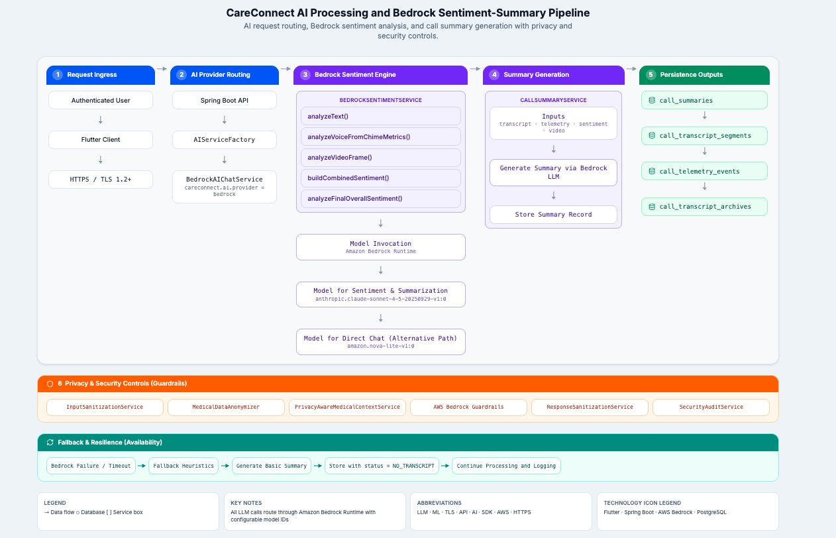
Figure 6.1: CareConnect AI Processing and Bedrock Sentiment-Summary Pipeline

Figure 6.1 illustrates the end-to-end AI processing workflow used by CareConnect. Authenticated requests are routed through a provider abstraction layer that supports Amazon Bedrock and alternative AI providers. Prior to model invocation, healthcare-related content passes through sanitization, anonymization, and privacy-aware processing services to reduce exposure of sensitive information. AI-generated outputs, including sentiment analysis and call summaries, are validated and persisted while fallback mechanisms provide resiliency during service disruptions.

6.3.1.1 Design Objectives
The CareConnect AI architecture was designed to support both current summarization capabilities and future healthcare-focused analytics workflows. Because AI services process sensitive communication and healthcare-related information, the architecture emphasizes flexibility, privacy protection, reliability, and maintainability. These objectives guided the selection of Amazon Bedrock, the provider abstraction model, and the supporting privacy-aware processing services.
The AI integration architecture was designed to satisfy the following objectives:
- Generate concise post-call summaries from transcript data.
- Support sentiment analysis of patient and caregiver interactions.
- Enable future SOAP note generation workflows.
- Support risk stratification and condition detection capabilities.
- Maintain flexibility through provider abstraction and model selection.
- Protect sensitive healthcare information through privacy-aware processing.
- Provide graceful degradation when AI services become unavailable.
- Support future expansion of analytics and healthcare monitoring features.

6.3.1.2 AI Processing Architecture
The AI processing workflow begins when communication artifacts are generated during patient-caregiver interactions. Transcript data, telemetry information, and contextual healthcare information are collected and passed through privacy-aware processing services before being submitted to AI providers.
At a high level, the workflow consists of the following stages:
- Collection of transcript and communication data.
- Privacy-aware context preparation and anonymization.
- AI provider selection and request orchestration.
- Model inference through Amazon Bedrock.
- Processing of generated outputs.
- Storage of summaries, sentiment results, and risk indicators.
This architecture separates AI responsibilities from core business services and enables support for multiple Amazon Bedrock foundation models through centralized provider orchestration and configuration-driven model selection. Additional providers may be incorporated in the future without significant application redesign.

6.3.1.3 AI Service Components
The AI subsystem is implemented through a collection of specialized services that separate provider integration, privacy controls, security functions, and business workflows. This modular design reduces coupling between components and allows individual services to evolve independently as AI capabilities expand. The following table summarizes the primary services that participate in AI processing activities.

Table 6.1
Primary services that participate in AI processing activities
Component | Responsibility
AIServiceFactory | Coordinates AI requests and resolves the active Bedrock model configuration
BedrockAIChatService | Communicates with Amazon Bedrock foundation models, including Claude and supported alternative models
BedrockSentimentService | Sentiment analysis processing
PrivacyAwareMedicalContextService | Privacy-aware context generation
MedicalDataAnonymizer | PHI masking and anonymization
InputSanitizationService | Validation and sanitization of AI inputs
ResponseSanitizationService | Validation and sanitization of AI outputs
SecurityAuditService | Monitoring and audit support for AI workflows

These services collectively provide a secure and extensible foundation for AI-assisted healthcare functionality.

6.3.1.4 Future Team A Enhancements
Although the current implementation focuses primarily on summarization and sentiment analysis, the architecture was intentionally designed to accommodate additional healthcare-oriented AI capabilities. The provider abstraction model, privacy-aware processing pipeline, and extensible data model create a foundation that can support more advanced clinical and analytical workflows in future milestones.
The AI architecture is designed to support planned Team A functionality, including:
- Enhanced call summary generation
- SOAP note generation
- Risk stratification
- Voice-based condition detection
- Clinical urgency identification
- Expanded healthcare analytics workflows
These capabilities will build upon the existing Bedrock integration while leveraging new data structures and analytics services introduced during future milestones.

6.3.2 Bedrock Configuration
Amazon Bedrock serves as the primary AI platform within the CareConnect architecture. Bedrock provides managed access to foundation models used for summarization, sentiment analysis, healthcare insight generation, and future clinical support workflows.

The platform accesses Bedrock through dedicated service abstractions that isolate provider-specific implementation details from application business logic. This approach simplifies maintenance and supports future provider substitution if business requirements change.

6.3.2.1 Current Model Configuration
The current implementation utilizes Amazon Bedrock as the primary AI platform and supports multiple foundation models through configuration-driven selection. Anthropic Claude serves as the primary model for summarization and clinical AI workflows, while Amazon Nova models remain available as supported alternatives for future use cases and evaluation activities.

Table 6.2
Models currently configured within the platform
Model | Purpose
Anthropic Claude 3 Sonnet | Primary summarization and clinical AI workflows
Amazon Nova Pro | Alternative Bedrock-supported model
Amazon Nova Lite | Lightweight Bedrock-supported model and future fallback option

Model selection is controlled through configuration settings and service-layer orchestration rather than direct application dependencies.

6.3.2.2 Bedrock Service Architecture
The Bedrock implementation is structured around a collection of services that separate infrastructure configuration, provider management, privacy controls, and application-facing AI functionality. This layered architecture improves maintainability and simplifies future integration of additional AI providers. The following table summarizes the primary components involved in Bedrock operations.

Table 6.3
Primary components involved in Bedrock operations
Component | Responsibility
AwsAccessConfig | AWS client configuration and credential management
AIServiceFactory | AI provider selection
BedrockAIChatService | Prompt submission and response processing
BedrockSentimentService | Sentiment analysis workflows
PrivacyAwareMedicalContextService | Context preparation and anonymization

These components separate infrastructure concerns, AI orchestration, privacy controls, and business workflows into independent layers.

6.3.2.3 Provider Configuration
The active AI provider is controlled through application configuration. This design allows CareConnect to switch providers or introduce new providers without modifying business services.
The provider architecture supports the following:
- Provider abstraction
- Centralized model configuration
- Runtime provider selection
- Environment-specific AI configuration
- Future support for additional LLM platforms

6.3.2.4 Request Processing Workflow
To ensure consistency, security, and privacy compliance across AI operations, all Bedrock requests follow a standardized processing pipeline. This workflow applies validation, anonymization, and sanitization controls before and after model inference activities.
- Communication or healthcare data is collected.
- Privacy-aware context is generated.
- Sensitive information is anonymized when required.
- Input validation and sanitization are performed.
- Requests are submitted to Bedrock models.
- Generated responses are validated and sanitized.
- Results are persisted and made available to users.
This workflow helps ensure that AI-generated outputs are processed consistently and securely.

6.3.2.5 Integration with Team A Features
The Bedrock integration serves as a foundational dependency for several Team A initiatives planned for future milestones. By centralizing AI capabilities through provider abstractions and reusable service components, new healthcare-focused features can be implemented without introducing significant architectural changes.
- Call summary generation.
- SOAP note generation.
- Risk stratification.
- Clinical urgency detection.
- Condition identification.
- Future healthcare analytics enhancements.
The Bedrock architecture provides the foundation required to implement these capabilities while maintaining consistency with existing summarization and sentiment analysis workflows.

6.3.2.6 Operational Considerations
Reliable operation of AI services requires controls that address configuration management, monitoring, error handling, and service availability. The Bedrock integration incorporates several operational capabilities intended to improve resiliency and simplify long-term maintenance.
- Centralized configuration management.
- Runtime provider selection.
- AI request monitoring.
- Error handling and logging.
- Privacy-aware processing.
- Graceful degradation mechanisms.
These capabilities improve reliability and allow the application to continue operating even when AI services experience temporary failures or availability issues.

6.3.3 Call Summary and SOAP Note Generation
Call summary and the planned SOAP note generation is handled by CallSummaryService in coordination with BedrockSentimentService. The summary is generated automatically at call end and produces a structured JSON payload containing clinical observations, assessment, and recommended actions derived from the full call transcript and sentiment analysis results.

The generation process begins when CallController's end-call handler invokes CallSummaryService.generateAndStoreSummary() with the callId, the generating user's ID, and the latest sentiment scores per channel (TEXT, VOICE, VIDEO, COMBINED). The service first retrieves the formatted transcript via CallTranscriptService.getFormattedTranscript(), which returns the complete speaker-labeled conversation text. The formatted transcript and channel sentiment scores are passed to BedrockSentimentService.summarizeTranscript(), which constructs a prompt for the Amazon Nova Pro model (amazon.nova-pro-v1:0). The prompt instructs the model to produce a structured JSON response containing: headline (maximum 80 characters), overallAssessment, keyConcerns (array), recommendedActions (array), and riskLevel (HIGH/MODERATE/LOW).

The generated summary JSON is persisted in the call_summaries table with status=COMPLETE, the transcript segment count, generating user ID, and the generation timestamp. If transcript data is unavailable (empty transcript), a placeholder summary is stored with headline "No transcript captured" and assessment "Call transcript was not available for summarization."
The SOAP (Subjective, Objective, Assessment, Plan) note structure is embedded within the summary prompt design. The overallAssessment field corresponds to the Assessment component, keyConcerns map to Subjective/Objective observations, and recommendedActions align with the Plan component. This structure enables physicians and caregivers to quickly identify actionable clinical information from the AI-generated output.

6.3.4 Risk Stratification
Risk stratification classifies patient risk levels based on sentiment analysis results and AI-generated clinical observations. The system operates at two levels: real-time sentiment-based classification during the call and post-call summary-based risk assessment.

During the call, BedrockSentimentService produces a combined sentiment score (0.0–1.0) using weighted averaging of VOICE (50%) and VIDEO (50%) channels. The score maps to clinical labels: scores above 0.60 indicate CALM status, scores between 0.35 and 0.60 indicate ANXIOUS status, and scores below 0.35 indicate DISTRESSED status.

The ClinicalUrgencyBanner renders in three states: green (CALM/POSITIVE), yellow (ANXIOUS/NEUTRAL), or red (DISTRESSED/NEGATIVE), providing an immediate visual indicator of patient emotional status to care-circle members. The banner is populated from the final SENTIMENT_FINAL telemetry event recorded at call end.
Post-call risk assessment is supported by PatientRiskService, which maintains a registry of RiskType definitions and allows authorized users to flag specific risks for a patient. The flagRisk() method enforces uniqueness constraints to prevent duplicate risk flags and records the flagging user and timestamp for audit purposes.

6.3.5 Voice-Based Condition Detection
Voice-based condition detection leverages acoustic analysis of call audio to identify potential health conditions that manifest in speech patterns. The current implementation provides real-time voice sentiment analysis through BedrockSentimentService.analyzeVoiceFromChimeMetrics(), with planned extensions for specialized condition detection models.

The existing voice analysis pipeline receives three metrics from the Flutter client's Chime SDK integration: averageLevel (microphone amplitude as a decimal 0.0–1.0), speechRatio (proportion of the analysis window containing speech), and variability (standard deviation of amplitude). These metrics are submitted to the backend via the telemetry endpoint and processed by BedrockSentimentService to produce voice channel sentiment scores.

The planned ConditionDetectionService introduces a plug-in model architecture where each detection model implements a standardized interface accepting voice metrics or transcript segments and returning condition flags. The model registry design allows new detection models to be registered through configuration rather than code changes, supporting iterative expansion of detection capabilities.

Detected conditions are persisted in the condition_flags table with fields for callId, patientId, conditionCode (standardized medical terminology), confidence (0.0–1.0), detectionModel (identifier of the model that produced the flag), and detectedAt timestamp. All condition flags are presented with compliance disclaimers and require clinical verification before any clinical action is taken.

6.3.6 Graceful Degradation
Graceful degradation ensures that core patient-facing features continue to function when AWS Bedrock or other AI services are unavailable. The design principle is that no user-facing workflow should fail entirely due to AI service unavailability. Instead, the system falls back to reduced functionality with appropriate user notification. BedrockSentimentService implements the following fallback hierarchy for text sentiment analysis:
- If BedrockRuntimeClient is available and awsEnabled=true, the service invokes the Nova Pro model with a structured prompt.
- If Bedrock is unavailable, the service falls back to analyzeTranscriptHeuristic(), which uses keyword matching and basic NLP patterns to produce approximate sentiment scores without AI assistance.

For combined sentiment scoring, when Bedrock is unavailable, the service uses a local weighted average of voice and video channel scores without AI enrichment. The final combined score still produces valid CALM/ANXIOUS/DISTRESSED labels using the same threshold constants.

Summary generation degrades as follows:
- If the Bedrock summarization call fails, CallSummaryService stores a fallback summary entity with headline "Summary unavailable" and assessment "Automated summary could not be generated."
- The call_summaries record is still created with status tracking the failure, ensuring the UI renders gracefully.

For the AI chat service used by PatientNotetakerService, the AIServiceFactory provides provider switching: if the configured provider (bedrock) is unavailable at runtime, the processAiSummary() method catches the exception, logs the failure, and returns a "Failed to generate AI Summary" message rather than propagating the error.

Condition detection models (planned) will implement individual timeout and failure handling, such that each model invocation has an independent timeout, and a model failure does not prevent other models from executing. The system records partial results when some models succeed and others fail, ensuring maximum information extraction under degraded conditions.

6.3.7 PHI and HIPAA Considerations
The CareConnect platform processes healthcare-related information including patient profiles, communication records, transcripts, sentiment results, risk assessments, and AI-generated summaries. Because several AI-assisted workflows operate on information that may contain personally identifiable information (PII) or protected health information (PHI), the system incorporates privacy-aware processing mechanisms designed to reduce unnecessary exposure of sensitive data while supporting clinical and operational objectives. The AI architecture was designed to follow the principle of minimum necessary disclosure, ensuring that only the information required to perform a specific AI task is made available during processing.

6.3.7.1 Privacy-Aware AI Processing
Because AI workflows may process healthcare-related information, CareConnect incorporates multiple privacy-focused services that reduce unnecessary exposure of sensitive data before information is submitted to external AI providers. These services support anonymization, sanitization, auditing, and privacy-aware context generation while helping maintain consistency with the platform's broader security and privacy objectives. Table 6.4 summarizes the primary components involved in privacy-aware AI processing.

The primary privacy components include those in Table 6.4.

Table 6.4
Primary components involved in privacy-aware AI processing
Component | Responsibility
MedicalDataAnonymizer | Masks, anonymizes, and pseudonymizes sensitive healthcare information
PrivacyAwareMedicalContextService | Generates privacy-aware context for AI processing
InputSanitizationService | Validates and sanitizes AI request inputs
ResponseSanitizationService | Validates and sanitizes AI-generated outputs
SecurityAuditService | Supports monitoring and auditing of AI-related operations

These services help ensure that AI workflows receive only the information necessary to generate summaries, sentiment analysis, risk indicators, and future clinical insights.

6.3.7.2 Protected Health Information Controls
AI-assisted workflows may operate on information derived from communication records, patient monitoring activities, and healthcare-related interactions. As a result, multiple categories of protected health information (PHI) may be encountered during processing activities. Understanding the types of information involved is important for applying appropriate privacy controls and access restrictions.
Healthcare-related data may be present within:
- Patient profiles
- Caregiver notes
- Chat messages
- Call transcripts
- Video call metadata
- Symptom tracking records
- Mood and wellness information
- AI-generated summaries
- Risk assessment records

Prior to AI processing, identifiable information may be masked, removed, or pseudonymized depending on the processing scenario. This approach reduces unnecessary disclosure of patient information while preserving the contextual information required for accurate analysis.
Future Team A features, including SOAP note generation, condition detection, and risk stratification, will utilize the same privacy-aware processing framework.

6.3.7.3 AI Data Flow Protection
To reduce the risk of unauthorized disclosure or unintended exposure of healthcare-related information, the AI processing pipeline incorporates privacy and security controls at multiple stages of the request lifecycle.

Input Protection
Before data is submitted to an AI provider:
- Relevant healthcare context is collected.
- Privacy-aware processing rules are applied.
- Sensitive identifiers are anonymized when appropriate.
- Input validation and sanitization are performed.
- Requests are routed through approved AI service interfaces.

Output Protection
After AI responses are received:
- Generated content is validated.
- Output sanitization rules are applied.
- Responses are evaluated for unexpected content.
- Results are stored using existing application security controls.
- Authorized users are provided access through role-based permissions.

This layered approach helps prevent accidental disclosure of sensitive information during AI-assisted workflows.

6.3.7.4 Access Control and Authorization
Access to AI-generated content is governed by the same security framework used throughout the CareConnect platform. Authentication, authorization, and auditing controls ensure that AI-generated information is accessible only to users with an appropriate business need and authorized relationship to the associated patient.
Security controls include:
- JWT-based authentication.
- Role-based access control (RBAC).
- Permission-based service authorization.
- Method-level authorization enforcement.
- Protected API endpoints.
- Audit and telemetry controls.

Only authorized users may access patient-related summaries, analytics results, risk indicators, and future condition detection outputs. Access control requirements for AI-generated information follow the same care-circle relationship model used for patient data throughout the platform.

6.3.7.5 Data Storage and Retention
AI processing activities may generate new records that become part of a patient's communication history, analytics profile, or healthcare monitoring workflow. These artifacts must be protected using the same security controls applied to other sensitive platform data and managed according to established retention policies.
AI-generated artifacts may include:
- Call summaries
- Sentiment analysis results
- Risk assessment records
- Future Condition detection indicators
- Future SOAP note outputs

These records are stored using the same database security controls applied to other healthcare-related data, including:
- Encrypted database storage.
- Controlled access through application services.
- Secret management through AWS Secrets Manager and Systems Manager Parameter Store.
- Secure authentication and authorization controls.

Retention of AI-generated information follows the platform's broader data retention strategy and account lifecycle policies.

6.3.7.6 Audit and Monitoring
Monitoring and auditing capabilities help ensure the reliability, security, and accountability of AI-assisted workflows. These capabilities provide operational visibility into system behavior while supporting troubleshooting, performance analysis, and future compliance initiatives.
The platform includes mechanisms that support:
- AI request monitoring.
- Security auditing.
- Telemetry collection.
- Error tracking.
- Operational logging.

Future enhancements may expand audit capabilities to provide additional visibility into AI-generated outputs, model usage, and healthcare workflow decisions.

6.3.7.7 Team A Privacy Considerations
Several planned Team A enhancements expand the platform's use of AI-assisted healthcare analysis and therefore introduce additional privacy and security considerations. These features must continue to leverage the existing privacy-aware processing framework while ensuring that sensitive healthcare information remains appropriately protected throughout the AI lifecycle.

SOAP Note Generation
Future generated SOAP notes may contain sensitive healthcare observations and therefore require the same privacy protections applied to other patient records.

Risk Stratification
Risk assessment results may influence care decisions and must be accessible only to authorized users within a patient's care circle.

Voice-Based Condition Detection
Future condition detection workflows may analyze transcript and communication data to identify potential health indicators. These workflows must continue to utilize privacy-aware context generation and anonymization services before AI processing occurs.

Clinical Urgency Detection
Clinical urgency indicators may contain sensitive healthcare information and should be protected using existing authorization controls and secure storage mechanisms.

6.3.7.8 Summary
The CareConnect AI architecture incorporates multiple safeguards to protect PII and PHI throughout the AI processing lifecycle. Privacy-aware context generation, anonymization services, sanitization controls, authentication mechanisms, role-based access controls, and secure AWS infrastructure collectively provide a foundation for responsible AI-assisted healthcare workflows. These protections allow Team A enhancements to leverage Bedrock-powered capabilities while minimizing unnecessary exposure of sensitive healthcare information.

6.4 Telemetry and Analytics Design
This section defines telemetry and analytics design, including event taxonomy, ingest and storage, admin dashboard data, and PII/PHI exclusion rules, supporting WBS telemetry work without exposing identifiers in analytics payloads.

6.4.1 Overview
We track how the app is used (like call lengths and system errors) to monitor system health and build admin dashboards. We do not track personal user data so we stay HIPAA compliant.

6.4.2 Telemetry Event Taxonomy
Every tracked event uses a simple JSON format. It includes an event ID, the type of event (like CALL_JOIN), a hidden user ID, a timestamp, and extra details.

6.4.3 Telemetry Storage Architecture
The mobile app sends batches of events to our backend. The backend saves these events into a PostgreSQL database table called telemetry_events. This runs in the background so it does not slow down the app.

6.4.4 Admin Analytics Dashboard
The backend sends combined data (like daily users or average call times) to the Admin dashboard. Only users with the ROLE_ADMIN tag can view this data.

6.4.5 PII and PHI Constraints
We scrub all personal data before saving it. If an event accidentally contains a real name, email address, or health info, the backend deletes that specific text before it goes into the database.

6.5 Cross-Team Functional Dependencies
Team E additionally depends on the shared Bedrock model allow-list and ECS task-role IAM in the platform stack, Chime or transcript upstream emitters for summary indexing, Cognito/JWT enforcement of USE_AI_FEATURES, Amplify frontend configuration for BACKEND_URL and CORS, and RDS pgvector enablement from the data stack parameter group.
CareConnect is a shared capstone codebase, with five class teams extending the same backend, AI layer, and deployment surface. Team A owns WBS the requirements video call workflows, telemetry, Bedrock integration, deployment, and RBAC, but several deliverables depend on agreements with Teams B, C, D, and E before production integration is safe. This section records those dependencies, the Team A contacts responsible for coordination, the decisions still required, and current status as of Milestone 3.

Team A acts as a coordination point for backend governance, shared API boundaries, and security patterns. Production AI binding, caregiver-visible outputs, and several cross-team features remain blocked pending decision until the contracts in Table 6.5 are resolved. Governance work, including RBAC audit, route ownership manifest, and invoice endpoint protection, can proceed in parallel and is listed where it unblocks other teams.

6.5.1 Dependency Register
Table 6.5 lists functional dependencies drawn from the class Cross-Team Dependency Matrix and the Milestone 3 Coding Readiness Report. Matrix IDs (D-001 through D-028) are included where the class matrix assigns them.

Table 6.5
Cross-team functional dependencies
Dependency | Teams or Owners Involved | Decision Needed | Status
D-001 — AWS Bedrock / LLM access | Team A (Kodi); Team E; AWS account admin | Which models are approved for Milestone 3 (Claude vs Nova vs mock); quota and IAM scope for shared use | Open — repository currently uses Amazon Nova Lite; Claude is not bound
D-002 — AI Gateway / provider abstraction | Team A (Kodi); Team E | Single gateway interface (request/response DTO, fallback, PHI rules); approved Milestone 3 provider path | Open — fragmented AI providers in inherited code
D-003 — RBAC / endpoint protection | Team A (Brandon); all teams | Standard protection pattern; endpoint matrix for sensitive routes | In progress — audit underway
D-004 — Backend API change control | Team A (Dominique); class PM; all teams | Static route ownership manifest; process for adding or renaming endpoints | Open — manifest not yet published
D-014 — Backend connectivity / Chime SDK | Team A (Dominique); Team B | Staging environment for Chime E2E testing; IAM for call and recording tests | In progress
D-016 — Transcript / diarization format | Team A (Dominique); Team C; Team E | Transcript segment DTO (speaker label, role, timestamps, source); speaker identity rules | Open
D-017 — Call summary ownership | Team A (Dominique); Team E | Boundary between Team A call summaries and Team E Ask AI / visit summaries | Open
D-018 — AI condition detection governance | Team A (Dominique, Kodi); Team E | Safety, consent, and disclaimer rules before production condition flags | Open — mock-only until resolved
D-021 — Caregiver visibility / consent | Team A (Brandon); Team E; Team C; Team D | What caregivers may view, retrieve, approve, or modify for AI outputs | Open
D-028 — QR / invite role assignment | Team A (Brandon); Team D | Role assigned when a user joins via invite or QR link | Open
Invoice LLM endpoint security | Team A (Brandon); Team D; Team B | Remove open access on invoice LLM extraction; require authentication and care-circle checks | In progress — known inherited gap
CI/CD, staging, and deployment IAM | Team A (Srijan); Team B | Scoped IAM for staging; repeatable deploy runbook; JaCoCo and security regression in pipeline | In progress
Backend voice intent route | Team A (Brandon, Dominique); Team C | Route, request/response DTO, supported intents, RBAC, and failure handling | Open — do not implement unilaterally
EVV route ownership and live submission | Team A (Brandon); Team D | Which team owns EVV endpoints; restrictions on live submission in Milestone 3 | Open
Wearable API backend boundaries | Team A (Srijan); Team D | Shared infrastructure vs team-owned routes for wearable data | Open
Ask AI / RAG / pgvector schema | Team A (Kodi); Team E | Team E owns RAG planning; Team A must not add production pgvector writes until approved | Open
Audit ledger vs platform analytics | Team A (Donielle); Team E | Overlap between audit logging and WBS Telemetry requirments | Open
Dedicated testing team handoff | Team A (all); external testing class | System regression, UAT, and broad E2E — outside Team A unit/integration scope (Project Plan Section 10.2) | In progress — Team A delivers test artifacts
AWS Bedrock Claude extraction service availability and IAM role access | Team A | Confirm Bedrock endpoint and model ID are provisioned and accessible for Team D invoice workflows | In progress
Managed LLM access (Bedrock) for Ask AI embeddings and answers | Team A / Cloud; Team E consumers | Provision endpoint/BAA; keep Titan embed v1 on the task-role allow-list | In progress
Shared retrieval / summary schema contract | Team E (Ravichandra Vasireddy) + Summaries/STML | Lock versioned fields for transcripts, summaries, embeddings, mail | In progress
Caregiver visibility policy for AI outputs | Team E Safety (David Oguh) + RBAC owners | Finalize visibility matrix before caregiver-facing Ask AI demo | Open
Gmail OAuth for USPS Informed Delivery ingest | Team E (Arturo Santana) / Cloud | Complete OAuth setup; replace mock mailbox data | Open

6.5.2 Team A Contact Summary
External teams should use Table 6.6 to identify the primary Team A contact for each collaboration area. Escalation for unresolved blockers flows from the Team Lead (Dominique Rattray) to the class Project Manager.

Table 6.6
Team A contacts by external team
External Team | Primary Team A Contacts
Team B (CI/CD, staging, E2E) | Srijan (deployment/IAM); Donielle (test execution); Dominique (Chime E2E); Brandon (security regression)
Team C (voice, transcripts) | Dominique (transcript shape, speaker verification); Brandon (voice RBAC, voice intent); Donielle (Spanish voice backend); Kodi (mock vs production AI actions)
Team D (invoices, EVV, invites) | Brandon (invoice, EVV, invite RBAC); Kodi (Bedrock invoice migration); Srijan (wearable boundaries, data models)
Team E (AI gateway, RAG, summaries) | Kodi (AI gateway, RAG boundaries); Dominique (summary/transcript ownership, condition detection); Brandon (consent/visibility); Donielle (audit/analytics overlap)

6.5.3 Impact on Team A WBS
Several WBS items cannot close until dependencies in Table 6.5 are resolved. WBS Section 3.5 (AI condition detection implementation) remains blocked by D-018 and D-021. Mock-only demonstrations are acceptable until governance is approved. WBS Section 3.4 (SOAP summaries and urgency banner) is partially blocked by D-017 until the summary boundary with Team E is clear. WBS Section 3.7 (production Bedrock/Claude) is blocked by D-001 and D-002. WBS Section 3.9 - 3.10 (grant/revoke and full RBAC) depends on D-003 and D-028, although invoice endpoint protection can proceed immediately. Furthermore, Team A will update this section in the appendix as dependencies move from Open to In progress to Resolved at each milestone integration checkpoint.

TTD-B-6.5 Cross-Team Testing Dependencies
Team B's testing work depends on deliverables and decisions from other teams. These dependencies are distinct from the Team A cross-team dependency register in Section 6.5 and track items specific to Team B's testing scope.

Table 6.7
Team B cross-team testing dependencies
Dependency | Teams Involved | Decision Needed | Status
Backend connectivity for E2E | Team B + Team A | Backend URL and credentials for CI E2E runs | Open — Team A coordination needed
CloudFormation pipeline ownership | Team B + Team A | Whether Team A owns the pipeline or Team B builds test gates independently | Open — in coordination
SWEN 661 component delivery | Team B + SWEN 661 | Which components, by which milestone | Open — being monitored
AI persona feature design | Team B + owning team | Feature interaction model for supplemental accessibility criteria | Pending Milestone 3

6.6 Electronic Visit Verification (EVV) Enhancements
Item | Team Response
Requirement IDs or Names | REQ-5.1.1-001, REQ-5.1.1-002, REQ-5.1.1-003, REQ-5.1.2-001, REQ-5.1.2-002, REQ-5.1.2-003, REQ-5.1.3-001, REQ-5.1.3-002, REQ-5.1.3-003,
Feature Summary | Team D enhances EVV workflow reliability across three areas: visit lifecycle gap closure and correction (5.1.1), aggregator dependency tracking and operational visibility (5.1.2), and EVV submission design with error handling readiness (5.1.3). Together these ensure that EVV records are complete, aggregator-ready, and auditable from scheduling through downstream submission handoff.
Primary User Flow | 1. Caregiver or admin opens the EVV dashboard and selects a visit record.  2. User advances the visit through lifecycle states: scheduled, check-in, in-progress, check-out, completed.  3. System validates required fields at each transition and surfaces missing or invalid data.  4. For aggregator dependency: admin views aggregator readiness status and blocking conditions in operational view before submission.  5. User corrects identified field issues and retries the failed transition or submission preparation step.  6. System validates and confirms readiness, then queues the record for downstream EVV aggregator or EDI handoff.
Main System Behaviors | Supports all EVV visit lifecycle state transitions from scheduling through completion. Enforces required field validation before state progression is allowed. Supports non-destructive correction and retry of failed transitions and submission preparation steps. Surfaces aggregator dependency status and blocking conditions in administrative views. Validates required EVV data elements before export or submission readiness is confirmed. Preserves timestamped, auditable records of all state changes, corrections, and submission preparation outcomes.
Inputs | Visit identifiers, caregiver and user workflow actions, EVV field updates, aggregator status signals, submission preparation triggers, export configuration values.
Outputs | [Updated EVV visit record states, field validation feedback, aggregator readiness indicators, retry outcomes, submission preparation results, EDI/handoff queue entries, and audit event records.
Alternate / Error Flows | If a required field is missing at state transition: system blocks progression and surfaces a field-level error with recovery guidance. If aggregator is unavailable or blocking: admin view reflects the condition and prevents submission until resolved. If submission preparation fails: system routes the record to a correctable error state, preserves existing data, and provides actionable failure context for retry.

6.7 AI-Assisted Invoicing (AWS Bedrock + Claude)
Item | Team Response
Requirement IDs or Names | REQ-5.2.1-001, REQ-5.2.1-002, REQ-5.2.1-003, REQ-5.2.2-001, REQ-5.2.2-002, REQ-5.2.2-003, REQ-5.2.3-001, REQ-5.2.3-002, REQ-5.2.3-003
Feature Summary | Team D migrates the invoice AI extraction provider from the legacy path to AWS Bedrock Claude while preserving existing intake behavior and reviewer workflow continuity. The feature covers invoice intake and extraction (5.2.1), reviewer validation and approval (5.2.2), and Bedrock model configuration and controlled failure handling (5.2.3).
Primary User Flow | 1. Billing user uploads an invoice image or document through the intake screen.  2. System submits the invoice content through the Bedrock Claude extraction path and returns structured field output.  3. Reviewer opens the extracted invoice draft and inspects extracted fields alongside confidence context.  4. Reviewer corrects any inaccurate or missing fields.  5. Reviewer approves the invoice or routes it for manual handling if extraction quality is insufficient.  6. System stores the final reviewed invoice with extraction metadata and approval record.
Main System Behaviors | Processes invoice extraction through AWS Bedrock Claude for all Team D invoice workflows. Returns structured invoice fields required for reviewer validation including confidence metadata. Preserves the existing upload-review-approve workflow continuity after provider migration. Presents extracted fields as editable before final approval is permitted. Validates Bedrock extraction configuration before processing invoice requests. Routes failed or low-confidence extractions to a manual review queue with failure context preserved. Maintains traceability of AI-assisted extractions versus manual reviewer corrections.
Inputs | Invoice image or document file, Bedrock model configuration, reviewer field edits, approval or manual-route actions, model and schema configuration state.
Outputs | Structured invoice draft with extracted fields and confidence indicators, reviewer correction records, approval status, failure or retry messages, manual queue entries, and audit log entries.
Alternate / Error Flows | If extraction confidence is below threshold: system creates draft with low-confidence warnings and routes to mandatory manual review. If Bedrock configuration is invalid or unavailable: system blocks extraction, records the failure context, and routes the invoice to the manual queue. If a transient provider error occurs: system marks the request as retriable with original content preserved for resubmission.

6.8 QR/Invite Care Circle Onboarding
Item | Team Response
Requirement IDs or Names | REQ-5.3.1-001, REQ-5.3.1-002, REQ-5.3.1-003, REQ-5.3.2-001, REQ-5.3.2-002, REQ-5.3.2-003, REQ-5.3.3-001, REQ-5.3.3-002, REQ-5.3.3-003
Feature Summary | Team D delivers secure invite-based onboarding that allows existing users to bring new participants into a care circle through tokenized URL links and QR codes. The feature covers invite token issuance and delivery (5.3.1), invite acceptance and role assignment (5.3.2), and token lifecycle and exception handling (5.3.3).
Primary User Flow | 1. Inviter initiates invite creation and selects the intended recipient role.  2. System generates a unique, time-limited invite token and delivers it as a URL and QR code.  3. Recipient opens the invite link or scans the QR code to begin onboarding.  4. System validates the token state (valid, expired, revoked, already used) before allowing progression.  5. Recipient completes registration and identity verification steps.  6. System assigns the appropriate care circle membership and role scope and routes the new user to their role dashboard.
Main System Behaviors | Generates unique, time-limited invitation tokens for care circle onboarding. Delivers tokens as both URL links and QR codes. Validates token state before allowing any onboarding progression. Assigns care circle membership and role scope upon successful acceptance. Blocks onboarding for invalid, expired, revoked, or already-used tokens. Prevents duplicate onboarding from reused invitation tokens. Preserves onboarding session continuity and provides guided recovery messaging for token failures.
Inputs | Invite creation request, recipient role selection, token payload from URL or QR scan, recipient registration and verification details, token validation outcomes.
Outputs | Invite URL and QR code artifacts, token validation result, onboarding status, role-linked care circle account association, token lifecycle events, and session routing to role dashboard.
Alternate / Error Flows | If token is expired: system blocks progression and presents expiration messaging with guidance to request a new invite. If token is already used: system blocks progression and prevents duplicate account creation. If token is revoked: system displays a revocation message and provides contact guidance. If registration fails mid-flow: system preserves the session context so the user can retry without requiring a new token.

6.9 Wearable Device Integration
Item | Team Response
Requirement IDs or Names | REQ-5.4.1-001, REQ-5.4.1-002, REQ-5.4.1-003, REQ-5.4.2-001, REQ-5.4.2-002, REQ-5.4.2-003, REQ-5.4.3-001, REQ-5.4.3-002, REQ-5.4.3-003
Feature Summary | Team D delivers wearable device integration covering secure connector authorization and account linking (5.4.1), metric synchronization, normalization, and dashboard visibility (5.4.2), and threshold alert management and sync failure notifications (5.4.3).
Primary User Flow | 1. User navigates to wearable integration settings and selects a supported connector to link.  2. System initiates the provider authorization flow and completes secure account linking.  3. Wearable metrics begin syncing and are normalized into the dashboard view with latest-sync timestamps.  4. Admin or care coordinator configures threshold alert rules for supported metric types.  5. System evaluates incoming metrics against configured thresholds and sync freshness limits.  6. User or admin receives alert notifications and takes acknowledgment or escalation actions.
Main System Behaviors | Supports secure authorization workflows for configured wearable connectors. Persists account link state and connection health status. Ingests and normalizes supported wearable metric payloads. Displays latest sync timestamps and connection health in dashboard views. Supports configurable threshold alert rules for supported wearable metrics. Triggers alert and notification workflows when thresholds are breached or sync freshness falls below configured limits. Supports alert acknowledgment and escalation actions.
Inputs | Connector authorization responses, wearable metric payloads, threshold configuration rules, sync freshness limits, alert acknowledgment actions.
Outputs | Account link status, normalized metric display, sync timestamps, threshold alert events, notification deliveries, acknowledgment records, and escalation state.
Alternate / Error Flows | If connector authorization fails: system displays failure context and provides retry or re-authorization guidance without losing existing link state. If metric sync is stale beyond the configured limit: system surfaces a sync freshness warning and prompts reconnect. If a threshold alert is not acknowledged within a defined window: system escalates the alert to the appropriate care team member.

6.10 Home Care Document Digitization
Item | Team Response
Requirement IDs or Names | REQ-5.5.1-001, REQ-5.5.1-002, REQ-5.5.1-003, REQ-5.5.2-001, REQ-5.5.2-002, REQ-5.5.2-003, REQ-5.5.3-001, REQ-5.5.3-002, REQ-5.5.3-003
Feature Summary | Team D digitizes home care documentation into structured, validated intake forms with a full document lifecycle and profile-linked traceability. The feature covers structured form digitization and validation (5.5.1), document review states and administrative actions (5.5.2), and traceability and profile-linked persistence (5.5.3).
Primary User Flow | 1. User opens a digital home care form from the document intake screen.  2. User completes required structured fields; system validates required entries in real time.  3. User saves the form as a draft for later completion or submits for review.  4. Reviewer or admin opens the submitted document and inspects content.  5. Admin accepts the document or returns it with correction guidance.  6. System records the lifecycle state change with actor identity and timestamp and links the document to the appropriate user profile.
Main System Behaviors | Provides structured digital intake forms for approved home care document types. Validates required fields before draft save and enforces completion rules before submission. Supports draft, submitted, pending review, and accepted or returned document lifecycle states. Allows authorized reviewers to accept or return submitted documents. Persists digitized document records linked to the appropriate user profile. Preserves status history and actor and timestamp metadata for all document state changes. Maintains source-to-structured traceability for audited document review.
Inputs | Structured form field data, document type selection, save or submit actions, reviewer accept or return decisions, reviewer comments, profile context.
Outputs | Structured document records, lifecycle status, review decisions, correction guidance, traceability metadata, actor and timestamp audit records.
Alternate / Error Flows | If required fields are missing at submission: system blocks submission and highlights incomplete fields with actionable guidance. If a document is returned by the reviewer: system notifies the submitter with correction context and allows re-submission without creating a duplicate record. If a draft is abandoned: system retains the draft record linked to the user profile for later resumption.

6.11 Screening and Comprehensive Assessment Workflows
Item | Team Response
Requirement IDs or Names | REQ-5.6.1-001, REQ-5.6.1-002, REQ-5.6.1-003, REQ-5.6.2-001, REQ-5.6.2-002, REQ-5.6.2-003, REQ-5.6.3-001, REQ-5.6.3-002, REQ-5.6.3-003
Feature Summary | Team D delivers structured clinical intake workflows covering initial screening capture (5.6.1), comprehensive multi-domain assessment capture (5.6.2), and risk scoring, submission controls, and escalation readiness (5.6.3).
Primary User Flow | 1. Assessor opens a new screening or comprehensive assessment from the patient profile.  2. System loads the appropriate structured form sections and required field rules for the assessment type.  3. Assessor completes sections and saves a draft for later resumption as needed.  4. Assessor records disposition or risk context as part of assessment completion.  5. Assessor submits the completed assessment; system validates required fields and records submission.  6. System generates follow-up action prompts based on risk or disposition context and persists the assessment linked to patient and assessor metadata.
Main System Behaviors | Supports structured screening fields required for intake and disposition decisions. Supports comprehensive assessment domains including clinical, social, functional, and legal history. Associates each screening and assessment record with patient identity and assessor metadata. Supports save-as-draft and resume for partially completed assessment sessions. Supports final submission with required field enforcement. Preserves risk and disposition metadata associated with screening and assessment outcomes. Generates escalation or follow-up action context based on outcome rules. Persists completed assessments in patient records for longitudinal retrieval.
Inputs | Assessment form responses per structured domain, assessor identity and time context, patient profile linkage, disposition and risk values, draft save and final submission actions.
Outputs | Persisted screening and assessment records, submission status, risk and disposition metadata, follow-up or escalation action context, and longitudinal patient record updates.
Alternate / Error Flows | If required fields are incomplete at submission: system blocks final submission and surfaces field-level guidance per section. If a session is interrupted: system preserves draft state so the assessor can resume without data loss. If elevated risk is captured: system presents escalation prompt and requires explicit disposition acknowledgment before the assessment can be closed.
Design notes: The runtime pipeline authorizes scope, retrieves and fuses candidates, builds cited context, invokes the model, applies optional safety or HITL hold rules, and returns the answer with citations. Voice queries join the same retrieval path after speech-to-text. Denied-scope asks produce 403 responses that are audit logged with the requester and patient identifiers.
Ask AI provides grounded, cited answers over a patient’s stored care records. The design combines RBAC-scoped hybrid retrieval (PostgreSQL full-text search and pgvector similarity) with a Bedrock assembler that must cite retrieved sources rather than invent unsupported clinical advice.

6.12 AI-Assisted Retrieval (Ask AI)
Design notes: Caregiver visibility remains consent-aware. Selected mail text may be indexed into the shared retrieval corpus so Ask AI can cite mail when the caller’s scope allows.
The USPS Informed Delivery mail agent ingests mail digests and images, applies OCR with Textract fallback where required, persists MailPiece entities described in §4.9, and exposes patient-facing mail review flows.
Ask AI feature specification (Team E)
Table 6.12
Item | Team Response
Requirement IDs or Names | FR-AI-1 through FR-AI-10; governed by REQ-SC-1–9
Feature Summary | Lets authorized users ask natural-language questions over scoped care records and receive grounded, cited answers.
Primary User Flow | 1. User submits a question. 2. System authenticates and authorizes scope. 3. Hybrid retrieval runs. 4. Model assembles a cited answer. 5. Safety rules apply. 6. Client displays answer and sources.
Main System Behaviors | Answers only from authorized indexed records; never invents unsupported clinical advice; audit logs asks and 403s.
Inputs | Text question or voice-derived text; patient scope; optional source filters.
Outputs | Grounded answer; source citations; disclaimer; optional hold/escalation state.
Alternate / Error Flows | No relevant records → clear empty-state message. Out-of-scope patient → 403. Bedrock unavailable → graceful degradation.

6.13 USPS Informed Delivery Mail Agent
Design notes: Confirmed actionable summary items feed reminder cues and remain visible in STML-oriented presentation without requiring the patient to re-read full transcripts.
Short-Term Memory (STML) support shapes patient-facing summaries, reminders, and Ask AI responses toward brief, high-signal content. Workflows prefer short confirmation paths over long multi-step forms when an actionable item can be confirmed in place.
USPS Informed Delivery mail agent (Team E)
Table 6.13
Item | Team Response
Requirement IDs or Names | FR-USPS-1 through FR-USPS-7
Feature Summary | Retrieves, extracts, indexes, classifies, and presents Informed Delivery mail for the patient.
Primary User Flow | 1. User opts in and authenticates mailbox access. 2. Agent ingests digest/metadata. 3. OCR runs when needed. 4. MailPiece is stored and listed. 5. Optional Ask AI indexing.
Main System Behaviors | Metadata-first extraction; OCR/Textract fallback; consent-aware caregiver visibility.
Inputs | USPS notification emails; optional mail images; OAuth tokens.
Outputs | Normalized MailPiece (sender, delivery date, visible text, tier, OCR status).
Alternate / Error Flows | No mail image → recorded empty-image state. Low OCR confidence → manual review.

6.14 Short-Term Memory (STML) Support
Design notes: Responses that are held show an explicit hold state rather than silent failure. Patient copy remains short and STML-friendly; caregiver copy may surface additional consented clinical detail.
Safety, Consent & Clarity defines patient-facing guardrails for Ask AI and generative summaries. The assistant does not provide diagnosis, treatment, or dosage recommendations. Caregiver visibility stays consent-scoped, secondary validation or HITL hold-and-release applies where configured, and AI-generated text carries clear source attribution.
STML support (Team E)
Table 6.14
Item | Team Response
Requirement IDs or Names | STML-1 through STML-5; builds on summary and Ask AI outputs
Feature Summary | Memory-recall experiences such as a Daily Memory Brief and short confirmation paths.
Primary User Flow | 1. On app open, user sees Daily Memory Brief. 2. User may confirm actionable items. 3. Brief updates from recent summaries/retrieval.
Main System Behaviors | Consumes summary and retrieval outputs; prefers short, high-signal copy.
Inputs | Recent summaries and indexed records; recall queries.
Outputs | Daily Memory Brief; plain-language recall answers; confirmation states.
Alternate / Error Flows | No recent activity → clear empty-state brief.

6.15 Safety, Consent & Clarity
Safety, consent, and clarity (Team E)
Table 6.15
Item | Team Response
Requirement IDs or Names | REQ-SC-1 through REQ-SC-9; SAF-1+
Feature Summary | Cross-cutting governance for AI output: disclaimers, citations, consent, and HITL hold/release.
Primary User Flow | 1. AI output is generated. 2. Secondary validation runs. 3. Safe output shows with disclaimer/citations, or Tier-2 hold routes to review.
Main System Behaviors | Persistent non-dismissible AI notices; default-restricted caregiver visibility; audit of held releases.
Inputs | All AI output; user role and consent; configured safety thresholds.
Outputs | Validated output with disclaimers and citations; escalation tickets when held.
Alternate / Error Flows | Tier-2 medication/emergency cues → withhold and escalate rather than silent failure.

7. Infrastructure and Deployment Design
The CareConnect platform is deployed within Amazon Web Services (AWS) using a cloud-native architecture designed to support scalability, security, maintainability, and operational resilience. Infrastructure resources are provisioned and managed through AWS CloudFormation, enabling repeatable deployments and environment consistency across development, testing, and production environments.
The deployment architecture separates networking, data, platform, and application runtime concerns into independent CloudFormation stacks. This modular approach simplifies infrastructure management, promotes reuse of shared resources, and allows components to be updated independently while maintaining controlled dependencies between services.

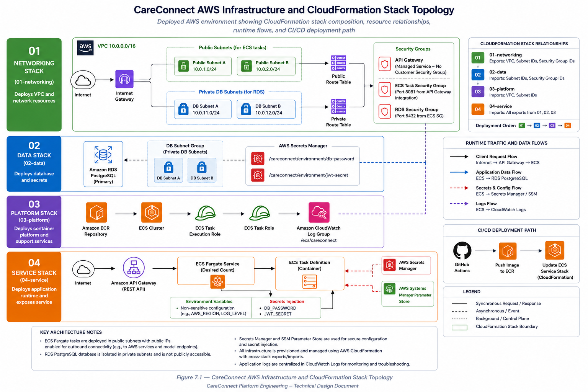
Figure 7.1: CareConnect AWS Infrastructure and CloudFormation Stack Topology

Figure 7.1 illustrates the AWS infrastructure supporting the CareConnect platform. The environment is organized into four CloudFormation stacks that provision networking, data, platform services, and application runtime resources. Client requests enter the environment through Amazon API Gateway and are routed to ECS Fargate services for application processing before interacting with Amazon RDS PostgreSQL. AWS Secrets Manager and Systems Manager Parameter Store provide centralized configuration and secret management.

TDD-B-7 Deployment and Infrastructure Coordination
All CI/CD infrastructure must be defined via AWS CloudFormation, with no manual AWS console configuration. This section documents Team B's testing-infrastructure requirements and open coordination items with Team A; the platform's AWS service inventory itself already appears once in Section 2.4.1 and is not repeated here.

7.1 AWS Infrastructure Overview
The AWS infrastructure for CareConnect is designed as a cloud-native ecosystem that prioritizes security, maintainability, scalability, and adherence to healthcare regulatory standards through modular, automated deployment practices. The architecture emphasizes separation of concerns and repeatable provisioning while supporting future expansion as platform requirements evolve.
Team D backend features run across three environments: local development, shared test validation, and final demonstration. Local development uses Docker-compatible or local Spring Boot execution with seeded data and mock integrations. The test environment supports pre-integration validation and approved non-production service access when available. The final demonstration environment uses shared hosted infrastructure and only approved provider contracts. This approach allows Team D to validate application behavior early while reducing the risk of rework caused by unstable or unapproved external dependencies.
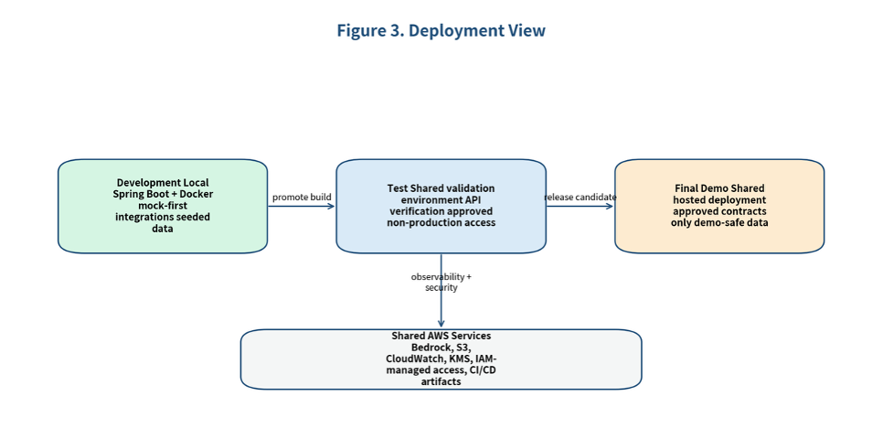
Figure 3. Deployment view for Team D backend components.

7.1.1 Infrastructure Objectives
The AWS infrastructure architecture was designed to satisfy several key objectives. By establishing a secure and compartmentalized cloud ecosystem, the platform supports scalable application delivery, controlled access to sensitive healthcare information, and consistent deployment practices. Furthermore, this architectural foundation serves as a mechanism for enforcing regulatory alignment and end-to-end data protection standards.
- Provide a scalable cloud-native deployment platform.
- Support secure handling of healthcare-related information.
- Enable repeatable infrastructure provisioning through Infrastructure as Code (IaC).
- Separate infrastructure concerns through modular CloudFormation stacks.
- Centralize configuration and secret management.
- Support monitoring, logging, and operational visibility.
- Facilitate automated deployment through CI/CD workflows.
- Enable future growth and service expansion.
These objectives guided the selection of AWS services and the overall deployment strategy.

7.1.2 CloudFormation Stack Organization
Infrastructure resources are provisioned through four primary CloudFormation stacks that are deployed in a defined sequence. This modular approach enforces a strict separation of concerns, ensuring that core networking, persistent data storage, and compute layers are isolated into independent lifecycles to minimize blast radiuses during updates.
01 – Networking Stack
The Networking Stack establishes the foundational network resources required by the platform, including:
- Virtual Private Cloud (VPC)
- Public subnets
- Private database subnets
- Internet Gateway
- Route tables
- Security groups
This stack provides the network isolation and connectivity required by application and database services.
02 – Data Stack
The Data Stack provisions persistent storage and secret management resources, including:
- Amazon RDS PostgreSQL
- Database subnet groups
- AWS Secrets Manager secrets
- Database credential storage
- JWT secret storage
These resources provide secure and durable storage for application data and configuration secrets.
03 – Platform Stack
The Platform Stack provisions shared runtime services used by application workloads, including:
- Amazon Elastic Container Registry (ECR)
- Amazon ECS Cluster
- ECS IAM roles
- CloudWatch log groups
These resources provide the foundation for container execution and operational monitoring.
04 – Service Stack
The Service Stack deploys the application runtime components, including:
- ECS Fargate services
- ECS task definitions
- Runtime environment configuration
- Secret injection mechanisms
This stack exposes application services and manages runtime execution of backend workloads.

7.1.3 Networking Architecture
The CareConnect environment utilizes a dedicated VPC containing both public and private subnets. Public subnets host externally accessible services including the ECS Fargate tasks. Private database subnets host Amazon RDS PostgreSQL. Network access is controlled through layered security groups that restrict communication between infrastructure components. Database access is limited to authorized ECS services. This architecture reduces exposure of sensitive resources while maintaining secure communication between application components.

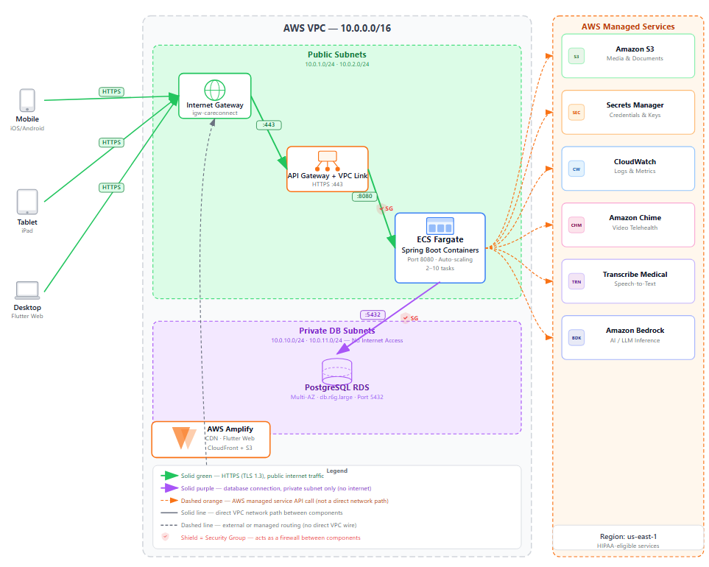
Figure 7.2: CareConnect AWS VPC Networking Diagram

7.1.4 Data Layer Resources
The primary data store for CareConnect is Amazon RDS PostgreSQL. The database persists application data including user accounts, patient records, communication artifacts, analytics information, and AI-generated summaries.
Key data-layer capabilities include:
- Managed PostgreSQL service.
- Database subnet isolation.
- Encrypted storage.
- Automated backup support.
- Secure access through VPC networking.

In addition to database resources, AWS Secrets Manager stores sensitive configuration values such as database credentials and JWT signing secrets.

7.1.5 Platform Services
Several AWS platform services support application deployment and operations. These managed offerings isolate infrastructure complexities from core application code, giving the platform automated scaling, uniform access controls, and comprehensive centralized monitoring right out of the box.

Amazon ECS: Amazon Elastic Container Service (ECS) provides container orchestration and runtime management for backend services. Applications are deployed using ECS Fargate, eliminating the need to manage underlying server infrastructure.

Amazon ECR: Amazon Elastic Container Registry stores versioned container images used during deployment workflows.

Amazon CloudWatch: CloudWatch provides centralized logging, monitoring, and operational visibility for application services and infrastructure resources.

AWS Identity and Access Management (IAM): IAM roles are used to control access to AWS resources, enabling secure interaction between ECS services, Secrets Manager, Parameter Store, and other platform services.

7.1.6 Runtime Service Architecture
Runtime application traffic follows a layered architecture designed to provide secure request handling, isolated data execution, and centralized operational visibility. The complete end-to-end processing lifecycle of an inbound client request flows through the following structured sequence:
- Client requests enter through Amazon API Gateway.
- API Gateway routes requests to ECS Fargate application containers.
- Application services process requests and execute business logic.
- Data is persisted within Amazon RDS PostgreSQL.
- Configuration values and secrets are retrieved from centralized management services.
- Logs and telemetry are published to Amazon CloudWatch.

This architecture supports scalability, fault isolation, centralized configuration management, and operational monitoring.

7.1.7 Security Considerations
The infrastructure architecture incorporates several security controls designed to establish a comprehensive defense-in-depth posture across all system boundaries. By embedding security directly into the cloud fabric, the platform strictly minimizes its attack surface while proactively isolating critical backend data domains. It includes the following:
- Network segmentation through public and private subnets.
- Security group enforcement.
- IAM-based access controls.
- Secret storage through AWS Secrets Manager.
- Configuration management through Systems Manager Parameter Store.
- Centralized logging and monitoring.
- Controlled database access paths.
These controls help protect application resources and sensitive healthcare-related information while supporting operational requirements.
TDD-B-7.1 Existing CloudFormation Architecture
Backend services are deployed through CloudFormation-managed infrastructure updates, with application builds triggering the deployment pipeline rather than manual releases. Environment-specific configuration values are managed through CloudFormation parameters and environment-scoped settings rather than hardcoded values. At the time of this document, Team B has not confirmed the existence of a dedicated testing stack separate from staging or production, which the following sections address.

TDD-B-7.2 Chime SDK Backend Connectivity
The Amazon Chime SDK was, through Milestone 2, the primary blocker preventing completion of several messaging and video-call E2E scenarios; connectivity has since been restored, as documented in Section 1.7.3, but the resolution requirements below are retained for reference.
Chime SDK functionality typically requires Amazon Chime SDK Meetings, Chime Messaging APIs, IAM permissions for meeting creation and management, and backend service endpoints for session creation and authentication.
As of Milestone 2, Team B had not independently verified that all required Chime SDK resources were provisioned and reachable from the test environment, which blocked approximately ten E2E scenarios involving messaging, voice, or video communication. Unblocking required confirming Chime SDK services were provisioned in AWS, verifying backend API endpoints were operational, validating IAM permissions and credentials, confirming CloudFormation templates included the required Chime resources, and providing Team B an accessible environment for E2E validation. All 10 blocked scenarios now pass as documented in Section 11.14.3.

7.2 ECS Fargate Backend Deployment
The Java 17 Spring Boot backend is containerized using Docker and deployed to AWS ECS Fargate. The deployment is fully automated via a GitHub Actions pipeline (backend-app-deploy.yml). Upon merging code to the main branch, the pipeline securely authenticates with AWS using OIDC, builds the application image, and executes CloudFormation scripts to update the Fargate service. This ensures the environment is provisioned consistently across dev, cfdemo, staging, and prod stages.

7.3 Frontend Deployment via Amplify
The Flutter web application is deployed via AWS Amplify. Amplify is configured to monitor the project's GitHub repository and triggers a build automatically whenever changes are pushed to the deployment branch. Amplify compiles the Flutter source code into optimized static assets and hosts them on a global Content Delivery Network (CDN) to ensure low-latency access for end-users.

7.4 Mobile Deployment Readiness
Mobile artifacts for Android and iOS are generated as part of the backend CI/CD build process. The pipeline utilizes the appropriate keystores and provisioning profiles stored in AWS Secrets Manager to sign the release binaries. Once validated, these APK/AAB and IPA files are prepared for distribution via the Google Play Console and Apple App Store Connect.

7.5 GitHub Actions CI/CD Pipeline
The CareConnect platform utilizes GitHub Actions to automate build, testing, deployment, and infrastructure delivery workflows. The CI/CD pipeline provides a repeatable deployment process that reduces manual effort, improves consistency between environments, and helps ensure application quality through automated validation activities.
The deployment pipeline supports both application and infrastructure changes, allowing source code, container images, and AWS resources to be managed through version-controlled workflows.

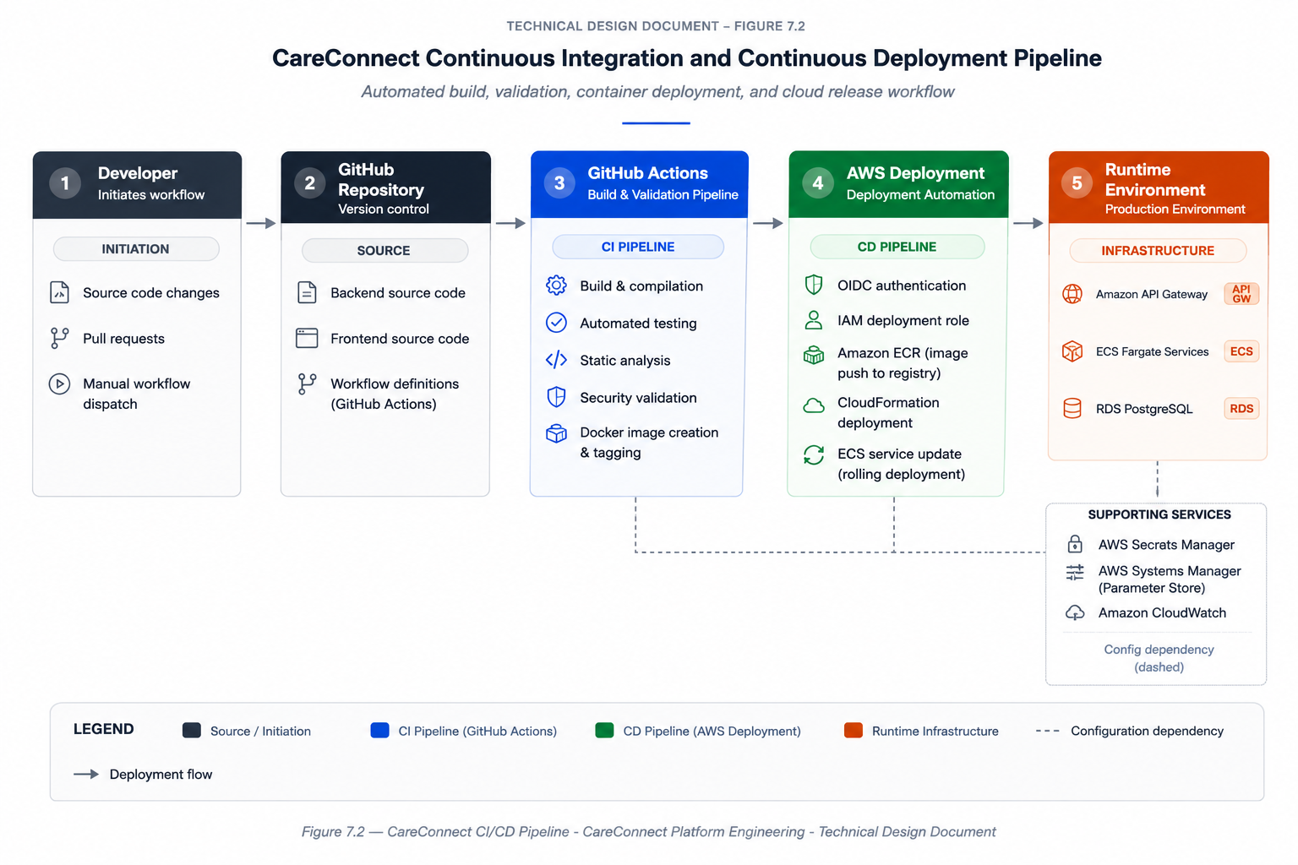
Figure 7.3: CareConnect Continuous Integration and Continuous Deployment Pipeline

Figure 7.3 illustrates the automated workflow used to build, validate, package, and deploy CareConnect application components. GitHub Actions orchestrates testing, security validation, container creation, and deployment activities, while AWS deployment services provision and update runtime infrastructure using secure OIDC-based authentication. The deployed runtime environment includes Amazon API Gateway, Amazon ECS Fargate services, and Amazon RDS PostgreSQL.

7.5.1 Pipeline Objectives
The CareConnect CI/CD pipeline was designed to support reliable, repeatable, and secure application delivery across multiple environments. By automating validation and deployment activities, the pipeline reduces manual effort while improving consistency, traceability, and overall software quality. The following objectives guided the design and implementation of the deployment workflow.
The CI/CD pipeline was designed to achieve the following objectives:
- Automate application build and deployment processes
- Validate code quality before deployment
- Support repeatable environment provisioning
- Reduce manual deployment errors
- Enable secure AWS authentication without long-lived credentials
- Support deployment across development, testing, and production environments
- Improve traceability through version-controlled deployment workflows

7.5.2 GitHub Actions Workflows
CareConnect utilizes GitHub Actions as the primary automation platform for building, validating, and deploying application components. Separate workflows are used to support application delivery, infrastructure provisioning, and environment management activities. The following table summarizes the primary workflows currently used within the project.

Table 7.1
Existing primary workflows
Workflow | Purpose
build-and-analyze.yml | Executes automated build and validation activities
backend-app-deploy.yml | Deploys backend application changes
backend-full-deploy.yml | Deploys backend application and infrastructure resources
Infrastructure deployment workflows | Provision and update AWS resources through CloudFormation

These workflows coordinate code validation, container creation, deployment orchestration, and AWS resource management.

7.5.3 Build and Validation Process
Prior to deployment, the CI/CD pipeline executes a sequence of automated validation and packaging activities designed to verify application quality and deployment readiness. These steps help identify defects early in the delivery process while ensuring that deployment artifacts are generated consistently across environments.
The CI/CD pipeline performs several automated activities prior to deployment:
- Source code checkout
- Dependency installation
- Application compilation
- Automated testing execution
- Static analysis and validation
- Container image creation
- Artifact publication
- Deployment execution

This automated process helps identify defects early and ensures deployment artifacts are generated consistently.

7.5.4 Container Deployment Workflow
CareConnect backend services are deployed using containerized workloads running on Amazon ECS Fargate. Containerization promotes consistency across environments while simplifying deployment, scaling, and operational management. The deployment workflow follows a standardized sequence of activities that move application artifacts from source code to production infrastructure.
The deployment process consists of:
- Build container image
- Push image to Amazon ECR
- Update ECS task definition
- Deploy updated task definition through CloudFormation workflows
- Launch updated ECS Fargate tasks
- Verify deployment health and runtime availability through Amazon API Gateway and AWS monitoring services
This approach enables consistent deployments while supporting rollback and environment isolation capabilities.

7.5.5 AWS Authentication
Secure authentication is a critical component of the deployment pipeline because CI/CD workflows require access to AWS infrastructure resources. To minimize credential management risks, CareConnect utilizes OpenID Connect (OIDC) federation rather than storing long-lived AWS access keys within repository configuration. This approach provides several security and operational advantages.
Benefits include:
- Reduced credential management overhead
- Improved security posture
- Temporary credential issuance
- Centralized IAM policy enforcement
- Reduced risk of credential leakage
The workflow assumes authorized IAM roles during deployment activities and receives temporary credentials required to interact with AWS resources.

7.5.6 Deployment Monitoring
Deployment success is verified through AWS service health checks and monitoring tools. CloudWatch logging and ECS service health indicators provide visibility into deployment status and operational health following release activities.

7.5.7 CI/CD Design Considerations
The CI/CD architecture was intentionally designed with future growth and operational maturity in mind. As the CareConnect platform evolves, additional automation, testing, security validation, and deployment controls may be incorporated without requiring significant redesign of the underlying pipeline. The architecture currently supports the following future enhancement opportunities:
The CI/CD architecture was designed to support future enhancements including:
Additional automated testing stages.
- Expanded infrastructure validation.
- Security scanning integration.
- Mobile application deployment automation.
- Environment-specific deployment approvals.
This design provides a scalable foundation for ongoing platform development and operational delivery.

Pipeline Architecture
The CareConnect CI/CD pipeline is built entirely via AWS CloudFormation and triggered through GitHub Actions. Team B's stages run alongside the shared pipeline and gate merges into Team B's own branches before code reaches the class-wide develop branch.
Pipeline triggers:
- Push to any feature/b-* branch: build and unit test stages only (about 5 minutes, fast feedback).
- Pull request into team-b-develop: full pipeline — build, unit tests, coverage gate, E2E, accessibility.
- Merge from team-b-develop to develop (Monday integration): Team B's own gates (unit, coverage, accessibility) must pass.
- Merge from develop to main (weekly release): full pipeline plus deployment, with Team A triggering the ECS Fargate rollout.

Table 7.2
CI/CD pipeline stages
# | Stage | Tool / Version | Actions | Failure Behavior
1 | Source Retrieval | GitHub Actions checkout | Pulls code; validates branch naming (feature/b-*); sets JAVA_HOME to JDK 17 | Branch naming violation fails immediately
2 | Build | flutter build, mvn build | Flutter build; Maven build (Spring Boot 3.x); dependency resolution; static analysis | Any compile error or lint failure blocks the PR
3 | Unit Tests | flutter_test (SDK 3.44.0), mvn test (JDK 17) | Runs all 466 flutter test files; runs mvn test in backend/core/ | Any test failure blocks the PR
4 | Coverage Report Generation | lcov, JaCoCo 0.8.x | flutter test --coverage -> lcov.info; mvn verify -> jacoco.xml; artifacts uploaded to S3 | Missing report artifacts fails this stage
5 | Coverage Gate Enforcement | Custom threshold script | Per-module check: 100% Shift Scheduling/EVV; 95% auth/other; 90% UI (warning only) | Failure message posted to the PR with module, actual %, required %
6 | E2E Tests | integration_test (SDK 3.44.0) | Flutter integration_test on Android emulator; Chime SDK v3.x tests | Any E2E failure not marked BLOCKED blocks the PR
7 | Accessibility Scan | axe-core 4.x, Flutter Semantics (SDK 3.44.0) | axe-core on the Flutter web build; Semantics tree validation | Critical/serious violations block the PR
8 | Artifact Storage | AWS S3 | Coverage reports (lcov.info, jacoco.xml) to S3; logs to CloudWatch | Non-blocking (warning only)
9 | Deploy (Team A) | CloudFormation API 2010-09-09, ECS Fargate | Runs only on merge to main after all Team B gates pass | Blocked if any prior stage failed

A PR into team-b-develop is blocked if any unit test fails, an E2E test fails without a documented BLOCKED root cause, a Hard Gate coverage threshold is not met, a critical or serious axe-core accessibility violation is detected, the build fails, or the required reviewer approval is missing. Merge into main additionally requires all Team B unit and E2E tests passing on team-b-develop, coverage gate compliance across all Team B modules, no unresolved Critical or Major defects open against Team B's own code, and Team Lead approval.
Pipeline secrets (staging backend URL, database credentials, JWT secret, and third-party IDs) are stored in GitHub Actions encrypted secrets rather than in workflow files.

Coverage Gate Configuration
Coverage enforcement uses two tools operating in parallel: the JaCoCo Maven plugin's built-in rule configuration fails the Maven build when backend thresholds are not met, and a custom threshold script evaluates lcov output for the frontend. The table below shows the enforced threshold and gate type per module category.

Table 7.3
Coverage gate thresholds by module category
Module Category | Line | Branch | Enforcement | Failure Behavior
Shift Scheduling | 100% | 100% | Hard Gate | Pipeline fails; PR blocked; error posted with specific files below threshold
EVV | 100% | 100% | Hard Gate | Pipeline fails; PR blocked; error posted with specific files below threshold
Authentication / Session | 95% | 95% | Hard Gate | Pipeline fails; PR blocked
Messaging / Chime SDK v3.x | 95% | 95% | Hard Gate | Operational — gate enforced from M3 Sprint 1 onward
Visual / UI Components | 90% | N/A | Warning Only | PR comment only; merge not blocked
All other modules | 95% | 90% | Hard Gate | Pipeline fails; PR blocked

The JaCoCo rule configuration in backend/core/pom.xml defines a check goal scoped to a package with 100% minimum line and branch coverage ratios for hard-gated packages; the equivalent frontend enforcement is implemented in a Python threshold script invoked in CI with per-module thresholds and the lcov report as input.

How the Gate Differs for Transactional vs. Visual Modules
The following table describes the gate differences in transactional versus visual modules for the dimensions of threshold, gate type, rationale, and error messages.

Table 7.4
Transactional vs. visual/UI gate comparison
Dimension | Transactional Modules (Shift Scheduling, EVV) | Visual / UI Modules
Threshold | 100% line and 100% branch — no exceptions | 90% line only — branch coverage not gated
Gate type | Hard Gate — blocks PR merge on any shortfall | Warning Only — posts a PR comment; merge proceeds
Rationale | Data loss or compliance failure risk; EVV records carry legal implications; scheduling conflicts carry patient safety implications | UI placement and rendering components are visually validated; full branch coverage on layout code provides diminishing returns
Error message | COVERAGE GATE FAILED, with specific file list, actual %, and required % | COVERAGE WARNING, with current % and 90% target; no merge block

Test Pipeline Infrastructure Requirements
To support Team B's automated testing strategy, additional infrastructure resources are required within the existing CloudFormation-managed environment. A dedicated staging or testing stack is preferred to prevent automated tests from impacting production or shared staging resources.
Additional resources may include:
- A dedicated S3 bucket for coverage reports and test artifacts.
- CloudWatch log groups for test execution logs.
- IAM roles supporting GitHub Actions deployment and reporting.
- Parameter Store or Secrets Manager entries for test credentials.
- ECS task definitions supporting automated E2E execution.
The CloudFormation deployment process should enforce Team B's testing gates prior to deployment approval. Implementation requires coordination with Team A to integrate Team B's testing stages into the deployment pipeline, configure artifact storage locations, grant access to staging resources, expose deployment status and test results, and support automated rollback behavior when critical testing failures occur.

7.6 Secrets and Configuration Management
The CareConnect platform utilizes centralized configuration and secret management services to securely provide runtime settings, credentials, API keys, and infrastructure parameters. The architecture separates sensitive configuration from application source code and supports secure deployment across multiple environments.
This approach improves security, simplifies environment management, and reduces the risk of credential exposure within development and deployment workflows.

7.6.1 Design Objectives
Effective configuration and secret management are essential for maintaining secure, reliable, and portable deployments across multiple environments. The CareConnect platform utilizes centralized configuration services and secure secret storage mechanisms to reduce operational risk while supporting automated deployment workflows. The following objectives guided the design of the configuration management architecture.
The configuration management architecture was designed to:
- Eliminate hard-coded credentials
- Support environment-specific configuration
- Securely manage secrets and sensitive values
- Simplify deployment across environments
- Reduce operational overhead
- Improve auditability and credential lifecycle management

7.6.2 Configuration Sources
Configuration data originates from multiple sources depending on whether the platform is running locally, within CI/CD pipelines, or in cloud-hosted environments. Separating configuration from application code improves security, simplifies environment management, and supports deployment flexibility. The following table summarizes the primary configuration sources used by the platform.
Table 7.5
Primary configuration sources
Source | Purpose
Environment Variables | Runtime application configuration
AWS Systems Manager Parameter Store | Centralized application parameters
AWS Secrets Manager | Secure secret storage
GitHub Repository Variables | CI/CD workflow configuration
GitHub Secrets | Secure deployment credentials and workflow secrets
Application Properties Files | Non-sensitive application defaults

These configuration sources work together to provide secure and flexible runtime behavior.

7.6.3 AWS Secrets Manager
AWS Secrets Manager serves as the primary repository for sensitive credentials and security-related configuration values. By externalizing secrets from application code and deployment artifacts, the platform reduces the risk of credential exposure while supporting centralized access management and auditing.
AWS Secrets Manager is used to store highly sensitive values including:
- Database passwords
- JWT signing secrets
- Service credentials
- Environment-specific secure configuration
During deployment, ECS task definitions retrieve required secrets from Secrets Manager and inject them into running containers.
Benefits include:
- Centralized secret storage
- Secret rotation support
- Fine-grained IAM access control
- Auditability and monitoring

7.6.4 AWS Systems Manager Parameter Store
AWS Systems Manager Parameter Store is used to manage application configuration values that do not require full secret protection but must remain centrally managed.
Examples include:
- Environment configuration values
- Service endpoints
- Feature configuration settings
- Runtime application parameters
The application loads these parameters during startup, enabling environment-specific behavior without requiring application code changes.

7.6.5 Runtime Secret Injection
During application startup, configuration values and secrets are retrieved and injected into running containers through a standardized initialization process. This workflow ensures that sensitive information remains external to source code while remaining available to application services at runtime.
The startup process follows these steps:
- ECS task launches.
- Secrets Manager values are retrieved.
- Parameter Store values are loaded.
- Environment variables are populated.
- Application startup validation executes.
- Runtime services initialize.

This process ensures sensitive values remain external to application code while supporting automated deployments.

7.6.6 Configuration Validation
Before application services become fully operational, startup validation routines verify that required configuration values are available and correctly configured. This process helps identify deployment issues early and prevents applications from running with incomplete or invalid settings.
Validation includes:
- Database connectivity settings
- JWT configuration
- AWS region configuration
- Secret availability
- Required environment variables
Applications fail fast when critical configuration is missing or invalid, reducing the likelihood of runtime failures.

7.6.7 Security Considerations
Protecting configuration data and secrets is a critical component of the platform's overall security posture. The configuration management architecture incorporates several controls that limit access, protect sensitive values, and support auditing and operational governance.
The configuration architecture incorporates multiple security controls:
- IAM-controlled access to secrets.
- Temporary deployment credentials through OIDC.
- Encrypted secret storage.
- Environment isolation.
- Controlled ECS task permissions.
- Centralized configuration auditing.
These controls help protect sensitive information while supporting secure deployment and operational workflows.

7.6.8 Future Enhancements
As deployment requirements evolve, the configuration management architecture can be extended to provide additional automation, governance, and operational visibility. Several enhancements have been identified that may improve scalability, maintainability, and security in future releases.
Future improvements may include:
- Automated secret rotation.
- Expanded configuration auditing.
- Enhanced environment validation.
- Additional deployment policy enforcement.
- Centralized configuration dashboards.

The current architecture provides a secure and scalable foundation capable of supporting future platform growth while maintaining strong security and operational practices.

7.7 Branch Strategy, PR Workflow, and Hotfix Process
TDD-B-7.7
Team B follows a structured Git branching model to maintain code quality and support continuous integration with the class-wide repository.
Branching model — development flow: feature/b-* -> team-b-develop -> develop -> main.
- feature/b-* — individual branches for testing features, test cases, accessibility tooling, and CI/CD enhancements.
- team-b-develop — Team B's integration branch; all feature branches merge here after review.
- develop — the shared class-wide integration branch; Monday merge target.
- main — stable release branch; milestone submissions and deployment.
Before opening a PR, contributors confirm local unit tests pass, coverage reports are generated, no critical linting errors remain, and the branch is current with its target.
The hotfix process is used exclusively for critical bugs discovered after a merge to team-b-develop or main, where the fix cannot wait for the next scheduled sprint cycle.
- A hotfix branch is warranted when: a Critical defect is discovered after merge to team-b-develop or main.
- The defect blocks milestone submission, breaks the CI pipeline for all team members, or causes data integrity issues.
- The fix cannot wait for the next scheduled sprint cycle.
Minor and Major defects follow the standard feature branch workflow (feature/b-*) and are not eligible for the hotfix process.
Hotfix steps: confirm the defect meets the Critical threshold; branch from the affected branch (team-b-develop or main), not from a feature branch, using a hotfix/b-<brief-description> naming pattern; implement the minimal corrective change without bundling unrelated work; run targeted regression on the hotfix branch before opening a PR; open an expedited PR targeting the affected branch; obtain the required minimum one Team B reviewer approval (Team Lead approval for infrastructure-affecting changes); merge once CI passes and approval is obtained, with no exceptions to automated gates; propagate the fix to all active feature/b-* branches; and close the corresponding GitHub Issue with a reference to the merging PR.
If a hotfix affects the shared develop or main branch, the Team Lead notifies Team A (DevOps) directly. If a hotfix touches the CloudFormation pipeline configuration, it requires review before merge. Hotfix branches are deleted after merge; there are no long-lived hotfix branches.

Table 7.6
Hotfix approval and propagation by scenario
Scenario | Target Branch | Approvals Required | Propagate To
CI pipeline broken on team-b-develop | hotfix/b-* -> team-b-develop | 1 teammate + Team Lead | All active feature/b-* branches
Critical defect on develop (post-Monday merge) | hotfix/b-* -> develop | Team Lead + Team A awareness | team-b-develop + all feature/b-*
Production defect on main | hotfix/b-* -> main | Team Lead + Team A (deployment impact) | develop + team-b-develop + all feature/b-*

7.8 Deployment Environments
When 03-platform.yaml changes Bedrock, SSM, or KMS permissions used by Ask AI embeddings, operators must update the platform stack and force a new ECS deployment. App-only redeploys refresh the service image without refreshing IAM. After an app-only pass, CorsAllowedList must still include the Amplify origin or the hosted welcome page reports backend unhealthy even when curl health checks succeed.
Environment | Purpose | Owner / Status
Development | Daily coding, unit testing, service testing, and mock-first workflow validation | Team D / active
Test | Validation before classwide integration, API contract checks, and controlled non-production integration verification | Shared pipeline support with Team D validation
Final Demo | Stable demonstration of approved workflows and shared hosted release candidate | Shared platform ownership with Team D feature validation
Test (Team E AI) | AWS validation for Ask AI, summaries, and mail before class-wide integration | Team E / Planned
Final Demo (Team E AI) | Milestone demonstration environment for grounded retrieval and mail flows | Team E / Planned

7.9 Rollback Procedure
Backend rollback returns ECS to a prior ECR image tag with a forced service deployment. Platform IAM rollbacks redeploy the previous 03-platform.yaml changeset. Retrieval index rows already written for a source_record_id are replaced on re-ingest rather than automatically undone when an image rolls back.
If a Team D change causes a failed build, broken protected route, invalid state transition, unstable workflow, or unsafe external-service behavior, the response will be to stop forward promotion, identify the offending build or configuration change, and restore the last known stable version through the shared pipeline. Any provider-specific endpoint or feature flag contributing to the defect should be returned to mock, preview, or approved sandbox mode until corrected. After restoration, the team must run smoke checks across login and role protection, EVV core flows, invoice review, invite handling, and any impacted document or assessment APIs before declaring recovery complete. The defect, rollback action, and required remediation should then be documented before another deployment attempt is made.

8. Security Design
This section describes how CareConnect protects authentication, authorization, transport, stored data, and AI-related input/output across Team A’s full work breakdown (video calls, telemetry, Bedrock/Claude, deployment, RBAC). Controls are classified as implemented (inherited codebase, validated for M2), designed for M2 (documented and aligned with deployment/AI work), or planned (M3–M4 per project schedule).

Scope boundary Note: Team A owns the Spring Boot backend (backend/core/) and AWS deployment templates. The SWEN 661 team builds the primary Flutter UI and consumes Team A APIs, while Team A validates and integrates it. Client-side items are noted under Client (Flutter) so they can be budgeted separately or coordinated with 661.

8.1 Overview
CareConnect processes healthcare-oriented data: user profiles, care-circle relationships, video call transcripts, optional recordings, documents, invoices, and AI-generated summaries. Security design follows defense in depth, such that every protected API and WebSocket connection requires authentication, authorization is enforced on the server, sensitive data is encrypted in transit in deployed environments and at rest in AWS and AI paths apply input/output controls. Team A will close security and privacy gaps called out in the project plan, such as incomplete RBAC for care-circle personas, inconsistent authorization on sensitive resources, telemetry that could admit identifiers, AI paths without uniform sanitization, and deployment documentation that does not yet fully describe production transport and store protections.

8.1.1 Security Objectives
Table 8.1 summarizes security objectives mapped to WBS tasks and milestones. Each row states what Team A will deliver for authentication, authorization, telemetry privacy, AI safety, deployment transport, and HIPAA-aligned handling before production merge of sensitive call and AI features.

Table 8.1
Describes the planned outcomes, associated WBS points, and associated Milestones.
Objective | Planned outcome | Primary WBS | Milestone
Authenticate callers | Retain stateless JWT + BCrypt; no change to mechanism unless WBS is updated | (inherited) | —
Authorize by role and care-circle | PHYSICIAN and REPRESENTATIVE roles; DB-backed permissions; middleware + method security | WBS 3.9 | M3
Delegate feature access | Caregivers grant/revoke feature flags via API; UI consumes API | WBS 3.10.1 | M3 (API)
Protect video and transcripts | Harden participant checks; multi-attendee registry; encrypted recording pipeline | WBS 3.1 | M3
Telemetry privacy | Enforce Team A telemetry content standard; admin dashboard | WBS 3.6 | M2 doc / M3 dev
Safe AI usage | Sanitize all Bedrock entry points; document cross-team Bedrock setup | WBS 3.7 | M2 doc / M3 dev
Secure deployment | Document and validate HTTPS ingress, Fargate layout, app-store security research | WBS 3.8 | M2 doc / M3 dev
HIPAA-aligned handling | Access control, encryption in transit/at rest in AWS, audit-friendly telemetry | Plan 6.3, WBS 1.8.1 | M2–M4

8.1.2 Inherited baseline
The inherited codebase already provides Spring Security with a stateless JWT filter chain, BCrypt password hashing, OAuth routes, RolePermissionService mappings for ADMIN/CAREGIVER/PATIENT/FAMILY_MEMBER, HSTS/CORS headers, partial transcript participant checks, Chime integration, dev telemetry routes, and input/response sanitization on the primary AI chat path. Team A plans to audit, extend, and harden per WBS.

8.2 Authentication Flow
Section 8.2 documents authentication and planned RBAC authorization flows: inherited JWT, BCrypt, and OAuth behavior, planned hardening actions, new care-circle roles, database-backed permission storage, middleware enforcement, and grant/revoke endpoints.

8.2.1 Current Implementation
The following reflects the repository before Team A modifications, and it is the baseline that serves as the foundation for the upcoming identity and access control enhancements, documenting the existing authentication mechanisms and security posture that will be maintained or extended throughout the project lifecycle.

Authentication model:
- Stateless JWT: SessionCreationPolicy.STATELESS; no server HTTP session.
- Login: POST /v1/api/auth/login → AuthService (BCrypt) → JwtTokenProvider issues JWT.
- Request validation: JwtAuthenticationFilter reads Authorization: Bearer <token>.
- WebSockets: CallNotificationHandler and CareConnectWebSocketHandler validate JWT on connect.
- OAuth: /oauth/ public; CustomOAuth2UserService maps to CareConnect user and ROLE_* authority.

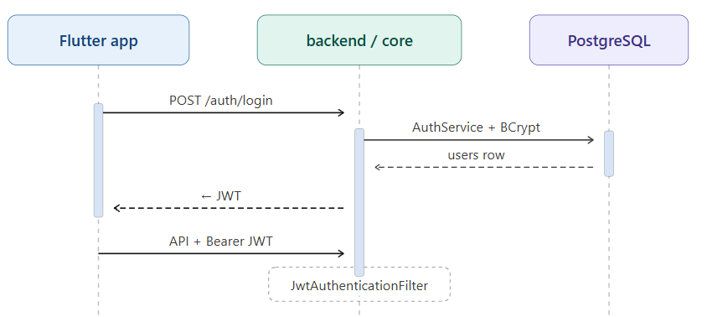
Figure 8.1: Illustration of the current implementation of the auth flow.

Sessions are stateless (SessionCreationPolicy.STATELESS), meaning the server does not keep an HTTP session cookie. Instead, the JWT is the proof of login.

Inherited Token and local integration settings
The system relies on a standardized collection of environment variables and properties to manage local development configurations and cryptographic operations. These baseline parameters establish predictable runtime defaults for server routing, token lifecycles, and cross-origin security while ensuring seamless communication between the Flutter client and the Spring Boot backend.

Table 8.2
Token and local integration settings
Setting | Source | Inherited value / rule
Active profile | spring.profiles.active | dev for local work
HTTP port | SERVER_PORT → server.port | 8081 per team local guide (8080 default in application.properties)
JWT secret | SECURITY_JWT_SECRET → security.jwt.secret | Base64 in backend/core/.env; ≥ 256-bit decoded for HS256
JWT lifetime | jwt.expiration.ms | 10800000 (3 hours) in application-dev.properties
CORS (dev) | careconnect.cors_allowed | http://localhost:*
Flutter backend URL | --dart-define=BACKEND_URL | http://localhost:8081 recommended; empty define falls back to 8080
Token storage | Flutter app | flutter_secure_storage

Inherited Roles
- Administrator: ROLE_ADMIN
- Caregiver: ROLE_CAREGIVER
- Patient: ROLE_PATIENT
- Family member: ROLE_FAMILY_MEMBER

Inherited HTTP policy
- Public: /v1/api/auth/, password reset/setup paths, /oauth/, Swagger, /actuator/, selected billing/address/test routes, OPTIONS /, /ws/ handshake, /v1/api/invoices/extract-llm, dev POST /v1/api/dev/telemetry.
- Admin-only examples: /v1/api/debug/, dev telemetry admin GET/PUT.
- Default: remaining /v1/api/, /v2/api/, /v3/api/, /api/ require authentication.

Detailed path lists remain in SecurityConfig.java until Team A publishes an updated matrix after RBAC work (M3).

8.2.2 Planned Implementation
Team A will not change the core authentication mechanism (JWT + BCrypt + OAuth) in WBS scope. Instead, the team will ensure all new endpoints and WebSocket handlers introduced by WBS work require authentication consistent with the inherited filter chain.

- Document login/JWT/WebSocket flow in TDD (this section).
- Verify dev setup: SECURITY_JWT_SECRET (Base64, ≥256 bits), backend on expected port (8081 per team guide).
- List public vs protected routes at high level (SecurityConfig permitAll vs authenticated).
- Tighten password-reset security; review all permitAll endpoints; reduce secret leakage in samples/logs.

Table 8.3
Planned actions
Item | Planned action | WBS | Milestone
JWT on new APIs | All Team A REST and WS surfaces require valid JWT unless explicitly documented public | Cross-cutting | M3
Token handling documentation | Document required SECURITY_JWT_SECRET, BACKEND_URL, and release https:///wss:// expectations in deployment and analytics guides | WBS 3.7.4, 3.6.8–3.6.10 | M2

8.2.3 Planned Authorization and RBAC (WBS 3.9)
Team A will implement SRS F-08 and WBS 3.9-3.10 so authorization is enforced in backend middleware and method-level security, not in the Flutter app alone.

8.2.3.1 Role Model
Team A will add care-circle roles required by the SRS and project plan. These expanded role mappings will establish fine-grained authorization boundaries to ensure users can only access patient clinical records and application functionalities permitted by their specific care circle assignments.

Table 8.4
New roles
Role | Enum / authority | Description
PHYSICIAN | ROLE_PHYSICIAN | Licensed clinician in the care circle; read/write per permission matrix
REPRESENTATIVE | ROLE_REPRESENTATIVE | Delegated access to specific features (e.g., medications, invoices)

Existing roles (ADMIN, CAREGIVER, PATIENT, FAMILY_MEMBER) remain. Team A will update Role, UserDetailsServiceImpl, JWT/OAuth authority mapping, and permission maps accordingly (WBS 1.7, 2.5).

8.2.3.2 Permission Storage
Per WBS 2.5 and 3.9, Team A will shift the platform away from hardcoded role mappings to a dynamic, database-driven model that supports real-time access changes. The implementation will complete the following for permission storage:
- Design normalized RBAC tables (roles, permissions, role-permission assignments, optional user-feature grants).
- Ship Flyway migration(s) for the schema.
- Extend RolePermissionService (and related services) to load permissions from the database rather than static maps alone, preserving backward compatibility during migration.

8.2.3.3 Enforcement Mechanism
Team A will use both authorization middleware as a central filter or handler interceptor that evaluates care-circle relationship and feature permission before controller execution (WBS 3.9.2), as well as method-level security with @PreAuthorize / @PostAuthorize on controllers and services for fine-grained rules (WBS 3.9.2).

Care-circle read/write rules per feature will be documented in the permission matrix and applied in code (WBS 2.5.2, 3.9.3 – 3.9.4). Team A will verify rules against HIPAA access expectations (WBS 3.9.4).

8.2.3.4 Grant and Revoke Feature Access
Team A will allow only caregivers who are linked to a patient’s care circle to grant or revoke delegated feature access (for example medications or invoices). Patient self-service for delegate grants is out of scope unless the project manager directs otherwise. Grant and revoke will be exposed as REST endpoints per WBS 2.5.3 and 3.10.1, operating on a target user within a patient context.

This TDD specifies the request/response contract and server-side enforcement only. The frontend team working with the owner of WBS 3.10.2 will implement Flutter toggle UI that calls those endpoints. On every protected API call, the server will re-evaluate granted permissions, while client UI state is never authoritative for authorization.

Planned API Sketch
POST /v1/api/care-circle/{patientId}/permissions/grant
POST /v1/api/care-circle/{patientId}/permissions/revoke
GET /v1/api/care-circle/{patientId}/permissions
Authorization: Bearer <JWT> (caller must be CAREGIVER for patient)
Request body: { "targetUserId": "<uuid>", "feature": "MEDICATIONS" | "INVOICES" | ... }

Team A will publish OpenAPI entries during WBS 2.5.3.

8.2.3.5 RBAC Deliverables and Milestones
This section outlines the structured timeline and specific engineering outputs required to implement the dynamic Role-Based Access Control (RBAC) framework. Each work package maps discrete deliverables to target project milestones to ensure incremental validation, thorough testing, and timely deployment of the updated security architecture.

Table 8.5
RBAC Deliverables
WBS task | Planned deliverable | Milestone
1.7.1 - 1.7.2 | Role/permission gap analysis and matrix | M2
2.5.1 & 3.9.1 | RBAC schema + Flyway | M3
3.9.2 | Middleware + @PreAuthorize coverage on in-scope controllers | M3
1.7.4, 2.5.2, 3.9.3 - 3.9.4 | Care-circle rules for all personas including new roles | M3
2.5.3, 3.10.1 | Grant/revoke API + tests | M3
3.10.2 | Flutter toggles | M3
4.5 | Unit and integration tests | M3
All RBAC docs | Updated permission matrix in repository docs | M4

8.3 Transport Security
The CareConnect platform implements a rigid transport security framework to protect all data in transit from eavesdropping, tampering, and man-in-the-middle attacks. By enforcing encrypted communication channels across both public and private network boundaries, the system ensures that sensitive health information remains entirely confidential during transmission. This multi-layered transport architecture relies on industry-standard cryptographic protocols and strict web security headers to guarantee data integrity across all client-server interactions.

8.3.1 Current implementation
The baseline transport layer relies on standard web security headers and localized routing patterns to protect early-stage deployment iterations. These initial configurations focus on preventing common web vulnerabilities while laying the groundwork for end-to-end encryption in production. The current implementation includes the following security controls and environment baselines:
- API chain sets HSTS (365 days), X-Frame-Options: DENY, content-type options, CORS via CorsConfigurationSource.
- CSRF disabled for stateless JWT APIs.
- Local dev uses HTTP / ws://; deployed design targets ALB HTTPS → ECS Fargate (cloudformation-fargate/).

8.3.2 Planned Transport Security (WBS Deployment)
This section outlines the scheduled engineering tasks and deliverables required to transition CareConnect from local HTTP configurations to a production-grade, encrypted transport layer. These milestones ensure that all client-server traffic strictly adheres to modern mobile platform security standards and cloud ingress protection policies.

Table 8.6
Planned transport security
Planned action | Detail | Milestone
Document production URL scheme | Flutter app must use https:// and wss:// | M2
Validate HTTPS listener | Confirm CloudFormation listener and deployment guide alignment (WBS 1.4.6 - 1.4.7) | M3
HTTPS-only ingress | Treat non-TLS client access to production API as out of policy; document in deployment guide (Plan 6.4) | M3
App store transport expectations | Document iOS ATS and Android cleartext policies in app-store checklists (WBS 1.5 - 1.6) | M2 doc

8.4 Data Encryption
The CareConnect platform enforces a strict cryptographic framework designed to safeguard sensitive data both at rest and in transit, ensuring comprehensive compliance with HIPAA privacy standards. By utilizing industry-standard encryption algorithms and automated key management, the platform neutralizes the risk of unauthorized data exposure across all storage volumes, object repositories, and database schemas. This defensive layer guarantees that protected health information (PHI), user credentials, and operational logs remain completely unreadable to unauthorized entities throughout their entire lifecycle.

8.4.1 Current Implementation
Inherited data protection covers several assets. PostgreSQL runs in local Docker for development. When deployed via the Fargate stack, RDS is encrypted. Files and uploads use local storage in dev (app.file.storage.use-s3=false). With AWS storage enabled, they go to S3 with KMS. Call recordings and archives follow the Chime/KVS/S3 pipeline when AWS is enabled, with transcript rows in the database and an optional S3 archive. Transcript access is enforced by CallTranscriptService.hasTranscriptAccess and participant checks in CallController. Local secrets live in backend/core/.env, which is gitignored.

8.4.2 Planned Data Protection (WBS Video Call and Deployment)
This section details the upcoming engineering milestones and security measures required to fortify the platform's data storage and transmission channels. These planned activities focus on robust transcript authorization, secure multi-attendee tracking, and fully documented AWS encryption parameters to ensure complete compliance across all runtime environments.

Table 8.7
Planned data protection
Planned action | Detail | WBS | Milestone
Harden transcript authorization | Consistent participant (and role) checks on all transcript read/write/summary paths; reject cross-call access | 3.1 | M3
Caregiver-only conference invite | Preserve and test caregiver-only invite rule | 3.1 | M3
Multi-attendee registry | CallAttendee persistence, idempotent join, conference notification fixes | 3.1, 3.2 | M3
Recording pipeline security | KVS pool, IAM least privilege (CCAPPROLE), encrypted S3 buckets, post-transcription deletion of per-attendee artifacts | 3.2 | M3
S3 presigned URL hardening | CORS and Accept-Ranges for byte-range playback | 3.2, 3.3 | M3
HIPAA gate | Formal review before production merge of recording/summary features | 1.8 | M2 doc / M4 sign-off
Deployment encryption documentation | Document RDS SSE, S3 KMS, and in-transit TLS in operations guide | 2.4 | M2

8.4.3 Planned Client Credential Handling
Team A will document that the Flutter app continues to store JWTs in flutter_secure_storage and must not log tokens. Release builds will be documented to require secure backend URLs (WBS 1.6).

8.5 Input and Output Sanitization
The CareConnect platform incorporates a rigorous input and output sanitization framework to neutralize common application-layer vulnerabilities, such as Cross-Site Scripting (XSS), SQL injection, and malicious data payloads. By validating and cleaning all structured data at the application perimeter and intercepting dynamic outputs before they are processed by internal services or AI components, the system maintains strict data integrity and runtime security. This multi-layered validation strategy forms a core piece of the platform's defense-in-depth posture, ensuring that both human-generated inputs and machine-generated strings comply safely with system expectations.

8.5.1 Current Implementation
The current iteration of the platform deploys focused, localized validation filters across critical communication and intelligence interfaces rather than a generalized global filter pipeline. These early-stage controls ensure that dynamic, user-generated string inputs and complex machine-orchestrated data payloads are sanitized prior to execution or rendering. The baseline architecture establishes the following immediate security boundaries:
- InputSanitizationService and ResponseSanitizationService on AI chat (DefaultAIChatService)
- JsonSanitizer for invoice LLM JSON
- Transcript ingest limits in CallTranscriptService
- careconnect.ai.enabled supports graceful AI degradation when Bedrock is unavailable

8.5.2 Planned Sanitization (WBS Bedrock and Call Summaries)
This section outlines the scheduled enhancements and validation milestones required to scale the platform's sanitization framework across all intelligent data pipelines. These target actions focus on hardening large language model integrations, protecting logs from accidental health information leakage, and ensuring user interfaces safely handle machine-generated insights.

Table 8.8
Planned Sanitization
Planned action | Detail | Milestone
Extend sanitization to all Bedrock paths | Apply input/output sanitization to CallSummaryService, BedrockSentimentService, and any new Bedrock prompts added in WBS 3.4.1 | M3
Maintain careconnect.ai.enabled | Document operational procedure; no behavioral change planned unless defect found | M2 doc
SOAP / risk / action-item prompts | Review prompts for PHI leakage in logs; structured JSON only to clients | M3
Voice condition flags (WBS 3.5) | Disclaimers in UI copy; HIPAA storage notes per WBS 3.5.10 - 3.5.12 | M2 doc / M3

8.6 Telemetry Content Standard Policy (WBS Telemetry)
To preserve data integrity and prevent structural non-compliance, the platform enforces strict data sanitization rules at the client and ingestion boundaries. This standardized classification framework guarantees that diagnostic tracking and behavioral metrics are captured seamlessly without ever risking the exposure of sensitive patient records. Team A will adopt and document the following standard for all new and expanded telemetry (WBS 3.6):

Table 8.9
Telemetry Content Standard
Rule | Requirement
No direct identifiers | Events must not contain email, legal name, phone, address, date of birth, medical record number, or free-text clinical content.
User reference | Only opaque userId (UUID) already used by the application.
Session reference | Opaque sessionId; no device serial numbers.
Error messages | Stack traces and messages scrubbed of paths and tokens; no patient names in message fields.
Network metadata | IP addresses stored truncated (/24) or hashed; not used for profiling.
Geo | No GPS coordinates in analytics events.
Retention | Dev ingest: 90-day rolling retention documented; production analytics retention defined in WBS 3.6.9 before M4.
Access | Query/export of raw telemetry limited to ROLE_ADMIN (inherited dev routes pattern extended to production analytics APIs).

8.7 Summary of Security Controls by Work Package
This section provides a consolidated matrix that maps the platform's security enhancements directly to their respective engineering work packages and development milestones. By aligning critical themes, such as transcript hardening, telemetry sanitization, and role-based access controls, with specific project timelines, Team A ensures that verification gates and compliance checks are systematically integrated into each release cycle.

Table 8.10
Summary of Security Controls
Feature | Security theme | M2 (doc) WBS | M3 (dev) | M4 (finalize)
Video | Transcript hardening, attendee registry, KVS/IAM/S3, caregiver invite, clip playback URLs | 1.1 &1.8 | Implement 3.1–3.5 security tasks | Verify tests + gate
Telemetry | PII standard, system map, dashboard design, analytics doc | 1.2, 2.2.1, 3.6.8 - 3.6.11 | 1.2.6, 3.6.7 | Doc vs code alignment
Bedrock | IAM/quota/setup guides, cross-team doc | 1.3.5 - 1.3.10, 3.7.4 | Sanitize all Bedrock paths | Integration sign-off
Deployment | Process doc, app-store security research, HTTPS validation | 1.4 - 1.5 | 3.8 infra templates | Release readiness
RBAC | Permission matrix | This document 6.1.3 | Roles, Flyway, middleware, grant/revoke API | Matrix + OpenAPI current

8.8 Logging and Monitoring
Ask AI audit events record requester identity, patient scope, denied-scope 403 outcomes, citation source identifiers, and model identifier without persisting full PHI prompts in clear text. IndexWorker logs warnings or errors when rows dead-letter or when the Bedrock runtime client is unavailable so embedding gaps remain operable.
The mobile application follows security best practices to protect user sessions and locally stored information. Authentication tokens and other sensitive session data are stored using platform-supported secure storage solutions. Automatic session expiration and inactivity controls help reduce the likelihood of unauthorized access if a device is lost, stolen, or left unattended.

9. Performance and Scalability
Chapter 9 describes performance and scalability objectives, horizontal scaling strategy (ECS Fargate, RDS failover), and CloudWatch monitoring used to validate SRS latency and uptime targets in deployed environments.

9.1 Performance and Scalability Objectives
To guarantee a responsive and seamless user experience, the CareConnect platform is bound to strict performance thresholds and high-availability targets. The system architecture enforces an upper latency limit requiring all standard API endpoints to process requests and return payloads in under 300 milliseconds under normal operating loads. For real-time communication workflows, the media signaling and routing infrastructure must optimize negotiation paths to ensure that interactive video call connections are fully established in under 3 seconds from initiation.

To support these responsive benchmarks without degradation, the core production environment is engineered for high availability, targeting a minimum systemic uptime of 99.9%. Achieving this operational standard requires a combination of automated failover protocols and continuous health monitoring to eliminate single points of failure across the platform's infrastructure.

9.2 Scalability Strategy
The CareConnect platform leverages elastic cloud infrastructure to dynamically accommodate fluctuating transaction volumes, ensuring sustained performance during peak utilization periods. The primary scaling vectors are managed across separate application and data tiers to eliminate computing bottlenecks:

Horizontal Application Scaling: The backend microservices runtime is deployed on Amazon Elastic Container Service (ECS) using AWS Fargate for serverless container orchestration. Automated scaling policies are configured to track real-time resource indicators, such as CPU utilization and memory thresholds. When application traffic spikes, the cluster programmatically provisions additional container instances to balance the network load across the infrastructure grid.

Database High Availability and Resilience: The persistence layer relies on a PostgreSQL engine deployed via Amazon Relational Database Service (RDS). This structural configuration establishes synchronous data replication between a primary database instance and a physically isolated standby instance in a separate zone, guaranteeing automated failover capabilities and continuous operational availability in the event of an infrastructure or localized sector outage.

9.3 Performance Monitoring
The platform utilizes Amazon CloudWatch as its centralized observability and monitoring solution to maintain continuous visibility over systemic health and operational performance. CloudWatch agent integrations continuously collect and aggregate system-level metrics, application runtime logs, and performance indicators across the containerized environment.

Automated alarm thresholds are configured to detect anomalies in real time, including prolonged API latency spikes, elevated HTTP error rates, and critical memory or CPU utilization ceilings. Upon breach of any predefined threshold, CloudWatch triggers immediate notification workflows to alert the engineering team, enabling proactive incident response and rapid mitigation before end-user workflows are impacted.

9.4 Bottleneck Mitigation
Indexing claim leases (default ten minutes) cover Titan embedding work that runs after the ingest transaction commits. Unimplemented visit-summary work uses a multi-hour no-burn park so polls do not reclaim the same outbox row every fifteen seconds. Embedding batches retry on throttle, and hybrid retrieval remains bounded by RBAC scope and top-k reciprocal-rank fusion.
To sustain performance, specific mitigations include:
- Database Optimization: Comprehensive query indexing; connection pooling via HikariCP (explicitly named in SRS).
- Caching: Redis Cache (SRS-confirmed active component) is used to reduce DB load for frequently read data (e.g., role definitions, unchanged care plans).
- Payload Processing: Uploaded images are compressed prior to AWS Textract OCR; EDI exports are batched; Bedrock prompts are dynamically size-optimized to prevent token-limit exhaustion.
Additional Responsibilities
Beyond the core TDD sections, the QA / Security Lead assumes oversight for the following continuous lifecycle tasks. Per Project Plan v2.0 §3.2.9, Team A owns the CI/CD pipeline platform itself; Team D supplies the test artifacts and security gates that run on it. Per the v2.0 §10.1 roles table, the QA / Security role is Responsible for “testing workflows, regression testing, defect verification” and is Responsible for Testing & QA and Documentation in the §10.2 RACI matrix.
- Security Reviews: Conducting per-sprint threat modeling exercises using the STRIDE methodology (Team D extended decision) for all newly designed features.
- Vulnerability Scanning (Project Plan v2.0 §6): Running dependency scanning, static analysis, and container/image scanning in CI before every release, plus targeted penetration-style test scenarios for high-risk workflows (EVV submission, AI invoice approval, PHI export).
- Test Planning: Authoring the Software Test Plan (Milestone 2 deliverable, due 06/13/2026 per Project Plan v2.0 §5) covering unit, integration, contract, End-to-End (E2E), security/penetration, and performance/load testing scenarios. A refreshed Software Test Plan is also a Milestone 3 deliverable (due 07/25/2026), bundled with the Programmer Guide and Deployment & Operations Guide.
- Performance Validation: Executing load-test baselines at the conclusion of each milestone to verify SLA adherence using JMeter (primary) and k6 (CI smoke tests). Both tools are Team D extended decisions; Project Plan v2.0 does not name a specific load-testing tool.
- Traceability Review: Maintaining the SRS REQ-ID → TDD component → test-case mapping matrix to demonstrate full requirements coverage in the Test Report (Milestone 4, 08/04/2026 per Project Plan v2.0 §5).
- Risk Register Alignment: Reviewing test coverage against Project Plan v2.0 §8.2 risks — particularly(PHI/AI data leak),(token replay), and(EVV aggregator access) — to ensure each risk has at least one corresponding test case before each milestone gate.

Team E bottleneck mitigation for Ask AI indexing and retrieval
Table 9.4
Potential Bottleneck | Impact | Mitigation Strategy | Implementation
LLM inference latency | Slow Ask AI answers | Minimize context; cache embeddings; stream where practical | Gateway minimization; pgvector prefilter
OCR throughput | Slow mail processing | Metadata-first; async OCR with progress states | Textract fallback only when needed
Index refresh lag | Stale retrieval | Async indexing within the freshness target | Outbox IndexWorker + claim lease covering embedding
Cloud cost spikes | Budget risk | Weekly billing review; lifecycle rules; scale-to-zero where possible | AWS budgets/alerts

10. Error Handling
The platform implements a centralized fault-tolerance architecture designed to intercept unhandled exceptions gracefully across the execution runtime. To prevent stack trace exposures and information leakage, a global error handling interception layer captures all uncaught application exceptions before they propagate to the client application.

This mechanism sanitizes outbound response payloads, translating raw, internal system faults into generic, developer-friendly error messages that abstract away database schemas, microservice dependencies, and internal code implementations. By strictly decoupling runtime debugging data from client-facing responses, the platform ensures that private infrastructure details and sensitive metadata remain protected against profiling and reverse-engineering vectors.
To prevent sensitive data leakage while providing actionable debugging information, CareConnect utilizes a globally standardized error response envelope. The global Spring @ControllerAdvice exception handler intercepts all thrown exceptions and sanitizes them before reaching the Flutter client.
- HTTP Status Codes: 400 (Bad Request), 401 (Unauthorized), 403 (Forbidden), 404 (Not Found), 409 (Conflict), 422 (Unprocessable Entity), 429 (Too Many Requests), 500 (Internal Server Error), 503 (Service Unavailable).
- Resiliency: External dependencies (AWS Bedrock, Chime, wearable APIs) are wrapped using the Resilience4j circuit-breaker library. Transient failures trigger retry/backoff with jitter.
- Offline Error Queuing: EVV actions occurring during network disruption are locally queued in the Flutter client within the SRS-mandated 24-hour offline window (SRS §2.4.3 / §6.4) and synchronized later. After 24 hours, forced re-authentication is enforced per SRS.

SECURITY NOTE
Internal stack traces and PHI are NEVER serialized into the details or message fields of an API error response.

{
"timestamp": "2026-06-12T14:32:01.123Z", "traceId": "1-67891234-abcdef1234567890", "code": "ERR_409_CONFLICT",
"message": "The EVV Check-in record conflicts with an existing entry.", "details": [
"Visit ID already has an active check-in timestamp."
]
}

11. Testing Strategy
Chapter 11 defines Team A's Test-Driven Development strategy for the inherited codebase. This includes the objectives, WBS-scoped test focus, unit and integration patterns, CI tooling, coverage expectations, inherited suite inventory, and defect closure rules referenced by the Software Test Plan.

TDD-B-11 - Testing, Quality Assurance, and Accessibility Design
This section assembles Team B's team-owned technical design for CareConnect quality assurance: testing tooling, code coverage strategy, CI/CD coverage gates, branch and hotfix workflow, Milestone 2 prototype results, accessibility and VPAT compliance planning, and testing-scope security and performance considerations. A small number of factual conflicts in the source Team B document — including references to a MySQL production database, an Application Load Balancer, and a DeepSeek LLM integration, none of which match the canonical stack described in Chapters 2 and 3 or the class formatting guide — were intentionally excluded pending resolution in a live cross-team session, per the SOP's guidance that interface mismatches are engineering conflicts and not something to settle by silently editing paragraphs.

11.1 Testing Objectives
Our testing strategy is designed for an inherited system, not a greenfield build. We use Test-Driven Development to reduce regression risk while implementing the approved Work Breakdown Structure (WBS) scope, with emphasis on high-risk call workflows, transcript and recording processing, AI-assisted condition detection, and deployment-sensitive behavior. The primary quality objectives are functional correctness, security and authorization integrity, data-handling safety for sensitive call artifacts, and integration stability across backend APIs, AWS-dependent services, and Flutter clients.

Test-Driven Development is operationalized as a strict red-green-refactor loop at feature granularity, meaning we encode expected behavior from WBS acceptance intent in failing tests first, implement the minimal code to pass, then refactor while keeping those tests as regression guards. The same discipline applies to backend Java services and Flutter clients.

11.2 Scope of Testing
This strategy covers all five top-level WBS areas in the Team A project plan, plus inherited behavior those areas touch. We perform feature-level unit and integration validation before external handoff. Broader system UAT may remain downstream, but each WBS section must have reproducible pass/fail evidence.

Table 11.1
Areas of testing focus
WBS | Feature Area | Primary test focus
4.1 | Video call leftover features | Participant/conference handling, speaker ID/KVS, sentiment clip playback, SOAP summaries, AI voice condition detection, HIPAA gate
4.2 | Telemetry and analytics | page/feature/sync/error/session events, admin analytics dashboard, PII guardrails
4.3 | Bedrock / Claude support | Access needs
4.4 | Deployment | Architecture and CI/CD mapping, CloudFormation/KVS/SSM/IAM validation
4.5 | RBAC | schema + authorization middleware, care-circle permission matrix, grant/revoke feature access

TDD-B-11.2 - Scope Within Architecture
Team B does not own CareConnect's system architecture; this section instead defines how Team B's testing responsibilities intersect with the frontend, backend, and DevOps work owned by the other class teams.
- SWEN 661: All 661-delivered UI components must pass an axe-core 4.x accessibility scan before acceptance into Team B's testing scope.
- Teams A/C/D/E: Team B writes and maintains unit and end-to-end tests for Team B's own assigned workflows (Shift Scheduling, EVV, Authentication, and Messaging) and coordinates with the owning teams on interface changes that affect those tests.
- Team A (DevOps): The CloudFormation CI/CD pipeline must include Team B's test gates (unit, E2E, coverage, and accessibility) before a build is eligible for deployment.

11.3 Unit Testing
Backend unit tests isolate services with mocked AWS clients, repositories, and security context. Inherited suites (ChimeServiceTest, CallRecordingServiceTest, CallTranscriptServiceTest, CallTelemetryServiceTest, RolePermissionServiceTest, CallPermissionServiceTest) define the team pattern: deterministic setup, explicit branches, no live network in unit runs.

Table 11.2
Unit test emphasis per WBS item
WBS | Unit-test emphasis
4.1 | Chime join/idempotency, CallAttendee, recording/KVS orchestration (mocked), transcript merge and fallback
4.1 | Playback status maps, recordingStartedAt; summary parsing, SOAP/risk fields, null legacy records
4.1 | Plug-in interface, model registry, ConditionDetectionService routing; Flutter VoiceConditionFlagsWidget + disclaimer
4.2 | Event builders, guardrails (no raw PII in payloads), opt-out / allowed event names
4.5 | Permission matrix, middleware decisions, grant/revoke service logic
4.3 | Bedrock client wiring with awsEnabled=false or mocked BedrockRuntimeClient (see BedrockSentimentServiceTest)

Frontend widget tests use flutter_test, MockClient, and fakes for SharedPreferences / secure storage. WBS 3.3 drives clip boundaries and dispose/reload, WBS 3.6.7 drives dashboard widgets when implemented, and WBS 3.10 drives access-toggle UI.

Unit Testing Framework
The unit testing framework covers both the Flutter/Dart frontend and the Spring Boot backend, producing per-module coverage reports enforced by CI/CD gates.

Table 11.3
Unit testing framework functional design
Item | Team B Response
Requirement IDs | TR-001, TR-002, TR-003, TR-004, TR-005
Feature Summary | Design and implement the unit testing framework for the Flutter/Dart frontend (Flutter SDK 3.44.0) and Spring Boot backend (JDK 17). The framework produces per-module coverage reports and enforces tiered coverage thresholds via CI/CD gates.
Primary User Flow | Developer modifies code -> runs flutter test / mvn test locally -> CI triggers on PR -> coverage gate validates thresholds -> merge allowed or blocked -> coverage report stored in S3
Main System Behaviors | flutter_test (SDK 3.44.0) executes all 466 test files; lcov generates coverage reports (frontend/coverage/lcov.info); JaCoCo Maven Plugin 0.8.x runs during mvn test (89%/77%); GitHub Actions pipeline runs both suites on every PR
Inputs | Source code changes; test files in /test; environment variables; pom.xml JaCoCo 0.8.x plugin configuration
Outputs | lcov.info coverage file; JaCoCo 0.8.x HTML/XML report; CI pass/fail on GitHub PR; coverage summary in weekly status report
Alternate / Error Flows | flutter test compile failure: apply the FileHandlerFactory fix described in Section 1.7.1. JaCoCo not reporting: verify JAVA_HOME is set to JDK 17. Coverage threshold not met: build blocks merge.

11.4 Integration Testing
CallFlowIntegrationTest (@SpringBootTest, H2, mocked AWS) remains the call-lifecycle template: join → sentiment → end with CallTelemetryEvent rows persisted. We extend this pattern across WBS sections:
- Section 4.1: Post-call path (record → concat → transcribe → summary → optional condition flags → playback URL).
- Section 4.2: New analytics events persisted and visible to authorized admin routes; call telemetry still regression-protected via call APIs.
- Section 4.3: Bedrock-dependent flows verified in integration or Swagger smoke (summaries, sentiment) before marking Bedrock-dependent tasks done.
- Section 4.5: API tests for grant/revoke and negative cases (wrong role, wrong patient link); extend existing *RbacTest controller patterns.
Files frontend/integration_test/rbac_integration_test.dart and video_call_e2e_test.dart support broader flows but require a running backend; they complement, not replace, fast TDD loops.

End-to-End Testing
End-to-end coverage targets four critical CareConnect workflows: Shift Scheduling, EVV, Authentication, and Messaging over the Amazon Chime SDK, which is now fully operational for automated testing.

Table 11.4
End-to-end testing functional design
Item | Team B Response
Requirement IDs | ET-001, ET-002, ET-003
Feature Summary | Design and implement end-to-end test coverage for four critical CareConnect workflows: Shift Scheduling, EVV, Authentication, and Messaging (Amazon Chime SDK v3.x — now operational).
Primary User Flow | Tester runs integration_test (Flutter SDK 3.44.0) on a device/emulator -> test navigates the full UI workflow from login to completion -> assertions validate screen states, API responses, and data persistence -> results are logged
Main System Behaviors | integration_test drives the Flutter app against a local backend; all 10 Chime SDK v3.x E2E tests pass as of June 2026 (10/10, full detail in Section 1.7.3)
Inputs | Running Flutter app; backend URL; seeded test credentials; PostgreSQL test database seeded via a dedicated migration script
Outputs | E2E test pass/fail per workflow; blocked test list with root cause; viability assessment for Milestone 3; CI pipeline integration
Alternate / Error Flows | Backend unavailable: E2E suite suspended; unit tests continue. Device/emulator failure: environment requirements documented in the Software Test Plan.

11.5 Performance Testing
Rather than relying primarily on synthetic load tests that simulate artificial traffic spikes, the platform’s performance validation strategy prioritizes systemic resilience, predictable latency, and high availability under stress. The engineering approach emphasizes rigorous verification of bounded timeouts, accurate operational status reporting, and structured degradation paths when downstream dependencies encounter latency. This ensures that the user experience remains stable, predictable, and secure even during periods of network congestion or resource constraints.

Table 11.5
Assertions per scenario
Scenario | What we assert | WBS
Concatenation slow | PROCESSING, playbackReady: false | 3.3
Transcribe / KVS failure | Fallback transcript; controlled error state | 3.2
Condition model timeout | Empty flags; no false clinical claims in UI | 3.5
Clip seek at spike | Offset from recordingStartedAt; stop at ±30s | 3.3
Analytics burst | Events accepted without blocking UI thread | 3.6
RBAC check latency | Permission path stays within plan target (~300ms) under normal load | 3.9

TDD-B-11.5 Performance Testing Targets
Performance expectations here apply to Team B's testing infrastructure itself — how quickly the test suites and CI pipeline run — and are distinct from the application performance and scalability objectives covered in Chapter 9.

Objectives
- Full flutter test suite (466 files, Flutter SDK 3.44.0): under 5 minutes on a developer machine.
- mvn test (JaCoCo 0.8.x, JDK 17): under 8 minutes.
- GitHub Actions CI run (build + unit + coverage + E2E + accessibility): under 20 minutes.
- Coverage report generation (genhtml): under 2 minutes.

Bottleneck Mitigation
This section describes the performance bottlenecks that we are aware of along with their impact, mitigation and implementation plan.

Bottleneck | Impact | Mitigation | Implementation
466 flutter tests exceeding CI time | Slow PR feedback | flutter test --concurrency; cache pub dependencies in CI | Configure in .github/workflows
JaCoCo 0.8.x full report on every PR | Slow backend CI run | Run coverage only on PRs to team-b-develop, not feature pushes | GitHub Actions workflow condition
E2E integration_test requiring a real emulator | Complex CI setup | Android emulator action in GitHub Actions; cache emulator image | Added to CI workflow for M3
Growing test suite | Suite time increases | Parallel execution; selective regression scope for Monday-merge runs | Managed as part of suite composition
Table 11.6: Testing pipeline bottlenecks and mitigations

11.6 Security and Compliance Testing
Emergency and high-priority notification capabilities are designed to maximize reliability during critical situations. The system incorporates fault-tolerant communication mechanisms and alternative delivery paths when primary communication channels are unavailable. These safeguards help ensure that urgent alerts and notifications continue to reach intended recipients even during periods of degraded connectivity or service interruptions.

Security is embedded in TDD acceptance for WBS Section 1 (participant/transcript/recording access), Section 2 (no PII in telemetry payloads), Section 5 (server-side RBAC; UI hiding is insufficient alone), and Section 4 (TLS, secrets, encryption documentation).
Control | Existing test anchor | WBS
Call transcript/recording access | CallControllerTest, CallTranscriptServiceTest | 3.2, 3.3
Patient-only sentiment | CallFlowIntegrationTest, CallControllerTest | 3.1-3.5
Caregiver–patient link | CallPermissionServiceTest | 3.1, 9
Role / permission model | RolePermissionServiceTest, PermissionTest, *RbacTest controllers | 3.9
Telemetry guardrails | telemetry_guardrails_test.dart, sentiment telemetry sanitization in integration tests | 3.6
AI condition flags | (planned) | 3.5, 1.8
HIPAA production gate | Review packet + test report | 1.8
Table 11.7: Test anchors for each control point

WBS 1.8 blocks production merge of sensitive Video Call features (3.2–3.5) until BAA, retention, and authorization evidence are attached. Section 5 RBAC and Section 2 analytics must satisfy documented PII constraints (3.6.10) before production analytics expansion.

TDD-B-11.6 Security Considerations for Testing
Team B does not own security design for CareConnect; that design is covered in Chapter 8. The following considerations apply specifically to Team B's testing scope.

TDD-B-11.6.1 Test Data Privacy
All test data uses seeded database users only. No PHI, production patient data, or real caregiver credentials are used in any Team B test suite.

TDD-B-11.6.2 Authentication Testing
A dedicated block of test cases validates the JWT token lifecycle against the platform's Spring Security configuration, covering issuance, refresh, expiry, and revocation paths.

TDD-B-11.6.3 AI Tool Usage Security
Team B used Claude (Anthropic) to assist with documentation drafting. No source code, credentials, API keys, or production data were shared with any AI tool during this process.

11.7 Accessibility Testing
Ask AI, summary review, and mail surfaces are in scope for the shared VPAT plan: adequate contrast, keyboard focus order, screen-reader labels for citation lists, and short, STML-friendly language in patient-facing copy.
The CareConnect platform enforces strict accessibility and resilience standards across all client-facing surfaces to guarantee usability under adverse operational conditions. Rather than treating missing data, network timeouts, or hardware failures as terminal application errors, the user interface must elegantly adapt its presentation layer. Front-end components are engineered to degrade gracefully, ensuring that critical caregiver workflows, disclaimers, and administrative insights remain navigable, readable, and compliant with universal design principles even when underlying media or telemetry streams are interrupted.

UI surface | States to verify | WBS
Call telemetry / clip player | Loading, no recording, playbackReady: false, active clip | 3.3
Summary / SOAP / urgency | Null legacy fields, banners, risk level | 3.4
Condition flags | Empty list, disclaimer always visible | 3.5
Admin analytics dashboard | Empty data, filters, readable tables | 3.6
Feature access toggles | On/off, unauthorized user hidden | 3.10
Ask AI answer + citation list | Focus order, screen-reader labels for citations, non-medical disclaimer visibility | Team E Ask AI
Summary card confirmation | Keyboard-complete confirm/decline; contrast for AI notices | Team E Summaries / STML
Mail view tiers | Readable importance tier labels; empty and low-OCR states | Team E USPS
Table 11.8: Accessibility surface states to verify

TDD-B-11.7.1 Accessibility Testing and VPAT Module
This subsection documents the functional design for Team B's third assigned testing module: accessibility validation and VPAT production, complementing the tooling and milestone plan described in Section 1.9.

Item | Team B Response
Requirement IDs | AC-001 through AC-009, VP-001 through VP-004
Feature Summary | Design and implement accessibility testing for WCAG 2.1 AA and Section 508 compliance. Produce an ITI VPAT 2.4 by Milestone 4. Define supplemental criteria for voice/AI persona features not covered by WCAG, using axe-core 4.x and Lighthouse.
Primary User Flow | Developer submits a PR -> axe-core 4.x automated scan runs in CI -> violations flagged -> manual keyboard/screen reader testing at each milestone -> findings documented in the VPAT tracker -> remediation assigned -> VPAT updated
Main System Behaviors | axe-core 4.x runs on every PR via CI; Flutter Semantics (SDK 3.44.0) validates screen reader labels in widget tests; a Lighthouse audit runs at each milestone
Inputs | CareConnect web build for Lighthouse; Flutter widget tree for Semantics; SWEN 661-delivered UI components for the acceptance gate; AI persona feature model
Outputs | axe-core scan results per PR; Lighthouse audit report per milestone; WCAG violations list; interim VPAT at M3; final ITI VPAT 2.4 at M4
Alternate / Error Flows | SWEN 661 components delivered late: VPAT documented with expected delivery date. AI persona unavailable: supplemental criteria marked pending in the VPAT.
Table 11.9: Accessibility testing and VPAT module functional design

TDD-B-11.7.2 Accessibility and VPAT Compliance
Team B's accessibility scope extends beyond standard WCAG 2.1 AA compliance to include supplemental criteria for voice and AI persona features, informed by Milestone 1 faculty feedback.

TDD-B-11.7.2.1 Automated Accessibility Tools
Tool | Version | Purpose | Status
axe-core | 4.x (latest stable) | Automated WCAG rule scanning | Confirmed at Milestone 1
Flutter Semantics | Flutter SDK 3.44.0 | Widget-level screen reader validation | In use — bundled with the Flutter SDK
Lighthouse | Chrome DevTools (bundled) | Full accessibility audit for the web build | Scheduled for Milestone 2
WAVE | Browser extension (latest) | Manual supplemental audit | Supplemental
Table 11.10: Automated accessibility tooling

TDD-B-11.7.2.2 Voice/AI Persona Supplemental Criteria
Because WCAG does not directly address voice-driven and AI-persona interactions, Team B defines the following supplemental criteria for accessibility-dependent users.
- Voice command recognition accuracy of at least 95% for accessibility-dependent users.
- Error recovery possible without a keyboard for all voice-triggered actions.
- Timeout thresholds provide adequate time for users with motor disabilities.
- Spoken confirmation is provided for all AI-triggered actions.
- Every AI-driven action is also accessible via keyboard and screen reader.

TDD-B-11.7.2.3 VPAT Plan
The VPAT (Voluntary Product Accessibility Template) is delivered incrementally across milestones.
- Milestone 2: supplemental voice/AI criteria defined; early Lighthouse audit findings documented.
- Milestone 3: full WCAG 2.1 AA audit (axe-core 4.x) complete, with a violations list by severity and owner.
- Milestone 4: final ITI VPAT 2.4 conformance statement submitted.

Accessibility Area | Design Requirement
Keyboard navigation | Users should be able to complete key workflows without a mouse when applicable.
Screen reader support | Interactive controls should have clear labels when applicable.
Color contrast | Text and key UI elements should meet readable contrast expectations.
Responsive behavior | Supported screen sizes and orientations should remain usable.
Error messages | Messages should be clear, specific, and non-technical.
Touch targets | Interactive controls should meet minimum touch target sizes for mobile use (at least 44x44 px; preferred 48x48 px for primary actions).

11.8 Test Environment
To ensure consistent, isolated, and reproducible test executions across the development lifecycle, the CareConnect app utilizes distinct testing configurations mapped to specific software layers. By segregating local in-memory units from mock-driven integration contexts, the engineering team can validate system behaviors rapidly without polluting production datastores or incurring unnecessary cloud service costs. This structured approach guarantees that architectural dependencies are accurately simulated and validated before code transitions to the continuous integration and deployment pipelines.

Layer | Stack | Notes
Backend unit | JUnit 5, Mockito, AssertJ | spring.profiles.active=test
Backend integration | @SpringBootTest, @WebMvcTest, MockMvc, H2 | AWS @MockitoBean
Backend quality | JaCoCo, Checkstyle, SpotBugs, PMD, OWASP dependency-check | CI-friendly
Frontend unit/widget | flutter_test, mockito, MockClient | No live backend
Frontend integration | integration_test, flutter drive (web E2E) | Seeded users + API
Deployment validation | CloudFormation review, GitHub Actions, staged AWS | WBS Deployment (mostly manual/checklist)
Table 11.11: Test environment

TDD-B-11.8 - Testing Frameworks and Tooling

TDD-B-11.8.1 Flutter/Dart Frontend Testing Stack
The frontend testing stack is built entirely on tooling bundled with or officially supported by the Flutter SDK.
Tool/Framework | Version | Rationale | Status
flutter_test | Flutter SDK 3.44.0 | Native to the Flutter SDK; zero additional setup; bundled | Confirmed — 466 files, all pass
integration_test | Flutter SDK 3.44.0 | Official Flutter E2E package; replaces deprecated flutter_driver | Confirmed — 10 Chime E2E tests pass
Mockito (Dart) | ^5.5.1 | Well-maintained Dart port; @GenerateMocks code generation | Confirmed in pubspec.yaml
build_runner | ^2.4.9 | Generates .mocks.dart via flutter pub run build_runner build | Confirmed in pubspec.yaml
flutter_lints | ^5.0.0 | Static analysis; enforces Flutter/Dart best practices | Confirmed in pubspec.yaml
lcov / genhtml | System (Ubuntu 22.04+) | Coverage report generation; integrates with GitHub Actions | Confirmed — frontend/coverage/lcov.info
Table 11.12: Flutter/Dart frontend testing stack
Prototype run result (June 2026): flutter test, run against all 466 test files, confirmed the toolchain functions end to end; the run is detailed in Section 1.7.1.

TDD-B-11.8.2 Alternatives Evaluated
Team B evaluated and rejected the following alternatives before settling on the stack above.
Alternative | Considered For | Reason Not Selected | Selected Instead
flutter_driver (deprecated) | E2E testing | Deprecated by the Flutter team since Flutter 2.0; unsupported in SDK 3.44.0 | integration_test (SDK 3.44.0)
Cypress | E2E testing | JavaScript-based; does not integrate with Flutter/Dart natively | integration_test (SDK 3.44.0)
Istanbul/nyc | JS coverage | CareConnect's frontend is Flutter/Dart, not JavaScript | lcov / genhtml
Cobertura | Java coverage | JaCoCo 0.8.x is the standard Maven plugin with better Spring Boot 3.x support | JaCoCo Maven Plugin 0.8.x
Table 11.13: Alternatives evaluated

TDD-B-11.8.3 Spring Boot Backend Testing Stack
The backend testing stack follows the conventional Spring Boot 3.x testing toolchain.
Tool/Framework | Version | Rationale | Status
JUnit 5 | 5.x (bundled in spring-boot-starter-test 3.x) | Standard for Spring Boot 3.x | Confirmed in pom.xml
Mockito (Java) | 5.x (bundled in spring-boot-starter-test 3.x) | Standard JUnit 5 companion | Confirmed in pom.xml
Spring Boot Test | 3.x | Official Spring test slice annotations | Confirmed in pom.xml
JaCoCo Maven Plugin | 0.8.x | HTML and XML reports; 89% instruction / 77% branch at Milestone 2 | Confirmed — backend/core/target/site/jacoco/
Table 11.14: Spring Boot backend testing stack

11.9 Inherited Test Inventory and Coverage Notes
The prior cohort left substantial automation (Team A extends it per TESTING_NORMS.md in the repository codebase). Tables below map existing suites to WBS sections and gaps for TDD additions.

11.9.1 Section 3.1 - 3.5: Video call / AI clinical
This section catalogs the inherited unit and integration test footprint for the core audio-visual streaming pipeline and its downstream automated transcription services, highlighting critical verification gaps that must be resolved to achieve full work package coverage.

Test class / file | Existing coverage | Gap (TDD)
ChimeServiceTest | Local/AWS modes, idempotent meeting, transcription start | 3.1 SNS, multi-attendee registry
CallRecordingServiceTest | Start/stop, concat, presign, cleanup | 3.2 KVS, per-attendee Transcribe, CORS/Accept-Ranges
CallTranscriptServiceTest | Segments, archive merge, hasTranscriptAccess | 3.2 merged speaker-labeled output
PostCallTranscriptionService | (no dedicated unit class) | 3.2 orchestration + fallback
CallSummaryServiceTest, BedrockSentimentServiceTest | Summary + sentiment heuristics | 3.4 SOAP/risk; Bedrock paths for 3.x
CallControllerTest / Extended, CallFlowIntegrationTest | Join, sentiment RBAC, recording, transcript, telemetry DB | 3.1 conference; 3.5 condition API
post_call_telemetry_summary_screen_test.dart | Loaded/empty post-call screen | 3.3 clip player, offsets
3.5 AI condition detection | None | Registry, ConditionDetectionService, widget disclaimer
Table 11.15: Existing test file coverage

11.9.2 Section 3.6: Telemetry and analytics
This section evaluates the existing suite of automated tests covering client-side events, dashboard metrics, and telemetry persistence pathways while identifying critical validation gaps across the analytics infrastructure.

Test class / file | Existing coverage | Gap (TDD)
CallTelemetryServiceTest, Extended | Call-scoped telemetry persistence | 1.2 audit map (doc + tests where applicable)
telemetry_test.dart, telemetry_guardrails_test.dart, telemetry_settings_test.dart | Client telemetry HTTP, opt-out, allowed events | 2.2 page visit, sync, error, session events
DevTelemetryControllerTest | Dev telemetry endpoints | 3.6 admin dashboard (none in repo yet)
Call flow integration | SENTIMENT_* events, no raw text in DB payload | 4.2 documented event catalog tests
Table 11.16: Telemetry focused tests

11.9.3 Section 3.7: Bedrock
This section reviews the current automated test coverage for Large Language Model integrations, focusing on verifying fallback routines and structural summary generation contract adherence within the AI pipeline.

Test class / file | Existing coverage | Gap (TDD)
BedrockSentimentServiceTest | Fallback + mocked Bedrock | 4.3 playground-equivalent smoke test checklist
CallSummaryServiceTest | Summary persistence | End-to-end summary generation contract once Bedrock enabled
— | — | 3.7.4 documentation verified by review, not JUnit alone
Table 11.17: Bedrock test coverage

11.9.4 Section 3.8: Deployment
This section outlines the baseline test coverage for the platform's infrastructure-as-code configuration and automated continuous integration workflows while defining the runbook verification gates required to secure the deployment pipeline.

Artifact | Existing coverage | Gap (TDD)
CloudFormation / guides | Manual ops | 4.4.2 infra checklist; KVS pool, SSM, IAM from 3.2.6
CI workflows | GitHub Actions in repo | 4.4.1 pipeline validation runbook
Table 11.18: Deployment test coverage

11.9.5 Section 3.9: RBAC
This section details the automated test configurations validating the platform's role-based access controls, mapping existing coverage of user permission services against critical implementation gaps across backend controllers and mobile interface components.

Test class / file | Existing coverage | Gap (TDD)
CallPermissionServiceTest | Caregiver–patient link, video-call enablement | 3.10 full matrix per feature
RolePermissionServiceTest, PermissionTest, AuthorizationServiceTest | Core permission model | 3.9 new schema + middleware
CheckInControllerRbacTest, WebSocketControllerRbacTest, others | Feature-specific RBAC | 3.10 roll rules across call, transcript, invoices, etc.
rbac_integration_test.dart, rbac_test_screen_test.dart, permission_test.dart | Flutter RBAC UI/helpers | 3.10 grant/revoke toggles + API integration
CallControllerTest | Recording/transcript 403 patterns | 4.5 align with new grant/revoke endpoints
Table 11.19: RBAC test coverage

11.9.6 WBS Coverage Backlog Summary
This section synthesizes the outstanding engineering gaps and testing priorities across all active work packages, providing a targeted execution roadmap to achieve comprehensive test coverage prior to production deployment.

WBS | Status | TDD priority
3.1–3.4 | Partial inherited tests | Extend per WBS task test hours
3.5 | Greenfield tests | High before merge
1.8 | Process + evidence | Gate on 1.2–1.5 prod
3.6 | Partial (call + client telemetry) | 2.2 events, 2.3 dashboard, 2.5 docs
3.7 | Partial (Bedrock unit) | Smoke + dependency docs
3.1-3.5 | Mostly manual | Checklists tied to milestones
3.9-3.10 | Partial (legacy RBAC) | Migrations, middleware, grant/revoke
Table 11.20: Coverage summary

11.10 Defect Tracking
Defects are logged against the owning WBS task (Sections 1–5). A defect is closed only when the failing test passes and affected suites stay green.
A WBS section is done when:
- Its planned unit/integration tests exist and pass
- Security-sensitive paths include negative tests
- WBS Deployment section assumptions are documented where relevant
- WBS Video call items 3.2–3.5 do not production-merge without 1.8 evidence
- WBS telemetry changes comply with documented PII rules and RBAC changes are enforced server-side.

11.11 Testing Technology Decisions and Assumptions
TDD-B-11.11
The following decisions and assumptions underlie Team B's testing tooling choices and carry the stated impact if they later prove incorrect.

Decision / Assumption | Rationale | Impact if Wrong
integration_test (SDK 3.44.0) over flutter_driver | flutter_driver is deprecated since Flutter 2.0 and unsupported in Flutter SDK 3.44.0 | None — no viable alternative exists
JaCoCo Maven Plugin 0.8.x over Cobertura | JaCoCo is the standard Maven plugin with better Spring Boot 3.x integration | Would need migration; low risk
CloudFormation API 2010-09-09 only for CI/CD | Course requirement confirmed at Milestone 1 — no exceptions | Violates course requirement; disqualifies submission
PostgreSQL test database on port 5433 for local testing | Seed environment confirmed during the Milestone 2 prototype run | E2E tests will fail if port or database version differs
JDK 17 as backend runtime | Spring Boot 3.x requires Java 17 minimum; JAVA_HOME must be set | Backend will not start; all backend tests fail
Table 11.21: Team B Testing technology decisions and assumptions

11.12 API Endpoint Test Coverage
TDD-B-11.12
Team B does not own API design; API endpoints remain the responsibility of the owning feature teams described in Chapter 5. This table records which endpoints Team B's integration_test E2E suite and JUnit 5 integration tests exercise.
API Group | Endpoints Exercised by Team B Tests | Test Cases | Owning Team
Authentication / JWT | POST /auth/login, POST /auth/register, POST /auth/refresh, POST /auth/logout | TC-B-AUTH-001-012 | Feature team
EVV / Visit Management | POST /visits/checkin, POST /visits/checkout, GET /visits, GET /visits/{id}/audit | TC-B-EVV-001-031 | Feature team
Shift Scheduling | POST /shifts, GET /shifts, PUT /shifts/{id}, DELETE /shifts/{id}, POST /shifts/{id}/cancel | TC-B-SS-001-018 | Feature team
Messaging | POST /messages, GET /messages/{conversationId} | TC-B-E2E-004 | Feature team
Video Call / Chime | POST /calls/create, POST /calls/join, POST /calls/end | TC-B-E2E-005 — 10/10 pass | Feature team
Health Check | GET /actuator/health | Entry criteria check | Backend / Team A
Table 11.22: API endpoints exercised by Team B tests

11.13 Code Coverage Strategy

TDD-B-11.13.1 Coverage Targets
Code coverage is Team B's primary quality metric and the basis for the CI/CD enforcement gate described in Section 1.6. Targets are tiered by module risk: transactional modules carry the highest bar, general modules a middle bar, and visual/UI modules a lower, warning-only bar.

Module Category | Target | M2 Baseline | Gap
High-risk transactional (Shift Scheduling, EVV) | 100% | 10.1% / 29.5% | Critical — M3 Sprint 1 priority
Visual / UI placement components | 90% | 87.4% / 73.2% | -2.6% line / -16.8% branch
All other modules | 95% | 90.9% / 79.3% | -4.1% line / -15.7% branch
Table 11.23: Coverage targets and Milestone 2 baseline

TDD-B-11.13.2 Coverage Measurement and Reporting
Coverage is measured separately for the frontend and backend and consolidated in CI before a threshold decision is made.
- Frontend: flutter test --coverage (Flutter SDK 3.44.0) in frontend/ generates frontend/coverage/lcov.info.
- HTML report: genhtml coverage/lcov.info --output-directory coverage/html produces frontend/coverage/html/index.html.
- Backend: mvn test (or mvn verify) in backend/core/ with JAVA_HOME set to JDK 17 runs JaCoCo 0.8.x.
- Backend report: backend/core/target/site/jacoco/index.html, with a CI-consumable XML report alongside it.
CI adds mvn verify to the backend job and flutter test --coverage to the frontend job, then uploads both reports to S3 after each run.

11.14 Milestone 2 Prototype and Viability Results
TDD-B-11.14
This section captures the results of the Milestone 2 exploration phase confirming tooling viability ahead of Milestone 3 implementation.

TDD-B-11.14.1 Flutter Test Run
Command: flutter test, executed from the project's frontend/ directory against the full 466-file suite.
Metric | Value | Notes
Tests passed (at cutoff) | 1,294 | Run terminated before suite completion due to a dart:js_interop cascade error
Tests failed (at cutoff) | 144 | Mix of pre-existing failures and compile errors from web-library leakage into the Dart VM
Run duration (at cutoff) | 3 min 38 sec | Suite was still running when the dart:js_interop compile failure terminated remaining test files
SDK confirmed active | flutter_test, Mockito ^5.5.1, build_runner ^2.4.9, flutter_lints | All confirmed present in pubspec.yaml and loading correctly
Table 11.24: Flutter test run results (at cutoff)
Configuration issue and root cause: a page in the EVV feature imports a web-only file handler utility that is incompatible with the Dart VM used by flutter test, producing a dart:js_interop compile cascade that aborts the remaining suite. The documented fix replaces the direct web import with a factory that selects the correct handler at runtime, applied to two lines in the affected file. This fix must be applied at the start of Milestone 3 Sprint 1 before running flutter test --coverage to obtain a valid baseline.
Known failing test files identified during the Milestone 2 run:
Test File | Failures | Category | Root Cause
sign_up_screen_test.dart | 71 | Config | DotEnv not initialized in the test environment
patient_dashboard_page_test.dart | 19 | Async timing | Widget not settled before assertion fires; needs pumpAndSettle()
voice_command_ai_test.dart | 14 | Navigation | Route/navigation mismatch in test harness setup
app_database_stub_test.dart | 5 | Stub logic | Offline sync deduplication logic incomplete in stub
upcoming_checkins_widget_test.dart | 5 | Async timing | Mock patient list not loaded before render assertion
env_constant_test.dart | 3 | Config | Required environment constant not passed via build define; test expects an exception
caregiver_dashboard_widgets_test.dart | 2 | Async timing | Mock patient data not resolved before render
checkout_location_page_test.dart | 1 | Widget count | Widget count mismatch — likely a UI change since the test was written
Table 11.25: Known failing test files (Milestone 2 run)

TDD-B-11.14.2 Code Coverage Baseline Run
Commands: flutter test --coverage from frontend/ generates frontend/coverage/lcov.info, with an HTML report produced via genhtml; mvn test from backend/core/ (JAVA_HOME set to JDK 17) produces the JaCoCo HTML report.
Module | Line % | Branch % | M3 Target | Notes
Backend overall (JaCoCo 0.8.x) | 89% | 77% | 95% | Build succeeded
Frontend — Shift Scheduling | 10.1% | ~10% | 100% | 79 of 782 lines — critical, M3 Sprint 1 priority
Frontend — EVV | 29.5% | ~29% | 100% | 1,469 of 4,982 lines — critical, M3 Sprint 1 priority
Frontend — Visual / UI | 87.4% | 73.2% | 90% | Near line target; branch gap needs M3 widget tests
Frontend — All other modules | 90.9% | 79.3% | 95% | 4.1% line gap / 15.7% branch gap — closeable in M3
Table 11.26: Coverage baseline results (Milestone 2)

TDD-B-11.14.3 E2E Test Run
Command: flutter test integration_test/video_call_e2e_test.dart, run against a local backend to validate the previously blocked Chime SDK video-call workflow.
Metric | Value | Notes
Total E2E tests in suite | 10 | Chime SDK / video-call workflow
Passed | 10 / 10 | Confirmed with exit code 0
Failed | 0 | No failures
Blocked | 0 | Previously blocked pending Chime SDK connectivity; now fully operational as of June 2026
Backend required | Yes | Spring Boot on the standard local port; PostgreSQL test database; JAVA_HOME set to JDK 17
Seed migration | Confirmed | Dedicated seed script and migration populate test users
Table 11.27: E2E test run summary

A representative sample of the 10 passing E2E tests:
TDD ID | Test Name | Result
CALL-001 | app launches and displays an initial screen | PASS
CALL-001 | MaterialApp is present after launch | PASS
CALL-001 | login page renders email and password fields | PASS
CALL-001 | login helper navigates past login screen when backend is available | PASS
CHIME-004 | call screen shows loading indicator then transitions to call or error UI | PASS
SENT-002 | sentiment panel is visible after caregiver joins an active call | PASS
SENT-002 | sentiment panel is NOT visible when the user is a patient | PASS
CHIME-006 | end call button is present and tappable in an active call | PASS
CHIME-006 | tapping end call does not throw an unhandled exception | PASS
CHIME-004 | Chime embed area is present after a successful call join | PASS
Table 11.28: E2E tests confirmed passing (sample)

TDD-B-11.14.4 Viability Assessment
The tooling stack is fully viable for Milestone 3 implementation. The Flutter testing ecosystem executes reliably across the full suite once the configuration issue identified in Section 1.7.1 is resolved.
The single remaining environment risk is the dart:js_interop compile issue described above, which has a documented, low-effort fix scheduled for the start of Milestone 3 Sprint 1.
Most importantly, the previously blocked Chime SDK E2E tests are now fully operational. All 10 video-call and messaging E2E scenarios pass, removing what had been the largest outstanding risk to Team B's end-to-end testing scope.

11.15 Error Handling in Testing Infrastructure
TDD-B-15
This section documents how errors surface in Team B's testing infrastructure and the expected system response and recovery action for each scenario.

Scenario | Message / System Response | Recovery Action
Coverage gate failure (lcov / JaCoCo 0.8.x) | COVERAGE GATE FAILED: [module] — [actual]%, required [target]%. Add unit tests for: [files] | PR blocked; GitHub PR comment with module, actual %, required %, and specific files
Unit test failure (flutter_test / JUnit 5.x) | [test file] — FAILED: [test name] — Expected: [x] Actual: [y] | Pipeline fails; stack trace logged to GitHub Actions; developer investigates before re-push
E2E test failure (integration_test) | integration_test FAILED: [scenario] — [error message] | Pipeline fails; screenshot captured; developer investigates backend/database state
Backend unavailable (Spring Boot 3.x) | BACKEND UNREACHABLE: connection refused | E2E suite suspended; unit tests continue; documented per the Software Test Plan
Accessibility violation (axe-core 4.x) | axe-core: [violation type] — [element] — [WCAG criterion] | PR blocked; violation reported to the class-wide channel; responsible team assigned
JaCoCo 0.8.x not configured | mvn test: JaCoCo plugin not found | Developer adds jacoco-maven-plugin 0.8.x to pom.xml; re-runs mvn verify
dart:js_interop compile error (Flutter SDK 3.44.0) | Compilation failed — dart:js_interop incompatible with the Dart VM | Apply the FileHandlerFactory fix described in Section 1.7.1; re-run flutter test
Table 11.29: Error handling scenarios in the testing pipeline

11.16 Assumptions and Constraints for Testing Scope
TDD-B-11.16

TDD-B-11.16.1 Assumptions
- The CareConnect backend (Spring Boot 3.x / JDK 17) is fully accessible to Team B for local and CI testing.
- SWEN 661 delivers at least one UI component by mid-Milestone 3, allowing Team B to begin accessibility gate testing.
- All team members have confirmed Flutter SDK 3.44.0 / Dart 3.12.0 environments before Milestone 3 coding begins.
- Team A provides CloudFormation pipeline access before Milestone 3 CI/CD gate work begins.
- The tiered coverage targets (100%/90%/95%) confirmed at Milestone 1 will not change.

TDD-B-11.16.2 Constraints
- The CI/CD pipeline must be built via AWS CloudFormation only — no manual AWS console configuration.
- No production code is written until the TDD is approved; Milestone 2 is the design phase.
- The VPAT must follow the ITI VPAT 2.4 format — no alternative formats accepted.
- The Chime SDK v3.x E2E suite (10 tests) is confirmed operational as of June 2026 — all 10 pass.
Team B has no control over feature delivery from the other class teams — coverage progress depends on receiving stable features to test.

11.17 Requirements Traceability
TDD-B-11.17
The following table maps each Team B SRS requirement to the TDD section and design element that addresses it.
SRS Req ID | Requirement Summary | TDD Section | Design Element
TR-001 | Tiered coverage: 100%/90%/95% by module (lcov / JaCoCo 0.8.x) | Section TDD-B-11.13.1 — Coverage Targets | Tiered threshold table with M2 baseline and gap analysis
TR-002 | Unit tests written before merge (flutter_test / JUnit 5.x) | Section TDD-B-7.7 — PR Requirements | PR gate: unit tests must pass before a PR opens
TR-003 | Coverage reports generated via CI/CD (lcov + JaCoCo 0.8.x) | Section TDD-B-7.5 — Pipeline Stages | Stage 4 and Stage 5 (report generation and gate enforcement)
TR-004 | All unit tests pass before merge | Section TDD-B-7.5 — Merge Blocking Rules | Hard gate blocking merge on threshold failure
TR-005 | Coverage measured by line/feature; traceability maintained | Section TDD-B-11.13 and this table | lcov per-module reporting; JaCoCo 0.8.x XML; RTM
ET-001 | E2E covers all critical workflows | Section TDD-B-11.14.3 — E2E Test Run | All 10 Chime SDK v3.x E2E tests pass; TC-B-E2E-001-005 defined
ET-002 | Tested workflows function end-to-end | Section TDD-B-11.4 — E2E Module Spec | integration_test (SDK 3.44.0) functional spec; operational at M2
ET-003 | Regression on team-b-develop before merge | Section TDD-B-7.5 — Pipeline Triggers | Pipeline gate runs Team B's own regression suite prior to Monday merge
AC-001-AC-009 | WCAG 2.1 AA accessibility criteria | Section TDD-B-11.7 — Accessibility and VPAT Compliance | axe-core 4.x, Lighthouse, Flutter Semantics (SDK 3.44.0)
VP-001-VP-004 | VPAT production requirements | Section TDD-B-11.7.2.3 — VPAT Plan | ITI VPAT 2.4 format; M3 progress; M4 final
Table 11.30: Team B requirements traceability matrix
11.18 Testing Levels

11.18.1 System Testing
System testing will validate complete end-to-end workflows from the perspective of end users.
Key scenarios include:
- Creating and managing EVV records
- Uploading and reviewing invoices
- Joining a care circle through QR code or invite link
- Connecting wearable devices and viewing synchronized data
- Completing digital home care forms
- Completing screening and assessment workflows
System testing will verify that workflows function correctly across multiple user roles and device types.

11.18.2 Security Testing
Security testing will verify that Team D features properly protect sensitive healthcare information and enforce access restrictions.
Focus areas include:
- Authentication and authorization validation
- Role-based access control (RBAC)
- Secure handling of invitation tokens
- PHI protection and data access restrictions
- Input validation and error handling
- Secure API communication
Security testing will also verify that mock implementations do not expose sensitive information during development and testing activities.

11.18.3 Accessibility Testing
Accessibility testing will verify that Team D features are usable by individuals with diverse abilities and comply with applicable accessibility best practices. Testing will focus on ensuring that users can successfully interact with EVV workflows, invoice review screens, onboarding processes, wearable dashboards, and digital forms regardless of physical or cognitive limitations.
Testing Objectives
- Verify compliance with WCAG 2.1 Level AA accessibility guidelines where feasible.
- Ensure all functionality can be accessed using keyboard navigation.
- Validate compatibility with screen readers and assistive technologies.
- Confirm adequate color contrast and readability across all interfaces.
- Ensure form inputs include appropriate labels, instructions, and error messaging.
Verify responsive layouts remain accessible across desktop, tablet, and mobile devices.

11.19 Feature-Specific Test Cases

11.19.1 EVV Test Coverage
- EVV-001: Caregiver completes valid check-in for assigned patient → SUCCESS
- EVV-002: Caregiver attempts check-in for unassigned patient → BLOCKED
- EVV-003: Caregiver completes valid check-out after active check-in → SUCCESS
- EVV-004: Caregiver attempts check-out without active check-in → BLOCKED
- EVV-005: EVV record contains missing required fields → VALIDATION ERROR
- EVV-006: Supervisor reviews EVV exception record → SUCCESS
- EVV-007: User without supervisor/admin role attempts EVV exception review → BLOCKED
- EVV-008: EVV payload preview is generated without live aggregator submission → SUCCESS
- EVV-009: System attempts live aggregator submission without approved credentials → BLOCKED
- EVV-010: EVV correction is submitted with reason and audit trail → SUCCESS

11.19.2 AI-Assisted Invoice Test Coverage
- INV-001: User uploads supported invoice file type → SUCCESS
- INV-002: User uploads unsupported invoice file type → VALIDATION ERROR
- INV-003: Invoice extraction runs using mock OCR/LLM fixture → SUCCESS
- INV-004: Extracted invoice fields display in reviewer workflow → SUCCESS
- INV-005: Reviewer edits extracted invoice fields before approval → SUCCESS
- INV-006: Reviewer approves invoice after human review → SUCCESS
- INV-007: System attempts to auto-approve invoice without human review → BLOCKED
- INV-008: Duplicate invoice is detected during review → WARNING
- INV-009: Bedrock/Claude provider is unavailable during extraction → FALLBACK / MANUAL REVIEW
- INV-010: User without billing/reviewer permissions accesses invoice review screen → BLOCKED

11.19.3 QR Code and Invite-Link Onboarding Test Coverage
- QR-001: Authorized user generates invite link → SUCCESS
- QR-002: Authorized user generates QR code invitation → SUCCESS
- QR-003: Invited user opens valid invite link → SUCCESS
- QR-004: Invited user scans valid QR code → SUCCESS
- QR-005: User accepts valid invitation and joins care circle → SUCCESS
- QR-006: Expired invitation token is used → BLOCKED
- QR-007: Already-used invitation token is reused → BLOCKED
- QR-008: Invalid or malformed invitation token is submitted → BLOCKED
- QR-009: Invitation displays inviter identity and care circle name before acceptance → SUCCESS
- QR-010: Unauthorized user attempts to generate care-circle invitation → BLOCKED

11.19.4 Wearable Device Integration Test Coverage
- WEAR-001: User connects supported wearable account using mock authorization → SUCCESS
- WEAR-002: User denies wearable authorization request → BLOCKED / USER CANCELLED
- WEAR-003: Wearable metric sync receives valid mock data → SUCCESS
- WEAR-004: Wearable dashboard displays latest synced metric and timestamp → SUCCESS
- WEAR-005: Wearable metric exceeds configured threshold → ALERT GENERATED
- WEAR-006: Wearable sync fails due to missing provider access → ERROR MESSAGE DISPLAYED
- WEAR-007: User revokes wearable consent → SUCCESS
- WEAR-008: System attempts sync after consent revocation → BLOCKED
- WEAR-009: Unauthorized caregiver attempts to view patient wearable data → BLOCKED
- WEAR-010: Stale wearable data is detected after no recent sync → WARNING

11.19.5 Home Care Document Digitization Test Coverage
- DOC-001: User uploads approved home care document type → SUCCESS
- DOC-002: User uploads unsupported document type → VALIDATION ERROR
- DOC-003: User submits required document fields with valid input → SUCCESS
- DOC-004: User submits form with missing required fields → VALIDATION ERROR
- DOC-005: Document is saved in draft state → SUCCESS
- DOC-006: Document is submitted for review → SUCCESS
- DOC-007: Home Care Agency Supervisor approves submitted document → SUCCESS
- DOC-008: Home Care Agency Supervisor returns document for correction → SUCCESS
- DOC-009: Unauthorized user attempts to approve document → BLOCKED
- DOC-010: Submitted document is linked to correct patient/caregiver profile → SUCCESS

11.19.6 Screening and Assessment Test Coverage
- ASM-001: Caregiver starts new screening assessment → SUCCESS
- ASM-002: Screening assessment saves as draft → SUCCESS
- ASM-003: User submits screening with required fields complete → SUCCESS
- ASM-004: User submits screening with missing required fields → VALIDATION ERROR
- ASM-005: Comprehensive assessment opens required multi-section form → SUCCESS
- ASM-006: Comprehensive assessment saves progress across sections → SUCCESS
- ASM-007: User submits comprehensive assessment with all required sections complete → SUCCESS
- ASM-008: User submits comprehensive assessment with incomplete sections → VALIDATION ERROR
- ASM-009: Submitted assessment becomes read-only after submission → SUCCESS
- ASM-010: Supervisor reviews submitted assessment → SUCCESS
- ASM-011: Unauthorized user attempts to view assessment → BLOCKED
- ASM-012: High-risk assessment response triggers escalation flag → SUCCESS

SAFE-002: Held answer exposes hold state to client → SUCCESS
SAFE-001: Ask AI refuses diagnosis or dosing advice → BLOCKED
STML-001: Patient sees short confirmation path for actionable summary item → SUCCESS
MAIL-002: OCR fallback to Textract when primary path fails → SUCCESS
MAIL-001: USPS digest ingest creates MailPiece with OCR text → SUCCESS
IDX-003: Missing Bedrock client leaves embedding NULL and logs warning → SUCCESS
IDX-002: Deferred visit summary parks without burning attempts → SUCCESS
IDX-001: IndexWorker claims outbox row with lease and processes SUMMARY_CREATED → SUCCESS
SUM-002: SUMMARY_CREATED indexing writes retrieval chunks for confirmed content → SUCCESS
SUM-001: Reviewer confirms summary item via confirm endpoint → SUCCESS
ASK-005: Bedrock unavailable during ask → GRACEFUL DEGRADATION
ASK-004: Ask AI response includes source citations for grounded claims → SUCCESS
ASK-003: User asks for patient outside RBAC scope → BLOCKED
ASK-002: Caregiver asks for assigned patient under consent scope → SUCCESS
ASK-001: Authorized patient asks in-scope question via POST /api/ai/ask → SUCCESS

11.19.7 Ask AI and Team E Feature Test Coverage
11.20 Test Automation
Automated testing will be used whenever practical to improve test coverage, reduce manual effort, and support regression testing.
Team E automation covers JUnit and Mockito suites for retrieval, indexing, and embedding services; Flutter widget tests for Ask AI screens where present; and CI gates on Team AE develop branches. Shared pipelines use non-PHI fixtures only.
Automated testing activities include:
· Backend unit tests for service-layer functionality
· API integration tests
· Form validation tests
· Invitation token validation tests
· EVV workflow validation tests
· Automated regression testing for critical user workflows
Continuous Integration (CI) pipelines will execute automated test suites during development to identify defects early and prevent regressions.
For external dependencies such as EVV aggregators, AWS Bedrock, wearable APIs, and OCR providers, automated tests will utilize mock services and predefined test fixtures until production integrations are approved and available.
The overall objective of test automation is to provide repeatable validation of Team D functionality while supporting rapid development and maintaining software quality throughout the capstone project lifecycle.

12. Known Issues
This section records acknowledged limitations in the inherited CareConnect codebase and in Team A’s operating context at the start of implementation. These items are not treated as ad-hoc defects in the issue tracker unless they regress after a fix; they are baseline risks, gaps, and dependencies that shape how we interpret test results, security claims, and milestone acceptance. Items tied to WBS are expected to close or be formally waived as that work merges, with the HIPAA gate governing production readiness for sensitive call and AI features.

12.1 Inherited product and security posture
The project plan describes CareConnect as a working prototype, not a production-ready product. Inherited behavior includes JWT authentication and partial role checks, but server-side RBAC is not complete for all care-circle personas: permissions still rely heavily on application-level mappings rather than the normalized database-backed model planned in WBS Section 5. Client-side hiding of features is not an acceptable sole control. Team A’s security design treats backend enforcement as the deliverable.
Additional inherited security characteristics that reviewers and testers must account for include the following:
- Local development over HTTP and ws:// while production targets HTTPS
- CSRF disabled for stateless JWT APIs
- Public or lightly restricted routes (for example Swagger, actuator, and dev telemetry ingest) documented in the inherited SecurityConfig
- Uneven AI input/output sanitization (stronger on the primary AI chat path than on all Bedrock entry points used for summaries and sentiment).

Table 12.1
Summary of known state of current requirements
Topic | Known state | Primary WBS / this doc
RBAC enforcement | Incomplete for full care-circle matrix | 3.9, Section 8.2
Production transport | HTTP locally; HTTPS planned for deploy | 3.8, Section 8.3
Bedrock sanitization | Not uniform across all LLM paths | 3.7, 3.4, Section 8.5
HIPAA posture | Safeguards planned; no certification claim | 1.8, Project Plan Section 6.3
Invoice LLM extraction | public route | 3.10, Section 8.2

12.2 Video call, recording, and transcription (WBS Video Calls)
This section outlines the current state and identified limitations regarding the video conferencing, recording, and transcription capabilities inherited by the team. It provides a detailed overview of the technical debt and specific functional gaps that must be addressed to ensure system stability and feature parity. There are a few items from handoff that are of note:
- WBS 1.1.2 pre-catalogued limitations that remain in scope until implementation and tests land, meaning offline conference invitees do not receive push notifications (SNS exists but is not wired into the call flow)
- End-call WebSocket notification reaches the original recipient only, not all conference invitees
- There is a 2×2 video grid cap on the multi-participant layout.

Automated coverage today is strong for basic Chime join/end and recording status maps (ChimeServiceTest, CallRecordingServiceTest, CallFlowIntegrationTest) but does not yet prove the speaker-identification pipeline (CallAttendee, KVS, per-attendee Transcribe, merged transcripts), dedicated PostCallTranscriptionService unit tests, or sentiment clip playback (SentimentClipPlayerWidget, recordingStartedAt offset arithmetic, byte-range presigned URLs).

Operational notes for testers: system-initiated recordings (initiatedByUserId == null) are transcription-oriented and expose playbackReady: false (clip playback in WBS 3.3 applies to user-initiated or claimed recordings). ChimeService stores active meetings in memory on a single JVM, which is acceptable for local and single-instance ECS but is a scaling caveat if horizontal replication is introduced without a distributed meeting registry.

Table 12.2
Issues and impact on testing
Issue | Impact on testing | WBS
SNS / conference notifications | E2E invite flows may appear broken | 3.1
End-call WS scope | Conference attendees may miss hang-up signal | 3.1
KVS / speaker-ID pipeline | No inherited unit proof of merge/fallback | 3.2
Clip player / byte-range | Widget and API offset tests missing | 3.3
AI condition detection | No implementation or tests in repo | 3.5

12.3 Telemetry and analytics (WBS Telemetry)
Call telemetry (sentiment events, join/end, post-call summary screen) is partially implemented and partially tested. Platform analytics (page visits, feature usage, sync/error/session events, admin dashboard) is not complete, meaning the project plan confirms no admin or product-owner analytics dashboard exists yet (WBS 3.6.6), and WBS 3.61 - 3.6.5 event types lack full automated coverage. Team A’s telemetry content standard (no direct identifiers in analytics events) is documented as planned in Section 8.6. Inherited events require ongoing audit. Call-flow integration tests already verify that raw sentiment text is not persisted in telemetry payloads, but that does not substitute for a full event catalog and retention policy (WBS 3.6.8 - 3.6.11).

12.4 Bedrock, Summaries, and AI Condition Detection (WBS AWS Bedrock / AI)
Bedrock-dependent features are often validated with mocked clients or careconnect.ai.enabled=false, so green unit tests do not guarantee live AWS quota, model access, or regional configuration. Also, quota increases and console model access (WBS 3.2) can delay integration proof. WBS 3.1.2 warns that parallel work on PostCallTranscriptionService and BedrockSentimentService (WBS 3.2 and 3.4) is prone to merge conflicts, but sequencing should keep WBS 3.2 stabilized before heavy WBS 3.4 prompt changes.
Voice-based condition detection (WBS 3.5) is greenfield, meaning no ConditionDetectionService, no condition_flags migration tests, and no VoiceConditionFlagsWidget tests in the repository. To note, the product must not present condition flags as medical diagnoses. As an aside, disclaimer and HIPAA storage notes are explicit WBS requirements.

12.5 Deployment, Environment, and Data Schema (WBS Deployment)
Deployment remains partially documented and largely validated manually (WBS RBAC). CloudFormation alignment, app-store readiness, and HTTPS ingress verification are checklist-driven rather than enforced by automated tests in the application repository. Local environment drift is a recurring source of false failures and must be treated as a known issue, not a product bug. For instance, backend port 8080 vs 8081, PostgreSQL host port 5432 vs 5433, password mismatches across guides, Flutter BACKEND_URL defaulting to 8080 when empty, OAuth web port 50030, and outdated references in frontend/README.md (for example MySQL).

The project plan notes legacy or parallel schema paths and that Flyway migrations may not be enforced consistently across all active profiles. Team A must verify the active runtime schema before RBAC migrations (WBS 3.9) and other Flyway work.

12.6 RBAC and external dependencies (WBS RBAC and Project Plan Section 12)
Planned roles PHYSICIAN and REPRESENTATIVE are not fully reflected in the inherited role model. Grant/revoke feature-access APIs (WBS 4.5) and Flutter toggle UI may be split across Team A (API + server enforcement per sec.md) and frontend team or another assignee for UI. Until APIs exist, UI work cannot be acceptance-tested end-to-end against final contracts.

Table 12.3
Dependencies and their effects
Dependency | Effect | Owner / status
Dedicated testing team (separate class) | System regression, UAT, broad E2E deferred | External; downstream of Team A
SWEN 661 UI handoff | Timeline unknown; may block UI-dependent integration | External; risk until date set
Bedrock quota / model access | Live AI smoke may be blocked | AWS / WBS 4.3
Repository access (historical) | Kickoff delay if access late | Resolved when repo granted

12.7 Testing and quality process limitations
Team A’s testing strategy (Section 11) intentionally does not duplicate the separate class testing team’s system-wide regression and UAT scope (Project Plan 10.2). Flutter integration_test and video_call_e2e_test.dart require a running backend and seeded accounts; they support milestone demos but sit outside the fast TDD loop. WBS Sections 3.7 relies on documentation and manual smoke evidence in addition to JUnit and flutter_test automation.

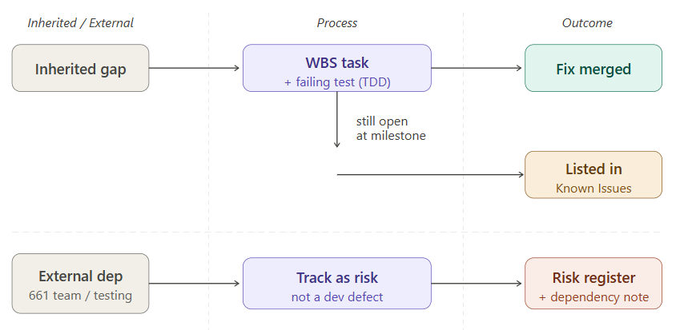
Figure 12.1: Known issue disposition

TDD-B-12.7 Known Issues, Limitations, and Open Items (Team B)
This section records Team B's own outstanding testing gaps, open coordination items, exclusions, and planned enhancements, as a companion to the Team A known issues in Chapter 12.

TDD-B-12.7.1 Technical Limitations
Limitation | Impact | Mitigation
Shift Scheduling coverage at 10.1% (79/782 lines) | 100% target not yet met | M3 Sprint 1 — dedicated unit test writing (flutter_test / JUnit 5.x)
EVV coverage at 29.5% (1,469/4,982 lines) | 100% target not yet met | M3 Sprint 1 — dedicated unit test writing (flutter_test / JUnit 5.x)
Visual/UI branch coverage at 73.2% | 90% target not yet met — branch gap larger than line gap | Widget tests (Flutter SDK 3.44.0) to be added in M3
dart:js_interop compile error prevents a full flutter test --coverage baseline | Accurate per-module lcov baseline requires the fix first | Apply the FileHandlerFactory fix at the start of M3 Sprint 1
Table 12.4: Team B technical limitations

TDD-B-12.7.2 Open Items
Table 1.24: Team B open items
Item | Notes | Target
Lighthouse audit — web build | Run ahead of the Milestone 2 submission deadline | Pre-M2 submission
SWEN 661 UI component delivery schedule | Confirm components and Milestone 3 timeline | Ongoing
CloudFormation test pipeline integration | Coordinate with Team A to confirm how unit tests, E2E tests, coverage gates, accessibility scans, S3 artifact storage, and CloudWatch logging integrate into the CloudFormation-managed CI/CD pipeline | M3 Sprint 1
Auth test case expansions (JUnit 5.x) | Password reset, registration, session timeout, RBAC | Pre-M3
Milestone 1 track-changes revisions | Project Plan and SRS | Pre-M2 submission
Diagram set for Google Doc | Architecture, CI/CD, branch strategy, coverage chart, testing pyramid | Pre-M2 submission

TDD-B-12.7.3 Exclusions
Out of scope for Team B: API design specification (owned by the feature teams — see Section 1.4.4 for the testing-coverage view of the API surface), data model design, and production security architecture, all of which are covered in their respective chapters elsewhere in this document.

TDD-B-12.7.4 Future Enhancements
- M3: apply the FileHandlerFactory fix and re-run flutter test --coverage for a definitive baseline.
- M3: implement CI coverage gate enforcement (lcov + JaCoCo 0.8.x) in GitHub Actions.
- M3: complete the first full WCAG 2.1 AA audit (axe-core 4.x + Lighthouse); submit the progress VPAT.
- M4: complete the final ITI VPAT 2.4 conformance statement.
- M4: achieve and verify at least 95% coverage across all modules.

12.8 Known Issues and Limitations

12.8.1 Technical Limitations
ID | Limitation | Impact | Mitigation or Next Step
LIM-01 | AWS Bedrock credentials not yet provisioned; all Bedrock-dependent features use MockBedrockAdapter in Milestone 2 | Invoice extraction not functional in Milestone 2 against live AI; mock returns predefined test data | Team A provisions when Anthropic account approved; spring.profiles.active=bedrock switches to live adapter
LIM-02 | DeepSeek invoice extraction source file not located; migration targets Bedrock as a net-new implementation | No DeepSeek fallback; no regression risk since Bedrock is the target direction | No action required; first InvoiceService implementation targets Bedrock API directly
LIM-03 | Google Health Connect is an Android only on-device; no equivalent available for iOS in Milestone 2 | Wearable features unavailable on iOS and web in Milestone 2; graceful message displayed | Apple HealthKit (iOS) integration targeted for Milestone 3 after Apple developer entitlement confirmed
LIM-04 | EVV gap analysis is preliminary; final gap list subject to revision | GAP-01 through GAP-04 may be revised or expanded following Spring 1 code review | Code review in Sprint 1 of Milestone 2; TDD to be amended if gaps change
LIM-05 | Home Care document forms are design-phase only in Milestone 2; final gap list subject to revision | DocumentService accepts uploads and stores in S3 but returns no extracted form data until Milestone 3 | Full OCR pipeline (Tesseract or AWS Textract) targeted for Milestone 3 after technology evaluation
LIM-06 | Comprehensive assessment JSONB sections (5 per record) may produce records in 5-10 KB in size for verbose clinical assessments | Potential performance impact for large patient cohorts at scale | Pagination required for list queries; JSONB sections excluded from list projections per Section 11

12.8.2 Known Issues
The following items capture Team E-specific limitations and open work for Ask AI, summaries, USPS mail, STML, and safety. They complement the shared issues in §12.8.

12.9 Team E Known Issues and Limitations
Visit-summary indexing may remain parked until the visit_summaries ingest path lands. Embedding columns can stay NULL when Bedrock is unavailable until backfill runs. Ask AI answer quality tracks retrieval-index freshness after transcript and summary emit.

12.9.1 Technical Limitations
App-only redeploys can reset CorsAllowedList to localhost defaults and break Amplify browser checks. Content-hash short-circuit skips re-chunking when the publisher hash is unchanged, even if chunker metadata alone would differ.
Team E technical limitations
Table 12.9.1
ID | Limitation | Impact | Mitigation or Next Step
TE-L1 | Output quality depends on transcript quality | Degraded summaries and Ask AI recall | Show confidence; allow correction; synthetic fixtures in test
TE-L2 | LLMs can produce unsupported content | Hallucinated medical-adjacent output risk | Citations, uncertainty flags, secondary validation / HITL
TE-L3 | Semantic search returns likely, not exact, matches | Some relevant items ranked low or missed | Hybrid FTS + vector retrieval; records-based framing
TE-L4 | No public USPS Informed Delivery full-image API | Incomplete mail capture | Metadata-first extraction; treat missing image as known state

12.9.2 Known Issues
Clinical decision-making, diagnosis, treatment selection, and dosage recommendations remain outside Ask AI scope.
Team E known issues
Table 12.9.2
ID | Issue | Impact | Owner | Resolution Plan
TE-K1 | Bedrock/OAuth not fully provisioned in all envs | Pipelines may run on mocks | Team A / Team E | Confirm access; swap real providers in target env
TE-K2 | Caregiver visibility policy not finalized | Blocks caregiver-facing demo | Team E Safety | Lock visibility matrix before caregiver release
TE-K3 | App-only redeploy can reset CORS allow-list | Amplify reports backend unhealthy | Platform / Team E | Re-apply Amplify origin after app-only deploys

12.9.3 Exclusions
Planned follow-ons include medication-timeline aggregation in retrieval responses, richer tier-two HITL workflows, speech-to-text hardening for voice asks, and broader mail classification.

12.9.4 Future Enhancements
Bedrock IAM must keep named foundation-model entries that include Titan embed text v1 rather than only a wildcard foundation-model resource. Transcript and summary emit ownership stays with the teams that persist Chime and call-summary records.
Team E future enhancements
Table 12.9.4
Enhancement | Description | Priority
Voice-Accessible Recall | Ask follow-up questions by voice and receive spoken/short answers | High
Cross-Session Memory | Link related items across summaries | High
Full OCR Pipeline | Complete mail-image extraction beyond metadata-first path | High
Medication Timeline in Retrieval | Aggregate medication events into Ask AI context | High
Caregiver Digest | Periodic consent-governed digest of recent sessions | Medium
Multilingual Summaries | Summary generation beyond English | Low

12.9.5 Cross-Team Resolution Notes

ID | Issue | Impact | Owner | Resolution Plan
KI-001 | AWS Bedrock provisioning blocked pending Anthropic account approval with Team A; cannot test live inference | Invoice extraction not functional against live AI in Milestone 2; MockBedrockAdapter returns predefined test data only | Team A | Team A provisions when Anthropic account approved; spring.profiles.active=bedrock switches to live adapter.
KI-002 | EVV codebase identified gaps that may be revised or expanded post-review of implementation | Final gap list subject to change; additional test cases may be required beyond the current 10 EVV cases | Cristobal Garcia | Full code review by Cristobal Garcia in Sprint 1 of Milestone 2; TDD section 5.1 to be amended if gaps change and corresponding test cases incorporated.
KI-003 | EVV aggregator outreach to 10+ organizations in progress pending Professor response; no confirmed integrations as of Milestone 2 planning | Live aggregator submission cannot be tested; Test cases remain blocked until credentials available | Cristobal Garcia | Outreach ongoing via teams-resolution-channel; AggregatorDependency table tracks per-aggregator status (PENDING, CONTACTED, AWAITING_RESPONSE, CREDENTIALS_RECEVIED); mock adapter covers all functional tests in Milestone 2

12.8.3 Exclusions
- Live EVV aggregator API submission
- EHR/FHIR data export or import (future milestone)
- WCAG 2.1 AA formal certification (owned by Team B; post-Milestone 2)
- Multilingual support - Spanish and voice control (owned by Team C in Milestone 2)
- Electronic signature workflows and legal enforceability
- Team A infrastructure: RBAC provisioning, video calls, telemetry/analytics, production deployment pipeline
- Team E features: USPS Informed Delivery, STML/AI agent, call summaries, visit summaries
- HealthKit (iOS) wearable integration (targeted for Milestone 3 after Apple entitlement confirmed)
- Fitbit, Garmin, and other third-party wearable device APIs (future milestones)
- Production AWS Bedrock inference (pending Anthropic account approval via Team A)
- Automated UI/end-to-end test execution (targeted for milestone 3)
- ML model development or custom-tuning of AI models

12.8.4 Future Enhancements
- Home care document digitization - OCR pipeline and field extraction of forms in Milestone 3
- Replace MockBedrockAdapter with live Bedrock implementation when credentials provisioned in Milestone 3
- Apple HealthKit (iOS) wearable integration in Milestone 3 pending Apple entitlement
- Automated end-to-end and UI test suite in Milestone 3
- Fitbit/Garmin wearable device integration as a future enhancement
- EHR/FHIR export for assessment and screening records as a future enhancement
- Predictive health trend analytics using Bedrock for wearable data patterns as a future enhancement
- Electronic signature integration for home care documents as a future enhancement

13. UX/UI Design Specification
Team D UI design keeps screens consistent with the shared CareConnect design direction. The approach prioritizes clear labels and non-technical user messages, accessibility and usability before visual polish, and explicit identification of all features that change navigation, forms, messages, or workflows. The six Team D feature modules — EVV, AI-Assisted Invoicing, Onboarding, Wearable Integration, Document Digitization, and Screening/Assessment — each introduce new or modified screens that are designed to minimize cognitive load and preserve workflow continuity.

13.1 UI Design Approach and Principles
- Keep screens consistent with the shared CareConnect design direction.
- Use clear labels and non-technical user messages.
- Design for accessibility and usability before visual polish.
- Identify any feature that changes navigation, forms, messages, or workflows.
- Write Not applicable if the assigned work does not affect UI or UX.

13.2 Screens and User Workflows Affected
Screen / Workflow | Change or Design Need | Affected Users | Dependencies
EVV Dashboard | Add aggregator readiness status indicators and submission preparation visibility. | Caregivers, Admins | EVV aggregator status API
EVV Visit Detail | Add correction and retry interaction states for invalid or incomplete records. | Caregivers, Admins | EVV Write Endpoints
Invoice Review | Add manual review fallback path and failure messaging for low-confidence or failed extractions. | Billing users, Reviewers | Invoice status API
Invite/Onboarding Entry | Add token intake screen, inviter context display, and token error states (invalid, expired, used) | New users, Inviters | Invite token API, deep-link routing
Registration and Role Routing | Add verification checkpoints, role assignment confirmation, and role-specific dashboard routing. | New users | Auth and role endpoints
Wearable Connect | Add connector authorization flow, link status, and connection health display. | Patients, Caregivers | Wearable connector OAuth adapters
Wearable Dashboard | Add latest sync timestamp, metric display, threshold indicators, and acknowledgement actions. | Patients, Caregivers, Admins | Wearable metric ingestion service
Home Care Document Form | Add structural digital form with field validation, draft save, and submit workflow | Caregivers, Patients | Document Storage API
Document Review | Add admin accept/return actions and correction guidance display. | Admins, Reviewers | Document status API
Screening From | Add structured multi-care field screening capture with draft/submit lifecycle. | Assessors | Assessment API
Comprehensive Assessment | Add multi-section form with domain grouping, draft resume, risk/disposition capture, and escalation prompts. | Assessors | Assessment and patient profile API
Ask AI | Records-grounded answer with persistent non-medical disclaimer and citations | Care recipient, caregiver | Retrieval Service, Safety layer
Summary card | AI-generated notice, headline + recap, per-item confirm path | Care recipient, caregiver | Summaries Service, Safety layer
Mail view | List pieces with sender, date, importance tier, and OCR/empty states | Care recipient, caregiver | USPS Mail Agent
Daily Memory Brief | Recent prioritized information on app open (STML-first) | Care recipient | STML Service

13.3 Wireframes, Mockups, or Screen Notes

13.3.1 EVV Dashboard
Dashboard uses card and table layout to surface visit state, aggregator readiness, and submission status. Detail screens show correction and retry affordances inline without full-page navigation disruption.
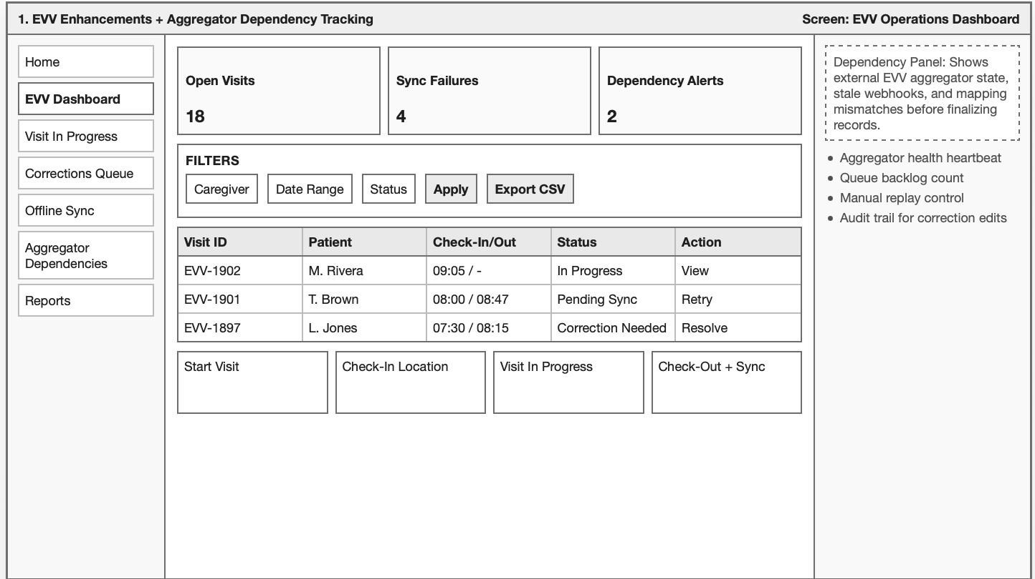
Figure 13.3.1 EVV Dashboard Mockup

13.3.2 AI Invoicing
Intake screen preserves the existing upload interaction. Extraction result view presents structured fields in an editable form with confidence indicators visible before approval is possible. Manual review routing is explicit and always available.
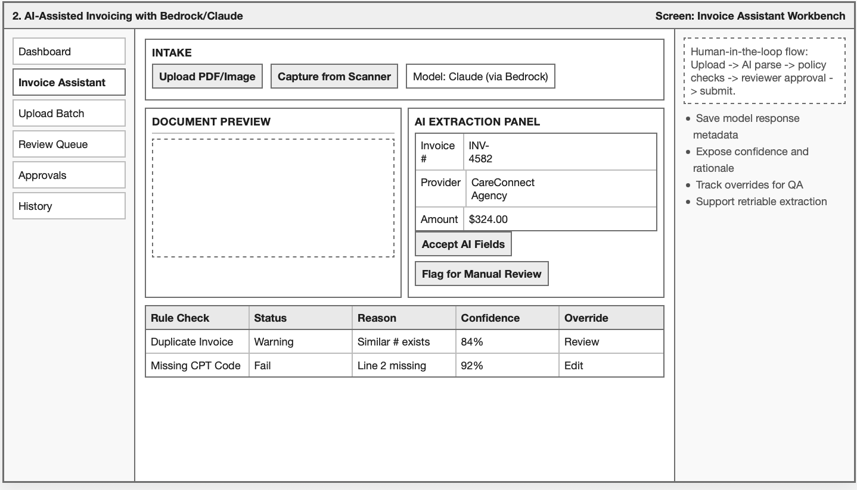
Figure 13.3.2 AI Invoicing Mockup

13.3.3 QR Onboarding
Token intake screen shows inviter context and accept/reject controls. Error states for expired, invalid, and already-used tokens each have distinct non-technical messaging and a next-step prompt.
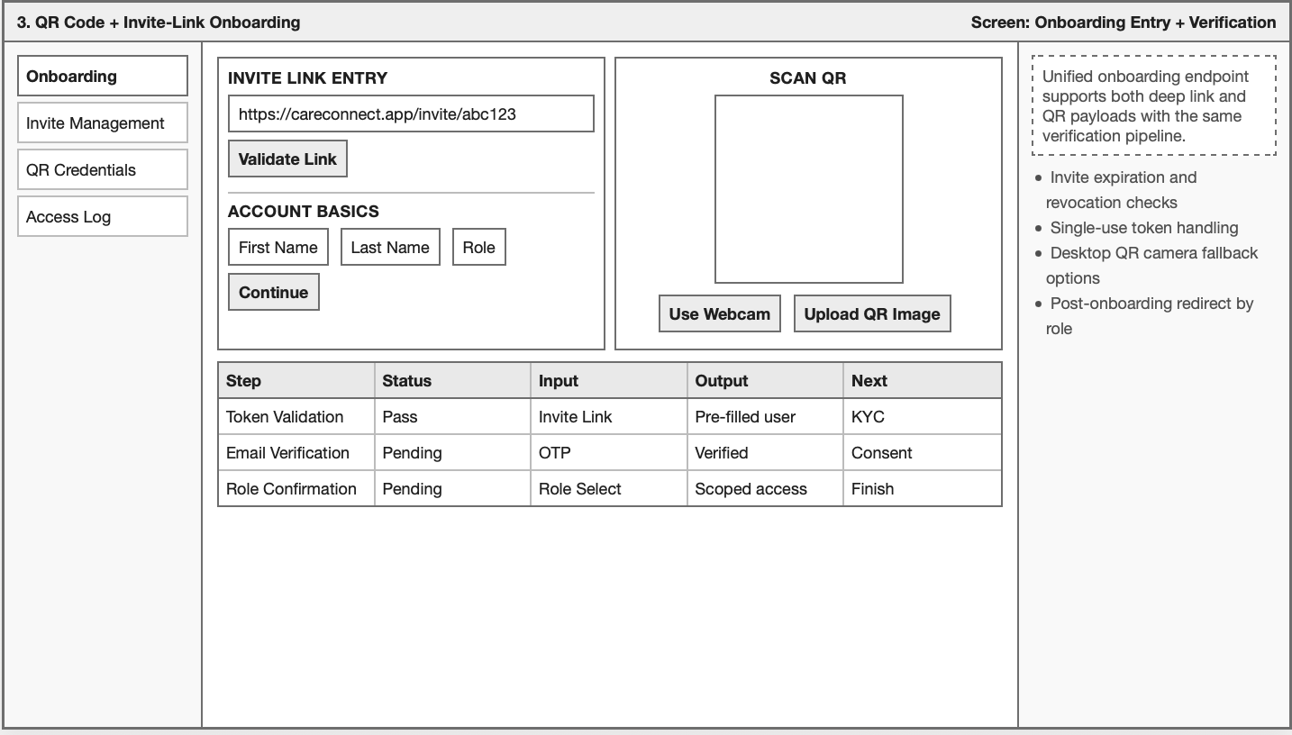
Figure 13.3.3 QR Onboarding Mockup

13.3.4 Wearables Integration
The Connect screen walks through the provider authorization flow step by step. Dashboard panels show sync timestamp, recency, and threshold alert status with clear acknowledgement controls.
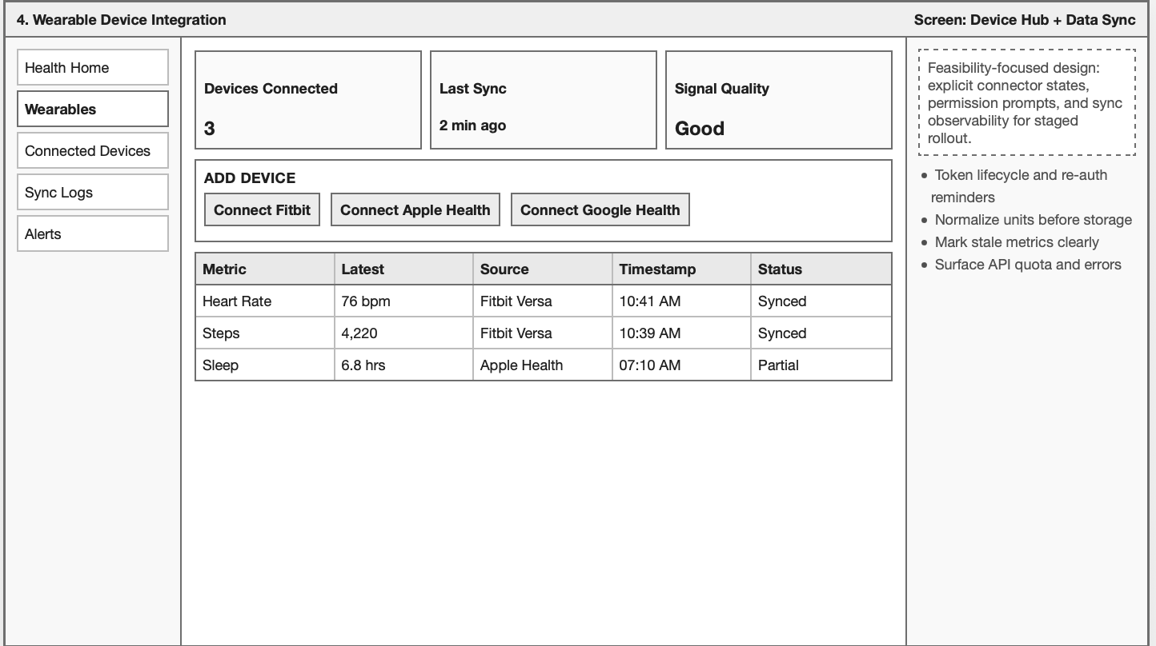
FIgure 13.3.4 Wearables Integration Mockup

13.3.5 Document Digitization
Forms us a section-by-section layout with visible required field indicators. Draft and submit actions are clearly differentiated. Review status is surfaced prominently on the document history screen.
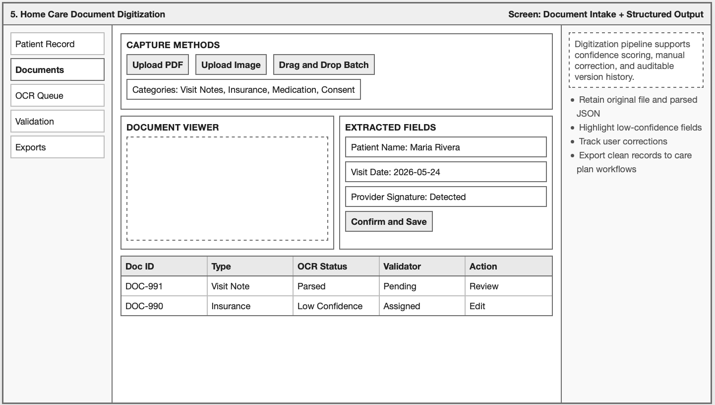
Figure 13.3.5 Document Digitization Mockup

13.3.6 Screening and Assessment
Multi-section forms use progress disclosure per domain. Draft save and resume are available at any point. Risk and disposition capture includes an explicit confirmation step before final submission is allowed.
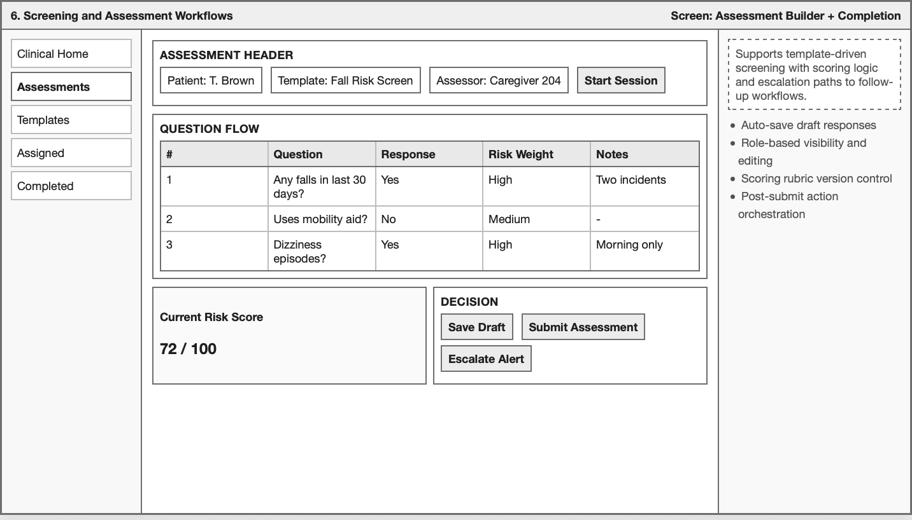
Figure 13.3.6 Screening and Assessment Workflow Mockup
Patient and caregiver UI copy defaults to en-US. Patient-mode Ask AI and STML text avoids dense medical jargon; caregiver mode may present additional clinical detail when consent allows. Localization follows existing Flutter l10n patterns when those packs are enabled.

13.4 Display Language and Localization Impact
Team E display text and localization notes
Table 13.4
Screen / Area | UI Text or Text Key | Needs Translation? | Notes
Ask AI / Summary | ai.disclaimer.notMedicalAdvice | No (English at launch) | Persistent, non-dismissible notice
Summary care item | ai.disclaimer.medical | No | Shown before care-item confirm
Mail view | mail.tier.critical/high/medium/low | No | Importance tier labels
Confirmation flow | action.confirm.once/session/decline | No | Multilingual summaries are a future enhancement

14. AI Usage Statement
AI was used in the making of this document, such as brainstorming, drafting, ideating concepts, and verification of the information contained within. All content included in this document was validated by one or more team members before acceptance as final. AI models utilized for this work include ChatGPT 5.5, ChatGPT 5.5 mini, Claude Sonnet 4.6, and Gemini.

TDD-B-13 AI Tool Usage Security
Team B used Claude Sonnet 4.8 to assist with documentation drafting. No source code, credentials, API keys, or production data were shared with any AI tool during this process.

15. Appendix
The appendices provide supplementary reference material that would clutter the main chapters. This includes inherited codebase file locations (Appendix A) and enlarged architecture figures for readability (Appendix B).

14.1 Appendix A: Reference Locations from Inherited Codebase
Appendix A indexes key inherited implementation paths for security, calls, Chime, sanitization, Flutter configuration, and Fargate templates. Use these paths when tracing design statements in Chapters 6 through 8 to repository code.

Topic | Path
Security filter chains | backend/core/src/main/java/com/careconnect/config/SecurityConfig.java
JWT | backend/core/src/main/java/com/careconnect/security/JwtTokenProvider.java, JwtAuthenticationFilter.java
Roles (pre–Team A) | backend/core/src/main/java/com/careconnect/security/Role.java, RolePermissionService.java
Calls and transcripts | backend/core/src/main/java/com/careconnect/controller/CallController.java, CallTranscriptService.java
Chime | backend/core/src/main/java/com/careconnect/service/ChimeService.java
Sanitization | backend/core/src/main/java/com/careconnect/service/security/InputSanitizationService.java, ResponseSanitizationService.java
Dev configuration | backend/core/src/main/resources/application-dev.properties
Flutter app URL | frontend/lib/config/env_constant.dart
Fargate | cloudformation-fargate/
Table A.1: Locations from inherited codebase

14.2 Appendix B: Enlarged Figures for Readability
Appendix B reproduces selected figures at larger scale for print and review. To view the original image as a whole, refer back to the sections from which they came.

14.2.1 Section 2.3.2, Figure 2.3

Figure 14.1: Section 2.3.2, Figure 2.3, Part 1

Figure 14.2: Section 2.3.2, Figure 2.3, Part 2

