CareConnect Accessibility Conformance Report
VPAT® Version 2.4 Rev — WCAG 2.1 Edition (with Section 508 Functional Performance Criteria)
SWEN 670 — CareConnect, Summer 2026 | Team B | Report date: July 24, 2026 | Author: Alex Yom (Team B Lead)

1. Product Information
- Name of Product/Version: CareConnect web application, develop branch build of July 24, 2026 (staging deployment).
- Product Description: A home-care coordination platform — Electronic Visit Verification (EVV) with HHAExchange submission, shift scheduling, secure messaging and video calls, health records, and AI-assisted summaries. Flutter web frontend, Spring Boot backend on AWS.
- Contact Information: Team B, SWEN 670 Summer 2026, UMGC — Alex Yom (Team Lead).
- Evaluation Methods Used: See Section 2.
- Applicable Standards/Guidelines: WCAG 2.1 (Level A and AA), Revised Section 508 Chapter 3 Functional Performance Criteria.
The following standards and guidelines are referenced in this report. WCAG 2.1 Level AAA is out of scope and not claimed.
Standard / Guideline | Included In Report
Web Content Accessibility Guidelines (WCAG) 2.1 — Level A | Yes
Web Content Accessibility Guidelines (WCAG) 2.1 — Level AA | Yes
Web Content Accessibility Guidelines (WCAG) 2.1 — Level AAA | No
Revised Section 508 standards (2017) — 36 CFR Part 1194, Appendix A/C/D | Yes

2. Evaluation Methods
Conformance claims in this report are grounded in four evidence sources, applied in the sequence shown below:
- Automated CI scanning — axe-core 4.x runs a WCAG 2.1 A/AA scan of the built Flutter web app inside the Team B CI pipeline on every pull request and every push to develop, so regressions are caught continuously rather than at audit time.
- Live deployment scanning — axe-core CLI 4.x was run against the deployed staging application (July 16, 2026). Initial scan: 2 violations. Both were remediated the same day (PR #338) and the post-fix re-scan reports 0 automated WCAG 2.1 A/AA violations. This scan was re-verified against the final pre-demo deployment on July 24, 2026 — the live application at https://main.ds3yhlzh31yi9.amplifyapp.com again returned 0 automated WCAG 2.1 A/AA violations, and the result remains independently reproducible by running an axe-core scan against that URL.
- Manual review — keyboard-only traversal of primary workflows (login, EVV check-in/out, HHAExchange submission, scheduling), inspection of the Flutter semantics tree via the semantics debugger, zoom/text-scaling verification at 200%, and light/dark theme contrast spot checks.
- Code-level audit — repository-wide review of semantic annotations, tooltip coverage (87 instances), form validation patterns, localization (14 languages), and theming.
Automated scanners detect an estimated 20–50% of accessibility issues; manual methods above cover keyboard operability, focus behavior, semantics quality, and content judgment that automation cannot. A known engine consideration is documented in 1.4.12: Flutter web renders to canvas, so conformance for text adaptation is achieved through the platform's text-scaling path rather than user CSS overrides.
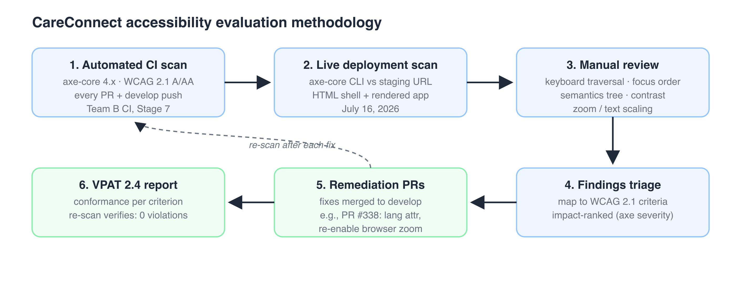

3. Terms
- Supports: The functionality of the product has at least one method that meets the criterion without known defects or meets with equivalent facilitation.
- Partially Supports: Some functionality of the product does not meet the criterion.
- Does Not Support: The majority of product functionality does not meet the criterion.
- Not Applicable: The criterion is not relevant to the product.

4. Conformance Summary
Fifty WCAG 2.1 success criteria were evaluated (30 Level A, 20 Level AA). No Level A criterion is unsupported. The single Does Not Support finding (1.2.4 Captions — Live) has a defined remediation path. Every Partially Supports finding carries a tracked backlog item (TB-A11Y-xx) with an M4 target.
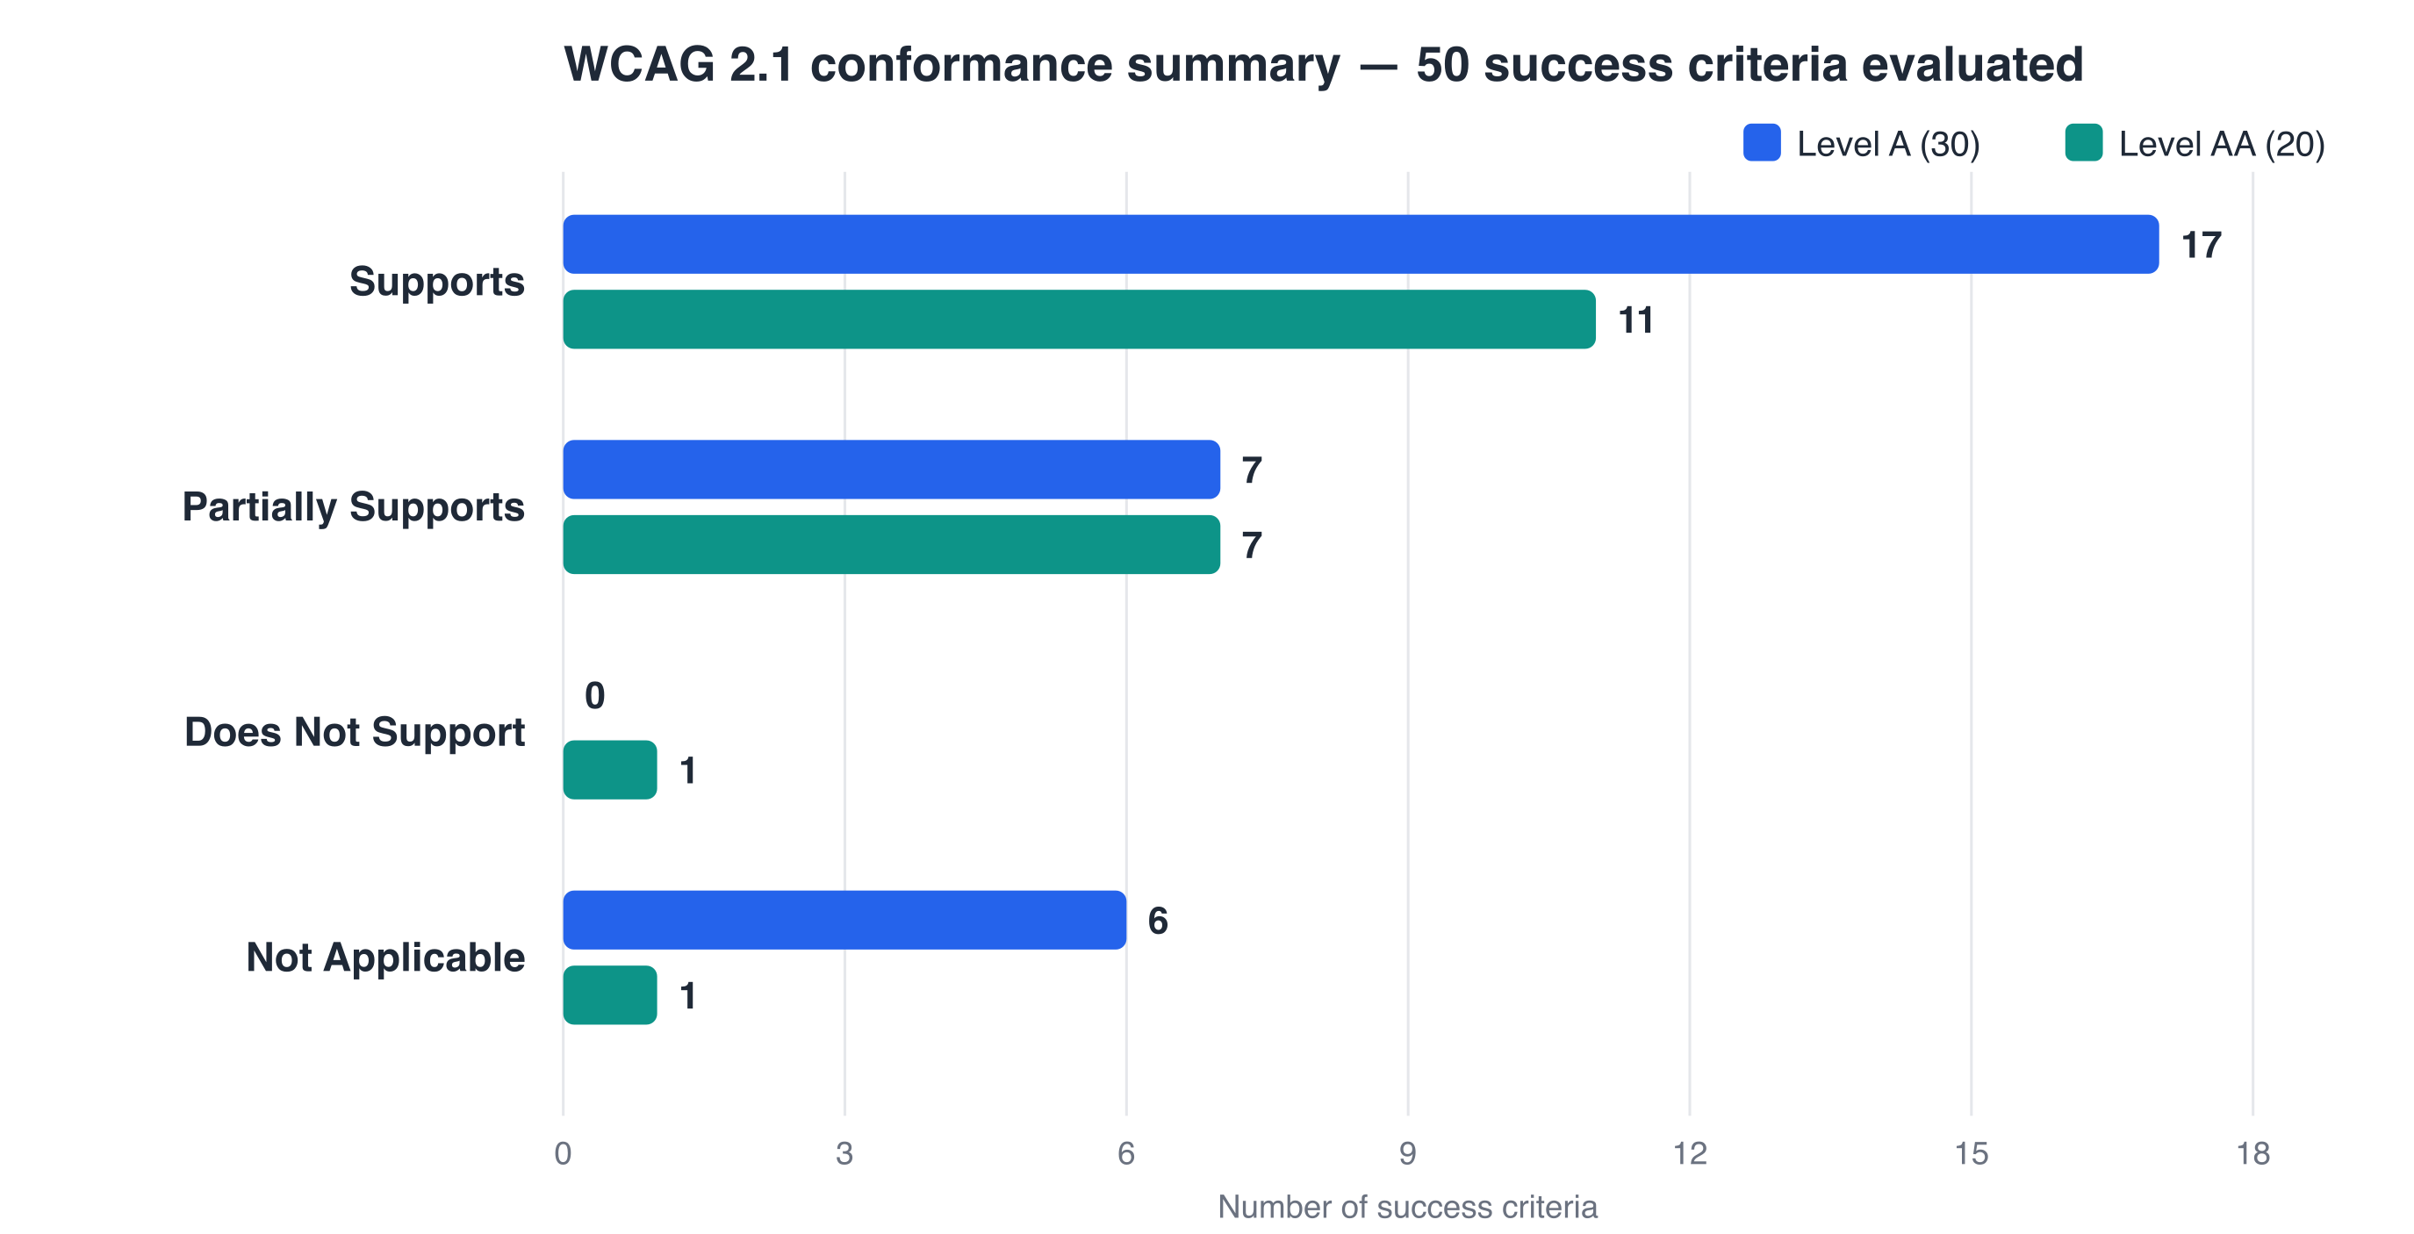

5. WCAG 2.1 Report — Table 1: Success Criteria, Level A
Criteria | Level | Conformance | Remarks and Explanations
1.1.1 Non-text Content | A | Partially Supports | Material icons are paired with text labels or tooltips (87 tooltip instances across the UI); decorative imagery is excluded from the semantics tree. Standard Flutter widgets (buttons, text fields) auto-generate accessible names. Explicit Semantics annotations on custom composite widgets are sparse and are being expanded (M4 backlog item TB-A11Y-01).
1.2.1 Audio-only and Video-only (Prerecorded) | A | Not Applicable | The product contains no prerecorded audio-only or video-only content.
1.2.2 Captions (Prerecorded) | A | Not Applicable | No prerecorded synchronized media.
1.2.3 Audio Description or Media Alternative (Prerecorded) | A | Not Applicable | No prerecorded synchronized media.
1.3.1 Info and Relationships | A | Partially Supports | Flutter's semantics tree conveys role, label, and state for standard Material controls (forms, lists, buttons, dialogs). Custom composite widgets — EVV status board, dashboard cards — do not yet expose their internal structure (header/cell relationships) programmatically; scheduled for M4 (TB-A11Y-02).
1.3.2 Meaningful Sequence | A | Supports | The generated semantics tree order follows the visual and logical layout order; verified with the Flutter semantics debugger on login, EVV, and scheduling flows.
1.3.3 Sensory Characteristics | A | Supports | Instructions reference control names and text labels, never shape, size, or position alone.
1.4.1 Use of Color | A | Partially Supports | Status indicators (e.g., EVV APPROVED / PENDING chips, shift-conflict warnings) pair color with a text label. Analytics charts currently encode some series by color alone; text legends exist but per-point patterns/markers are pending (TB-A11Y-03).
1.4.2 Audio Control | A | Not Applicable | No audio plays automatically.
2.1.1 Keyboard | A | Partially Supports | Flutter web provides Tab/Shift-Tab traversal, Enter/Space activation, and arrow-key list navigation for Material controls throughout. Drag-based interactions in scheduling do not yet have single-key alternatives (TB-A11Y-04).
2.1.2 No Keyboard Trap | A | Supports | Modal dialogs and pickers release focus on Esc or dismiss; verified by keyboard traversal on all primary flows.
2.1.4 Character Key Shortcuts | A | Not Applicable | No single-character keyboard shortcuts are implemented.
2.2.1 Timing Adjustable | A | Partially Supports | Authenticated sessions expire after 3 hours (JWT). No pre-expiry warning is shown; a warning dialog with an extend option is planned (TB-A11Y-05). No other time limits exist.
2.2.2 Pause, Stop, Hide | A | Supports | No content moves, blinks, scrolls, or auto-updates without a user action.
2.3.1 Three Flashes or Below Threshold | A | Supports | No flashing content.
2.4.1 Bypass Blocks | A | Partially Supports | The app is a single-page application with a persistent navigation shell; screen-reader users can navigate by semantics landmarks. A skip-to-content mechanism has not been implemented (TB-A11Y-06).
2.4.2 Page Titled | A | Supports | The document title is set, and route transitions update the page context announced to assistive technology.
2.4.3 Focus Order | A | Supports | Focus order follows the layout order via Flutter's default focus traversal policy; spot-checked on login, EVV check-in, and HHAExchange submission flows.
2.4.4 Link Purpose (In Context) | A | Supports | Navigation controls and buttons carry descriptive visible labels; icon-only buttons carry tooltips that double as accessible names.
2.5.1 Pointer Gestures | A | Supports | No functionality requires multipoint or path-based gestures; all actions are single-tap/click.
2.5.2 Pointer Cancellation | A | Supports | Material tap semantics complete on the up-event; press-and-slide-away cancels.
2.5.3 Label in Name | A | Supports | The visible text of controls is contained in their accessible names (Flutter derives the accessible name from the visible label for standard widgets).
2.5.4 Motion Actuation | A | Not Applicable | No functionality is triggered by device motion.
3.1.1 Language of Page | A | Supports | The web document declares lang="en". Remediated July 16, 2026 (PR #338) after an axe-core scan flagged the missing attribute; post-fix re-scan passes.
3.2.1 On Focus | A | Supports | Receiving focus never triggers a context change.
3.2.2 On Input | A | Supports | Changing a control's value never auto-submits or changes context; forms submit via explicit buttons.
3.3.1 Error Identification | A | Supports | Form validation errors are identified in text adjacent to the field (login, registration, EVV, and scheduling forms use Flutter validators with descriptive messages).
3.3.2 Labels or Instructions | A | Supports | All input fields provide visible labels and/or hint text via TextField decorations.
4.1.1 Parsing | A | Supports | The DOM generated by the Flutter web engine is well-formed; no duplicate IDs or malformed markup detected by axe-core.
4.1.2 Name, Role, Value | A | Partially Supports | Standard Material widgets expose name, role, and state through the Flutter semantics tree. Custom-painted widgets (charts, the incoming-call overlay) require explicit Semantics wrappers, which are sparse today (TB-A11Y-01).

6. WCAG 2.1 Report — Table 2: Success Criteria, Level AA
Criteria | Level | Conformance | Remarks and Explanations
1.2.4 Captions (Live) | AA | Does Not Support | Live video calls (AWS Chime SDK) do not provide real-time captions. Evaluating AWS Transcribe streaming integration as the remediation path; targeted for M4 (TB-A11Y-07). Chat messaging offers a text-based alternative channel.
1.2.5 Audio Description (Prerecorded) | AA | Not Applicable | No prerecorded synchronized media.
1.3.4 Orientation | AA | Supports | Layouts are responsive and function in portrait and landscape; landscape support for patient workflows was explicitly implemented and tested this semester.
1.3.5 Identify Input Purpose | AA | Partially Supports | Login email and password fields set autofill hints. Remaining personal-data fields (name, phone, address in registration/profile) do not yet declare autofillHints (TB-A11Y-08).
1.4.3 Contrast (Minimum) | AA | Partially Supports | The Material theme palette meets 4.5:1 for body text in both light and dark themes (primary text #1F2937 on white ≈ 14.7:1). A subset of muted caption styles and disabled states has not completed a full contrast audit (TB-A11Y-09).
1.4.4 Resize Text | AA | Supports | Browser pinch/zoom and text scaling were re-enabled July 16, 2026 (PR #338 removed maximum-scale=1.0 / user-scalable=no). Flutter honors OS and browser text scaling; layouts verified at 200% zoom.
1.4.5 Images of Text | AA | Supports | Text is rendered as text; no images of text are used.
1.4.10 Reflow | AA | Partially Supports | Responsive breakpoints reflow primary flows at narrow widths without two-dimensional scrolling; data-dense tables (EVV records, schedules) scroll horizontally by design as permitted. Two dashboard grids still clip below 400 px and are queued for a small-viewport pass (TB-A11Y-10).
1.4.11 Non-text Contrast | AA | Partially Supports | Buttons, input outlines, and focus indicators meet 3:1 against adjacent colors in the default theme. Some tertiary icons in dark mode are pending audit (TB-A11Y-09).
1.4.12 Text Spacing | AA | Partially Supports | The Flutter web engine renders text to canvas, so user CSS overrides of letter/word spacing do not take effect. Equivalent adjustment is available via OS/browser text scaling, which the app honors. This is an engine-level constraint documented for transparency.
1.4.13 Content on Hover or Focus | AA | Supports | Tooltips are dismissible (Esc / pointer move), hoverable, and persistent per Material behavior.
2.4.5 Multiple Ways | AA | Supports | Screens are reachable through the persistent navigation menu, role-based dashboards, and direct routes.
2.4.6 Headings and Labels | AA | Supports | Pages carry descriptive headers; sections and controls use descriptive labels (verified across login, EVV, scheduling, and settings).
2.4.7 Focus Visible | AA | Supports | Material focus indicators render on all interactive controls during keyboard traversal.
3.1.2 Language of Parts | AA | Supports | The app is fully localized in 14 languages via flutter_localizations; the active locale is exposed to assistive technology, and the language picker announces each language in its own name.
3.2.3 Consistent Navigation | AA | Supports | A shared navigation shell renders in the same relative order on every screen.
3.2.4 Consistent Identification | AA | Supports | Icons and labels come from a shared widget library, so identical functions are identified consistently.
3.3.3 Error Suggestion | AA | Supports | Validators provide corrective suggestions (e.g., expected email format, required-field prompts, password rules).
3.3.4 Error Prevention (Legal, Financial, Data) | AA | Partially Supports | Destructive actions and EVV submissions require confirmation dialogs; the Stripe payment flow includes a review step. A systematic audit of all data-modifying flows for reversibility/confirmation is pending (TB-A11Y-11).
4.1.3 Status Messages | AA | Partially Supports | SnackBar notifications carry live-region semantics on Android. Verification that the Flutter web engine announces them as ARIA live regions is in progress (TB-A11Y-12).

7. Revised Section 508 — Functional Performance Criteria (Chapter 3)
Criteria | Remarks and Explanations
Without Vision | The Flutter semantics tree supports screen readers (VoiceOver, TalkBack, NVDA via web semantics). Standard controls are labeled; custom-widget annotation is in progress (see 4.1.2).
With Limited Vision | OS/browser text scaling and zoom are honored (remediated PR #338); dark theme available; body-text contrast meets 4.5:1 in default themes.
Without Perception of Color | Status states pair color with text labels; analytics charts pending pattern alternatives (see 1.4.1).
Without Hearing | Core workflows are fully visual; chat messaging provides a text alternative to calls. Live-call captions are the outstanding gap (see 1.2.4).
With Limited Hearing | Same as above; no audio-only critical information.
Without Speech | No functionality requires speech input; voice features have text equivalents.
With Limited Manipulation | All actions are single-pointer, no path-based gestures; keyboard operation supported for standard controls (see 2.1.1).
With Limited Reach and Strength | No simultaneous-action requirements; touch targets follow Material minimums.
With Limited Language, Cognitive, and Learning Abilities | Consistent navigation, descriptive labels/instructions, error suggestions, and 18 pt minimum copy on clinical urgency surfaces per the course accessibility standard.

8. Revised Section 508 — Chapter 4: Hardware
CareConnect is a browser-based software application with no hardware component; the criteria in Chapter 4 (Hardware) do not apply to this product.
Criteria | Conformance Level | Remarks and Explanations
Chapter 4 — Hardware (401–415) | Not Applicable | CareConnect delivers no hardware. It is accessed through the user's own standard web browser and device, so hardware accessibility criteria are not applicable.

9. Revised Section 508 — Chapter 5: Software
Per 501.1 and E207.2, web software that conforms to WCAG 2.1 Level A and AA is deemed to satisfy the corresponding Chapter 5 provisions. Where a Chapter 5 criterion maps to WCAG, the WCAG result in Sections 5–6 above governs; software-specific provisions are addressed below.
Criteria | Conformance Level | Remarks and Explanations
501.1 Scope — Incorporation of WCAG 2.1 A & AA | Supports | The application is web software; its user interface is evaluated against WCAG 2.1 A and AA in the tables above, which govern the software provisions of this chapter.
502.2.1 User Control of Accessibility Features | Supports | The app does not override platform or browser accessibility settings; users retain control of OS/browser accessibility features (zoom, text scaling, contrast, screen reader).
502.2.2 No Disruption of Accessibility Features | Supports | No documented assistive-technology feature is disabled or disrupted; standard browser AT (screen readers, magnifiers) operates against the rendered UI.
502.3.1–502.3.14 Accessibility Services (AT interoperability) | Partially Supports | Standard Material/Flutter controls expose name, role, state, and value to assistive technology through the platform semantics tree (see WCAG 4.1.2). Custom-painted widgets (charts, incoming-call overlay) have sparse explicit annotations; expansion is tracked for M4 (TB-A11Y-01).
502.4 Platform Accessibility Features | Supports | The application honors platform/browser accessibility features (text scaling and zoom re-enabled per PR #338; OS high-contrast and reduced-motion respected by the Material theme).
503.2 User Preferences | Supports | The app inherits and does not block user platform settings for color, contrast, font type/size, and focus; it also provides an in-app light/dark theme and 14-language localization.
503.3 Alternative User Interfaces | Not Applicable | The product does not provide an alternative user interface that functions as assistive technology.
503.4 / 503.4.1 / 503.4.2 User Controls for Captions and Audio Description | Does Not Support | Live video calls (AWS Chime SDK) do not yet expose user controls for real-time captions or audio description. Remediation via AWS Transcribe streaming is targeted for M4 (TB-A11Y-07); chat messaging provides a text alternative in the interim. Prerecorded media is not present, so audio-description controls are otherwise not applicable.
504.2–504.4 Authoring Tools | Not Applicable | CareConnect is not an authoring tool; it does not produce content intended for use by third parties, so the authoring-tool provisions do not apply.

10. Revised Section 508 — Chapter 6: Support Documentation and Services
This chapter addresses the accessibility of product documentation and support services.
Criteria | Conformance Level | Remarks and Explanations
601.1 Scope | Supports | The project produces electronic support documentation (Deployment & Operations Guide, Programmer's Guide, Software Test Plan, and this VPAT); a User Guide is planned. Provisions below are assessed against those artifacts.
602.2 Accessibility and Compatibility Features | Partially Supports | This VPAT documents the product's accessibility and compatibility features. Consolidated end-user documentation of accessibility features (e.g., in a User Guide) is planned for a later milestone.
602.3 Electronic Support Documentation conforms to WCAG 2.1 | Partially Supports | Documentation is authored in electronic formats (Word/PDF/Markdown). Content structure (headings, tables, lists) is used, but the documents have not yet completed a formal WCAG 2.1 A/AA audit (e.g., PDF tag verification); scheduled as a documentation accessibility pass for M4.
602.4 Alternate Formats for Non-Electronic Documentation | Not Applicable | All support documentation is provided electronically; no non-electronic documentation is distributed.
603.2 Information on Accessibility and Compatibility Features | Partially Supports | As an academic capstone, formal support services are not operated. Accessibility and compatibility information is available through this VPAT and the project documentation.
603.3 Accommodations for Communication Needs | Not Applicable | No staffed support service (phone/help desk) is provided for this capstone deliverable; the provision is not applicable to the current project context.

11. Remediation Completed During This Evaluation
Findings from the live scan were fixed and verified within the evaluation window rather than deferred:
Date | Finding (axe-core) | WCAG Criterion | Resolution
2026-07-16 | html-has-lang (serious): document missing lang attribute | 3.1.1 Language of Page (A) | Added lang="en" to the web shell — PR #338. Post-fix re-scan: pass.
2026-07-16 | meta-viewport (moderate): maximum-scale=1.0 and user-scalable=no blocked zoom | 1.4.4 Resize Text (AA) | Removed the zoom-blocking viewport directives — PR #338. Post-fix re-scan: pass.

12. Remediation Roadmap (Milestone 4)
Item | Remediation | Criteria | Target
TB-A11Y-01 | Systematic Semantics annotations on custom widgets (charts, call overlay, dashboards) | 1.1.1, 4.1.2 | M4 Sprint 1
TB-A11Y-04 | Keyboard alternatives for drag-based scheduling interactions | 2.1.1 | M4 Sprint 1
TB-A11Y-05 | Session-expiry warning dialog with extend option | 2.2.1 | M4 Sprint 1
TB-A11Y-07 | Live captions for Chime video calls (AWS Transcribe streaming) | 1.2.4 | M4 Sprint 2
TB-A11Y-09 | Full contrast audit — muted text styles and dark-mode icons | 1.4.3, 1.4.11 | M4 Sprint 1
TB-A11Y-12 | Verify web live-region announcement of SnackBar status messages | 4.1.3 | M4 Sprint 1

13. Legal Disclaimer
This document is provided for the SWEN 670 CareConnect project (Summer 2026) and reflects the accessibility of the identified build as of the report date. It describes conformance as evaluated by the methods in Section 2 and does not constitute a certification. VPAT® is a registered trademark of the Information Technology Industry Council (ITI).

