CRP-analysis

GH, MG

26 2 2021

## Warning: package 'regclass' was built under R version 4.0.4

## Warning: package 'bestglm' was built under R version 4.0.4

## Warning: package 'leaps' was built under R version 4.0.3

## Warning: package 'VGAM' was built under R version 4.0.4

## Warning: package 'randomForest' was built under R version 4.0.4

# Analysis of blood analysis data set

## Read data set

tab1<-read.csv2("data_blood.csv")  
attach(tab1)

## Sum of five subtypes equals white blood cell counts

sum_cells <- NEU + EOS + BASO + LYM + MONO  
  
plot(sum_cells, WBC)  
abline(0,1, lty=3)

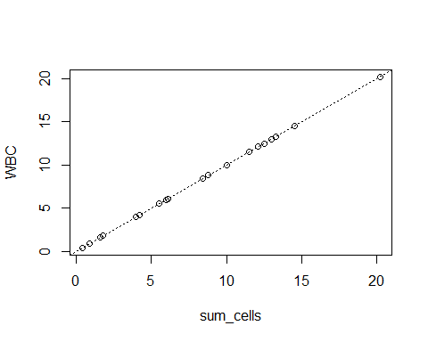

## Pairwise correlations

round(cor(cbind(NEU, EOS, BASO, LYM, MONO, WBC)),3)

## NEU EOS BASO LYM MONO WBC  
## NEU 1.000 0.211 -0.078 0.451 0.732 0.982  
## EOS 0.211 1.000 0.170 0.134 0.024 0.218  
## BASO -0.078 0.170 1.000 0.053 0.021 -0.045  
## LYM 0.451 0.134 0.053 1.000 0.765 0.601  
## MONO 0.732 0.024 0.021 0.765 1.000 0.831  
## WBC 0.982 0.218 -0.045 0.601 0.831 1.000

## Exact collineartiy

The analysis of the basic regression model will result in the program setting one of the coefficients to NA.

mod <- lm(CRP ~ NEU + EOS + BASO + LYM + MONO + WBC)  
summary(mod)

##   
## Call:  
## lm(formula = CRP ~ NEU + EOS + BASO + LYM + MONO + WBC)  
##   
## Residuals:  
## Min 1Q Median 3Q Max   
## -5.8418 -2.3144 0.4375 3.2276 4.5418   
##   
## Coefficients: (1 not defined because of singularities)  
## Estimate Std. Error t value Pr(>|t|)   
## (Intercept) 10.40609 1.82392 5.705 5.43e-05 ***  
## NEU 0.65243 0.31278 2.086 0.0558 .   
## EOS -19.47720 7.78284 -2.503 0.0253 *   
## BASO -6.96221 24.28428 -0.287 0.7785   
## LYM -3.08362 2.07602 -1.485 0.1596   
## MONO -0.04194 2.72566 -0.015 0.9879   
## WBC NA NA NA NA   
## ---  
## Signif. codes: 0 '***' 0.001 '**' 0.01 '*' 0.05 '.' 0.1 ' ' 1  
##   
## Residual standard error: 3.744 on 14 degrees of freedom  
## Multiple R-squared: 0.5387, Adjusted R-squared: 0.3739   
## F-statistic: 3.269 on 5 and 14 DF, p-value: 0.03657

Next, VIFs are computed using the package regclass. The function VIF results in an error as there is exact collinearity.

try(VIF(mod))

## Error in VIF(mod) : there are aliased coefficients in the model

## Near collinearity

Now we consider a model with just two variables, NEU and WBC. First we investigate correlation.

plot(NEU, WBC)  
abline(0,1,lty=3)  
text(0,20, paste("Correlation = ", round(cor(NEU, WBC),3)), adj=0)  
legend("bottomrigh", lty=3, legend="Diagonal")

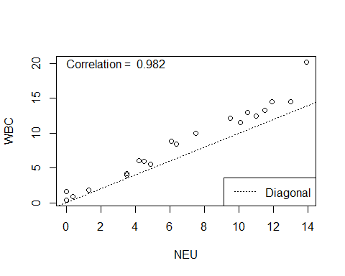

Now we fit the model and evaluate the VIFs.

mod2 <- lm(CRP ~ NEU + WBC)  
VIF(mod2)

## NEU WBC   
## 28.72946 28.72946

Evaluate the model:

summary(mod2)

##   
## Call:  
## lm(formula = CRP ~ NEU + WBC)  
##   
## Residuals:  
## Min 1Q Median 3Q Max   
## -5.7657 -3.7508 -0.5381 3.6528 6.9263   
##   
## Coefficients:  
## Estimate Std. Error t value Pr(>|t|)   
## (Intercept) 8.979 1.800 4.989 0.000112 ***  
## NEU 2.650 1.157 2.290 0.035071 *   
## WBC -1.954 0.957 -2.042 0.056982 .   
## ---  
## Signif. codes: 0 '***' 0.001 '**' 0.01 '*' 0.05 '.' 0.1 ' ' 1  
##   
## Residual standard error: 4.256 on 17 degrees of freedom  
## Multiple R-squared: 0.2762, Adjusted R-squared: 0.191   
## F-statistic: 3.243 on 2 and 17 DF, p-value: 0.0641

The regression coefficients are quite extreme, but this results from their meaning:

The regression coefficient of NEU has the interpretation of the expected difference in CRP corresponding to a difference of 1 G/L in NEU but keeping WBC constant. From the plot above we see that it is sometimes not possible to increase NEU by 1 G/L and at the same time holding WBC fixed, as NEU is a component of WBC and cannot exceed WBC. Hence the regression coefficient has a problematic interpretation.

Remedy: compute a new variable WBCnoNEU = WBC - NEU

WBCnoNEU <- WBC - NEU

Evaluate correlation again:

plot(NEU, WBCnoNEU)  
text(0,6, paste("Correlation = ", round(cor(NEU, WBCnoNEU),3)), adj=0)

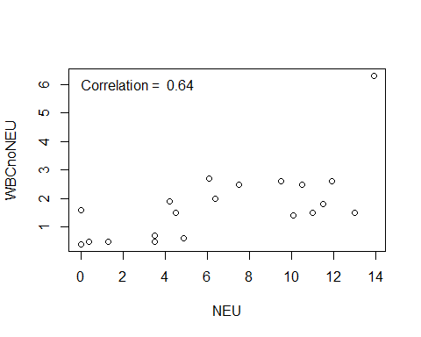 Fit model and evaluate VIFs:

mod3 <- lm(CRP ~ NEU + WBCnoNEU)  
VIF(mod3)

## NEU WBCnoNEU   
## 1.694783 1.694783

Evaluate the model:

summary(mod3)

##   
## Call:  
## lm(formula = CRP ~ NEU + WBCnoNEU)  
##   
## Residuals:  
## Min 1Q Median 3Q Max   
## -5.7657 -3.7508 -0.5381 3.6528 6.9263   
##   
## Coefficients:  
## Estimate Std. Error t value Pr(>|t|)   
## (Intercept) 8.9788 1.7998 4.989 0.000112 ***  
## NEU 0.6961 0.2811 2.477 0.024071 *   
## WBCnoNEU -1.9542 0.9570 -2.042 0.056982 .   
## ---  
## Signif. codes: 0 '***' 0.001 '**' 0.01 '*' 0.05 '.' 0.1 ' ' 1  
##   
## Residual standard error: 4.256 on 17 degrees of freedom  
## Multiple R-squared: 0.2762, Adjusted R-squared: 0.191   
## F-statistic: 3.243 on 2 and 17 DF, p-value: 0.0641

The standard errors for the coefficient of NEU is now considerably smaller, and the value of the coefficient is quite different from the model above. Still, the multiple $R^{2}$ is exactly equal to model mod2. The reason is that the coefficient of NEU now has a different meaning (expected difference in CRP corresponding to a difference in NEU of 1 G/L given constant concentrations of all other components of WBC). However, the coefficient of WBCnoNEU has the same meaning as in Model mod2 (expected difference in CRP corresponding to a difference in WBC of 1 G/L given constant NEU), and hence its value and standard error in model mod3 do not differ from those in mod2.