Database Consistency Test

Introduction
This EngineeringPaper.xyz sheet shows how to calculated the maximum stress and displacement for a cantilever beam loaded by a vertical force at its end. The geometry of the beam is shown in the figure below. The beam has a rectangular cross section with height h and width b. The maximum stress in a cantilever with length much larger than its height is due to bending stress that occurs at the base of the beam. For a downward force, the maximum stress will be a tensile force at the top of the beam and a compressive stress at the bottom of the beam. For beam sections that are symmetric top to bottom, the maximum tensile and compressive stresses will have equal magnitude. # 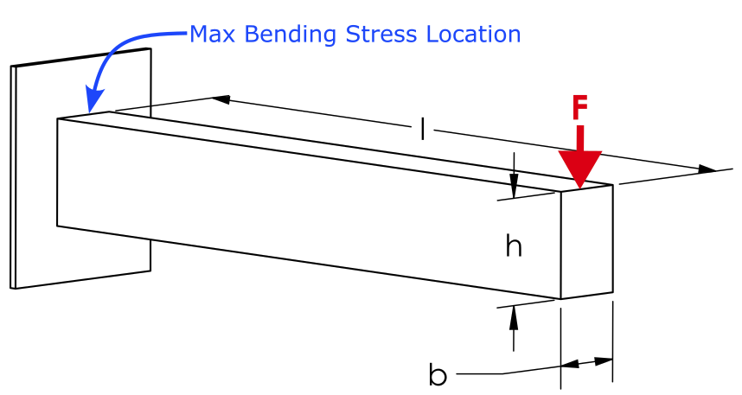 # # Select Beam Material

Select Beam Section
Source for beam section equations and images: https://en.wikipedia.org/wiki/List_of_second_moments_of_area

Define the Other Beam Parameters
$$l=500\left[mm\right]$$
$$F=500\left[N\right]$$

Define the Deflection and Stress Equations
The maximum displacement of a cantilever beam loaded at its end is defined by [1]:
$$y_{max}=−\frac{F⋅l^{3}}{3⋅E⋅I_{x}}$$
where Ix is the area moment of inertia of the cross section about the x-axis as selected in the table above. The maximum displacement can now be queried:
$$\boxed{y_{max}=\left[mm\right]=−0.165297794307557\left[mm\right]}$$
The maximum bending stress in a beam section is given by:
$$σ_{max}=\frac{M⋅c}{I_{x}}$$
where M is the bending moment at the section of interest and c is distance from the neutral axis of the beam to the top or bottom of the beam. The maximum moment occurs at the base of the beam and is defined by:
$$M=l⋅F$$
where l is the length of the beam. Now that everything is defined, the maximum stress can be queried and converted to [MPa] units:
$$\boxed{σ_{max}=\left[MPa\right]=5.33333333333333\left[MPa\right]}$$
These results can be compared to the results obtained from a finite element analysis using SolidWorks. The beam has the same dimensions, loading, and material as the rectangular cross-section and the aluminum table options above. The displacement plot is shown below. The maximum displacement magnitude obtained using finite element analysis is .175 [mm], which is close to the .165 [mm] obtained using the equations above. 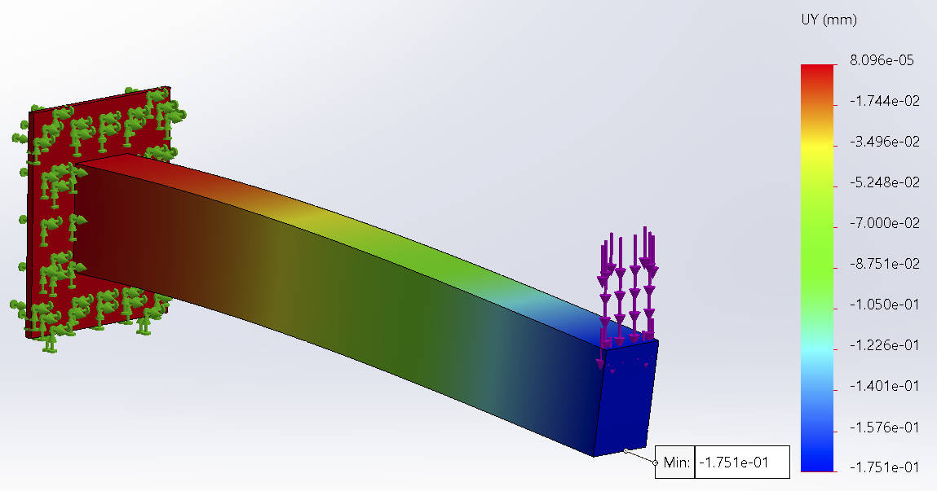
Similarly, the maximum stress calculation can be compared to the SolidWorks results. The maximum stress obtained from SolidWorks is 6.5 [MPa] as shown below. Note that this is higher than the 5.3 [MPa] obtained using the beam equation. This is the result of the stress concentration that occurs at the based of the cantilever where it meets the fixed boundary condition. A littler further from the fixed boundary condition, the finite element values are close to the calculated values. 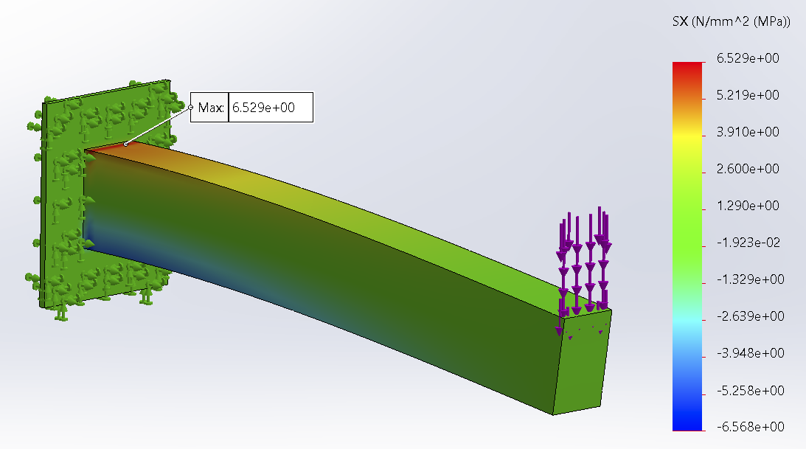
[1] Norton, R. L. “Machine design. A integrated approach, 5th Editi.” (2013).
$$y=\frac{F}{6⋅E⋅I_{x}}⋅\left(x^{3}−3⋅l⋅x^{2}\right)$$

Test 7

