Database Consistency Test

Introduction
This EngineeringPaper.xyz sheet shows how to calculated the maximum stress and displacement for a cantilever beam loaded by a vertical force at its end. The geometry of the beam is shown in the figure below. The beam has a rectangular cross section with height h and width b. The maximum stress in a cantilever with length much larger than its height is due to bending stress that occurs at the base of the beam. For a downward force, the maximum stress will be a tensile force at the top of the beam and a compressive stress at the bottom of the beam. For beam sections that are symmetric top to bottom, the maximum tensile and compressive stresses will have equal magnitude. # 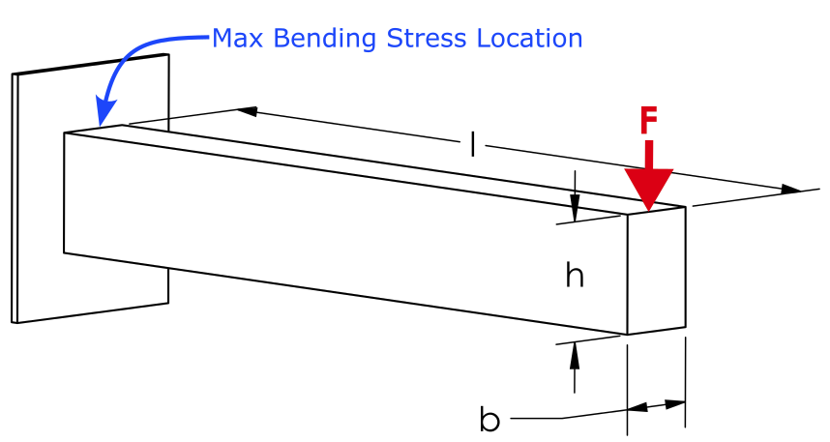 # # Select Beam Material

Select Beam Section
Source for beam section equations and images: https://en.wikipedia.org/wiki/List_of_second_moments_of_area

Define the Other Beam Parameters
$$l=500\left[mm\right]$$
$$F=500\left[N\right]$$

Define the Deflection and Stress Equations
The maximum displacement of a cantilever beam loaded at its end is defined by [1]:
$$y_{max}=−\frac{F⋅l^{3}}{3⋅E⋅I_{x}}$$
where Ix is the area moment of inertia of the cross section about the x-axis as selected in the table above. The maximum displacement can now be queried:
$$\boxed{y_{max}=\left[mm\right]=−0.165297794307557\left[mm\right]}$$
The maximum bending stress in a beam section is given by:
$$σ_{max}=\frac{M⋅c}{I_{x}}$$
where M is the bending moment at the section of interest and c is distance from the neutral axis of the beam to the top or bottom of the beam. The maximum moment occurs at the base of the beam and is defined by:
$$M=l⋅F$$
where l is the length of the beam. Now that everything is defined, the maximum stress can be queried and converted to [MPa] units:
$$\boxed{σ_{max}=\left[MPa\right]=5.33333333333333\left[MPa\right]}$$
These results can be compared to the results obtained from a finite element analysis using SolidWorks. The beam has the same dimensions, loading, and material as the rectangular cross-section and the aluminum table options above. The displacement plot is shown below. The maximum displacement magnitude obtained using finite element analysis is .175 [mm], which is close to the .165 [mm] obtained using the equations above. 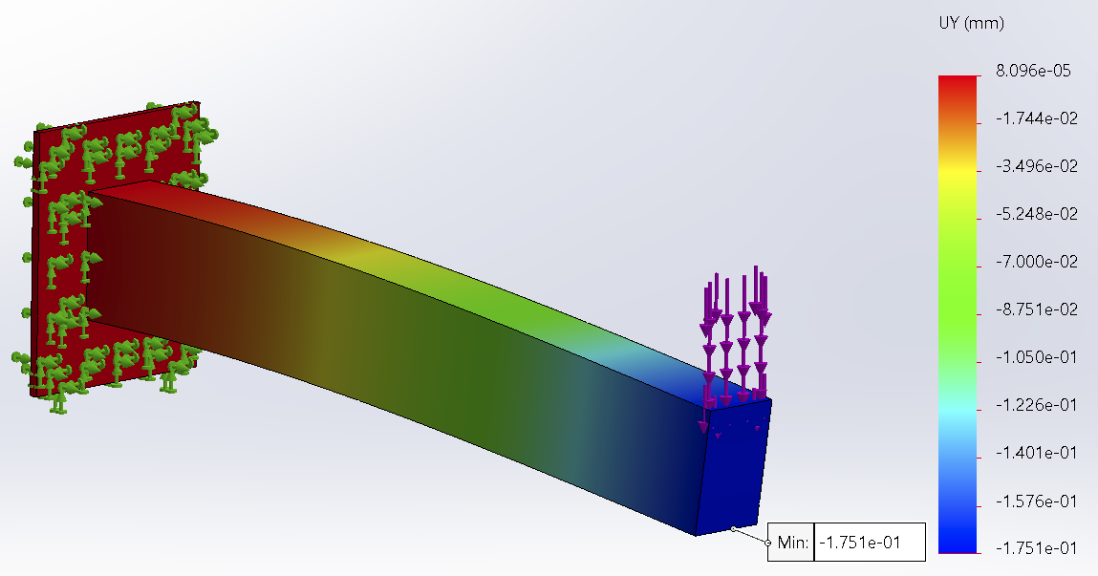
Similarly, the maximum stress calculation can be compared to the SolidWorks results. The maximum stress obtained from SolidWorks is 6.5 [MPa] as shown below. Note that this is higher than the 5.3 [MPa] obtained using the beam equation. This is the result of the stress concentration that occurs at the based of the cantilever where it meets the fixed boundary condition. A littler further from the fixed boundary condition, the finite element values are close to the calculated values. 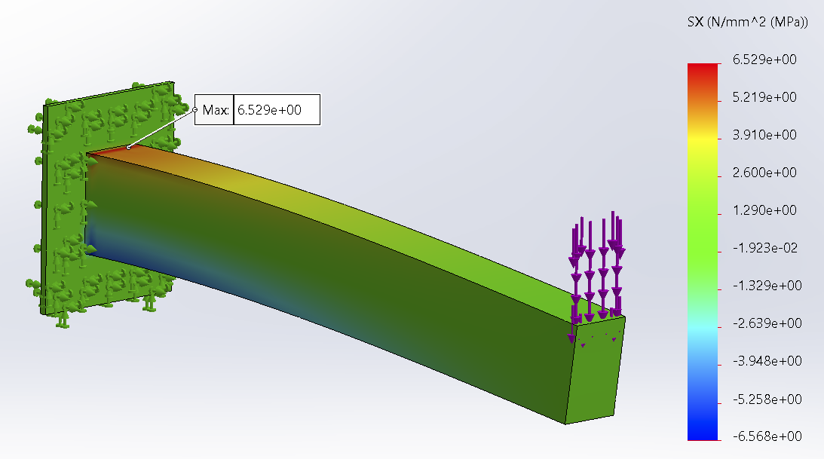
[1] Norton, R. L. “Machine design. A integrated approach, 5th Editi.” (2013).
$$y=\frac{F}{6⋅E⋅I_{x}}⋅\left(x^{3}−3⋅l⋅x^{2}\right)$$

All Colors
one
two
three
four
five
six
seven
eight
nine
ten
eleven
twelve
thirteen
fourteen
fifteen
sixteen
seventeen
eighteen
nineteen
twenty
twenty one
twenty two
twenty three
twenty four
twenty five

twenty six
twenty seven

twenty eight
twenty nine
thirty
thirty one
thirty two
thirty three
thirty four
thirty five
highlight
color and highlight
color and bold
color and bold and italics
color and highlight and bold and italics
no text formatting

MD Export Test (centered equations unchecked)
$x=20\left[m\right]$
Documentation cell with line of text followed by a scaled image:
Sentence with formula $\sqrt{Ω}$ in the middle, followed by equation on its own line:
$E=\frac{My}{I}$
With text after.
Line of text.
Another line of text.

$\text{Option 2} \left\{\begin{matrix}l_{1} & = 3\left[mm\right] \\ l_{2} & = 4\end{matrix}\right.$
$l_{2}=4$
$l_{1}=\left[m\right]=0.003\left[m\right]$
$Col1$ | $Col2$
 | $\left[m\right]$
6 | 7
8 | 9
$y=\left\{\begin{matrix}10 & : x>20 \\ 2 & : \text{otherwise}\end{matrix}\right.$
$\text{System}=\left\{\begin{matrix}1⋅s+2⋅t=10 & \\ 2⋅s−4⋅t^{2}=20 & \end{matrix}\right.$
$\text{Solution}=\left\{\begin{matrix}s & = 12 \\ t & = −1\end{matrix}\right.$
$\text{Roller Thrust Bearing} μ_{c}=0.01$
This left justified, below is a centered equation:
$x=2⋅y$
Below is a centered image:

This is right justified
This is justified text
- red
- blue
- one
- two
  - three
  - four
Normal text

MD Export Test (centered equations checked)
$$x=20\left[m\right]$$
Documentation cell with line of text followed by a scaled image:
Sentence with formula $\sqrt{Ω}$ in the middle, followed by equation on its own line:
$E=\frac{My}{I}$
With text after.
Line of text.
Another line of text.
$$\text{Option 2} \left\{\begin{matrix}l_{1} & = 3\left[mm\right] \\ l_{2} & = 4\end{matrix}\right.$$
$$l_{2}=4$$
$$l_{1}=\left[m\right]=0.003\left[m\right]$$
$Col1$ | $Col2$
 | $\left[m\right]$
6 | 7
8 | 9
$$y=\left\{\begin{matrix}10 & : x>20 \\ 2 & : \text{otherwise}\end{matrix}\right.$$
$$\text{System}=\left\{\begin{matrix}1⋅s+2⋅t=10 & \\ 2⋅s−4⋅t^{2}=20 & \end{matrix}\right.$$
$$\text{Solution}=\left\{\begin{matrix}s & = 12 \\ t & = −1\end{matrix}\right.$$
$$\text{Roller Thrust Bearing} μ_{c}=0.01$$
This left justified, below is a centered equation:
$x=2⋅y$
Below is a centered image:
This is right justified
This is justified text
- red
- blue
- one
- two
  - three
  - four
Normal text

Equation Comments Stress Test
cats and dogs
cats and dogs
@cats
- cats
- dogs
  - zebras
  - giraffes
    - rats
    - mice
    - squirrels
    - rabbits
      - bass
      - walleye
- eagles
- sparrows
  - pigeons
  - geese
$1\text{cats\{\} in the house}=1$
$1\text{cats\{ in the house}=1$
$1\text{cats\} in the house}=1$
$2\text{dogs[] in the house}=2$
$2\text{dogs[ in the house}=2$
$2\text{dogs] in the house}=2$
$3\text{zebras in the house}=3$
$4\text{giraffes! in the house}=4$
$5\text{mice\% in the house}=5$
$6\text{squirrels\& in the house}=6$
$7\text{rats^ in the house}=7$
$8\text{horses\# in the house}=8$
$9\text{cows @ in the house}=9$
$10\text{pigs \$ in the house} =10$
$11\text{goats * in the house}=11$
$12\text{rabbits() in the house}=12$
$12\text{rabbits) in the house}=12$
$12\text{rabbits( in the house}=12$
$13\text{sparrow -+/<>.,’;:\sim ?<>}=13$
$14\text{fox _ in the house}=14$
$15\text{bear\backslash in the house}=15$

Link Colors
Link test www.cnn.com
Link test www.cnn.com
Link test www.cnn.com
Created with EngineeringPaper.xyz

