Divergent migratory strategies lead to variable refueling performance amongst Gray catbirds (Dumetella carolinensis) during spring stopover in the Gulf of Mexico

Michael Griego

September 2024 Publish

## This is the script used to generate Figure 1 isoplot of the manuscript. Methods are based on Ma and Bowen (2019). The following script is using a subset of data included in the manuscript for ease of demonstration and to reduce computational resources.

library(assignR)

library(terra)

## terra 1.7.39

library(rnaturalearth)

## Support for Spatial objects (`sp`) will be deprecated in {rnaturalearth} and will be removed in a future release of the package. Please use `sf` objects with {rnaturalearth}. For example: `ne_download(returnclass = 'sf')`

library(rnaturalearthdata)

##   
## Attaching package: 'rnaturalearthdata'

## The following object is masked from 'package:rnaturalearth':  
##   
## countries110

library(ggplot2)  
library(raster)

## Load the North America map data, and plot it to visualize the region.

plot(naMap)

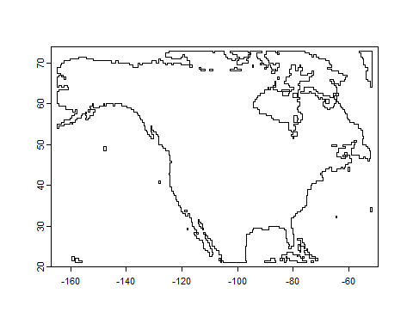 ## Load and plot the North American d2H isoscape.

plot(d2h_lrNA)

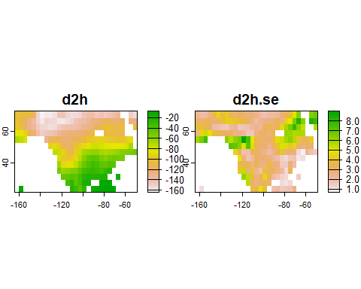

## Explore the known origin data; taxa must be biologically relevant to your focal species

names(knownOrig) # View the column names of the dataset

## [1] "sites" "samples" "sources"

## use View(knownOrig) to open the dataset in a viewer for manual inspection

## Subset the known origin data to include only ‘Passerine’ and apply the NA map as a mask.

d <- subOrigData(group = "Passerine", mask = naMap)

## 1397 samples are found from 741 sites

## Warning in refTrans(result, marker, ref_scale, niter): No calibration scale  
## reported, some samples dropped from scale transformation

## 1222 samples from 727 sites in the transformed dataset

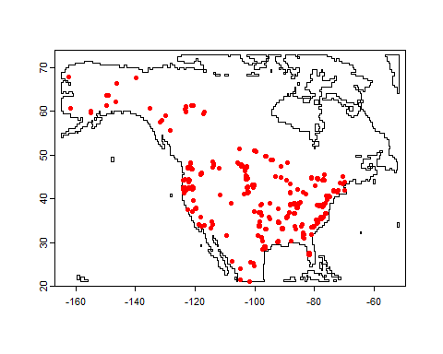

# Calculate the isoscape raster for the subset of known origin data.  
r <- calRaster(known = d, isoscape = d2h_lrNA, mask = naMap)

##   
##   
## ---------------------------------------  
## ------------------------------------------  
## rescale function uses linear regression model,   
## the summary of this model is:  
## -------------------------------------------  
## --------------------------------------  
##   
## Call:  
## lm(formula = tissue.iso ~ isoscape.iso[, 1], weights = tissue.iso.wt)  
##   
## Weighted Residuals:  
## Min 1Q Median 3Q Max   
## -134.526 -11.582 2.049 14.409 77.840   
##   
## Coefficients:  
## Estimate Std. Error t value Pr(>|t|)   
## (Intercept) 0.47675 0.98170 0.486 0.627   
## isoscape.iso[, 1] 0.84361 0.01438 58.649 <2e-16 ***  
## ---  
## Signif. codes: 0 '***' 0.001 '**' 0.01 '*' 0.05 '.' 0.1 ' ' 1  
##   
## Residual standard error: 21.98 on 1220 degrees of freedom  
## Multiple R-squared: 0.7382, Adjusted R-squared: 0.738   
## F-statistic: 3440 on 1 and 1220 DF, p-value: < 2.2e-16

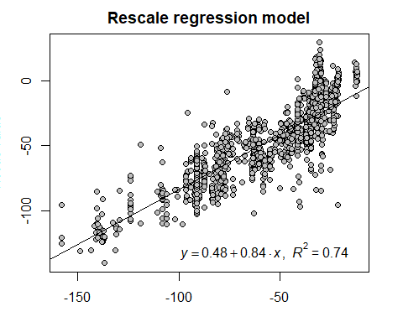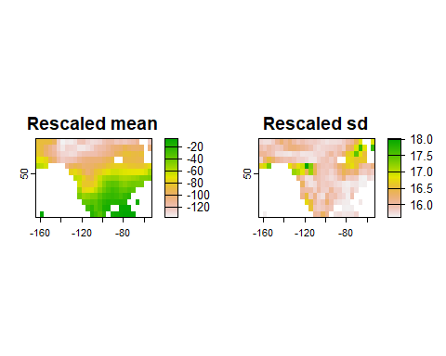

## NULL

# Plot the rescaled isoscape mean with custom colors and labels.  
Isoscape1 <- plot(r$isoscape.rescale$mean,   
 legend = TRUE,   
 col = bpy.colors(16),   
 xlab = "longitude",   
 ylab = "latitude",   
 legend.args = list(text = "d2H"))

## Warning in plot.window(...): "legend.args" is not a graphical parameter

## Warning in plot.xy(xy, type, ...): "legend.args" is not a graphical parameter

## Warning in title(...): "legend.args" is not a graphical parameter

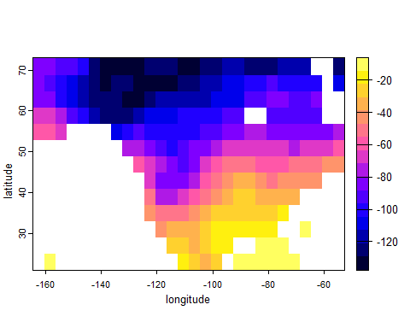 ## Process the GRCA data

# Remove missing data from the isotope dataset.  
GRCA_Isotopes_long <- na.omit(df)  
  
# Subset the origin data for the specific taxon 'Seiurus aurocapilla'; Ovenbird chosen due to similar molt patterns during life history thus incorporating d2H at breeding grounds similar to Catbird  
  
Ll_d <- subOrigData(taxon = "Seiurus aurocapilla", mask = naMap)

## 104 samples are found from 51 sites

## Warning in refTrans(result, marker, ref_scale, niter): No calibration scale  
## reported, some samples dropped from scale transformation

## 52 samples from 43 sites in the transformed dataset

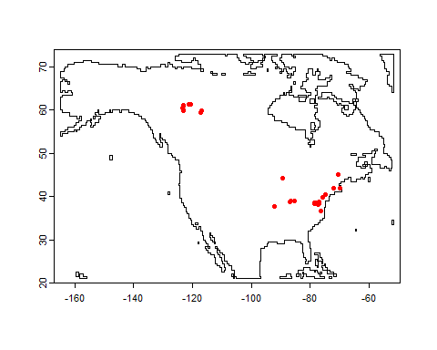

# Display the chain information from the subset data.  
Ll_d$chains

## [[1]]  
## [1] "OldEC.1_H_1" "EC_H_7" "EC_H_9" "VSMOW_H"

# Calculate the raster for the subset data with the isoscape and mask.  
d2h_Ll <- calRaster(known = Ll_d, isoscape = d2h_lrNA, mask = naMap)

##   
##   
## ---------------------------------------  
## ------------------------------------------  
## rescale function uses linear regression model,   
## the summary of this model is:  
## -------------------------------------------  
## --------------------------------------  
##   
## Call:  
## lm(formula = tissue.iso ~ isoscape.iso[, 1], weights = tissue.iso.wt)  
##   
## Weighted Residuals:  
## Min 1Q Median 3Q Max   
## -21.084 -9.851 0.539 7.627 47.138   
##   
## Coefficients:  
## Estimate Std. Error t value Pr(>|t|)   
## (Intercept) -9.08028 2.92746 -3.102 0.00316 **   
## isoscape.iso[, 1] 0.74304 0.02751 27.013 < 2e-16 ***  
## ---  
## Signif. codes: 0 '***' 0.001 '**' 0.01 '*' 0.05 '.' 0.1 ' ' 1  
##   
## Residual standard error: 14.74 on 50 degrees of freedom  
## Multiple R-squared: 0.9359, Adjusted R-squared: 0.9346   
## F-statistic: 729.7 on 1 and 50 DF, p-value: < 2.2e-16

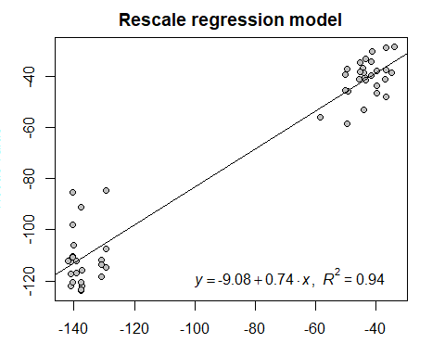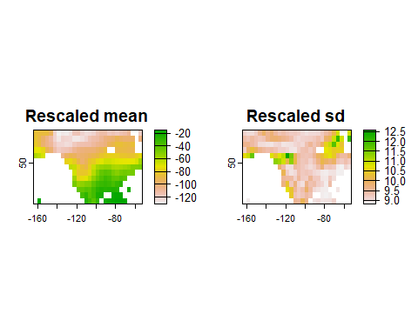

## NULL

# Calculate the probability distribution raster for the unknown GRCA isotope data.  
Ll_prob_long <- pdRaster(d2h_Ll, unknown = GRCA_Isotopes_long)

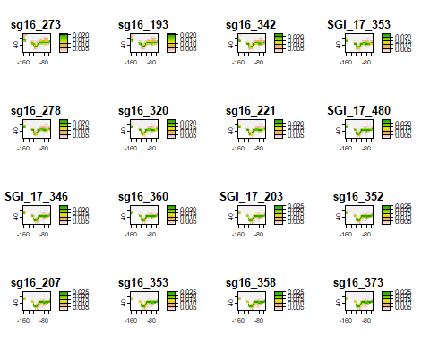

## NULL

# Increase the resolution of the raster by disaggregating with a bilinear method.  
L1_prob_hi <- disagg(Ll_prob_long, fact = 20, method = "bilinear")  
  
# Plot the quantile raster with a specified threshold.  
qtlRaster(L1_prob_hi, threshold = 0.3)

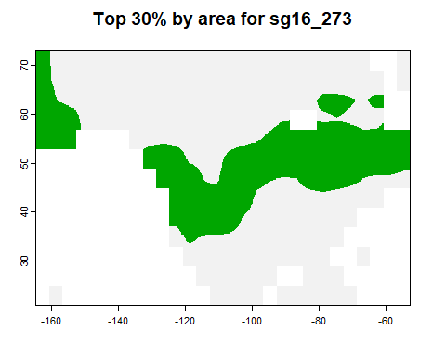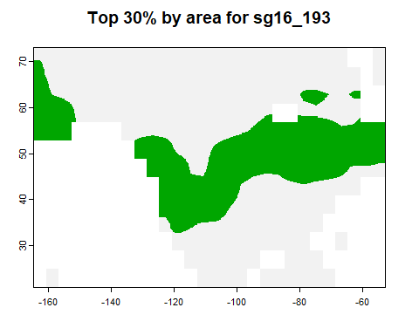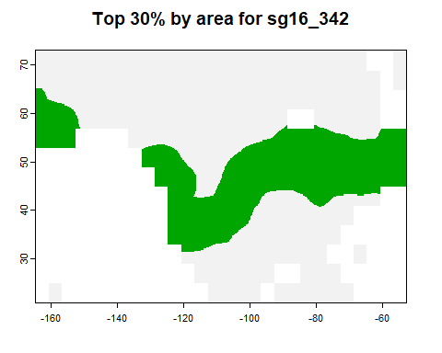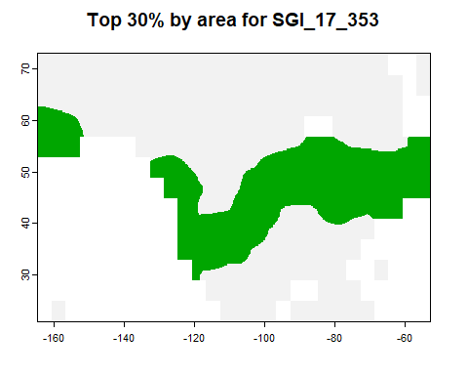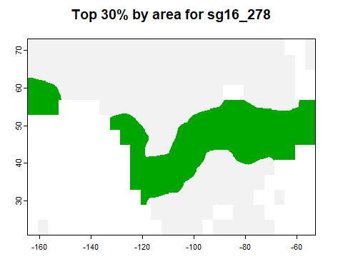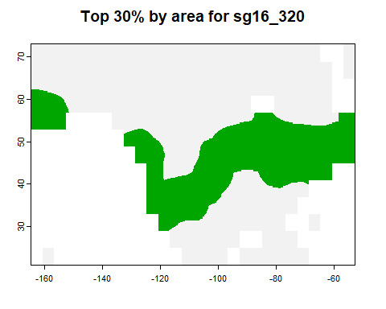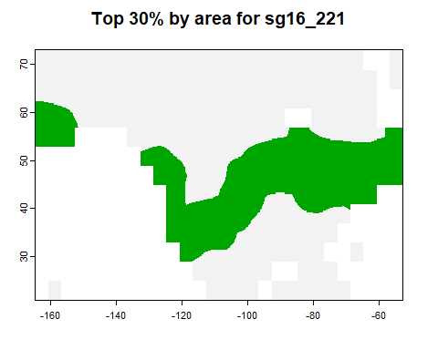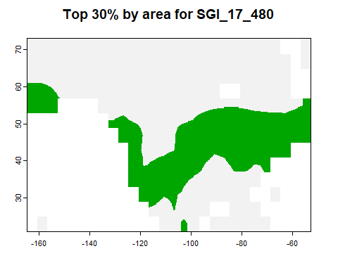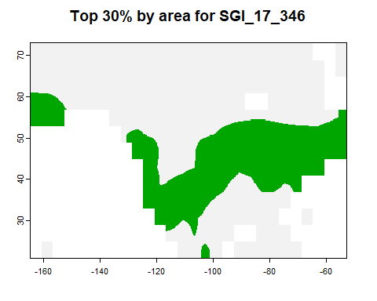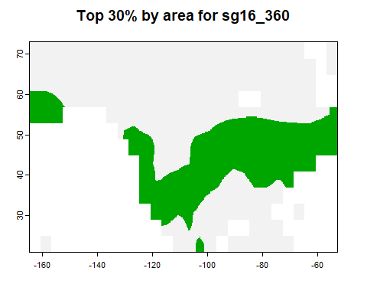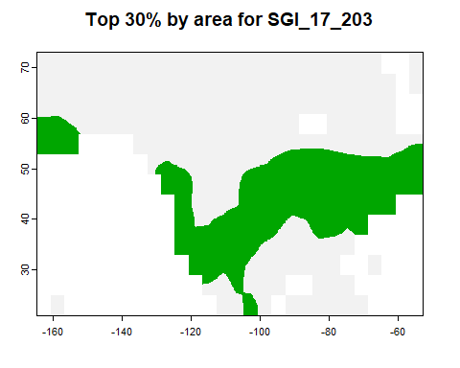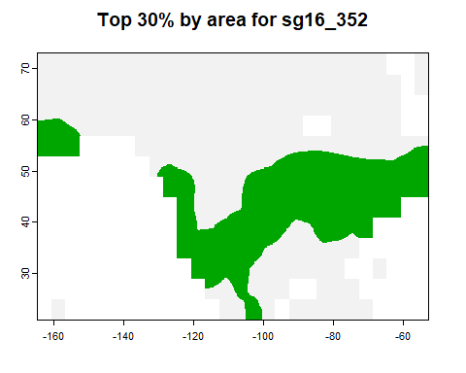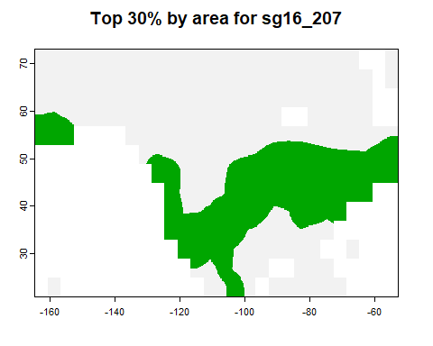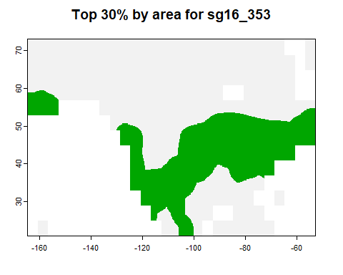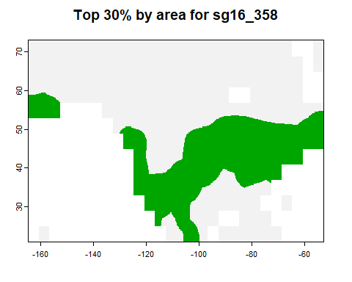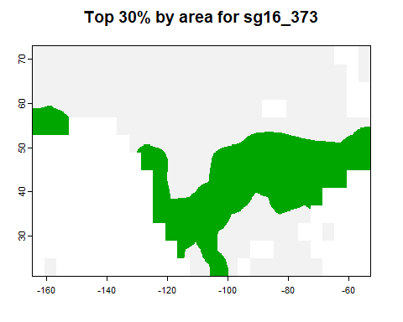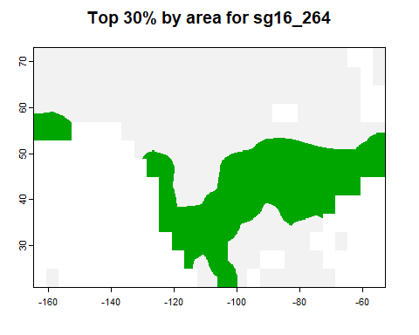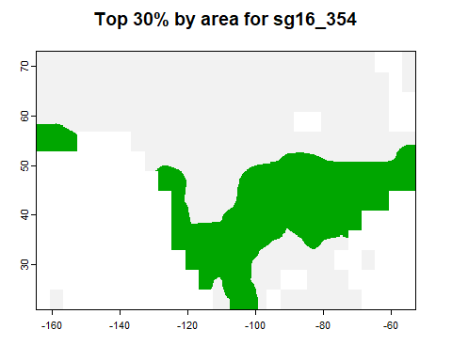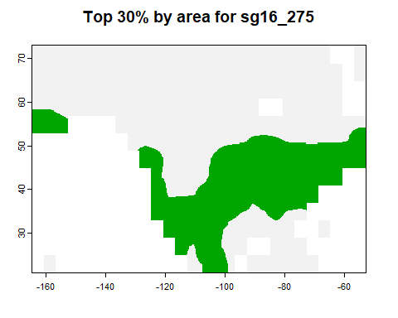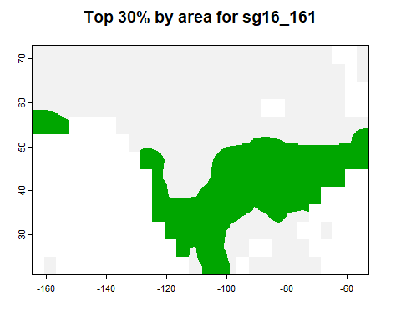

## class : SpatRaster   
## dimensions : 260, 560, 20 (nrow, ncol, nlyr)  
## resolution : 0.1999999, 0.1999999 (x, y)  
## extent : -164.6667, -52.66672, 20.99996, 72.99993 (xmin, xmax, ymin, ymax)  
## coord. ref. : lon/lat WGS 84 (EPSG:4326)   
## source(s) : memory  
## names : sg16_273, sg16_193, sg16_342, SGI_17_353, sg16_278, sg16_320, ...   
## min values : FALSE, FALSE, FALSE, FALSE, FALSE, FALSE, ...   
## max values : TRUE, TRUE, TRUE, TRUE, TRUE, TRUE, ...

# Calculate and display the joint probability.  
jointP(L1_prob_hi)

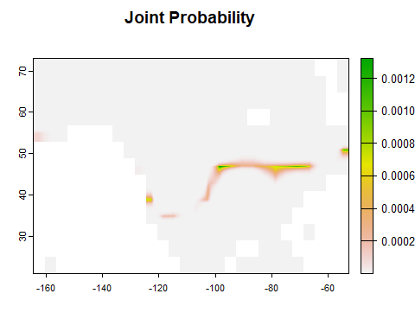

## class : SpatRaster   
## dimensions : 260, 560, 1 (nrow, ncol, nlyr)  
## resolution : 0.1999999, 0.1999999 (x, y)  
## extent : -164.6667, -52.66672, 20.99996, 72.99993 (xmin, xmax, ymin, ymax)  
## coord. ref. : lon/lat WGS 84 (EPSG:4326)   
## source(s) : memory  
## name : Joint_Probability   
## min value : 3.668748e-247   
## max value : 1.322593e-03