On-Screen Appearance Requirements

Page 1. This is the landing page of the website.

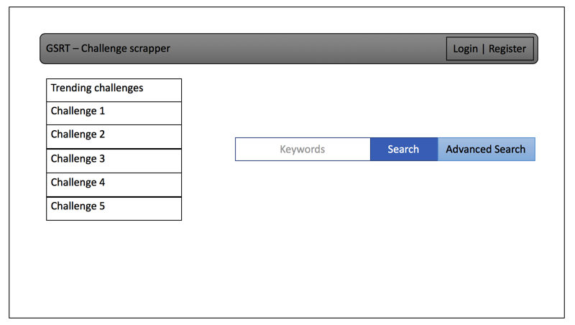

Page 2. User login page of the website, register page will have the same view. It’s a minimalistic design.

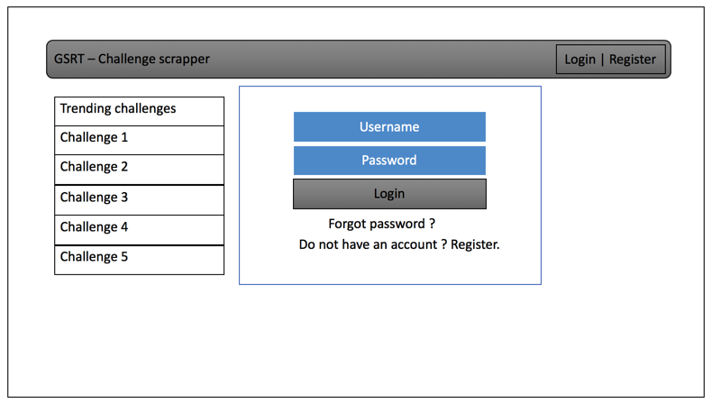

Page 3. It will display the challenges from the search criteria.

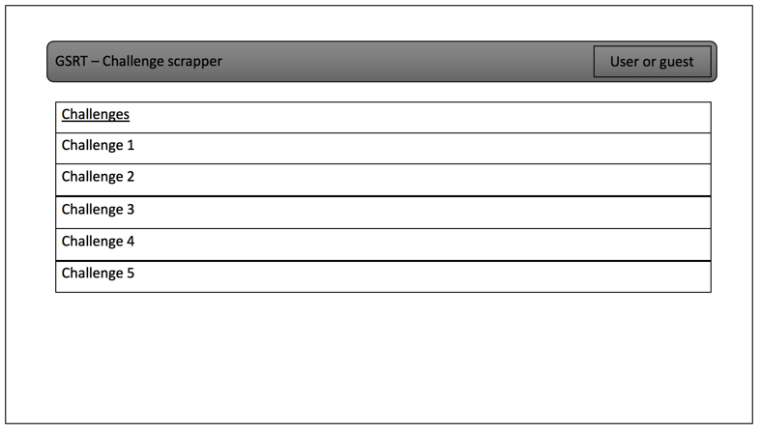

Page 4. Individual search results or challenges can be view separately, making notes capability is provided and will have the hint section too.

