December 2, 2018
Ashish Rastogi, Kirit Soheliya
GSRTB
FHSU
GSRTB challenge webscraper
Front End User Guide v1.0
GSRTB – Front End User Guide v 1.0

Table of Contents
1. Introduction. 2
2. Front End UI screen. 3
2.1 Home page 3
2.2 User registration 4
2.3 Existing User Login 5
2.4 Challenge detail 6
2.5 User Profile Page 9
2.6 User Logout 10

Figure 1 - Home Page 3
Figure 2 - User Registration 4
Figure 3 - Existing User Login 5
Figure 4 - Incorrect credential notification 6
Figure 5 - Challenge Detail 6
Figure 6 - Hints Tab 7
Figure 7 - Notes 7
Figure 8 - Edit Notes 8
Figure 9 - Saved Notes 9
Figure 10 - User Profile 9
Figure 11 - User Logout 10

Introduction.

This user guide is prepared for the users to get to know how to use the web scraping tool for searching the challenges. This tool will help people prepare for the interviews and personal development by searching the challenges for the particular technology or domain all at one place. Web scraper will pull the challenges from various websites.

There is a set method to get familiar with this web scraper tool and use it as needed. Purpose of User guide is to provide that understanding.

Front End UI screen.

In this action different UI screens are described along with method to access the web scrapper tool.

Home page

Home page can be accessed by typing the web address in the web browser of user’s choice. This UI is supported on all html5 and Java supported web browsers namely, Chrome, Mozilla Firefox, Safari etc.

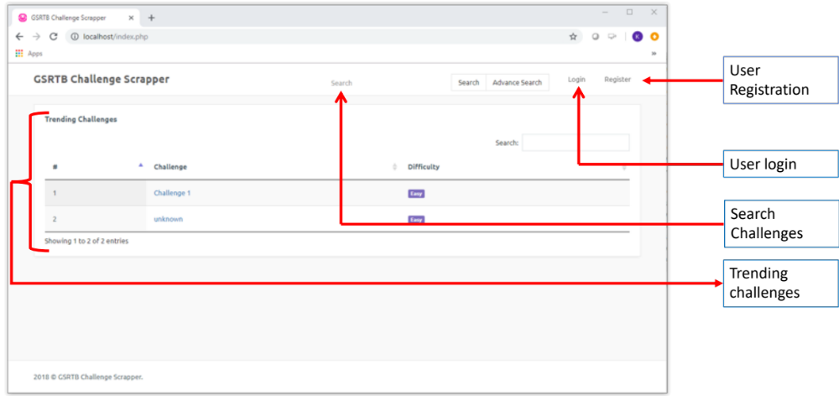
Figure 1 - Home Page

The UI home page will have four key sections; User registration, User Login, Search Challenges and Trending Challenges.
On clicking User registration, user will be presented a page to create a new user and password.
User login will let existing user to login to the web scrapper tool.
Search Challenges will let signed in user search for the challenges with particular keywords.
Trending Challenges section will display the most viewed and searched challenges.

User registration

At user registration stage, user have to provide following credentials:
- Full Name
- Valid Email ID
- Password as per the password policy.
By clicking submit button, user entry will be created and will be logged in automatically.

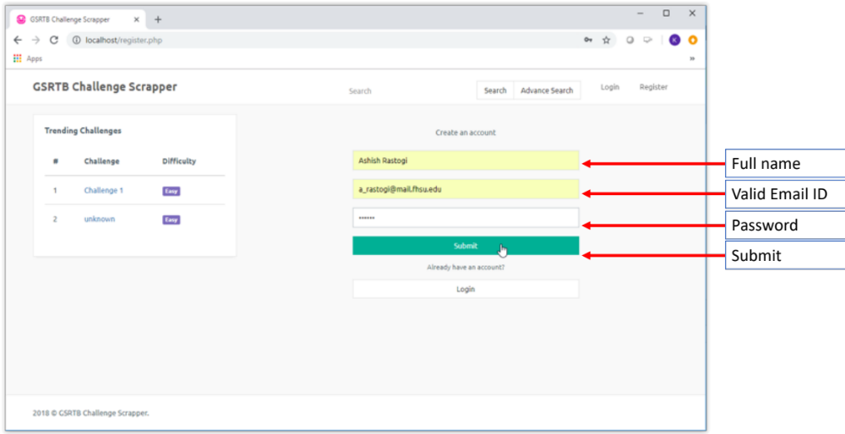
Figure 2 - User Registration

Existing User Login
For existing user to login into their account, user ID and password need to be entered into respective fields. If the credentials are correct per registration, user will be logged in. Incorrect credential will display an error message indicating wrong username or password or both.

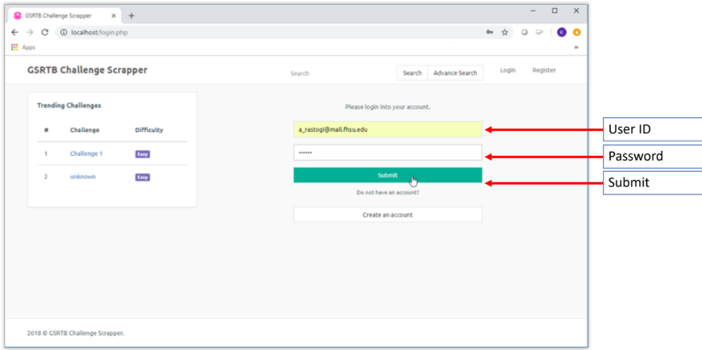
Figure 3 - Existing User Login

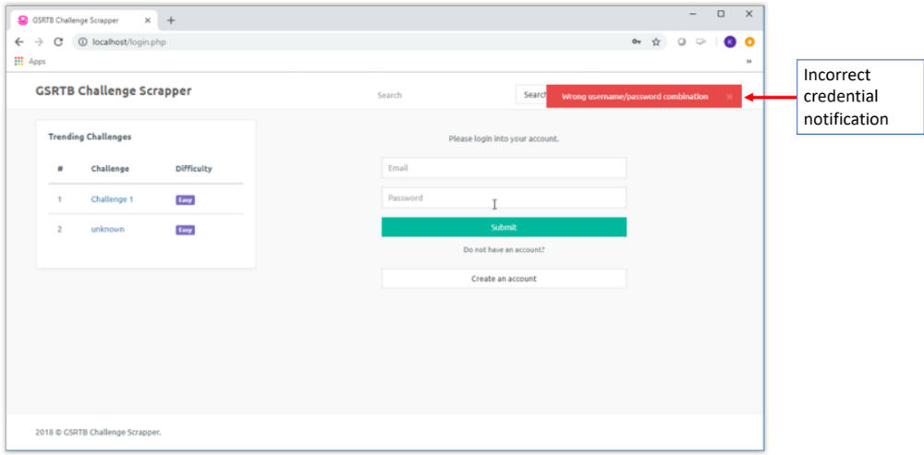
Figure 4 - Incorrect credential notification

Challenge detail

Challenge detail page is a busy page which contains lot of information about the searched challenge.

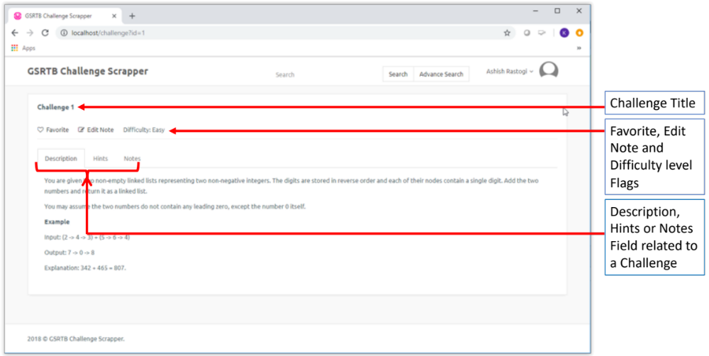
Figure 5 - Challenge Detail
Description Field will have all the information related to a searched challenge.
Hints tab will keyword or suggestions about the particular challenge and how to solve it.

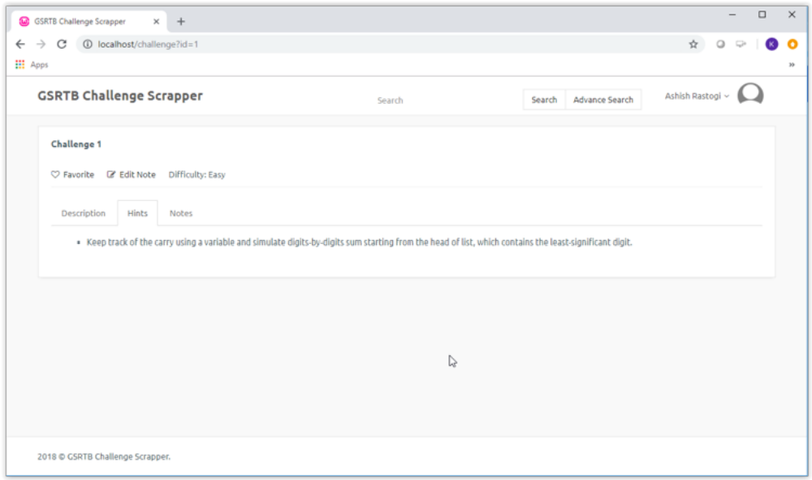
Figure 6 - Hints Tab
Notes Tab provides the capability for users to enter challenge specific customized summary and can be modified be as and when needed, by clicking edit notes button.

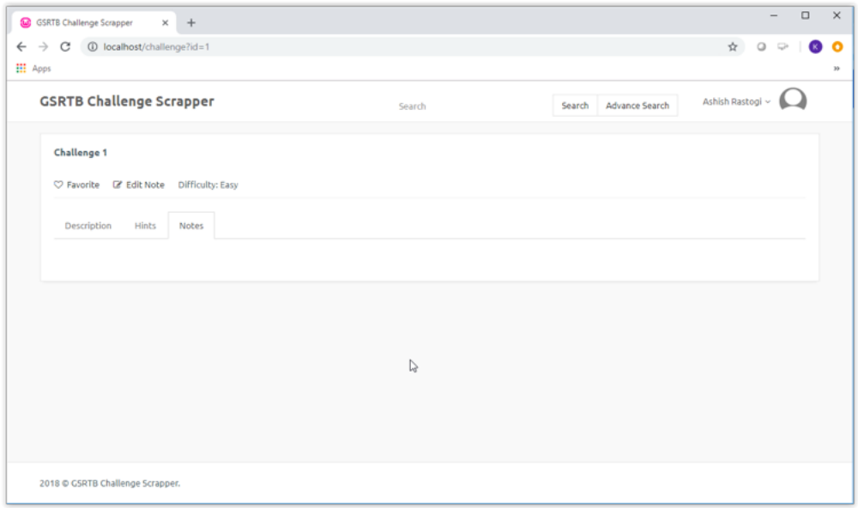
Figure 7 - Notes
Edit Note button is provided to logged in users for modifying the notes for a particular challenge. A pop-up window will open for users to update notes with 500-character implicit limit.

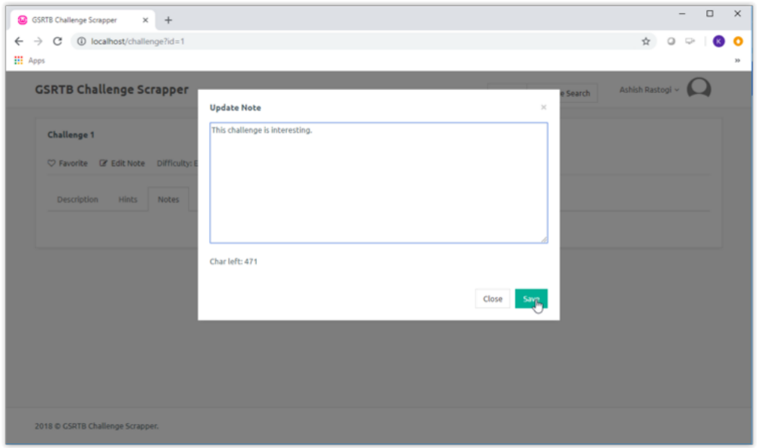
Figure 8 - Edit Notes
Pop-up window will let save or cancel the update, once saved it will update the Notes for the challenge.

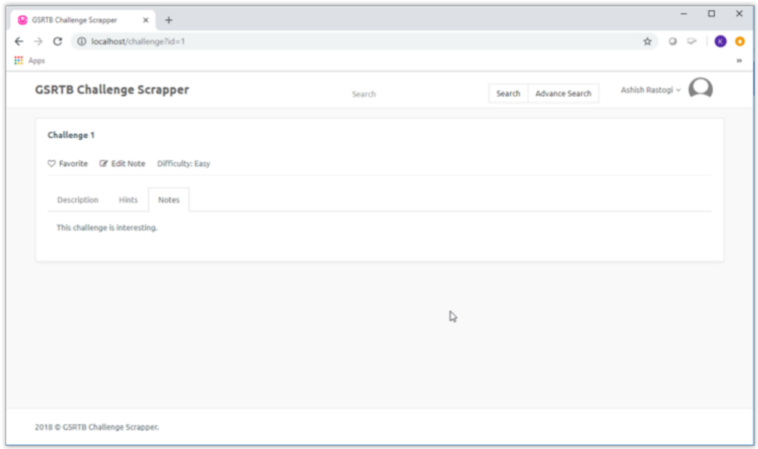
Figure 9 - Saved Notes

User Profile Page
User profile page will display user specific information. This page will exhibit all the challenges with favorite flag set.

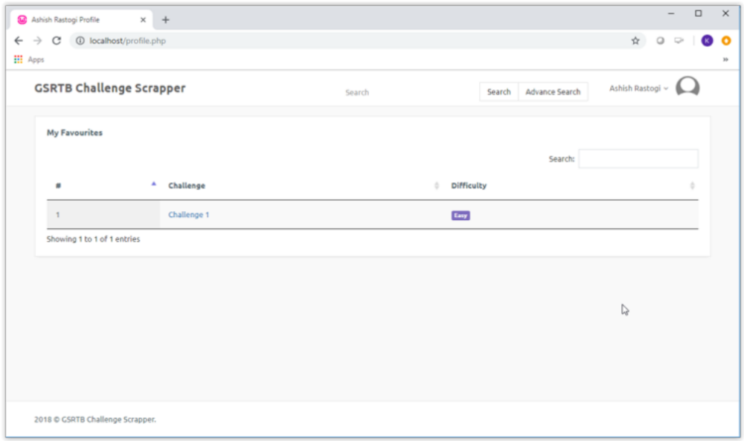
Figure 10 - User Profile

User Logout

If logout button is clicked user will logged out from the website and end up on login page.

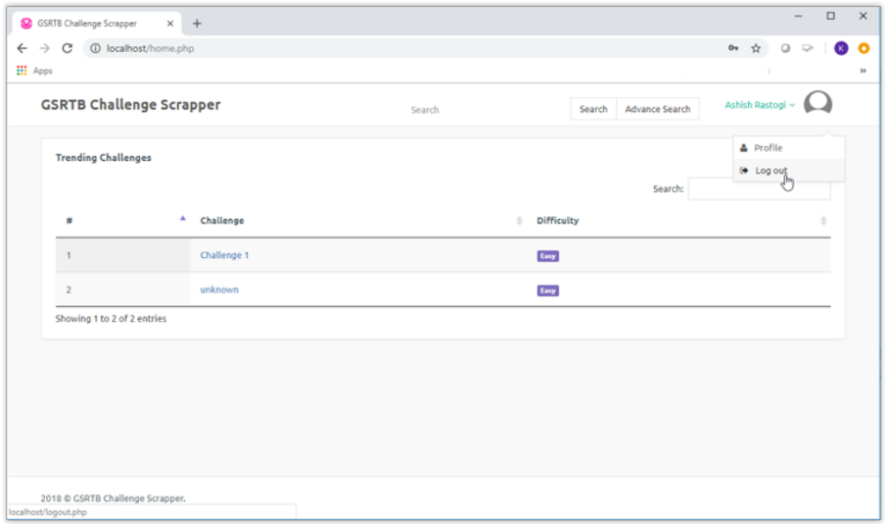
Figure 11 - User Logout

