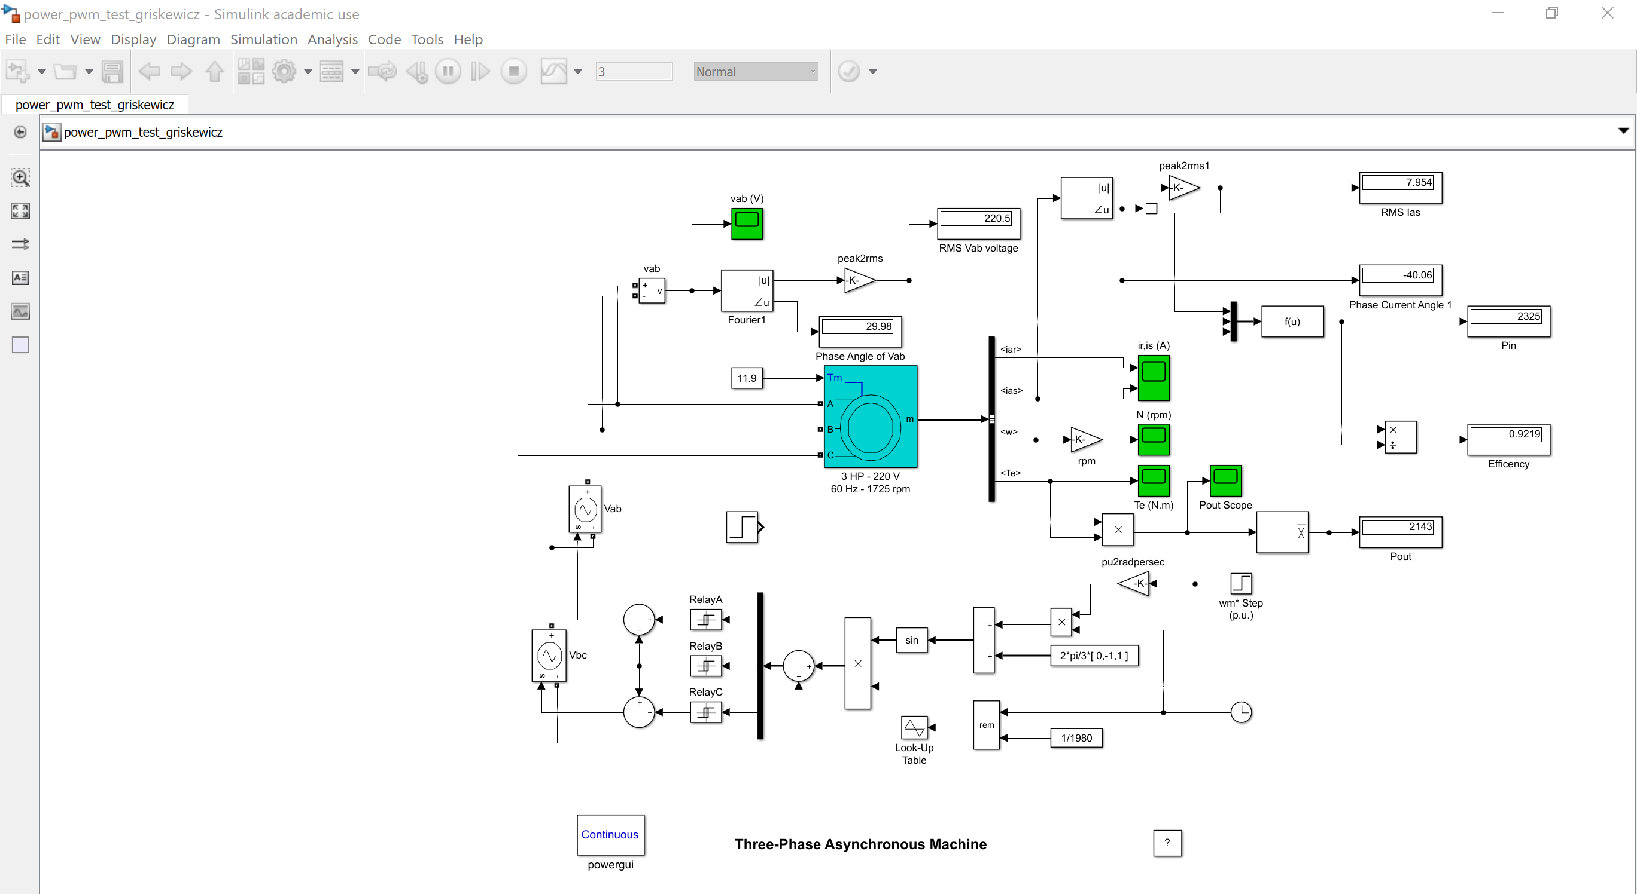

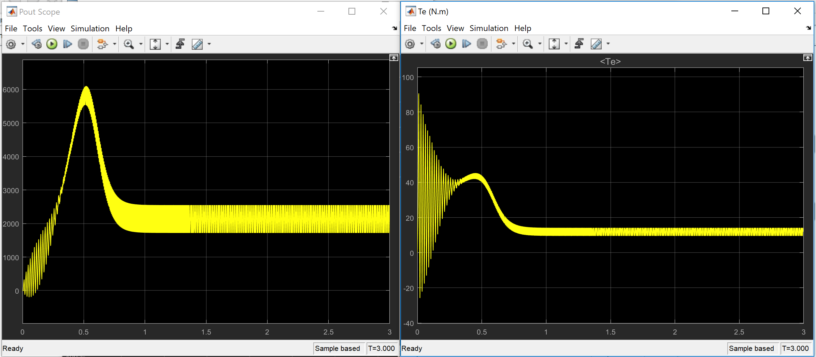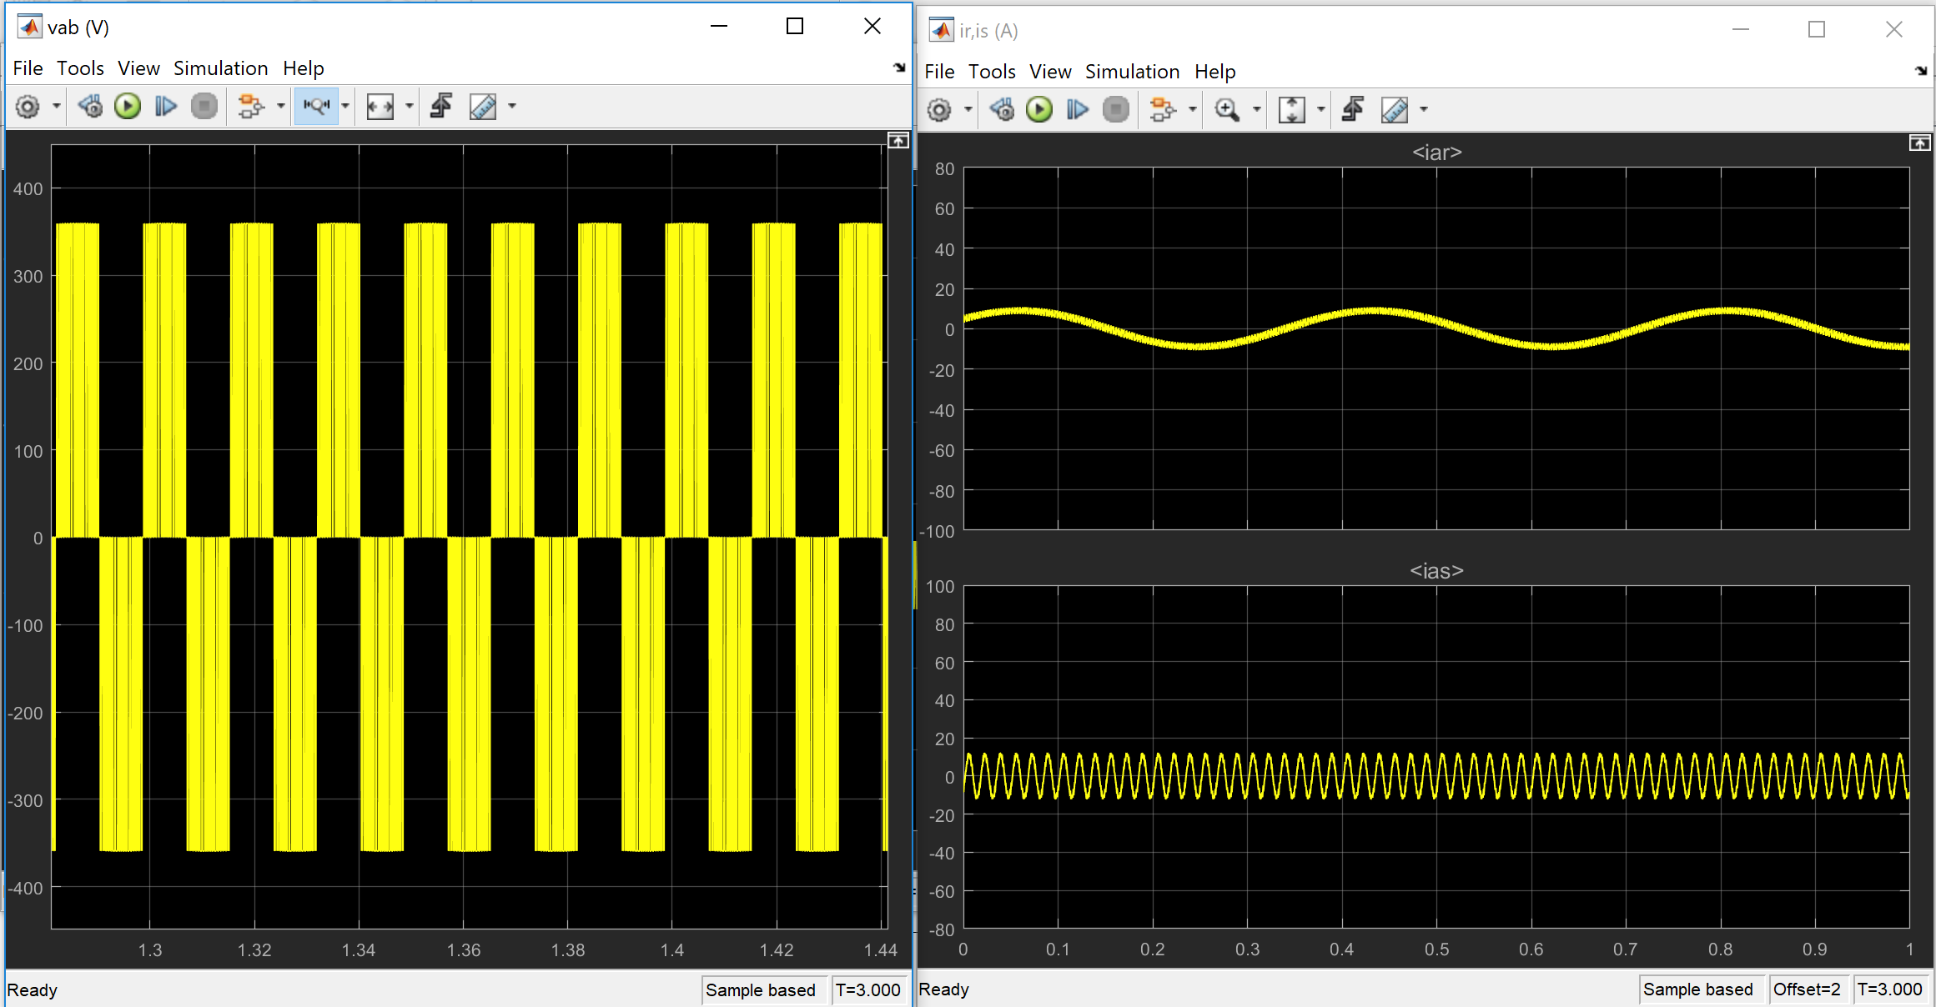

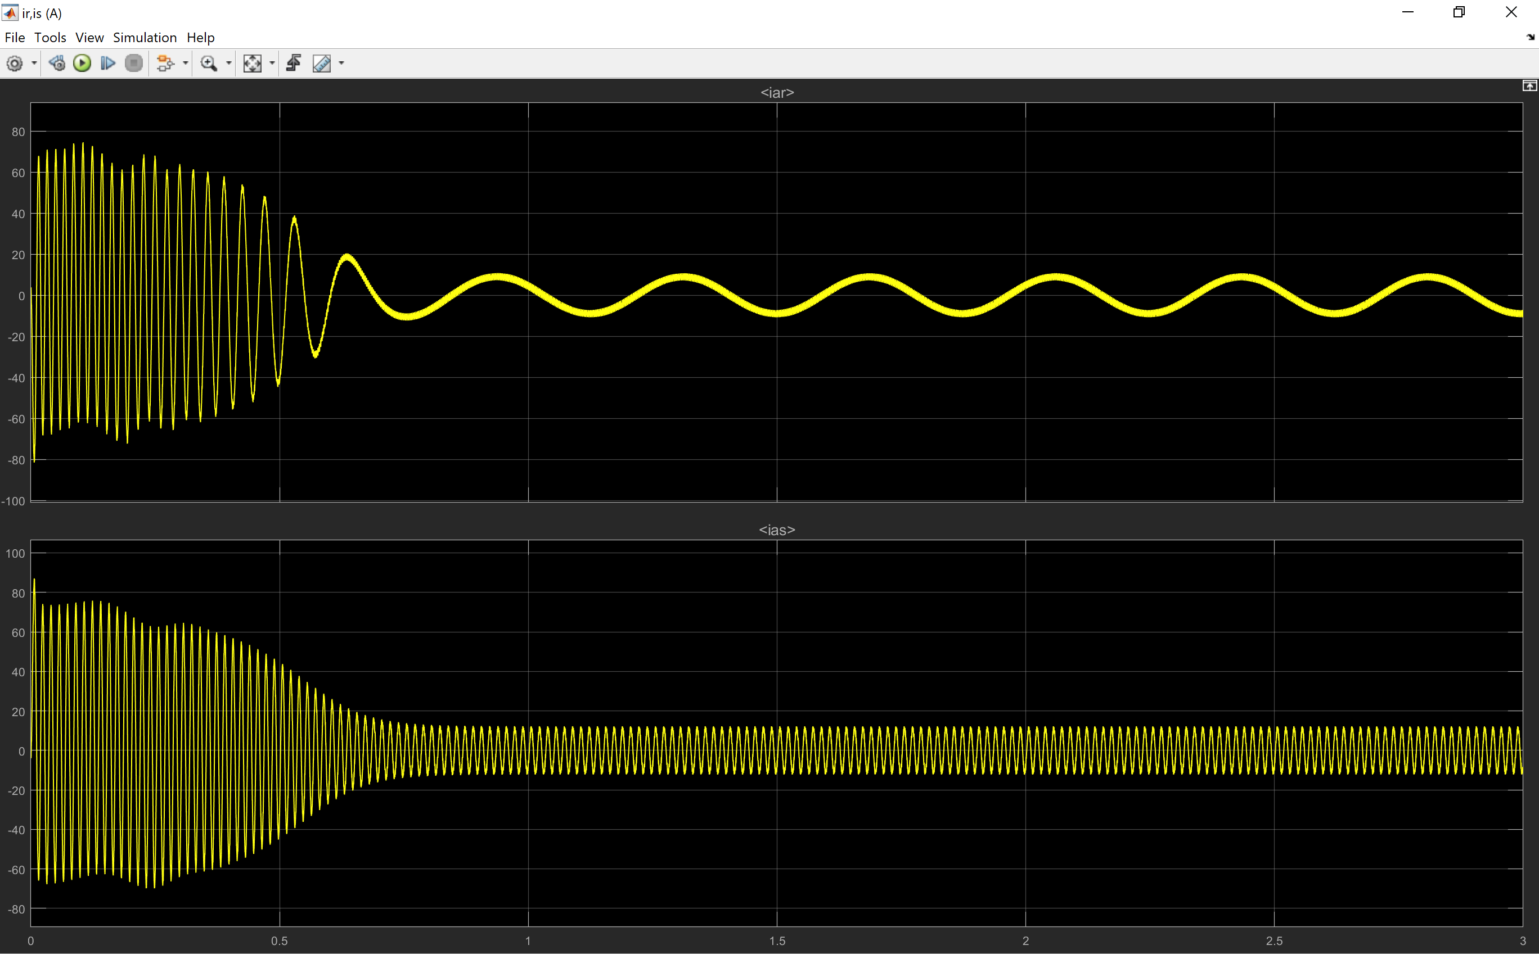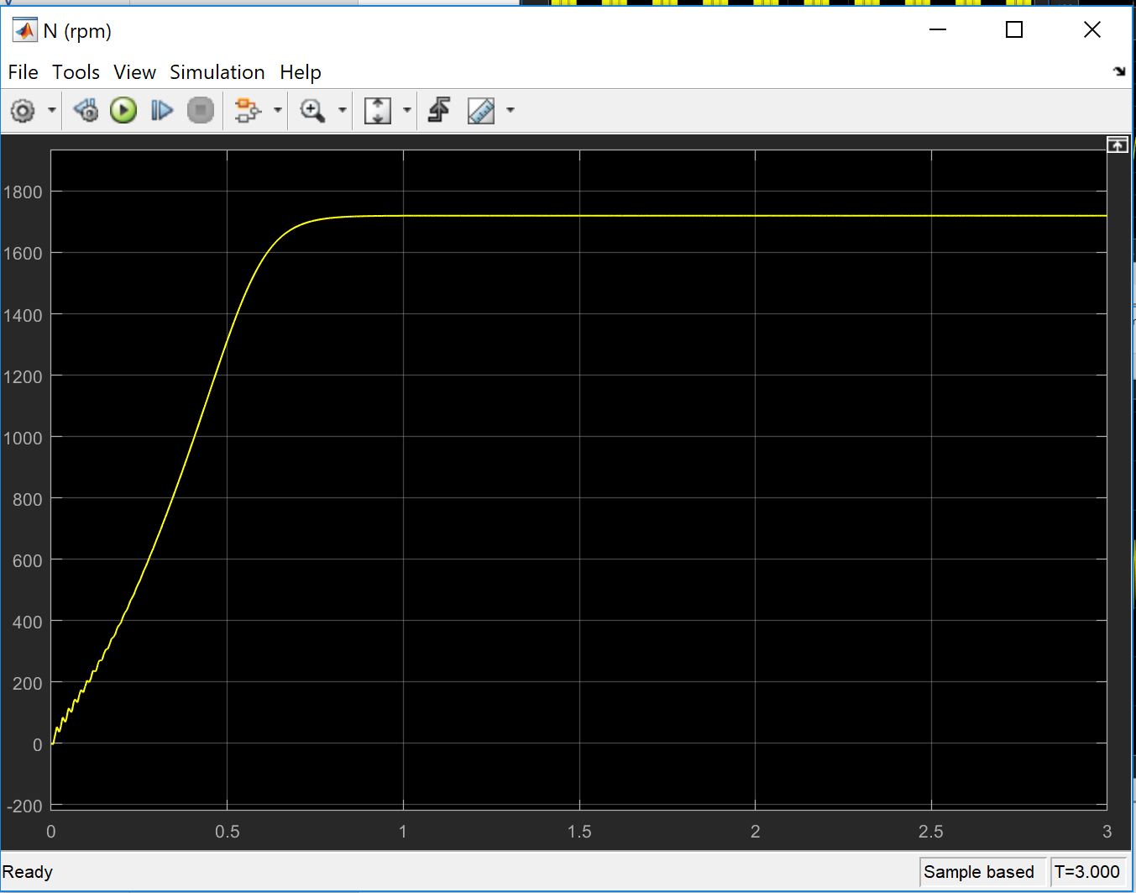

Pn=3\*746;

Vn=220;

fn=60;

Rs=.0435;

Lls=4e-3;

Rr=0.816;

Llr=2e-3;

Lm=69.31e-3;

Ls=Lls+Lm;

Lr=Llr+Lm;

J=0.089;

Also used 1719 RPM

P=4;

ns=120\*fn/P;

nm=1725;

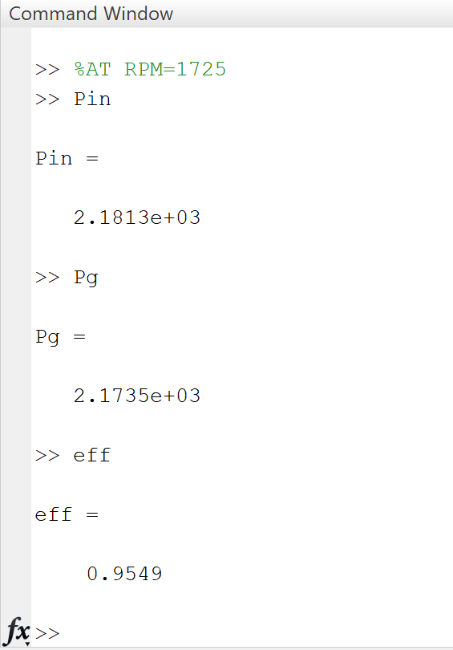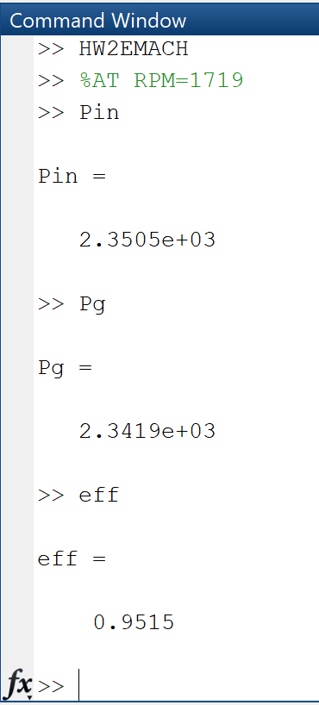

we=2\*pi\*fn;

wm=nm/60\*2\*pi;

wr=wm\*P/2;

s=(ns-nm)/ns;

Xlr=Llr\*we\*1i;

Xm=Lm\*we\*1i;

Xls=Lls\*we\*1i;

Zr=Rr/s+Xlr;

Zm=Xm;

Zeq=(Zm\*Zr)/(Zm+Zr);

Zs=Rs+Xls;

Zt=Zs+Zeq;

Vs=Vn/sqrt(3);

Is=Vs/Zt;

Ir=(Vs-Is\*Zs)/Zr;

S=3\*Vs\*conj(Is);

Pin=real(S);

Pls=3\*abs(Is)^2\*Rs;

Plr=3\*abs(Ir)^2\*Rr;

Pg=3\*abs(Ir)^2\*Rr/s;

Pmech=3\*abs(Ir)^2\*Rr\*(1-s)/s;

Tdev=3\*(P/2)\*(Rr/(s\*we))\*(Vs^2)/((Rs+Rr/s)^2+we^2\*(Lls+Llr)^2);

Tem=3/4\*(P/we)\*(Vs^2)/((Rs+Rr/s)^2+we^2\*(Lls+Llr)^2)-Rs;

Tstart=3\*(P/2)\*(Rr/we)\*(Vs^2)/((Rs+Rr/s)^2+we^2\*(Lls+Llr)^2);

eff=Pmech/Pin;

3.3)

When comparing 3.1 to 3.2 the efficiency is a bit different. When comparing the stator and rotor currents we can see that for 3.1:

Is=7.94∟-40.86°

IR=7.07∟6.7°

When comparing the stator and rotor currents we can see that for 3.2:

Is=8.11∟-40.86°

IR=6.53∟-6.7°

Once again like the efficiency the values differ a bit, where the MATLAB script in 3.2 shows a higher value. This may be the reason for the better efficiency. Please note that MATLAB provided values in a complex form and I used a CASIO Fx-115ES to convert. I also tried to add an RMS reader for IR as shown below:

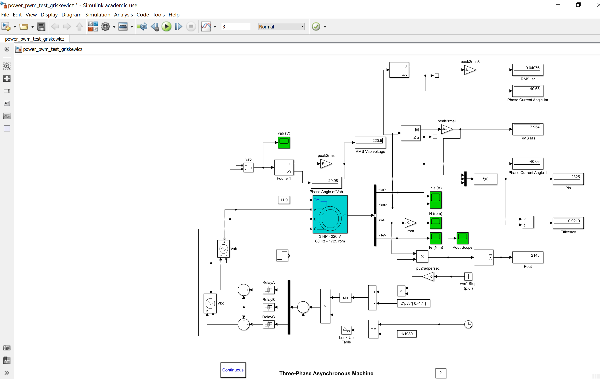

3.4)

