National Real Estate Prices (Python)
Technical Report
Evidence-based review of the repository, data pipeline, statistical outputs, and next-step recommendations
Project | Prepared from | Report date
national-real-estate-prices-python | Repository source files, generated CSV outputs, charts, and notebook artifacts | April 17, 2026

Executive Summary
- The repository successfully ports the original R workflow into Python and reproduces the end-to-end process of ingesting CPI, mortgage-rate, and FHFA house-price-index data; engineering aligned monthly and quarterly analysis tables; running correlation and pairwise regression analyses; and producing exploratory k-means regime clusters.
- The strongest empirical signals are co-movement relationships within housing inflation series rather than direct linear links from CPI or mortgage rates to house-price inflation. The highest full-sample correlations are Boulder vs. Colorado housing inflation (r = 0.889) and Mountain vs. USA housing inflation (r = 0.887).
- Mortgage rates and consumer inflation are positively related, with the relationship notably stronger in the quarterly regional sample (r = 0.604) and the long monthly sample beginning in 1971 (r = 0.586) than in the post-1991 monthly housing sample (r = 0.194).
- The overlap comparison indicates that updating the data sources changes coefficients only modestly on the shared historical window, which supports the stability of the Python implementation relative to the original project logic.
- The codebase is analytically useful and reproducible, but several labeling and methodology issues should be addressed: output filenames still reference 2022 although the refreshed data now extend into 2025–2026, the inflation-rate construction uses a nonstandard bootstrap for the first year of observations, and clustering is exploratory because no cluster-selection diagnostics are reported.

Technical Approach
The project is organized around four main scripts and one notebook mirror. `src/update_data.py` refreshes raw datasets from FRED and FHFA. `src/analysis.py` performs the complete transformation and statistical workflow, generating CSV tables and PNG figures. `src/compare_overlap.py` reconstructs the baseline/original-window comparison and quantifies how updated data affect the results on overlapping dates. `src/generate_html_report.py` compiles current outputs into an HTML dashboard, while `analysis.ipynb` mirrors the same workflow interactively.

Workflow implemented in code
Step | What the repository does
Data ingestion | Reads CPI, mortgage, and HPI series; downloads CPI automatically if missing and provides a separate update script for full refreshes.
Temporal alignment | Creates a FractionalYear key so monthly and quarterly series can be joined consistently across sources.
Feature engineering | Constructs annualized consumer and housing inflation series from levels for monthly and quarterly samples.
Statistical analysis | Computes Pearson correlation matrices, pair plots, and simple linear regressions using scipy.stats.linregress.
Unsupervised exploration | Standardizes selected features, applies PCA for visualization, and runs KMeans for multiple values of k.
Reporting | Writes CSV summaries, PNG charts, an executed notebook artifact, and an HTML summary page.

Data Used
The repository uses authoritative public macroeconomic and housing datasets. Consumer prices and mortgage rates are sourced from FRED, and house-price indexes are sourced from the FHFA master HPI file. The Python refresh script converts these feeds into the local CSV schemas expected by the analysis pipeline.
Dataset | Latest observation in repo | Rows
CPI-U (FRED CPIAUCSL) | 2026-03 | 662
30-year fixed mortgage rate (FRED MORTGAGE30US, monthly average) | 2026-04 | 661
FHFA HPI USA (monthly, purchase-only) | 2026-01 | 421
FHFA HPI Mountain Division (monthly, purchase-only) | 2026-01 | 421
FHFA HPI Colorado (quarterly, all-transactions) | 2025 Q4 | 204
FHFA HPI Denver MSA (quarterly, all-transactions) | 2025 Q4 | 199
FHFA HPI Boulder MSA (quarterly, all-transactions) | 2025 Q4 | 192
The analysis is performed on four derived tables. `df1` is a long monthly CPI and mortgage-rate panel from 1971 onward. `df` joins CPI, mortgage rates, and USA/Mountain HPI at monthly frequency from 1991 onward. `df2` joins CPI, mortgage rates, and Colorado/Denver/Boulder HPI at quarterly frequency from 1978 onward. `df3` merges the regional quarterly table with the broader USA and Mountain monthly housing inflation metrics for the overlapping years.

Analysis of Results
The regression summary produced by `src/analysis.py` shows that the most reliable linear relationships are between geographically related housing inflation series, while macro-to-housing links are positive but materially weaker.
Model | N | Slope | r | p-value
House Inflation Rate (Boulder) vs House Inflation Rate (Colorado) | 192 | 0.946 | 0.889 | 3.21e-66
House Inflation Rate (Mountain) vs House Inflation Rate (USA) | 420 | 1.297 | 0.887 | 1.12e-142
Mortgage Rate vs Consumer Inflation Rate | 192 | 0.722 | 0.604 | 1.91e-20
Mortgage Rate vs Consumer Inflation Rate (Long Monthly Series) | 659 | 0.641 | 0.586 | 5.78e-62
House Inflation Rate (Colorado) vs Consumer Inflation Rate | 192 | 0.758 | 0.389 | 2.36e-08
House Inflation Rate (Boulder) vs Consumer Inflation Rate | 192 | 0.705 | 0.340 | 1.40e-06
House Inflation Rate (USA) vs Consumer Inflation Rate | 420 | 1.082 | 0.335 | 1.68e-12
House Inflation Rate (Mountain) vs Consumer Inflation Rate | 420 | 1.377 | 0.292 | 1.03e-09

Interpretation of the main results
- Housing inflation co-moves strongly across related geographies. In the updated full sample, Mountain vs. USA housing inflation has slope 1.297 with r = 0.887, and Boulder vs. Colorado has slope 0.946 with r = 0.889.
- Consumer inflation and mortgage rates move together, but the strength depends on time scale. The long monthly sample from 1971 produces r = 0.586 and slope 0.641, while the 1991+ monthly sample linked to house-price series produces a weaker r = 0.194.
- Mortgage rates have a modest negative association with USA house inflation in the monthly sample (slope = -0.547, r = -0.191), which is directionally plausible but not strong enough to support causal claims on its own.
- Regional quarterly house-price inflation is more tightly connected within-state than to mortgage rates. Boulder vs. mortgage rate is weak and statistically insignificant in the full sample (r = 0.071, p = 0.325).

Selected correlation structure
View | Notable relationship | Correlation
Monthly df (1991+) | USA vs. Mountain house inflation | 0.887
Monthly df (1991+) | CPI inflation vs. mortgage rate | 0.194
Quarterly df2 | Colorado vs. Boulder house inflation | 0.889
Quarterly df2 | CPI inflation vs. mortgage rate | 0.604
Merged df3 | USA vs. Mountain house inflation | 0.906
Merged df3 | Colorado vs. Denver house inflation | 0.974
The k-means outputs are best interpreted as exploratory regime segmentations rather than validated clusters. The code standardizes variables, reduces dimensionality to two principal components for plotting, and writes cluster assignments for several values of k, but it does not compute silhouette scores, elbow diagnostics, or stability metrics.

Representative Figures
The repository generates a large chart set. The figures below are representative of the trend, regression, and correlation outputs used in the assessment.
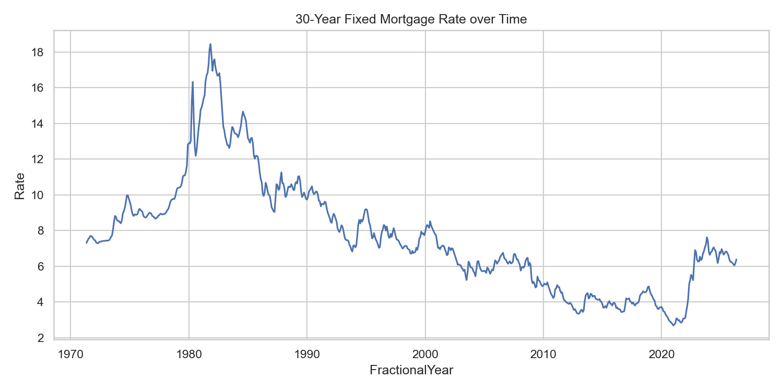
Figure 1. Mortgage rate trend used in the refreshed pipeline.
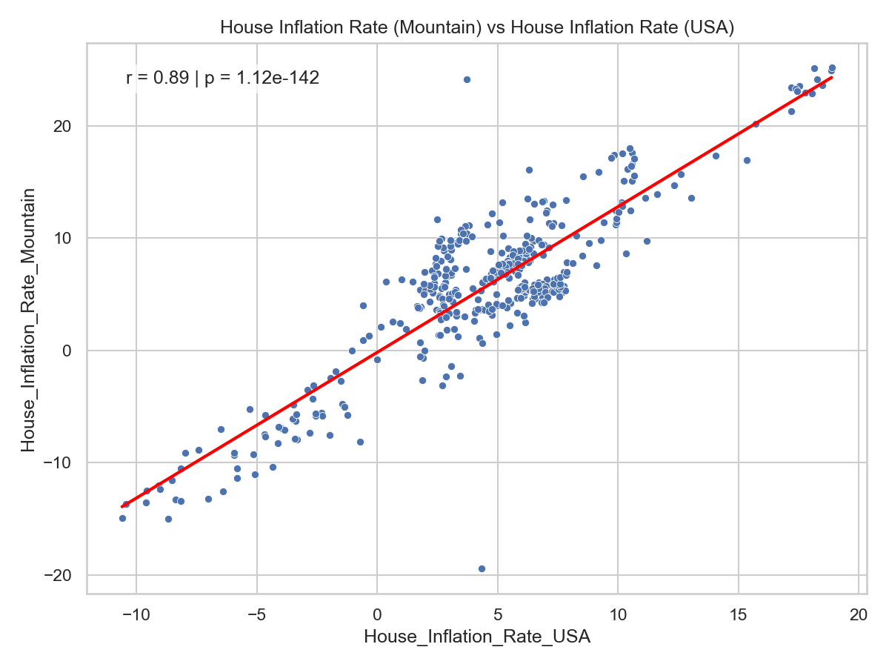
Figure 2. Mountain vs. USA housing inflation regression, one of the strongest relationships in the project.
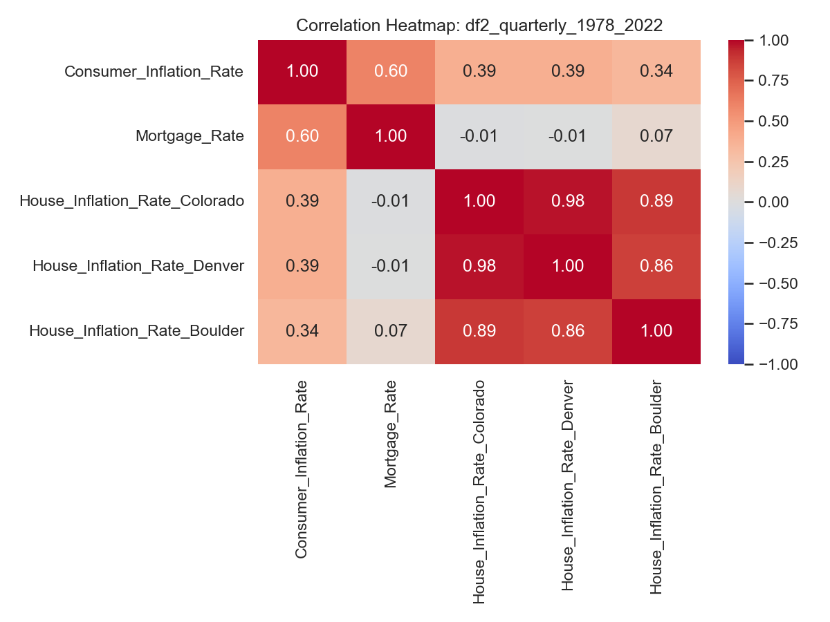
Figure 3. Quarterly regional correlation heatmap for CPI, mortgage rates, and Colorado/Denver/Boulder housing inflation.

Incorporated Findings from the Original 2022 Report

Methodological context added from the original write-up
The revised report now explicitly carries forward the framing used in the original project paper. That write-up describes the analysis as an observational study of CPI, consumer inflation derived from CPI, 30-year fixed mortgage rates, and FHFA Housing Price Index series at the national, Mountain Census Region, Colorado, Denver, and Boulder levels. It also documents a key preprocessing step that the Python repository mirrors conceptually: aligning monthly CPI and mortgage data with quarterly HPI series by converting calendar fields into fractional-year values so plots and joins can be compared on a common time axis.

Original benchmark results now referenced in the interpretation
The original 2022 report found only mild direct relationships between consumer inflation and housing inflation for the national and Colorado-area series: national house inflation versus consumer inflation had Pearson r = 0.33, Colorado versus consumer inflation had r = 0.37, and Boulder versus consumer inflation had r = 0.31, all with low adjusted R-squared values. By contrast, co-movement within housing markets was much stronger: Mountain Census Region versus USA housing inflation had r = 0.90, and Boulder versus Colorado housing inflation had r = 0.88. The earlier paper also reported that mortgage rates were moderately related to consumer inflation over the longer 1978–2022 window (r = 0.59) but only weakly related over 1991–2022 (r = 0.20), while national housing inflation versus mortgage rate was slightly negative (r = -0.21).

How the refreshed Python results compare
Those benchmark findings are directionally consistent with the refreshed Python outputs reviewed in this technical report. The updated repository still shows the clearest signal in geographically related housing inflation series, not in simple one-to-one links from CPI or mortgage rates to house-price inflation. Likewise, the mortgage-rate relationship remains time-period dependent rather than stable across the full sample. This continuity matters because it indicates that the Python port is not merely producing arbitrary new coefficients; it broadly preserves the substantive structure of the original analysis while extending the data vintage and automating the workflow.

Clustering interpretation retained, with stronger caveats
The original paper used k-means clustering as an exploratory device to separate historical regimes. For the 1991–2022 quarterly inflation panel it selected four clusters and interpreted them as roughly corresponding to 1991–2003, 2003–2007 plus 2012–2021, 2007–2012, and 2021–2022. For the longer 1971–2022 monthly mortgage-versus-inflation panel it selected three clusters spanning approximately 1971–1986, 1986–2004, and 2004–2022. This revised report incorporates that historical interpretation, but it also makes explicit that these clusters should be treated as heuristic regime groupings until validated with formal diagnostics, stability tests, and sensitivity analysis.

Implication for the revised conclusions
Incorporating the original report strengthens the narrative arc of the revised document: the project began as an exploratory R-based statistical study, and the current repository is best understood as a Python refresh and partial modernization of that study rather than a wholly new modeling framework. Accordingly, the report now grounds its conclusions in both sources: the original paper's historical interpretation and the repository's refreshed, reproducible outputs.

Conclusions and Recommendations
The repository provides a credible and well-structured Python translation of the original project and produces a coherent set of descriptive analytics. Its strongest value is as an exploratory macro-housing analysis pipeline and reporting foundation rather than a predictive or causal modeling system.
- Preserve reproducibility with dated snapshots of all refreshed input files and record the source vintage used in each run.
- Rename output files and table labels that still reference 2022, because the refreshed datasets now extend into 2025–2026 and the current names can mislead readers.
- Replace the current custom first-year inflation bootstrap with a documented, standard transformation strategy, such as leaving the first 12 monthly or first 4 quarterly annualized observations as missing or computing separate shorter-horizon rates explicitly.
- Extend the analysis beyond pairwise regressions by adding lagged multivariate models, rolling-window estimation, and robustness checks for autocorrelation, nonstationarity, and structural breaks.
- Add objective cluster validation, then connect cluster assignments to interpretable economic regimes before using them for scenario analysis.
- Automate quality checks for missing values, time continuity, and join coverage so that upstream data revisions are caught immediately.

Repository-specific caveats
- Some output filenames, such as `df_monthly_1991_2022.csv` and `df2_quarterly_1978_2022.csv`, no longer match the actual latest observations in the refreshed data.
- The comparison script references a Windows baseline path (`C:\Codex\National-Real-Estate-Prices-main`), which is convenient for local use but should be parameterized for portability.
- The analysis is primarily descriptive. Because it relies on simple bivariate regressions, it should not be interpreted as establishing causal effects among inflation, mortgage rates, and house prices.

Appendix: Key Output Artifacts Reviewed
Artifact | Purpose
src/analysis.py | Primary end-to-end analysis pipeline.
src/update_data.py | Refreshes CPI, mortgage, and FHFA HPI source data.
src/compare_overlap.py | Compares baseline and updated results over shared time windows.
outputs/regression_summary.csv | Pairwise regression coefficients, p-values, and sample sizes.
outputs/*_corr.csv and heatmaps | Correlation structure for monthly, quarterly, and merged samples.
outputs/kmeans_*.csv and PNGs | Exploratory clustering outputs and PCA-based visualizations.
outputs/up_to_date_analysis_report.html | HTML dashboard built from current generated outputs.

