Shirley Template




Version 1.0
Team7

Table of Contents
Introduction
Shirley Template is a tool for managing all sorts of templates! The templates contain placeholders, which will be replaced by user data. The result can be downloaded as zip file.
Furthermore you can register as user to the system and edit your profile data later on.
Register as User

<Body Text>
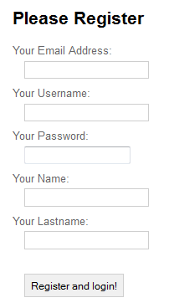
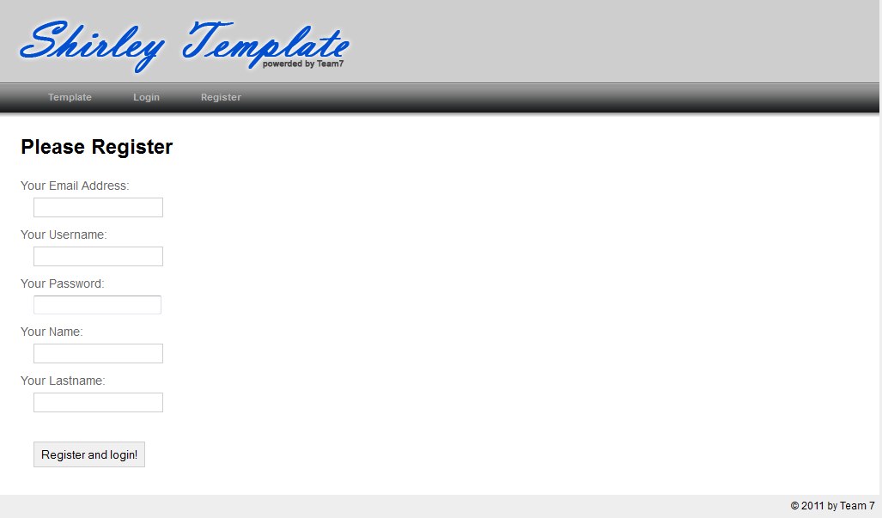

Heading 2

<Body Text>

Heading 3

<Body Text>

Heading 4

<Body Text>

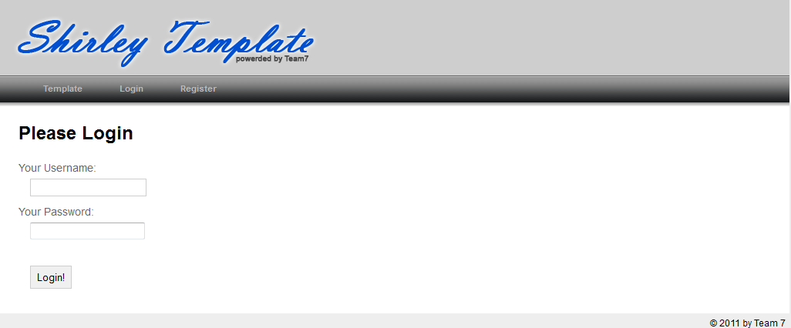
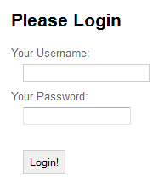
Login

Choose Template
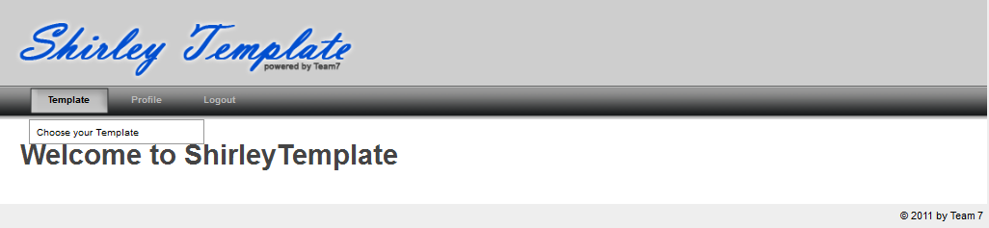

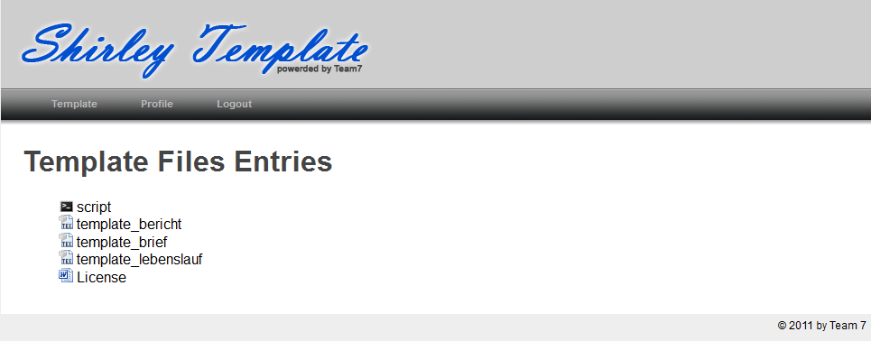

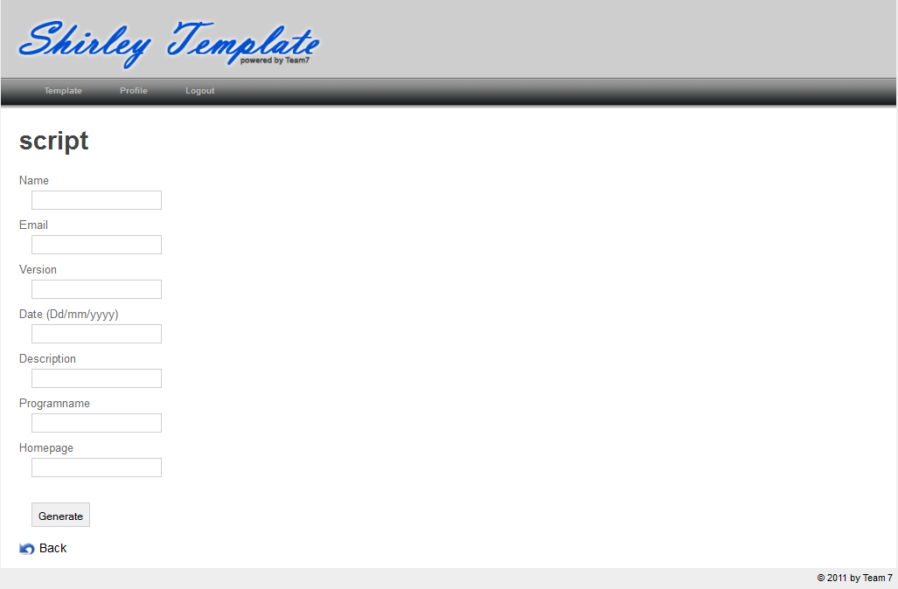

Edit Profile Data

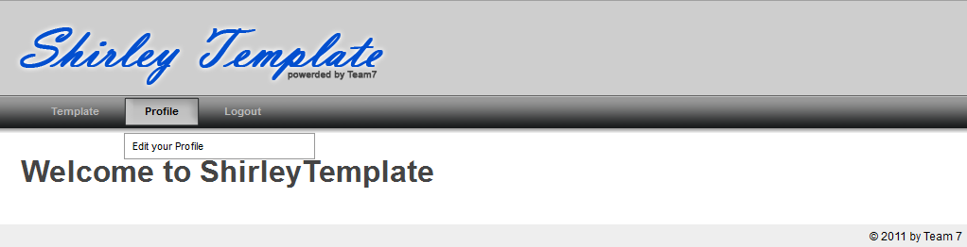
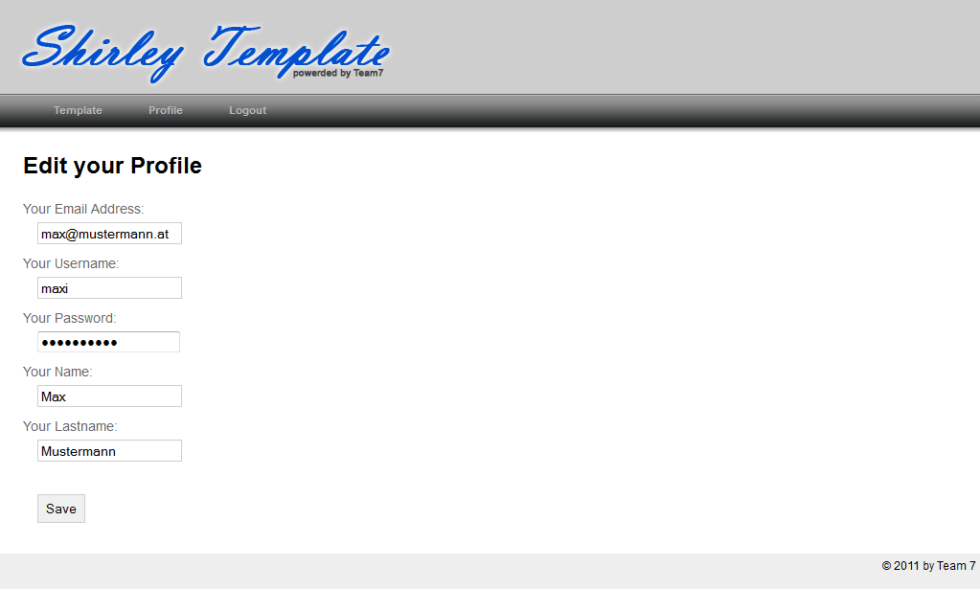

Logout

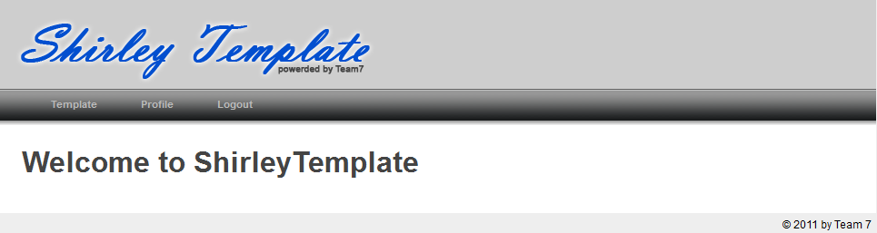
Glossary

