**Radio Button Card**

### Document Properties

| Item | Details |
| --- | --- |
| Document | Technical Specification Document |
| Application | Radio Button Card |
| Author | Monika Sawlani |
| Creation Date | 09/21/2020 |
| Last Updated | 09/21/2020 |
| Status | Completed |

Contents

Document Properties 1

1. Component Overview 3

1.1 Objective 3

1.2 Use Cases 3

2. Technical Specifications 3

2.1 NPM details 3

2.2 NPM repo 3

3.Unit Testing 3

4. Assumptions 3

5. Concerns and Issues 3

1. Component Overview

Radio button card is a component wherein we showcase numerous options from which the user can make a choice. On selection, the card shows further details and actions if required.

* 1. Objective

On selection, the card expands turning the radio button active and card changing background color to white. The border color remains consistent in both collapsed and expanded states.

* 1. Use Cases

* Default:- By default radio button is unchecked

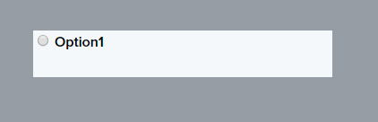

*Checked:-

1)On selection, the card expands turning the radio button active and card changing background color to white.



2) On selection, the card shows further details.

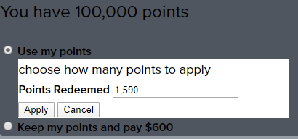

2.Technical Specifications

* Radio control button gets selected using mouse cursor action.
* Alignment of the radio button control on the form.
* CSS style of the radio button is as per the specification.

Card Properties

|  |  |
| --- | --- |
| **Properties** | **Values** |
| Width | 100% of the column |
| Min Height | 52px |
| Background Color | [$global-bg](https://tavisca.atlassian.net/wiki/spaces/ORXE3/pages/773392576/Color+Properties+0.3) |
| Border Color | [$secondary](https://tavisca.atlassian.net/wiki/spaces/ORXE3/pages/773392576/Color+Properties+0.3) |
| Body font | [$caption](https://tavisca.atlassian.net/wiki/spaces/ORXE3/pages/1189053562/Typography+0.3+-+Nomenclature#%24caption) |
| Body font color | [$secondary-text](https://tavisca.atlassian.net/wiki/spaces/ORXE3/pages/773392576/Color+Properties+0.3) |

**Radio button Card - Expanded Properties**

|  |  |
| --- | --- |
| **Properties** | **Values** |
| Width | 100% of the column |
| Min Height | 52px |
| Background Color | [$neutral](https://tavisca.atlassian.net/wiki/spaces/ORXE3/pages/773392576/Color+Properties+0.3) |
| Border Color | [$secondary](https://tavisca.atlassian.net/wiki/spaces/ORXE3/pages/773392576/Color+Properties+0.3) |
| Body font | [$caption](https://tavisca.atlassian.net/wiki/spaces/ORXE3/pages/1189053562/Typography+0.3+-+Nomenclature#%24caption) |
| Body font color | [$secondary-text](https://tavisca.atlassian.net/wiki/spaces/ORXE3/pages/773392576/Color+Properties+0.3) |

2.1 NPM details

Following packages are installed for project:

Orxe/cli version – v2.0.20

Following command are for creating and running the component:

* Installing orxe/cli - npm install -g @orxe3/cli
* Create a new component workspace - orxe new component-workspace Radio
* Create a component – orxe g c radio-button-card

Serving the component – orxe serve

2.2 NPM repo

<https://packages.common.cnxloyalty.com/service/rest/repository/browse/npm-stage-hosted/%40radio/radio-button-card/>

3.Unit Testing

Test cases are written for radio button component

Orxe-radio-button-card.ts:-

1)Should create

2)should check default properties for radio card

3) Should check radio and get attribute

4) Changes the value based on the radio buttons

5) Should check default value of selectedOption

6 Should call function onChange

**Screenshot of Coverage 90 %**

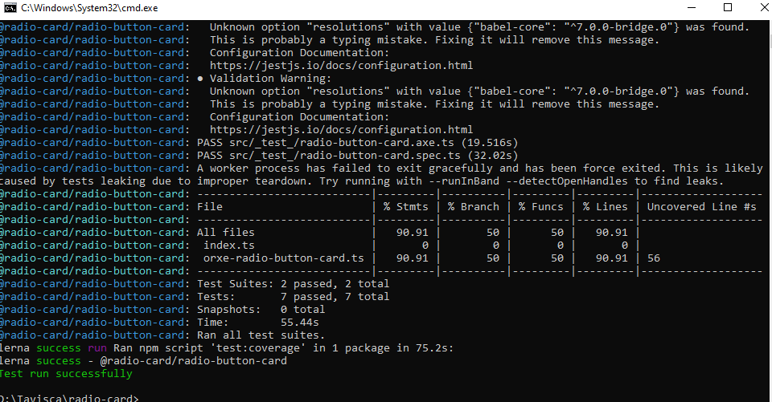

4. Assumptions

component is designed based on the guidelines given by Tavisca on confluence page

5. Concerns and Issues

NA