

Submitted By:
Gulzaib Hassan Fiaz 2025-CYS-46
Assignment:
Pacman Game
Submitted To:
Sir Shahmeer Nawaz

For the fulfillment of,
Object-Oriented Programming Lab Project
Department of Computer Engineering
University of Engineering and Technology, Lahore

A Graphical Representation

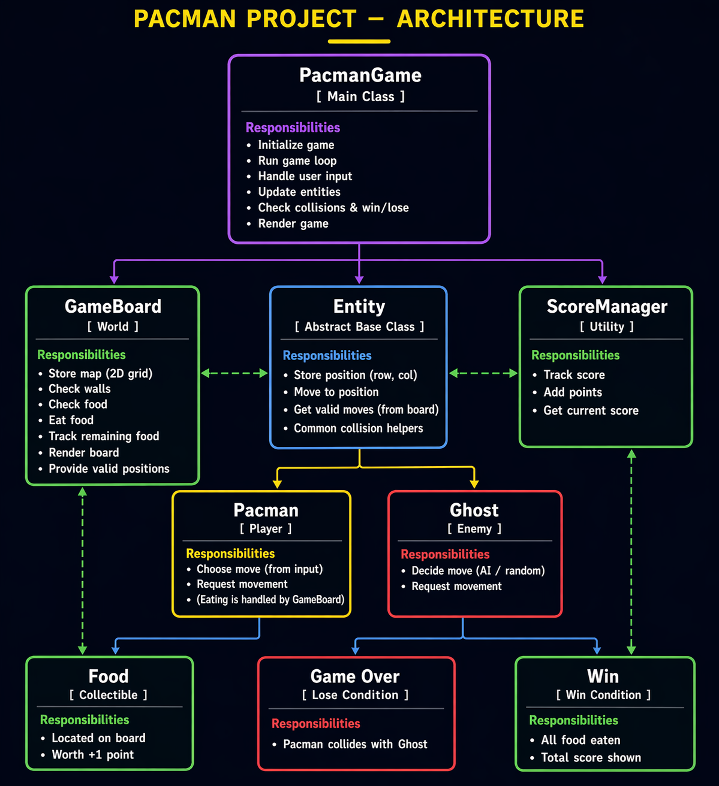

→ Pacman –--> Report
This project is about building a simple Pacman-style game using Java and OOP. The idea is to split responsibilities into different classes so the code is clean and makes sense.

We have a grid-based game where:
- @ represents Pacman
- G represents the ghost
- # are walls
- . are food dots
The player moves Pacman using keyboard input (w/a/s/d), eats food to gain score, and avoids the ghost. If Pacman touches the ghost → game over. If all food is eaten → win.

→ Classes Used

1. PacmanGame (Main Class)
This is the brains of the whole game.
.Contains the main method
.Creates objects of:
.GameBoard
.Pacman
.Ghost
.Runs the game loop
.Takes user input and updates movement

2. GameBoard
This class handles the map.
- Stores the 2D array (grid)
- Knows where walls and food are
- Prints the board
- Checks if food exists
. It does NOT control movement, it just provides information.

3. Pacman
This class represents the player.
- Stores position (row, col)
- Stores score
- Handles movement logic
- Interacts with GameBoard to:
  - avoid walls
  - eat food
Score increases when Pacman moves onto a food tile.

4. Ghost
This class represents the enemy.
- Stores its position
- Moves randomly each turn
- Cannot pass through walls
. The ghost moves randomly and doesn’t necessarily follow the player.

5. Food
→ Represents the dots.

Game Logic
- Game starts by initializing board, Pacman, and ghost
- Game enters a loop:
  - Print board
  - Take user input
  - Move Pacman
  - Move ghost
- Check conditions:
  - If Pacman meets ghost → Game Over
  - If no food left → Win

Scoring System
- Each food (.) gives +1 score
- Score is stored inside the Pacman class
- Displayed after each move

Limitations
This is not a perfect game. Some issues:
- Ghost AI is random (not intelligent)
- No lives system (instant game over)
- No real-time movement (turn-based)
- Food is permanently removed (no respawn)
- No graphical interface (console only)

Possible Improvements
- Add smarter ghost AI (chasing Pacman)
- Add multiple ghosts
- Add lives instead of instant death
- Add GUI

