Lecture4RMarkdown

MT

2025-02-27

## Markdown YAML Header

The header lets you change file type that the code is rendered as and add a table of contents

title: "Lecture4RMarkdown"  
author: "MT"  
date: "2025-02-27"  
output: # It will render as first output listed   
 md_document: # allows display in GitHub  
 variant: gfm # creates github flavored markdown  
 html_document:   
 toc: true # table of contents  
 toc_float: true  
word_document:   
pdf_document:

This is an example of an R Code chunk.

# this is R code, echo = TRUE, eval = FALSE  
summary(mtcars)

r chunks look like this

{r Name of Chunk, parameters = TRUE}

some parameters are: include, echo, and eval. These control if chunk is run and what parts are displayed.

Can include figures

library(ggplot2)  
data("mtcars")  
ggplot(mtcars, aes(x = wt, y = mpg)) +  
 geom_point()

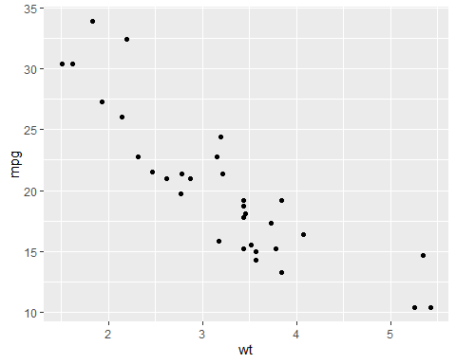

## R Markdown formatting options

# First level header

*this text is italics* by putting single asterisks around text

**this text is bold**  by putting double asterisks around text

#### List (this needs to be a heading for it to work)

* one item
* another item
  + one subitem with indent

Ordered list (or have line between it and the first list item)

1. item
2. item 2

### Links (second level header)

[Link to my github](https://github.com/mgt0021/ENTM6820.git)

## Images

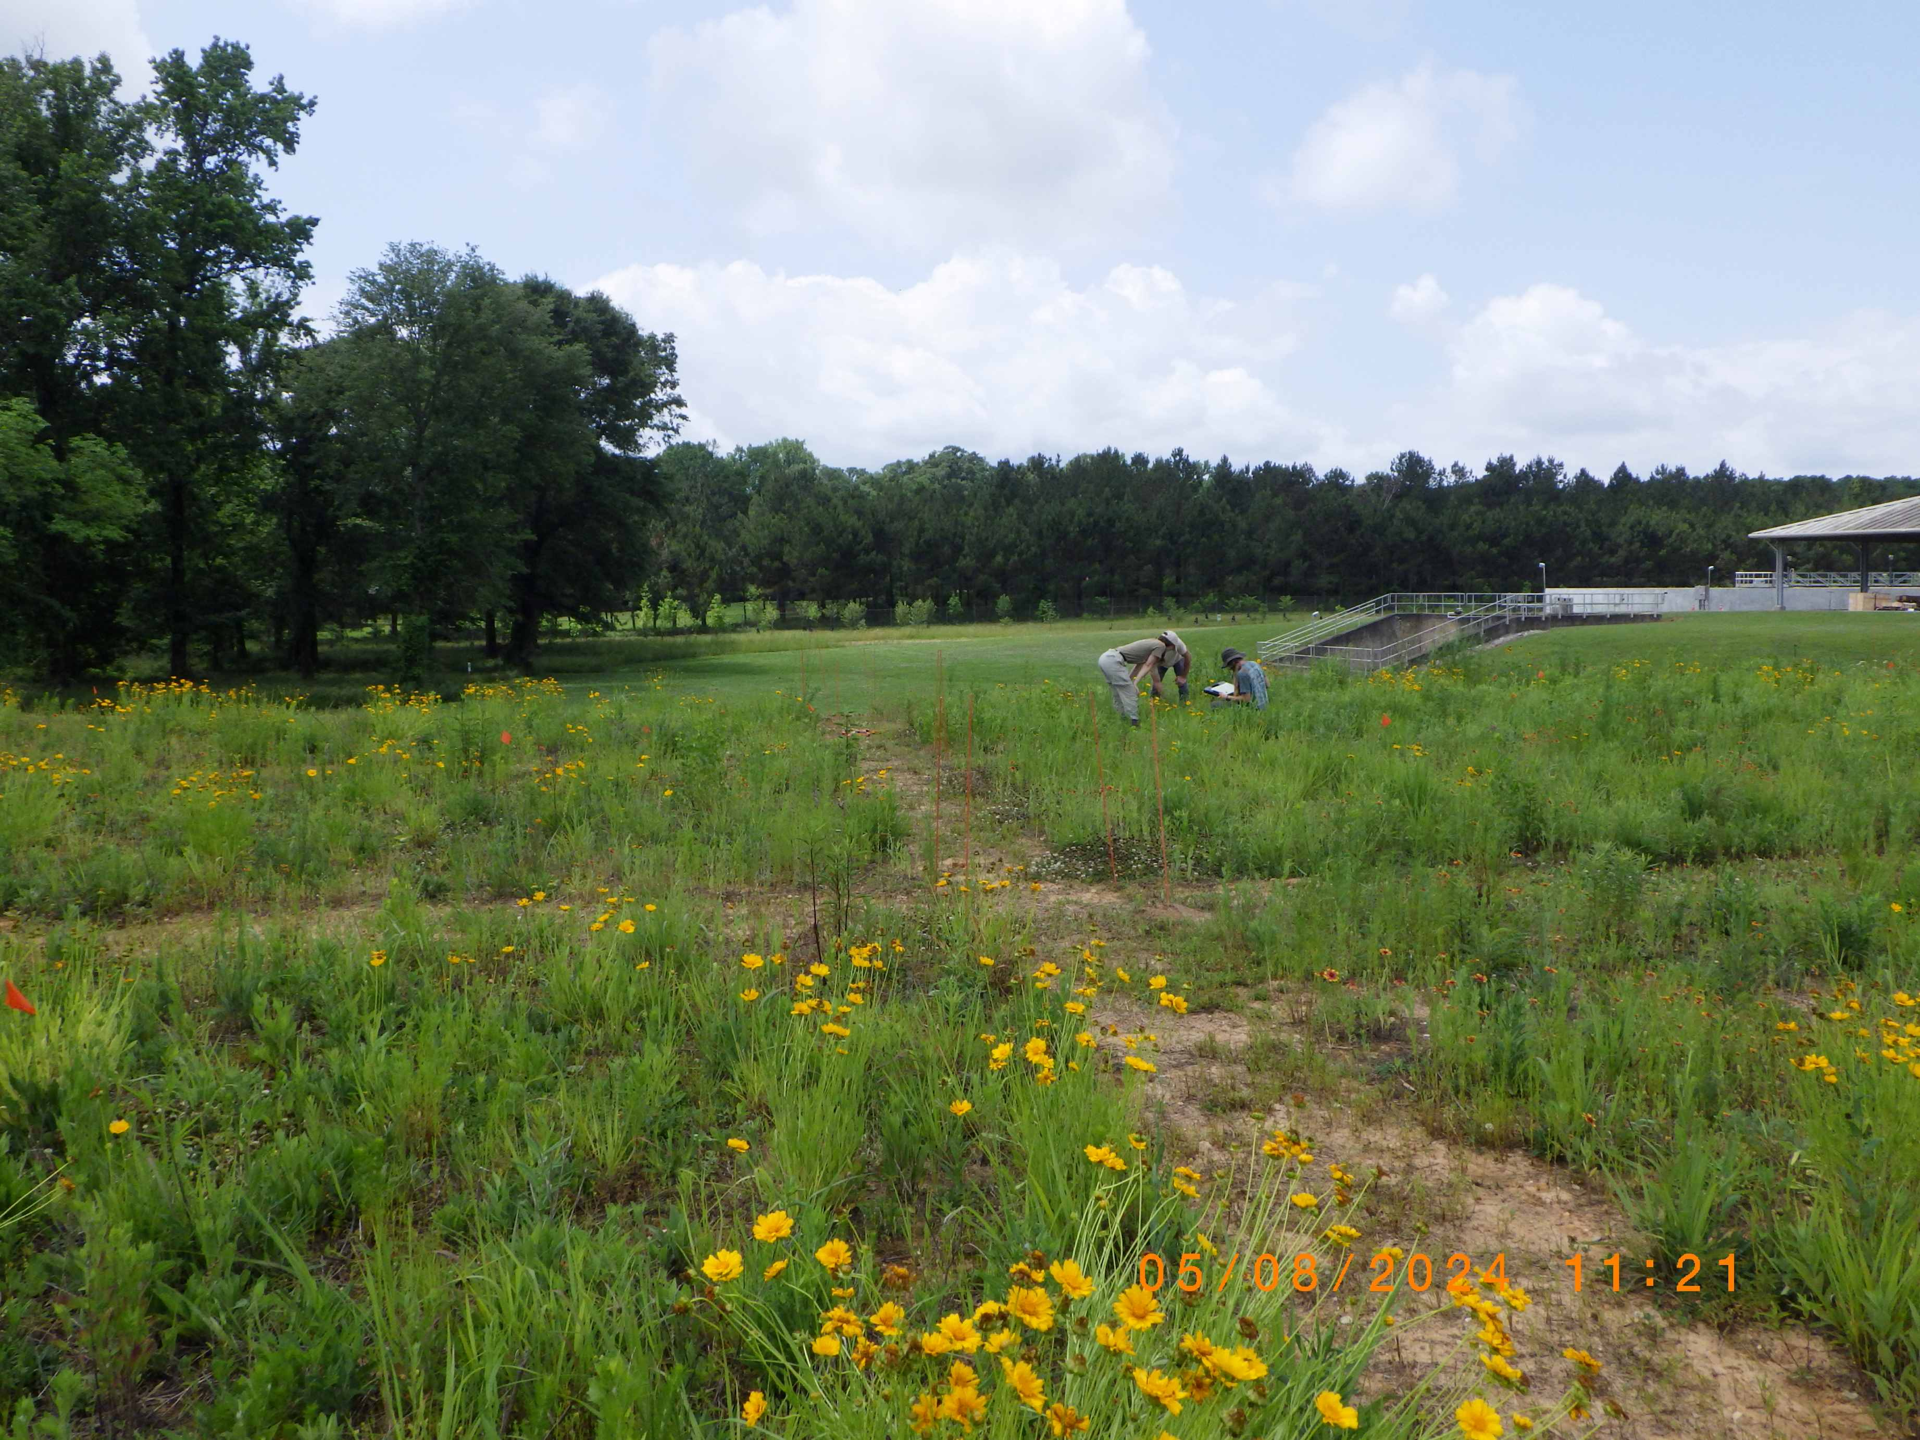

Image name

## Formatted tables

library(knitr)  
kable(head(mtcars, n = 5), digits=3, format = "markdown")

|  | mpg | cyl | disp | hp | drat | wt | qsec | vs | am | gear | carb |
| --- | --- | --- | --- | --- | --- | --- | --- | --- | --- | --- | --- |
| Mazda RX4 | 21.0 | 6 | 160 | 110 | 3.90 | 2.620 | 16.46 | 0 | 1 | 4 | 4 |
| Mazda RX4 Wag | 21.0 | 6 | 160 | 110 | 3.90 | 2.875 | 17.02 | 0 | 1 | 4 | 4 |
| Datsun 710 | 22.8 | 4 | 108 | 93 | 3.85 | 2.320 | 18.61 | 1 | 1 | 4 | 1 |
| Hornet 4 Drive | 21.4 | 6 | 258 | 110 | 3.08 | 3.215 | 19.44 | 1 | 0 | 3 | 1 |
| Hornet Sportabout | 18.7 | 8 | 360 | 175 | 3.15 | 3.440 | 17.02 | 0 | 0 | 3 | 2 |

## File Trees

library(fs)  
fs::dir_tree()

├── BacterialAlpha.csv  
├── Bull_richness.csv  
├── CodingChallenge1.R  
├── CodingChallenge2DataVisualization.R  
├── CodingChallenge3DataVisualizationAdvanced.R  
├── diff_abund.csv  
├── ENTM6820.Rproj # Top level directory .Rproh file = working directory  
├── fieldworkimage.JPG  
├── Lecture1IntroR.R  
├── Lecture2DataVisualization.R  
├── Lecture3DataVisualizationAdvanced.R  
├── Lecture4RMarkdown.html  
├── Lecture4RMarkdown.md  
├── Lecture4RMarkdown.Rmd  
├── Lecture4RMarkdown_files  
│ └── figure-gfm  
│ ├── pressure-1.png  
│ └── unnamed-chunk-1-1.png  
├── MycotoxinData.csv  
├── README.html  
├── README.md # Top level directory README  
└── TipsR.csv

## Zenodo

1. Create a zenodo account and link to github.
2. Go to GitHub tab in settings of zenodo.
3. Flip the switch for the repo you want to create a doi for
4. Create a release for that repo in github

* on the side window of the github repo page there should be a Releases section
* click create new release
* make a tag name (ex: v1.0.0)
* release title (ex: creating zenodo link)
* publish (creates zipped source code = stable working repository)

1. Go back to zenodo and a badge should appear next to the turned on repo name (sync and reload if it doesn’t pop up, it could take a couple minutes)
2. Copy badge markdown link and paste in README