CS375 A9 – Address Translation (Segmented, Paged Memory Simulator)
GitHub repo: https://github.com/mgthesee/CS375 (folder a9-address-translation)

Screenshots
Screenshot 1 (sample run with manual translations, valid and invalid):
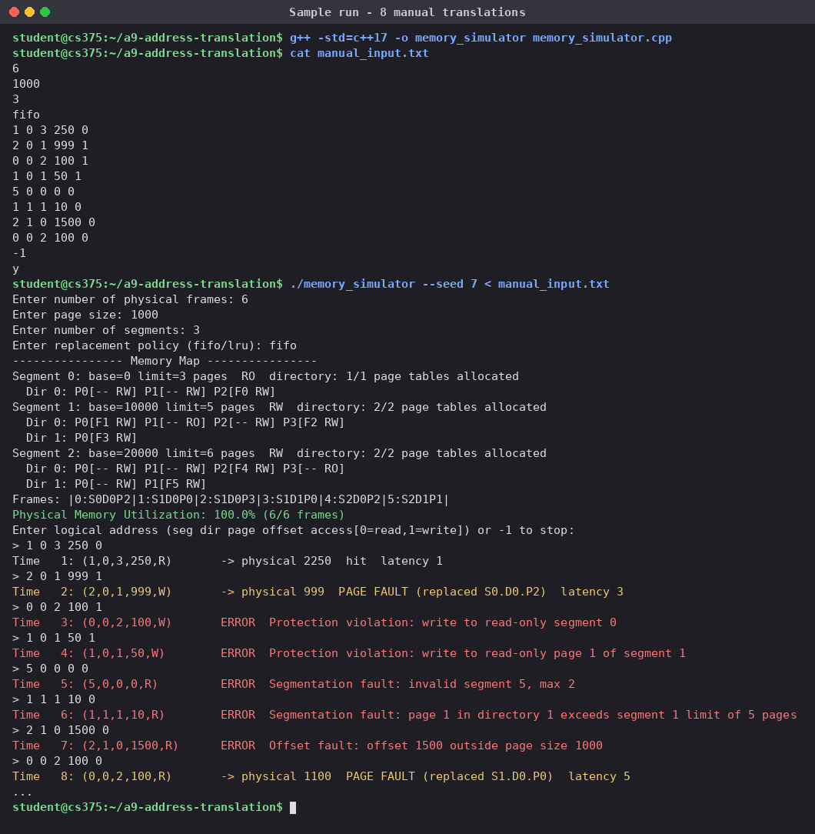

Screenshot 2 (memory map after the translations):
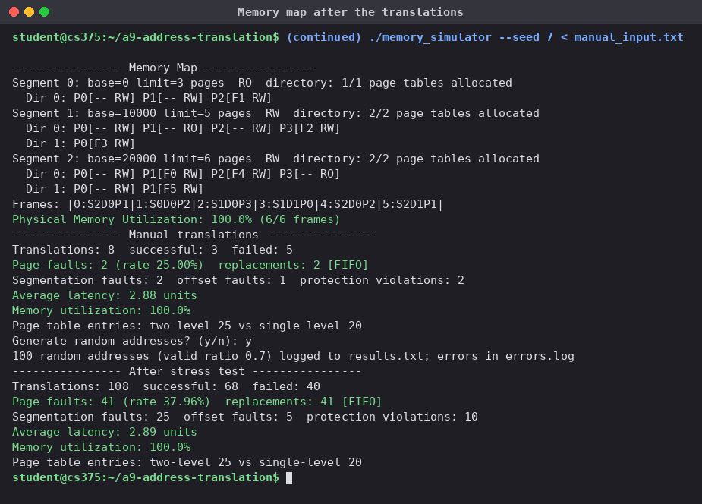

Screenshot 3 (random address test, results.txt and errors.log):
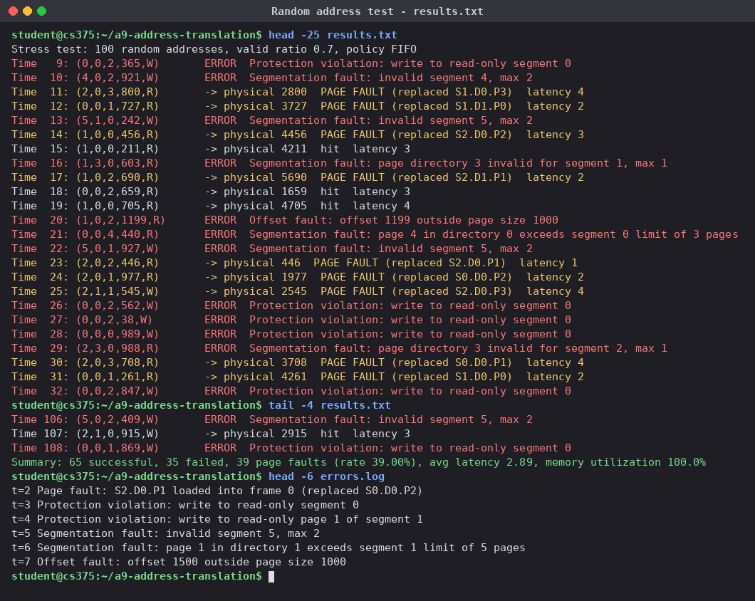

Screenshot 4 (config file and batch file):
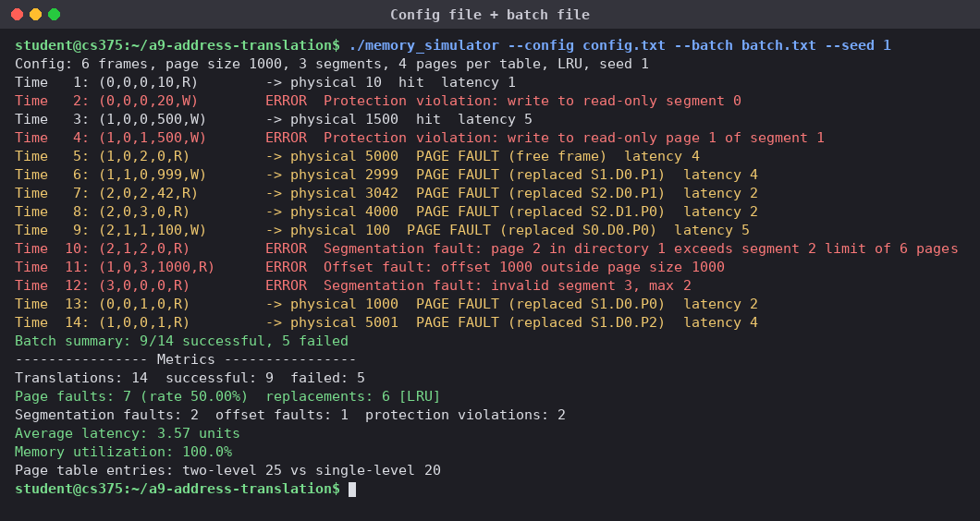

Screenshot 5 (FIFO vs LRU):
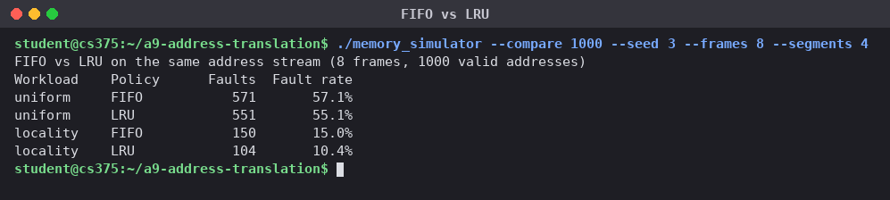

Screenshot 6 (page size 1000 vs 4000, two-level table size):
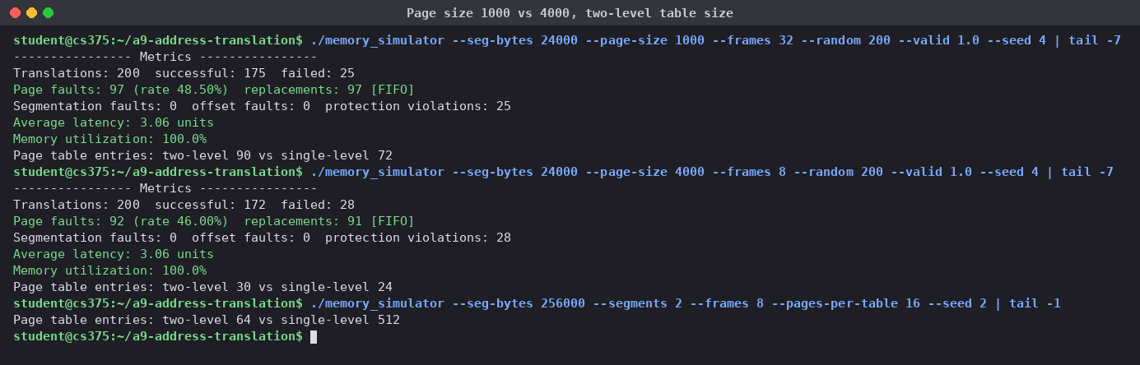

Screenshot 7 (configuration validation):
