Test Objects for Robot Experiments

Packing
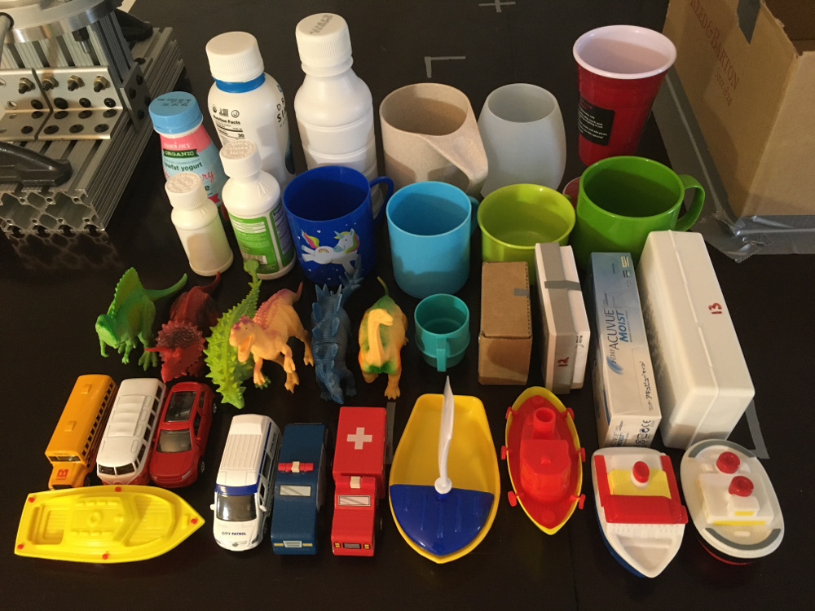
- Bottles are from the Bottles Set
- Plastic Sailing Boats
- D&D Distributing Three Sailboats
- Elegant Baby Bath Time Fun Rubber Water Squirties
- KIDAMI Die-cast Metal Toy Cars Set of 5
- Battat - Wooden Vehicles – Miniature Wooden Toy Cars & Trucks
- Prextex Realistic Looking 7" Dinosaurs Pack of 12
- eoocvt 4pcs Eco Friendly Healthy Wheat Straw Biodegradable Plastic Cup Mug
- Ornamin Mug 220 ml Green
- Tupperware Mini Multi Mug Coffee Cup Keychain Aqua Blue
- Kimmel Children's Place Mug Plastic Lime
- Baker Ross AR579 Unicorn Mugs-Pack of 4
- Silicone Wine Glasses
- Red Cup Living 8 oz. Wine Cup

Bottles
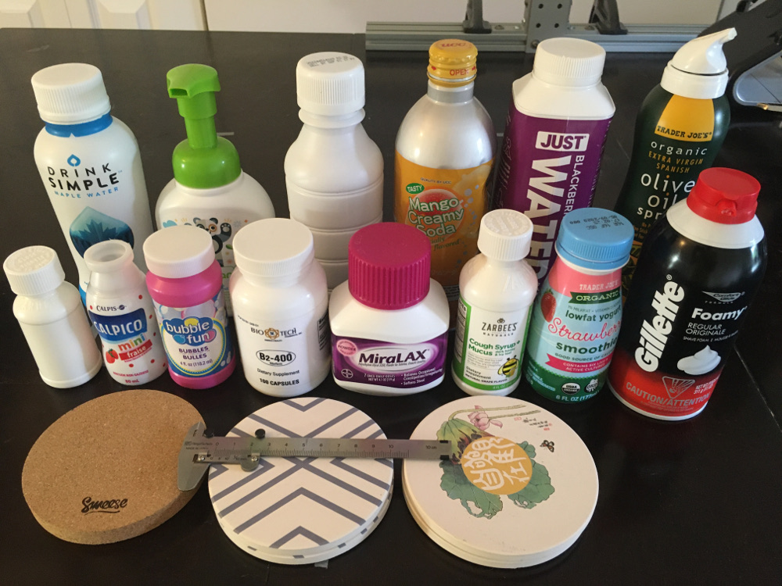
- Babyganics Alcohol-Free Foaming Hand Sanitizer, Pump Bottle, Fragrance Free, 8.45 oz
- Comfort Glide Foamy Regular Shave Foam
- Zarbee's Naturals Children's Cough Syrup
- Zarbee's Naturals Baby Cough Syrup with Agave & Thyme
- MiraLAX - Laxative - Unflavored Powder - 4.1 oz
- Biotech Pharmacal - B2-400 Riboflavin
- Just Water, Water Blackberry Infused Organic, 16.9 Fl Oz
- DRINKmaple Pure Maple Water, 12 Ounce
- Sweese 3402 Cork Coasters - 4 Inches for Drinks - Set of 10, Round
- LIFVER Coasters for Drinks, Absorbent Coaster Set of 6 with Cork Base

Blocks
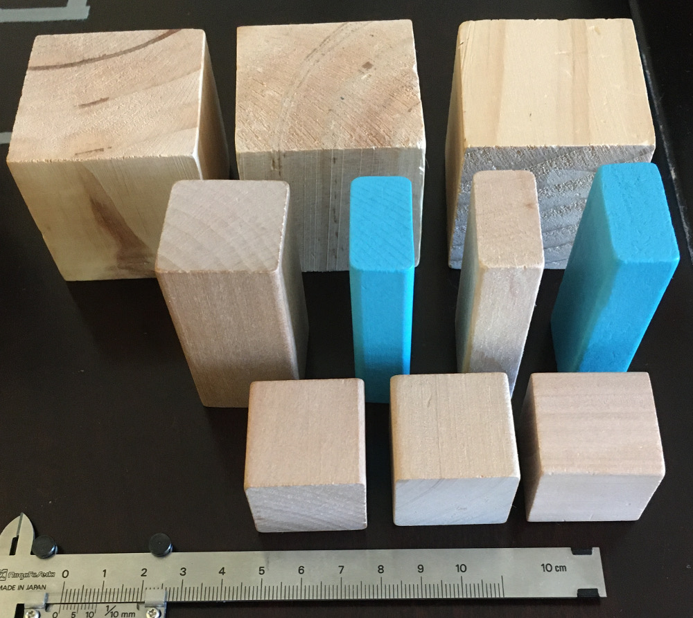
- Imagination Generation 100 Piece Natural Wooden Building Block Set with Carrying Bag – Children's Deluxe Stacking Toy Set
- Supla 20pcs 2 inch Wooden Cubes Unfinished Wood Blocks

