Monitoring tools for OpenESB.
Marat Gubaidullin: 21 Dec. 10

Introduction
This document contains a brief description of our current OpenESB monitoring tool.

Monitoring features
- Topology (DONE)
  - Nodes states
  - Standalone domains states
  - Cluster Instances states
- Assemblies (DONE)
  - Assemblies states
  - Service units states
  - Assemblies enabling/disabling functions
- BPEL instances (DONE)
  - BPEL instance states
  - BPEL activities states
  - BPEL variables
  - BPEL instances suspend/resume/terminate functions
- Performance visualisation (TODO)
  - BPEL Charts
  - Other
- OpenMQ messages (TODO)
  - Destinations
  - Messages

UI features
ScreenShot1 ScreenShot2 ScreenShot3 ScreenShot4

Architecture
The architecture is simple and summarise in the picture below:

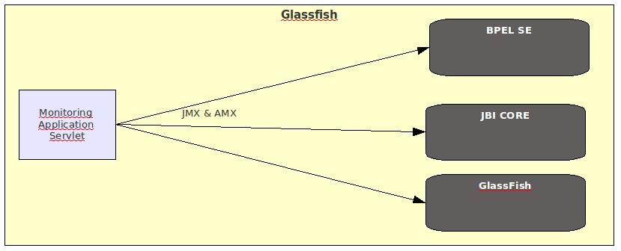
Props
- Lightweight and simple.
- No need additional infrastructure (working as a servlet in DAS GlassFish instance)
- Support standalone and cluster topologies
- Working with current release of OpenESB with the aid of JMX and AMX
- Time to market (currently there no monitoring tool but for our customers it's very important)

Cons
- No plug-in features in current release.

