Trust, Transparency, and AI
  - Facilitator Speaking Notes | NSPA 2026 | 60-Minute Workshop
Each slide includes a thumbnail and a simple suggested script. The last two slides are optional backup resources.

Slide 01 | Trust, Transparency, and AI
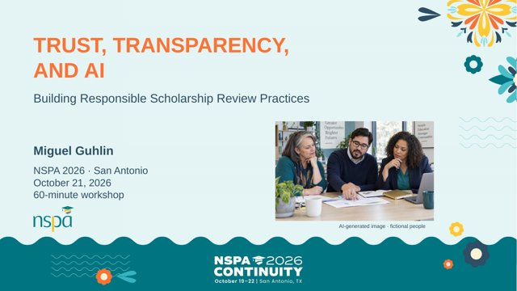
SAY
Welcome. Today we are looking at AI from both sides of the scholarship application: the people reviewing applications and the people submitting them. AI may save time, but we still need fair decisions that we can explain. We will practice prompt writing, look at three review examples, and finish with policy choices.

Slide 02 | A quick pulse
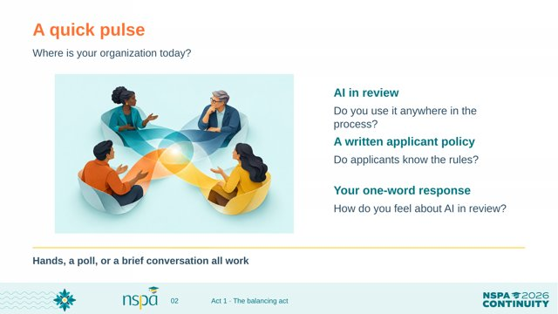
SAY
First, a quick show of hands. Does your organization use AI anywhere in scholarship review? Do you already have a written policy that applicants can read? Now give me one word that describes how you feel about AI in this process. There are no wrong answers. I want to see where we are starting.

Slide 03 | Our 60-minute route
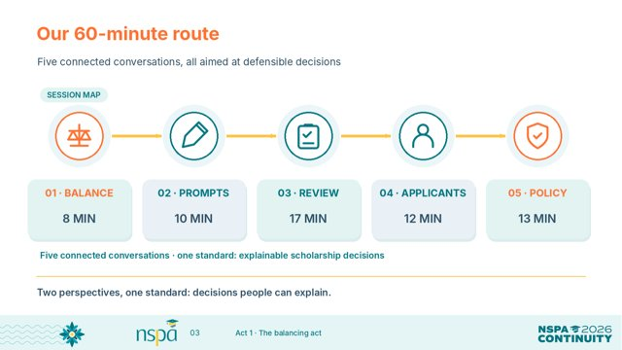
SAY
Here is our route for the hour. We will spend eight minutes on the balancing act, ten on prompting, seventeen on review workflows, twelve on applicants, and thirteen on policy. Each part builds on the last. We are aiming for one thing: scholarship decisions that people can understand and defend.

Slide 04 | The balancing act
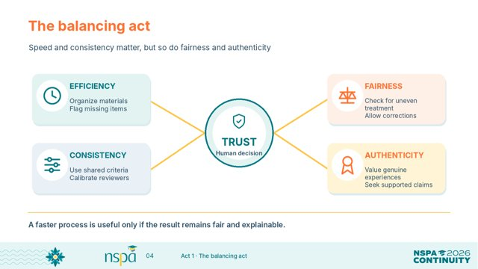
SAY
Scholarship teams need to move through applications efficiently. They also need to treat people consistently, be fair, and assess real accomplishments. AI may help with repetitive work, but speed is not enough. If we cannot point to the evidence and explain the decision, the process needs more work.

Slide 05 | Two sides of one application
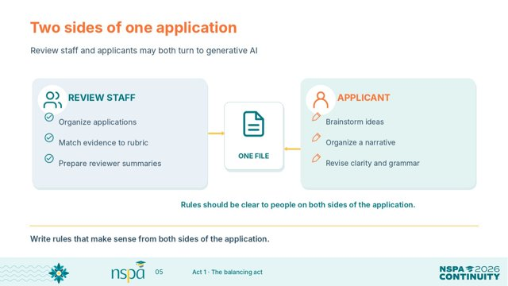
SAY
Think about the two sides of the desk. Reviewers may use AI to organize files or find evidence related to a rubric. Applicants may use it to brainstorm, outline, or improve grammar. These are different uses, but both need clear rules. We should write policies that make sense to both groups.

Slide 06 | Assist, check, or reserve for people
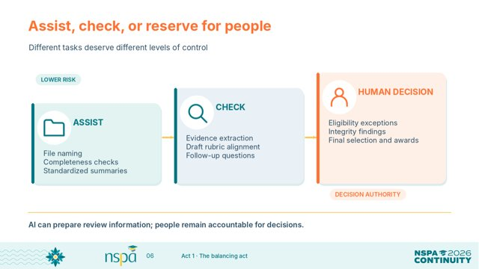
SAY
I find it useful to sort tasks into three groups. Some tasks, like naming files and checking for missing documents, are good candidates for assistance. Others, like matching evidence to a rubric, need careful human checking. Award decisions, exceptions, and appeals stay with people. The key is to decide the level of oversight before using AI.

Slide 07 | Build a prompt that can be checked
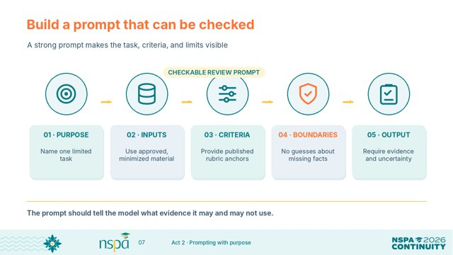
SAY
A good prompt makes our instructions visible. Name the specific task. Say what information the tool may use. Provide the actual rubric. Set boundaries: do not guess, and do not judge personal traits. Finally, ask for an output that shows the evidence and any uncertainty. That gives a reviewer something they can check.

Slide 08 | From a vague request to a review prompt
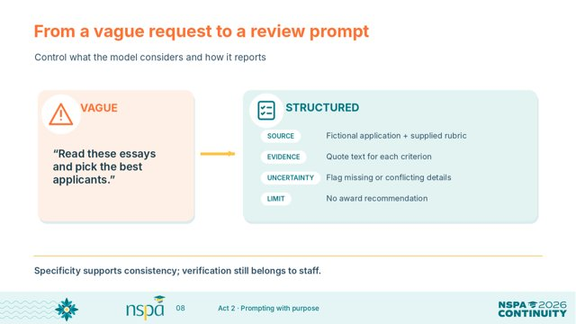
SAY
Look at the first request: 'Pick the best applicants.' It gives AI too much authority and no clear standard. The second request uses a supplied rubric, asks for quotations, identifies gaps, and says not to recommend an award. Which one would you feel more comfortable explaining to an applicant? The detailed request is better, but we still have to verify the result.

Slide 09 | Rubrics come before model output
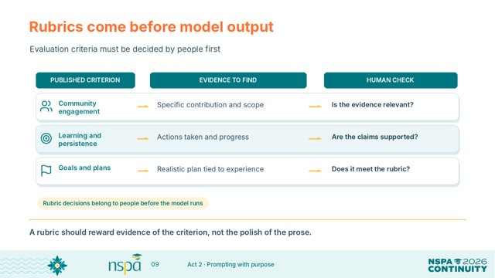
SAY
People need to decide what counts before the model responds. These sample criteria look at community engagement, learning and persistence, and goals. For each one, we ask what evidence should appear and what the reviewer must check. We are evaluating what the applicant has shown, not how polished the writing sounds.

Slide 10 | Try it: repair the weak prompt
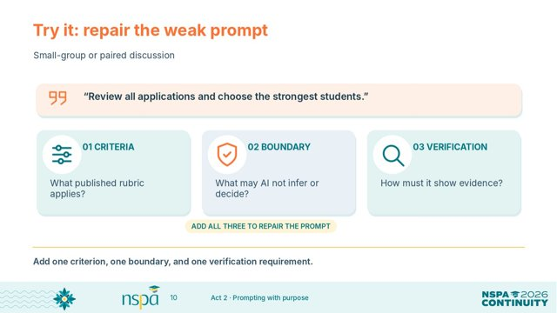
SAY
Turn to someone near you. Here is the weak prompt: 'Review all applications and choose the strongest students.' Give it one clear rubric criterion, one rule limiting what AI can do, and one way to verify the output. You only need a few sentences. Let's hear one improvement from the room.

Slide 11 | A review workflow you can explain
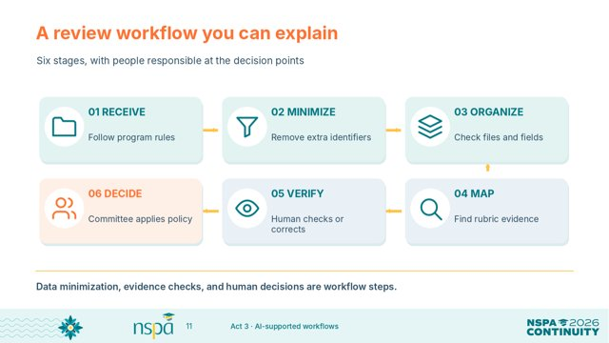
SAY
This is the six-step review path. Receive the materials, minimize personal information, organize files, map evidence to the rubric, verify the findings, and then make a human decision. Notice that AI is not the decision-maker. It can help prepare information, but staff confirm the evidence and the committee applies its policy.

Slide 12 | Demo 1: administrative review
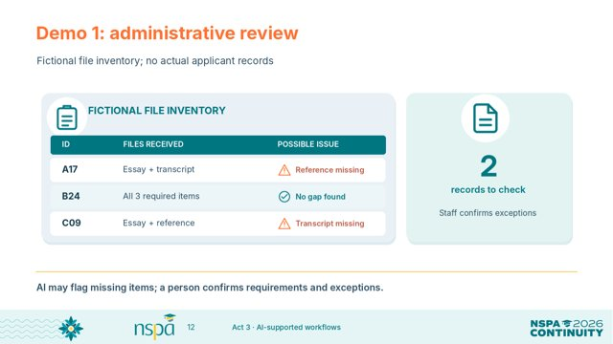
SAY
This first example is entirely fictional. We have three application codes and a list of required documents. The tool flags a missing reference for A17 and a missing transcript for C09. That is a useful checklist, not a rejection list. A person still confirms the requirements, checks for exceptions, and contacts applicants according to policy.

Slide 13 | Demo 2: map rubric evidence
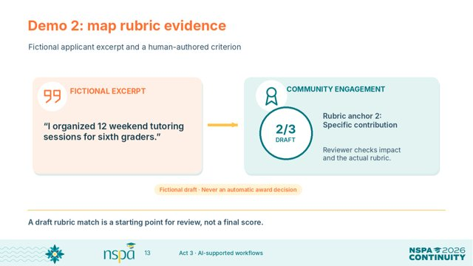
SAY
Here is a fictional applicant statement: 'I organized 12 weekend tutoring sessions for sixth graders.' AI can connect that sentence to a community engagement criterion and offer a draft score of two out of three under our example rubric. But the sentence does not tell us the impact. A reviewer has to check the scoring anchors and ask what evidence is still missing.

Slide 14 | Demo 3: prepare a reviewer handoff
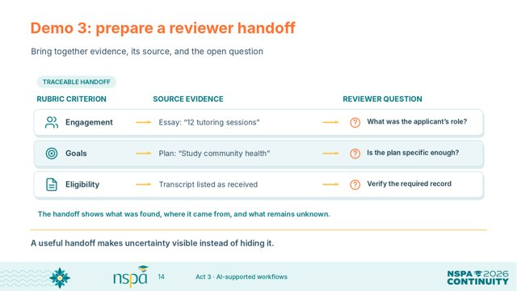
SAY
Now we combine the information into a reviewer handoff. Each row shows the criterion, the source evidence, and a question that remains. For example, twelve tutoring sessions sounds relevant, but what exactly was the applicant's role? We want summaries that make open questions visible so the next reviewer can follow up.

Slide 15 | Keep a person in the loop
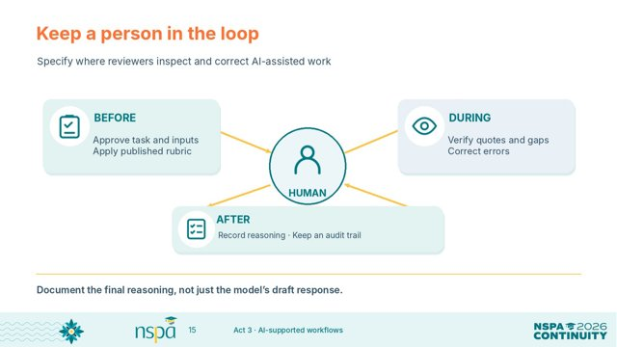
SAY
Human oversight has to happen before, during, and after the AI-assisted task. Before, approve the use and the data. During, verify quotes and correct mistakes. After, apply human judgment and record why the decision was made. Saying 'a person looked at it' is not enough unless that person had a real chance to correct it.

Slide 16 | Protect information before the prompt
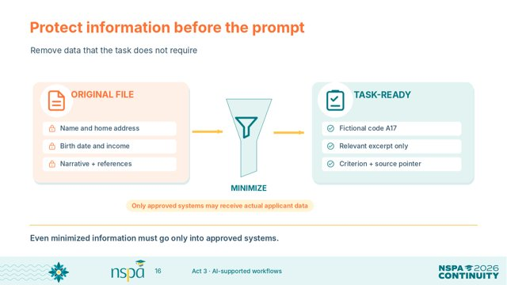
SAY
The original application might contain a name, address, birth date, family income, and references. Most of that is not needed to check a specific rubric criterion. The task-ready version uses an application code, a relevant excerpt, and a source pointer. Even after removing unnecessary details, we still only use tools approved for that information.

Slide 17 | Security starts before the upload
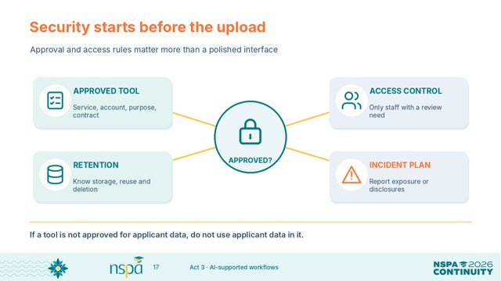
SAY
Before uploading anything, check four things. Is this tool approved for applicant data and this task? Who can access the information? How long is it stored, and is it reused? And what do we do if information is exposed? A friendly interface does not answer those questions. If the tool is not approved, do not put applicant data into it.

Slide 18 | Consistency does not guarantee fairness
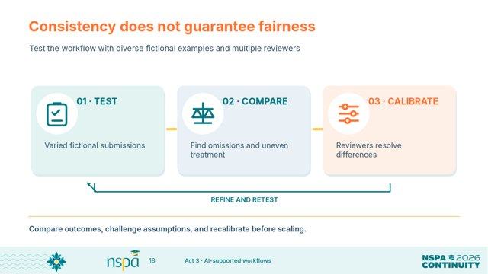
SAY
Using the same prompt for every application may look consistent. It does not automatically make the results fair. Test the workflow with varied fictional examples. Compare whether the system overlooks evidence or treats similar situations differently. Then have reviewers discuss differences and adjust the process before any real use.

Slide 19 | Applicants use AI, too
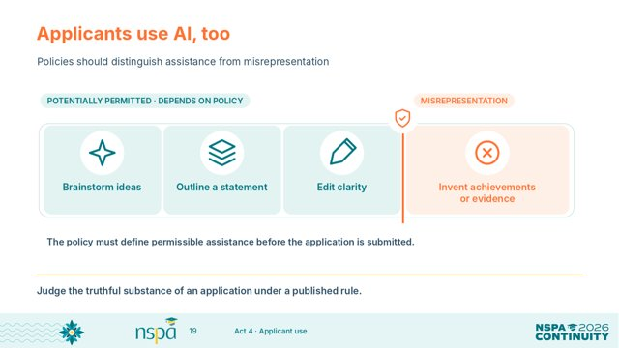
SAY
Applicants may use AI for brainstorming, outlining, or proofreading, depending on your rules. That is different from inventing achievements, hardship, experiences, or references. We need to make this distinction clear before students apply. The important question is whether the claims they submit are truthful and meet the published requirements.

Slide 20 | Assess substance, not the writing style
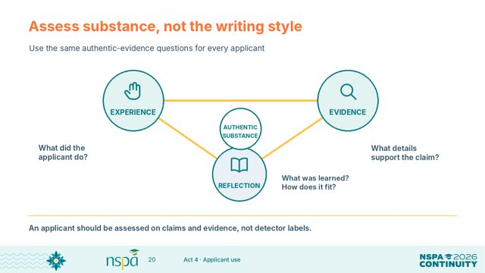
SAY
We should be careful not to confuse good grammar with proof of AI use. Instead, ask the same questions of every applicant. What did the person actually do? What evidence supports the claim? What did they learn, and how does it connect to their goals? Those questions focus on the substance of the application.

Slide 21 | AI detection is not proof of authorship
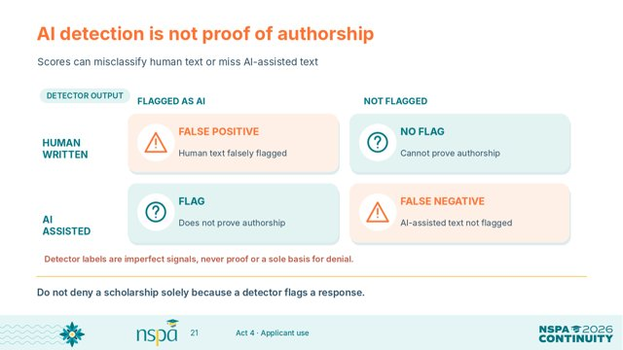
SAY
An AI detector can make two mistakes. It can flag something written by a person, or it can miss AI-assisted writing. So a detector score is not proof of who wrote the text. It should never be the only reason to deny someone a scholarship. We need to examine actual evidence and our published rules.

Slide 22 | A flagged essay: what would you do?
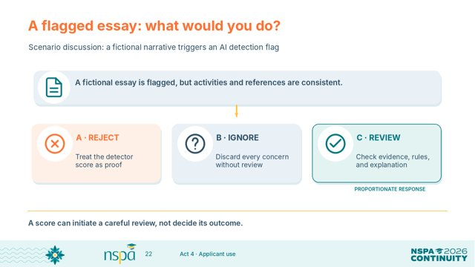
SAY
Here is a scenario. An essay gets flagged by a detector, but the student's activities and references appear consistent. Would you reject it, ignore the concern, or review the evidence and policy? Take a quick vote. The more defensible choice is a careful review, without treating the detector score as a verdict.

Slide 23 | A fair response to an AI concern
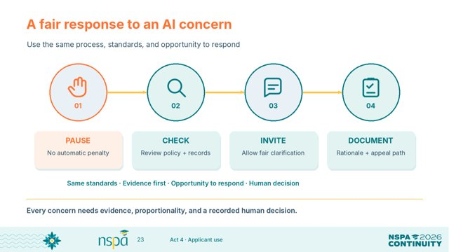
SAY
If a concern comes up, start by pausing any automatic penalty. Check the application and the rules that were available to the applicant. When appropriate, let the applicant clarify the concern. Finally, record the evidence and the human decision, including how it can be reconsidered. Use the same process for everyone.

Slide 24 | Make the applicant policy readable
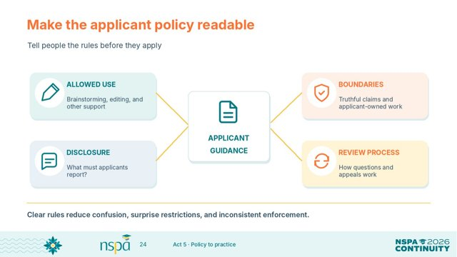
SAY
Applicants should be able to answer four questions before submitting. What AI help is allowed? What must be their own truthful work? Do they need to disclose AI use? And what happens if the organization has a concern? If our policy cannot answer those questions in plain language, we should revise it.

Slide 25 | Compare policy language
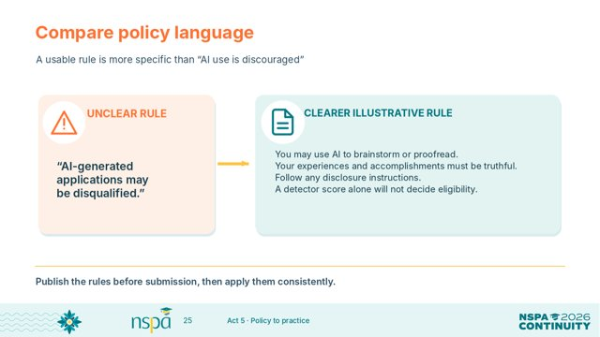
SAY
The first policy says AI-generated applications may be disqualified. That leaves too much unclear. The second example names allowed brainstorming or proofreading, requires truthful claims, points to disclosure instructions, and says a detector score alone will not decide eligibility. This is sample language, not a universal legal rule, but it shows what clarity looks like.

Slide 26 | Write staff-facing rules, too
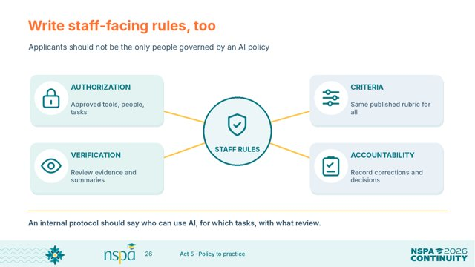
SAY
We should give staff rules as well as applicants. Staff need to know which tools and tasks are approved, what rubric to apply, how to verify AI-generated summaries, and what to document. If reviewers have no shared process, we cannot promise consistent treatment. Applicant and reviewer policies have to work together.

Slide 27 | Workshop: decide your local rules
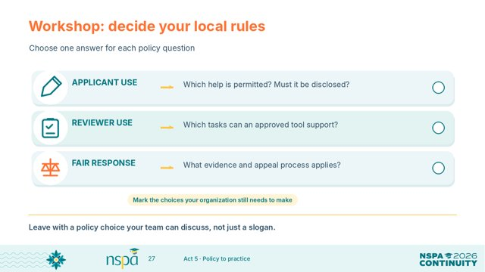
SAY
Take two or three minutes to make three local choices. First, what AI help can applicants use, and when should they disclose it? Second, which review tasks can an approved tool support? Third, how will you investigate concerns fairly? Choose answers you can bring back to your team. Would anyone share one decision?

Slide 28 | Bring it into your next review cycle
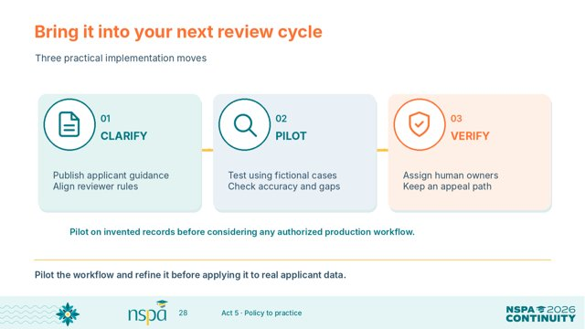
SAY
You do not have to change the entire process at once. First, clarify the rules. Next, pilot one limited AI-supported task using fictional cases and look for errors. Then decide who verifies the work and who makes final decisions. Improve the pilot before using real applicant information.

Slide 29 | What will you change first?
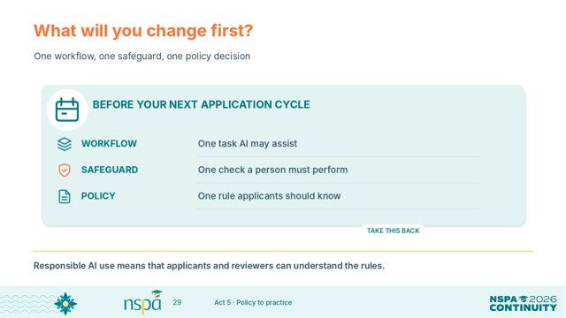
SAY
Let's close with three practical commitments. Name one review task AI might help with. Name one safeguard a person must perform. And name one policy statement every applicant should know. Think back to your opening reaction. What would help your team move forward while protecting trust?

Slide 30 | Backup: reusable reviewer prompt
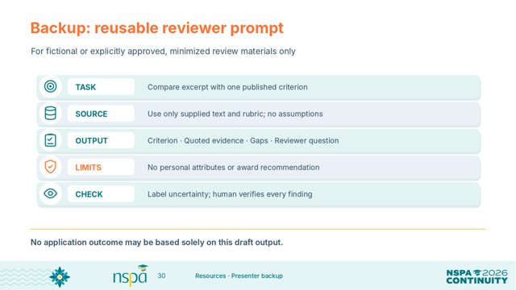
SAY
This is a take-home starting prompt, not part of our timed activity. It asks the tool to compare an approved excerpt with a published criterion, quote evidence, identify gaps, and avoid recommending an award. Use only fictional or properly approved, minimized information. Review every output before relying on it.

Slide 31 | Backup: sources and further reading
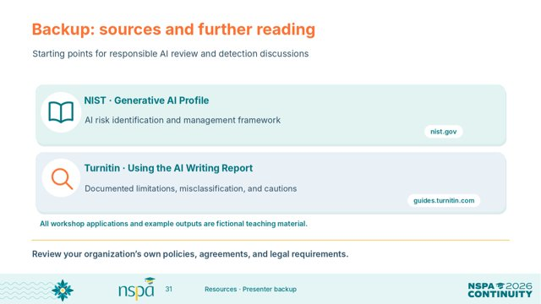
SAY
These are optional references for your team. The NIST Generative AI Profile is a place to begin thinking about risks and controls. Turnitin's guidance discusses limitations of AI writing detection. Use these alongside your own organization’s policies, contracts, and applicable requirements. Our workshop demonstrations used fictional data.

