*Hamlet* is widely regarded as one of Shakespeare’s greatest plays and perhaps as the greatest revenge tragedy of all time. However, a large part of our class was spent examining why Shakespeare’s plays are so highly regarded and what specific things Shakespeare does to elevate some of his plays to legendary status. Thus, I will be comparing *Hamlet* to another revenge tragedy written in a similar time period, *The Spanish Tragedy*. *The Spanish Tragedy* was actually published before *Hamlet* and is credited with influencing much of the plot of *Hamlet.* Because *Hamlet*  is so highly regarded, I wished to examine what changes Shakespeare made to Hamlet to make him more dynamic than Hieronimo, the protagonist of *The Spanish Tragedy.* In particular I will be examining the changes in perceptions of the protagonist in each of the plays and determine how dynamic each of the these characters are.

I will begin by analyzing the older of the two plays, *The Spanish Tragedy*, published in 1592. The protagonist and enactor of the revenge plot is Hieronimo, the Knight-Marshal of Spain which is the judge responsible for legal matters concerning the royal family. This position of high justice comes into question when Hieronimo’s son Horatio is killed causing him to battle thoughts of suicide before succumbing to madness and plotting revenge against Horatio’s murderers. To help determine how Hieronimo’s perceptions of himself, other characters, and general personality changed over the course of the play due to the plot of the revenge, I used a few different methods. First I extracted only Hieronimo’s lines from the text, cleaned the stage instructions, and partitioned his lines into the four different acts of the play. I then gathered the bigrams for characters that speaks to/mentions for in his lines most often and used these to help determine how Hieronimo’s perception of these characters changes over the course of the play. To help to determine how his perception of himself changes, I also gathered bigrams for the words ‘I’ and ‘me’. In act 1 Hieronimo does not have many lines, but in act 2 Hieronimo mentions the characters the Isabella and Horatio a few times along with I and me several times. The only significant bigram for Isabella was ‘good’ so I chose not to plot Isabella’s bigrams, but the common bigrams for Horatio, I, and me are below:

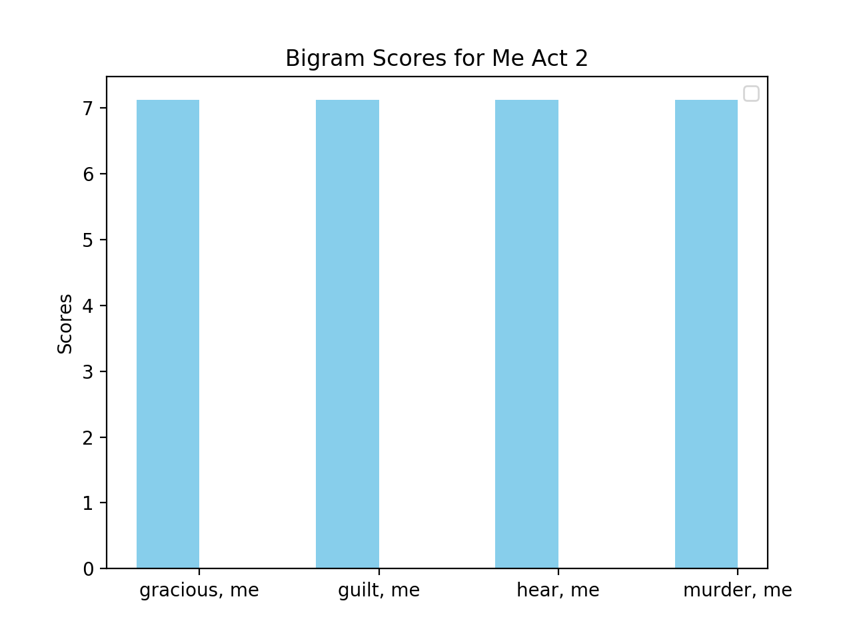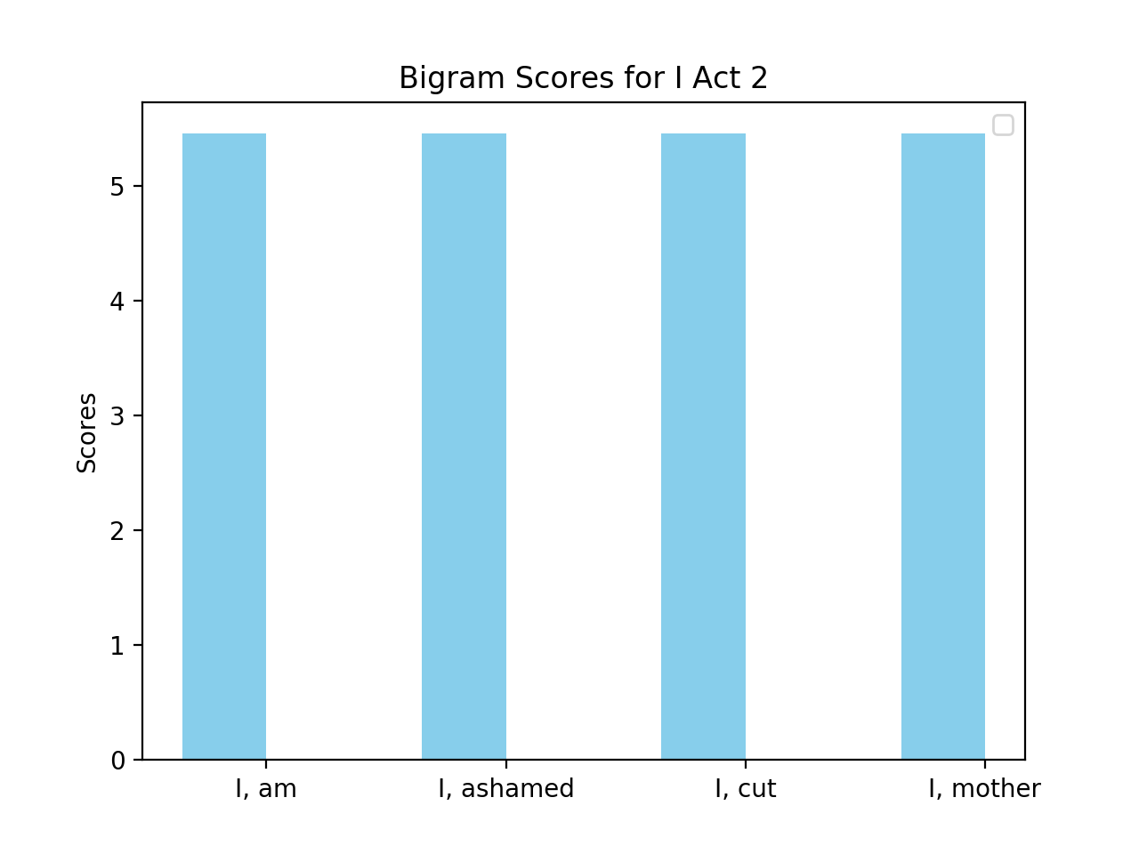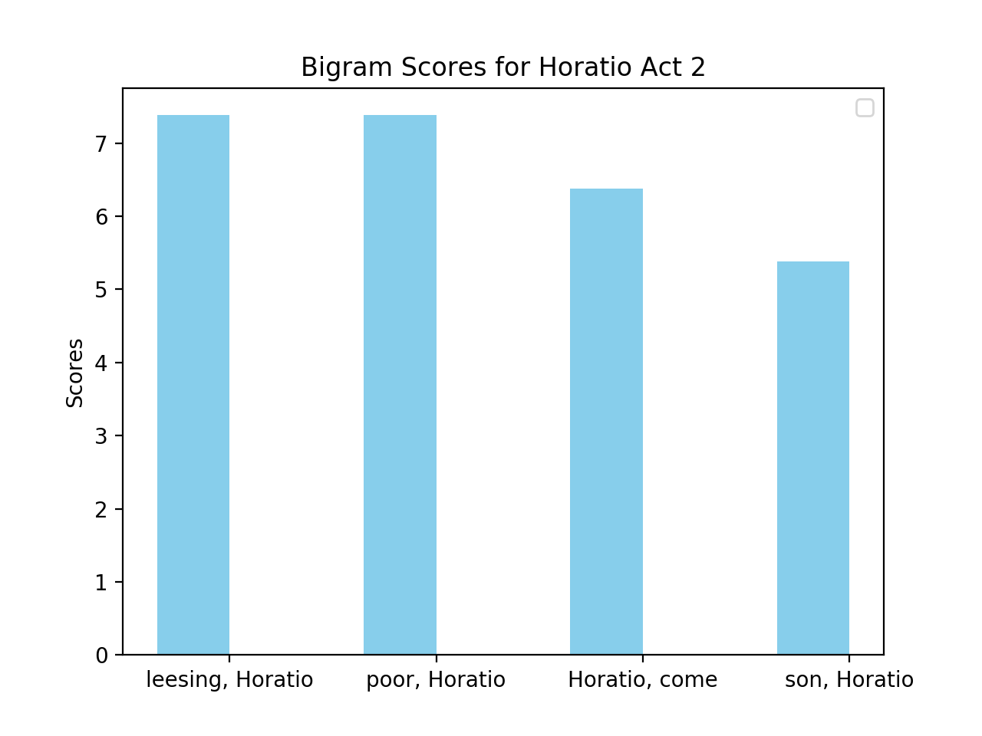

The significant words here are in the bigrams for I and me. Hieronimo uses the words ‘guilt’ and ‘ashamed’ in the bigrams for I and me which indicate that he is feeling guilty and blaming himself for the death of his son Horatio. The word ‘poor’ in the bigram for Horatio indicates that Hieronimo feels sorry for his son’s death and perhaps feels he should have done something to prevent it. Next, the most interesting bigrams in act 3 come from Horatio and Lorenzo:

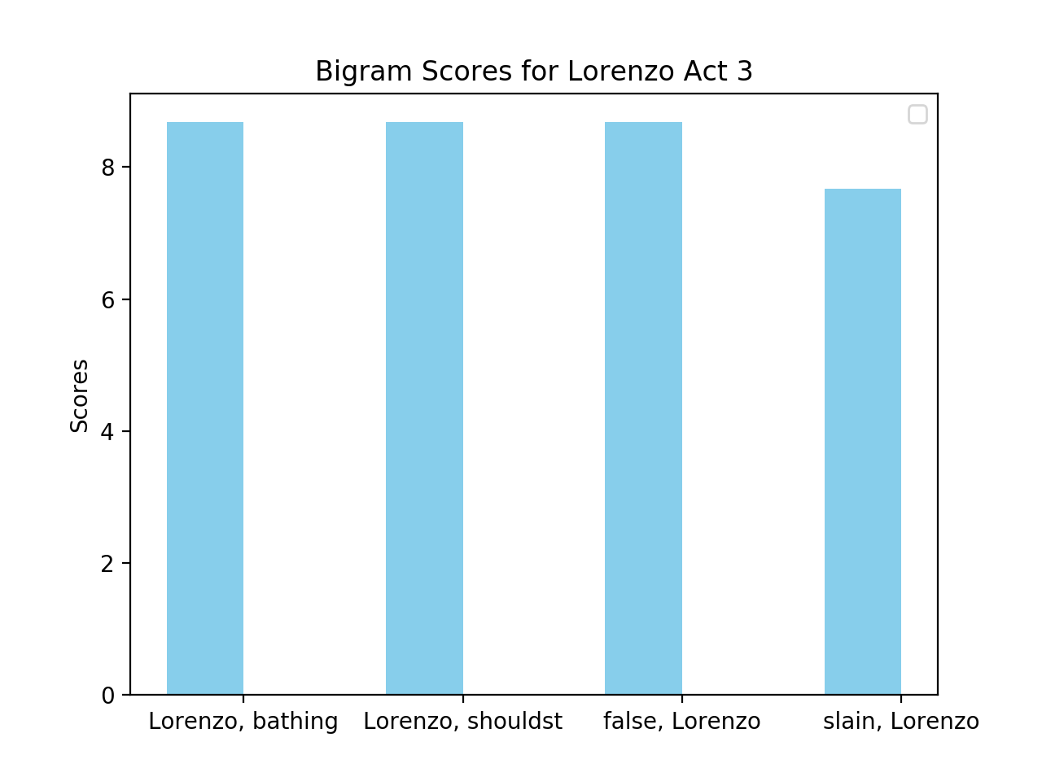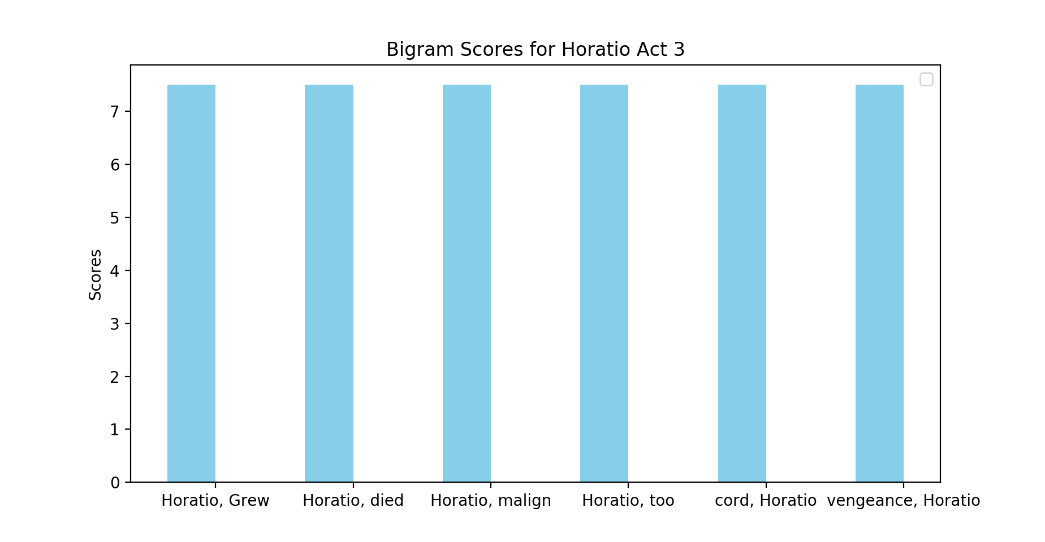

In this act Hieronimo begins to use more negative and violent language as he realizes that Lorenzo and Balthazar murdered Horatio and these bigrams demonstrate that. Hieronimo describes Lorenzo as ‘false’, meaning he is a liar, and uses ‘bathing’ to describe Lorenzo bathing Horatio in a cauldron of “boiling lead and blood of innocents” (*The Spanish Tragedy* 3.11.29). In the bigrams with Horatio, Hieronimo questions why Horatio was murder, and promises to seek vengeance for his death. Finally in act 4 the interesting bigrams came from you, me, and Horatio. I included you in my bigram analysis because often Hieronimo will be talking to a character and use you instead of the actual character’s name.

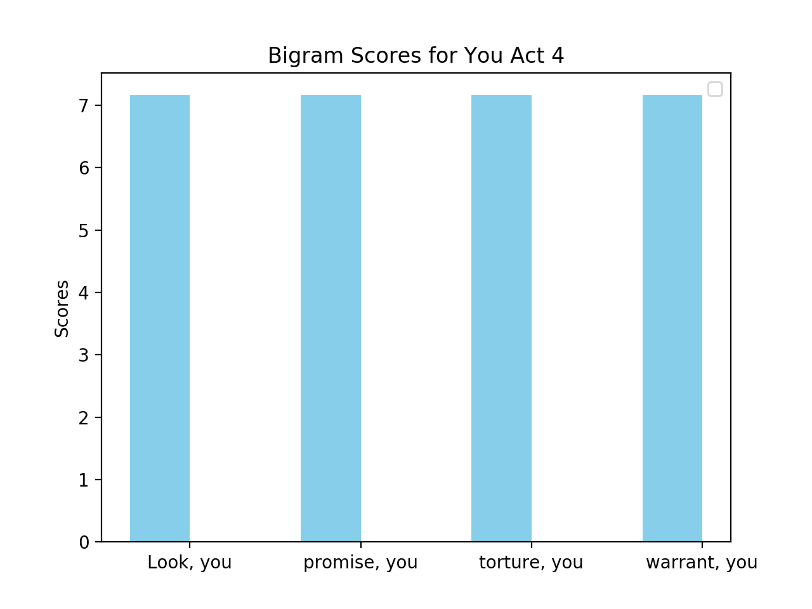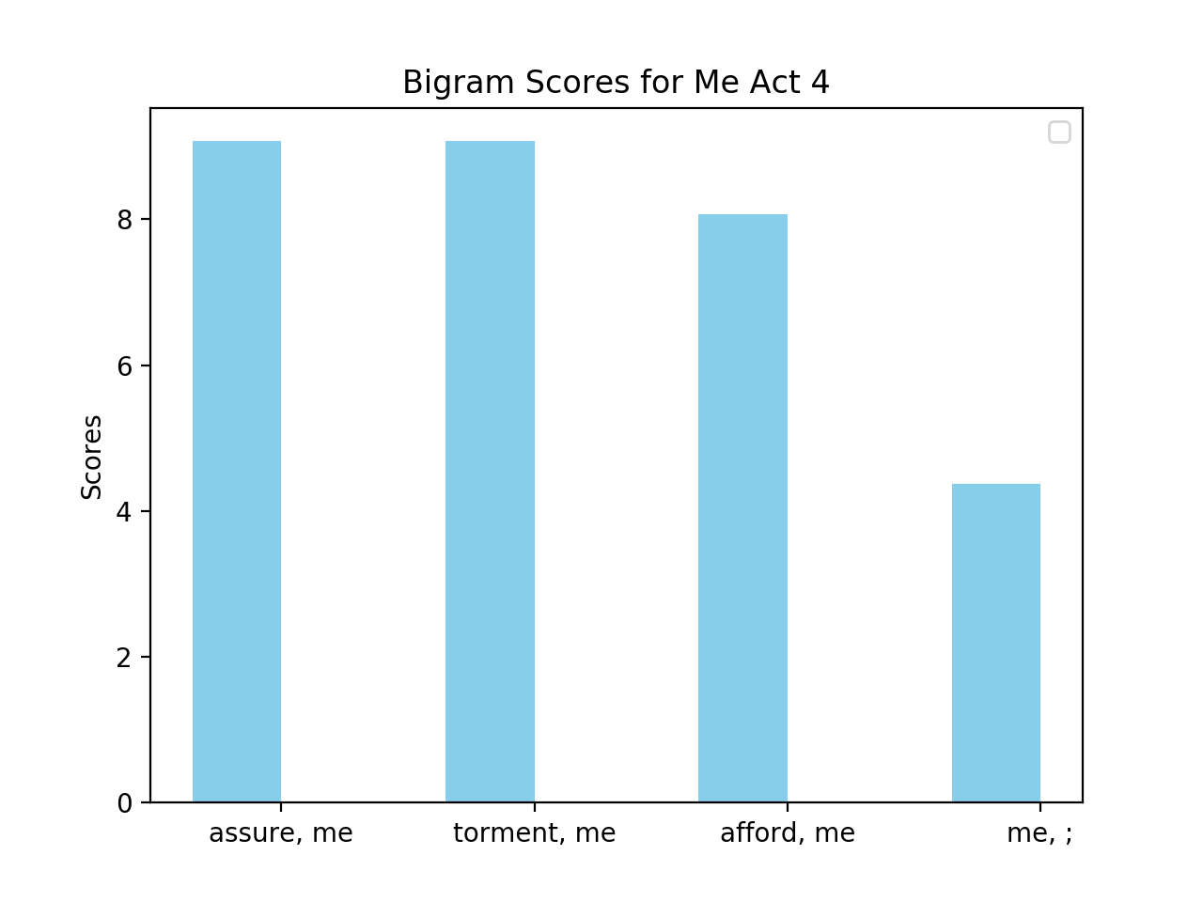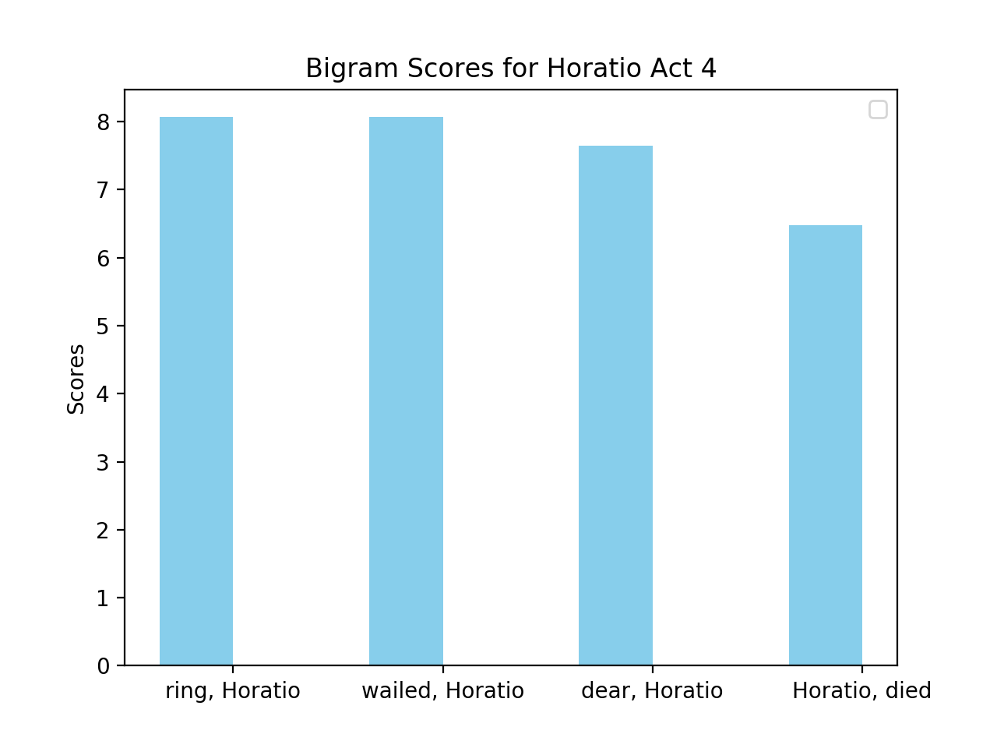

First, Hieronimo uses torture in response to the King saying that he will torture Hieronimo to get the truth out of him, Hieronimo states, “Do, do, do; and meantime I'll torture you.” (*The Spanish Tragedy* 4.4.195). This represents a clear shift in Hieronimo’s character because he began as a man of justice, but by the end of the play is threatening to torture the King. It is clear that the revenge has caused Hieronimo to succumb to madness and violence. To further support this, Hieronimo uses the words ‘torment’ and ‘wailed’ to describe to the King just how distraught he was after the murder of his son, Horatio. Hieronimo uses explains this to the King to perhaps justify his violence and madness; they came as a result of him being so sad after his son’s death. From the bigrams with other character names along with I, me, and you, we see Hieronimo undergoes a pretty large shift throughout the play. He begins as a man of justice, and has few lines in the first act before he knows Hieronimo has been murder. After this however, he grieves in act 2 before turning violent and enacting a revenge plot in acts 3 and 4. Hieronimo eventually decides to turn to revenge because of his grief, and he turns to such a violent revenge because the objects of his revenge are of the royal family so it would be impossible to win a court case.

To further examine how Hieronimo changes over the course of the play, I also did some sentiment analysis of some of his speeches. To determine how his perception of character changes, I looked at the “phrases” in Hieronimo’s lines where he mentions certain characters. I defined a phrase as the 10-word window before and after the mention of a given character. To determine the ‘sentiment’ of a given phrase, I use IBM Watson’s Tone Analyzer API. The Tone Analyzer uses deep learning with text data annotated linguistic and psychological researchers to determine the emotions in a given passage (IBM Cloud). Since Hieronimo has few lines in act 2, I began my analysis in act 2 by examining the phrases involving Horatio, I, and me. Plots of the main sentiments in the phrases involving each of these words are below:

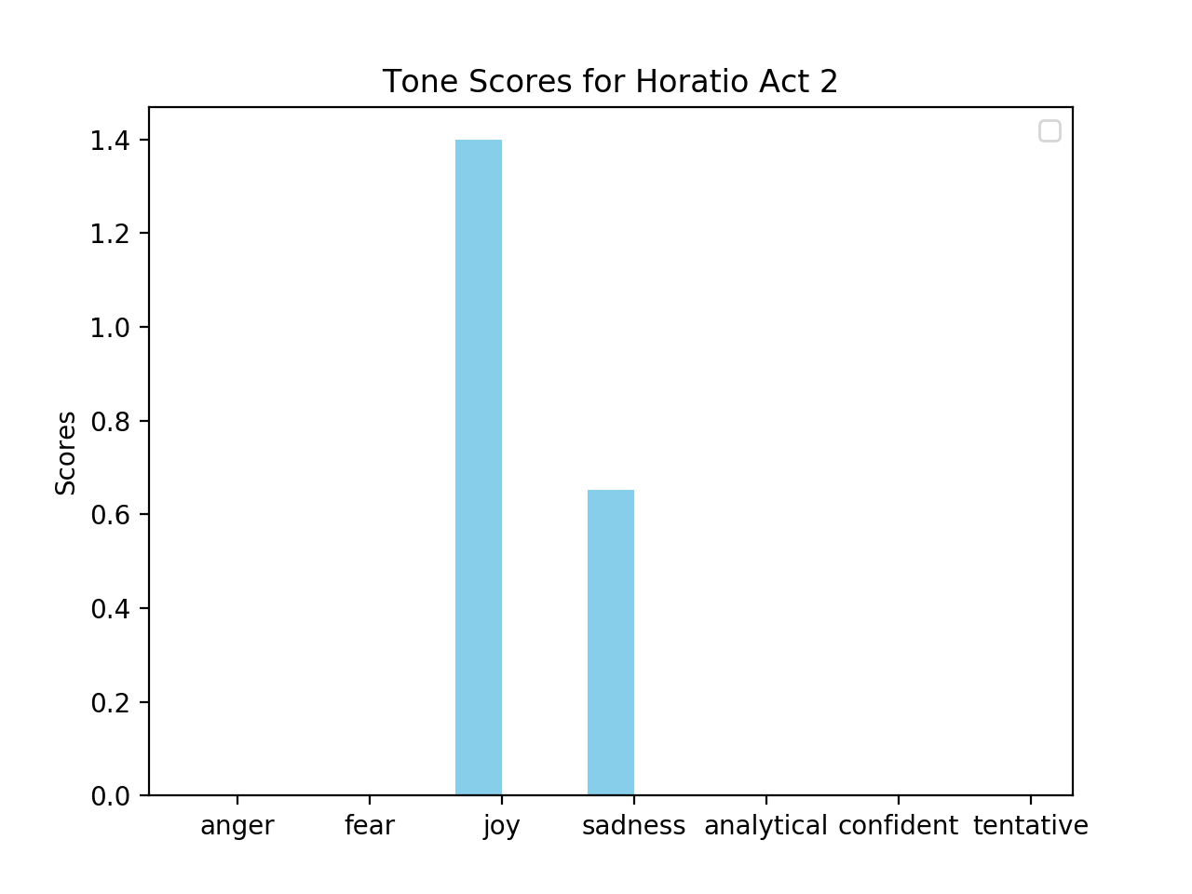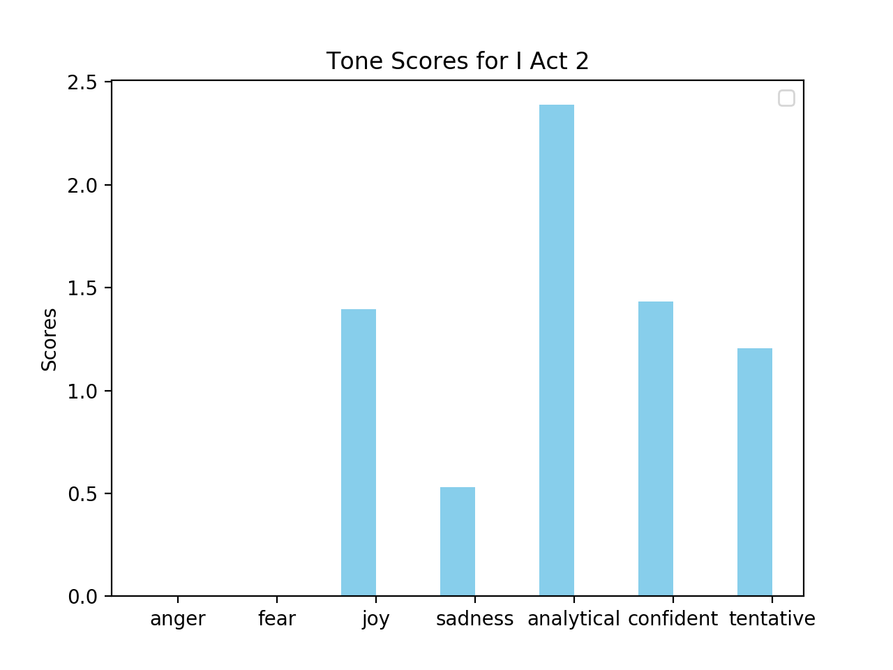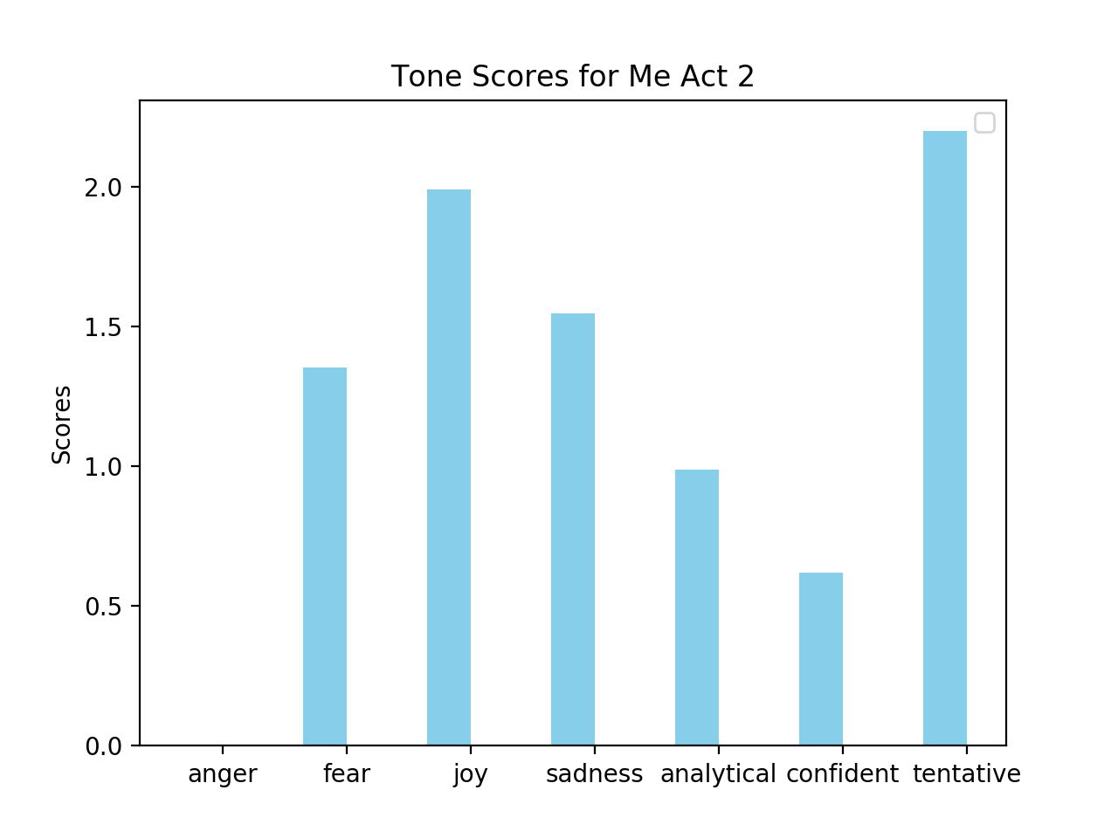

We see that the main tones involving Horatio are joy and sadness. The joy is because Hieronimo describes his son as “the joy of my life” and “my sweet son”, and the sadness is from Hieronimo question what Horatio did to lose his life. We see from these tones that Hieronimo is processing the death of a loved one in a very normal way; fondly looking back on him, while questioning why he died. The tones involving ‘I’ and ‘me’ were characterized as joyful and sad likely due to him mourning the death of his son, but also analytical and tentative. The phrases that are identified as analytical and tentative are when Hieronimo is considering what to do about his Horatio’s death. In acts 3 and 4 the most interesting tones were those involving Lorenzo. The plots for these tones are below:

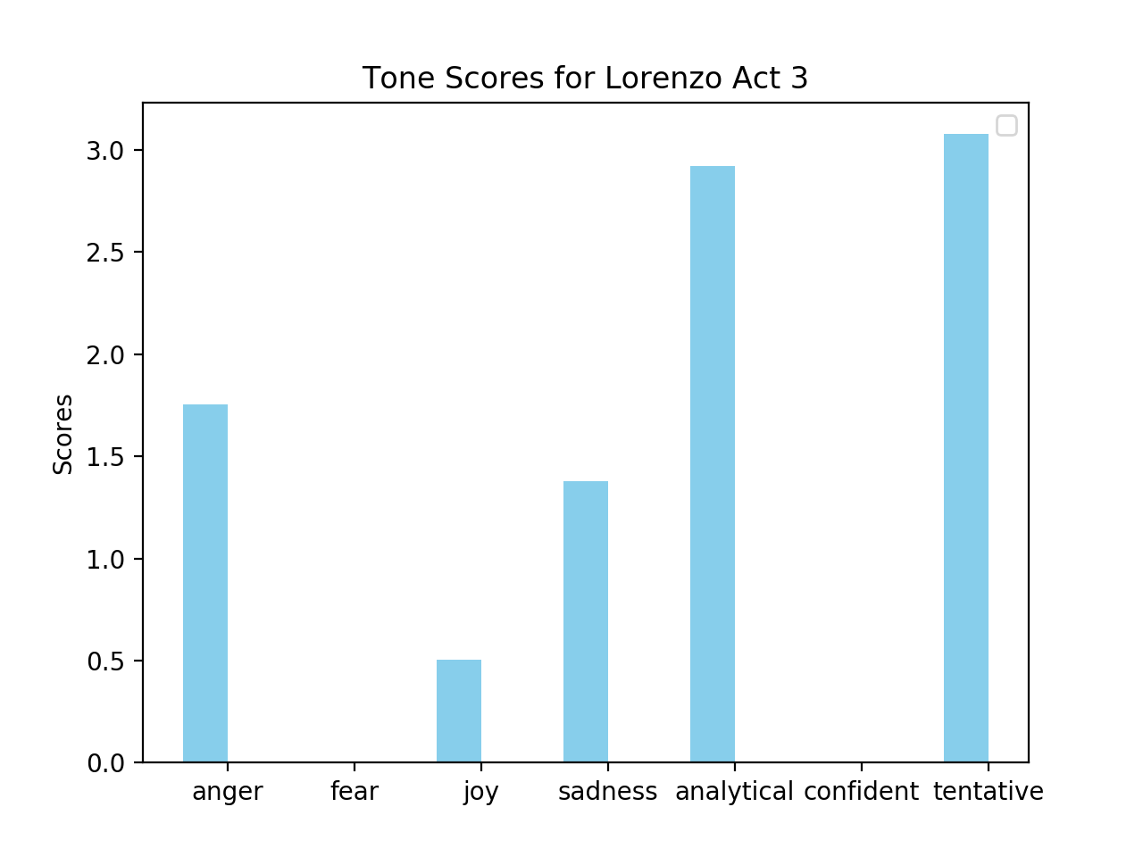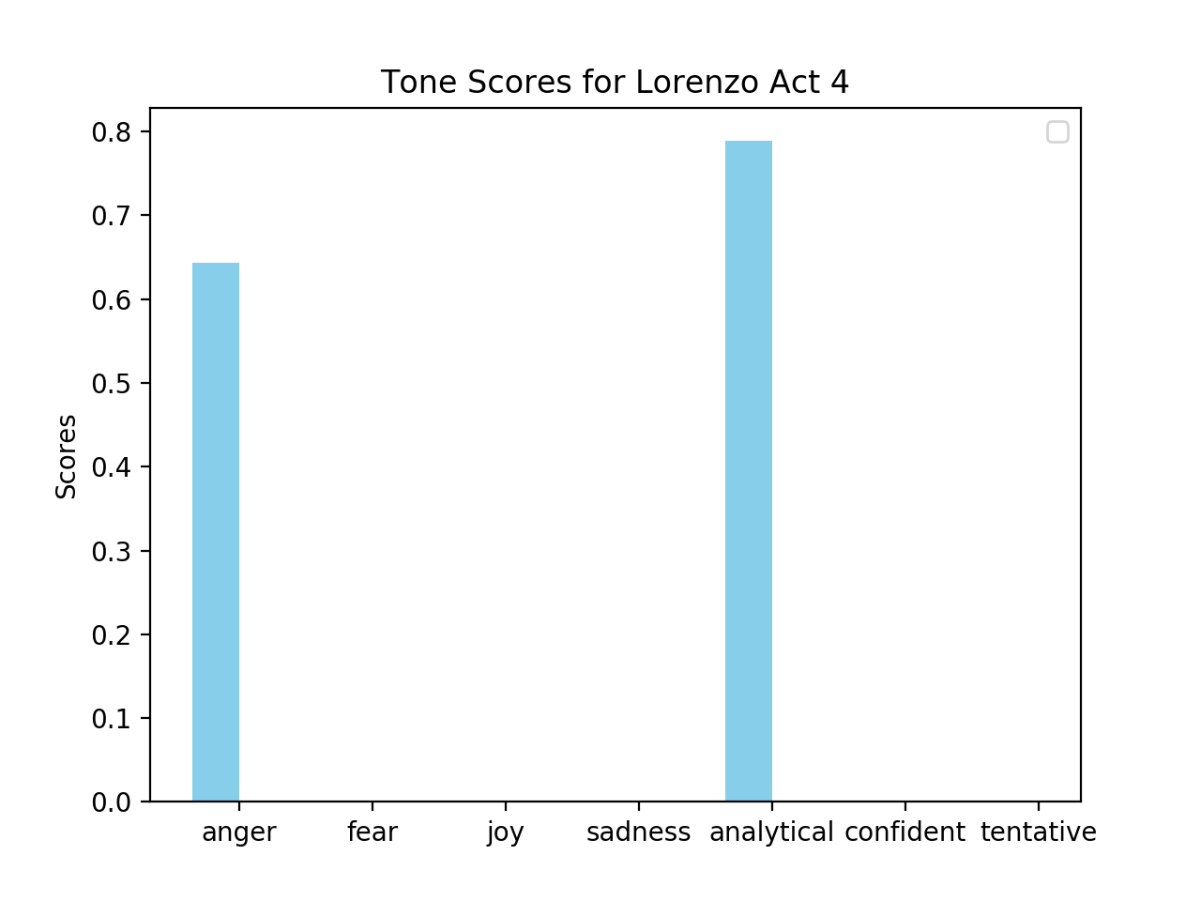

As we can see, in act 3 Hieronimo is equal parts tentative towards Lorenzo, and while he has some anger, he also has a bit of joy and some sadness towards Lorenzo as well. However, by act 4, Hieronimo is entirely anger and analytical towards Lorenzo. This further demonstrates how Hieronimo’s anger and intensity towards the revenge plot increases as the play goes on.

To further examine Hieronimo’s changes I also gathered the tone’s of his most important speeches. The first speech comes from act 2, scene 5, lines 51-56 and is when Hieronimo puts Horatio’s blood on a handkerchief to remind him of his death, the second is from act 3, scene 13, lines 11-20 and is when Hieronimo contemplates suicide but eventually chooses revenge, and the third is from act 4, scene 3, lines 21-30 when Hieronimo is fully committed to his revenge plot and about to enact it.

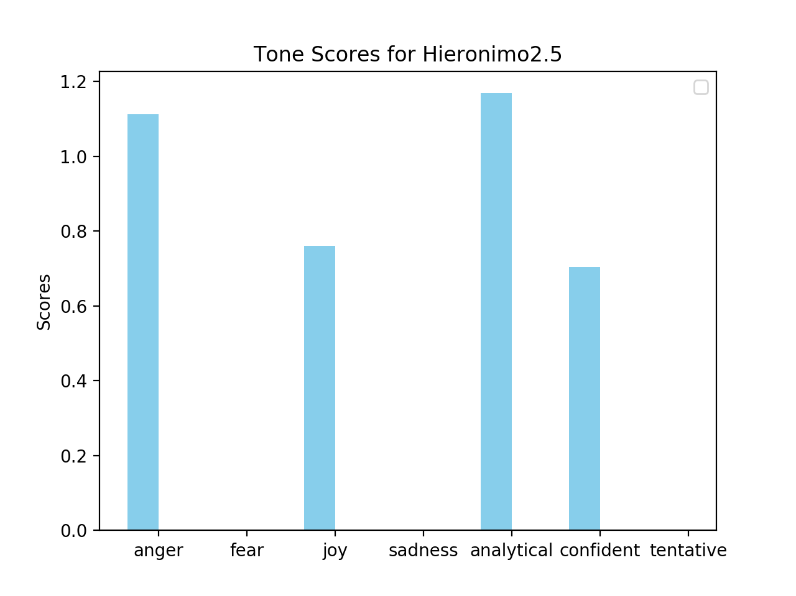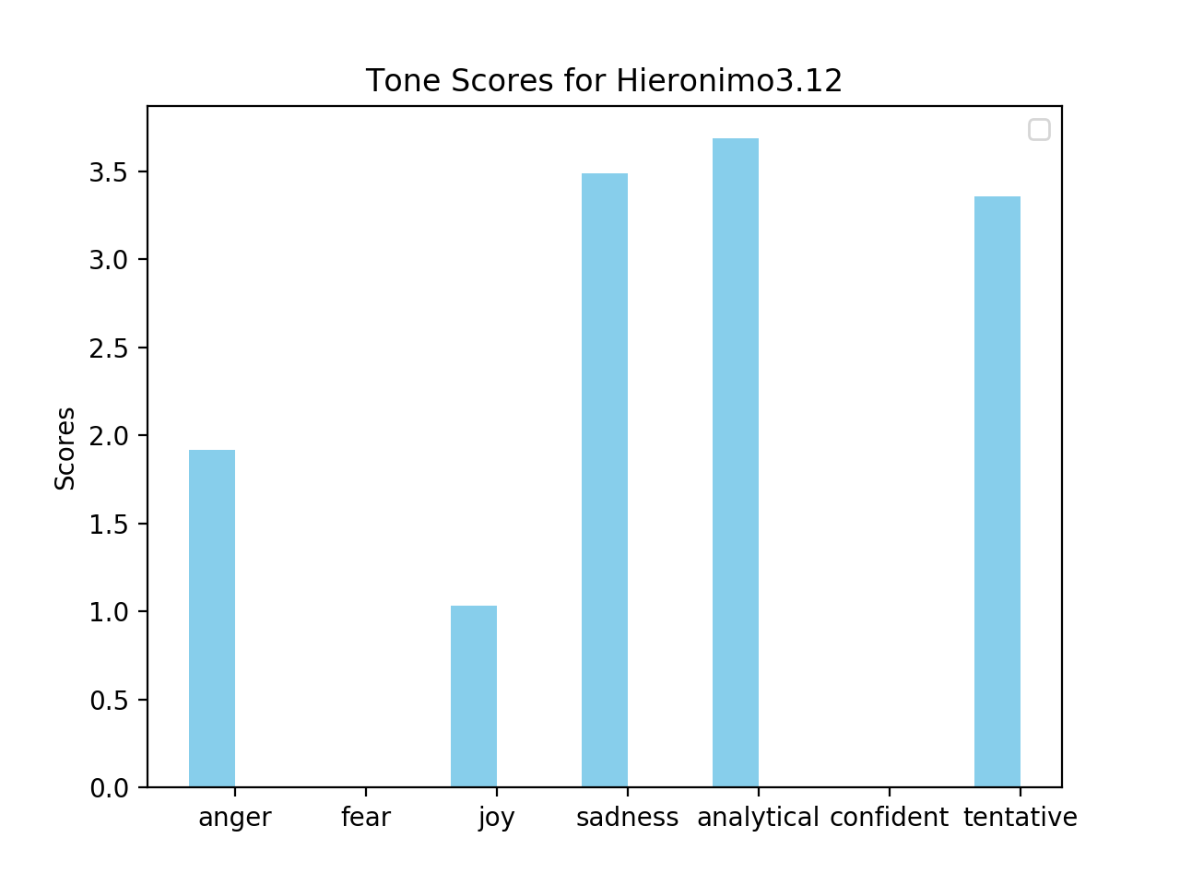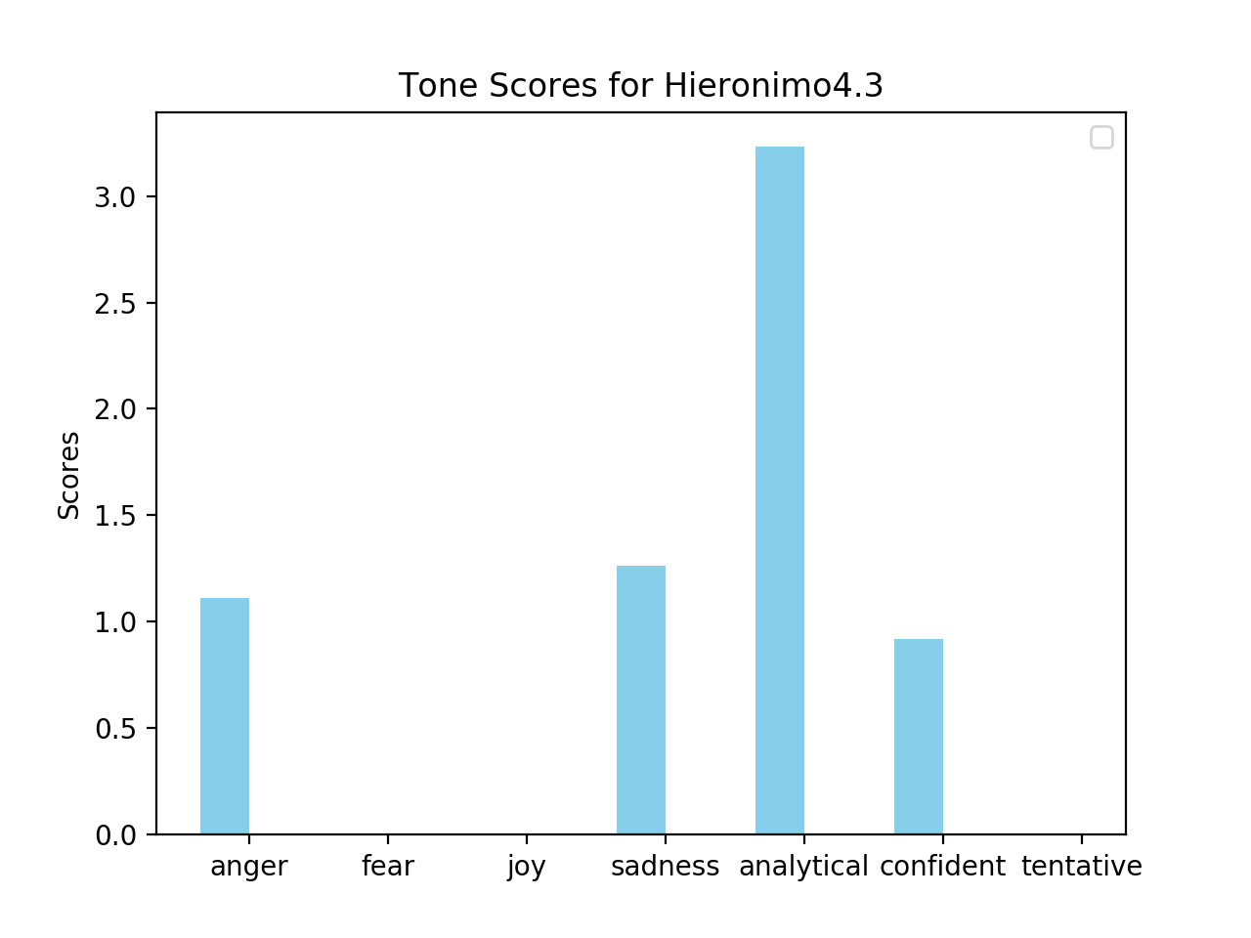

The tones from these speeches demonstrate Hieronimo’s progression throughout *The Spanish Tragedy*. He begins angry and sad about his son’s death, and vows to avenge him. However, in the middle of the play Hieronimo becomes increasingly more sad and even contemplates suicide before perhaps succumbing to madness and going through confidently with his revenge.

Next I performed a similar analysis on *Hamlet* and compared these results to those obtained from *The Spanish Tragedy.* The character that Hamlet cares most about and mentions most in his lines is his mother. Thus, I focused on tracking the progression of how Hamlet feels about his mother in my analysis:

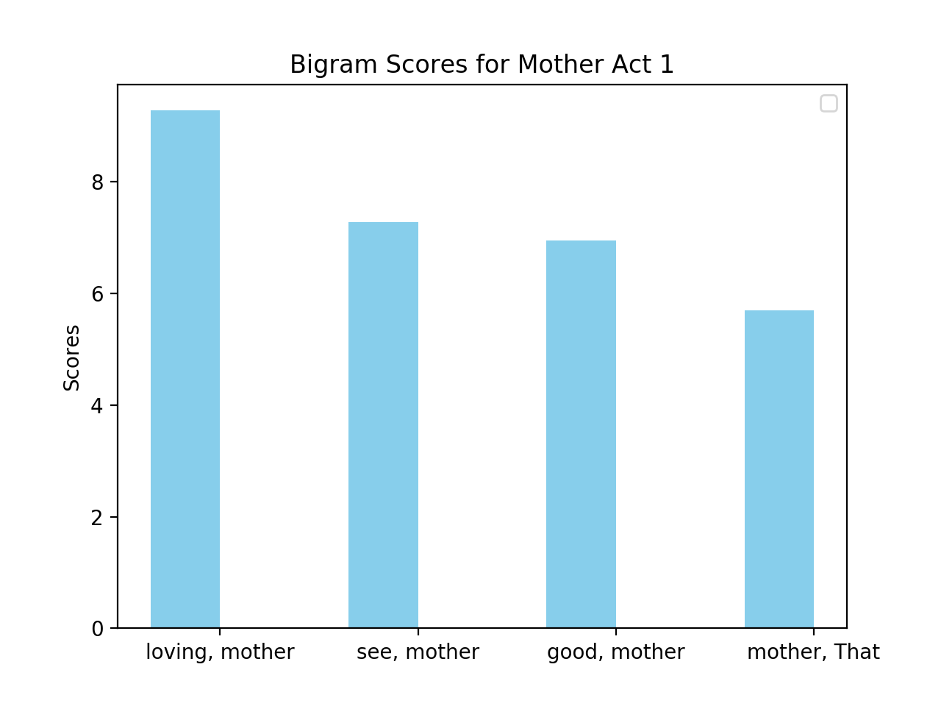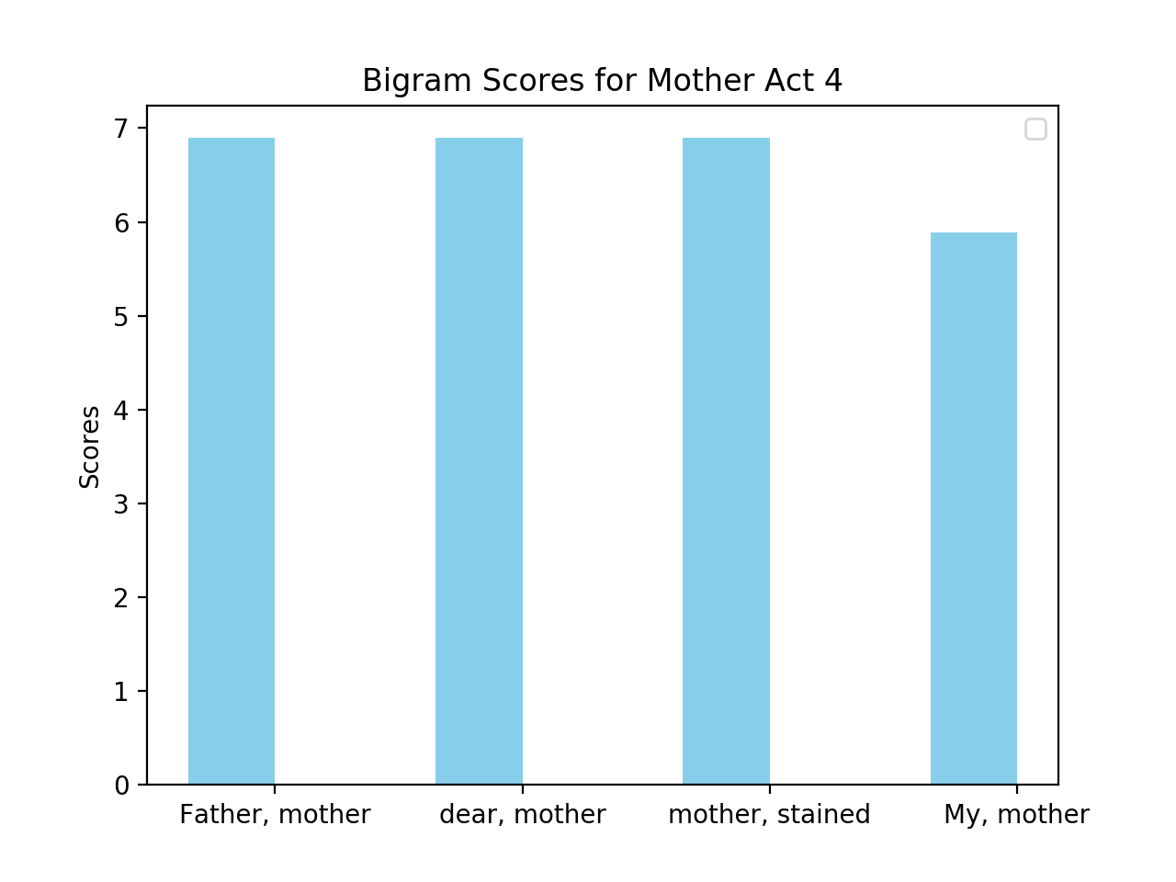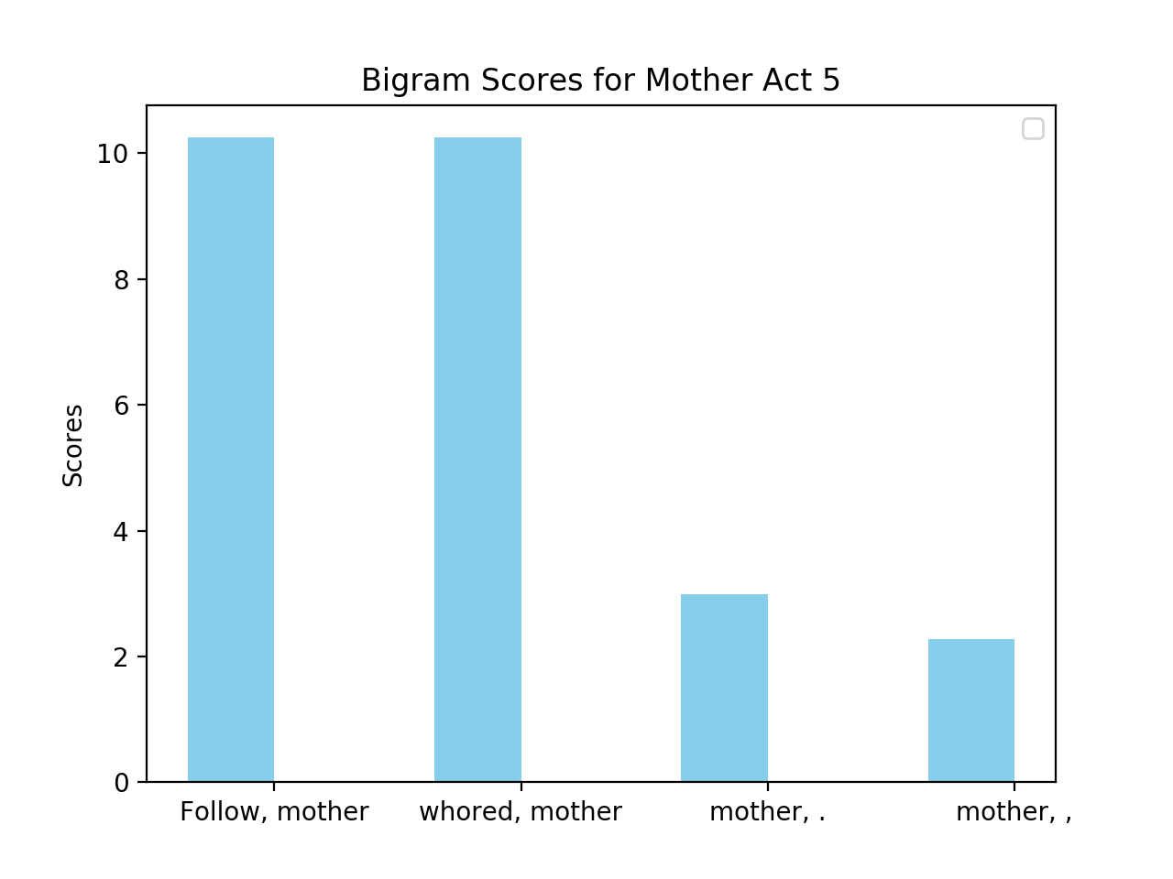

We see from the three plots the progression of how Hamlet perceives his mother. He begins as describing her as his ‘loving’, and ‘good’ mother when he characterizes her former relationship with his dead father. However, after discovering about how his uncle murder his father, he begins to hate their relationship even more and characterizes his mother as ‘stained’ and ‘whored’. This marks a difference between Hamlet and Hieronimo because Hieronimo does not really change his perceptions towards characters significantly throughout the play. He always grieves for his son, and always despises Lorenzo and Balthazar for killing his son. While Hamlet always hates the relationship between Claudius and his mother, Gertrude, he does not use negative language to describe his mother until the third act of the play after he has known about Claudius’ murder of his family for a couple acts, and thus has begun to hate the evil nature of their relationship even more. We see then Hamlet perhaps has more depth than Hieronimo because perceptions towards his mother change throughout the play, while Hieronimo’s perceptions of other characters remain rather constant.

To further characterize the similarities and differences between Hamlet and Hieronimo we can examine how their general personalities, and perceptions of themselves change. We examined previously how Hieronimo’s general personality changes due the death of his son because he is pushed to extreme sadness which causes him to contemplate either suicide or avenging his son. He chooses to avenge his son, and in choosing this becomes less emotion and very focused on his plan of revenge. Hamlet undergoes a similar dilemma; however, the results are different. To characterize how Hamlet responds to his father asking him to avenge his death, I examined the tones from 5 of Hamlet’s soliloquies. I examined the soliloquy when Hamlet reveals his initial anger at his mother and that he is contemplating suicide, when he finds out about his father’s murder, the “to be or not to be” speech, when he does not kill a pray Claudius, and the final soliloquy when he decides he must be a man of action and avenge his father. The tones from each of these soliloquies is below:

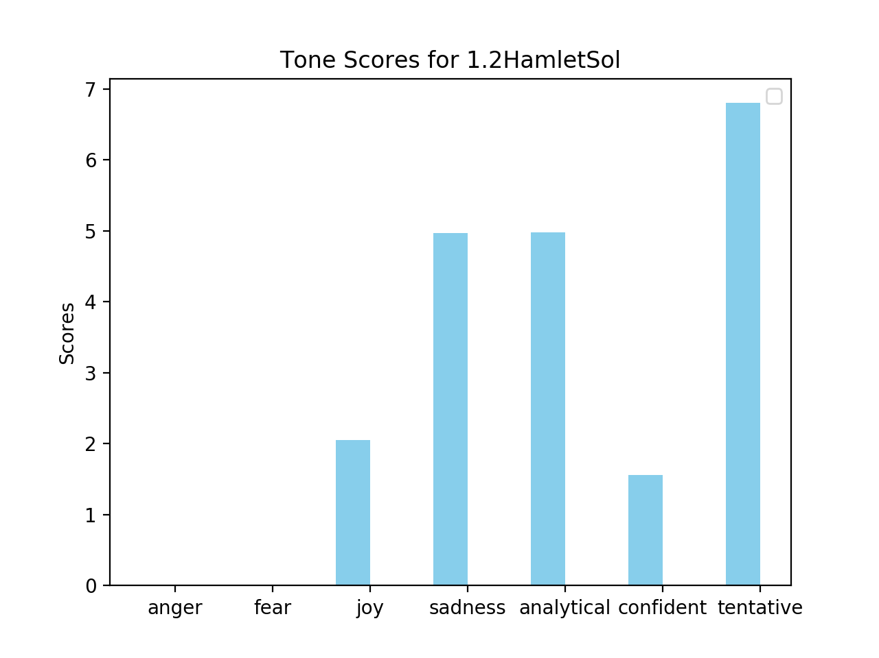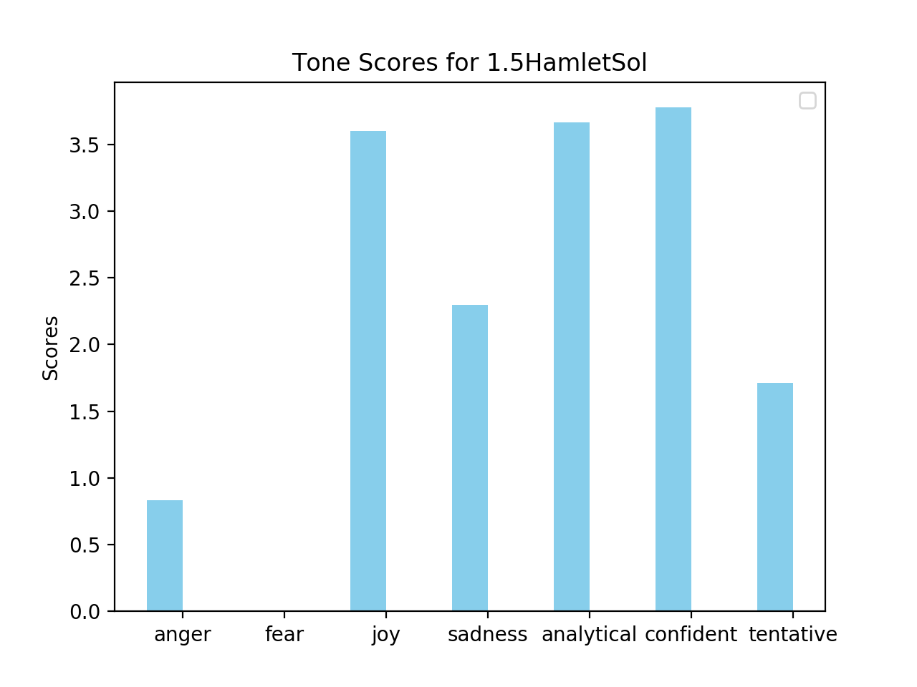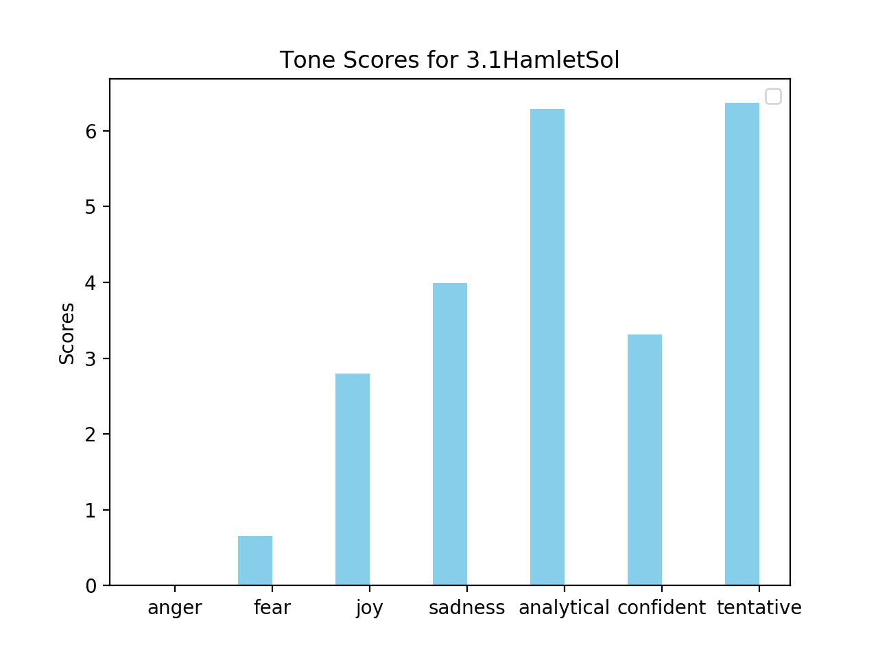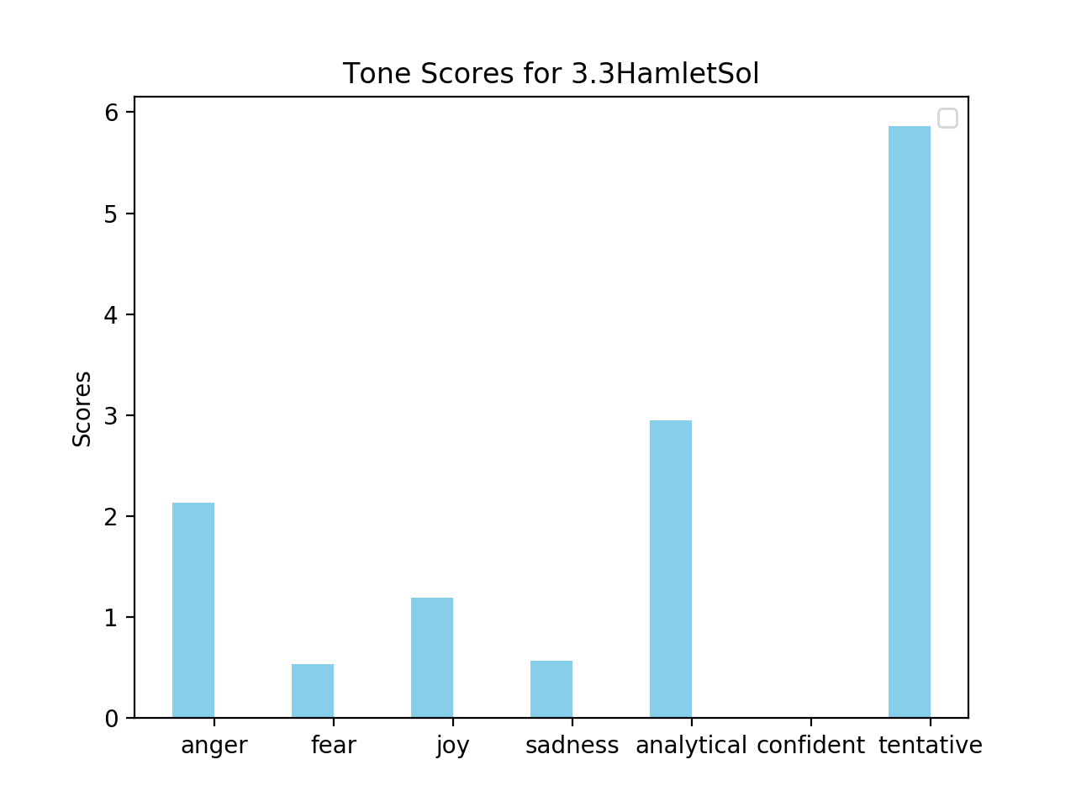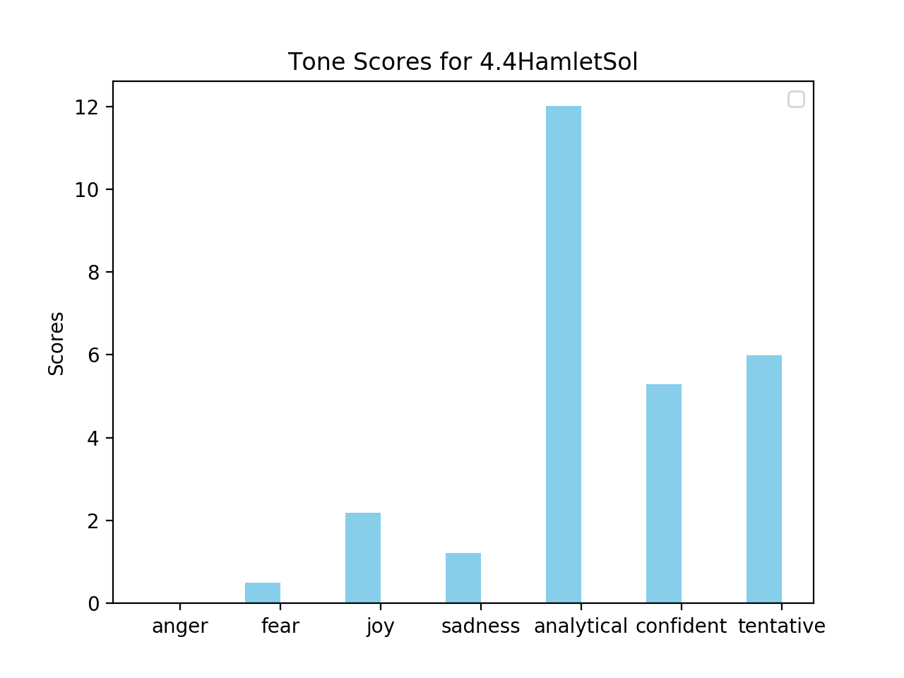

We see from these results that Hamlet does undergo a progression throughout the play, though it is not as linear as Hieronimo’s. In the first soliloquy Hamlet is tentative because he does not know if he should commit suicide and sad due to his father’s death. By the second soliloquy however, Hamlet has discovered that Claudius murder his father and thus some of his sadness turns to anger. He also becomes more confident in his direction because his father has told Hamlet to avenge him. The third soliloquy however is more similar to the first; Hamlet once again contemplates suicide and becomes less confident about his revenge against Claudius. In the third soliloquy Hamlet is once again tentative; he does not want to kill Claudius while he is praying and allow him to go to heaven. Finally, by the final soliloquy Hamlet has decided that he needs to avenge his father, and decides to go back to Denmark to do this.

Overall, Hamlet’s emotions are much more sporadic than Hieronimo, and his speeches are more analytic than Hieronimo’s. Thus, it does make sense that *Hamlet* is regarded more highly than *The Spanish Tragedy* because the protagonist in *Hamlet* is more dynamic than in *The Spanish Tragedy*. Although Hamlet is a similar character to Hieronimo in many regards (they both begin as rather non-violent, non-malicious characters and end up killing people who have wronged them), they differ one key point. Hieronimo is more decisive; he does contemplate suicide, but once he decides he must avenge his son he does not change his mind and concocts a plan to kill Lorenzo and Balthazar. Hamlet on the other hand flip-flops regularly between wanting to avenge his father and wanting to commit suicide. Even when he has a perfect opportunity to kill Claudius, he delays because he does not want Claudius to end up in heaven. Hamlet being less decisive perhaps makes him a more interesting character because it makes him seem more vulnerable to his own thoughts than Hieronimo is.

Works Cited

“IBM Cloud.” IBM Cloud Docs, 19 Sept. 2017, console.bluemix.net/docs/services/tone-analyzer/science.html#the-science-behind-the-service.