[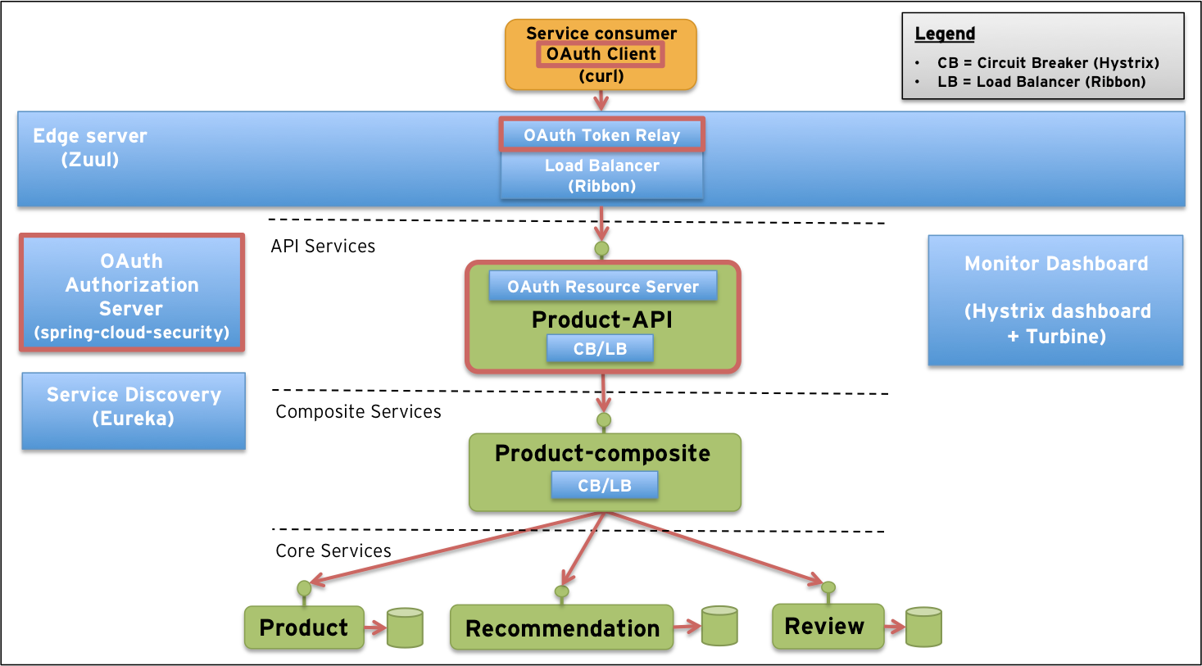](http://callistaenterprise.se/blogg/teknik/2015/04/27/building-microservices-part-3,%20secure%20API's%20with%20OAuth/)[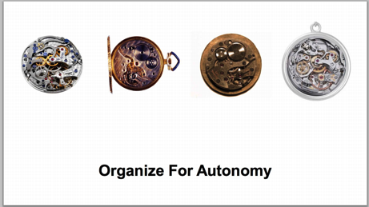](http://media.amazonwebservices.com/jp/summit2014/TE-01.pdf)[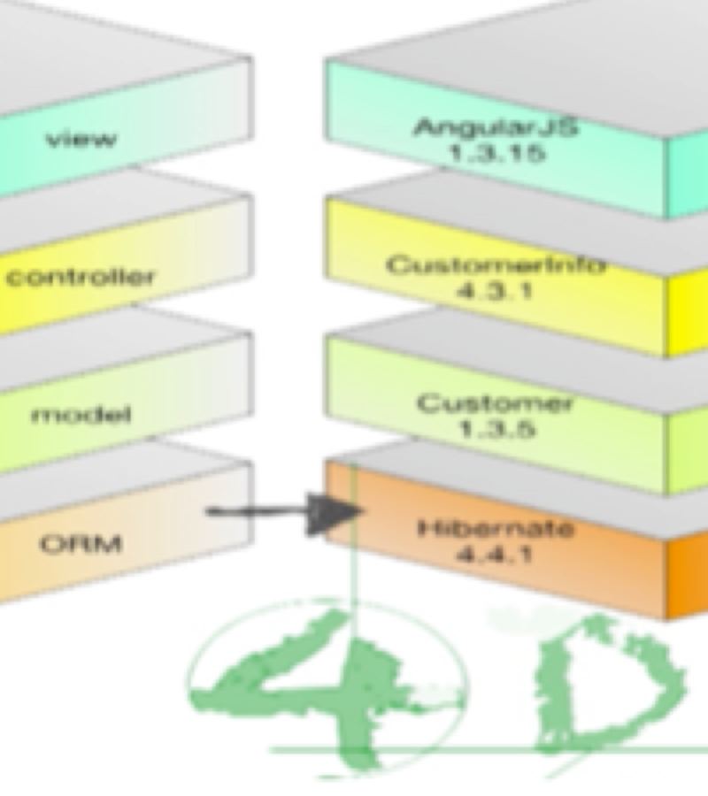](https://player.oreilly.com/videos/9781491932636)[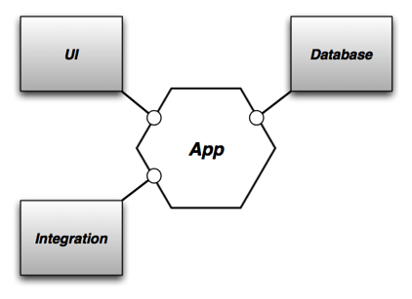](http://alistair.cockburn.us/Hexagonal+architecture)[](http://www.kpcb.com/internet-trends)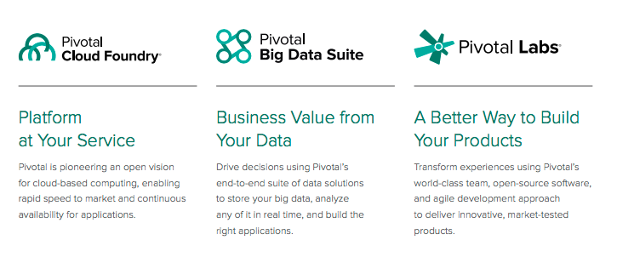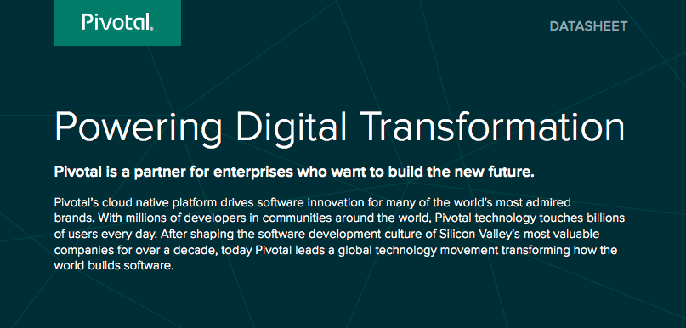

Thank you!

#### **Motivations for Modern Architectures**

#### Trend from 3D to 4D Architecture

#### The 4th D is Change

#### Autonomy allows for Change

#### **Approaches and Frameworks**

#### Spring and Related Frameworks

#### Autonomous Business Services

#### Steps to Fine-grained Autonomy

#### Examples

#### **How Pivotal helps Enterprises Transform**

#### Application Infrastructure ( Spring and Cloud Foundry)

#### Labs (Agile, DevOps, Data Science)

#### MPP Analytics (Greenplum, Hadoop, and Hawq)

#### **Questions for Pivotal:**

#### MDM Strategies that work with Microservices

#### How to validate data integrity when it cuts across service boundaries

#### Propagating changes between parent and child services

#### **Questions for customer:**

#### Scope and timing of first project to target a new architecture

#### List of technical requirements that might be challenging

### **Next Steps:**

### Review Data Strategies

### Labs Visit

### Cloud Foundry Overview

Follow Up

* [Mary Meeker KPCB](http://www.forbes.com/profile/mary-meeker/)
  + [Internet trends](http://www.kpcb.com/internet-trends)
* [Neal Ford](http://nealford.com/)
  + [Architecture Trends (4D)](https://player.oreilly.com/videos/9781491932636)
* [Amazon Deck on Innovation](http://media.amazonwebservices.com/jp/summit2014/TE-01.pdf)
* [Hexagonal Architecure](http://alistair.cockburn.us/Hexagonal+architecture)
* [Comparison of Spring and Dropwizard](http://www.schibsted.pl/2015/07/spring-boot-and-dropwizard-in-microservices-development/)
* [Synerzip](https://www.linkedin.com/pulse/microservices-reference-architecture-spring-boot-cloud-anil-allewar)
* [Callista](http://callistaenterprise.se/blogg/teknik/2015/04/27/building-microservices-part-3,%20secure%20API's%20with%20OAuth/)
* [Lambda Arch](http://lambda-architecture.net/).
* Etrade and Kafka
* [Conference on Distributed Event-Based Systems (DEBS)](http://www.debs2015.org/)
  + [Lambda Example w/Spring](http://www.slideshare.net/SpringCentral/spring-one2gx-2014carlosqueiroz)

# Agenda

## Dig Deeper (List of References)

* Creators and founding member of Cloud Foundry; founding member of the ODPi communities
* 1000+ Fortune 2000 companies as customers
* ~1,800 of the world’s top developers, engineers, consultants, and professionals
* EMC, VMware and $105M investment by GE
* Silicon Valley headquarters, 14 offices across globe
* 130+ infrastructure, consulting, and technology provider partners

Trusted by Companies Around the Globe

Southwest Indian Railways

CoreLogic Philips Comcast

Hulu Groupon

Mercedes-Benz Netflix

Sundance Institute UnionBank

BMW Humana

# Aliquam consectetuer posuere lorem.

Why Pivotal?