LAB EXERCISE:
Write a simple "Hello World" program in two different programming languages of your choice. Compare the structure and syntax.
Ans: # using python
print("Hello World")
# using c language
#include <stdio.h>
int main() {
printf("Hello World");
return 0;
}

Comparison of Structure and Syntax
Feature | C | Python
Program length | Longer | Very short
Main function | Required | Not required
Semicolons | Required | Not required
Syntax | Strict | Simple and readable
Compilation | Compiled | Interpreted

Research and create a diagram of how data is transmitted from a client to a server over the internet.

Request

Server
Phone

PC
network

LAPTOP

Respons
clients

Client server modal

The process of interacting with servers through a browser involves several steps:
1. User Enters the URL (Uniform Resource Locator):
The user types a website address (e.g., www.example.com) into the browser's address bar.
2. DNS (Domain Name System) Lookup:
The browser contacts a DNS server to convert the domain into an IP address.
3. Establishing a Connection:
The browser sends an HTTP/HTTPS request to the server using the resolved IP address.
4. Server Responds:
The server sends back website files (HTML, CSS, JavaScript, images).
5. Browser Renders the Webpage
- DOM interpreter: Processes HTML to structure the page.
- CSS interpreter: Applies styles
- JavaScript Engine: Adds interactivity (using JIT compilation for performance).

Design a simple HTTP client-server communication in any language.

Server Code (HTTP Server)

from http.server import BaseHTTPRequestHandler, HTTPServer

class MyHandler(BaseHTTPRequestHandler):
def do_GET(self):
self.send_response(200) # HTTP status code
self.send_header("Content-type", "text/html")
self.end_headers()
self.wfile.write(b"Hello from Server")

server = HTTPServer(("localhost", 8080), MyHandler)
print("Server running on port 8080...")
server.serve_forever()

Client Code (HTTP Client)

import requests

response = requests.get("http://localhost:8080")
print("Server Response:", response.text)

Research different types of internet connections (e.g., broadband, fiber, satellite) and list their pros and cons.

Types of Internet Connections

1. Broadband (DSL / Cable)
Description:
Uses telephone lines (DSL) or cable TV lines to provide internet.
Pros:
- Widely available
- Affordable
- Faster than dial-up
Cons:
- Speed depends on distance and number of users
- Slower than fiber
- Performance may drop during peak hours

2. Fiber Optic Internet
Description:
Uses fiber-optic cables to transmit data as light.
Pros:
- Very high speed
- Reliable and stable connection
- Best for streaming, gaming, and online work
Cons:
- Expensive
- Not available in all areas
- Installation cost is high

3. Satellite Internet
Description:
Uses satellites to provide internet, mainly in remote areas.
Pros:
- Available almost anywhere
- Useful in rural and remote locations
Cons:
- High latency (delay)
- Expensive
- Affected by weather

4. Mobile Data (4G / 5G)
Description:
Uses cellular networks through SIM cards.
Pros:
- Portable
- Easy to set up
- 5G offers very high speeds
Cons:
- Data limits
- Speed depends on signal strength
- Can be costly

5. Dial-Up Internet
Description:
Uses telephone lines and a modem.
Pros:
- Very cheap
- Available in remote areas
Cons:
- Very slow
- Cannot use phone while connected
- Outdated technology

Simulate HTTP and FTP requests using command line tools (e.g., curl).

Simulating HTTP Requests (using curl)

1 HTTP GET Request:
curl http://example.com
What it does:
- Sends an HTTP GET request
- Receives and displays the webpage content

2 HTTP GET with Headers
curl -I http://example.com
What it does:
- Shows HTTP response headers (status code, server type, etc.)

3HTTP POST Request
curl -X POST -d "username=student&password=1234" http://example.com/login
What it does:
- Sends data to the server
- Simulates form submission

Simulating FTP Requests (using curl)

1FTP Download File
curl ftp://ftp.example.com/file.txt --user username:password
What it does:
- Connects to FTP server
- Downloads a file

2FTP Upload File
curl -T upload.txt ftp://ftp.example.com/ --user username:password
What it does:
- Uploads a file to FTP server

3 List FTP Directory
curl ftp://ftp.example.com/ --user username:password
What it does:
- Displays files and folders on FTP server

Identify and explain three common application security vulnerabilities. Suggest possible solutions.

1 SQL Injection
Explanation:
Attackers insert malicious SQL code into input fields (like login forms) to access or modify the database.
Example:
Entering ' OR '1'='1 in a login field.
Possible Solutions:
- Use prepared statements (parameterized queries)
- Validate and sanitize user input
- Use database access controls

2 Cross-Site Scripting (XSS)
Explanation:
Attackers inject malicious scripts into web pages that run in users’ browsers.
Example:
Injecting JavaScript into a comment field.
Possible Solutions:
- Escape and encode user input/output
- Use Content Security Policy (CSP)
- Validate input before displaying it

3 Weak Authentication
Explanation:
Occurs when applications use weak passwords or poor login protection, allowing attackers to gain access.
Example:
Using simple passwords like “123456”.
Possible Solutions:
- Enforce strong password rules
- Use multi-factor authentication (MFA)
- Limit login attempts and use CAPTCHA
Identify and classify 5 applications you use daily as either system software or application software.
• Windows Operating System – System Software
- It manages the computer’s hardware and allows other programs to run.
• Android Operating System – System Software
- It controls the phone and supports all mobile apps.
• Google Chrome – Application Software
- It is used for browsing the internet and searching information.
• Microsoft Word – Application Software
- It is used for typing assignments and documents.
• WhatsApp – Application Software
- It is used for messaging, calls, and sharing files.

Design a basic three-tier software architecture diagram for a web application.

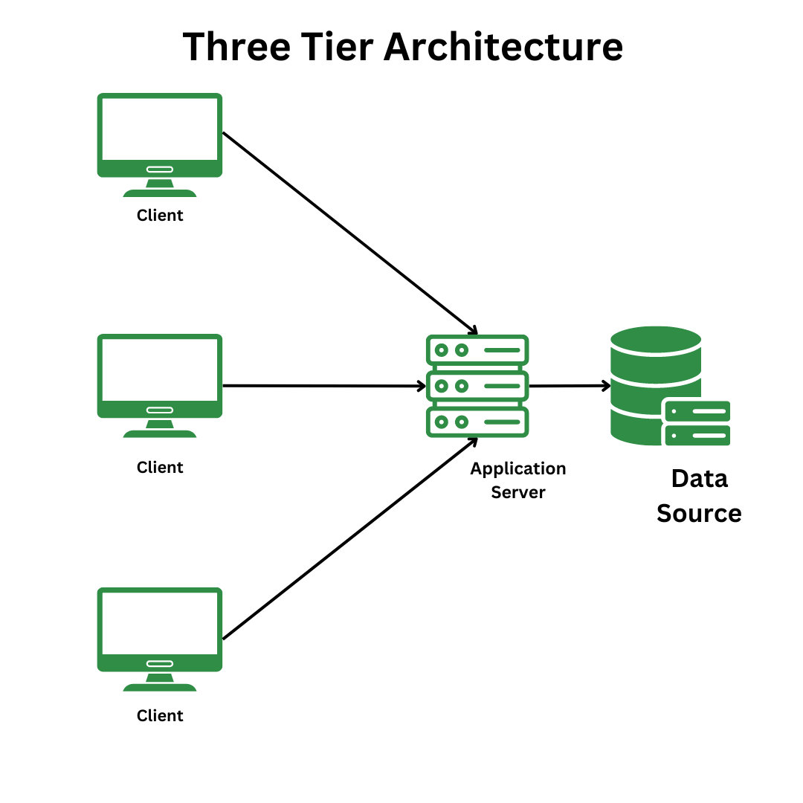

Create a case study on the functionality of the presentation, business logic, and data access layers of a given software system.
This case study explains how the Presentation Layer, Business Logic Layer, and Data Access Layer work together in an online shopping website.

1. Presentation Layer (User Interface):
Functionality:
- This layer interacts directly with the user.
- It displays products, prices, images, and buttons.
- It collects user input such as login details, search queries, and orders.
Examples in the system:
- Web pages (Home page, Login page, Product page)
- Shopping cart screen
- Checkout page
Role:
- Sends user requests (like “add to cart”) to the business logic layer.
- Displays results received from the system.

2. Business Logic Layer (Application Layer):
Functionality:
- This layer processes all business rules and decisions.
- It checks user login credentials.
- It calculates total price, discounts, and taxes.
- It manages order placement and payment processing.
Examples in the system:
- Validating user accounts
- Checking product availability
- Applying discount codes
Role:
- Acts as a bridge between the presentation layer and data access layer.
- Ensures rules are followed before data is stored or retrieved.

3. Data Access Layer (Database Layer):
Functionality:
- This layer handles data storage and retrieval.
- It communicates directly with the database.
- It saves user information, orders, and product details.
Examples in the system:
- User database
- Product inventory database
- Order and payment records
Role:
- Receives requests from the business logic layer.
- Stores and fetches data securely and efficiently.

Explore different types of software environments (development, testing, production). Set up a basic environment in a virtual machine.

Software Environments and Virtual Machine Setup (Simple Case)

1. Types of Software Environments

a) Development Environment
- Purpose: Where developers write and modify code.
- Who uses it: Developers.
- Features: Debug tools, sample data, frequent changes.
- Example: Coding a website on a laptop using VS Code and a local server.

b) Testing Environment
- Purpose: To test the software and find errors.
- Who uses it: Testers/QA team.
- Features: Test data, bug tracking, controlled changes.
- Example: Checking if login, payments, and pages work correctly.

c) Production Environment
- Purpose: Live system used by real users.
- Who uses it: Customers/end users.
- Features: High security, real data, stable performance.
- Example: The live website or app accessible on the internet.

2. Setting Up a Basic Environment in a Virtual Machine (VM)

Tools Needed
- VirtualBox (Virtual machine software)
- Ubuntu Linux ISO (Operating system)
- Computer with internet

Step-by-Step Setup
- Install VirtualBox
  - Download and install VirtualBox on your computer.
- Create a New Virtual Machine
  - Open VirtualBox → Click New
  - Name: Dev-Environment
  - Type: Linux
  - Version: Ubuntu (64-bit)
- Allocate Resources
  - RAM: 2 GB (minimum)
  - CPU: 1–2 cores
- Install Operating System
  - Select Ubuntu ISO file
  - Start the VM
  - Follow on-screen steps to install Ubuntu
- Set Up Development Tools
  - Install basic tools:
    - Web browser
    - Code editor (VS Code)
    - Web server (Apache or Node.js)
- Use as Development Environment
  - Write and test code safely inside the VM
  - No risk to your main computer

Create a student account on Github and collaborate on a small project with a classmate.

Create a GitHub Student Account
- Go to github.com and click Sign up
- Enter your email, username, and password
- Verify your email and log in

(Optional) Get GitHub Student Pack
- Go to GitHub Education
- Apply for Student Developer Pack
- Use your school email or student ID

Part 2: Create a Small Project Repository
- Click “+” → New repository
- Repository name: class-project
- Set visibility to Public
- Click Create repository

Part 3: Add a Classmate as a Collaborator
- Open your repository
- Click Settings
- Go to Collaborators
- Enter your classmate’s GitHub username
- Click Add collaborator
- Classmate accepts the invitation

Create a list of software you use regularly and classify them into the following categories: system, application, and utility software.

1. System Software
(System software manages the computer and allows other software to run)
- Windows Operating System – Runs the computer and controls hardware
- Android Operating System – Runs the smartphone and manages apps

2. Application Software
(Application software helps users perform specific tasks)
- Google Chrome – Used for internet browsing
- Microsoft Word – Used for typing assignments and documents
- WhatsApp – Used for messaging and calls
- YouTube – Used for watching educational and entertainment videos

3. Utility Software:
(Utility software helps maintain and protect the system)
- Windows Defender – Protects the computer from viruses
- Disk Cleanup – Removes unnecessary files to free space
- WinRAR – Compresses and extracts files

Follow a GIT tutorial to practice cloning, branching, and merging repositories.

I followed a Git tutorial to practice the basic Git commands. First, I cloned a repository from GitHub using the git clone command, which created a copy of the project on my local computer.
Next, I practiced branching by creating a new branch with git branch and switching to it using git checkout (or git switch). This allowed me to make changes without affecting the main branch.
After making changes, I practiced merging by switching back to the main branch and using the git merge command to combine the changes from my branch into the main branch.

Write a report on the various types of application software and how they improve productivity.
Application software is a type of computer program designed to help users perform specific tasks. Unlike system software, which manages the hardware, application software is used directly by people to complete work, communicate, or entertain themselves. Using the right application software can greatly improve productivity by saving time, reducing errors, and making tasks easier.
Types of Application Software
- Word Processing Software
  - Examples: Microsoft Word, Google Docs
  - Purpose: Used to create, edit, and format documents.
  - How it improves productivity: It allows fast document creation, spell-checking, and easy formatting, saving time compared to handwriting. Collaborative features also let multiple people work on the same document simultaneously.
- Spreadsheet Software
  - Examples: Microsoft Excel, Google Sheets
  - Purpose: Used to organize data, perform calculations, and create charts.
  - How it improves productivity: Automates calculations using formulas, reduces errors in data analysis, and makes it easier to visualize information with graphs and charts.
- Presentation Software
  - Examples: Microsoft PowerPoint, Prezi
  - Purpose: Used to create slideshows for meetings, lectures, or reports.
  - How it improves productivity: Helps convey ideas clearly and quickly, with visual aids that make presentations more engaging and easier to understand.
- Database Management Software
  - Examples: Microsoft Access, MySQL
  - Purpose: Used to store, manage, and retrieve large amounts of information efficiently.
  - How it improves productivity: Quickly finds and organizes information, reduces duplication, and supports decision-making by providing accurate data.
- Graphic Design Software
  - Examples: Adobe Photoshop, Canva
  - Purpose: Used to create and edit images, graphics, and designs.
  - How it improves productivity: Makes designing faster and easier than manual methods, with templates and tools that save time and effort.
- Communication Software
  - Examples: Zoom, Slack, Microsoft Teams
  - Purpose: Used to communicate and collaborate with others.
  - How it improves productivity: Enables instant communication, online meetings, and file sharing, reducing delays and improving teamwork.
- Web Browsers and Internet Applications
  - Examples: Google Chrome, Firefox, Google Workspace
  - Purpose: Used to access information and online tools.
  - How it improves productivity: Provides access to information quickly and supports online work like email, cloud storage, and collaboration tools.

Create a flowchart representing the Software Development Life Cycle (SDLC).

Requirements

Testing
Deployment
Maintence
Development
Design
Analysis

Write a requirement specification for a simple library management system.
Requirement Specification for a Simple Library Management System (LMS)
1. Introduction
The Library Management System (LMS) is designed to automate the management of a library. It helps in keeping track of books, managing members, and handling borrowing and returning of books efficiently. The system aims to reduce manual work and improve accuracy in library operations.
2. Purpose
The purpose of this system is to:
- Manage book inventory.
- Keep track of library members.
- Record book borrowing and returning.
- Generate reports for library staff.
3. Functional Requirements
Functional requirements describe the main functions the system must perform:
- Book Management
  - Add new books to the system.
  - Update book details (title, author, ISBN, quantity).
  - Delete books that are no longer available.
  - Search for books by title, author, or category.
- Member Management
  - Register new library members.
  - Update member details (name, contact, membership ID).
  - Remove members from the system.
- Borrowing and Returning
  - Issue books to members.
  - Track due dates for borrowed books.
  - Accept returned books and update availability.
  - Calculate fines for overdue books (if applicable).
- Reporting
  - Generate lists of available books.
  - Generate borrowing history for members.
  - Generate overdue books report.
4. Non-Functional Requirements
Non-functional requirements describe system qualities:
- User-Friendly Interface: Simple and easy-to-use interface for library staff.
- Reliability: The system should maintain accurate records without errors.
- Performance: Should handle multiple users and quick search queries.
- Security: Only authorized users can access the system.
5. System Constraints
- The system should run on standard desktop computers.
- Data should be stored in a database (like MySQL or SQLite).
- Must support at least 5000 book records and 1000 members.
6. Assumptions and Dependencies
- Library staff will have basic computer knowledge.
- Internet connection may be required if cloud-based storage is used.

Perform a functional analysis for an online shopping system.
Functional Analysis of an Online Shopping System
1. Introduction
An Online Shopping System allows users to browse products, place orders, make payments, and track deliveries via the internet. The system is designed to provide convenience to customers while helping sellers manage inventory and orders efficiently.
2. Functional Requirements
Functional requirements describe the main functions the system must perform:
- User Account Management
  - Users can register and create an account with personal details.
  - Users can log in and log out securely.
  - Users can update profile information and reset passwords.
- Product Management
  - Admin can add, update, or remove products.
  - Products should have details like name, price, description, and availability.
  - Users can search and filter products by category, price, or rating.
- Shopping Cart
  - Users can add products to the shopping cart.
  - Users can update quantities or remove items from the cart.
  - Users can view the total cost, including taxes and discounts.
- Order Management
  - Users can place orders for the items in their cart.
  - The system generates an order summary with estimated delivery time.
  - Admin can track order status (e.g., pending, shipped, delivered).
- Payment Processing
  - Users can make payments using various methods (credit/debit card, e-wallet, online banking).
  - The system should securely process and confirm payments.
  - Payment receipts should be generated for user records.
- Delivery Management
  - Users can provide delivery addresses and track shipments.
  - Admin can update the delivery status for each order.
  - Notifications (email/SMS) should be sent to users for order updates.
- Customer Support
  - Users can contact support through chat, email, or help forms.
  - FAQs and product guides should be available for self-help.
- Review and Rating System
  - Users can rate and review purchased products.
  - Admin can moderate reviews to prevent inappropriate content.
3. Non-Functional Requirements
- Usability: Easy-to-use interface for both customers and admins.
- Performance: Fast response for searches and checkout process.
- Security: Protect user data, secure payment processing, and prevent unauthorized access.
- Reliability: System should handle high traffic without downtime.
- Scalability: Should support increasing number of users and products.

Basic System Architecture for a Food Delivery App
1. Overview
The Food Delivery App connects customers, restaurants, and delivery personnel. It manages orders, payments, and delivery tracking in real-time. The architecture is designed to ensure smooth communication between users and the backend system.

Design a basic system architecture for a food delivery app.
Components of the System Architecture
- User Interface (Front-End)
  - Customer App: Allows users to browse restaurants, place orders, make payments, and track deliveries.
  - Restaurant App: Allows restaurants to receive orders, update menu items, and manage order status.
  - Delivery Personnel App: Allows delivery drivers to receive delivery requests, update status, and navigate to customer locations.
- Backend Server (Application Layer)
  - Order Management Module: Handles order placement, status updates, and order history.
  - User Management Module: Manages user profiles, login, and authentication.
  - Payment Processing Module: Handles secure payment transactions and generates receipts.
  - Notification Module: Sends real-time updates (order confirmations, delivery status, alerts).
- Database Layer
  - User Database: Stores customer, restaurant, and delivery personnel details.
  - Menu Database: Stores restaurant menu items, prices, and availability.
  - Order Database: Stores order details, status, and history.
  - Payment Database: Stores payment transactions securely.
- Third-Party Services (Optional)
  - Maps & Navigation API: For route planning and delivery tracking.
  - SMS/Email API: For sending notifications and alerts.
  - Payment Gateway: For processing online payments securely.
Customer App |
| (Place Orders, |
| Track Orders)

Backend Server
(Application Layer)
- Order Mgmt
- User Mgmt
- Payment Proc
- Notifications

Delivery App
(Track & Update Delivery Status
& Route)
Restaurant App
(Manage, Orders, Menu)

Databases
- Users
- Orders
- Menu
- Payments

Third-Party APIs
- Payment Gateway
- Maps/Navigation
- SMS/Email

Develop test cases for a simple calculator program.

Test Cases for Simple Calculator
Test Case ID | Operation | Input 1 | Input 2 | Expected Output | Remarks
TC01 | Addition | 5 | 3 | 8 | Valid addition
TC02 | Addition | -4 | 6 | 2 | Addition with negative number
TC03 | Subtraction | 10 | 4 | 6 | Valid subtraction
TC04 | Subtraction | 3 | 8 | -5 | Result is negative
TC05 | Multiplication | 7 | 5 | 35 | Valid multiplication
TC06 | Multiplication | 0 | 9 | 0 | Multiply by zero
TC07 | Division | 20 | 4 | 5 | Valid division
TC08 | Division | 7 | 2 | 3.5 | Division with decimal result
TC09 | Division | 5 | 0 | Error message | Division by zero
TC10 | All operations | 0 | 0 | 0 / Error | Zero input handling

Document a real-world case where a software application required critical maintenance.

Real-World Case: Critical Maintenance of WhatsApp Service
Application Name: WhatsApp
Type: Messaging Application

Problem Description
WhatsApp experienced a major service outage where users were unable to send or receive messages. The issue affected millions of users worldwide and disrupted personal and business communication.

Cause of the Issue
The problem was caused by a server configuration failure during a routine system update. This led to backend servers not responding correctly to user requests.

Maintenance Required
- Immediate server rollback to the previous stable version
- Fixing configuration errors
- Restarting affected services
- Monitoring system performance after recovery

Impact
- Global service downtime for several hours
- Users unable to communicate
- Business operations using WhatsApp were affected

Outcome
After critical maintenance, WhatsApp restored all services. The company improved system monitoring and backup procedures to prevent similar issues in the future.

Create a DFD for a hospital management system.

DFD Level 0 (Context Diagram)
External Entities:
- Patient
- Doctor
- Admin
Process:
- Hospital Management System
Data Flows:
- Patient → Hospital Management System: Patient details, appointment request
- Hospital Management System → Patient: Appointment confirmation, bills
- Doctor → Hospital Management System: Diagnosis, treatment details
- Hospital Management System → Doctor: Patient records, schedule
- Admin → Hospital Management System: Staff details, updates

DFD Level 1 (Detailed Diagram)

Processes:
- Patient Registration
- Appointment Management
- Treatment & Diagnosis
- Billing & Payment

Data Stores:
- D1: Patient Database
- D2: Doctor Database
- D3: Appointment Database
- D4: Billing Records

Data Flow Explanation:

1. Patient Registration
- Patient → Registration Process: Personal details
- Registration Process → Patient Database: Stored patient data

2. Appointment Management
- Patient → Appointment Process: Appointment request
- Appointment Process → Appointment Database: Appointment details
- Appointment Process → Patient: Appointment confirmation

3. Treatment & Diagnosis
- Doctor → Treatment Process: Diagnosis details
- Treatment Process → Patient Database: Updated medical records

4. Billing & Payment
- Billing Process → Billing Records: Bill details
- Billing Process → Patient: Bill receipt

Draw a flowchart representing the logic of a basic online registration system.
Start

Open Registration
Page
Enter User (Name, Email, Password)
Details

Validate Input Details
valid

Yes No
End

Registration Successful
Show Error Message
Re-enter Details
Save User Data to Database

