Hair Sensor Array V2: Differential Amplifier

Half bridge amplifier, with digital trimmer to balance the bridge and microcontroller.

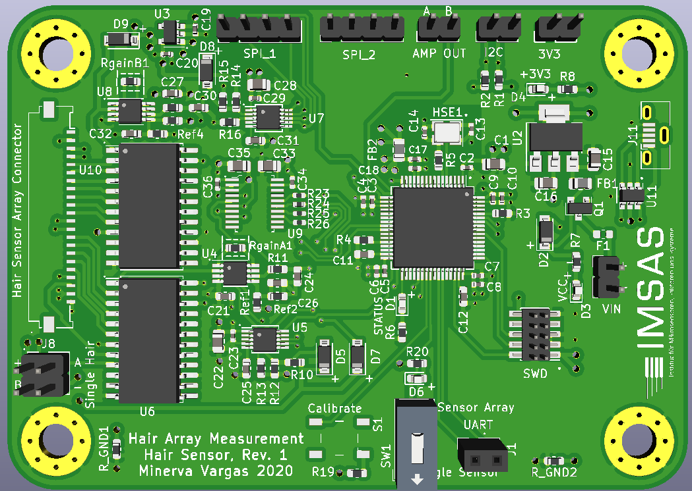

|  |  |  |  |
| --- | --- | --- | --- |
| Component | Designator | Quantity | Value |
| Fuse 500mA | F1, | 1 | Fuse_0603_1608Metric |
| UART Connector | J1, | 1 | 2 pins |
| Debugger Connector | J2, | 1 | Connector_PinHeader_1.27mm: 2x05 SMD |
| I2C Connector | J3, | 1 | 2 pins |
| VCC Connector | J4, | 1 | 2 pins |
| SPI Connector | J5, | 1 | 2 pins |
| 3V3 Connector | J6, | 1 | 2 pins |
| Sensor Array Connector | J7, | 1 | Connector FFC-FPC: Molex 1x22 P1.00mm |
| Sensor Connector | J8, | 1 | 2 pins |
| Amp Sensor out | J9, | 1 | 2 pins |
| Switch | SW1, | 1 | Button Switch (Slide) |
| INA326 | U4, U8, | 2 | INA326EA/250 |
| 24 Bit ADC | U9, | 1 | MCP3562 TSSOP-20 |
| 1V reg | U3, | 1 | TLV71310PDBV SOT-23-5 |
| USB connector | J11 | 1 | USB_Micro-B_Molex-105133- 0001 |
| Var dig resistor | U5, U7 | 1 | AD5272BRM MSOP-10 P0.5mm |
| ESD protection for USB | U11 | 1 | USBLC6-2SC6 |
| Cap Semi 0805 | C1, C15, C16, C22, C28, C33, C35, | 7 | 10u |
| Cap Semi 0402 | C2, C3, C4, C5, C6, C7, C8, C9, C10, C17, C19, C20, C23, C29, C34, C36, | 16 | 100n |
| C18, | 1 | 10n |
| C13, C14, | 2 | 12p |
| Cap Semi 0603 | C11, C12, | 2 | 2.2u |
| C21, C24, C25, C27, C30, C31, | 6 | 1u |
| C26, C32, | 2 | 0.2n |
| LED | D1, D3, D4, D6, | 4 | LED |
| Diode | D2, D5, D7, D8, D9, | 5 | B5819W |
| Inductor | FB1, FB2, | 2 | 100 @ 100 MHz |
| Crystal | HSE1, | 1 | 16MHz |
| Mosfet | Q1 |  | AO3401A |
| Resistor 0603, 0402 | R1, R2, R6, R7, R19, | 5 | 2k2 |
| R3, R4, R10, R14, | 4 | 10k |
| R5, | 1 | 220 |
| R8, R20, | 2 | 1.5k |
| R23, R24, R25, R26, | 4 | 100, 0402 |
| R11, R17, | 2 | 100 |
| R12, R15, | 2 | 16k |
| R13, R16, | 2 | 20k |
| Ref1, Ref2, Ref3, Ref4, | 4 | 1M |
| RgainA1, RgainB1, | 2 | 2k |
| R_GND1, R_GND2, | 2 | 0 |
| Switch | S1, | 1 | 1825910-6 |
| Microcontroller | U1, | 1 | STM32F405RGTx |
| 3.3V Voltage regulator | U2, | 1 | AMS1117-3.3 |
| Multiplexer | U6, 10, | 2 | CD74HC4067M |