**Simple Arithmetic**

Lab 3

Section B

Mitchell Wadle

09/15/17

**Lab Problems:**

Problem 1 – Mysterious Outputs

We were given a sample code and asked to run it. When compiled and executed the answer weren’t printing the correct answers. There is a problem with the code that is not giving us the result we want so we had to fix it to print the code that we want.

Problem 2- Simple Arithmetic

We were asked to write a program that evaluate a list of simple operations. This include simple math as well as understanding how the program understands orders of operation. Programs don’t understand orders of operation they just compute from one side of the line to the other. Our program had to be written so that operations are carried out in the order in which they are supposed to. After computing those, were asked to write a program that calculated the area of a circle given a certain circumference, Convert feet to meters, and convert Fahrenheit to Centigrade.

Problem 3 – Esplora

The final problem asked us to plug in the Esplora and run some tests. These tests show a range of values after moving the Esplora around.

**Analysis:**

The mysterious outputs prints the wrong answers for each operation because of a coding mistake. The first one doesn’t print right because it needs to return a double value and is returning an integer value. This prints the wrong value for the operation. The second one prints zero because there is not a variable assigned to %d in the printf statement. The final one prints a large string of numbers. This is because we have 2 double values divided by one another and they have a %d to add in the answer which is an integer not a double.

The simple arithmetic we pretty straight forward. They gave use and operation and we had to make it print the correct output. Some were given to us ok but other required altering the line to give us the correct output. The area of the circle in terms of the circumference was a bit different. First I needed to take an input and store it in a variable name. Next I calculated the area by writing the formula in notepad so that the computer would evaluate the expression correctly. Then once the area has been calculated just print the area. This problem require the use of the pow function for when you square your circumference. This meant that at the top of the code we had to include the <math.h> so that the pow function would be available. The feet to meters and the Fahrenheit to Centigrade were the same way. After writing the correct equation, you just print your result.

The third problem showed us a range of values for every millisecond the Esplora was running. These values changed as the Esplora was moved around. This shows the data that is being taken when the Esplora is being moved.

**Design:**

For the first problem, all we had to do was copy the code and evaluate the mistakes it was making. No design was really needed for this step.

Problem 2 required us to evaluate many expressions. For this I made one printf line and copied it for every expression. I then changed each line to print the appropriate information given the expression. The circle area required finding the conversion formula and making an expression in our code to solve it correctly. Same with the meters and degree ones.

Problem three requires the explore.exe file and an Esplora with the cable. We plug the Esplora into the computer and ran the tests. Results showed up right in Cygwin.

**Testing:**

Problem one we ran once to see the outputs. When we corrected or otherwise found the mistakes, the mistakes were fixed and the code was ran again. If wrong again continue process until the code ran properly.

For the first 11 problems in the second part, I did one problem at a time. Running it and rerunning it to make sure each operation was printing the right stuff. When it came to the circumference a few different ideas were tested in order to get the correct value for the area. This require running and rerunning the same code to see if the expression printed the right result. Meters and degrees were the same way.

Testing the Esplora was a little different. We had to plug the Esplora into the computer and run the test command. This showed the results in real time in Cygwin and we could see how the values changed as the Esplora was moved.

**Comments:**

Lab was simple but at the same time required some own thinking in order for us to get the correct values for some of the problems.

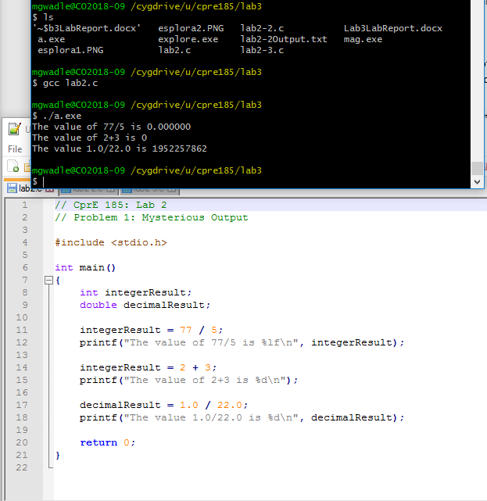Screen Shots:

Problem 1

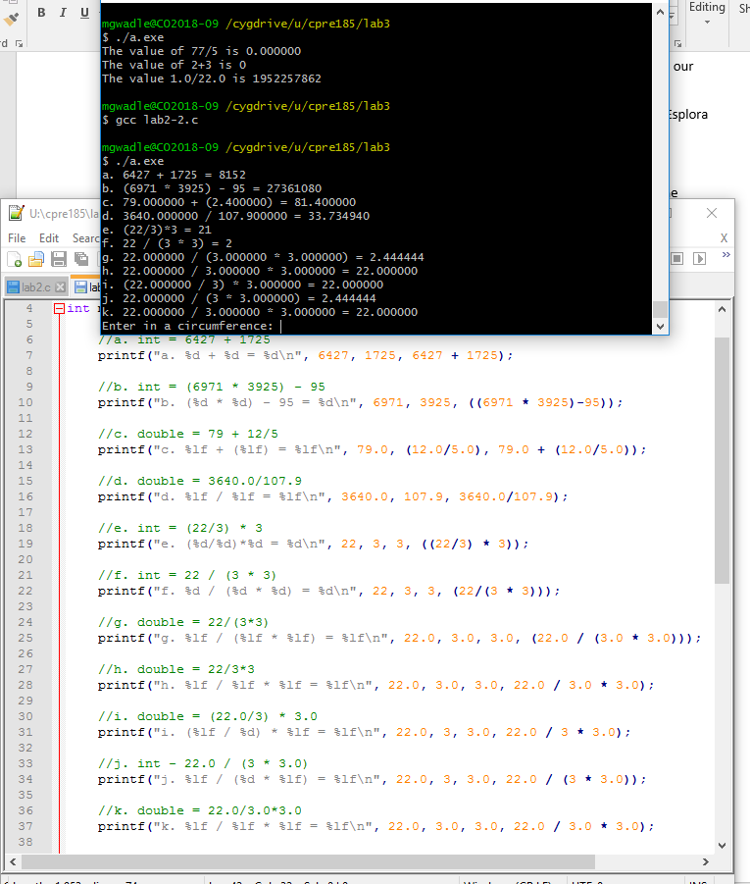

Problem 2

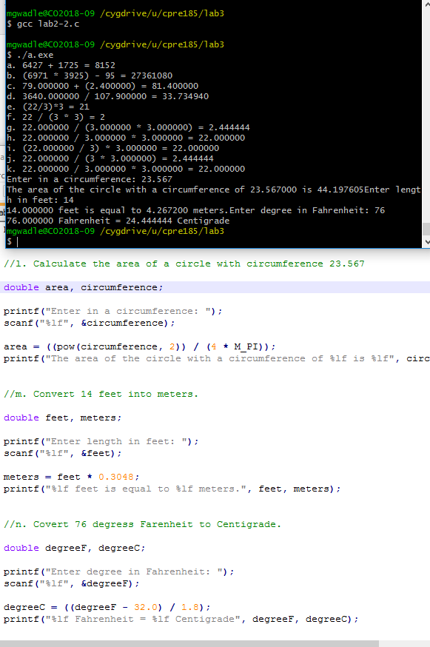

Problem 3

