CHAPTER I
THE PROBLEM AND ITS BACKGROUND
This chapter presented the underlying issues that inspired the development of the proposed smart queue management system. It discussed the existing challenges in traditional queue handling processes, particularly in establishments with high customer volume, and highlights the limitations in waiting time estimation, customer flow monitoring, and service efficiency. By examining current technological trends and the growing application of machine learning in operational systems, the chapter established the need for a web-based intelligent queue management solution that improved customer experience, enhanced operational efficiency, and supported data-driven decision-making.
- Introduction
Efficient queue management is an essential component of quality service delivery in establishments such as hospitals, banks, government offices, schools, and retail businesses. Long waiting times and poorly organized queues often result in customer dissatisfaction, operational inefficiencies, and reduced productivity. Traditional queue systems commonly rely on manual processes or basic first-come, first-served mechanisms that do not adapt to changing customer demand and service conditions.
The advancement of web technologies and artificial intelligence has introduced opportunities for developing smarter and more efficient queue management systems. Machine learning algorithms are capable of analyzing historical queue data and generating predictive insights that help estimate customer waiting times more accurately. Predictive queue systems allow service providers to optimize operations while helping customers better manage their time and expectations.
Recent studies highlight the effectiveness of machine learning in operational management systems. Research conducted by Kumar et al. (2022), Lee and Park (2021), and Chen et al. (2020) demonstrated that predictive analytics and intelligent queue systems significantly improve service efficiency, reduce congestion, and enhance customer satisfaction. Local studies and reports also emphasize the growing demand for digital transformation in service-oriented establishments in the Philippines. These findings support the development of intelligent queue management platforms integrated with machine learning-based prediction models.
The proposed study, titled “A Web-Based Smart Queue Management System with Machine Learning-Based Waiting Time Prediction Using Random Forest Algorithm,” aimed to provide a smarter and more efficient approach to queue handling. The system utilized a random forest algorithm to predict customer waiting times based on queue-related data such as customer count, service duration, and arrival rate. It also incorporated QR code verification, SMS authentication, analytics dashboards, and automated appointment validation to improve service reliability and customer convenience.
- Background of the Study
Queue management systems have become increasingly important in organizations that serve large numbers of customers daily. Many establishments currently use traditional queue systems that only assign queue numbers and display customer order. However, these systems often lack intelligent features such as predictive waiting time estimation, customer verification, and real-time analytics. As a result, customers frequently experience uncertainty regarding waiting times, while administrators face challenges in efficiently monitoring customer flow and service performance.
The emergence of machine learning technologies has introduced new opportunities for improving queue management systems. Random Forest Algorithm, a machine learning algorithm that uses multiple decision trees to improve accuracy and reduce overfitting. In this study, the Random Forest Algorithm is used to analyze historical queue data and predict customer waiting time.
The proposed system integrates web technologies and machine learning algorithms to provide a smarter and more efficient queue management platform. The system collects and analyzes historical queue data to train predictive models capable of generating estimated waiting times. It also includes QR code-based reference numbers, SMS authentication for customer validation, automated voiding of late appointees, and analytics dashboards with graphical interpretations of queue performance.
- Statement of the Problem
A study is undertaken to develop a Web-Based Smart Queue Management System with Machine Learning-Based Waiting Time Prediction Using Random Forest Algorithm that improved queue operations, customer experience, and service efficiency in service-oriented institutions. The system is intended to assist businesses in increasing customer flow, lowering wait times, and improving service efficiency. The study sought to support data-driven decision-making and improve customer satisfaction in service-oriented environments by fusing intelligent predictive technologies with queue management principles.

The study sought to answer the following questions:
- What can be developed to efficiently manage customer queues, appointments, and service processes?
- What can be utilized to predict customer waiting time?
- How to improve queue monitoring and customer verification?
- How to inform customers about their queue status and upcoming turn?
- How can the system provide better monitoring and decision-making?
- What reports can the system generate?
- How can the system support senior citizens and persons with disabilities (PWDs)?
- How can the system protect user and queue data?
- Objectives of the Study
General Objective
The goal of the study is to offer a more intelligent and effective method of managing queues. Based on queue-related data, the system used a random forest algorithm to forecast customer wait times.
Specific Objectives
The following are developed / created:
- A web-based system for queue management, appointment scheduling, and customer queue monitoring.
- Machine learning algorithms are implemented for predicting customer waiting time using historical queue data.
- QR code queue tracking and reference number generation are developed for faster queue verification and monitoring.
- SMS notification features are integrated to inform customers about queue updates and upcoming service turns.
- An analytics dashboard with charts, visualizations, and interpretation of queue performance data is developed.
- The following reports are generated:
- Queue Summary Report
- Predicted vs Actual Waiting Time Report
- Peak Hour Analysis Report
- Service Counter Performance Report
- Machine Learning Accuracy Report
- Priority queue management features for senior citizens and persons with disabilities (PWDs) are implemented.
- Security measures based on the Confidentiality, Integrity, and Availability (CIA Triad) principles are applied to protect user and queue data.
- Scope and Delimitation
Scope
This study focused on the design and development of a Web-Based Smart Queue Management System intended for service-oriented institutions such as clinics, government offices, educational institutions, and business establishments. The system aimed to improve queue management processes by providing digital queue ticket generation, appointment scheduling, real-time queue monitoring, waiting time prediction, analytics dashboard visualization, and report generation.
The system allowed customers to generate queue tickets, monitor queue status, receive SMS notifications, and track their queue using QR codes and reference numbers. Staff members managed queue operations, update queue status, and handle customer servicing, while administrators monitored system analytics, generated reports, and managed users and system configurations.
The study integrated machine learning algorithms such as Random Forest Algorithm to analyze historical queue data and predict customer waiting times.

The system also included features such as:

Digital Ticket Generation

QR Code Queue Tracking

SMS Notifications

Analytics Dashboard

Priority Queue Management for Senior Citizens and Persons with Disabilities (PWDs)

The study generated reports including:

Queue Summary Report

Predicted vs Actual Waiting Time Report

Peak Hour Analysis Report

Service Counter Performance Report

Machine Learning Accuracy Report
The developed system is evaluated using the ISO/IEC 25010 Software Quality Model in terms of functionality, usability, reliability, performance efficiency, security, and maintainability.
Delimitations
These are the limitations of the study:
- The study is limited to a web-based implementation only and does not include mobile application development.
- The machine learning prediction is limited to waiting time estimation based on historical queue data and does not cover advanced artificial intelligence techniques such as deep learning.
- SMS notification functionality may depend on third-party SMS gateway availability and internet connectivity.
- The study focused only on internal queue management operations and does not include integration with external enterprise systems or national databases.
- Theoretical Framework
This study is based on Queueing Theory, Machine Learning Theory, and the SERVQUAL Model, which collectively explained how intelligent queue management systems can improve operational efficiency, customer satisfaction, and service quality. The system applied these concepts by utilizing machine learning algorithms, predictive analytics, and digital queue management technologies to optimize customer flow and waiting time estimation.
The theoretical framework for the smart queue management system is anchored on three foundational concepts that guide the system’s design, functionality, and objectives: (a) Queueing Theory and (b) Machine Learning Theory. These frameworks helped ensure that the system is efficient, intelligent, user-centered, and capable of improving both customer experience and operational performance.
- Queueing Theory explained how queues are formed, managed, and optimized in service-oriented environments. It focused on customer arrival rates, service times, waiting lines, and service efficiency. The system applied this theory by organizing customer flow through an intelligent web-based queue platform capable of monitoring queues in real time.
The system utilized queue-related variables such as customer count, service duration, and arrival rates to manage waiting lines more effectively. Features such as QR code verification, automated appointment handling, and queue prioritization helped improve customer flow and reduce service congestion. By applying queue management principles, the system supported more organized and efficient service delivery.
- Machine Learning Theory emphasizes the ability of systems to learn patterns from historical data and generate predictions without explicit programming. The proposed system incorporates machine learning techniques to analyze queue-related information and estimate customer waiting times.
- Conceptual Framework
The conceptual framework of the study followed the Input–Process–Output–Feedback (IPO) Model, which illustrated how the collected queue data, machine learning algorithms, and system processes are transformed into meaningful queue management services, predictive analytics, and reports.
The framework showed the relationship between the system inputs, processing procedures, generated outputs, and evaluation feedback used to improve the proposed Smart Queue Management System.
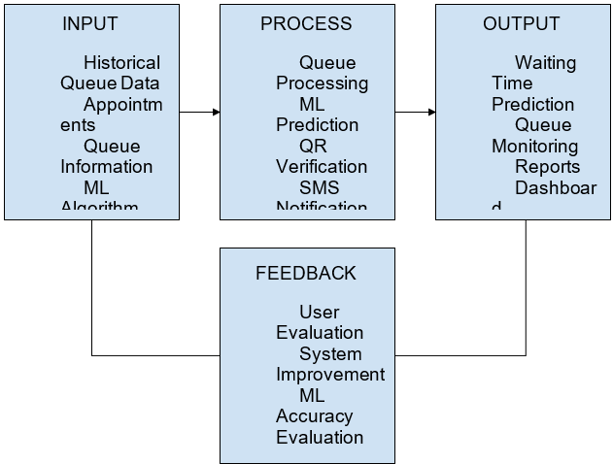
Figure 1: Input-Process-Output Model
- Significance of the Study
The study entitled “A Web-Based Smart Queue Management System with Machine Learning-Based Waiting Time Prediction Using Random Forest Algorithm” benefited the following:

Customers - The system helped customers estimate their waiting time more accurately, allowing them to manage their schedules efficiently. It also reduced uncertainty, long waiting periods, and overcrowding in service areas.

Establishments and Organizations - Organizations such as hospitals, banks, schools, government offices, and retail establishments benefited from improved queue management, better customer flow monitoring, and enhanced service efficiency. The analytics dashboard assisted administrators in making data-driven decisions.

Administrators and Staff - The system simplified queue monitoring and appointment management. Features such as QR code verification, SMS authentication, and automated voiding of inactive appointees reduced manual work and improved operational productivity.

Researchers - Future researchers used this study as a reference for developing intelligent queue management systems and applying machine learning algorithms in operational management and predictive analytics.

Information Technology Students - The study provided learning opportunities for students in the fields of web development, machine learning, predictive analytics, database management, and system integration.

Future Developers - The system served as a foundation for future enhancements such as mobile application integration, advanced machine learning models, and real-time queue optimization technologies.

- Operational Definition of Terms
The following terms are operationally defined as used in the study:

Analytics Dashboard - A graphical interface used by administrators to monitor queue statistics, customer flow, waiting times, and system performance.

Appointment Validation - The process of confirming customer appointments through QR codes and SMS authentication before queue processing.

Customer Flow - The movement and management of customers within the queueing system from registration to service completion.

Machine Learning - A branch of artificial intelligence that enables systems to learn from historical data and generate predictions or decisions without explicit programming.

Predictive Analytic - The use of historical and real-time data to forecast future outcomes, such as estimated waiting times in a queue management system.

QR Code Verification - A security and validation feature that uses QR codes to confirm customer identity and appointment authenticity.
Queue Ticket Generation - The process of automatically issuing digital queue numbers or tickets to customers. In this study, the system generates queue tickets with reference numbers and QR codes for queue tracking.

Queue Management System - A digital system designed to organize, monitor, and manage customer queues efficiently within service-oriented establishments.
Random Forest Algorithm - A machine learning algorithm that uses multiple decision trees to improve accuracy and reduce overfitting. In this study, the Random Forest Algorithm is used to analyze historical queue data and predict customer waiting time.
Real-Time Queue Monitoring - The process of continuously tracking and updating queue information as queue activities occur. In this study, users can monitor queue status and estimated waiting times in real time.

Service Duration - The amount of time required to serve a customer within the queue management system.

SMS Authentication - A security mechanism that sends verification codes or notifications to customers through SMS messaging services.

Waiting Time Prediction - The estimation of the time a customer must wait before receiving service, generated using machine learning algorithms and queue-related data.

Web-Based System - A software application accessible through web browsers using internet connectivity without requiring local installation.
CHAPTER II
REVIEW OF RELATED LITERATURE AND STUDIES
This chapter presented relevant literature and previous studies related to queue management systems, machine learning-based prediction, and intelligent service management technologies. It included both foreign and local studies that supported the development of the proposed smart queue management system. The reviewed materials provided insights into predictive analytics, waiting time estimation, customer service optimization, and web-based operational systems. These studies served as the foundation for understanding how the system aligned with existing technologies and addresses current limitations in traditional queue management systems.
- Foreign Literature
According to Kumar et al. (2022), intelligent queue management systems integrated with predictive analytics significantly improved operational efficiency and customer satisfaction in public service centers in Singapore. The study utilized machine learning techniques to analyze customer arrival rates and service durations in order to predict waiting times. Results showed that predictive queue systems reduced customer uncertainty and improved service flow. This study supports the proposed system by emphasizing the importance of machine learning-based waiting time prediction in enhancing queue management efficiency.
Lee and Park (2021) developed a web-based queue monitoring platform in South Korea that integrated real-time queue tracking and predictive waiting time estimation. The system utilized historical queue data to estimate waiting times and provide customers with real-time updates. Their findings showed improved customer satisfaction and reduced congestion in service facilities. The proposed system builds upon this concept by incorporating QR code verification, SMS authentication, and analytics dashboards.
Chen et al. (2020) conducted a study on AI-driven customer service systems in China, focusing on predictive queue analytics in banking institutions. The researchers found that predictive algorithms improved customer flow management and enabled better allocation of service resources. The study also emphasized the role of intelligent dashboards and real-time monitoring in improving operational decision-making. This supports the integration of analytics and machine learning features in the proposed system.
Smith and Johnson (2021) studied the implementation of intelligent queue systems in healthcare facilities in the United States. Their research showed that predictive queue management reduced patient waiting times and improved scheduling efficiency. The study highlighted the importance of integrating machine learning algorithms with web technologies to provide accurate waiting time predictions and improve healthcare service delivery.
Garcia et al. (2022) explored the application of artificial intelligence in customer service management systems in Spain. The researchers discovered that AI-powered queue systems improved customer engagement and minimized overcrowding in service centers. Their findings suggested that predictive analytics and real-time monitoring significantly improved operational efficiency and customer satisfaction.
Ahmed and Hassan (2020) conducted a study in the United Arab Emirates regarding digital queue systems integrated with QR code verification and SMS notification services. Their findings revealed that digital authentication improved queue security and reduced fraudulent transactions. The study supports the proposed system’s integration of QR code verification and SMS authentication for customer validation.
Wilson et al. (2021) examined the effectiveness of analytics dashboards in queue monitoring systems in Canada. The researchers found that graphical reports and real-time queue analytics helped administrators monitor service efficiency and make data-driven operational decisions. This study supports the analytics dashboard component of the proposed system.
- Foreign Studies
According to Kumar et al. (2022), intelligent queue management systems integrated with predictive analytics significantly improved operational efficiency and customer satisfaction in public service centers in Singapore. The study utilized machine learning techniques to analyze customer arrival rates and service durations in order to predict waiting times. Results showed that predictive queue systems reduced customer uncertainty and improved service flow. This study supports the proposed system by emphasizing the importance of machine learning-based waiting time prediction in enhancing queue management efficiency.
Lee and Park (2021) developed a web-based queue monitoring platform in South Korea that integrated real-time queue tracking and predictive waiting time estimation. The system utilized historical queue data to estimate waiting times and provide customers with real-time updates. Their findings showed improved customer satisfaction and reduced congestion in service facilities. The proposed system builds upon this concept by incorporating QR code verification, SMS authentication, and analytics dashboards.
Chen et al. (2020) conducted a study on AI-driven customer service systems in China, focusing on predictive queue analytics in banking institutions. The researchers found that predictive algorithms improved customer flow management and enabled better allocation of service resources. The study also emphasized the role of intelligent dashboards and real-time monitoring in improving operational decision-making. This supports the integration of analytics and machine learning features in the proposed system.
- Local Literature
According to Dela Cruz et al. (2022), many government offices in the Philippines still rely on manual queue systems, resulting in long waiting times and inefficient customer flow. Their study proposed a basic web-based queue management platform that improved service organization but lacked predictive capabilities. The findings highlighted the need for smarter queue systems capable of estimating waiting times and improving customer experience.
Rivera and Santos (2021) conducted a study on digital queue systems used in selected hospitals in Metro Manila. The researchers observed that although digital queue numbering systems reduced manual errors, customers still experienced uncertainty due to the absence of accurate waiting time estimates. The study recommended the integration of predictive technologies and real-time queue monitoring systems to improve service delivery.
Bautista et al. (2020) explored the use of web-based service management systems in local government units. Their findings indicated that customers preferred systems that provided transparency, queue visibility, and estimated waiting times. The study emphasized that integrating predictive analytics into service platforms could significantly improve operational efficiency and customer satisfaction. These findings support the development of the proposed machine learning-based queue management system.
Lopez and Ramirez (2021) conducted research on appointment management systems in private clinics in Quezon City. Their findings revealed that web-based appointment systems improved scheduling efficiency and reduced overcrowding. However, the researchers noted that the systems lacked intelligent waiting time prediction features. The proposed study addresses this limitation through the integration of random forest algorithm-based predictive analytics.
Santos et al. (2022) studied the effectiveness of QR code technology in customer verification systems in Philippine universities. The study found that QR code-based validation improved transaction speed, reduced manual verification errors, and enhanced security. This supports the implementation of QR code verification in the proposed queue management system.
Torres and Villanueva (2020) investigated the use of SMS notification systems in public service offices in Manila. The researchers discovered that SMS authentication and notifications improved communication between customers and service providers. Customers were able to receive updates regarding appointments and queue schedules, leading to better service experiences.
Reyes et al. (2021) explored the application of analytics dashboards in monitoring customer transactions in retail establishments. Their findings indicated that graphical analytics improved managerial decision-making and helped organizations identify operational bottlenecks. This study supports the integration of an analytics dashboard in the proposed system.
- Local Studies
According to Dela Cruz et al. (2022), many government offices in the Philippines still rely on manual queue systems, resulting in long waiting times and inefficient customer flow. Their study proposed a basic web-based queue management platform that improved service organization but lacked predictive capabilities. The findings highlighted the need for smarter queue systems capable of estimating waiting times and improving customer experience.
Rivera and Santos (2021) conducted a study on digital queue systems used in selected hospitals in Metro Manila. The researchers observed that although digital queue numbering systems reduced manual errors, customers still experienced uncertainty due to the absence of accurate waiting time estimates. The study recommended the integration of predictive technologies and real-time queue monitoring systems to improve service delivery.
Bautista et al. (2020) explored the use of web-based service management systems in local government units. Their findings indicated that customers preferred systems that provided transparency, queue visibility, and estimated waiting times. The study emphasized that integrating predictive analytics into service platforms could significantly improve operational efficiency and customer satisfaction. These findings support the development of the proposed machine learning-based queue management system.
- Synthesis
The reviewed foreign and local literature highlight the growing importance of intelligent queue management systems in improving operational efficiency, customer satisfaction, and service quality. Foreign literature emphasized the effectiveness of machine learning algorithms, predictive analytics, real-time monitoring, and intelligent dashboards in reducing waiting times and improving queue management processes. These studies demonstrated that predictive queue systems provide more accurate waiting time estimation and help organizations optimize customer flow and resource allocation.
Local literature revealed that many organizations in the Philippines still rely on traditional or basic digital queue systems that lack predictive capabilities. Although web-based queue platforms and digital numbering systems improved service organization and reduced manual errors, customers still experienced uncertainty due to inaccurate waiting time estimation. Local researchers recommended integrating predictive technologies, analytics dashboards, QR code verification, and SMS authentication to improve service delivery and customer convenience.
The reviewed literature supports the development of the proposed “Web-Based Smart Queue Management System with Machine Learning-Based Waiting Time Prediction Using Random Forest Algorithm.” Unlike previous systems that focused mainly on queue numbering and monitoring, the proposed study integrates machine learning-based waiting time prediction, QR code verification, SMS authentication, analytics dashboards, and automated appointment validation into a single platform. Through these features, the proposed system aims to improve operational efficiency, reduce customer waiting time uncertainty, enhance security, and provide data-driven insights for administrators.
Overall, the reviewed literature provides strong theoretical and practical foundations for the development of the proposed intelligent queue management system and confirms the relevance of integrating machine learning and web technologies in modern service-oriented environments.

CHAPTER III
METHODOLOGY
This chapter presented the research methods and design used in developing the Web-Based Smart Queue Management System. It explained how the system is planned, built, and evaluated — from identifying user needs to testing system performance. The methodology is designed to ensure that the system is practical, reliable, and directly responsive to the real challenges experienced in queue management settings.
- Research Design
This study used an Applied Research Design, which focused on creating a practical solution to a real-world problem. The main goal is to develop a web-based system that uses machine learning to predict waiting times and manage queues more efficiently in service-oriented environments such as clinics, government offices, banks, and similar establishments.
The research involved actual users and service staff as participants, selected through purposive sampling to ensure that only those who directly experience queue management challenges are included. This approach ensured that the system is built around actual needs rather than assumptions
- Data Collection
Data is collected through multiple approaches to ensure accuracy and completeness. Survey questionnaires are distributed to end-users and staff to identify common problems with existing queue systems, as well as expectations from a digital solution. Direct observation of actual queue processes in service environments is also conducted to understand the flow of people, peak hours, and bottlenecks.
System usage logs and queue transaction data are gathered to train and validate the machine learning model for waiting time prediction. Historical queue data such as arrival rates, service times, and queue lengths are used as inputs to the predictive model. Basic forecasting methods including trend analysis and regression modeling are applied to strengthen the system's prediction accuracy.
All ethical standards are observed throughout the research process, including obtaining informed consent from participants and ensuring data privacy in compliance with the Data Privacy Act of 2012 (Republic Act No. 10173).
- System Development Life Cycle
The development of the Smart Queue Management System followed a structured process known as the System Development Life Cycle (SDLC) - a framework that guides the planning, creation, testing, and deployment of a software system.
For this study, the Agile Model is selected as the most suitable SDLC approach. Unlike the traditional Waterfall model which follows a strict linear sequence, Agile allows the development team to work in short cycles called sprints, where features are built, tested, and improved continuously based on user feedback. This is especially fitting for a machine learning-based system where the prediction model needs to be regularly tested and refined as more data becomes available.
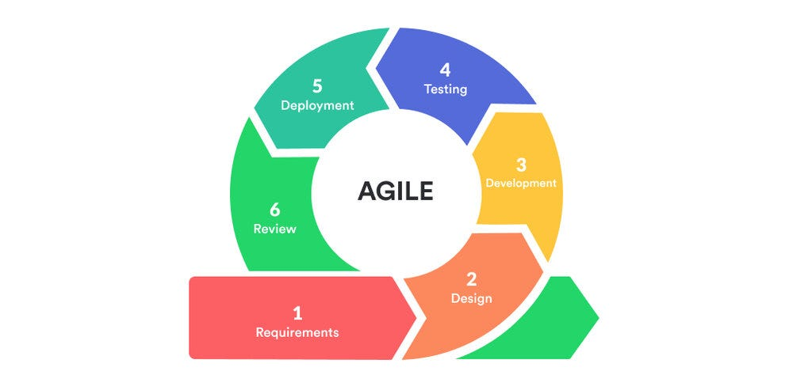
Figure 2: SLDC Agile Model

The Agile model is chosen because:
- The system's machine learning component requires repeated testing and tuning.
- User feedback from early prototypes can be incorporated quickly.
- Changes in requirements can be handled without disrupting the entire development process.
The following phases are carried out throughout development:
Planning — The team identified the core features of the system, including queue number generation, real-time waiting time prediction, service window management, and reporting. Goals, timelines, and resource needs were established at this stage.
Requirement Analysis — The researchers gathered and documented all functional and non-functional requirements of the system. This included understanding how users join a queue, how service windows operate, and what data is needed to train the machine learning model.
Requirement | Feature | Description
Requirement # 1 | Queue Registration | Clients can register and receive a queue number via the web.
Requirement # 2 | Waiting Time Prediction | ML model estimates how long a client will wait
Requirement # 3 | Real-Time Queue Display | Live queue status visible to clients and staff
Requirement # 4 | Queue Analytics | Dashboard showing daily queues
Requirement # 5 | Notification System | Alerts when a client's turn is near
Requirement # 6 | Queue History Logs | System records all transactions for review
Requirement # 7 | Service Window Management | Admin can manage and assign service windows
Table 1. Requirement Table
System Design — Detailed design specifications are created, including the system architecture, database structure, user interface layouts, and the machine learning pipeline for waiting time prediction.
Implementation (Sprints) — The system is developed in multiple sprints. Each sprint focused on a specific module such as user registration, queue number generation, the ML prediction engine, and the admin dashboard. Features are coded, reviewed, and refined within each cycle.
Testing — After each sprint, testing is conducted to check for bugs and ensure that all features worked correctly. Both functional testing (does each feature do what it's supposed to?) and user acceptance testing (is it easy and comfortable to use?) are performed.
Deployment — The completed system is set up and made accessible to users. Basic orientation is provided to both clients and staff to ensure smooth adoption.
Maintenance — Ongoing support is provided after deployment to fix issues, apply updates, and continuously improve the machine learning model's prediction accuracy as more queue data accumulates.
- Database Design
A well-structured database is essential to store, manage, and process all queue-related data accurately and efficiently. The database design for the Smart Queue Management System covered how data flows into, through, and out of the system — from the moment a client joins the queue to the generation of analytics reports.
- Context Diagram
The Context Diagram provided the highest-level view of the system. It showed the system as a single process and illustrated how it interacted with its external entities — the Client, the Service Staff, and the Administrator. Data flowed in and out of the system through these three actors.
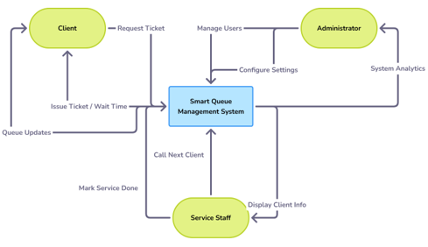
Figure 3: Context Diagram
- Data Flow Diagram
The DFD showed the break-down of the system into its major processes and showed how data flowed between them. It provided a more detailed view of internal operations, including queue registration, waiting time prediction, service management, and report generation.
(paste the illistration of a SIMPLE DFD)
Figure 4: Data Flow Diagram
<below is an example of a simple DFD>

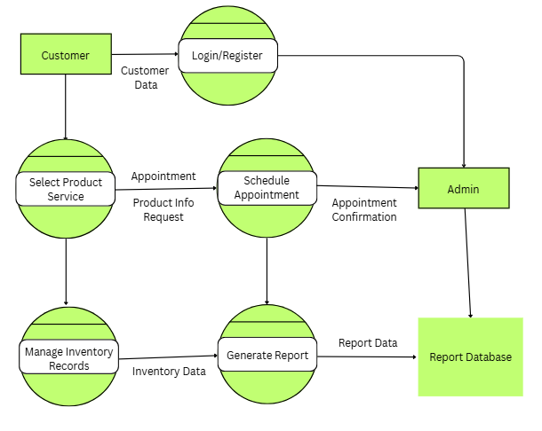
- Entity Relationship Diagram
A system's data structures are designed, documented, and analyzed using an Entity-Relationship Diagram (ERD), which is a conceptual and visual blueprint. It connects the dots between useful database design and theoretical research.
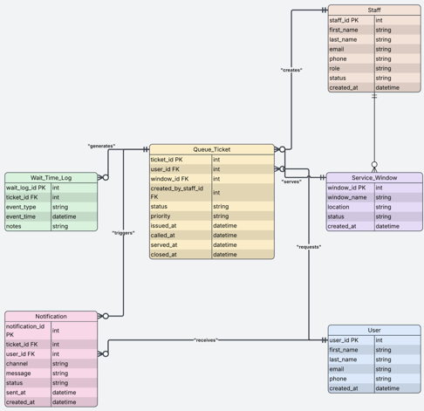
Figure 5: Entity Relationship Diagram

Entity Descriptions:

USER — Primary Key: user_id. Stores account information for all system users. A user can be a client, service staff, or administrator based on their assigned role.

STAFF — Primary Key: staff_id, Foreign Key: user_id. Contains employment and shift details for staff members. One staff member is linked to one user account and can manage one or more service windows.

SERVICE_WINDOW — Primary Key: window_id, Foreign Key: staff_id. Represents each active service counter or desk. One window can serve multiple queue tickets over time.

QUEUE_TICKET — Primary Key: ticket_id, Foreign Keys: user_id, window_id. The core entity of the system. Records each client's queue number, status, and timestamps from issuance to service completion.

WAIT_TIME_LOG — Primary Key: log_id, Foreign Key: ticket_id. Stores both the ML-predicted and actual waiting times for each ticket. This data is used to train and improve the prediction model over time.

NOTIFICATION — Primary Key: notif_id, Foreign Key: ticket_id. Records all alerts sent to clients, such as reminders when their turn is approaching.
- Use Case Diagram
The scope and functional requirements of a suggested system, piece of software, or technological solution are defined, clarified, and communicated through the use of a use case diagram. It emphasizes who will use the system and what they hope to accomplish with it.
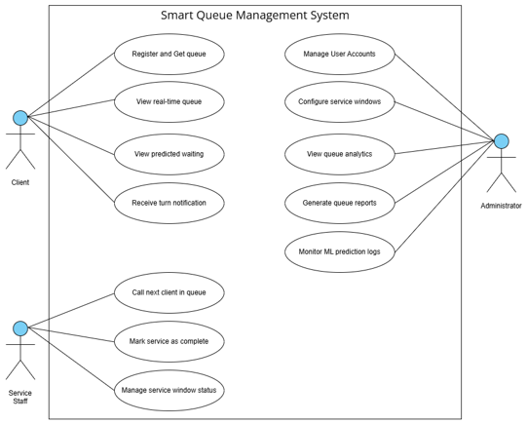
Figure 6: Use Case Diagram

Client Use Cases:

Register and receive a queue number through the web portal

View the real-time status of the queue

See their predicted waiting time generated by the ML model

Receive browser or SMS notifications when their turn is approaching

Service Staff Use Cases:

Call the next client in line from the queue display

Mark a service transaction as complete to update the queue

Open, close, or update the status of their assigned service window

Administrator Use Cases:

Manage user accounts for clients and staff

Configure and assign service windows

View queue analytics through the dashboard

Generate daily or weekly queue reports

Monitor machine learning prediction accuracy logs

Development Tools
The Smart Queue Management System is built using modern, widely used web technologies chosen for their reliability, compatibility, and suitability for machine learning integration.
Frontend: HTML, CSS, and JavaScript are used to create a clean, responsive user interface that works smoothly on both desktop and mobile browsers. The interface allows clients to join queues and track their status in real time.
Backend: PHP is used to handle server-side operations such as user authentication, queue processing, and database communication. PHP is well-suited for web-based systems and pairs naturally with MySQL.
Database: MySQL served as the primary database for storing user accounts, queue tickets, service window data, waiting time logs, and system notifications.
Machine Learning: Python is used to develop and train the waiting time prediction model. Libraries such as scikit-learn (for regression and model training), pandas (for data processing), and Flask (to expose the ML model as an API endpoint) are used. The PHP backend communicates with the Python-Flask ML service to retrieve predictions in real time.
Development Environment: Visual Studio Code is used as the primary code editor. XAMPP is used for local server hosting and testing during development.
This combination of technologies ensures a stable, scalable, and intelligent system that can grow as more queue data becomes available to improve prediction accuracy.
- Evaluation Procedure
The system is evaluated using ISO 25010 that provides a standard for assessing the web-system’s quality based on the following criteria:

Functional Sustainability – (define according to your system.)

Reliability - (define according to your system.)

Usability - (define according to your system.)
Performance Efficiency - (define according to your system.)
Security – (define according to your system.)
Maintainability - (define according to your system.)
- Evaluation Tool

The primary research instrument for this study is an evaluation questionnaire using the ISO 25010 software quality standards.
Shown below is the ISO 25010 evaluation form:
Legend: 4- Strongly Agree 3 – Agree 2 – Disagree 1 – Strongly Disagree
CRITERIA | SA | A | DA | SDA
1. Functionality | 4 | 3 | 2 | 1
1.1 The system correctly generates queue tickets and manages the order of clients according to the established queue rules.
1.2 The system correctly displays real-time queue information and generates the required waiting time predictions, notifications, and reports.
2. Reliability | 4 | 3 | 2 | 1
2.1 (what item in Reliability you want evaluated?)
2.2 (what item in Reliability you want evaluated?)
3. Efficiency | 4 | 3 | 2 | 1
3.1 (what item in Efficiency you want evaluated?)
3.2 (what item in Efficiency you want evaluated?)
4. Usability | 4 | 3 | 2 | 1
4.1 The system is easy to learn and use for clients, service staff, and administrators without requiring advanced technical knowledge.
4.2 The system presents buttons, forms, messages, queue information, and navigation clearly across desktop and mobile screen sizes.
- Security | 4 | 3 | 2 | 1
5.1 The system allows users to access only the pages, information, and actions authorized for their assigned roles.
5.2 The system protects personal information against unauthorized viewing, alteration, disclosure or deletion.
- Maintainability | 4 | 3 | 2 | 1
6.1 (what item in Maintainability you want evaluated?)
6.2 (what item in Maintainability you want evaluated?)
Table 1: The ISO 25010 Evaluation Form
- Respondents of the Study
The study involved two groups of respondents: (a) user respondents and (b) technical experts.
(a) End-Users – They are composed of 40 individuals. They include walk-in clients, or customers who regularly experience waiting in queues, as well as frontline staff such as receptionists, tellers, or service agents who manage and assist queues on a daily basis. They are qualified as user respondents because they represent the primary audience of the system and can provide meaningful feedback on ease of use, clarity of features, and overall satisfaction from a practical standpoint.
(b) Technical Experts - They are composed of 10 individuals. They consist of IT professionals, software developers, and system analysts with expertise in web development, database management, machine learning, and software quality assurance. They are qualified as technical respondents due to their background in software engineering and system evaluation, enabling them to assess the system in terms of technical performance, security, reliability, and adherence to quality standards.
A total of 50 respondents participated in the evaluation phase of this study.
- Statistical Tools
The following statistical tools are used in the study:
- Frequency Distribution (Relative Frequency)
The standard frequency is the raw count (f) of how often a value occurs, and the relative frequency shows the proportion of the total data set that the value represents.
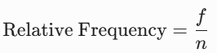
Where:
f = The frequency of an individual score or category
n = The total number of scores or the total sample size (sum f)

- Percentage Distribution
The percentage distribution converts the relative frequency into a percentage, making it easier to compare categories regardless of the total sample size. The formula is shown below:
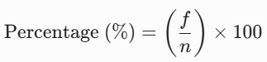
Where:
P = Percentage
f = Frequency of responses
n = Total number of respondents

Weighted Mean

A weighted average, also known as a weighted mean, is a computation that takes into account the differing reliability, frequency, or significance of several data points in a study.

A weighted mean gives some values more "say" according to predetermined criteria, in contrast to a simple average where all numbers have the same weight. The formula is shown below:
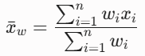
Where:
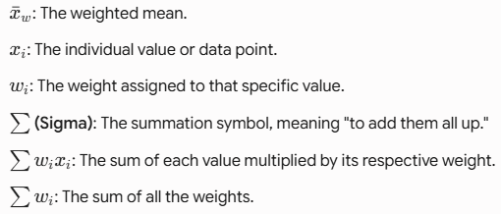

- Likert Scale
The Likert scale is a widely used tool in quantitative research and evaluation for measuring individuals’ attitudes, opinions, or perceptions. It consists of a series of statements or questions to which respondents indicate their level of agreement. Each response is assigned a numerical value, enabling statistical analysis of the results. For this study, a 4-point Likert Scale is employed, with values ranging from 4 (“Strongly Agree”) to 1 (“Strongly Disagree”). The corresponding scale is presented in the table below:
Weighted Point | Scale | Difference | Verbal Interpretation
4 | 3.01-4.00 | 0.99 | Strongly Agree
3 | 2.01-3.00 | 0.99 | Agree
2 | 1.01-2.00 | 0.99 | Disagree
1 | 0.99-1.00 | 0.01 | Strongly Disagree
Table 2: The 4-Point Likert Scale

