Superset ID: 6373431

COGNIZANT DIGITAL NURTURE 4.0 JAVA FSE

WEEK-2

PLSQL_EXERCISES

**Exercise 1: Control Structures**

**Scenario 1:** The bank wants to apply a discount to loan interest rates for customers above 60 years old.

**Question:** Write a PL/SQL block that loops through all customers, checks their age, and if they are above 60, apply a 1% discount to their current loan interest rates.

**Scenario 2:** A customer can be promoted to VIP status based on their balance.

**Question:** Write a PL/SQL block that iterates through all customers and sets a flag IsVIP to TRUE for those with a balance over $10,000.

**Scenario 3:** The bank wants to send reminders to customers whose loans are due within the next 30 days.

**Question:** Write a PL/SQL block that fetches all loans due in the next 30 days and prints a reminder message for each customer.

CODE

TABLES CREATION AND VALUES INSERTION

*CREATE TABLE Customers (*

*CustomerID NUMBER PRIMARY KEY,*

*Name VARCHAR2(100),*

*DOB DATE,*

*Balance NUMBER,*

*LastModified DATE*

*);*

*CREATE TABLE Loans (*

*LoanID NUMBER PRIMARY KEY,*

*CustomerID NUMBER,*

*LoanAmount NUMBER,*

*InterestRate NUMBER,*

*StartDate DATE,*

*EndDate DATE,*

*FOREIGN KEY (CustomerID) REFERENCES Customers(CustomerID)*

*);*

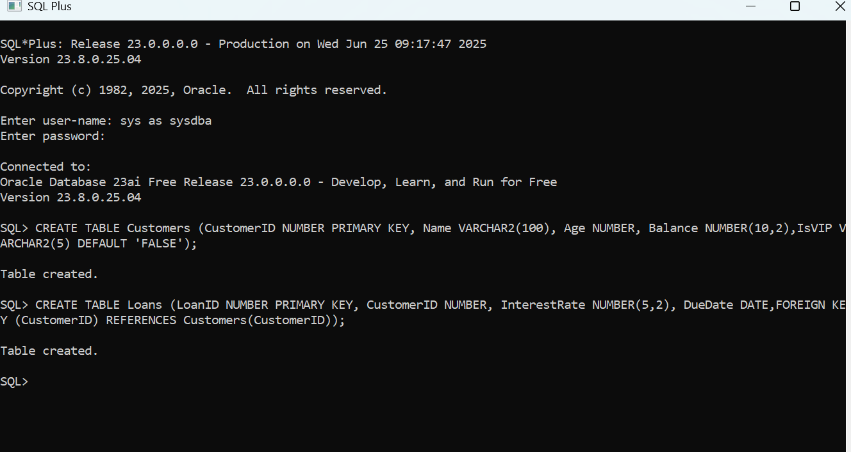

**SCENARIO 1**

*BEGIN*

*FOR cust_rec IN (*

*SELECT c.CustomerID, l.LoanID, l.InterestRate,*

*FLOOR(MONTHS_BETWEEN(SYSDATE, c.DOB)/12) AS Age*

*FROM Customers c*

*JOIN Loans l ON c.CustomerID = l.CustomerID*

*)*

*LOOP*

*IF cust_rec.Age > 60 THEN*

*UPDATE Loans*

*SET InterestRate = InterestRate - 1*

*WHERE LoanID = cust_rec.LoanID;*

*END IF;*

*END LOOP;*

*COMMIT;*

*END;*

*/*

OUTPUT

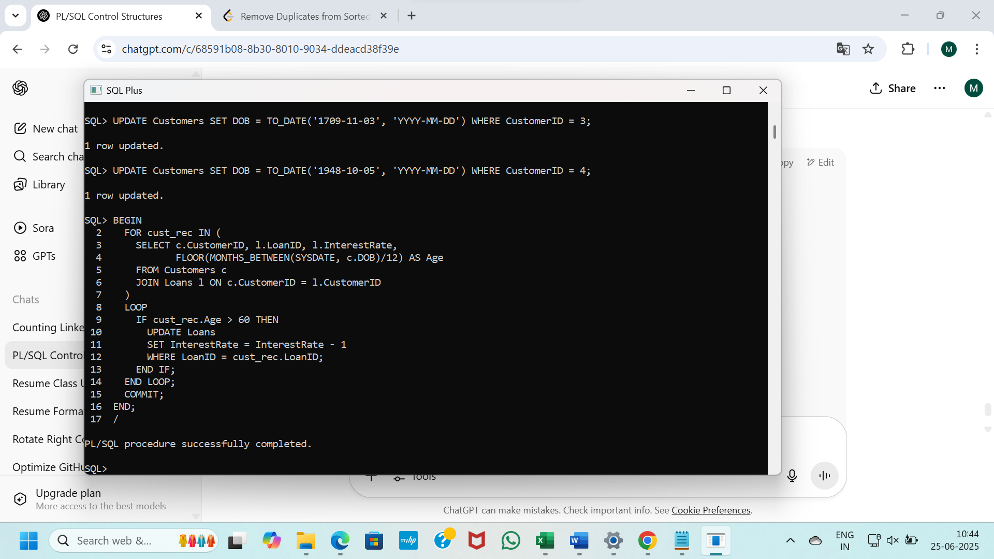

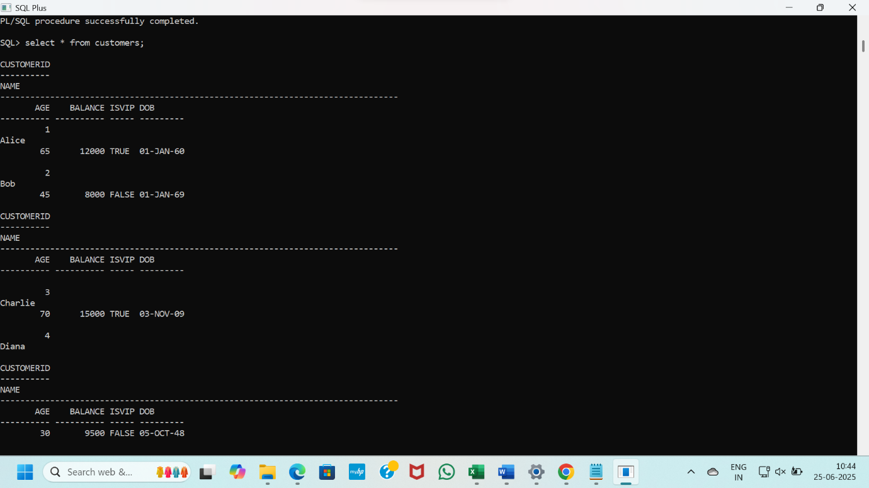

**SCENARIO 2**

*BEGIN*

*FOR cust_rec IN (SELECT CustomerID, Balance FROM Customers)*

*LOOP*

*IF cust_rec.Balance > 10000 THEN*

*UPDATE Customers*

*SET IsVIP = 'TRUE'*

*WHERE CustomerID = cust_rec.CustomerID;*

*END IF;*

*END LOOP;*

*COMMIT;*

*END;*

*/*

OUTPUT

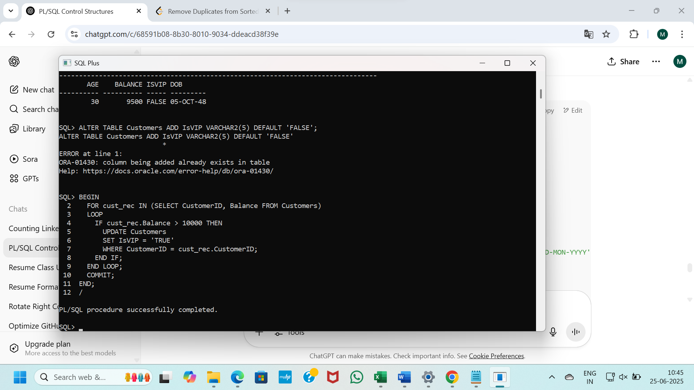

**SCENARIO 3**

*BEGIN*

*FOR loan_rec IN (*

*SELECT LoanID, CustomerID, EndDate*

*FROM Loans*

*WHERE EndDate BETWEEN SYSDATE AND SYSDATE + 30*

*)*

*LOOP*

*DBMS_OUTPUT.PUT_LINE('Reminder: Loan ID ' || loan_rec.LoanID ||*

*' for Customer ID ' || loan_rec.CustomerID ||*

*' is due on ' || TO_CHAR(loan_rec.EndDate, 'DD-MON-YYYY'));*

*END LOOP;*

*END;*

*/*

OUTPUT

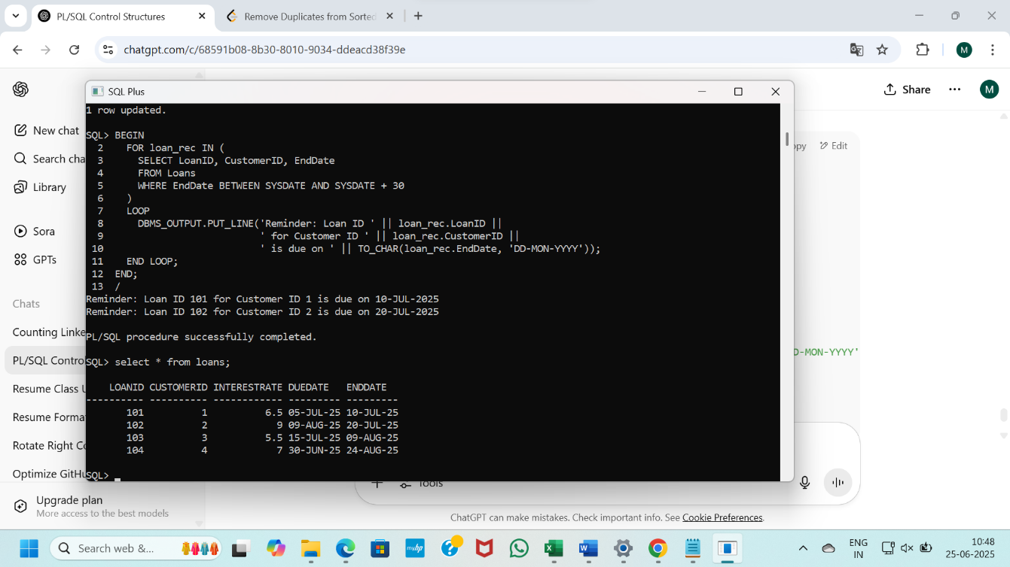

**Exercise 3: Stored Procedures**

**Scenario 1:** The bank needs to process monthly interest for all savings accounts.

* + **Question:** Write a stored procedure **ProcessMonthlyInterest** that calculates and updates the balance of all savings accounts by applying an interest rate of 1% to the current balance.

**Scenario 2:** The bank wants to implement a bonus scheme for employees based on their performance.

* + **Question:** Write a stored procedure **UpdateEmployeeBonus** that updates the salary of employees in a given department by adding a bonus percentage passed as a parameter.

**Scenario 3:** Customers should be able to transfer funds between their accounts.

* + **Question:** Write a stored procedure **TransferFunds** that transfers a specified amount from one account to another, checking that the source account has sufficient balance before making the transfer.

CODE

*CREATE TABLE Employees (*

*EmployeeID NUMBER PRIMARY KEY,*

*Name VARCHAR2(100),*

*Position VARCHAR2(50),*

*Salary NUMBER,*

*Department VARCHAR2(50),*

*HireDate DATE*

*);*

*CREATE TABLE Accounts (*

*AccountID NUMBER PRIMARY KEY,*

*CustomerID NUMBER,*

*AccountType VARCHAR2(20),*

*Balance NUMBER,*

*LastModified DATE,*

*FOREIGN KEY (CustomerID) REFERENCES Customers(CustomerID)*

*);*

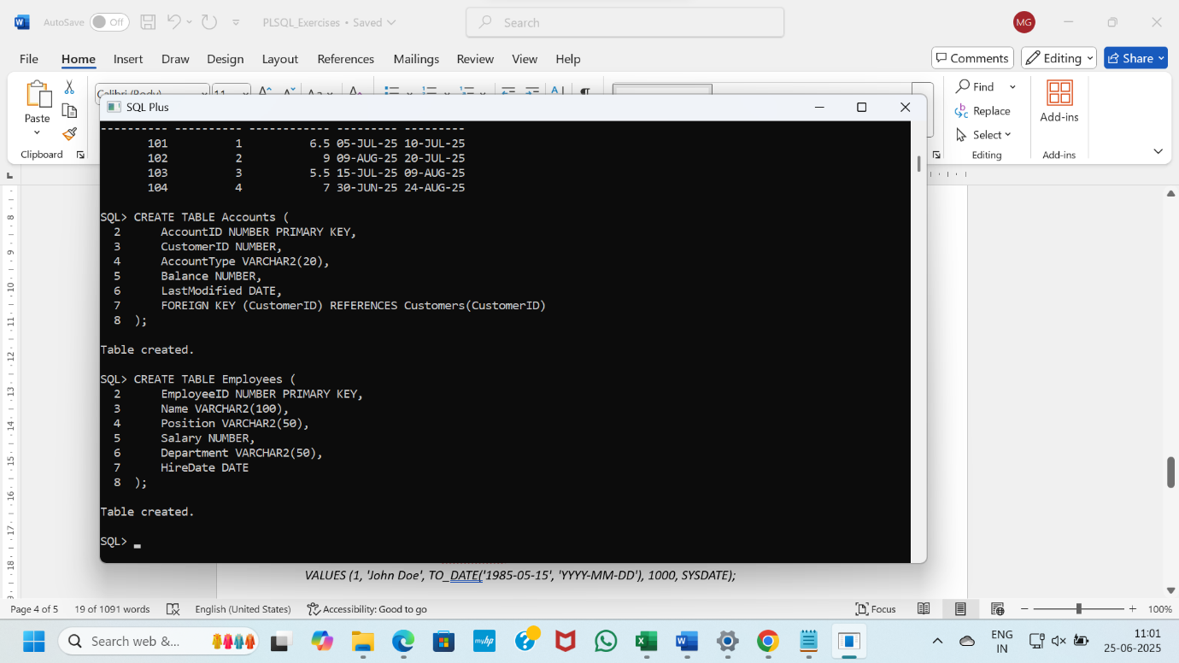

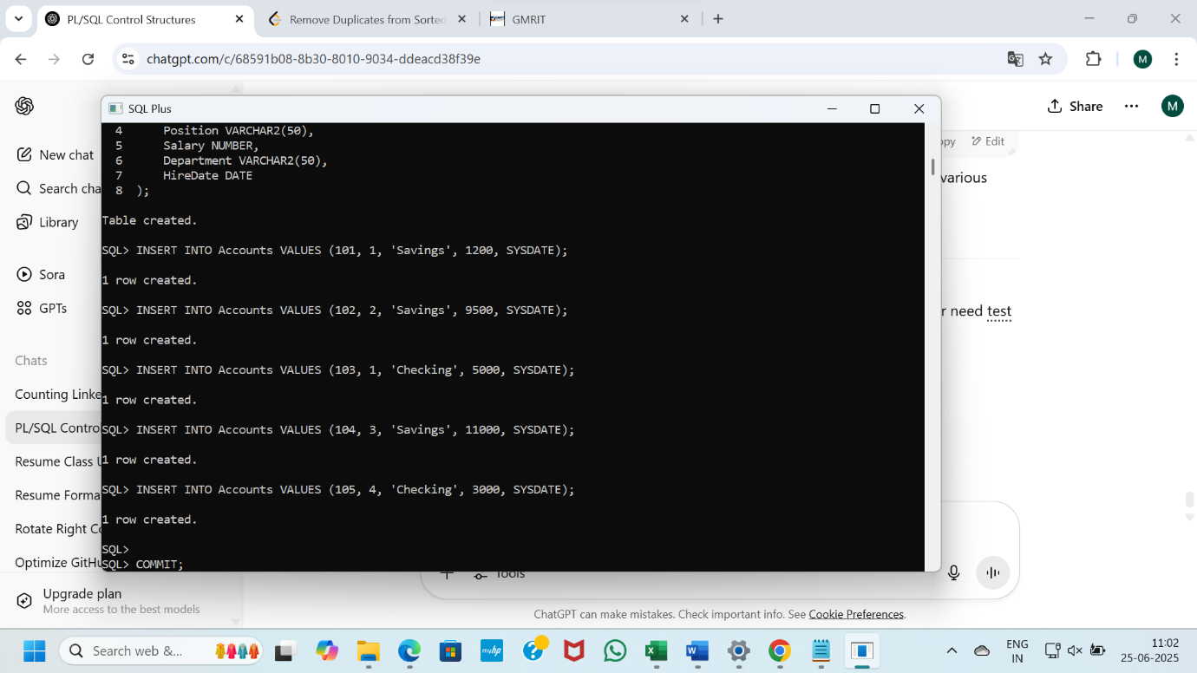

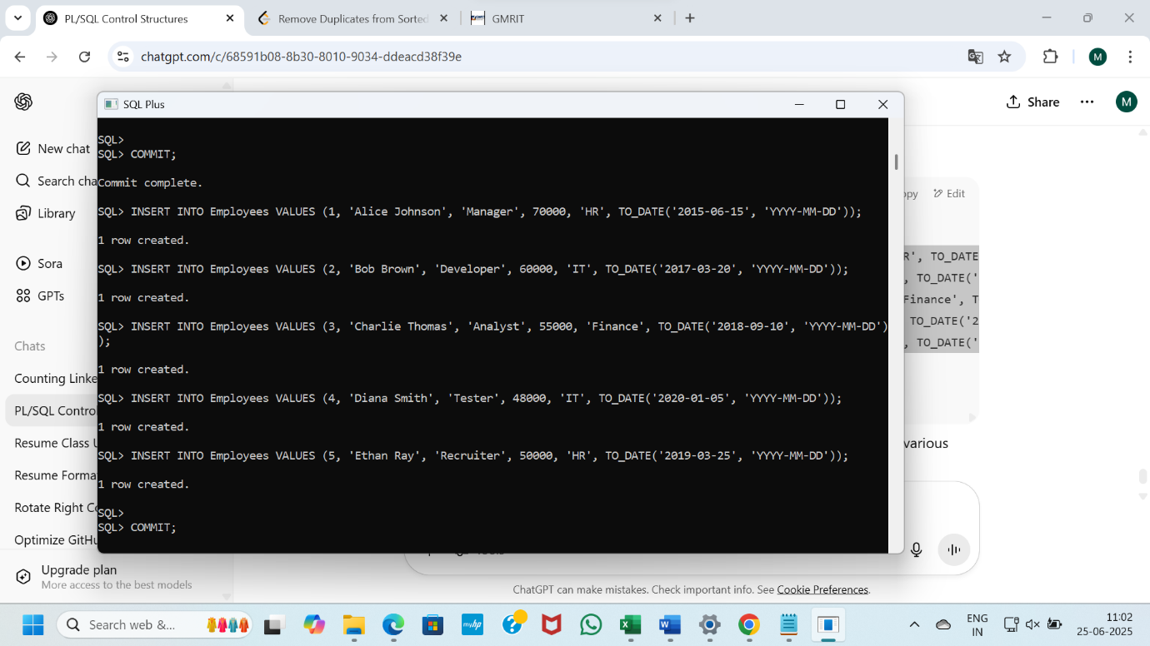

**SCENARIO 1**

CREATE OR REPLACE PROCEDURE ProcessMonthlyInterest IS

BEGIN

FOR acc IN (

SELECT AccountID, Balance

FROM Accounts

WHERE AccountType = 'Savings'

)

LOOP

UPDATE Accounts

SET Balance = Balance + (acc.Balance * 0.01),

LastModified = SYSDATE

WHERE AccountID = acc.AccountID;

END LOOP;

COMMIT;

END;

/

BEGIN

ProcessMonthlyInterest;

END;

/

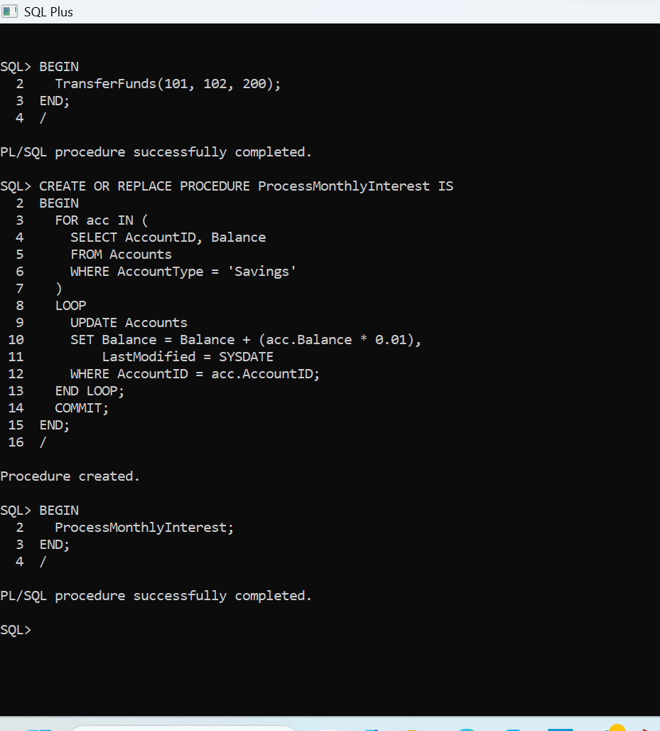

**SCENARIO 2**

CREATE OR REPLACE PROCEDURE UpdateEmployeeBonus (

dept_name IN VARCHAR2,

bonus_percent IN NUMBER

) IS

BEGIN

UPDATE Employees

SET Salary = Salary + (Salary * (bonus_percent / 100))

WHERE Department = dept_name;

COMMIT;

END;

/

BEGIN

UpdateEmployeeBonus('IT', 10);

END;

/

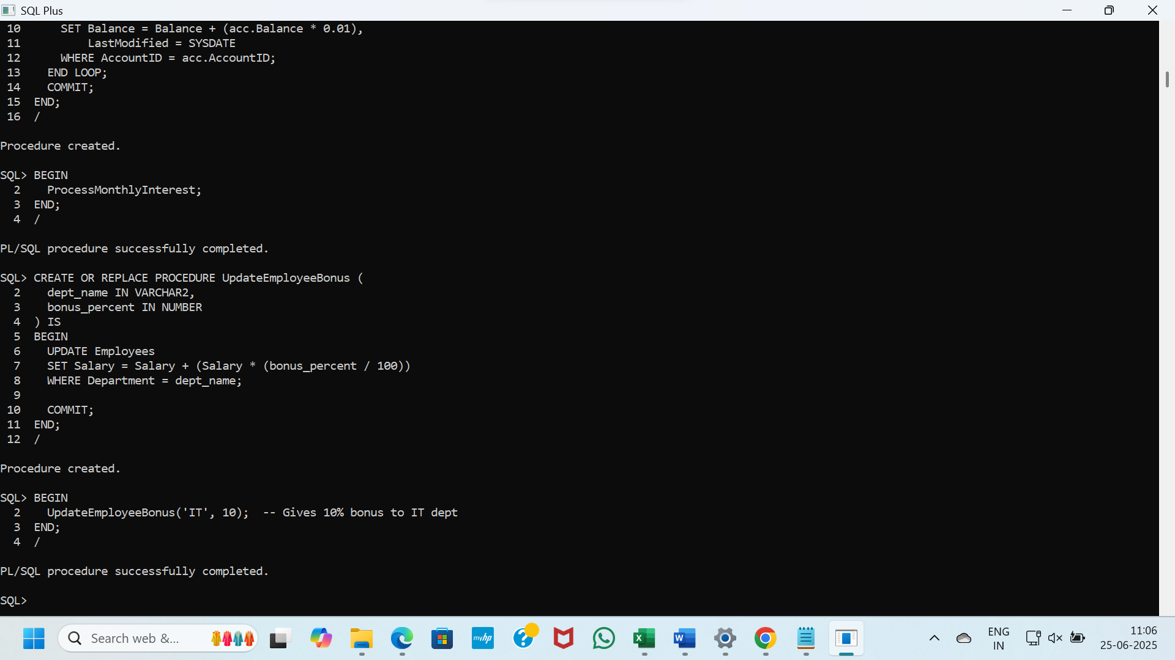

**SCENARIO 3**

CREATE OR REPLACE PROCEDURE TransferFunds (

from_account IN NUMBER,

to_account IN NUMBER,

amount IN NUMBER

) IS

source_balance NUMBER;

BEGIN

SELECT Balance INTO source_balance

FROM Accounts

WHERE AccountID = from_account

FOR UPDATE;

IF source_balance < amount THEN

RAISE_APPLICATION_ERROR(-20001, 'Insufficient balance.');

END IF;

UPDATE Accounts

SET Balance = Balance - amount,

LastModified = SYSDATE

WHERE AccountID = from_account;

UPDATE Accounts

SET Balance = Balance + amount,

LastModified = SYSDATE

WHERE AccountID = to_account;

COMMIT;

END;

/

BEGIN

TransferFunds(1, 2, 200);

END;

/

OUTPUT

