LAB 1: Display Density Metrics & Image Array Mechanics in NumPy
Human-Computer Interaction (HCI) & Computer Graphics (CG)
Muhammad Zunair • 2k24/CSE/109

Task 1 — Display Pixel Density (PPI/DPI) Calculator
This script prompts the user for horizontal/vertical resolution and physical diagonal size, then computes total pixel count, simplified aspect ratio (via GCD), DPI, and a density classification.

Source Code
"""
Task 1: Display Pixel Density (PPI/DPI) Calculator
----------------------------------------------------
Prompts the user for a screen's horizontal/vertical resolution and its
physical diagonal size, then computes:
- Total pixel count
- Simplified aspect ratio (using GCD)
- DPI / PPI
- Density classification
"""

import math

def calculate_display_metrics(w_px: int, h_px: int, d_inches: float) -> dict:
"""Compute total pixels, aspect ratio, DPI, and density category."""
total_pixels = w_px * h_px

# Simplify aspect ratio using the greatest common divisor
divisor = math.gcd(w_px, h_px)
aspect_ratio = f"{w_px // divisor}:{h_px // divisor}"

# Diagonal pixel count (Pythagorean theorem) and DPI/PPI
diagonal_px = math.sqrt(w_px ** 2 + h_px ** 2)
dpi = diagonal_px / d_inches

# Density classification
if dpi < 100:
category = "Low Density (Standard Monitor)"
elif dpi <= 200:
category = "Medium Density (HD Display)"
else:
category = "High Density (Retina / Mobile)"

return {
"total_pixels": total_pixels,
"aspect_ratio": aspect_ratio,
"dpi": round(dpi, 2),
"category": category,
}

def main():
print("--- DISPLAY METRICS CALCULATOR ---")
w_px = int(input("Enter horizontal resolution (pixels): "))
h_px = int(input("Enter vertical resolution (pixels): "))
d_inches = float(input("Enter physical diagonal size (inches): "))

metrics = calculate_display_metrics(w_px, h_px, d_inches)

print("\n--- DISPLAY METRICS ANALYSIS ---")
print(f"Total Pixel Count : {metrics['total_pixels']:,} pixels")
print(f"Aspect Ratio : {metrics['aspect_ratio']}")
print(f"Calculated DPI : {metrics['dpi']} DPI")
print(f"Density Category : {metrics['category']}")

if __name__ == "__main__":
main()

Output — Desktop Monitor (1920×1080, 24")
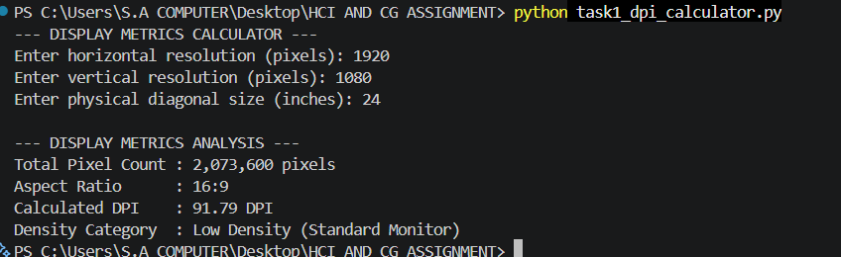

Output — Smartphone (1170×2532, 6.1")
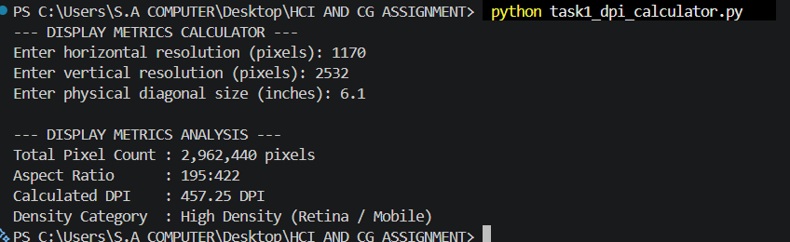

Task 2 — Synthetic Image Matrix Creation
Builds a 300×400×3 uint8 array of zeros and fills each quadrant with a solid color using NumPy slicing, then reports the array's shape, dtype, size, and memory footprint.

Source Code
"""
Task 2: Environment Setup & Synthetic Image Matrix Creation
-------------------------------------------------------------
Builds a 300x400x3 uint8 image array from scratch and fills each
quadrant with a solid color using array slicing.
"""

import numpy as np

def build_quadrant_image(height: int = 300, width: int = 400) -> np.ndarray:
"""Create an (H, W, 3) uint8 array with 4 solid-color quadrants."""
img = np.zeros((height, width, 3), dtype=np.uint8)

mid_h, mid_w = height // 2, width // 2

img[0:mid_h, 0:mid_w] = [255, 0, 0] # Top-Left: Red
img[0:mid_h, mid_w:width] = [0, 255, 0] # Top-Right: Green
img[mid_h:height, 0:mid_w] = [0, 0, 255] # Bottom-Left: Blue
img[mid_h:height, mid_w:width] = [255, 255, 255] # Bottom-Right: White

return img

def main():
img = build_quadrant_image()

print("--- SYNTHETIC MATRIX METRICS ---")
print(f"Array Shape (H, W, C) : {img.shape}")
print(f"Data Type : {img.dtype}")
print(f"Total Elements : {img.size:,} values")
print(f"Memory Footprint : {img.nbytes:,} bytes ({img.nbytes / 1024:.2f} KB)")

# Save a visual so you can screenshot/include it in your report
from PIL import Image
Image.fromarray(img).save("synthetic_quadrants.png")
print("\nSaved visual output to synthetic_quadrants.png")

if __name__ == "__main__":
main()

Terminal Output
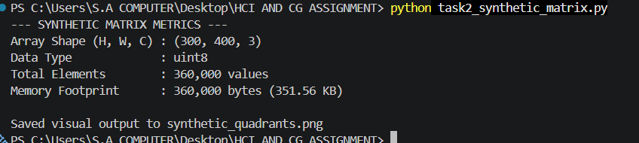

Generated Image
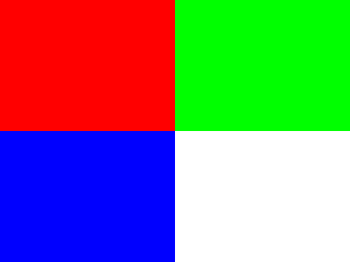
Figure: 300×400 quadrant image (Red / Green / Blue / White)

Task 3 — Channel Slicing & Isolation
Loads an image, extracts the R/G/B 2D intensity grids via Axis-2 slicing, builds single-channel color views, and displays a 2×3 matplotlib grid of colored and grayscale channel views.

Source Code
"""
Task 3: Channel Slicing & Isolation
--------------------------------------
Loads sample.jpg, extracts the R/G/B channels via Axis-2 slicing, builds
single-channel color views, and displays a 2x3 matplotlib grid:
Top row -> Red-only, Green-only, Blue-only color images
Bottom row -> Grayscale intensity maps for each channel
"""

import numpy as np
import matplotlib.pyplot as plt
from PIL import Image

def load_image_array(path: str) -> np.ndarray:
"""Load an image file into an (H, W, 3) uint8 NumPy array."""
return np.array(Image.open(path).convert("RGB"))

def extract_channels(img: np.ndarray):
"""Return the 2D R, G, B intensity grids using Axis-2 slicing."""
red_channel = img[:, :, 0]
green_channel = img[:, :, 1]
blue_channel = img[:, :, 2]
return red_channel, green_channel, blue_channel

def build_isolated_color(img: np.ndarray, channel_index: int) -> np.ndarray:
"""Return a 3-channel image with only `channel_index` active."""
isolated = np.zeros_like(img)
isolated[:, :, channel_index] = img[:, :, channel_index]
return isolated

def main():
img = load_image_array("sample.jpg")
red, green, blue = extract_channels(img)

red_only = build_isolated_color(img, 0)
green_only = build_isolated_color(img, 1)
blue_only = build_isolated_color(img, 2)

print("--- CHANNEL EXTRACTION SUMMARY ---")
print(f"Original Image Shape : {img.shape}")
print(f"Red Channel 2D Shape : {red.shape} | Mean Intensity: {red.mean():.2f}")
print(f"Green Channel 2D Shape: {green.shape} | Mean Intensity: {green.mean():.2f}")
print(f"Blue Channel 2D Shape : {blue.shape} | Mean Intensity: {blue.mean():.2f}")

fig, axes = plt.subplots(2, 3, figsize=(12, 7))

axes[0, 0].imshow(red_only); axes[0, 0].set_title("Red-Only"); axes[0, 0].axis("off")
axes[0, 1].imshow(green_only); axes[0, 1].set_title("Green-Only"); axes[0, 1].axis("off")
axes[0, 2].imshow(blue_only); axes[0, 2].set_title("Blue-Only"); axes[0, 2].axis("off")

axes[1, 0].imshow(red, cmap="gray"); axes[1, 0].set_title("Red Intensity"); axes[1, 0].axis("off")
axes[1, 1].imshow(green, cmap="gray"); axes[1, 1].set_title("Green Intensity"); axes[1, 1].axis("off")
axes[1, 2].imshow(blue, cmap="gray"); axes[1, 2].set_title("Blue Intensity"); axes[1, 2].axis("off")

plt.tight_layout()
plt.savefig("task3_channel_grid.png", dpi=150)
print("\nSaved figure to task3_channel_grid.png")
print("Display Window : Matplotlib 2x3 Subplot Grid Rendered.")

if __name__ == "__main__":
main()

Terminal Output
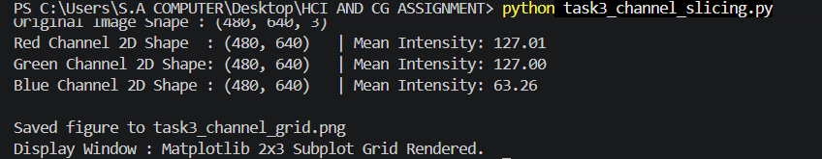

Matplotlib Figure
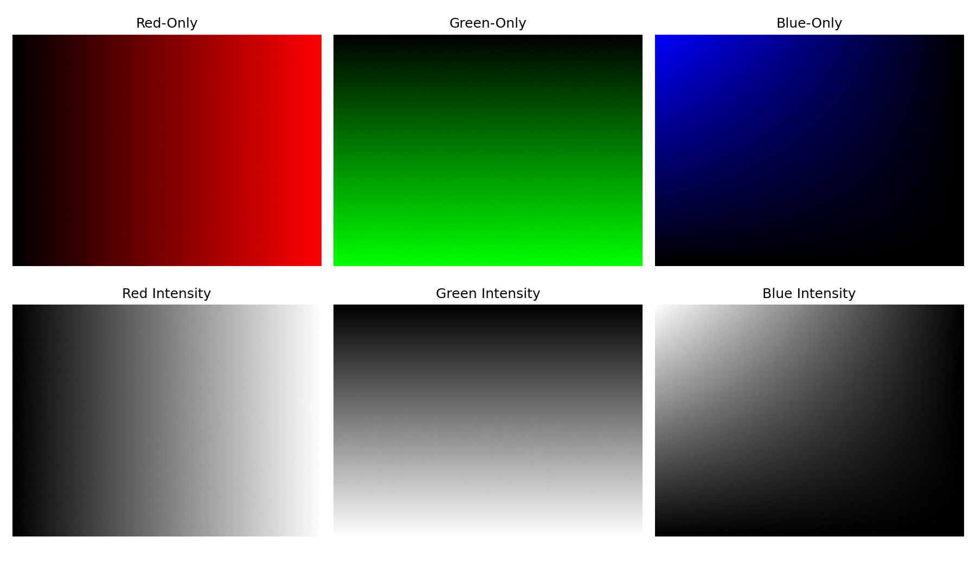
Figure: Top row = isolated color channels, bottom row = grayscale intensity maps

Task 4 — Spatial Downsampling & Pixelation via Striding
Downsamples the image by keeping every 8th pixel along rows/columns (NumPy striding), re-expands it with np.repeat() to visualize the pixelation, and reports the resulting dimension and memory savings.

Source Code
"""
Task 4: Spatial Downsampling & Pixelation via Striding
----------------------------------------------------------
Downsamples an image by taking every N-th pixel (striding), then
re-expands it back to the original size with np.repeat() to visualize
the resulting pixelation, and reports the size/memory savings.
"""

import numpy as np
import matplotlib.pyplot as plt
from PIL import Image

N = 8 # step factor

def load_image_array(path: str) -> np.ndarray:
return np.array(Image.open(path).convert("RGB"))

def downsample(img: np.ndarray, step: int) -> np.ndarray:
"""Keep every `step`-th pixel along rows and columns."""
return img[::step, ::step, :]

def re_expand(small_img: np.ndarray, step: int) -> np.ndarray:
"""Blow the downsampled array back up using np.repeat on axes 0 and 1."""
expanded = np.repeat(small_img, step, axis=0)
expanded = np.repeat(expanded, step, axis=1)
return expanded

def main():
img = load_image_array("sample.jpg")
small = downsample(img, N)
expanded = re_expand(small, N)

dim_reduction = (1 - 1 / N) * 100 # reduction per axis (row count and column count each shrink by factor N)
mem_savings = (1 - small.nbytes / img.nbytes) * 100

print(f"--- DOWNSAMPLING ANALYSIS (N = {N}) ---")
print(f"Original Shape : {img.shape} | Memory: {img.nbytes:,} bytes")
print(f"Downsampled Shape : {small.shape} | Memory: {small.nbytes:,} bytes")
print(f"Re-expanded Shape : {expanded.shape} | Visual: Blocky Pixelation")
print(f"Dimension Reduction: {dim_reduction:.2f}% reduction per axis")
print(f"Memory Savings : {mem_savings:.2f}% data reduction")

fig, axes = plt.subplots(1, 2, figsize=(10, 5))
axes[0].imshow(img); axes[0].set_title("Original"); axes[0].axis("off")
axes[1].imshow(expanded[: img.shape[0], : img.shape[1]])
axes[1].set_title(f"Re-expanded (N={N}) — Pixelated")
axes[1].axis("off")
plt.tight_layout()
plt.savefig("task4_downsampling.png", dpi=150)
print("\nSaved figure to task4_downsampling.png")

if __name__ == "__main__":
main()

Matplotlib Figure & Analysis
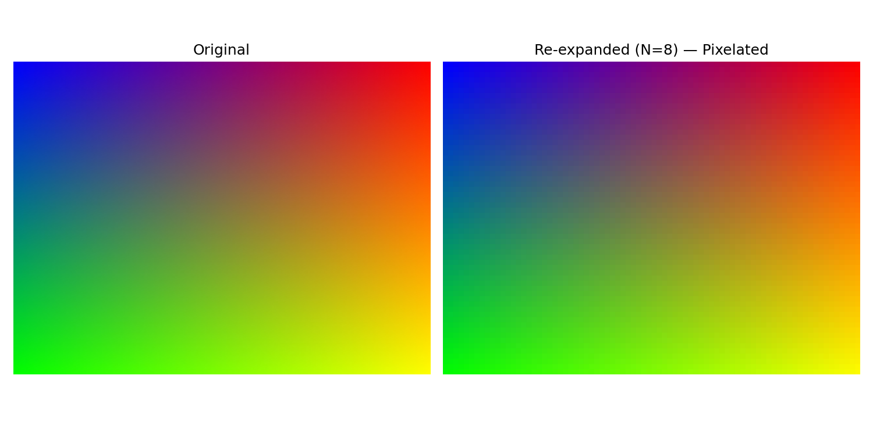
Figure: Original vs. re-expanded (N=8) pixelated image
Original Shape: (480, 640, 3) | Memory: 921,600 bytes
Downsampled Shape: (60, 80, 3) | Memory: 14,400 bytes
Dimension Reduction: 87.50% per axis | Memory Savings: 98.44%

Short Answer
Why does adding an Alpha channel (RGBA) increase an image array's memory consumption by 33% compared to standard RGB?
An RGB image stores 3 channels per pixel (Red, Green, Blue), while RGBA adds a 4th channel (Alpha, for transparency). Since each channel is typically stored as one byte (uint8) per pixel, memory usage scales directly with channel count: RGB uses 3 bytes/pixel and RGBA uses 4 bytes/pixel. The increase from 3 to 4 channels is a jump of 1 extra channel out of the original 3, i.e. 1/3 ≈ 33% more memory, even though the actual image resolution (H × W) hasn't changed at all.

