|  |  |  |
| --- | --- | --- |
| Time for 1000 request with 3 file | | |
|  | Apache2 | Nginx |
| index.html | 6.672s | 6.526s |
| index.php | 8.921s | 8.896s |
| io.php | 7.177s | 7.150s |

|  |  |  |
| --- | --- | --- |
| Request/second | | |
|  | Apache2 | Nginx |
| index.html | 149.88 | 153.23 |
| index.php | 112.10 | 112.41 |
| io.php | 139.33 | 139.86 |

Here is the screentshot for the test:

Index.html for Apache(first) and Nginx(second)

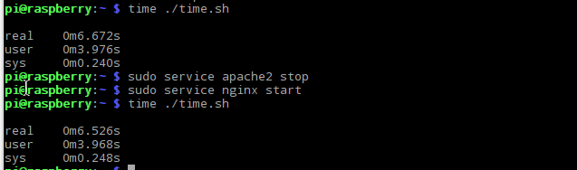

Index.php( just call phpinfo()) for Apache(first) and Nginx(second)

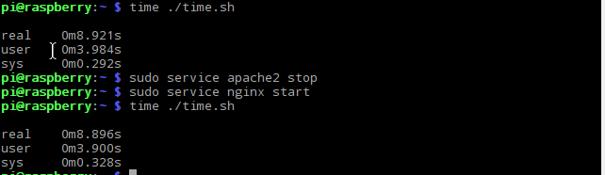

Io.php (save data of access to log.txt) for Apache(first) and Nginx(second)

