**Task 1**

* Will have to go back to using 8 bits for each entry of instruction and data memory.
* Need to find an alternative to blt or implement it in Verilog
* This is what I did:
* Got chat gpt to convert 32 bit instructions to 8 bit.
* Issues with PC_In because of blt instruction

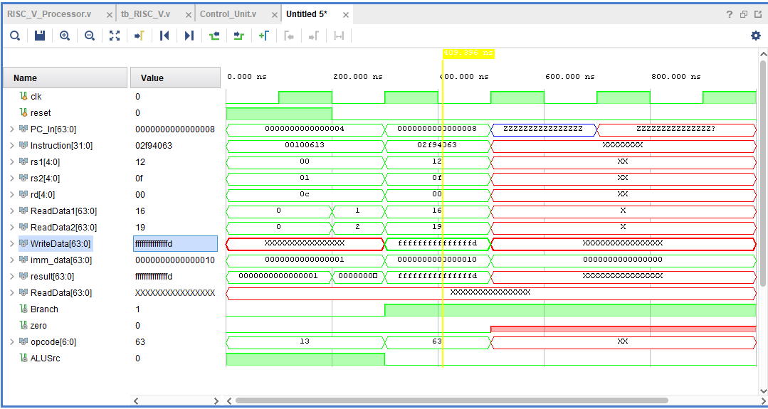

* 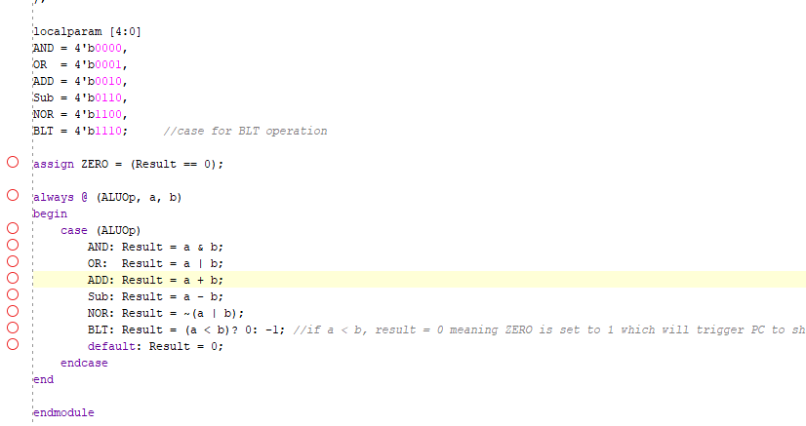
* 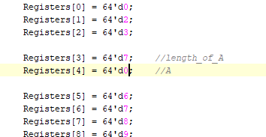
* No slli support so I made it myself:
* 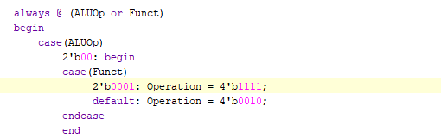
* 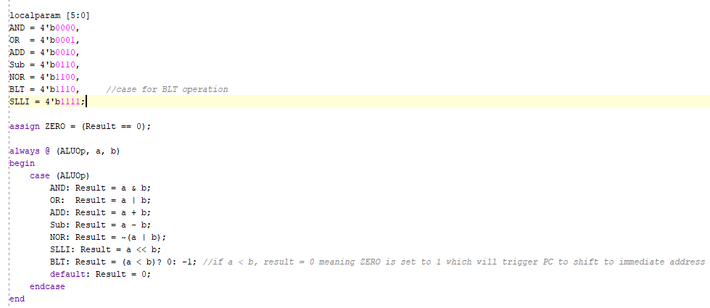
* 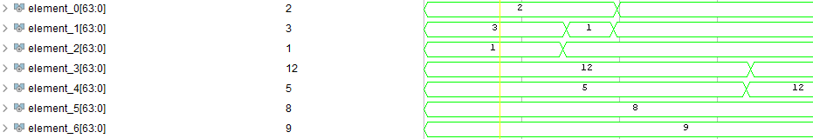
* 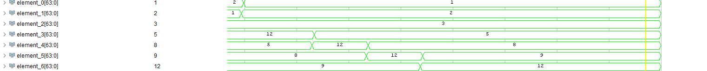
* 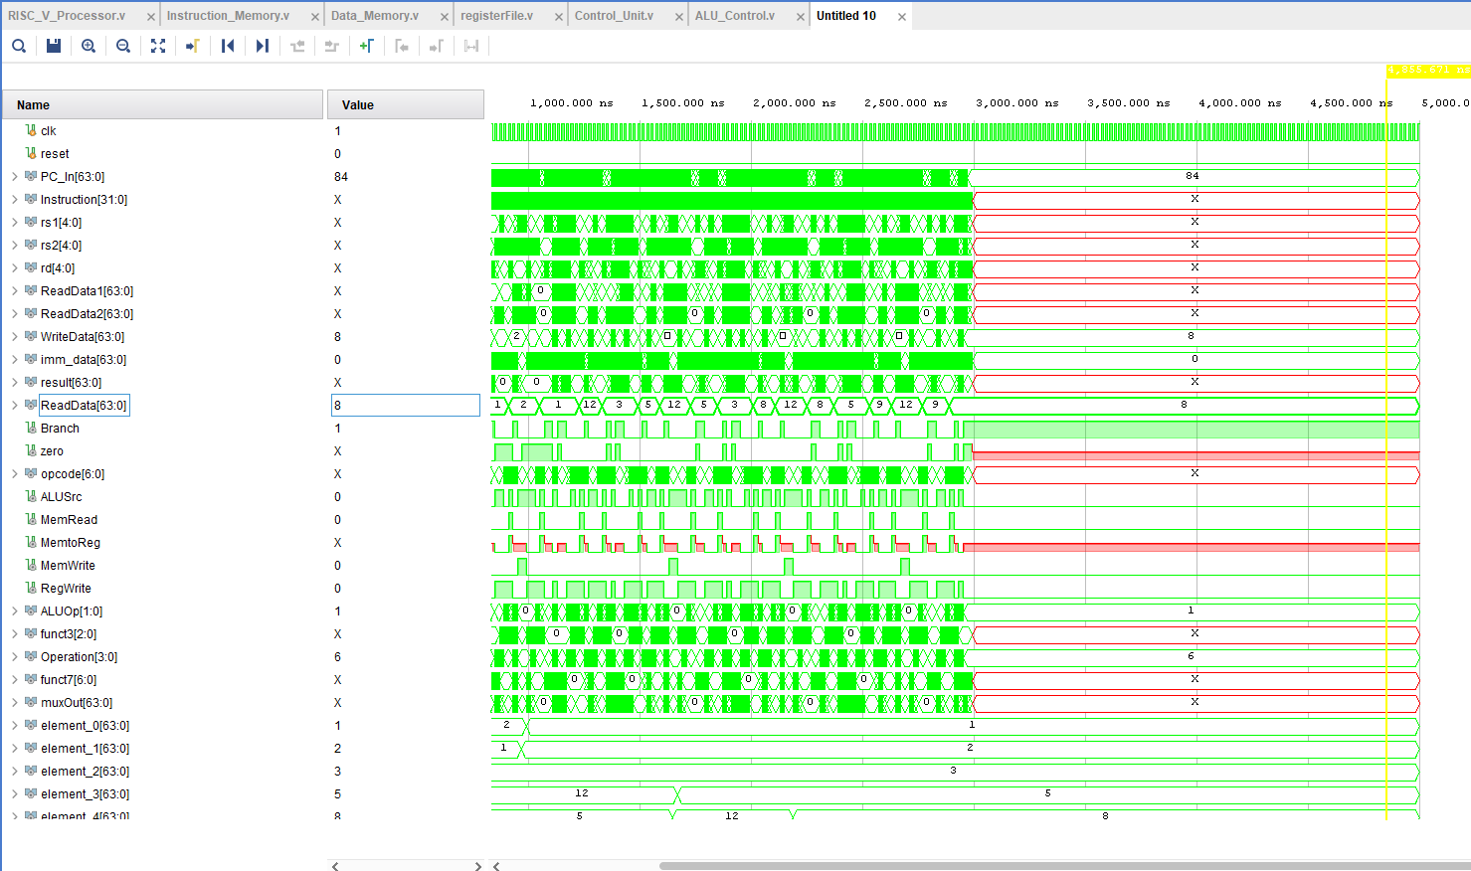

**Task 2**