Appliance Energy Use: Time-Series Forecasting Case Study
Module: Data Analysis with AI
Assignment 2
Student: ____________________ Student ID: ____________________
Submission date: 13 August 2026

Executive summary
This study forecasts household appliance energy use from the UCI Appliances Energy Prediction dataset. The original ten-minute observations were converted to hourly means and the final fourteen days were retained for testing. Five benchmark forecasts, a conditional SARIMAX model, and two recursive XGBoost models were compared using MAE, RMSE, MASE and bias. The operational XGBoost model, which uses calendar variables and past target values only, achieved the lowest RMSE (63.31) and MASE (0.75). SARIMAX was second by RMSE (69.62), while the weekly seasonal-naive method was the strongest simple benchmark by MAE and MASE. The model using realised future sensor and weather values performed worse and must also be interpreted as a conditional rather than fully operational forecast. The evidence therefore supports the operational XGBoost model for deployment, subject to rolling-origin validation and prediction-interval development.
Important reproducibility note: the included foundation-model entry is a transparent placeholder equal to the daily seasonal-naive forecast. It is not presented as a genuine Chronos, TimesFM or TimeGPT result and must be replaced before claiming completion of that specific requirement.

1. Introduction
Short-term household electricity forecasting can support demand response, automated control and improved energy awareness. Appliance demand is difficult to predict because it combines repeated routines with irregular high-consumption events. The objective was to test whether increasingly complex methods provide meaningful accuracy gains over transparent baseline forecasts.
The forecasting target was hourly appliance energy use. The principal evaluation period was the final 14 days (336 hours), and all methods generated forecasts over the same timestamps. The analysis addressed benchmark strength, seasonal structure, SARIMAX performance, feature usefulness, leakage and covariate availability, and the balance between accuracy and deployment complexity.

2. Data and preprocessing
The dataset covers 2016-01-11 17:00:00 to 2016-05-27 18:00:00. After resampling, it contained 3,290 hourly observations with no remaining missing values. The target mean was 97.78, standard deviation 81.21, minimum 28.33, and maximum 608.33. Hourly averaging reduces computational cost and dampens extreme ten-minute fluctuations, but it also removes some short-lived peaks.
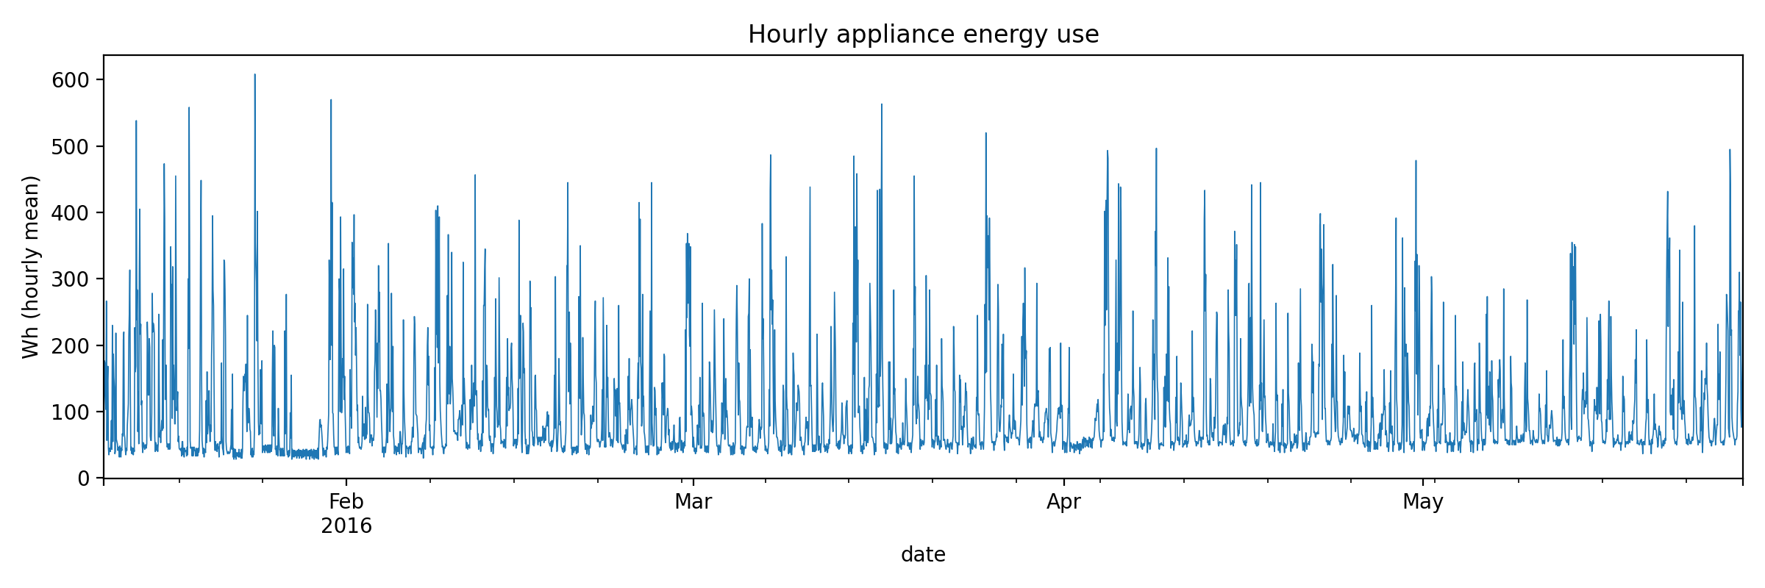
Figure 1. Hourly appliance energy use across the full sample.
The timestamp was parsed as a datetime index, columns were converted to numeric values, hourly means were calculated, and any gaps created by resampling were interpolated in time. The split was chronological rather than random to preserve forecasting realism. No scaling was required for the tree model, and all lag and rolling target features were generated from past values only.

3. Exploratory time-series analysis
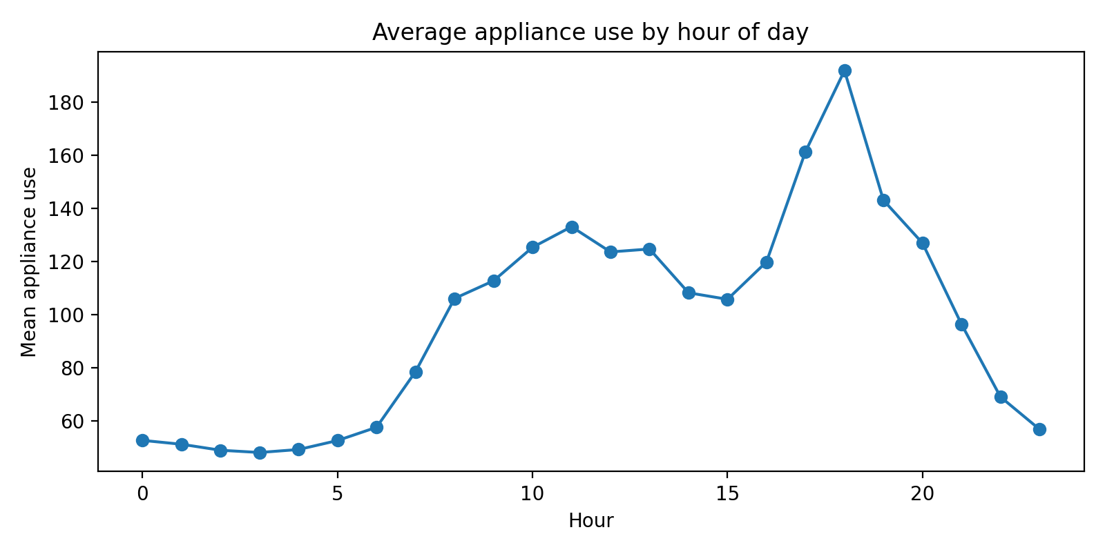
Figure 2. Average appliance use by hour of day.
The hourly profile shows an interpretable within-day pattern, consistent with household routines. The autocorrelation function contains substantial short-lag dependence and repeated structure at daily lags, supporting both seasonal benchmarks and a daily seasonal SARIMAX component.
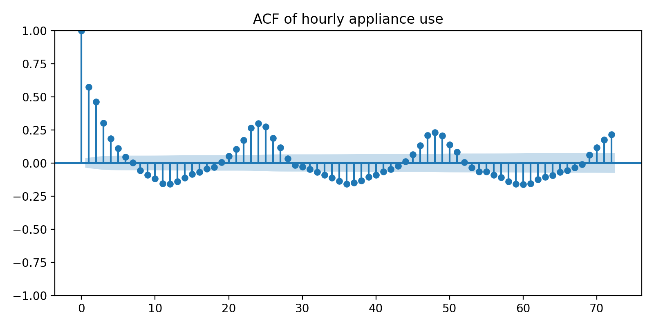
Figure 3. Autocorrelation function for the training series.
The augmented Dickey-Fuller test returned a statistic of -8.761 and p-value below 0.001. The unit-root null was rejected. This does not imply that all seasonal structure has disappeared; it indicates that the level series is not well described as a simple non-stationary random walk. Seasonal terms and residual diagnostics remained necessary.

4. Forecasting design and metrics
The test set comprised the final 336 hourly observations. The models were assessed using MAE, RMSE, MASE and bias. MAE gives a direct average error, RMSE places greater weight on large misses, MASE scales error against an in-sample daily seasonal-naive denominator, and bias indicates systematic over- or under-prediction. A MASE below one represents improvement over that scaling benchmark.

5. Models

5.1 Benchmark forecasts
The benchmark set contained the historical mean, last-value naive, daily seasonal naive (lag 24), weekly seasonal naive (lag 168), and drift forecasts. These models establish whether complexity is justified and reveal whether level persistence or seasonal repetition dominates.

5.2 SARIMAX
A SARIMAX(1,0,1)x(1,0,1,24) model with a constant was estimated on the most recent 60 training days. Outdoor temperature, outdoor humidity, wind speed, visibility and dew point were supplied as exogenous variables. Because realised test-period weather values were used, this is a conditional forecast. In operation, equivalent weather forecasts would be required. The optimiser issued a convergence warning, so the estimates should be treated cautiously and checked against a completed AIC grid search.

5.3 Feature-based models
Two XGBoost regressors were fitted. The operational version used hour, day of week, weekend status, cyclical calendar encodings, target lags (1, 2, 3, 6, 12, 24, 48 and 168 hours), and shifted rolling means and standard deviations. Forecasts were produced recursively, so later horizons used earlier predictions rather than actual future target values. The conditional version additionally used realised sensor and weather variables from the test period.
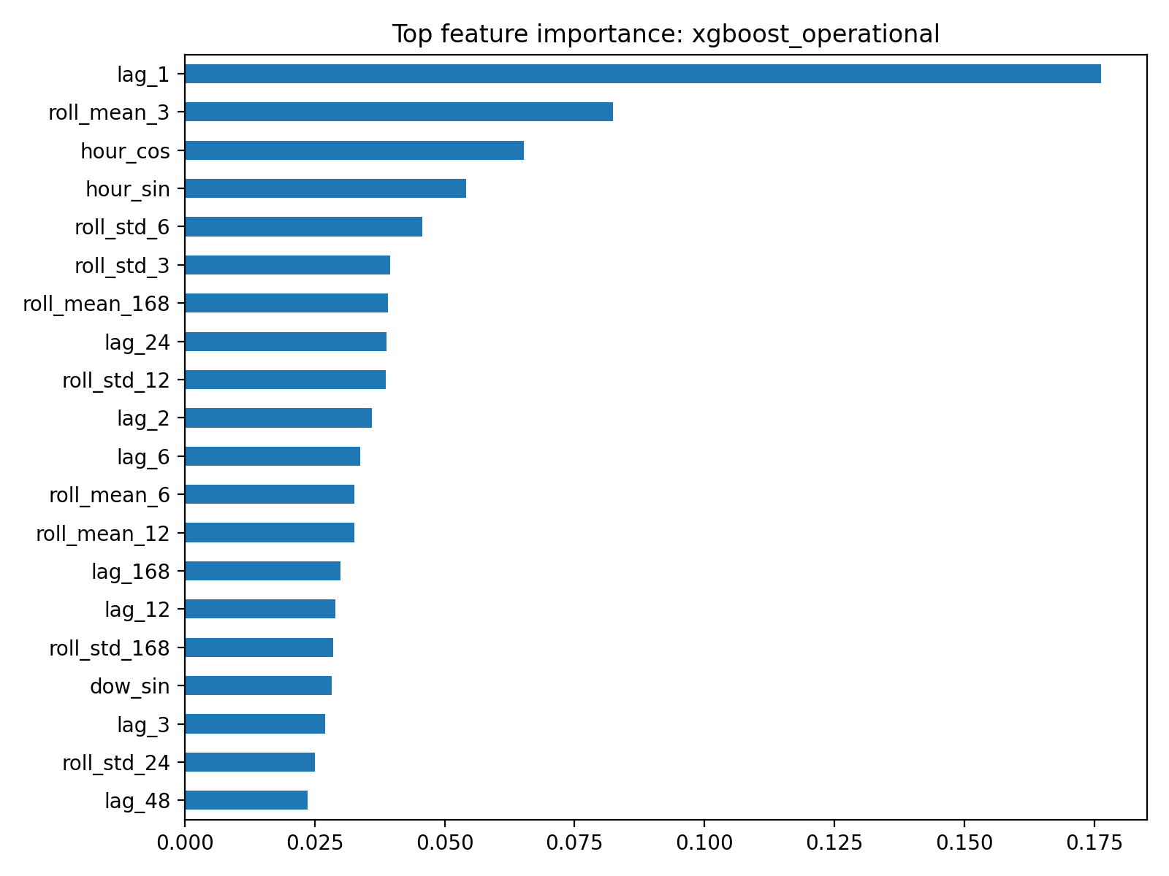
Figure 4. Leading feature importances for the operational XGBoost model.

5.4 Foundation model
The repository contains a foundation-model interface, but no pretrained Chronos, TimesFM or TimeGPT weights/API were available in the execution environment. The saved foundation placeholder repeats the daily seasonal-naive forecast solely to keep the pipeline executable. It must not be interpreted as foundation-model evidence.

6. Results
model | MAE | RMSE | MASE | Bias
xgboost_operational | 40.24 | 63.31 | 0.75 | 6.67
sarimax_conditional | 42.92 | 69.62 | 0.80 | -4.10
xgboost_conditional | 54.34 | 73.92 | 1.02 | 23.90
mean | 50.32 | 74.91 | 0.94 | -3.11
weekly_seasonal_naive | 42.63 | 79.29 | 0.80 | -10.82
daily_seasonal_naive | 86.96 | 129.23 | 1.63 | 64.01
foundation_placeholder | 86.96 | 129.23 | 1.63 | 64.01
naive | 250.64 | 258.82 | 4.69 | 247.76
drift | 266.37 | 274.61 | 4.99 | 264.50
Table 1. Model performance over the final fourteen days.
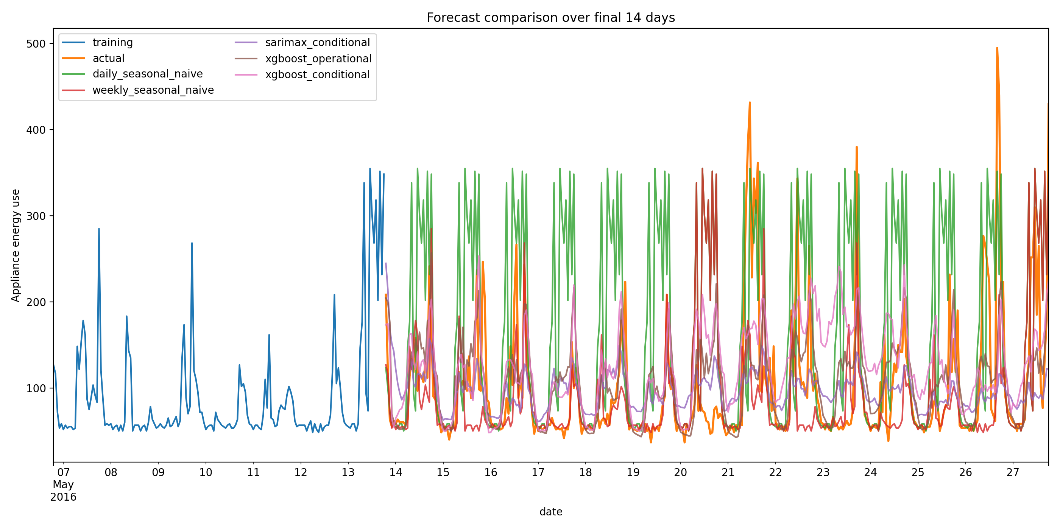
Figure 5. Forecast comparison over the complete test period.
The operational XGBoost model achieved the lowest RMSE and MASE, reducing RMSE by approximately 20% relative to the weekly seasonal-naive benchmark. SARIMAX ranked second by RMSE. The weekly seasonal naive remained highly competitive and recorded slightly lower MAE than SARIMAX, demonstrating strong weekly repetition. The daily seasonal-naive forecast over-predicted this particular test period, while last-value and drift forecasts failed badly because the final training observation was unusually high relative to subsequent demand.

7. Critical discussion and required questions

1. Strongest benchmark
The weekly seasonal-naive model was the strongest benchmark, with MAE 42.63, RMSE 79.29 and MASE 0.80. It substantially outperformed daily seasonal naive. This indicates that appliance use in this sample repeats more reliably by weekday and hour than by the immediately preceding day, although irregular events still produce large errors.

2. Does SARIMAX improve on the benchmark?
SARIMAX improved RMSE from 79.29 to 69.62, but its MAE (42.92) was marginally worse than the weekly benchmark (42.63). It therefore reduced some large errors without consistently reducing absolute error. Residual autocorrelation remained, and convergence was imperfect, suggesting that the chosen specification did not capture all temporal dependence.
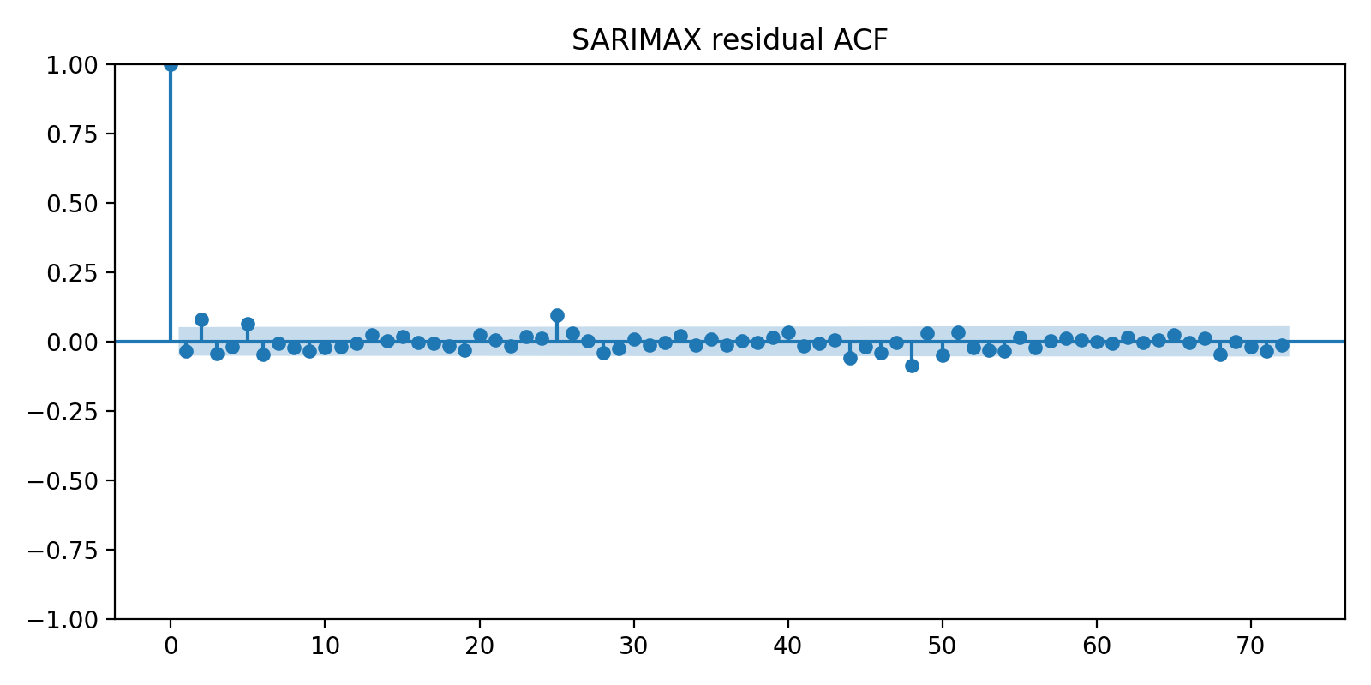
Figure 6. SARIMAX residual autocorrelation.

3. Do engineered features improve the feature model?
The operational lag/time model was the best overall method. Past target lags and rolling summaries were more useful than adding realised sensor and weather covariates: the conditional XGBoost model had RMSE 73.92 versus 63.31 operationally. This counter-intuitive result may reflect noise, redundant variables, limited tuning, and recursive error interaction. Feature importance is model-specific and should be supplemented with permutation or SHAP analysis.

4. Does the foundation model outperform?
No valid conclusion can be drawn because a genuine foundation model was not executed. The placeholder duplicates daily seasonal naive and therefore has identical metrics. A final submission should run one approved model, document model version and inference settings, and compare the resulting forecasts on exactly the same holdout.

5. Which variables are known at the forecast origin?
Future hour, weekday and weekend indicators are known exactly. Past appliance values and lagged/rolling summaries are also available at the origin. Future indoor temperature, humidity and realised outdoor weather are not normally known. Using their observed test values produces a conditional forecast and can overstate deployable performance. Operational alternatives include weather forecasts, separate sensor forecasts, or exclusion of unknown covariates.

6. Recommended practical model
The operational XGBoost model is recommended because it produced the best RMSE and MASE while relying only on information available at forecast time. It is computationally manageable and can capture nonlinear lag interactions. The weekly seasonal-naive model should remain as a fallback because it is transparent, cheap and robust. Deployment should include monitoring, scheduled retraining, fallback logic, and uncertainty estimates.

8. Limitations and future improvements
The analysis used a single terminal holdout, so rankings may depend on the selected fortnight. A rolling-origin evaluation across multiple seasons would provide stronger evidence. SARIMAX was fitted on a shortened recent window for computational practicality and did not fully converge. The required p,d,q AIC search is supplied as a checkpointing script but was not completed in this execution. Hyperparameter tuning should use training-only validation folds. Prediction intervals were available for SARIMAX but not XGBoost. Quantile boosting, conformal prediction, or bootstrapping could address this. Finally, a real foundation model must replace the placeholder.
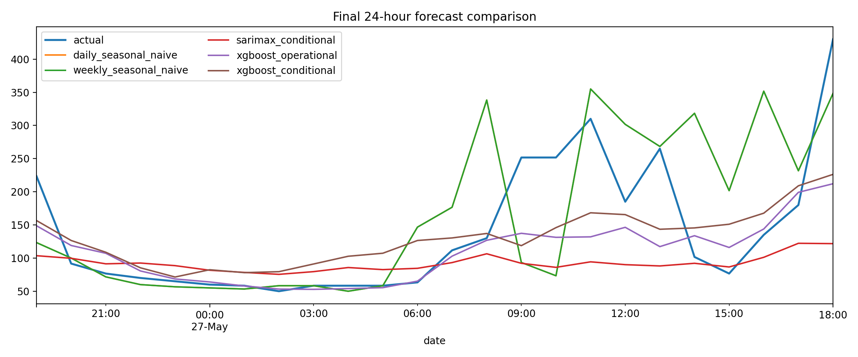
Figure 7. Final 24-hour forecast comparison.

9. Conclusion
The results show that household appliance demand contains strong weekly repetition, but nonlinear modelling of recent target history and calendar structure provides additional value. The recursive operational XGBoost model delivered the strongest overall accuracy and did not require future sensor or weather observations. SARIMAX improved large-error performance relative to the strongest benchmark but offered only limited MAE improvement and retained diagnostic concerns. Complexity was justified for XGBoost, but not automatically for every advanced model. Transparent benchmarks remain essential for both evaluation and operational fallback.

References
Candanedo, L. M., Feldheim, V., and Deramaix, D. (2017). Data driven prediction models of energy use of appliances in a low-energy house. Energy and Buildings, 140, 81-97.
Hyndman, R. J., and Athanasopoulos, G. (2021). Forecasting: Principles and Practice (3rd ed.). OTexts.
Box, G. E. P., Jenkins, G. M., Reinsel, G. C., and Ljung, G. M. (2015). Time Series Analysis: Forecasting and Control (5th ed.). Wiley.
Chen, T., and Guestrin, C. (2016). XGBoost: A scalable tree boosting system. Proceedings of KDD, 785-794.

Reproducibility statement
The repository includes the data file, processing and modelling script, metrics, forecasts, figures, tests, requirements, README and a separate checkpointing AIC grid-search script. Running scripts/run_full_analysis.py reproduces the reported outputs in the supplied environment.

