**README**

**Assumptions:** Reading the requirement doc it seemed like you wanted a web API project however you mentioned the project should be a console app so I then decided to use HttpListener and manually listen to request. Also you mentioned that third party library were not allowed so this supported my judgement of using HttpListener.

**Solution:**

**Web Server:** This is the main object which hold all of the other object. Its main purpose is to start listening to request and coordinate all other objects.

**Route Engine:** I needed a way to be able to map URL to handlers which respond i.e. when the request is /user the route which contains /user is called and the handler method is called. Route Engine just contains a list of routes and some helpful methods.

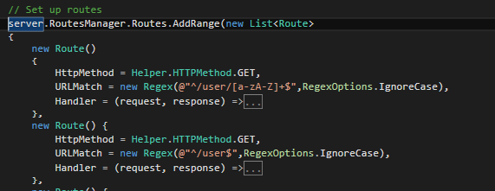**Route:** I decided to create a route object. A route has an HttpMethod such as GET, POST, PUT and a URL. Routes have to be flexible so I decided to use regular expression since they are good at matching strings.

**User:**  User is just a class to represent each user just contain name and age.

**Testing:** Only tested a few method.