Company Lockers Pvt. Ltd.
Product LockedMe.com
Prototype of the application
https://github.com/mha77/Phase1

The prototype of the application is operated as a command line program without GUI or Webinterface. It‘s usage is to store files in a folder, search for them, view the content, delete files and retrieve them in ascending order.

The implementation is done with the IDE IntelliJ and Java 17. Apache Commons is added to the project.

The Implementation is done in 2 sprints:
Sprint 1:
- Clarify the specification and requirements.
- Implement functionality to add files
- Implement functionality to delete files
- Implement functionality to close the program

Sprint 2
- Implement search mechanism
- Implement view content mechanism
- Implement retrieve files in ascending order
- Documentation

Documentation of the Functionality:
Here will be introduced the different options of the program

Welcome Screen:
This is shown when the application starts. It‘s expected to press a number between 1 and 6 and press enter.
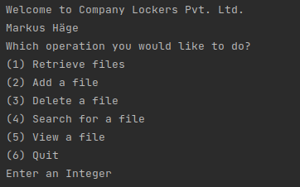

Retrieve Files:
Files which are already registered in the app can be listed on the screen. Here you can see 3 *.txt files.
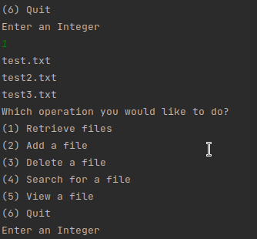

Add a File:
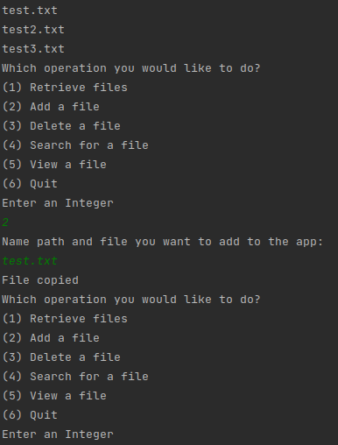
Here a file from the filesystem can be saved in a folder relatively to the project path.

Delete a file:
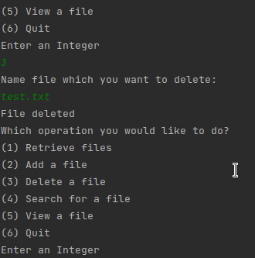
A file from the project folder can be deleted here. The filename has to be entered.

Search for a file:
Here you can search a file. Enter the filename and the program looks in its folder if it exists.
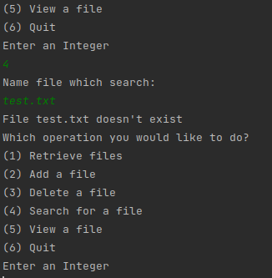

View a file:
Here you can see the content of a file. The filename has to be entered.

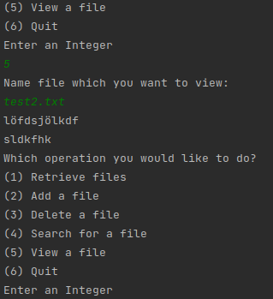

Quit:
Here you can exit from the program.

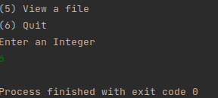

Flowchart:
