Sister Parties

Matthias Haber

March 1, 2016

## Paper Graphs

# Factional Discipline CDU-CSU German Bundestag 2005 - 2011

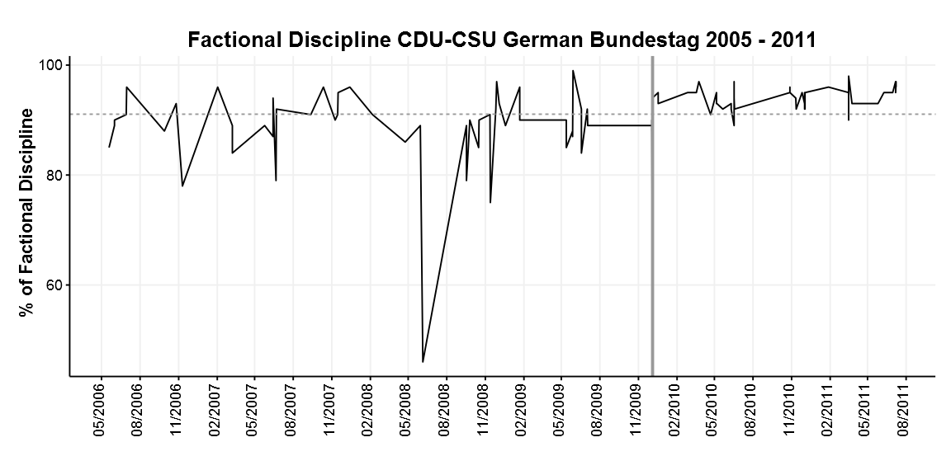

# Positions of CDU (black) and CSU (grey) Parties and Leaders 1990 - 2011

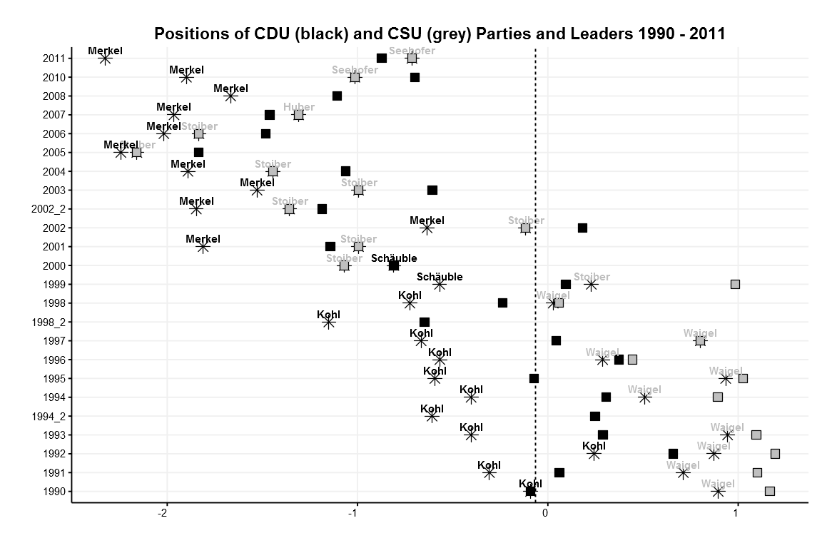

# Mean Positions of CDU and CSU Leaders 1990-2011 BW

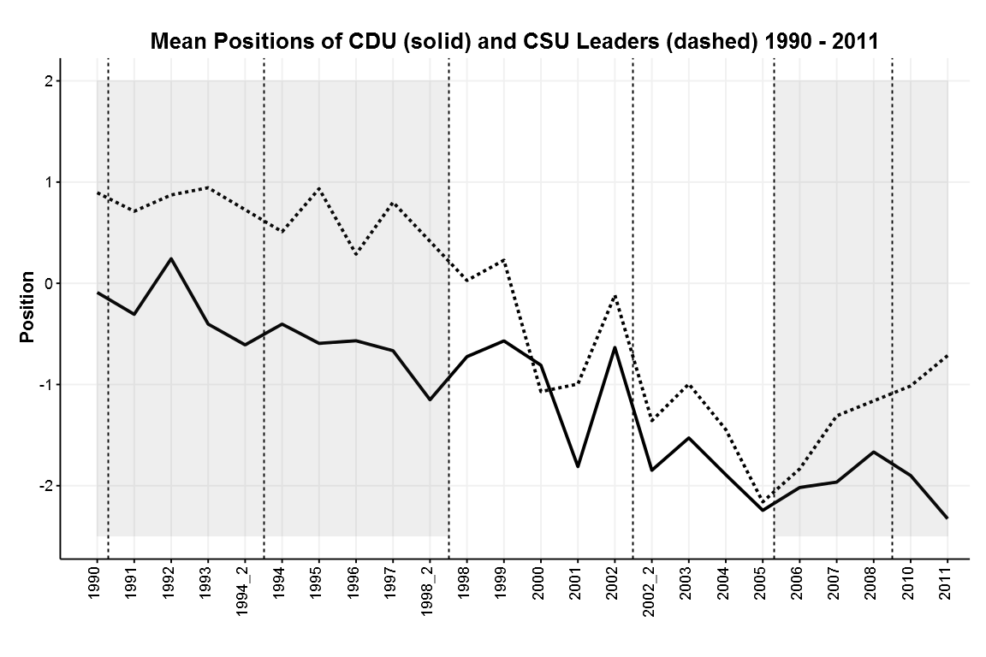

# Effect of Vote share on Distance

