Keyboarding Master
Art Assets Document

Monky Games L.L.C.
Michael Speth

Purpose
This document details the art requirements for the Keyboarding Master project.

Concept
The look and feel of the application should futurized zen. Meaning the art should be clean and simplified with the hint of technological influence.

Requirements
The following is a list of requirements. The assets are broken up into 3 rounds of assets. The first round will be for release 0.5 of the application (displayed as v0.5). The second round of assets will be for release 1.0 (displayed as v1.0). The third is for the game engine/trainer release (v2.0). There will also be one-off assets for specific devices and profiles (hopefully will be funded and displayed as v+).

Colors
The color scheme should be grey/silver against black. The color of text is white. Backgrounds to logos/headers/etc can be off purple. The following table contains the color details.
Description | RGB | HTML Notation | Image
Soft Background | 160,147,207 | a093cf
Buttons/Logos/Etc | 206,206,224 | cecee0
Text | 255,255,255 | ffffff
Background | 0,0,0 | 000000

Logo (v0.5)
The name is Keyboarding Master. So think of a Zen or Buddhist master. The logo should be of a Zen/Buddhist statue sitting with legs crossed holding a keyboard in its lap. The arms should be at its side holding/presenting the keyboard. The image below should provide a good example of the look of the logo.
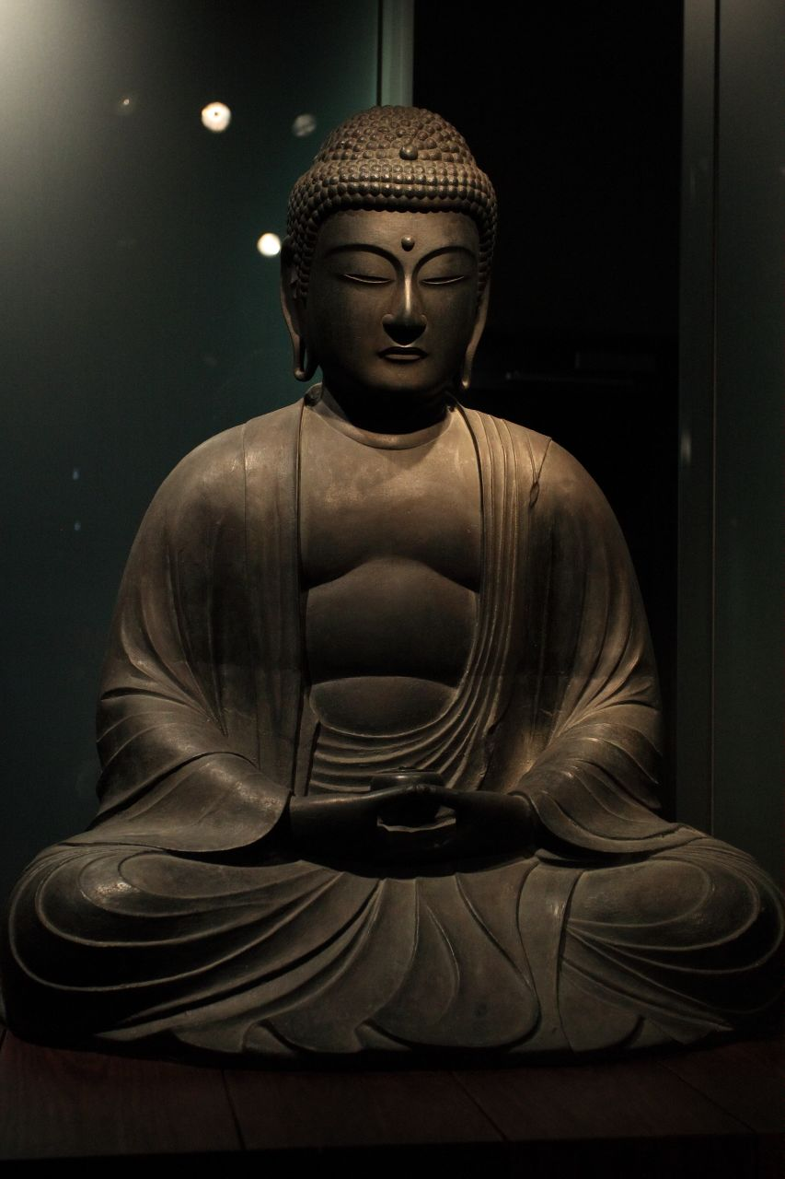Illustration 1: Logo Reference - Body Image
The head should be bald (without the head dress thing) and have little stars similar to Krillin. The facial features should be a cross between Asian and Caucasian. The ears should be normal (not the typical budda ears which is signified by long and wide).
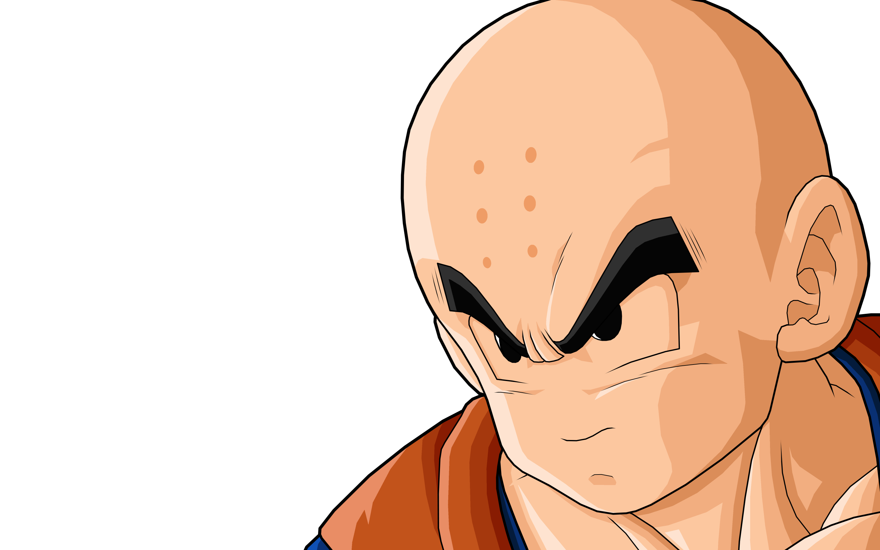Illustration 2: Logo Reference - Head
The keyboard should be generic looking. No cables should be drawn (it must be wireless :P). The keyboard perspective should be slightly tilted upwards. This means that the viewer should be able to see the keys from an angle, but the keys aren't completely flat. Use your discretion for the angle.
The logo should be text free so that it can be used throughout the project (on documentation, web page, and in the application itself). The size of the logo should be something relatively big so that it can be scaled down for the appropriate usage. Note, it doesn't need to be scaled down to something very small (less than 100x100 pixels because it would just lose too much detail).

Font
I am not set on any one font; however, I think something like BeastMachines shown below might work. Please use your discretion with the font. Which ever font is chosen, we must have permission to use it (copyright issues). I haven't looked into BestMachines but it can be found here: http://www.urbanfonts.com/fonts/Beast_Machines.htm
Illustration 3: Font Example

Banner (v0.5)
The banner is used primarily for the web page. See illustration 4 below. Note, I used the default font here, but this should be changed to the font determined in the above section.
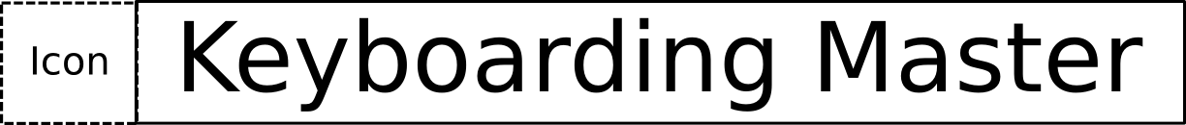Illustration 4: Banner

System Tray Icon (v0.5)
The application uses the system tray to display information about the status of the application; so it requires a system tray icon. The size of the icon should be 22x22 pixels. It should be a simplified version of the logo that works at that resolution. The colors should be the same as the logo as well. The background color is the software background and the foreground color is the grey/silver.

Desktop Shortcut Icon (v0.5)
This can be the same as the logo (scaled) unless you can think of a more appropriate design. The typical size of a desktop icon is 48x48 pixels.

Mapping Function Icons (v0.5)
The following icons are used in a pull-down menu that indicates the type of configuration for a button. Each icon should have a transparent background. The foreground color should be the grey/silver. There should be 2 sizes: one size should fit in a pulldown and the other should be larger displayed in a popup used for configuration. Pulldown should be 22x22. The popup version should be 48x48.

Name | Description
Disabled | The button is disabled. Could be a simple circle with a diagonal line through it.
Single key | The button maps to a single key. The icon could be a drawing of a keyboard key.
Mouse Button | The button maps to a mouse button (mouse click/mouse wheel/etc). Could be a picture of a mouse without any cables.
Keymap | Each configuration contains 8 keymaps. Think of them as configurations within configurations. Keymaps enable quickly to switch between configurations. Its like a weapon swap but for configurations. So this would map a keypress to switching to another keymap. We might need to discuss this one because I don't have any good ideas.
Default | Sets the button to the default mapping. I don't have any good ideas on this one either.

Profile Action Icons (v0.5)
The following icons are used for profile functions. A profile contains configuration information for a program. A profile is basically a file so the typical file operations can be applied to the profile. The constraints of the profile icons are the same as the mapping icons: transparent background and foreground color is grey/silver. The current plan is to only need a small icon set since the popups will use system defined file choosers. The icons will be used in a pulldown and should be 22x22 in size.
Name | Description
New | Creates a new profile.
Clone | Clones an existing profile (ie, copies and renames the profile).
Delete | Deletes the profile.
Import | Adds a profile from a file to the user's available profiles.
Export | Saves the profile out to a file (outside of the application).
PDF | Saves the profile as a pdf file.

Profile Action Icons (v1.0)
The following icons do not need to be initially designed but are included for a completeness. These will be needed for release 1.0 which is planned for next year. These icons have the same constraints as the above Profile Action Icons except there should be a larger size icon and small size: 48x48 & 22x22 respectively.
Name | Description
Share | Shares the profile online. Allows other users to download the profile.
Unshare | Stops sharing the profile online.
Download | Downloads a shared profile.

Sort Icons (v0.5)
The following icons are used for sorting profiles. They will be displayed in pulldowns only and should be 22x22 in size.
Name | Description
Game | The type of profiles listed are games.
Application | The type of profiles listed are applications: such as gimp/libre office/chrome/etc.

Device Icons (v1.0)
The following icons are used in a popup window (top left corner) to display a particular function. Note, doesn't need to be completed with first round of assets.
Name | Description
Download Device | Used in a download popup that shows a list of available devices.

Game Engine (v2.0)
The interface for the game engine/trainer hasn't been designed yet so the art asset requirement for this are not yet defined.

Stylized Icons (v1.0+)
Jnostromo currently lists application library icons used for building jnostromo. The following icons will be used in the Keyboarding Master application. I would like stylized icons to match the theme of Keyboarding Master with the icons below. Note, these are the least critical art assets so can be done last. The icon size should be around 48x48.
Name | Description | Icon
Linux | Designed to run on linux, but will be requesting funding to add Windows/Mac support. Everything is developed in Java but there is some native code required for device drivers. | 
Jinput | Jinput doesn't have an icon so I created one. You have complete liberty to make something better! | 
Java | The application is built through java. Feel free to pick a different java logo and modify it to the theme.
JavaFX | The GUI Library. Note, jnostromo doesn't use javafx so I haven't looked too hard to find a good one. User your discretion. | 
Db4o | Is an embedded database. This might not need to be modified.
Install Builder | An installer application which jnostromo has a free license to use. Keyboarding Master will also use it (just have to get a license). | 
KryoNet | A network library. | 

Device & Profile Specialized Icons (v+)
One of the possible methods to monetize the development of Keyboarding Master is to get donations or corporate sponsors for the development of device drivers and certified profiles. So I am hoping to have follow-on work when a device or profile becomes funded.

Art Asset Plan
I have produced a planning document that contains a schedule for release 0.5 of Keyboarding Master. I have assigned 1 day per art asset and have assumed a typical 5-day work week. So I think the latest date that the art assets can be produced is December 10.
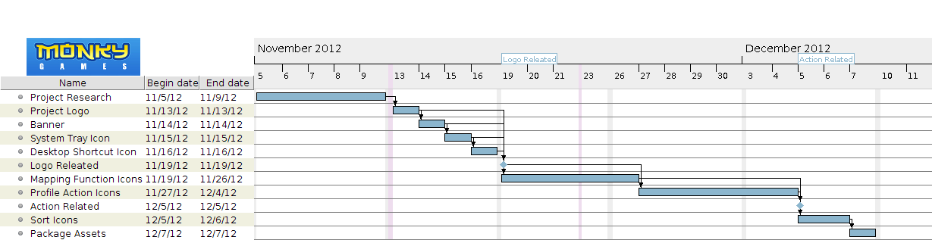
The following assumes a logo takes a maximum of 3 hours and an icon takes 1 hour (on average). I have also added 5 hours of research/planning.
Release | Hours
v0.5 | 18
v1.0 | 4
v2.0 | ?

See Planning document for more details.

Research
- jnostromo tutorial: https://www.youtube.com/watch?feature=player_embedded&v=EkLRJiqoE_o
- jnostromo project website: https://sourceforge.net/projects/jnostromo/
- jnostromo user website: http://www.monky-games.com/Home/jnostromo
- Razer Synapse 2.0: http://www.youtube.com/watch?v=h7T-9Ln-0mU&feature=plcp

