Keyboarding Master
Requirements Document

Monky Games L.L.C.
Michael Speth

Purpose
The keyboarding master is a utility software program designed to allow users to customize the input from connected devices such as the keyboard and mouse. This requirements document details the goals and plan to build the software described.

Stakeholder
Monky games was registered as an L.L.C in the USA but has been dissolved since 2010. The name is currently being used for Free Software developed primarily by Michael Speth.

Target Demographics
The initial target will be GNU/Linux gamers but will be expanded to OSX and Windows gamers. The software could also be used in conjunction with productivity applications such as gimp, adobe photoshop, and etc.

Product Overview
The keyboard master provides its users with the ability to custom configure their input devices for specific applications within a unified configuration environment. The main unique feature for input devices is the keymap concept. Each application can utilize 8 unique keymaps in which the user can toggle through via user assigned shortcuts. This enables a user to maintain a more ergonomic hand position when one hand is required for other duties such as mouse or tablet.
The user configurations (known as profiles) can explicitly be saved to the cloud or can be saved locally (its the users choice). A user name and password will be required to save to the cloud. Profiles stored on the cloud can be shared with the public allowing other users to download the profile. A profile spot-light can be added to highlight popular profiles and the profile's creator.
Profiles can contain specific information about the game or application it represents. Each mapping can have a unique icon and map description to help the user understand how the map can be used. The profile can also have an icon and a description about the profile (including instructions on how to use this profile with the game/application).
Device drivers will be required to make use of the profiles. Some devices will be able to use generic drivers such as a 104-key keyboard or a 3-button mouse. Other devices such as the Razer Nostromo will require a unique driver. Each device driver will have specialized graphics for use in the profile configuration tool.
A subproject called keyboarding trainer will be included which allows users to test out their configurations; it also allows for users to “train” on the profile in order to become skilled at the configuration layout. The keyboarding trainer is a simple game engine that has varying difficulty levels. There will be 2 modes: learning and training. The learning mode isn't scored and presents the maps one by one. It repeats maps and after the user has correctly found the map after a set number of times for the entire profile, the user is awarded a completion award (for that profile).
The training mode is a game which is scored based on the completion time, number of attempts at the short cut, and error count. Depending on the difficulty, the user will be able to “miss”. So an easy difficultly, the user can miss an unlimited time. On hard difficulty, if the user misses, then the user moves to the next map without any additional chances. Awards will be awarded depending on the score and completing level. Users will be able to participate in a ladder for selected profiles (authorized by Monky Games).

Monetization
In order to pay for hosting services (such as Amazon cloud or google's hpc), keyboarding master must design a monetization policy. There are three areas that have been identified that are possible to provide income.
User Donation: With previous projects such as jnostromo, user's request that their favourite device be added. Embedding a donate button either on the web site or in the actual software with a request for device driver could motivate people to donate money. The big caveat is that in order to develop drivers for some devices, the actual device is required. It would be good to have fund meters for specific devices (micro-kickstarters). These would enable people to see the required money in order to fund the development of the device. They could donate but money would be held until the threshold was received (such as in kick starter). Pypy.org is a good example of how this works. One of the pypy devs makes about $40K USD per year from donations.
Another site that could help with funding is gittip.org. Its a micro payment system that users can donate money on a weekly basis for general work. No specific goals required.
Sponsored Profiles: Game companies and application companies could donate to become a “paid” sponsor for a specific program. The incentive is marketing for them as well as a certified profile. There could be 3 levels, the first level is advertising for their game (an advert on the login screen that is rotated on a weekly basis). The second level is a certified profile (which also gives them adverts). Certified profiles will have icons denoting the certificate. The third is a certified training which is open to public competition. The certified profile and the certified training can be embedded in their web site (including results).
Devices: Device manufacturers could donate to have a certified device driver. Monky games would work with device manufacturers to develop additional features such as adding LED support (on devices that have LEDs), multi-platform support, and customized UI graphics. A device spot-light will showcase on a weekly basis the device of the week. A device will also have an icon to signify its been certified.

Requirements

Device
- A device will have a driver which contains all device specific information.
- A device has one or two images suitable for viewing in the UI.
- A device has a icon used for selecting the device in the UI.
- A device has a binding map that instructs the UI the location of an input that can be configured.
- The binding map contains the default output generated by the system for the input (used by the system to remap the key).
- The binding map should be a db4o file.
- A tool for creating the binding map that includes placing inputs and selecting device images. A UI would be best, but the minimum is a command line tool (command line tool isn't required if UI is developed).

Profile
- Derived from jnostromo's profile.
- Add type field: indicates that this profile is an application or game.
- Add program field: the name of a game or application.
- Add author field: the name of this profile's creator.

UI
- A splash screen with the banner icon.
- A login screen: contains the ui components in the images below. If the user selects local access, then the email, password, remember email, and create account components are disabled.
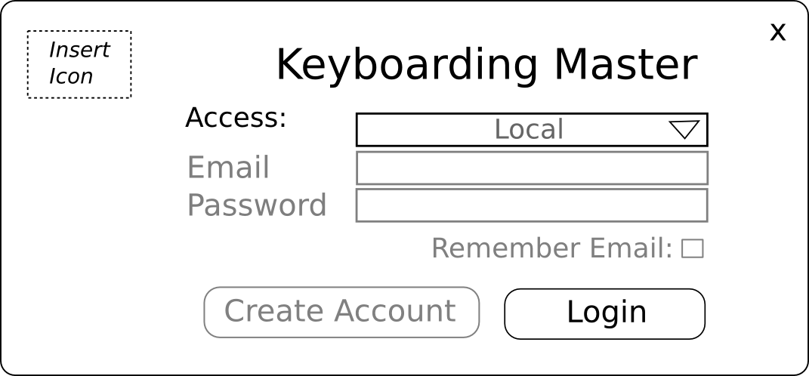
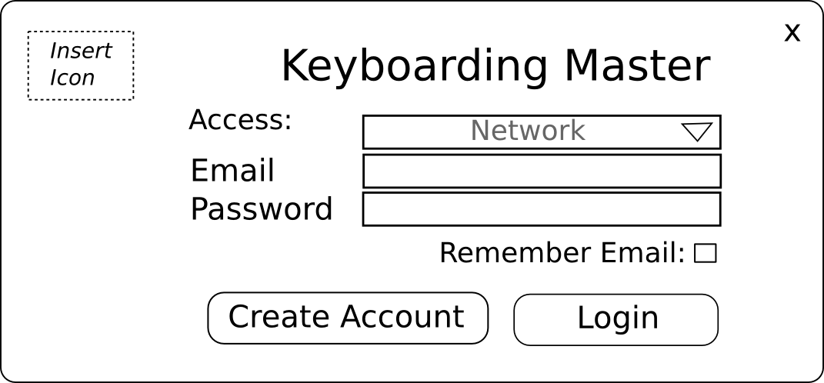
- Main Panel: contains profile navigation and selecting keys to be configured.
  - If its a local account, the account displays “local”. The green circle indicates if a user is connected to the network and red indicates its disconnected. Both are only shown if its a networked account.
  - Updates: updates are checked if the user logs in with a networked account, if updates are available, then the text become a button appears and displays “update” which kicks off the update process
  - The device pull down: contains a list of “installed” drivers. If no drivers are installed, then the profile is blank. The profiles cannot be added unless there is a driver installed.
  - The device information: only displays updates for the online version, if there is an update, a button is displayed for updating the device driver.
  - The left side: contains profile information that is sorted by type (game/application), program name (ie gimp/starcraft/etc), and the name of the profile. In type and program pull downs, an icon is associated with the respective field. The profile also contains a description.
  - Middle/Right: Contains the keymap input panel. Similar to jnostromo except the pull downs are removed allowing for a larger picture. The picture is image mapped with buttons so that each button can be clicked that opens up a configuration menu. If the device has more then 1 side (like a mouse), than two image maps are set side by side.
  - Middle/Right: Display Descriptions opens a window that contains the configuration maps for the currently selected keymap. There is an icon switch, that allows icons to be included in the popup or to be excluded (just text description).
  - Bottom left: contains a row of icons representing the technology that makes this all work.
  - Bottom right: Save – saves the profile (otherwise its not applied in the currently working profile). Hide – minimizes the window. Edit mode allows the input from the key to bring up the configuration menu (how it works exactly in jnostromo).
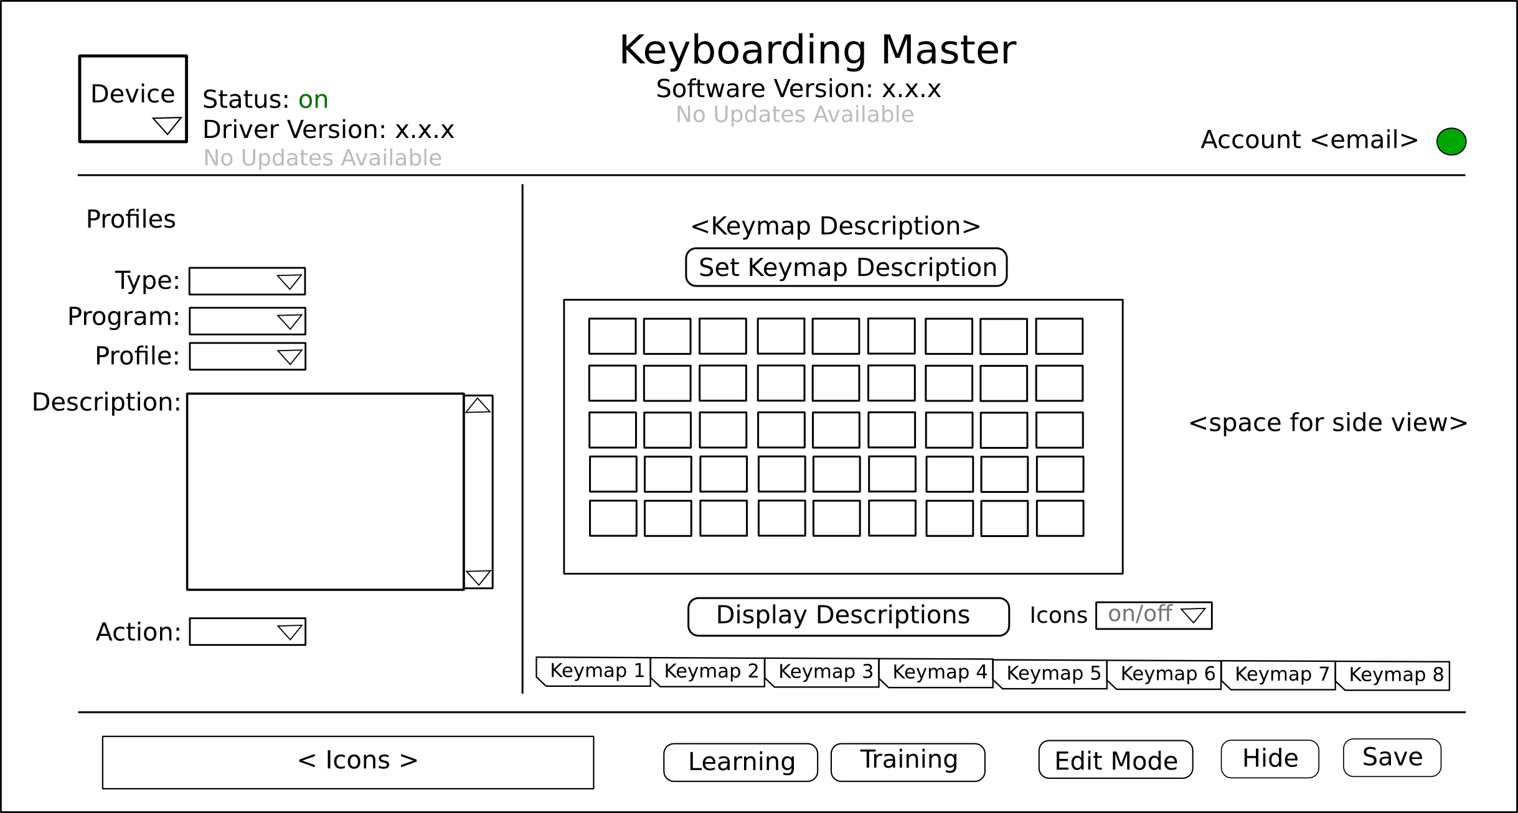
- Input Popup: opens when a user clicks on any input.
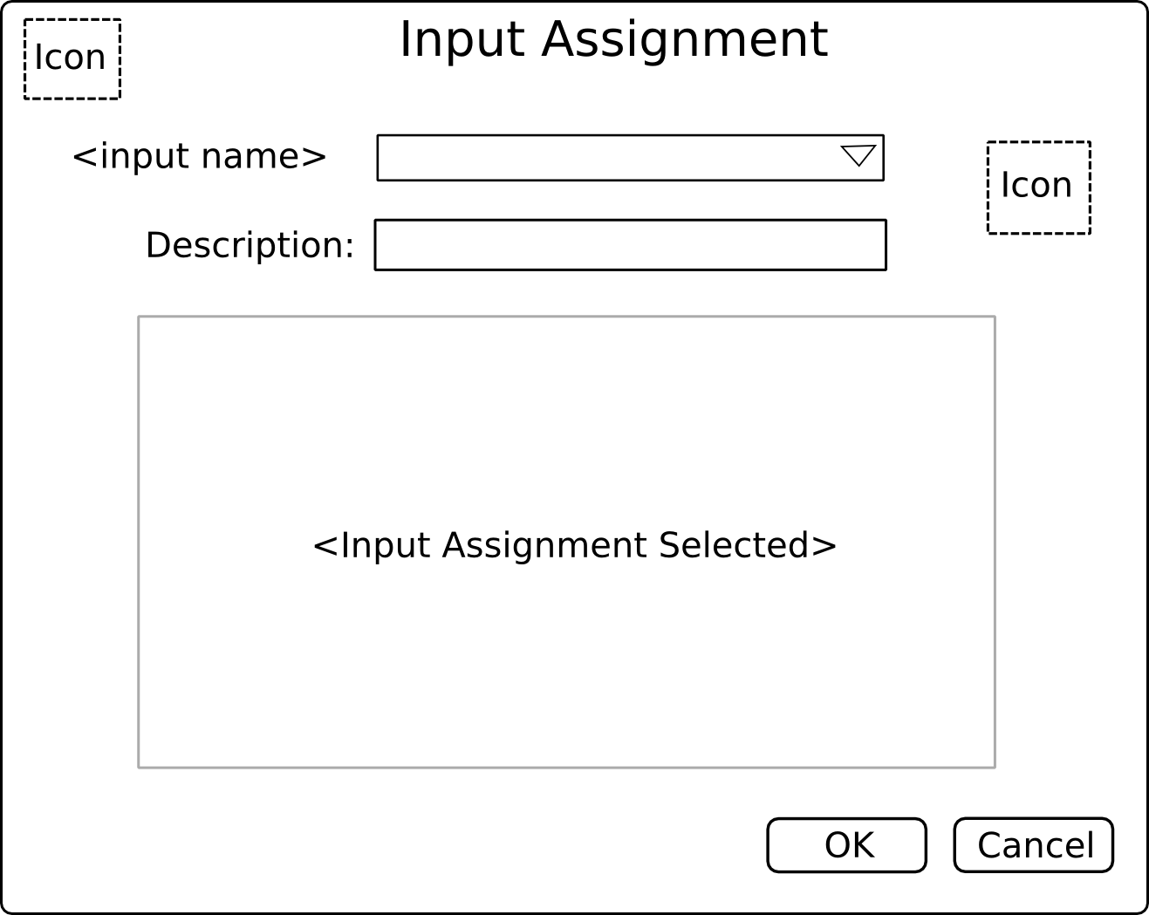
- Device Add Popup: a popup used to add new devices.
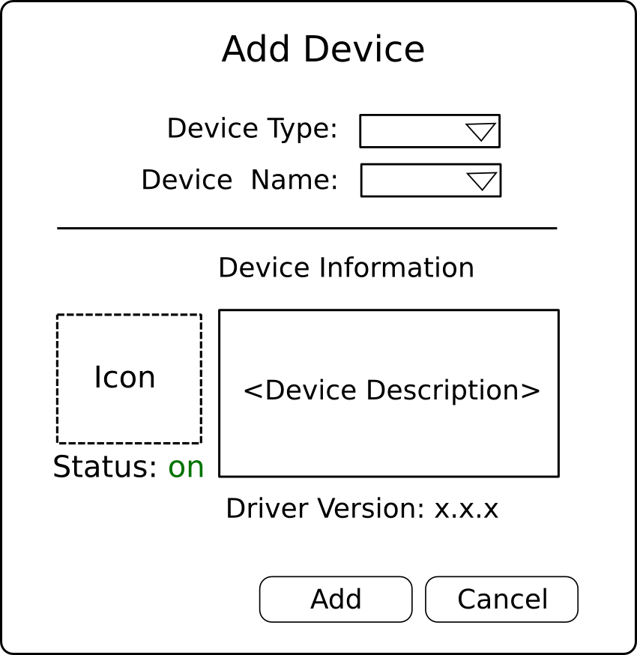
- New Profile Popup: a popup used to create a new profile.
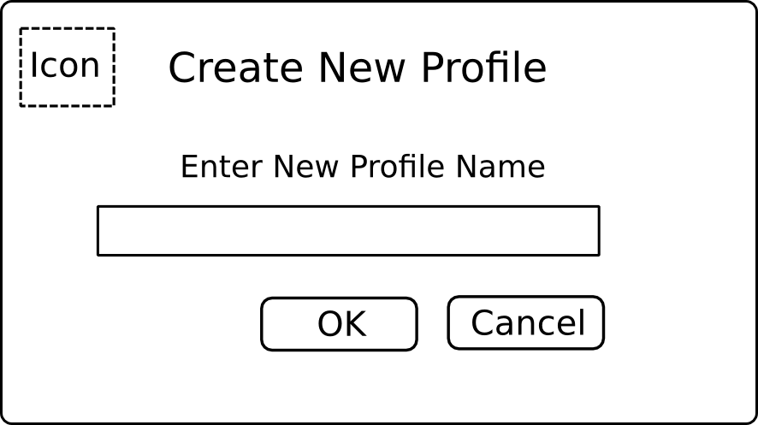
- Clone Profile Popup: identical to Create New Profile except reads: Clone Profile.
- Delete Profile: allows the user a choice if they should delete or not.
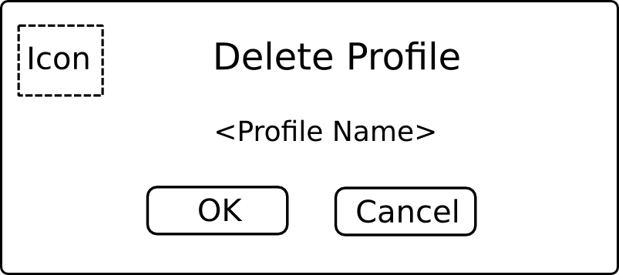
- Create Account Popup: a popup that displays the email address, and 2 password fields.
- Export Profile: JavaFX FileChooser for saving a file.
- Import Profile: JavaFX FileChooser for loading a file.
- Download Profile: allows the user to search on available profiles with applicable filters.
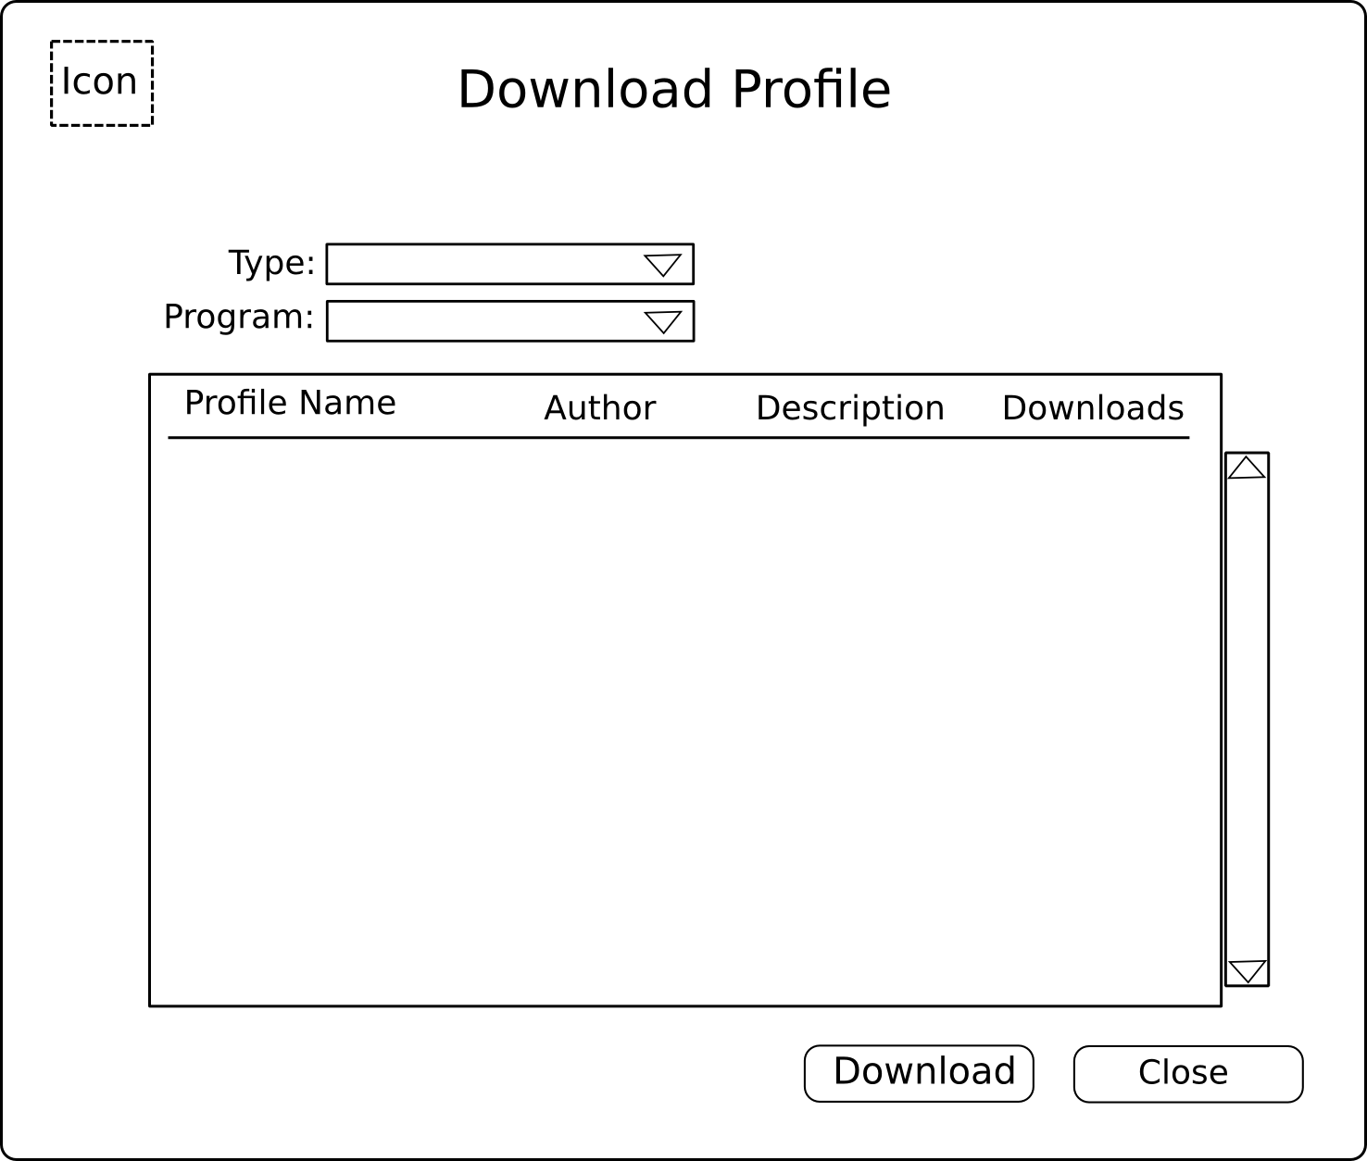
- Share Profile: allows a user to share their profile. Pops open a JavaFX Dialog asking yes or no to share.
- UnShare Profile: allows the user to stop sharing profile. Pops open a JavaFX Dialog asking yes or no.
- Download Device: allows a user to download new devices without having to update to a newer version of the main software.
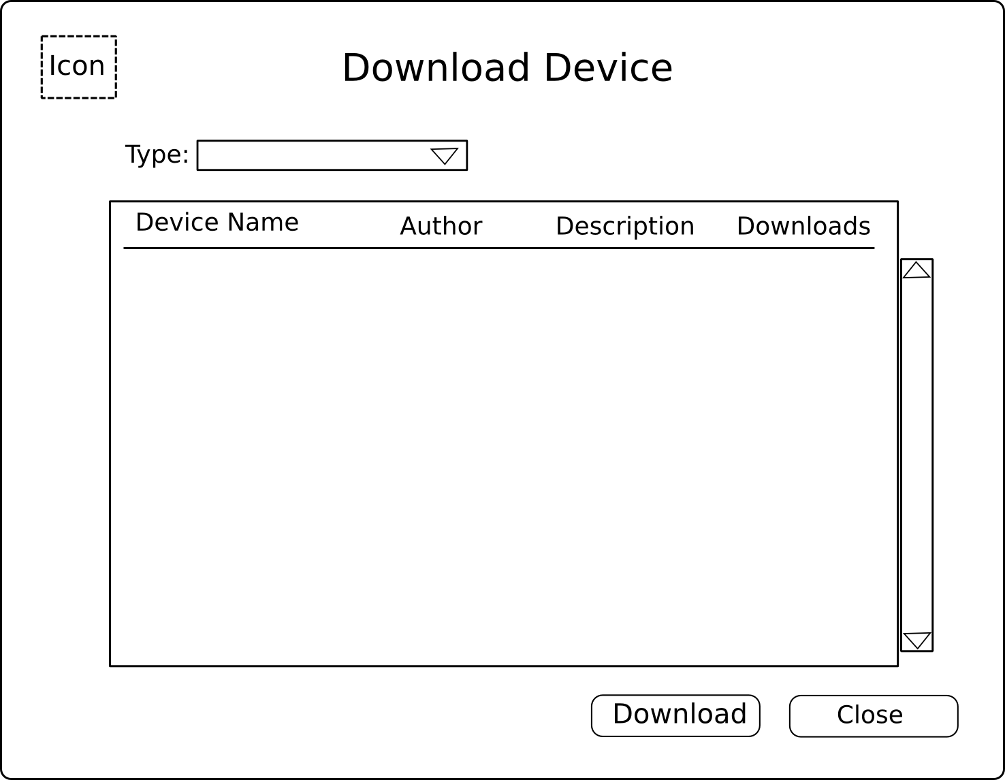
- Each icon at bottom of main pops up a product description (same as in jnostromo).

Networking
- Use Kryonet for client/server communication.
- The server provides two levels of authorization: user and admin.
- A user can upload profiles to the server (stored under their own account).
- A user can delete profiles from their account.
- A user can share uploaded profiles with the public.
- An admin can suspend a user's account (disables access as well as disables other users from accessing the shared profile).
- An admin can delete a user's account.
- An admin can only be logged in from localhost.
- An admin can upload device drivers.
- An admin can upload public profiles.
- An admin can reset the ladder.
- Users can download updates to drivers (and be notified of newer versions of drivers).
- Users can download updates to the main program and be notified of newer versions.

Icons
- Banner icon: to be used for the web page banner and application loading screen.
- System tray icon: to be used in the system tray (22x22).
- Desktop shortcut icon: to be used on the desktop and on the login screen.
- Icons for mapping functions (disabled, keymap, single key, mouse button, default).
- Action Icons (new, clone, delete, share, unshare, download, import, export, pdf)
- Sort Icons: game and application.
- Popup Icons: download device.
- Stylized icons for the technologies that are used (linux, jinput, java, db4o, install builder, kryonet) that fits the theme.

Web page
- A simple interface similar to pypy.org. On the right hand side there should be a donate bar with specific goals/device driver requests/etc.
- Header should have a large icon and the title of the project.
- Should have a few rotating screen shots of the application.
- Should also contain a featured driver or profile in the rotating screen shots.
- A download button the front page.
- An about page that details what the application is.
- An instructions page that shows step by step on how to use the application.

Constraints
The keymap concept has already been implemented in the jnostromo software; this project will borrow some of the code base from jnostomo such as the keymap and jinput driver support. The jnostromo software is released under the GPLv3 so the keyboard master project will also adopt this software license.

Project Plan
The major releases are listed below.

Release 0.5
GUI with same features as jnostromo.
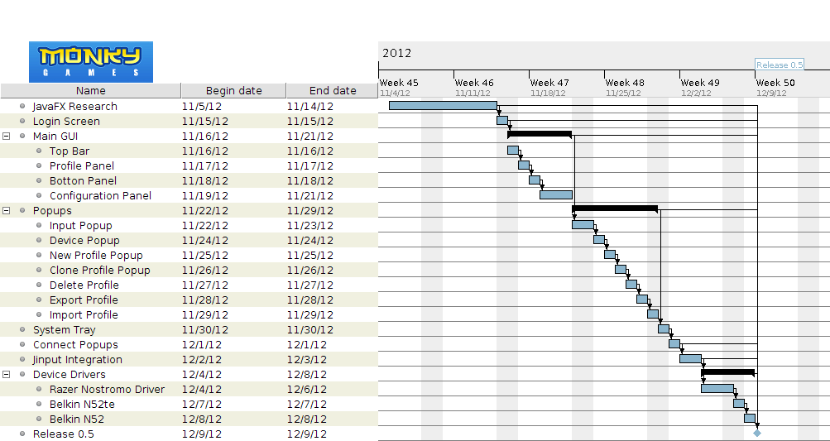

Release 1.0
Networked Enabled (can save profile to server).

Release 1.5
Sharing Enabled.

Release 2.0
Game Engine/Trainers.

