Version: 1.00

Last Update: 1/20/2019

1. **Resource and Tools:**

**Kubernetes and Minikube:**

Kubernetes is an open-source system for automating deployment, scaling, and management of containerized applications. This cluster will be deployed on a local machine to host and run Docker Images of applications that will server requests triggered by end user. Minikube is a tool that will be used to deploy Kubernetes cluster on a local machine. Kubectl will be also installed as well to interact with Kubernetes cluster using CLI

**Docker Images:**

Docker Images are built to be used in Kubernetes Deployments

**2. Cluster Architecture:**

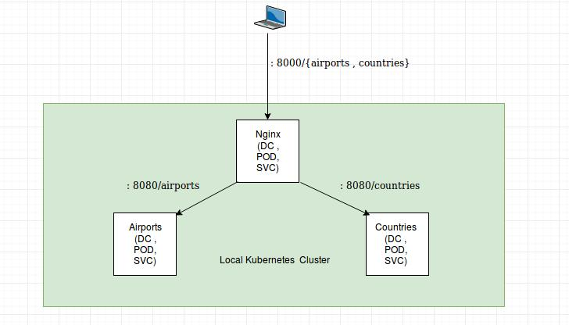

**3. Deployment Playbook:**

- airports namespace is created.

- NetworkPolicy is created to allow access from nginx namespace only.

- airports-assembly deployment is created.

- Expose airports-assembly locally within the cluster so it can be reached from ingress using service name

**3. Deployment Execution:**

Please refer to README file attached to the repo.