1. **Introduction:**

The tasks for this assignment were to create a series of four linked HTML/CSS webpages. The goal was also to layout and architect the pages as well as use CSS to beautify the content on the various pages and make them mobile friendly. For each of the hyperlink files, namely index.html, page-1.html, page-2.html, and page-3.html—I linked a stylesheet that corresponded with the file … Concerning the particular focus of this project, the attention was paid to using media queries and the adaptable layout, the choice of attractive text and background colors, and the usage of custom properties to define color palettes for several stylesheets for the first time. This project by itself was showing how to improve the code in general by introducing CSS classes. Due to this comprehensive strategy, the work was more versatile and visually engaging when it came to designing the web interface.

1. **Objectives:**

* Develop four HTML based web pages with proper structure (Home, Page-1, Page-2, Page-3).
* Writing and connecting four related CSS stylesheets (global.css, style-1.css, style-2.css, style-3.css).
* Use media queries and negative spacing to optimize each page for other available screen size.
* Position different text and background color styling on the various web page in the site.
* Prepare page-3.html with classes and / or custom CSS properties in the stylesheet (style-3.css).appropriate structure.

1. **Tasks**
2. [HTML Web Pages](https://www.munnelly.com/frontend/lessons/working-with-html), You create and work with four web pages, named **index.html**, **page-1.html**, **page-2.html**, and **page-3.html**.All four pages are displayed with the default web browser styles. None are linked to CSS stylesheets.

**NOTE:** Please include your Name and Student ID in the title tag of each web page.

**Code:**

index.html

<!DOCTYPE html>

<html lang="en">

<head>

    <title>Muhammed Hadeed Akram 74282</title>

</head>

<body>

    <h1>Hi, I'm Muhammed Hadeed Akram</h1>

    <h2>Web Designer</h2>

    <p>I created this website to showcase some of my recent web design work.</p>

    <h3>Sample Web Pages</h3>

    <a href="page-1.html">A Tale of Two Cities</a><br>

    <a href="page-2.html">Purple Rain</a><br>

    <a href="page-3.html">Web Page with Sections</a>

</body>

</html>

**Output:**

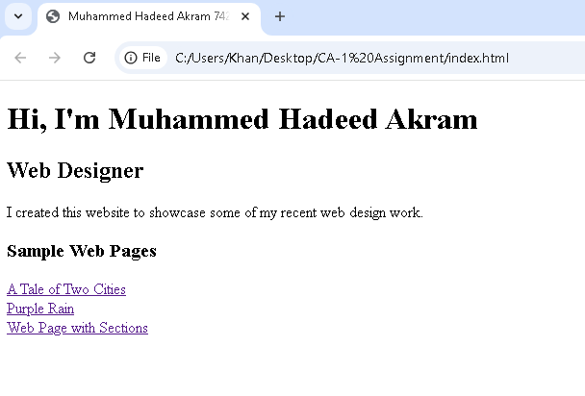

**Explaination:**

This code developed a basic webpage for the purpose of presentation of “Muhammed Hadeed Akram” as a web designer. It contains a short introduction and the addresses of three other example web page designs. There is a proper use of headings, paragraphs, proper links so it conforms to HTML standards of how information should be presented.

Code:

page-1.html

<!DOCTYPE html>

<html lang="en">

<head>

    <title>Muhammed Hadeed Akram 74282</title>

</head>

<body>

    <h1>A Tale of Two Cities</h1>

    <p>It was the best of times, it was the worst of times, it was the age of wisdom, it was the age of foolishness, it was the epoch of belief, it was the epoch of

        incredulity, it was the season of Light, it was the season of Darkness, it was the spring of hope, it was the winter of despair.</p>

        <p>We had everything before us, we had nothing before us, we were all going direct to Heaven, we were all going direct the other way - in short, the period

            was so far like the present period, that some of its noisiest authorities insisted on its being received, for good or for evil, in the superlative degree of

            comparison only.</p>

    <h2>Small Heading</h2>

   <p>There were a king with a large jaw and a queen with a plain face, on the throne of England; there were a king with a large jaw and a queen with a fair face,

    on the throne of France. In both countries it was clearer than crystal to the lords of the State preserves of loaves and fishes, that things in general were

    settled for ever.</p>

    <h2>Small Heading</h2>

    <p>All these things, and a thousand like them, came to pass in and close upon the dear old year one thousand seven hundred and seventy-five. Environed by

        them, while the Woodman and the Farmer worked unheeded, those two of the large jaws, and those other two of the plain and the fair faces, trod with stir

        enough, and carried their divine rights with a high hand.

        </p>

        <h3>Smaller Heading</h3>

        <p>A wonderful fact to reflect upon, that every human creature is constituted to be that profound secret and mystery to every other. A solemn consideration,

            when I enter a great city by night, that every one of those darkly clustered houses encloses its own secret; that every room in every one of them encloses its

            own secret; that every beating heart in the hundreds of thousands of breasts there, is, in some of its imaginings, a secret to the heart nearest it!</p>

            <p>by Charles Dickens, published by <b>Chapman</b> and <b>Hall</b> in 1859.</p>

            <p><b>Source:</b> Wikipedia.</p>

    <a href="index.html">Back to Home page</a>

</body>

</html>

**Output:**

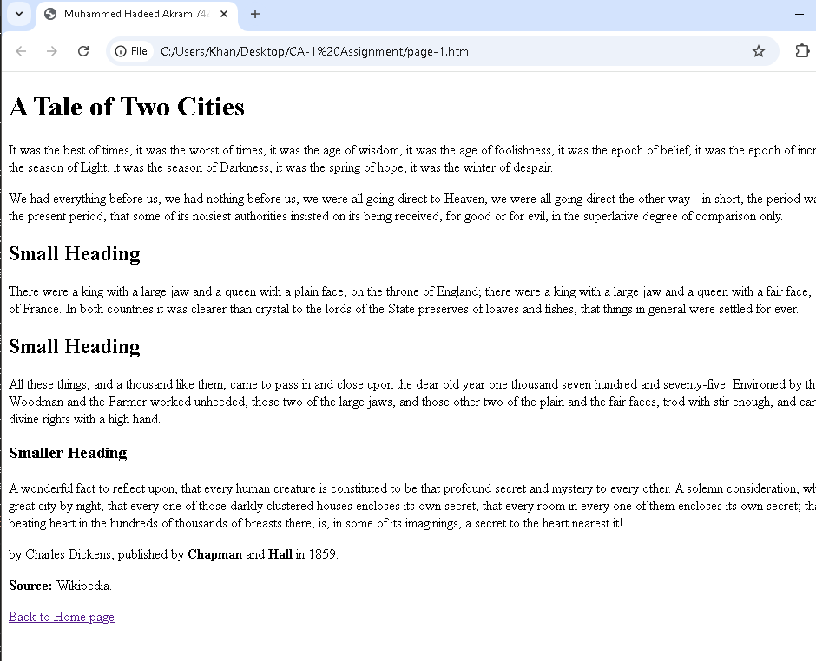

**Explaination:**

This HTML code represent Webpage titled “A Tale of Two Cities,” but it only contains a small sample of the Charles Dickens book. It consists of headings such as <h1>, <h2>=<h3> for the organization of content and <p> for the story. The text is a combination of some quotation from novel and it also identify the source is taken from Wikipedia. On the bottom, link (<a>) again is used in order to come back to homepage which is linked as index.html. It does not even use CSS for styling but the layout is very simple as well.

**Code:**

page-2.html

<!DOCTYPE html>

<html lang="en">

<head>

    <title>Muhammed Hadeed Akram 74282</title>

</head>

<body>

    <h1>Purple Rain</h1>

    <h2>Introduction</h2>

    <p>Purple Rain is a song by American musician Prince and his backing band The Revolution. It is the title track from the 1984 album of the

        same name, which in turn is the soundtrack album for the 1984 film of the same name.</p>

    <h2>Origins</h2>

    <p>Originally written as a country song and intended to be a collaboration with Stevie Nicks, Prince explained the meaning of the song as

        follows: "When there's blood in the sky... red and blue = purple. Purple rain pertains to the end of the world and being with the one you

        love and letting your faith/god guide you through the purple rain."</p>

<h2>Recording</h2>

<p>The song was recorded during a benefit concert for the Minnesota Dance Theatre at the First Avenue nightclub in Minneapolis on August 3,

    1983. City Pages described the 70-minute performance as Prince's "sweatiest and most soulful hometown concert yet."</p>

<h2>Reception and Legacy</h2>

<p>The song ranked number 144 on the Rolling Stone list of the 500 Greatest Songs of All Time. Q magazine placed it at number 40 in its list

    of the 100 Greatest Guitar Tracks, and Pitchfork named it the best song of the 1980s. The song is also included in The Rock and Roll Hall

    of Fame's 500 Songs that Shaped Rock and Roll.</p>

    <p><b>Source:</b> Wikipedia.</p>

    <a href="index.html">Back to Home page</a>

</body>

</html>

**Output:**

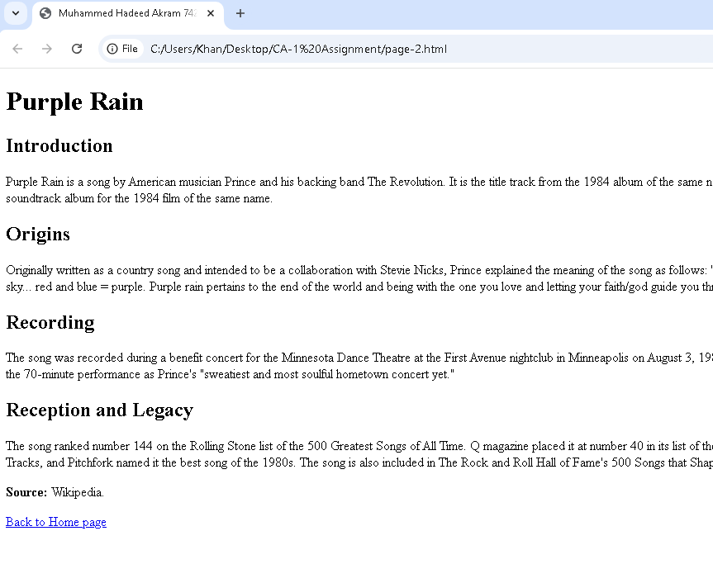

**Explaination:**

This HTML code is a web page with the name “Purple Rain” as a song by prince. It comprises well-defined sections titled by <h1><h2>, “Introduction”, “Origins”, “Recording”, “Reception and Legacy-” and small textual descriptions of each section. The content focuses on the exposition of the song and details on the recording as well as reception by the critics. Finally, there is a citation to Wikipedia and an HTML link to go back to the homepage which is called index.html. The page markup is basic and everything that you would expect with standard HTML code with no style applied on it in any way.

**Code:**

page-3.html

<!DOCTYPE html>

<html lang="en">

<head>

    <title>Muhammed Hadeed Akram 74282</title>

</head>

<body>

    <div class="s1"><h2>Nice section heading</h2>

    <p>Lorem ipsum dolor sit amet consectetur adipisicing elit. Debitis dolorem officia, eius beatae voluptatum esse in nostrum tempora quos commodi iusto ratione perspiciatis aliquam laborum, iure atque error

        nemo possimus.<br>

        Lorem, ipsum dolor sit amet consectetur adipisicing elit. Soluta, reiciendis. Ratione blanditiis repellat aliquid neque, exercitationem corporis iste ullam at laudantium? Pariatur quasi iusto eligendi voluptates

        alias odit sequi nesciunt.</p>

        </div>

        <div class="s2"><h2>Nice section heading</h2>

            <p>Lorem ipsum dolor sit amet consectetur adipisicing elit. Debitis dolorem officia, eius beatae voluptatum esse in nostrum tempora quos commodi iusto ratione perspiciatis aliquam laborum, iure atque error

                nemo possimus.<br>

                Lorem, ipsum dolor sit amet consectetur adipisicing elit. Soluta, reiciendis. Ratione blanditiis repellat aliquid neque, exercitationem corporis iste ullam at laudantium? Pariatur quasi iusto eligendi voluptates

                alias odit sequi nesciunt.</p>

                </div>

                <div class="s3"><h2>Nice section heading</h2>

                    <p>Lorem ipsum dolor sit amet consectetur adipisicing elit. Debitis dolorem officia, eius beatae voluptatum esse in nostrum tempora quos commodi iusto ratione perspiciatis aliquam laborum, iure atque error

                        nemo possimus.<br>

                        Lorem, ipsum dolor sit amet consectetur adipisicing elit. Soluta, reiciendis. Ratione blanditiis repellat aliquid neque, exercitationem corporis iste ullam at laudantium? Pariatur quasi iusto eligendi voluptates

                        alias odit sequi nesciunt.</p>

                        </div>

                        <div class="s4"><h2>Nice section heading</h2>

                            <p>Lorem ipsum dolor sit amet consectetur adipisicing elit. Debitis dolorem officia, eius beatae voluptatum esse in nostrum tempora quos commodi iusto ratione perspiciatis aliquam laborum, iure atque error

                                nemo possimus.<br>

                                Lorem, ipsum dolor sit amet consectetur adipisicing elit. Soluta, reiciendis. Ratione blanditiis repellat aliquid neque, exercitationem corporis iste ullam at laudantium? Pariatur quasi iusto eligendi voluptates

                                alias odit sequi nesciunt.</p>

                                </div>

                                <div class="s5"><h2>Nice section heading</h2>

                                    <p>Lorem ipsum dolor sit amet consectetur adipisicing elit. Debitis dolorem officia, eius beatae voluptatum esse in nostrum tempora quos commodi iusto ratione perspiciatis aliquam laborum, iure atque error

                                        nemo possimus.<br>

                                        Lorem, ipsum dolor sit amet consectetur adipisicing elit. Soluta, reiciendis. Ratione blanditiis repellat aliquid neque, exercitationem corporis iste ullam at laudantium? Pariatur quasi iusto eligendi voluptates

                                        alias odit sequi nesciunt.</p>

                                        </div>

                                        <div class="s6"><h2>Nice section heading</h2>

                                            <p>Lorem ipsum dolor sit amet consectetur adipisicing elit. Debitis dolorem officia, eius beatae voluptatum esse in nostrum tempora quos commodi iusto ratione perspiciatis aliquam laborum, iure atque error

                                                nemo possimus.<br>

                                                Lorem, ipsum dolor sit amet consectetur adipisicing elit. Soluta, reiciendis. Ratione blanditiis repellat aliquid neque, exercitationem corporis iste ullam at laudantium? Pariatur quasi iusto eligendi voluptates

                                                alias odit sequi nesciunt.</p>

    <a href="index.html">Back to Home page</a>

</div>

</body>

</html>

**Output:**

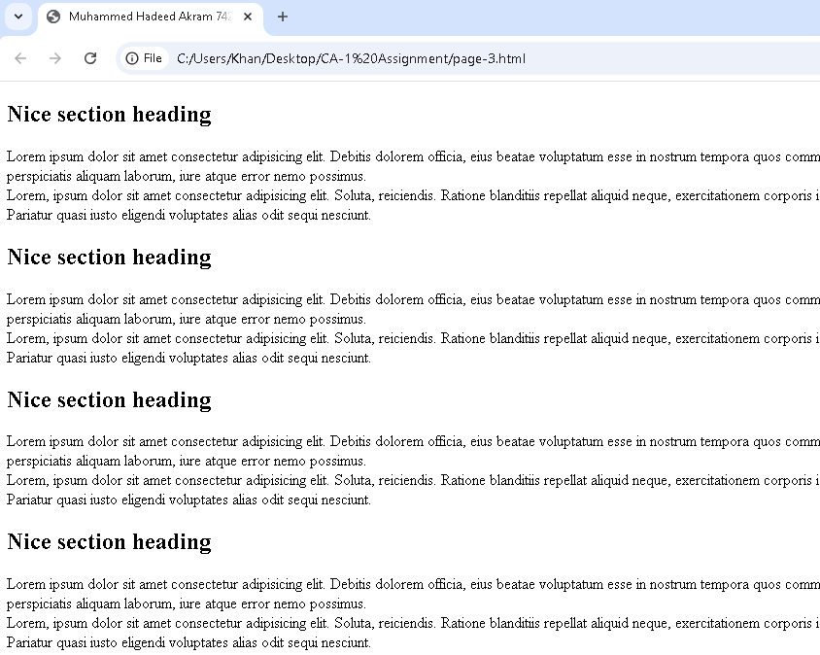

**Explaination:**

The following HTML code is a web page with more than one parts having a heading part and a body part. Every section is encased in one <div> with the respective class ( s1, s2, s3…), which, in case there are CSS inserted, can be styled differently. Instead, the headings (<h2>) are labeled “Nice section heading,” and all the paragraphs include dummy text. On the bottom, there is a link (<a>) to go back to the firstly page which is also index.html. The structure has to be so designed that can be styled or laid out easily in future.

1. [**CSS Stylesheets**](https://www.munnelly.com/frontend/lessons/working-with-css), You create and work with four stylesheets, named **global.css**, **style-1.css**, **style-2.css** and **style-3.css**. You link these CSS files to your four previously created web pages, and add various style properties and values to them.

**Code:**

<link rel="stylesheet" href="global.css">

global.css

/* Base styles for larger screens */

body {

    text-align: center;

}

**Output:**

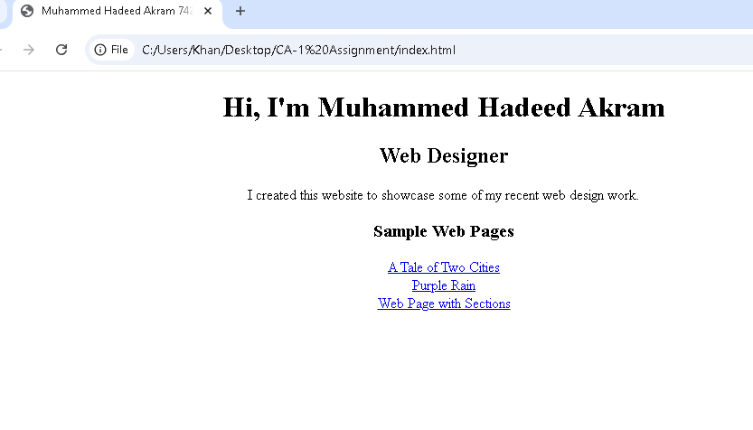

Explaination:  
First i connect global.css with index.html. In this global.css stylesheet i style our body content by giving text-align = center.

**Code:**

<link rel="stylesheet" href="style-1.css">

style-1.css

/* Base styles for larger screens */

body {

    margin: 0;

    padding: 0;

}

h1 {

    text-align: center;

    font-size: 2.5rem;

}

**Output:**

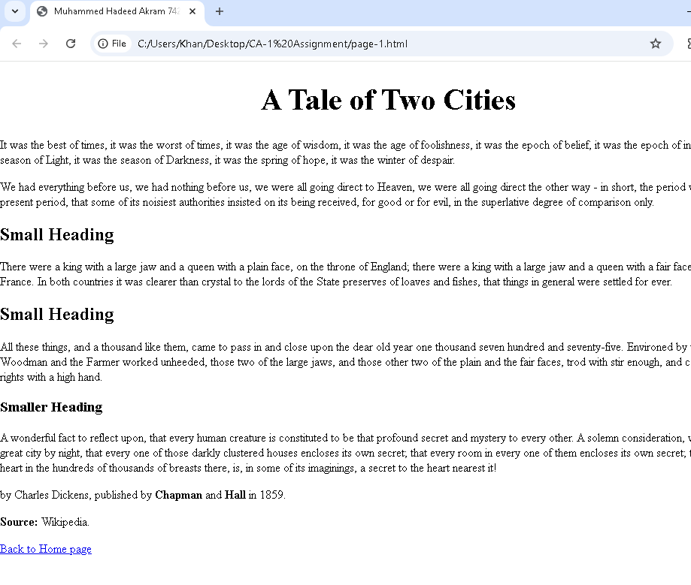

**Explaination:**

First i connect style-1.css with page-1.html. In this stylesheet i centered our h1 tag contain title “A Tale of Two Cities” by giving text-align = center.

**Code:**

 <link rel="stylesheet" href="style-2.css">

style-2.css

/* Base styles for larger screens */

body {

    margin: 0;

    padding: 0;

}

h1 {

    text-align: center;

    font-size: 2.5rem;

    margin-top: 20px;

}

**Output:**

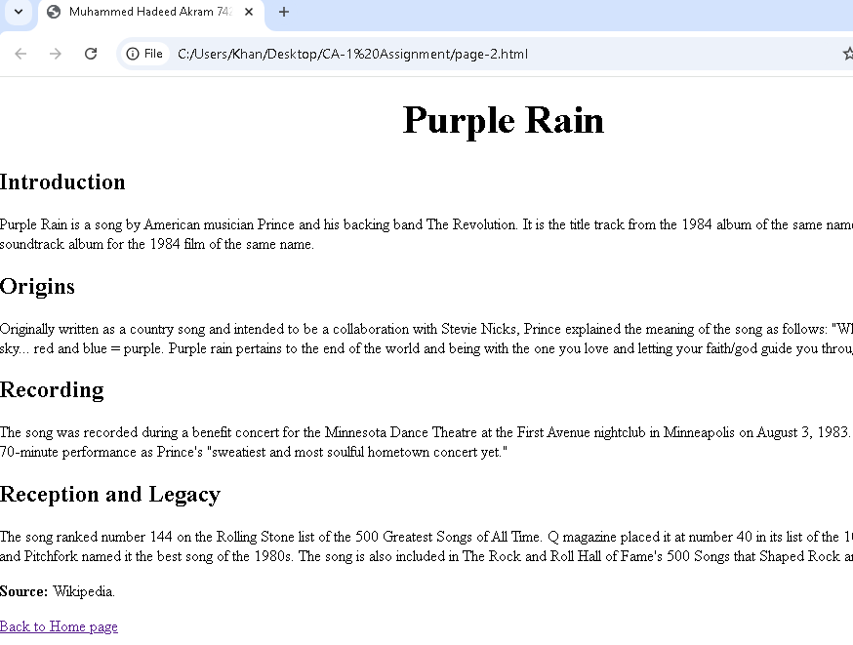

**Explaination:**

First i connect style-2.css with page-2.html. In this stylesheet i centered our h1 tag contains title “Purple Rain” by giving text-align = center.

**Code:**

 <link rel="stylesheet" href="style-3.css">

style-3.css

/* Base styles for larger screens */

body {

    margin: 0;

    padding: 20px;

}

**Output:**

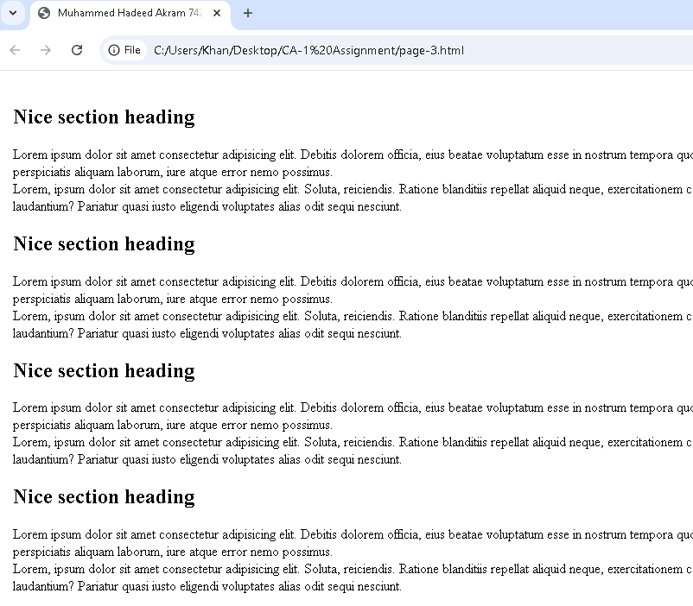

Explaination:

I simply connect style-3.css with page3.html.

1. Responsive Design, You make four web pages responsive to different screen sizes by adding negative spacing and media queries to their four linked stylesheet files. These are the global.css, style-1.css, style-2.css, and style-3.css.

**Code:**

global.css

/* Base styles for larger screens */

body {

    margin: 0;

    padding: 0;

    text-align: center;

}

h1 {

    font-size: 2.5rem;

    margin-top: 20px;

}

h2 {

    font-size: 2rem;

    margin-bottom: 20px;

}

h3 {

    font-size: 1.8rem;

    margin: 20px 0;

}

p {

    font-size: 1.2rem;

    margin-bottom: 30px;

}

a {

    display: inline-block;

    font-size: 20px;

    padding: 10px 15px;

    margin: 10px;

}

/* Responsive design for medium screens (tablets) */

@media (max-width: 768px) {

    h1 {

        font-size: 2rem;

    }

    h2 {

        font-size: 1.7rem;

    }

    h3 {

        font-size: 1.5rem;

    }

    p {

        font-size: 1rem;

    }

    a {

        font-size: 18px;

        padding: 8px 12px;

        margin: 8px;

    }

}

/* Responsive design for small screens (mobile phones) */

@media (max-width: 480px) {

    h1 {

        font-size: 1.8rem;

    }

    h2 {

        font-size: 1.4rem;

    }

    h3 {

        font-size: 1.2rem;

    }

    p {

        font-size: 0.9rem;

        margin-bottom: 20px;

    }

    a {

        font-size: 16px;

        padding: 6px 10px;

        margin: 5px;

    }

}

/* Negative spacing adjustments for small screens */

@media (max-width: 480px) {

    body {

        margin: -5px;

    }

    p {

        margin-bottom: -10px;

    }

}

**Output:**

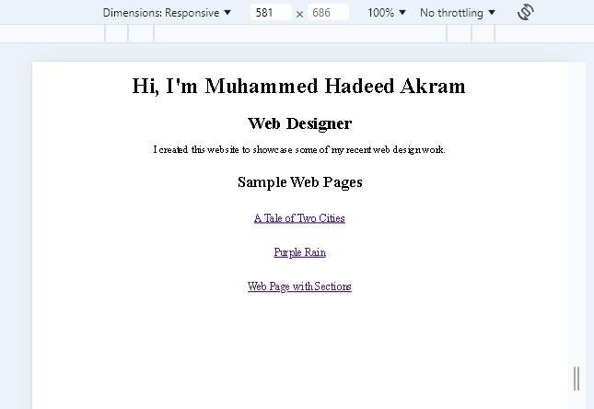

**Explaination:**

Here is CSS that sets the primary layout styles for extra large screen and contains mediumsizes (tablets) and smalls (mobile) screens. The base styles define font-sizes and line-heights, and margins & paddings for <h1>, <h3>, <p> & <a> for better and balanced spacing.

For medium screens (max-width: 768px, then decrease font sizes and padding, so it can be clearly read on the small screen of a tablet. On small screens (max-width: The probability density for devices with a width of less than 480px is decreased, the font sizes are reduced even more, and negative spacing is applied to the body and paragraphs to gain more space inside very tight displays. This means that the outcome can be easily organized in a readable manner and be functional across all the platforms.

**Code:**

style-1.css

/* Base styles for larger screens */

body {

    margin: 0;

    padding: 0;

}

h1 {

    text-align: center;

    font-size: 2.5rem;

    margin-bottom: 20px;

}

h2, h3 {

    margin-left: 80px;

}

p {

    font-size: 1.2rem;

    line-height: 1.6;

    margin: 15px auto;

    width: 90%; /* Content width limited to improve readability */

}

a {

    display: inline-block;

    text-align: center;

    text-decoration: none;

    font-size: 20px;

    margin-left: 80px;

}

/* Responsive design for medium screens (tablets) */

@media (max-width: 768px) {

    h1 {

        font-size: 2rem;

    }

    h2 {

        font-size: 1.5rem;

    }

    h3 {

        font-size: 1.2rem;

    }

    p {

        font-size: 1rem;

        padding: 10px 15px;

        margin: 5px 10px;

    }

    a {

        font-size: 19px;

        padding: 8px 12px;

    }

}

/* Responsive design for small screens (mobile phones) */

@media (max-width: 480px) {

    h1 {

        font-size: 1.5rem;

    }

    h2 {

        font-size: 1.2rem;

    }

    h3 {

        font-size: 1rem;

    }

    p {

        font-size: 0.9rem;

        padding: 5px 10px;

        margin: 5px 5px;

    }

    a {

        font-size: 17px;

        padding: 6px 10px;

    }

}

/* Adjust negative spacing */

@media (max-width: 480px) {

    body {

        margin: -5px;

    }

    p {

        margin-bottom: -10px;

    }

}

**Output:**

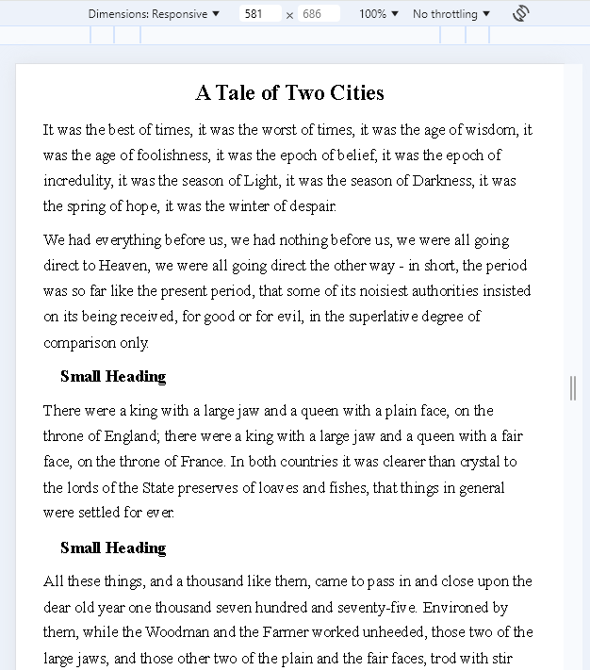

**Explaination:**

Here is CSS that sets the primary layout styles for extra large screen and contains mediumsizes (tablets) and smalls (mobile) screens. The base styles define font-sizes and line-heights, and margins & paddings for <h1>, <h3>, <p> & <a> for better and balanced spacing.

For medium screens (max-width: 768px, then decrease font sizes and padding, so it can be clearly read on the small screen of a tablet. On small screens (max-width: The probability density for devices with a width of less than 480px is decreased, the font sizes are reduced even more, and negative spacing is applied to the body and paragraphs to gain more space inside very tight displays. This means that the outcome can be easily organized in a readable manner and be functional across all the platforms.

**Code:**

style-2.css

/* Base styles for larger screens */

body {

    margin: 0;

    padding: 0;

}

h1 {

    text-align: center;

    font-size: 2.5rem;

    margin-top: 20px;

}

h2 {

    font-size: 2rem;

    margin-top: 20px;

    margin-bottom: 15px;

    margin-left: 80px;

}

p {

    font-size: 1.2rem;

    line-height: 1.6;

    margin: 15px auto;

    width: 90%; /* Content width limited to improve readability */

}

a {

    display: inline-block;

    font-size: 20px;

    text-decoration: none;

    margin-left: 80px;

    color: white;

}

/* Responsive design for medium screens (tablets) */

@media (max-width: 768px) {

    h1 {

        font-size: 2rem;

    }

    h2 {

        font-size: 1.7rem;

    }

    p {

        font-size: 1rem;

        width: 90%; /* Widen the text area slightly */

    }

    a {

        font-size: 18px;

        padding: 8px 12px;

    }

}

/* Responsive design for small screens (mobile phones) */

@media (max-width: 480px) {

    h1 {

        font-size: 1.8rem;

    }

    h2 {

        font-size: 1.4rem;

    }

    p {

        font-size: 0.9rem;

        width: 95%; /* Almost full width for small screens */

    }

    a {

        font-size: 16px;

        padding: 6px 10px;

    }

}

/* Negative spacing adjustments for small screens */

@media (max-width: 480px) {

    body {

        margin: -5px;

    }

    p {

        margin-bottom: -10px;

    }

}

**Output:**

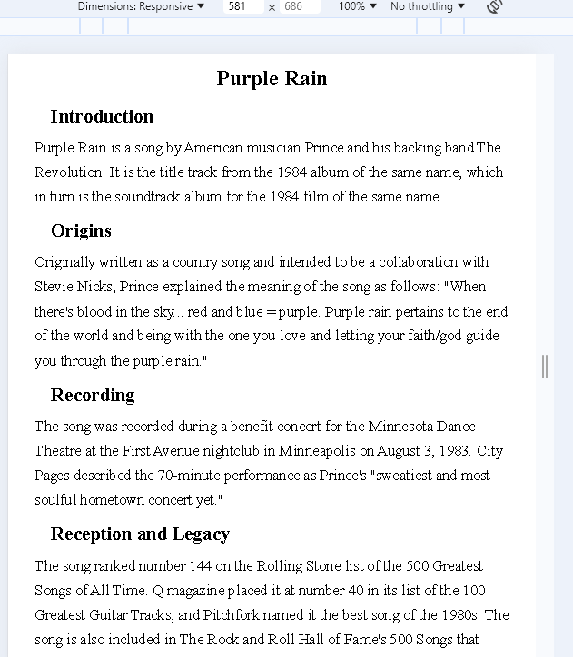

**Explaination:**

Here is CSS that sets the primary layout styles for extra large screen and contains mediumsizes (tablets) and smalls (mobile) screens. The base styles define font-sizes and line-heights, and margins & paddings for <h1>, <h3>, <p> & <a> for better and balanced spacing.

For medium screens (max-width: 768px, then decrease font sizes and padding, so it can be clearly read on the small screen of a tablet. On small screens (max-width: The probability density for devices with a width of less than 480px is decreased, the font sizes are reduced even more, and negative spacing is applied to the body and paragraphs to gain more space inside very tight displays. This means that the outcome can be easily organized in a readable manner and be functional across all the platforms.

**Code:**

style-3.css

/* Base styles for larger screens */

body {

    margin: 0;

    padding: 20px;

}

h2 {

    font-size: 2rem;

    margin-top: 20px;

   margin-left: 80px;

}

p {

    font-size: 1.2rem;

    line-height: 1.6;

    margin: 15px auto;

    width: 90%; /* Content width limited to improve readability */

}

a {

    display: inline-block;

    font-size: 20px;

    text-decoration: none;

   margin-left: 80px;

}

/* Responsive design for medium screens (tablets) */

@media (max-width: 768px) {

    h2 {

        font-size: 1.7rem;

    }

    p {

        font-size: 1rem;

        width: 90%;

    }

    a {

        font-size: 18px;

        padding: 8px 12px;

    }

}

/* Responsive design for small screens (mobile phones) */

@media (max-width: 480px) {

    h2 {

        font-size: 1.4rem;

    }

    p {

        font-size: 0.9rem;

        width: 95%;

    }

    a {

        font-size: 16px;

        padding: 6px 10px;

    }

}

/* Negative spacing adjustments for small screens */

@media (max-width: 480px) {

    body {

        margin: -5px;

    }

    p {

        margin-bottom: -10px;

    }

}

**Output:**

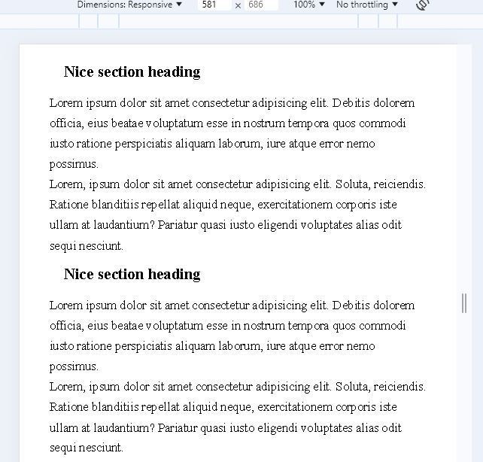

Explaination:

Here is CSS that sets the primary layout styles for extra large screen and contains mediumsizes (tablets) and smalls (mobile) screens. The base styles define font-sizes and line-heights, and margins & paddings for <h1>, <h3>, <p> & <a> for better and balanced spacing.

For medium screens (max-width: 768px, then decrease font sizes and padding, so it can be clearly read on the small screen of a tablet. On small screens (max-width: The probability density for devices with a width of less than 480px is decreased, the font sizes are reduced even more, and negative spacing is applied to the body and paragraphs to gain more space inside very tight displays. This means that the outcome can be easily organized in a readable manner and be functional across all the platforms.

1. Working with Colours, You add text and background colours to the four stylesheet files you created previously. These are the global.css, style-1.css, style-2.css, and style-3.css.

**Code:**

**global.css**

/* Base styles for larger screens */

body {

   background-color: palegreen;

    margin: 0;

    padding: 0;

    text-align: center;

}

h1 {

    font-size: 2.5rem;

    margin-top: 20px;

}

h2 {

    font-size: 2rem;

    margin-bottom: 20px;

}

h3 {

    font-size: 1.8rem;

    margin: 20px 0;

}

p {

    font-size: 1.2rem;

    margin-bottom: 30px;

}

a {

    display: inline-block;

    font-size: 20px;

    padding: 10px 15px;

    margin: 10px;

    color: green;

}

/* Responsive design for medium screens (tablets) */

@media (max-width: 768px) {

    h1 {

        font-size: 2rem;

    }

    h2 {

        font-size: 1.7rem;

    }

    h3 {

        font-size: 1.5rem;

    }

    p {

        font-size: 1rem;

    }

    a {

        font-size: 18px;

        padding: 8px 12px;

        margin: 8px;

    }

}

/* Responsive design for small screens (mobile phones) */

@media (max-width: 480px) {

    h1 {

        font-size: 1.8rem;

    }

    h2 {

        font-size: 1.4rem;

    }

    h3 {

        font-size: 1.2rem;

    }

    p {

        font-size: 0.9rem;

        margin-bottom: 20px;

    }

    a {

        font-size: 16px;

        padding: 6px 10px;

        margin: 5px;

    }

}

/* Negative spacing adjustments for small screens */

@media (max-width: 480px) {

    body {

        margin: -5px;

    }

    p {

        margin-bottom: -10px;

    }

}

**Output:**

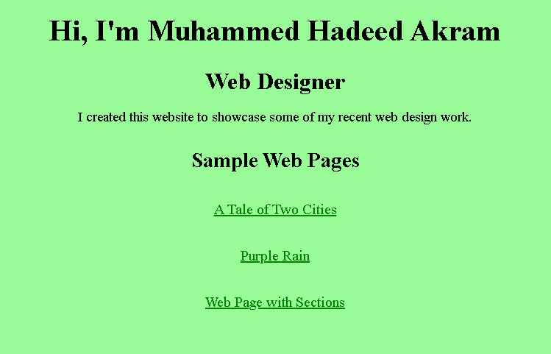

Explaination:

In global.css stylesheet i give body background-color = palegreen.

**Code:**

**style-1.css**

/* Base styles for larger screens */

body {

    background-color:rgb(231, 231, 224);

    margin: 0;

    padding: 0;

}

h1 {

    text-align: center;

    font-size: 2.5rem;

    margin-bottom: 20px;

    color: brown;

}

h2, h3 {

    margin-left: 80px;

    color: brown;

}

p {

    font-size: 1.2rem;

    line-height: 1.6;

    margin: 15px auto;

    width: 90%; /* Content width limited to improve readability */

}

a {

    display: inline-block;

    text-align: center;

    text-decoration: none;

    font-size: 20px;

    margin-left: 80px;

}

/* Responsive design for medium screens (tablets) */

@media (max-width: 768px) {

    h1 {

        font-size: 2rem;

    }

    h2 {

        font-size: 1.5rem;

    }

    h3 {

        font-size: 1.2rem;

    }

    p {

        font-size: 1rem;

        padding: 10px 15px;

        margin: 5px 10px;

    }

    a {

        font-size: 19px;

        padding: 8px 12px;

    }

}

/* Responsive design for small screens (mobile phones) */

@media (max-width: 480px) {

    h1 {

        font-size: 1.5rem;

    }

    h2 {

        font-size: 1.2rem;

    }

    h3 {

        font-size: 1rem;

    }

    p {

        font-size: 0.9rem;

        padding: 5px 10px;

        margin: 5px 5px;

    }

    a {

        font-size: 17px;

        padding: 6px 10px;

    }

}

/* Adjust negative spacing */

@media (max-width: 480px) {

    body {

        margin: -5px;

    }

    p {

        margin-bottom: -10px;

    }

}

**Output:**

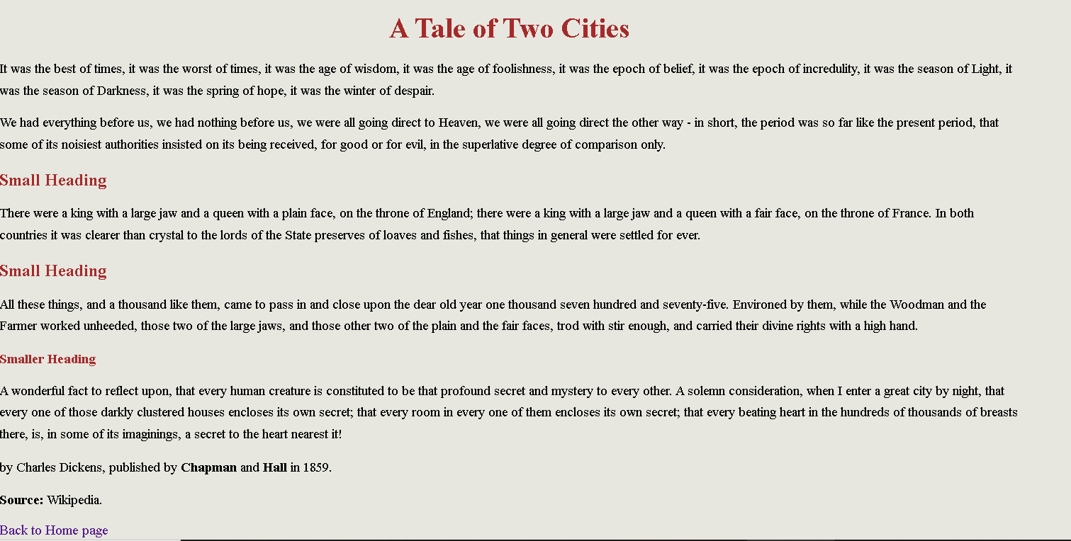

**Explaination:**

In style-1.css stylesheet i give body background-color = rgb(231, 231, 224). I give h1,h2 tag color = brown.

**Code:**

**style2.css**

/* Base styles for larger screens */

body {

    background-color: rgb(124, 11, 134);

    margin: 0;

    padding: 0;

}

h1 {

    text-align: center;

    font-size: 2.5rem;

    margin-top: 20px;

    color: white;

}

h2 {

    font-size: 2rem;

    margin-top: 20px;

    margin-bottom: 15px;

    margin-left: 80px;

    color: white;

}

p {

    font-size: 1.2rem;

    line-height: 1.6;

    margin: 15px auto;

    width: 90%; /* Content width limited to improve readability */

    color: white;

}

a {

    display: inline-block;

    font-size: 20px;

    text-decoration: none;

    margin-left: 80px;

    color: white;

}

/* Responsive design for medium screens (tablets) */

@media (max-width: 768px) {

    h1 {

        font-size: 2rem;

    }

    h2 {

        font-size: 1.7rem;

    }

    p {

        font-size: 1rem;

        width: 90%; /* Widen the text area slightly */

    }

    a {

        font-size: 18px;

        padding: 8px 12px;

    }

}

/* Responsive design for small screens (mobile phones) */

@media (max-width: 480px) {

    h1 {

        font-size: 1.8rem;

    }

    h2 {

        font-size: 1.4rem;

    }

    p {

        font-size: 0.9rem;

        width: 95%; /* Almost full width for small screens */

    }

    a {

        font-size: 16px;

        padding: 6px 10px;

    }

}

/* Negative spacing adjustments for small screens */

@media (max-width: 480px) {

    body {

        margin: -5px;

    }

    p {

        margin-bottom: -10px;

    }

}

**Output:**

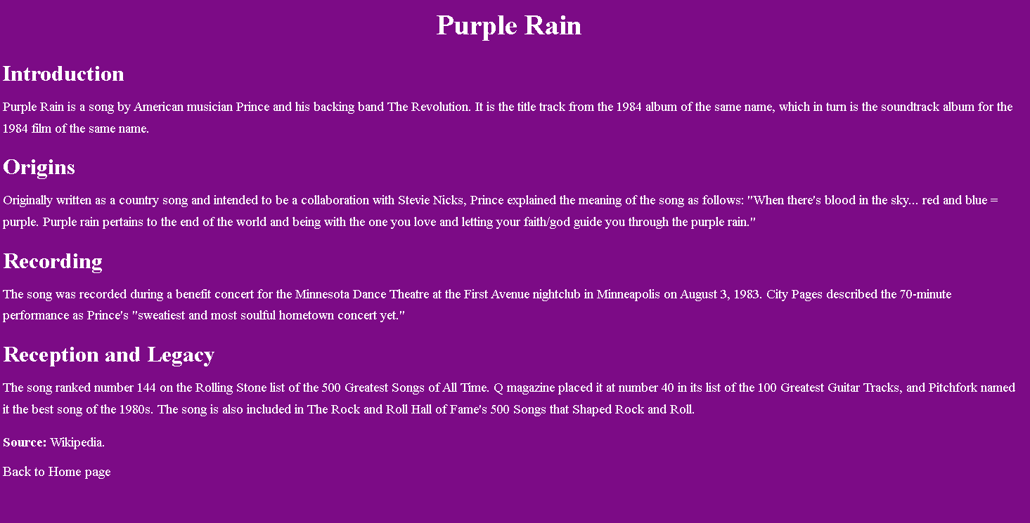

**Explaination:**

In style-2.css stylesheet i give body background-color = rgb(124, 11, 134). I give h1,h2,p tag color = white.

**Code:**

style-3.css

/* Base styles for larger screens */

body {

  background-color: aqua;

    margin: 0;

    padding: 20px;

}

h2 {

    font-size: 2rem;

    margin-top: 20px;

   margin-left: 80px;

}

p {

    font-size: 1.2rem;

    line-height: 1.6;

    margin: 15px auto;

    width: 90%; /* Content width limited to improve readability */

}

a {

    display: inline-block;

    font-size: 20px;

    text-decoration: none;

   margin-left: 80px;

}

/* Responsive design for medium screens (tablets) */

@media (max-width: 768px) {

    h2 {

        font-size: 1.7rem;

    }

    p {

        font-size: 1rem;

        width: 90%;

    }

    a {

        font-size: 18px;

        padding: 8px 12px;

    }

}

/* Responsive design for small screens (mobile phones) */

@media (max-width: 480px) {

    h2 {

        font-size: 1.4rem;

    }

    p {

        font-size: 0.9rem;

        width: 95%;

    }

    a {

        font-size: 16px;

        padding: 6px 10px;

    }

}

/* Negative spacing adjustments for small screens */

@media (max-width: 480px) {

    body {

        margin: -5px;

    }

    p {

        margin-bottom: -10px;

    }

}

**Output:**

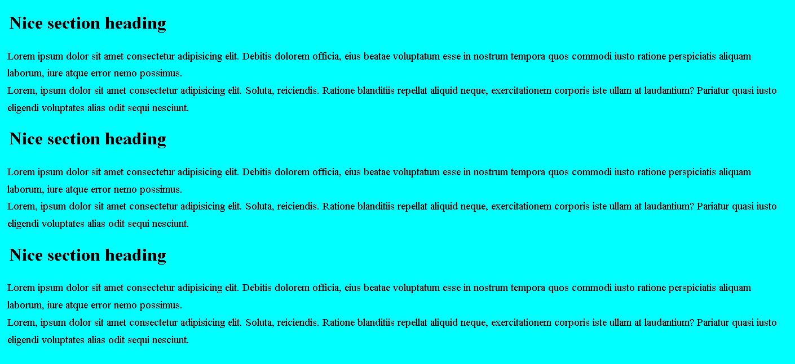

**Explaination:**

In style-3.css stylesheet i give body background-color = aqua.

1. Classes and Custom Properties, You add classes to the page-3.html web page and the style-3.css stylesheet. You also add custom colour properties to style-3.css.

**Code:**

style-3.css

/* Base styles for larger screens */

body {

    margin: 0;

    padding: 20px;

}

h2 {

    color: blue;

    font-size: 2rem;

    margin-top: 20px;

   margin-left: 80px;

}

p {

    font-size: 1.2rem;

    line-height: 1.6;

    margin: 15px auto;

    width: 90%; /* Content width limited to improve readability */

}

a {

    display: inline-block;

    font-size: 20px;

    text-decoration: none;

   margin-left: 80px;

}

.s1{

    background-color: rgb(231, 231, 224);

}

.s2{

    background-color: palegreen;

}

.s3{

    background-color: aqua;

}

.s4{

    background-color: rgb(147, 49, 167);

}

.s5{

    background-color: rgb(168, 54, 54);

}

.s6{

    background-color: bisque;

}

/* Responsive design for medium screens (tablets) */

@media (max-width: 768px) {

    h2 {

        font-size: 1.7rem;

    }

    p {

        font-size: 1rem;

        width: 90%;

    }

    a {

        font-size: 18px;

        padding: 8px 12px;

    }

}

/* Responsive design for small screens (mobile phones) */

@media (max-width: 480px) {

    h2 {

        font-size: 1.4rem;

    }

    p {

        font-size: 0.9rem;

        width: 95%;

    }

    a {

        font-size: 16px;

        padding: 6px 10px;

    }

}

/* Negative spacing adjustments for small screens */

@media (max-width: 480px) {

    body {

        margin: -5px;

    }

    p {

        margin-bottom: -10px;

    }

}

**Output:**

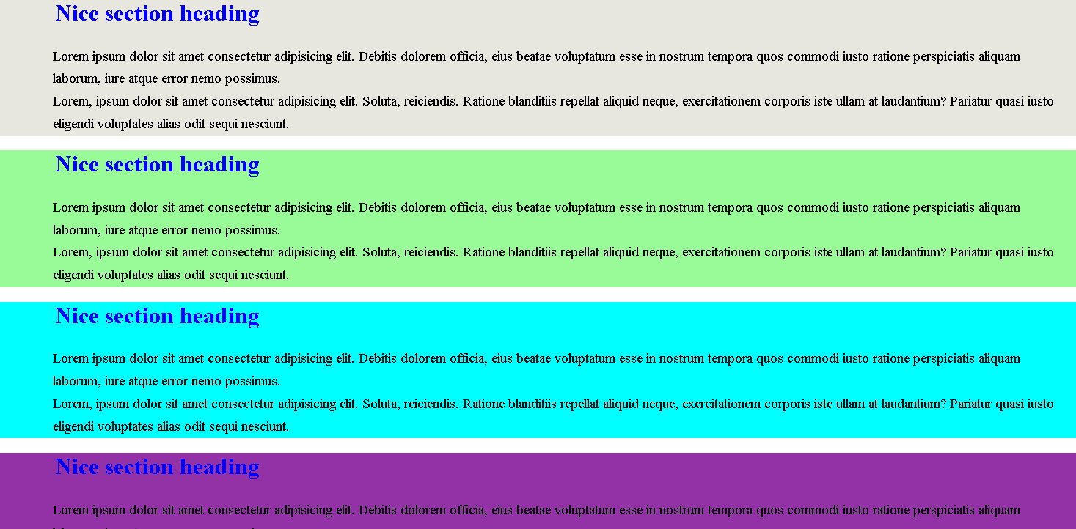

**Explaination:**

First I use <div> tag in page-3.html then assign every div a class like s1,s2,s3 etc. In style-3.css stylesheet I call these class one by one and give background-colors and h1,p colors to display these sections.

1. **Conclusion:**

Within the framework of this assignment, I was able to illustrate how to create HTML web pages’ architecture and apply CSS. In order to create new and clean looking web pages, I applied the use of the responsive design. Colors, classes, and custom properties all helped improve the aesthetic appeal coupled with improving for the style’s replayability. This project ensured that I clearly grasped important concepts of website development such as the linking of external stylesheet and the use of advanced CSS in developing modern appeals of a webpage.